
NOISE MANAGEMENT PLAN – BROOKSIDE/BRECKLES, GP3232YJ

Introduction

This Noise Management Plan (NMP) has been prepared to support the overall Environmental Management System (EMS) in place at Brookside/Breckles Poultry Unit. The overriding principle of this NMP is to ensure the day-to-day activities are carried out in accordance with this document to help minimise the overall environmental impact. This NMP has been prepared as Best Practice.

Pathways and Receptors

The pathway for any potential noise sources would be via the atmosphere, with the most sensitive receptors being inhabitants of nearby residential dwellings, the wind direction will significantly influence how receptors are affected.

Sensitive Receptors within 400m of Brookside farm permit boundary are:

- Residential, 11m, E (TL 94947 93874)
- Residential 29m, N (TL94890 94006)
- Residential 55m, N (TL 94866 94042)
- Commercial 149m, N (TL94725 94131)
- Commercial 247m, N TL94790 94211)
- Residential 257m, N (TL94879 94246)
- Residential 296m, NE (TL94907 94287)
- Residential 295m, NE (TL94942 94291)
- Residential 194m, NE (TL94935 94189)
- Residential 48m, ENE (TL94966 94035)
- Residential 219m, ENE (TL95159 94033)
- Residential 288m, ENE (TL95232 94023)
- Residential 360m, ENE (TL95298 94063)
- Residential 296m, ESE (TL95101 93493)

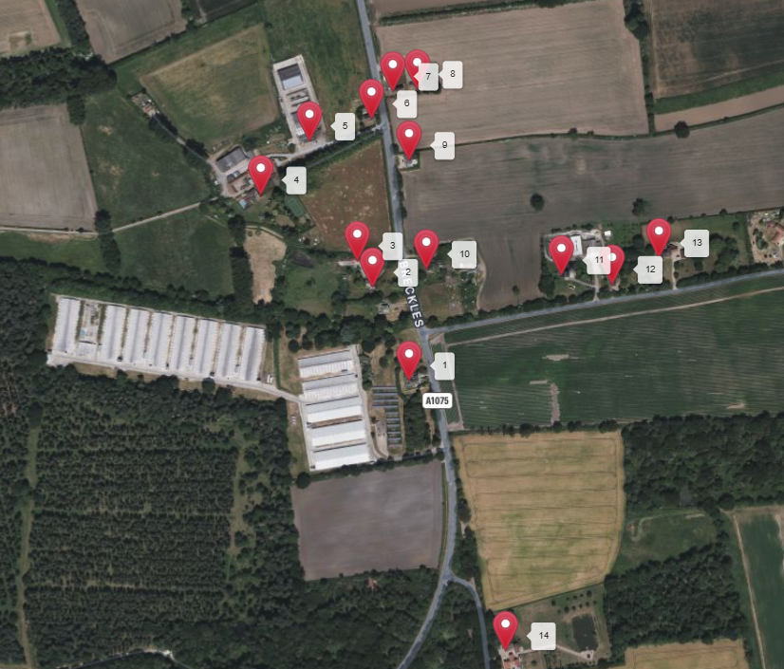

Noise Management and Control Measures

Noise Related Issue | Potential Risk and Problems | Actions taken to prevent and minimise risk
Perceptible noise from ventilation fans during conditions of low background noise. | Ensure that fans are well maintained and cleaned at the end of each production cycle to reduce mechanical noise and maintain efficiency. | Current Practice
Noise from feed deliveries and feed mixing. | Request the use of modern well silenced vehicles. Whenever possible avoid feed deliveries at anti-social hours e.g. late evening/night time/early morning. | Current Practice
Noise from auxiliary generator engine. | Where the generator is located inside a building. Ensure doors are kept closed when the engine is operating. | Current Practice
Mechanical noise from equipment. | Ensure all equipment is properly maintained, set and lubricated in accordance with the inspection and maintenance schedule. | Current Practice
Bird noise when catching. | Only trained handlers will fill crates with minimum disturbance to the birds. Schedule loading so that birds are quickly loaded on to lorries and removed from the site. | Current Practice
Noise from forklift and other vehicles when catching. | Keep forklift movements to a minimum. Request the use of modern well silenced vehicles. Ensure all equipment is maintained in good condition. Utilise large trailers to minimise traffic. | Current Practice
Noise during cleaning out. | Where possible operate the loader inside the sheds and load trailers close to doors. Ensure all equipment is maintained in good condition. Utilise large trailers to minimise traffic. | Current Practice
Noise from standby generator | Testing shall be limited to one hour per week. The generator is serviced every 6 months and an engineer is on standby for call outs if any issues arise | Current practice
Building works and repairs | These shall only be carried out during sociable hours and as far as practical no building maintenance work shall be conducted at the weekends. | Current Practice
Routine alarm testing | Only to be carried out on weekdays during daytime hours | Current Practice
On site staff | Staff shall be considerate to any neighbours and ensure that unnecessary noise is avoided | Current Practice
On Farm Monitoring and Continual Improvement
- Any abnormal noises should be investigated.

Noise Complaints Procedures
Any noise complaints received in direct relation to the installation shall be recorded. Noise complaints shall be fully investigated and records available at future inspections. Complaints received directly from the public shall notify the Environment Agency (EA).

Investigations shall take into account…

- The activities taking place at the time of the complaint.
- The timing of the complaint.
- The weather conditions at the time of the complaint.
- Any non-routine operations on site.
- Any changes that may have been made to Standard Operating Procedures.
- The receptor and the impact that may have been caused.

Following all investigations into complaints, if the issue is caused by an operation at the site, a discussion will be had with the EA any agreed mitigation measures will be implemented to help minimise the impact.

Review
This NMP will be subject to review following any EA substantiated complaint or every four years, whichever is sooner.

