DUST/BIOAEROSOL MANAGEMENT PLAN

There are five sensitive receptors within 100m of the boundary.

- Residential, 11m, E (TL 94947 93874)
- Farm dwelling, within permit boundary, N (TL94911 93972)
- Residential 29m, N (TL94890 94006)
- Residential 55m, N (TL 94866 94042)
- Residential 48m, ENE (TL94966 94035)

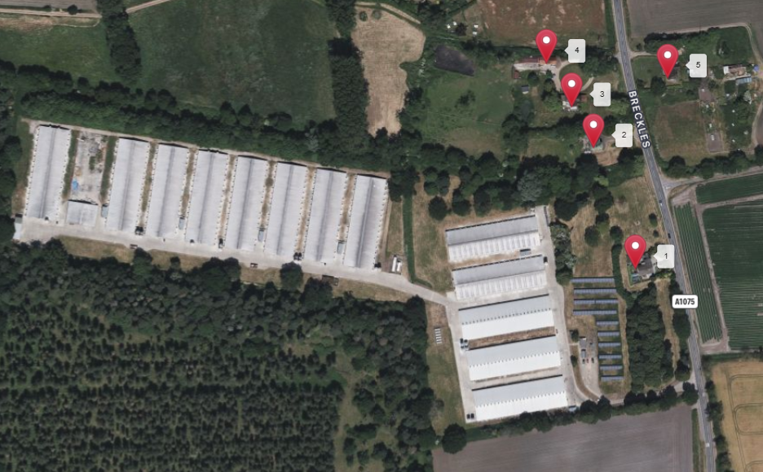

The main possible dust/bioaerosol sources are listed below:

- Feed delivery
- Feeding systems
- Bedding material
- Litter management
- Ventilation systems
- Stock inspections/management
- Cleaning operations
- Bird numbers

The flowing table describes how these sources are controlled

Possible dust source | Process | Reduction technique | Completion date
Feed | Feed delivery to silos  Feeding systems  Feed spillage | All bulk deliveries in sealed and covered trailers. Discharged directly into silos through sealed pipe work. Silo vent pipes covered with containment bags.  Feed delivered to sheds via sealed auger system and dropped directly to feed pans inside.  Any feed spillages cleared up and disposed of immediately. | In place  In place  In place
Feed | Feed type | All feed is pelleted and coated to prevent break up and dust production  Some rations include a percentage of whole wheat.. | In place
Bedding | Bedding type  Bedding application | Initial bedding is of dust extracted woodchip or wood shavings  Initial bedding spread by mini tractor and scraper, further bedding added by hand, using plastic wrapped bales.  Bedding depths maintained to absorb moisture from birds. | In place  In place
Litter | Litter management | Relative humidity and temperature controlled to maintain best litter conditions. | In place
Ventilation | Air exchange within rearing sheds | Ridge inlet and side extraction to ground from all sheds. Constantly monitored and adjusted to maintain best conditions.  Any accumulation of dust beneath outlets cleaned up and disposed of appropriately | In place
Shed cleaning | Litter removal | All litter removed by mechanical handlers, placed directly onto trailers which are sheeted as soon as loaded  Side doors remain closed during cleanout, all litter removed via end doors. | In place
Stock welfare | Husbandry practices | Husbandry work within sheds carried out in a quiet steady manner to reduce bird disturbance. | In place.

This plan will be reviewed every four years unless a problem occurs in the meantime.
Should dust emissions become an issue, further mitigation measures, such as screening will be investigated/implemented.

