BIOAEROSOL AND DUST ASSESSMENT / MANAGEMENT PLAN

Haveringland Poultry Unit
Locks Farm
School Road
Haverngland
Norwich
Norfolk
NR10 4QE

Permit no: EPR/VP3232YZ

Grid Reference: TG 1557 2059

Introduction
This bespoke Assessment and Management Plan has been prepared to support the overall Environmental Management System in place at Haveringland Poultry Unit. The overriding principle of this document is to ensure the day-to-day activities are carried as to minimise the overall environmental impact. As there are number sensitive receptors within proximity of the installation this document has been prepared as Best Practice.
The purpose of this document is to.
- Establish the likely emissions arising from the farm
- Set out procedures at the farm to mitigate or minimise the risk
- Formalise an effect method of dealing with any complaints quickly and efficiently

Potential Emission Sources

The following sources have been identified as contributing to a potential medium - high risk odour source.

- Emissions from compound feed selection
- Emissions from feed delivery and storage
- Emissions from ventilation techniques
- Emissions from litter conditions and management
- Emissions from bird depletion
- Emissions from cleanout (litter removal)
- Emissions and fine vapours generated from high pressure washing/disinfecting

Pathways and Receptors

The pathway for all of the above sources would be via the atmosphere, with the most sensitive receptors being inhabitants of nearby residential dwellings the wind direction will significantly influence how receptors are affected.

Sensitive Receptor Locator

The follow table has been produced to locate all sensitive receptors with 100 meters of the named permitted installation.

Receptor ID | Name of Receptor (if known) | Grid Reference of Receptor | Distance from installation - mtrs | Positioning
1 | 10 School Road | TG16172039 | 38 | E
2 | NA | NA | NA | NA
3 | NA | NA | NA | NA
4 | 7 School Road | TG16200243 | 6 | S
5 | Locks Farm House | TG15712048 | 4 | S
6 | Residential | TG15412047 | 6 | SW
7 | Old School Residential | TG15372046 | 5 | SW
8 | NA | NA | NA | NA
9 | NA | NA | NA | NA

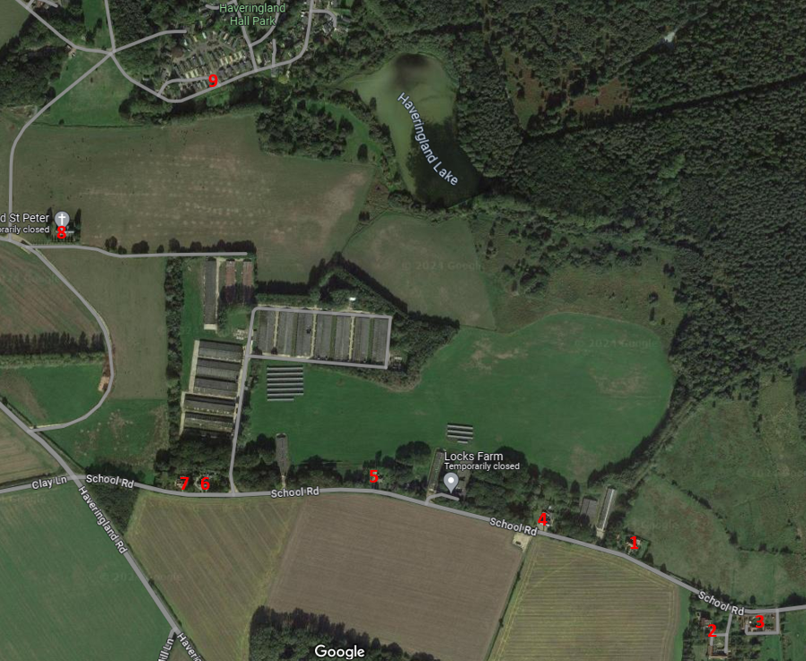

Management and Control Measures

Dust Related Issues |  | Potential Risk and Problems |  | Actions taken to prevent and minimise risk
Manufacture and selection of compound foods |  | Milling and mixing of compound feeds  Poor quality ingredients |  | No on-site milling or mixing  Feed specifications are prepared by the feed compounder’s nutrition specialist.  The nutritionist ensures that protein and phosphorous content is reduced as the rations change throughout the flock cycle  Feed is only supplied by a UKASTA accredited feed mill, so that only approved raw materials are utilised in production.  A feed sample for every load of feed delivered to the site is left and documented for both quality assessment and traceability. Samples are kept on site for a minimum of three months
Feed Delivery and storage |  | Spillages of feed during delivery and storage  Creation of dust during delivery |  | Feed delivery systems are sealed to minimise atmospheric dust.  Any spillages are cleaned up immediately. For major spillages over 500kg the feed mill would be notified who will send a vehicle out to clear the feed up and move to another on site silo. This process is carried out with a few hours if the food is still in a condition to be used.  For any major spillage greater than 500kg that is unfit for animal consumption the spillage will be cleared up into skips and removed from site for disposal via the appointed waste contractor within 24 hours of the incident.  For any minor spillage less than 500kg feed would be cleared up using bags and placed in the onsite general waste container for disposal.  Annual condition checks are carried out and documented.
Ventilation Techniques |  | Inadequate air movements within the buildings can lead to high airborne dust levels from the litter / birds  Inadequate control of inlet and fan controls leads to poor dispersal of potential dust build up  Fan design, installation and operations |  | The ventilation system is regularly adjusted either automatically or manually to aid optimum internal environmental conditions.  The ventilation system is designed to efficiently control the exchange of air from inside the building with that of clean air outside  Maintenance schedules are in place and are carried out in line with manufactures recommendation and guidance as stated in the EMS. This is to minimise the risk of any breakdowns during the flock cycle.  High velocity ridge mounted fan allow the air to be exhausted at a greater rate upwards of 11m/s which allowing a better dispersion higher up in the natural air steams.  Gable end fans are only used in times of extreme warm weather.
Litter Conditions, Material and Management |  | Type of Bedding used as both initial lay and top up |  | Dust extracted virgin wood shavings or chopped straw are both used as initial bedding and top up / replacement. Both products are quality checked at the production plant and routinely audited by internal / external auditing bodies.  Initial bedding is supplied in either loose bulk form (shavings) and blown into the buildings via an enclosed pipe. Other than bulk bedding litter is supplied baled in plastic wrapping which are transported into the houses before being spread.
Dust build up around extraction fans / gravelled / concrete areas |  | Dust left exposed to the elements can in turn cause several issues from fine particle release during drier windy day or if left to become wet / waterlogged can blind French drainage systems or pollute water courses |  | Dust build up is to routinely be swept up where left on concrete / hardstanding’s. Where dust fall’s gravel areas the gravel is to be routinely raked over to ensure blinding of areas does not occur. If heavy deposits accumulate over time the area of gravel is to be removed and replenished as required.
Destocking of livestock |  | Higher levels of dust release through increased ventilation  Turning over of any litter during machine access and in house movements |  | Ventilation controls to be used to control the release of dust while still maintaining optimum temperature control throughout the depletion process.  Machinery movements to be kept to a minimum to help reduce bird excitement breaking up of litter which in turn reduces the airborne particles, allowing for a consistent even dispersal of air / dust through the ventilation systems.
Clean out  (litter removal) |  | Creation of dust during clean down  Heaping up and removal of large quantities of potentially high levels of odorous material  Loading of lorries / trailers |  | All internal areas are blown down using high pressure air lances before the litter is removed so areas of trapped dust are minimised. Where practically possible fans are blown inwards to the buildings (gable and side mounted) roof mounted fans are blown outwards with the fan running to aid dispersion while dust is being released. This process usually happens within 12 hours of the birds being depleted.  Litter is scraped into a large heap running the length of the centre of the buildings, this in turn help aid the drying process and minimises loading time and help make the process more efficient throughout. As this process carries a lot of hazards for operators working within the buildings, ventilation is required at all times to keep the environment clear of dust and ammonia build up. During this time ventilation is needed to run at maximum. Once all the litter is removed and the floors mechanically swept the ventilation system is the powered down.
Washdown / disinfection |  | Fine particles released / disturbed whilst using high pressure lances and fan assisted sprayers  Fine particle generation from fan assisted sprayers |  | A process known as pre-soaking is carried out to dry buildings before high pressure washing commences. In this methodology a low-pressure rinse is carried out to all internal areas of the building allow any dust deposits to be dampened and allows heavy debris to “pre-soak”. This process allows a cooler environment to apply detergents to allowing them long cling activity help to break down any fats and heavy staining which in turn reduces the amount of aerosol effect created from using high pressure.  As disinfectants can be hazardous in use all buildings are sealed as best as practically possible before disinfection is carried out. The use of a fan assisted sprayer is routinely used to ensure full coverage to all internal areas is maximised within a controlled environment Products are only applied to a point of run to avoid excessive use. Once the building is disinfected buildings are left closed allowing any mist, dust or vapours to settle / dry off before ventilation fans are used to assist drying of larger areas.  Only DEFRA approved disinfectant and detergents are used on site and are applied by trained personnel,

On Farm Monitoring and Continual Improvement
- Internal relevant humidity, temperature and littler quality is to be monitored by farm personnel and recorded on each house card daily.
- Complaints and Subsequent actions are to be logged on site
- Staff is to receive training regarding Environmental Permitting Regulations – which will include odour management and any new company procedures.

Complaints Procedures
Any dust complaints received in direct relation to the installation shall be recorded on an farm complaints form. Dust complaints shall be fully investigated and available at future inspections. Complaints received directly from the public will be notified to the Environment Agency.

Investigations shall consider,

- The activities taking place at the time of the complaint
- The timing of the compliant
- The weather conditions at the time of the complaint
- Any abnormal operations either on site of nearby
- Any changes that may have been made to a standard operational procedure
- The receptor and the impact that may have been caused
- If further abatement techniques would better control / minimise the effects

Following all investigations into complaints if the issue is caused by an operation at the site a discussion will be had with the E.A any practical proactive measures which can be agreed will be implemented to help minimise the impact.

Review

This document will be subject to review following any E.A substantiated complaint or every four years whichever is sooner.

