Dear KATIE

As per our email correspondence, please find the below and attached, in answer to your questions (in red):

- A revised copy of Form Part A including sections 5a, b, and c and details of the company directors including their dates of birth.
Attached. Please note, Derek Thompson has just resigned as director of Refuels Ltd, as of Tuesday 25th November 2025. We are in the process of updating Companies House. His details are now not on this form.

- A revised copy of Form Part B4 confirming which technical standard, or alternative operating techniques you will be complying with, as requested in table 3a.
Attached

- A copy of the Environmental Management System (EMS) for the site.
The Environmental Management System for Refuels has been independently certified to ISO14001 by NQA; see attached certificate. To give additional context of our EMS also see attached a copy of our EMS Manual (Refuels Environmental Management System Manual.pdf).

- Confirm your procedures that are in place for assessing and training the customers who will be using and maintaining the site (i.e. do you require them to have completed the SPA vehicle mis-fuellers course, DSEAR (Dangerous Substances and Explosive Atmospheres Regulations) course, are they inducted/trained in waste acceptance, spillage response for the site.) In addition to the procedures as outlined within the submitted document titles ‘Refuels Ltd – Decanting Procedures & Emergency Actions V9’ this references European Agreement Concerning the Carriage of Dangerous Goods By Road (ADR 2023), The Carriage of Dangerous Goods by Road Regulations 2009, DSEAR Dangerous Substances & Explosive Atmospheres Regulations 2002. This document does not confirm any competency requirements and training provided for the operatives using the site.
Decanting product into the storage tanks is only authorised for those operators who have completed the SPA Vehicle Misfuellers course. The course contains the following content (pages below):
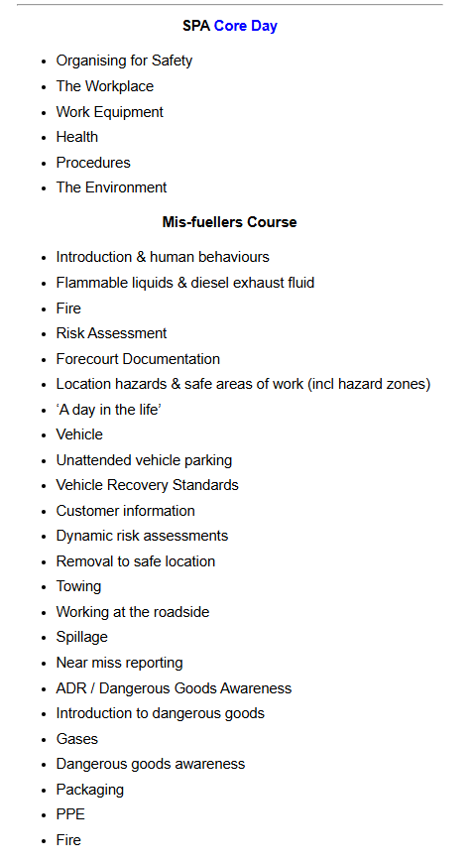
- The site is identified as an unmanned site, operated by the customers directly, and remotely managed by Refuels Ltd for data collection and monitoring. Please clarify how the site will be remotely managed. As the permit holder you should be in day-to-day control of site operations, confirm how this will be achieved.
Each storage tank is controlled via GSP link to our server. We monitor and completely control access to the storage tanks. The on-site programme limits access, based on it’s parameters (fuel volume for example). There is also a 24hr access number and emergency response. Only customers that have completed the SPA Vehicle Missfuels Course have tank access.
- A revised copy of Form Part B2 including evidence of technical competence as requested in section 3b.
Forms B2 attached, with 3c “Yes” ticked and its boxed section filled out. We have previously found that some boxes, filled out on a MacBook, do not show as filled on a PC when reopened. The text is as follows: Michael Taylor and Derek Thompson were asked by the shareholders of Pipeline Terminals Limited (Company Number 08370378 - Incorporated on 22 January 2013), after seven years of trading, to register as directors of that company (January 2020), to see if it could be saved, from the previous miss-management of that company, by the previous officers (Lee Burke, director, was fired for Gross Misconduct and Leon Brown disappeared to The States). Michael Taylor spent five months looking at all of the issues and decided that the company could not rise above it’s insolvency, so after trying to liquidate the company, using a private insolvency practitioner; where the shareholders did not agree on this path; he was forced to cease trading the company and present it to the government’s official receiver. All relevant information was given to the official receiver. No further action was required and Michael Taylor followed his fiduciary duties to the letter.

- A revised copy of Form Part B2 including details of any insolvency proceedings that have occurred for any companies that the current directors for Refuel Limited were active directors of, at the time that those companies became insolvent, as requested in section 3c.
Answered in 6. above
- A site-specific environmental risk assessment that considers receptors both residential and habitats, addressing emissions including odour and VOCs, spills and potential escape to groundwater and surface water, and fire.
Attached for each site.
- A site location plan identifying the location of the site in relation to sensitive receptors and outlining any external drainage (specifically surface water drainage) in close proximity/down flow gradient to the permitted area that can potentially be impacted on from loss of fuels from the permitted site.
Attached for each site.
- An updated site plan which includes the following:
- A date and reference number
- The site address and NGR
- A scale
- A boundary that is clearly outlined in green
- A north arrow
- Local features (such as nearby road names)
Attached for each site.
- A site-specific Site Condition Report (SCR) this should follow the format as outlined in Environmental permitting: H5 Site condition report - GOV.UK
Attached for each site
Kind regards

Mike Taylor
Director
Refuels Ltd

