Non_Technical Summary

AK Automotive are applying for a bespoke ELV permit to dismantle end of life vehicles.

A bespoke permit is required due to the presence of Strothers Hill SSSI which is less than 200m south of the boundary.

AK automotive plan to operate as a car breakers unit inside a building only. There is minimal ELV waste stored externally or on the site as a whole. Most waste is removed from the site daily and not stored for any length of time. The company operates a “one in one out” policy with regard to end of life vehicles to prevent stock piles building up.

There is a fire hydrant less than 10m from the boundary of the site and there is a sealed drainage system provided by a blind interceptor which is gulped out on a regular basis. All depollution is carried out inside a building. A small volume of batteries and tyres are stored during the day inside the building but these are removed from site within 24 hrs.

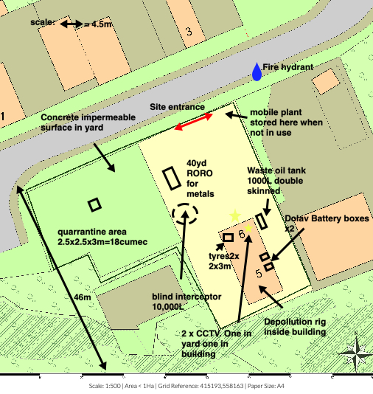

Waste Code | Description
16 | WASTES NOT OTHERWISE SPECIFIED IN THE LIST
16 01 | end-of-life vehicles from different means of transport [including off-road machinery] and wastes from dismantling of end-of-life vehicles and vehicle maintenance (except 13,14, 16 06 and 16 08)
16 01 03 | end-of-life tyres
16 01 04* | end-of-life vehicles
16 01 06 | end-of-life vehicles (containing neither liquids nor other hazardous components)
16 01 21* | hazardous vehicle components – catalytic converters containing RCF matting
16 01 22 | catalytic converters not containing RCF matting
16 06 | batteries and accumulators
16 06 01* | lead batteries
16 06 05 | other batteries and accumulators

