Project No: 312126

Dust & Emissions Management Plan [BRS_DEMP]

Prepared for:

BR Skip Hire
Foxdene
Rumstead Lane
Sittingbourne
Kent, UK
ME9 7RT

Contents Amendment Record

This report has been issued and amended as follows:

Revision | Description | Date | Signed
1.0 | Final | February 2023 | Graeme Kennett

Acknowledgement

This report has been prepared for the sole and exclusive use of BR Skip Hire in accordance with the scope of work presented in Mabbett & Associates Ltd (Mabbett) Letter Agreement (312126/LA/GK), dated 02 June 20242. This report is based on information and data collected by Mabbett. Should any of the information be incorrect, incomplete or subject to change, Mabbett may wish to revise the report accordingly.

This report has been prepared by the following Mabbett personnel:

MABBETT & ASSOCIATES LTD

___________________________________
Graeme Kennett, BSc(Hons)., MSc., MBPR (FACTS)
Principal Environmental Consultant

This report has been reviewed and approved by the following Mabbett personnel:

MABBETT & ASSOCIATES LTD

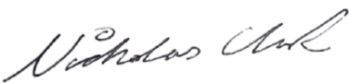
___________________________________
Nicholas Clark, MEng, AMIChemE
Environmental Engineer

Table of Contents

Section 1.0: Issue and revision record iii
Section 2.0: Introduction 4
2.1 Site background 4
2.2 Site operations 5
2.3 Sensitive receptors 5
2.4 Other local sources of dust emissions 7
Section 3.0: Operations at the BR Skip Hire Recycling Facility 8
3.1 Waste deliveries to the site 8
3.2 Overview of waste processing, dust and other emission controls 9
3.3 Mobile plant and equipment 10
Section 4.0: Dust and Particulate (PM₁₀) Management 11
4.1 Responsibility for implementation of the DEMP 11
4.2 Sources and control of fugitive dust/particulate emissions 11
4.3 Other considerations 18
4.3.1 Water usage/ availability: 18
4.3.2 Enclosure of waste processing & storage areas 18
4.4 Visual dust monitoring 18
Section 5.0: Particulate Matter (PM) Monitoring 20
5.1 Monitoring location 20
5.2 Operation of the PM monitoring equipment 21
5.3 Quality assurance/Quality control and record keeping 21
5.4 Equipment and data management 21
5.5 Additional detailed monthly reporting 21
5.6 Dust monitoring plan 22
Section 6.0: Actions When Alarm is Triggered 23
Section 7.0: Reporting and Complaints Response 26
7.1 Engagement with the Community 26
7.2 Engagement with the Community 26
7.3 Reporting of complaints 26
7.4 Management responsibilities 26
7.5 Summary 26
Section 8.0: Sources of Information 28
Appendix A: Dust Complaint Form 29

Issue and revision record

The following table will be used to record version and revision history.

Version | Date | Originator | Checked by | Approved by | Amendments
1 | 2022 | GK

Introduction

This Dust & Emissions Management Plan (DEMP) has been produced to accompany the bespoke permit variation application for the permitted site at:
EPR/ /DB3406XQ
Foxdene
Rumstead Lane
Sittingbourne
Kent, UK
ME9 7RT

BR Skips, ‘the operator’ operates a ‘written management system’ as required by permit condition 1.1.1 to ensure that their operations meet environmental standards and comply with the legislative requirements applicable to the site. After permit issue the DEMP will be adopted into the site’s management system to ensure that operations do not impact significantly upon the environment.

This DEMP has been produced in accordance with the EA Dust & Particulate Emission Management Plan Guidance ‘Control and Monitor emissions for your environmental permit’ (published 1st February 2016) and version 10 (October 2018) of the Dust & Emission Management Plan (DEMP) template, and relates to waste materials accepted, stored and treated at the site which have the potential to produce fugitive emissions.

The plan is intended to be a living document subject to on-going review and updating, with its intended audience being the staff at the site whose working practices can affect the emissions from the site.

Site background
The Waste Recycling Facility (WRF), centred at Ordnance Survey grid reference TQ 8359 5492 is located to the south-eastern side of the A429, south-east of Gillingham in Kent.

The recycling site will process construction and demolition, and other suitable producers, waste materials for either:
- Production of saleable product in accordance with the Aggregate Quality Protocol (AQP);
- Production of saleable product in accordance with RPS190; or
- Despatch from site as a waste for use by third parties under a suitable exemption/ waste management operation.

Site operations
The operation treats both non – hazardous and inert waste types, with the main inputs being mixed skips containing a variety of waste streams. These streams are separated into different waste types for bulking up for further processing elsewhere. Waste is mainly hand sorted or picked out via a 360º excavator and grab. Due to the size of the site and the nature of the business, volumes of wastes held on site will be kept to a minimum. This helps to preserve the quality of the recovered materials and is a major aid to fire prevention and minimisation.

Inert wastes are accepted and screened and/or crushed where required. Screening and crushing is on a campaign basis in that once sufficient material has been accepted, a screener/crusher is brought in to process the material which is then dispatched from site to various customers.

Deliveries will be undertaken between the hours of 7am and 6pm Monday to Friday and 7am to 5pm on Saturdays.

Materials will be unloaded on-site and stored in designated stockpiles up to 4m in height.

One excavator will be used to transfer waste from the designated stockpiles to the mobile crusher and crushed to a maximum size of 50mm.

Recycled aggregates will be removed by an excavator and stored in designated concrete storage bays up to 4m in height.

To maintain capacity within the site, regular shipment of the product off-site will be undertaken.

Operation of the mobile crushing plant will be for an average 4-hours per day.

The crushing plant will house spray bars to dampen down all areas of potential dust generation.

Sensitive receptors
A sensitive receptor is defined as any location which may be affected by air quality impacts because of the operation. All receptors that are potentially at risk from the site have been previously identified in a risk assessment. The DEMP focuses on the main receptors that are at risk from a dust and emissions perspective.

Receptors include:
- protected sites and species;
- anywhere used to grow food or to farm animals or fish;
- fields and allotments used to grow food;
- footpaths;
- homes, or groups of homes (such as villages or housing developments);
- playing fields and playgrounds;
- schools, hospitals and other public buildings;
- water, for example ponds, streams, rivers, lakes or the sea; and
- conservation and habitats protected areas and areas of scientific interest.

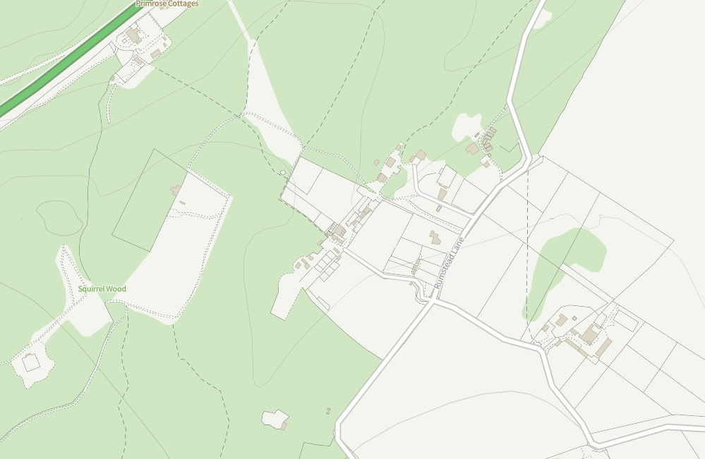
Figure 1: Location of Identified Receptors

Table 1: Identified Sensitive Ecological Receptors
Identifier | Receptor | Classification | Type | Direction | Distance (m)
1 | Squirrel Wood | Unclassified | Ecological | W | <10

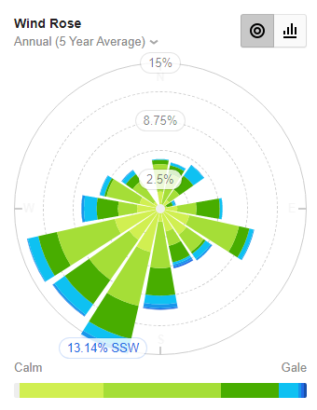
Figure 2: Wind Rose Annual

Table 2: Identified Sensitive Receptors
Identifier | Receptor | Type | Direction | Distance (m)
2 | - | Residential | NE | <50
3 | - | Residential | NE | 100
4 | - | Residential | E | 275
5 | The Dreys | Leisure | S | 325

Other local sources of dust emissions
The assessment also takes in to account any existing dust sources such as adjacent agricultural or any arboreal activities. The scale and nature of the works taking place at a scheme determines the level of residual dust emissions from fugitive sources. The following activities on inert processing sites are likely to have the greatest potential for dust emissions:
- Material handling;
- On-site transportation;
- Mineral processing;
- Stockpiling/exposed surfaces; and,
- Off-site transportation.

Table 3: Sources of Dust and/or Other Emissions
Company | Address | Business type | Distance (m)
Various agricultural | - | Agriculture | <250
Forestry Commission | Squirrel Wood | Forestry | <10

Operations at the BR Skip Hire Recycling Facility

Waste deliveries to the site
Waste will be delivered to the site by;
- 32t LGV tippers
- Hi Ab LGV (grab lorry)
- Skip wagons (hook and chain and ro-ro)

All LGVs operated by the operator will have a Euro 5 emission rating. It is likely that 3rd party hauliers will be at least Euro 5 emission rating.

All 8-wheel tipper vehicles will be fitted with a fly sheet and skip wagons/grab lorries will also be sheeted.

Overview of waste processing, dust and other emission controls
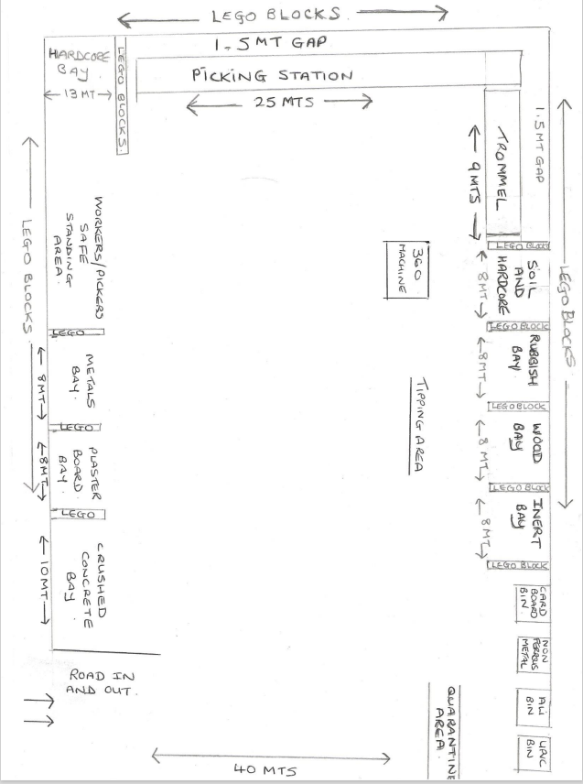
Figure 3: Site Layout

Table 4: Typical waste types brought to the BR Skip Hire recycling facility
EWC | Description | t/wk | Destination within facility
 |  |  | Crushing | Screening | Storage
17 01 01 | Concrete | 150-200
17 01 02 | Bricks
17 01 07 | Demolition wastes
17 05 04 | Soil and stones |  | 50 | 150 | 100
Total |  |  | 500 | 1500 | 100

Please note that the tonnes per week are expressed as a potential maximum accepted per week of each type and do not necessarily equate to the expected weekly delivery tonnages of all streams each week.

Mobile plant and equipment
Nitrogen Dioxide (NO₂) gas and Particulate Matter (PM) are common pollutants released by diesel-fuelled internal combustion engines and the site uses several items of plant with internal combustion engines. The following table lists the type, model and emission ratings for the mobile plant and equipment used on site.

Table 5: Equipment List
Description | Make | Model | Emission rating
360º Excavator | Doosan | DX140 | Tier 4
Crusher | Arjes | Impaktor 250 | EU Stage V
Trommel/screen | Propnar | MPB18.47/1

All machines are operated on a leased basis and are serviced on a regular basis by manufacturer supported dealerships as required by the manufacturer. Failure to adhere to the recommended service intervals invalidates the manufacturer 5-year warranty. Daily defect reporting is done via a software reporting system by all operators.

When due for replacement, machines are replaced by equipment that has the lowest emission standard possible at the time of the contractual arrangement.

Fuel use is monitored to reduce costs. All machines are switched off when not in use and there is a no-idling policy on site so that machines are not left idling for long periods of time, which will also reduce pollutant emissions.
.
Figure 4: Idle Free Zone Signage

Dust and Particulate (PM₁₀) Management

Responsibility for implementation of the DEMP
BR Skip Hire Compliance Manager (CM) is responsible for the DEMP and to ensure that it is used. The Site Manager (SM) is the deputy in this case as they are perfectly positioned with their attendance at the site to continually monitor and enforce the DEMP requirements. Operational staff training is delivered via toolbox talks and there is a direct line of contact between operatives and the CM. Should any issues arise, the CM has a direct line of communication to BR Skip Hire management.

It is envisaged that the DEMP will be reviewed on a bi-annual basis as a minimum. However, should this frequency be inadequate it will be reviewed annually. Due to the nature and location of the operation, along with the control measures in place, it is not thought that this frequency will need to be reduced further. Operational experience at the current site further confirms that the process can continue without receiving complaints.

Sources and control of fugitive dust/particulate emissions
Measures to control emissions have been considered in the context of the operational setting and the operations that are undertaken. Identified operations have the potential to produce and release particulates at the site are described below;
- Vehicles entering/leaving site with mud on wheels
- Vehicles and plant moving around the site kicking up dust
- Material falling from vehicles
- Discharging of waste materials
- Site surfaces
- Loading materials
- Particulate emissions from the exhaust of vehicles/plant/machinery on site.
- Material crushing
- Material screening
- Stockpiling materials
Wind-whip from stockpiles
The pathway for most of the releases is atmospheric dispersion; either primary, from the dust/particulate source (e.g., crushing and/or screening of materials) or secondary, where dust is stirred up by vehicle movements.

The BR Skip Hire Recycling Facility is in a wooded, rural setting, with a distance of at least 50m to the nearest, unconnected residential receptor.

Table 6: Source-Pathway-Receptor Routes
Source | Pathway | Receptor | Impact | Control
Vehicles entering or leaving site with debris on wheels | Tracking dust on wheels and vehicles, then mud dropping off wheels/vehicles when dry | Local highways | Visual soiling, also consequent resuspension as airborne particulates | Vehicles unlikely to have come in to contact with mud prior to accessing the site. Compacted surface ensures debris is not deposited on the public highway.
Vehicles and plant moving around the site kicking up dust | Atmospheric dispersion | Neighbouring businesses | Airborne particles | 10mph site speed limit in force.  Regular sweeping of vehicle routes will be undertaken.
Material falling from vehicles | Material falling from vehicle bodies | Local highways | Visual soiling, also consequent resuspension as airborne particulates | Sides/lips of tipping bodies swept before departure to remove any accumulated materials.
Discharging of waste materials | Atmospheric dispersion | Neighbouring businesses | Airborne particles | Accepted waste materials are generally not inherently dusty due to moisture content.  Should a dusty load be accepted that has the potential to elevate particulate emissions, the tipper will be re-orientated to reduce the potential for dust emissions.
Site surfaces | Contamination of trafficked areas. | Neighbouring businesses | Visual soiling, also consequent resuspension as airborne particulates | Site surfaces that are used by traffic will be regularly cleaned along with the measures described above.  Regular sweeping of vehicle routes will be undertaken.
Loading materials | Atmospheric dispersion | Neighbouring businesses | Airborne particles | The finer processed materials have a limited potential to generate airborne particles during loading. Shovel buckets will be kept as low as possible to the ground to reduce spillage. Loading shovel dump heights will be kept as low as possible. Material will be tipped in to trailers in a controlled manner to reduce the potential for particulates to be propelled from the trailer.
Particulate emissions from machinery exhausts | Atmospheric dispersion | Neighbouring businesses | Airborne particles | Anti-idling policy in place.  Low emission plant always used.
Material crushing | Atmospheric dispersion | Neighbouring businesses | Airborne particles | The processing plant will house spray bars to dampen down all areas of dust generation. Material crushed using a crusher and 360º presents a minimal risk of releasing dust.  Orientation of plant can be changed depending on wind direction.
Material screening | Atmospheric dispersion | Neighbouring businesses | Airborne particles | The processing plant will house spray bars to dampen down all areas of dust generation Orientation of plant can be changed depending on wind direction.
Stockpiling materials | Atmospheric dispersion | Neighbouring businesses | Airborne particles | The finer processed materials have a limited potential to generate airborne particles during loading. Loading shovel dump heights will be kept as low as possible. Material will be tipped on to stockpiles in a controlled manner to reduce the potential for particulates to be propelled from the trailer.  Shovel buckets will be kept as low as possible to the ground to reduce spillage.  Dampening down of stockpiles will be undertaken during loading periods, if required.
Wind-whip from stockpiles | Atmospheric dispersion | Neighbouring businesses | Airborne particles | Site is sheltered by the surrounding woodland that will reduce the potential for wind-whip.

Table 7: Measures that will be used to Control Dust/Particulates (PM) and Other Emissions
Abatement measure | Description/effect | Overall consideration and implementation | Trigger for implementation
Preventative measures
Site layout in relation to receptors | Crushing and screening activities that emit dust particles are located at the maximum potential distance from down-wind receptors without impacting upwind receptors.  Adjacent forestry belt offers protection from the wind. | Dust control has been considered by the operator through good process and site design, as well as identification of good housekeeping procedures.  The control methods to be employed at the proposed mineral extraction site are based on:  - Good operating and management practices to avoid emissions arising from activities;  - Good process design to minimise emissions;  - Abatement or control to reduce dust emissions; and,  - Disrupting the emission pathway to sensitive receptors | Wind strength and/or direction cannot be relied upon as a preventative measure.  As such, processing equipment is fitted with dust suppression equipment to prevent emissions.  There will be a Standard Operating Procedure (SOP) and training of staff with respect to correct operation of the equipment.  This lessens the likelihood of dust from the operations causing a nuisance to others.  However, the objective is to reduce dust at source and not to let dust leave the site boundary.
Site speed limit, ‘no idling’ policy and minimisation of vehicle movements on site | Reducing vehicle movements and idling will reduce emissions from vehicles. Procurement policy to only purchase clean burn road vehicles and non-road going mobile machinery.  Enforcement of the mandatory 10mph speed limit will limit re-suspension of particulates by vehicle wheels. | Straightforward to implement as part of good practice.  Measures are identified clearly in the site management system.  10 mph speed limit is identified clearly in the site management system and on site and implemented as appropriate measures | If significant volumes of dust are noted during routine visual monitoring the following actions will be taken:  - Observations undertaken to ensure that vehicles are obeying speed limits; and,  - Additional road sweeping.
Minimising drop heights for waste. | Minimising the height at which waste is handled will reduce the distance over which debris, dust and particulates could be blown and dispersed by winds. | Measure in place and form part of toolbox talks.  These steps are identified clearly in the site management system and implemented as appropriate measures. | Control measure will always be in place during site operations and will form a part of toolbox talks on an ongoing basis.
Ceasing operation during high winds and/or prevailing wind direction | Mobilisation of dust and particulates is likely to be greater during periods of strong winds and hence ceasing operation at these times may reduce peak pollution events. | The SM will monitor weather forecasts and ensure the necessary on-site precautionary measures are in place to prevent emissions.  All personnel employed on site will undertake visual monitoring for dust throughout the working day. Any observed problems will be reported to the SM who will investigate the cause and implement any necessary remedial action. | If significant volumes of dust are noted during routine visual monitoring the following action will be taken:  - All dust suppression equipment is operating correctly  - Action taken to ensure that vehicles are obeying speed limits; and,  - Additional sweeping of vehicle routes.
Easy to clean concrete impermeable surfaces | Creating an easy to clean impermeable surface, using materials such as concrete as opposed to unmade (rocky or muddy) ground within the site and on-site haul roads, reduces the amount of dust and particulate generated at ground level by vehicles and site activities.  Enforcement of the mandatory 10mph speed limit will limit re-suspension of particulates by vehicle wheels. | Provision of a hard surface between Burrell Way and the operational area;  - Entire site has a concrete surface;  - Site has a 10mph speed limit. | Waste treatment areas have an impermeable surface so any water can be captured and used for dust suppression.  Roadways in normal use and any other area where there is regular movement of vehicles have a concrete surface capable of being cleaned and are kept clean to prevent or minimise dust emissions and kept in good repair.
Minimisation of waste storage heights and volumes on site | Minimising the height at which waste is handled should reduce the distance over which debris, dust and particulates could be blown and dispersed by winds. Reducing storage volumes should reduce the surface area over which particulates can be mobilised. | This abatement measure is not likely to have a significant impact on dust emission levels. | Due to the nature of the inert recycling sector, large volumes of material are often treated on a campaign basis so increased volumes of material can be present.  High volume machines ensure that this is processed as swiftly as possible.
Reduction in operations (waste throughput, vehicle size, operational hours) | Reducing the amount of activity on site, including no tipping, crushing, or screening of high risk loads during windy weather as well as associated traffic movements should result in reduced emissions and re-suspension of dust and particulates from a site. | The site has procedures in place to reduce activity on site if required through complaints or known issues, or adverse weather conditions.  This includes a weather station to monitor weather so that working procedures can be modified if required. | All crushing and screening equipment is fitted with suppression equipment to reduce dust emission potential.  Fencing will be installed to provide a barrier between dust emissions and sensitive receptors.  Material with inherent moisture greater than 3%, e.g., sand or gravel, would not be expected to give rise to emissions of dust.
Remedial measures
On-site sweeping | Sweeping can be effective in managing larger debris, dust and particulates but may also cause the mobilisation of smaller particles.  Road sweeping vehicles damp down dust and particulates whilst brushing and collecting dust and particulates from the road surface, particularly at the kerbside.  This may generate dust and particulate movement that may become a Health and Safety issue if the filters and spray bars on the sweepers are not maintained. | Easy to apply but less effective than other measures. Covered in the management system procedures and implemented thoroughly.  Operation covered by regular toolbox talks along with the triggers for operation of the sweeper.  Sweeper maintained to ensure that its operation is effective.  Manufacturer maintenance schedules are adhered to detailing when consumable items on road sweepers are replaced (filters, brushes etc). | Roadways in normal use and any other area where there is regular movement of vehicles have a surface capable of being cleaned.  They are kept clean to prevent or minimise dust emissions and are kept in good repair
Water suppression with hoses & water jets | Damping down of site areas can reduce dust and particulate re-suspension and may assist in the cleaning of the site if combined with sweeping. | Can be water intensive, so only to be used in adverse weather conditions. | Mobile dust control suppression units will be utilised across the site. The units spray a fine mist at the source of dust emissions and can be manoeuvred to accommodate wind direction;
Water suppression with mist sprays | Installation of mist sprays at point source emissions like conveyors, crusher etc. It can also assist in the damping down of dust and particulates, therefore, reducing emissions from site. | Very effective at controlling point source emissions of dust and particulates. Can be installed to conveyors and areas where waste is dropped. ‘Halo’ rings can be fitted to conveyor drops on concrete crushers and screeners to minimise dispersion. | Mobile dust control suppression units will be utilised across the site. The units spray a fine mist at the source of dust emissions and can be manoeuvred to accommodate wind direction;

Other considerations

Water usage/ availability:
The site has a dedicated water supply as the impermeable surface drains to a water tank.

The dust prevention measures do not rely on general, non-specific, use of water. Water use is deliberately targeted to reduce wastage but also to ensure effective use. It is not relied upon as the sole control measure.

In the event of a drought dust emissions will remain abated and not cause pollution.

Enclosure of waste processing & storage areas
Due to the nature of the input materials and scale of the inert recovery operation it is not possible to enclose the processing operation or storage areas.

Visual dust monitoring
The SM will monitor weather forecasts and ensure the necessary on-site precautionary measures are in place to prevent emissions.

All personnel employed on site will undertake visual monitoring for dust throughout the working day as they are uniquely placed to observe and react to the effects of the operation they are carrying out at the time. Any observed problems will be reported to the SM who will investigate the cause and implement any necessary remedial action.

The monitoring locations are along the site perimeter to take into account the prevailing weather conditions and the changing position of operations within the site.

Out of hours provision for dust monitoring is not considered necessary due to the location of the site and the absence of any mechanical operations that may increase the potential for dust emissions to be generated outside operational hours. The operational hours are specifically stated within the planning permission for the site and limit the hours for both movement of vehicles and operation of externally located machinery.

Should regular complaints be received outside of operational hours over a period of two weeks or more dust mitigation measures will be reviewed. This may include the potential for stockpiles to be dampened prior to the end of the operational day.

It is acknowledged that certain operations (loading, screening, crushing) increase the potential for heightened releases of dust and other emissions. Increased monitoring takes place during these operations, with checks taking wind strength, direction and operation underway into account.

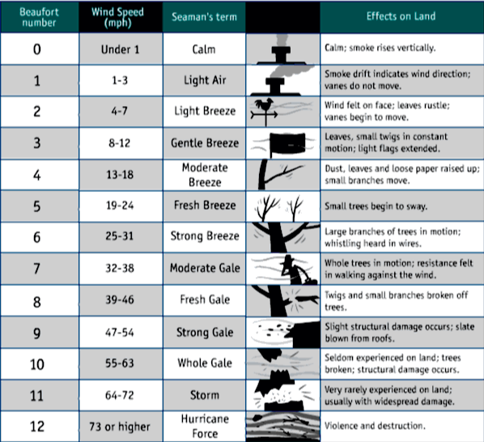
Figure 5: Beaufort Scale

Any formal monitoring undertaken will be recorded in the site diary.

Should a complaint be raised, the form in Appendix A will be completed to investigate and understand the potential issues. Where these are completed over a period a fuller picture will emerge as to the most successful strategies for deciding as to whether further controls are required.

Operating hours are defined, and conditioned, within the extant planning permission as follows;
Externally located plant and equipment shall not be used, except during the following hours:
0800 to 1800 Monday to Friday; and
0800 to 1300 Saturday.

No vehicles (including forklift trucks) shall enter the site, leave the site, manoeuvre, be loaded, or be unloaded within the site, except during the following hours:
0700 to 1800 Monday to Friday; and
0700 to 1300 Saturday.

Particulate Matter (PM) Monitoring

The site is in relatively open countryside at least 50m from the nearest sensitive unconnected residential receptor, so it is not considered likely that quantitative monitoring of particulate matter emissions is required.

If persistent dust emissions arise which necessitate PM monitoring, the scope, nature, location and frequency of monitoring will be discussed with a relevant monitoring specialist to establish the most suitable and effective method.

There are activities on-site that may create dust which could possibly drift off-site and cause an amenity nuisance. Such activities include:
- Vehicle input of wastes (vehicles may kick up dust during dry weather).
- The unloading and treatment of certain dry waste materials on the concrete pad.
- Crushing/screening operations of inert/soil type wastes during the treatment process.

Site staff supervising individual waste handling operations shall, during the undertaking out of those operations, undertake visual monitoring of aerial emissions. Where visible aerial emissions are detected, either dust plumes or areas affected by the fallout of dust, that are likely to be transported beyond the site boundary, action will be taken immediately to stop/reduce the rising of the dust.

The incident and the remedial action taken in response to the incident shall be recorded in the site diary.

Monitoring location
There are no set monitoring locations, other than a prescribed route around the site perimeter as the weather conditions and operations change, so that a fixed location may not always be representative. As the wind direction is most commonly from the southwest to the north-east, the monitoring route will be to the north and east of the site. The visual monitoring is required to be completed at least daily by the Site Supervisor or nominated site operative. The number of visual inspections is increased in accordance with the weather conditions and following an emissions incident or complaint. In windy conditions inspections will occur a minimum of four times a day. The inspections are undertaken during normal operating conditions and not during breaks. The inspection will include a check of surface condition, waste acceptance, tipping/loading activities, waste and material storage, use and effectiveness of dust suppression measures.

Before the staff member responsible for monitoring commences the route, they will observe the wind direction at the time and use it to inform the monitoring route taken.

It is not considered effective to stipulate a precise time for the routine monitoring to take place, it is far more appropriate for the routine dust monitoring to be a ‘task’ based inspection so that the dust impacts can be properly monitored as opposed to an arbitrary time when the operation with the most potential for dust generation may not be taking place. As such, routine dust monitoring would take place during crushing and/or screening operations, if required.

Should particulate matter monitoring be required, potential monitoring locations will be discussed with the relevant specialist to establish the most suitable and effective position. It is assumed that the location would usually be to the northeast of the site.

Operation of the PM monitoring equipment
The risk assessment has concluded that emissions of dust were able to be screened out as insignificant. However, it is acknowledged that should dust emissions be identified as an issue at the site and/or complaints are received as a result, the operator will review the mitigation measures and monitoring techniques detailed in this DEMP to improve detection and prevent emissions being discharged from the site proactively. The site diary and records of the visual inspections are reviewed by company senior management with the intention of identifying any trends in dust emissions and improving processes on site.

Quality assurance/Quality control and record keeping
The results of daily inspections and any remedial work will be recorded in the Site Diary as a minimum. Should any monitoring be carried out, the following will be recorded:
- The make and model of the monitoring equipment
- The serial number of the monitoring equipment
- When, how and by whom the data is checked
- When the equipment is calibrated
- How the equipment is calibrated
- Copies of the qualifications and training records of who carries out the calibration
- When and by whom the equipment is routinely inspected
- If the equipment is damaged and/or no longer able to collect reliable data.

Equipment and data management
Where dust emissions are identified as an issue at the site and complaints are received as a result, the operator will review the monitoring techniques detailed in this DEMP to improve detection and ensure that any emissions data is representative and enables measures to be undertaken to reduce emissions from being discharged from the site.

Additional detailed monthly reporting
Where dust emissions are continually identified as an issue at the site and complaints are received as a result, the operator will consider carrying out a more detailed investigation to work out the source of the pollution, whether it be from dust/particulate sources on site, sources of dust/particulates beyond the site boundary, background sources affecting the whole region, or more local sources.

Dust monitoring plan
Visual dust monitoring at the site boundary will be carried out as part of routine daily site inspections with any observations recorded and retained onsite.

All plant is inspected daily regularly and cleaned down after use to prevent the build-up of dust on machinery parts and hot exhausts.

Informal dust monitoring comprising of operational staff remaining vigilant for visual dust and particulate emissions will be carried out by operational staff members during the crushing and screening processes. Where dust emissions are identified during the treatment process, operations will pause, and the site boundary will be checked to ensure emissions are not leaving the site. Where dust emissions are seen to be leaving the site boundary, material will be dampened down before the treatment process resumes.

No dust monitoring will be carried out outside operational hours, the stockpile and distance to receptors will afford screening for unprocessed and processed stockpiles. Where regular complaints are being received outside of operational hours over a period of two weeks or more, dust mitigation measures will be reviewed with the potential for stockpiles to be dampened down prior to the end of shift.

All dust monitoring results will be recorded and retained in the site office along with dates, times, weather conditions, wind direction and the name of the individual carrying out the monitoring event. Records will also be kept in accordance with the site EMS.

Actions When Alarm is Triggered

When the alarm is triggered following actions are taken:
- The Site Manager (SM) assesses the activities underway and/or the nature of the waste materials being delivered immediately prior to the complaint being received, to work out what has caused the complaint.
- If the source cannot be established confidently the likely dust/particulate generating activities will be suspended, i.e., crushing, screening.
- Where the source originates from the site the SM will take appropriate action in terms of dust/particulate abatement, to ensure that the complaint is followed through. This may take the form of the following;
  - Investigating the source of the dust/particulates to prevent a re-occurrence.
  - Suspending operations which are not being conducted using best-practice controls.
  - Additional use of the dust abatement measures.
  - Logging findings of a – c in the site diary, and in the reporting template within the relevant appendix of the Environmental Permit.

In all cases, any new lessons learnt from the investigations are considered by company management and implemented into the dust & particulate emission management plan (if not already included), to prevent a re-occurrence of the complaint.

The complaint is not the sole indicator of a dust event at the site; the continuous visual monitoring of potential dust sources and activities safeguard play a vital part in managing dust and particulates.

Table 8: Contingency Measures
Potential emission source | Risk | Typical actions to reduce emissions | Trigger for contingency measure | Specific contingency measure  (Backstop) | Monitoring trigger that will indicate a return to normal operations
Dusty feedstock received at the processing site | Crushed waste accepted at the site produces excessive dust | The crushing plant will house spray bars to dampen down all areas of dust generation. | Dust detected at the point of discharge.  [Dust detected at boundary] | Increase wetting measures.  [Remove from site] | Dust not detected at site boundary.
Stockpiled unprocessed feedstock becomes too dry in hot weather. | Waste stockpiles are held for excessive periods of time without processing taking place. | Stockpiles on site are processed quickly.  Material deposited first is processed first.  Any waste generating excess dust will be given processing priority.  Dampening down of stockpiles will be undertaken. | Long periods of hot, dry weather reducing the moisture content of the material.  [Dust detected at boundary] | Ensure all material is processed as soon as possible and placed in stockpiles.  [Remove from site] | Dust not detected at site boundary.
Crushing and screening of materials | Waste materials are crushed or screened when the wind direction is towards areas accessed, or inhabited, by sensitive receptors. | Mobile dust control suppression units will be utilised across the site. The units spray a fine mist at the source of dust emissions and can be manoeuvred to accommodate wind direction. | Weather forecast is used to ascertain the effect of the wind speed/direction on the operation.  [Dust detected at boundary] | Operations that may release excessive dust are programmed to take place only during favourable weather conditions.  Careful monitoring of the conditions will ensure that the ‘window’ for processing is broad enough to allow flexibility to wait for suitable weather conditions.  [Cease processing and remove if excessively dusty] | Dust not detected at site boundary.
Facility maintenance/equipment cleaning | Accumulations of waste material are allowed to degrade and become dry and produce dust. | Regular clean downs of machinery will prevent dust from accumulating.  Areas will be swept/wetted when empty to prevent dust blowing. Regular dampening down of all vehicle routes will be undertaken; | When a stockpile is planned for removal, the area will be swept/tidied as the pile is reduced/removed. | Once a stockpile has been moved, it’s footprint will be scraped with the loader bucket to prevent a build – up of material. | Dust not detected at site boundary.
LGVs leaving site | Spilt accumulations of material are allowed to dry out become desiccated and produce emissions. | Brushing down of trailer sides and sheets in place before leaving will prevent material dropping from trailers and prevent dust being generated. | Long periods of hot, dry weather reducing the moisture content of the material. | All vehicles are checked and prevented from leaving site if not sheeted or clean. | Dust not detected at site boundary.

Reporting and Complaints Response

Engagement with the Community
The site will respond to the complainant once an investigation has been completed. This will include details as to the source of the complaint and the measures taken to correct it. Where the source did not originate from the site, the complainant will be informed as such and will be given an explanation as to how this conclusion was determined.

Depending on the time the complaint was received the site will respond within 2 working days. Any Environmental Permit requirements will take precedence.

Engagement with the Community
Being a good neighbour is important to BR Skip Hire and is very beneficial to their business. Should the site cause an impact on local residents/businesses they will be kept abreast of what the operator is doing to deal with any issues.

Reporting of complaints
All complaints will be dealt with according to the procedures identified in the site’s Quality and Environmental Management Systems.

Management responsibilities
Management responsibilities are detailed within the site’s Quality and Environmental Management Systems.

Summary
Inert waste processing and soil manufacturing operations are capable of producing dust and particulate emissions, however the dust produced will be limited by the nature of the operations and mitigation measures. In any event emissions can be controlled to confine and prevent their escape and to minimise airborne dispersal. At the BR Skip Hire Recycling Facility, the main emission causes relate to the screening and crushing operation and transportation of materials on and off the site.

Processing emissions will be controlled by using practical site management controls including careful movement by experienced operators, containment/screening to shelter other processing operations, limiting location of certain processing operations, operation of best practise in terms of housekeeping operations, and if necessary, with cessation of operations in certain weather conditions if dust blows beyond the site boundaries.

Successful site management ensures the control of air-borne emissions by including the following measures;
- Regular assessment of prevailing weather conditions and site operations:
- Use of sprays on processing equipment:
- Sheeting of all loads immediately after vehicle loading:
- Keeping hard surfaces damp in hot, dry, windy weather using a water bowser:
- Regular maintenance of all plant including water sprays, hoods and screens:
- Keeping vehicles clean and dust free and site surfaces free from dust/material:
- Limiting the speed of vehicles at all times:
- Mobile dust control suppression units will be utilised across the site. The units spray a fine mist at the source of dust emissions and can be manoeuvred to accommodate wind direction;
- Regular dampening down of all vehicle routes will be undertaken;
- Dampening down of stockpiles will be undertaken during loading periods, if required;
- The mobile crushing plant will be operational for an average of 4-hours a day in order to minimise dust generating activities;
- The crushing plant will house spray bars to dampen down all areas of dust generation;
- Fencing will be installed to provide a barrier between dust emissions and sensitive receptors:
- Careful moving of material:
- Postponing operations if significant wind-blown dust is likely to result; and,
- Ceasing operations if significant wind-blown dust is caused.

Ongoing monitoring of dust levels and review of the operation of the DEMP, with appropriate updating, will ensure continuing effective dust management at the BR Skip Hire Recycling Facility preventing adverse dust impacts off site.

This DEMP is formally reviewed by BR Skip Hire on a bi-annual basis as a minimum to ensure that the controls described are effective and reflect best available techniques. In addition, the DEMP will be reviewed following any relevant changes in site operations or procedures that are likely to have implications from an emissions generation/impact perspective.

Sources of Information

Holman et al (2014). IAQM Guidance on the assessment of dust from demolition and construction, Institute of Air Quality Management, London. www.iaqm.co.uk/text/guidance/construction-dust-2014.pdf. v1.1 [June 2016]

Process Guidance Note 3/16(12) Statutory guidance for mobile crushing and screening [September 2012] Defra

IAQM Guidance on the assessment of dust from demolition and construction v1.1 [June 2016]

Appendix A: Dust Complaint Form

Complainant details
Complainant name
Address

Postcode
Tel
Email
Date of complaint
Nature of complaint
Complaint ref
Investigation details
Investigation carried out by
Position
Date & time investigation carried out
Weather conditions
Wind direction and speed
Investigation findings
Feedback given to EA
Date feedback given
Feedback given to public (with date)
Review and improve
Improvements needed to prevent a reoccurrence
Proposed date for completion of the improvements
Actual date for completion
If different insert reason for delay

Does the DEMP need to be updated
Date that the DEMP was updated
Closure
Site manager review date
Site manager signature to confirm no further action required

Control and monitor emissions for your environmental permit - GOV.UK (www.gov.uk)
Use of manufactured topsoil: RPS 190 - GOV.UK (www.gov.uk)
Gillingham Wind Forecast, Kent ME7 1 - WillyWeather
EU: Nonroad: Emissions | Transport Policy

