Project No: 312192

Environmental Risk Assessment (BRS_ERA)

Prepared for:

BR Skip Hire
Foxdene
Rumstead Lane
Sittingbourne
Kent, UK
ME9 7RT

Contents Amendment Record

This report has been issued and amended as follows:

Revision | Description | Date | Signed
1.0 | Final | February 2023 | Graeme Kennett

Acknowledgement

This report has been prepared for the sole and exclusive use of BR Skip Hire in accordance with the scope of work presented in Mabbett & Associates Ltd (Mabbett) Letter Agreement (312126/LA/GK), dated 02 June 2022. This report is based on information and data collected by Mabbett. Should any of the information be incorrect, incomplete or subject to change, Mabbett may wish to revise the report accordingly.

This report has been prepared by the following Mabbett personnel:

MABBETT & ASSOCIATES LTD

___________________________________
Graeme Kennett, BSc(Hons)., MSc., MBPR (FACTS)
Principal Environmental Consultant

This report has been reviewed and approved by the following Mabbett personnel:

MABBETT & ASSOCIATES LTD

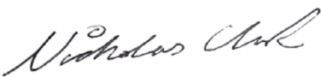
___________________________________
Nicholas Clark, MEng, AMIChemE
Environmental Engineer

Table of Contents

Section 1.0: Introduction 3
1.1 Site Setting 3
1.2 Operational Background 3
1.3 Risks from the Site 4
1.4 Risks from Noise and Vibration 5
1.5 Identify Risk of Accidents 5
1.6 Identify Receptors 5
Section 2.0: Summary of key parameters 7
Section 3.0: Summary List of Environmental Receptors 8
Section 4.0: Summary List of Sensitive Receptors 9
Section 5.0: Risk Criteria Rating 10
Section 6.0: Impact on the Environment 20
Section 7.0: Site Management 21
Section 8.0: Site Condition Report 22
Appendix A: Sensitive Receptor Plan 23
Appendix B: Identified Sensitive Receptor Tables 24

Introduction

BR Skip Hire, ‘the operator’, has instructed Mabbett & Associates Ltd to prepare a variation application to their bespoke permit, under the Environmental Permitting (England and Wales) Regulations 2016 (as amended), for the Waste Recycling Facility at:

EPR/ /DB3406XQ
Foxdene
Rumstead Lane
Sittingbourne
Kent, UK
ME9 7RT

Site setting
The Waste Recycling Facility (WRF), centred at Ordnance Survey grid reference TQ 8359 5492 is located to the south-eastern side of the A429, south-east of Gillingham in Kent.

The recycling site will process construction and demolition, and other suitable producers, waste materials for either:
- Production of saleable product in accordance with the Aggregate Quality Protocol (AQP);
- Production of saleable product in accordance with RPS190 ; or
- Despatch from site as a waste for use by third parties under a suitable exemption/ waste management operation.

Operational background
- The operation treats both non – hazardous and inert waste types, with the main inputs being mixed skips containing a variety of waste streams. These streams are separated into different waste types for bulking up for further processing elsewhere. Waste is mainly hand sorted or picked out via a 360o excavator and grab. Due to the size of the site and the nature of the business, volumes of wastes held on site will be kept to a minimum. This helps to preserve the quality of the recovered materials and is a major aid to fire prevention and minimisation.
- Inert wastes are accepted and screened and/or crushed where required. Screening and crushing is on a campaign basis in that once sufficient material has been accepted, a screener/crusher is brought in to process the material which is then dispatched from site to various customers.
- Deliveries will be undertaken between the hours of 7am and 6pm Monday to Friday and 7am to 5pm on Saturdays;
- Materials will be unloaded on-site and stored in designated stockpiles up to 4m in height;
- One excavator will be used to transfer waste from the designated stockpiles to the mobile crusher and crushed to a maximum size of 50mm.
- Recycled aggregates will be removed by an excavator and stored in designated concrete storage bays up to 4m in height;
- In order to maintain capacity within the site, regular shipment of the product off-site will be undertaken;
- Operation of the mobile crushing plant will be for an average 4-hours per day;
- The crushing plant will house spray bars to dampen down all areas of potential dust generation;

The proposed operation has the potential to cause air quality impacts because of fugitive dust emissions associated with the operation of the facility, as well as road traffic exhaust emissions from vehicles travelling to and from the site. An Air Quality Assessment (AQA) was therefore undertaken to determine baseline conditions and consider potential effects because of the proposals. The potential effects and control measures are contained in the following risk assessment and the separate Dust & Emissions Management Plan (DEMP) document.

Risks from the site
This qualitative environmental risk assessment followed these steps;
- Identified and considered risks for the proposed site, and the sources of those risks.
- Identified the receptors (people, animals, property and anything else that could be affected by the hazard) at risk from the site.
- Identified the possible pathways from the sources of the risks to the receptors.
- Assessed risks relevant to the specific activity and checked that they are acceptable and can be screened out.
- States the measures in place to control risks if they are too high.

The risk assessment identifies whether any of the following risks could occur and what the environmental impact could be:
- any discharge, for example sewage or trade effluent to surface or groundwater accidents;
- odour;
- noise and vibration;
- uncontrolled or unintended (‘fugitive’) emissions, e.g., dust, litter; or
- visible emissions, e.g., visible dust plumes

Where these are not considered to be significant risks, this is stated in the application.

For each risk that applies, each actual or possible hazard was identified and stated:
- the hazard, e.g., dust, litter, type of visible emission;
- the process that causes the hazard, e.g., screening and crushing inert waste;
- the receptors, e.g., people, animals, property and anything else that could be affected by the hazard;
- the pathways, i.e., how the hazard may get to a receptor;
- the measures that will be taken to reduce any risks;
- probability of exposure, for example whether a risk is unlikely or highly likely ;
- consequences, i.e., what harm could be caused; and
- what the overall risk is, based on what has already been stated in the table, e.g., ‘low when management techniques are applied’.

Risks from noise and vibration
An assessment of predicted noise levels from the following activities has been carried out for the planning permission and covered the following on-site operations;
- Crushing
- Temporary storage of materials.

Identify risk of accidents
Examples of possible accidents include:
- Spillages during the transfer of substances, e.g., loading or unloading vessels
- overfilling vehicle fuel tanks
- plant or equipment failure, e.g., over pressurised tanks and hydraulic pipework
- vandalism
- flooding
- inadequate bunding around tanks

The risk of accidents was assumed that operator error will occur at least once every 100 times an operation is carried out, e.g.
- drop or damage a drum from a forklift
- have a spillage from a tanker

Identify receptors
All the receptors that are potentially at risk from the site have been identified.

The main receptors that are potentially at risk were given the main focus, e.g., any groundwater beneath the site, and any other ecological and human receptors near the site were also considered.

These receptors included:
- protected sites and species
- anywhere used to grow food or to farm animals or fish
- drain and sewer systems
- factories and other businesses
- fields and allotments used to grow food
- footpaths
- groundwater beneath the site
- homes, or groups of homes (such as villages or housing developments)
- playing fields and playgrounds
- private drinking water supplies
- regionally important geological sites
- schools, hospitals and other public buildings
- water, e.g., ponds, streams, rivers, lakes or the sea
- conservation and habitats protected areas and areas of scientific interest (SSSIs, SPA, SAC, RAMSAR sites)

The risk assessment includes a scale plan (included in Appendix A) that shows:
- the site
- all the nearby receptors

Summary of key parameters

Table 1: Summary of Key Parameters
Facility | BR Skip Recycling Facility
Operator | BR SKIP HIRE
Permit ref | DB3406XQ
Location | Foxdene  Rumstead Lane  Sittingbourne  Kent, UK  ME9 7RT
NGR | TQ 8359 5492
what3words | ///gazette.firmer.redeemed
Location of key environmental sites | See Section 3.0
Risk assessment carried out by | Graeme Kennett
Date | 08 February 2023
Risk Criteria Summary
Parameter 1 | The site operates crushing, screening, and sorting plant to produce a range of materials including aggregates for use in construction projects and substitute soils.  Waste is stored (R13) prior to and post-treatment.
Parameter 2 | Quantity of waste accepted at the facility <15,000 tonnes per annum.
Parameter 3 | All waste will be stored and treated on an impermeable surface with a sealed drainage system.
Parameter 4 | There are no point source discharges to controlled waters.
Parameter 5 | The activities are not carried out within a groundwater source protection zone (SPZ)1, and not within 500 m of any well, spring, borehole used for the supply of water for human consumption, including private water supplies.
Parameter 6 | The treatment process is carried out within 25 m of the nearest sensitive receptor.
Parameter 7 | The treatment activity is not carried out within 500 m of a European Site or a Site of Special Scientific Interest (SSSI)

Summary List of Environmental Receptors

Table 2: Summary of Environmental Receptors
Site name/description | Distance from site | Details
Designated and non-designated habitats and wildlife sites
Squirrel Wood | <10 | No details available
Priority habitat inventory
 |  | None
Groundwater and abstractors
 |  | N/A
Groundwater vulnerability
 |  | Medium (Soluble rock risk)
Source Protection Zones
 |  | SPZ 3
Water protection zone and status
 |  | None
Soil classification
8
Slightly acid loamy and clayey soils with impeded drainage
Surface water
 |  | None within 1000m
Flood risk
 |  | Very low risk.
Air Quality Management Area (AQMA)
 |  | The site does not lie in an AQMA

Summary List of Sensitive Receptors

Table 3: Identified Sensitive Ecological Receptors
Identifier | Receptor | Classification | Type | Direction | Distance (m)
1 | Squirrel Wood | Unclassified | Ecological | W | <10

Table 4: Identified Sensitive Human Receptors
Identifier | Receptor | Type | Direction | Distance (m)
2 | - | Residential | NE | <50
3 | - | Residential | NE | 100
4 | - | Residential | E | 275
5 | The Dreys | Leisure | S | 325

Risk Criteria Rating

Risk ratings are based on the likelihood of an event occurring multiplied by the severity of potential impact. Ratings are made of residual risk following implementation of preventative measures on site. The following scale is applied to rate these parameters:

Table 5: Calculated Risk Level Criteria
Severity |  | Likelihood
1 | No environmental harm arising | 1 | Very unlikely to happen
2 | Fleeting localised impacts | 2 | Low probability/occasional
3 | Localised impacts medium term | 3 | Likely to occur
4 | Wider scale impacts of a fleeting nature, or localised impacts of a more persistent nature | 4 | Highly likely to occur
5 | Widespread/persistent impacts on high amenity/sensitive sites | 5 | Inevitable

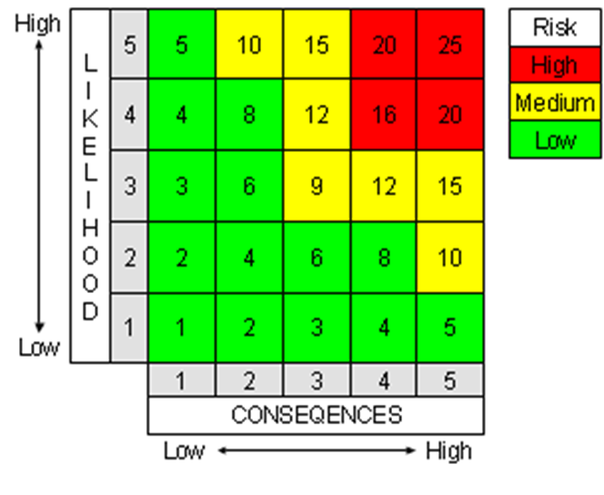
Figure 1: Risk Assessment Matrix

Table 6: Final Calculated Risk Levels
What do you do that can harm and what could be harmed? |  |  | Managing the risk | Assessing the risk
Hazard | Receptor | Pathway | Risk Management | Probability of exposure | Consequence | What is the overall risk?
What has the potential to cause harm? | What is at risk? What do I want to protect? | How can the hazard get to the receptor? | What measures will you take to reduce the risk? Who is responsible for what? | How likely is contact (1-5) | What is the harm that can be caused? (1-5) | What is the risk that still remains?  (Likelihood x Severity)
Release of dust (crushing) | Local human population | Air – windblown dispersion in the atmosphere | The crushing plant will be operational for an average of 4-hours a day to minimise dust generating activities.  The crushing plant will house spray bars to dampen down all areas of dust generation.  All personnel employed on site will undertake visual monitoring for dust throughout the working day. Any observed problems will be reported to the Site Manager (SM) who will investigate the cause and implement any necessary remedial action. | Very unlikely to happen  1 | Nuisance – dust on cars, clothing and inhalation of dusts  1 | Very low  1
Release of dust (screening) | Local human population | Air – windblown dispersion in the atmosphere | The screening plant will house spray bars to dampen down all areas of dust generation.  All personnel employed on site will undertake visual monitoring for dust throughout the working day. Any observed problems will be reported to the SM who will investigate the cause and implement any necessary remedial action. | Very unlikely to happen  1 | Nuisance – dust on cars, clothing and inhalation of dusts  1 | Very low  1
Dust from the movement of vehicles to and from site | Local human population | Air – windblown dispersion in the atmosphere | Provision of an impermeable surface for the site and between Rumstead Lane and the operational area.  Site will have an imposed speed limit of 10mph.  Regular sweeping down of all vehicle routes will be undertaken; | Very unlikely to happen  1 | Nuisance – dust on cars, clothing and inhalation of dusts  1 | Very Low  1
Mud on roads from the movement of vehicles to and from site | Local human population | Deposited on the ground by vehicles entering and exiting the site | Provision of an impermeable surface for the site and between Rumstead Lane and the operational area.  Site will have an imposed speed limit of 10mph.  Regular sweeping down of all vehicle routes will be undertaken; | Very unlikely to happen  1 | No environmental harm arising  1 | Low  1
Release of particulate matter from input material deliveries to, stored and despatched from site. | Local human population | Air – windblown dispersion in the atmosphere | Material arrives as inert wastes and are unlikely to generate dust.  All vehicles using the facility will ensure their loads are adequately sheeted or otherwise contained.  Dampening down of stockpiles will be undertaken during loading periods, if required. | Very unlikely to happen  1 | Nuisance – dust on cars, clothing and inhalation of dusts  2 | Low  2
Input material may contain litter. | Local human population | Air – windblown dispersion in the atmosphere | Incoming skip loads will contain litter and loose items. Regular litter picking will be used to reduce the potential for litter to be blown off-site.  Any office waste generated on site will be stored in sealed bins and removed from site on a regular basis to ensure that volumes of all types of waste do not accumulate on site.  Any litter is cleared from any affected areas outside the site as soon as possible. | Very unlikely to happen  1 | Nuisance – dust on cars, clothing and inhalation of dusts  1 | Low  1
 | Adjacent land
Odour from delivered input material | Local human population | Air – windblown dispersion in the atmosphere | Input material has a medium propensity to produce, or release, odour. | Odours are unlikely to impact on local receptors as materials are mainly non-odourous.  1 | Localised impacts medium term  1 | Low  1
Odour from the treatment process | Local human population | Air – windblown dispersion in the atmosphere | Treatment process has a low propensity to produce, or release, odour. | Odours are unlikely to impact on local receptors as materials are mainly non-odourous.  1 | Localised impacts medium term  1 | Low  1
Odour from storage of input material in the process | Local human population | Air – windblown dispersion in the atmosphere | Input material has a low propensity to produce, or release, odour. | Odours are unlikely to impact on local receptors as materials are non-odourous.  1 | Localised impacts medium term  1 | Low  1
Flies in waste | Local human population | Air | The input material is not susceptible to fly infestation. | Flies are unlikely to impact on local receptors as waste is not susceptible to fly infestation.  1 | Nuisance – unlikely  1 | Low  1
Rodent infestation | Local human and wildlife population | Over land | The input material is not it susceptible to rodent infestation. | Rodents are unlikely to impact on local receptors as waste is not susceptible to infestation.  1 | Nuisance – unlikely  1 | Low  1
Scavenging birds and animals | Local human and wildlife population | Over land and through the air | The input material is not it attractive to scavengers. | Scavengers are unlikely to impact on local receptors as waste is not attractive.  1 | Nuisance – unlikely  1 | Low  1
Noise from vehicle  movements/ deliveries | Users of highway,  local workplaces, and local dwellings. | Air | Vehicle movements for are scheduled to occur Monday to Friday during normal working hours.  The SM is responsible for ensuring vehicles are turned around efficiently, with least impact on the neighbouring properties and that vehicles are removed from the surrounding roads quickly.  Plant (and site surfaces) to be maintained in good order and operated in a manner conducive to not generating unnecessary noise.  Reversing alarm sounders on site-based mobile plant to be of the non-tonal type, unless otherwise dictated by health & safety considerations. | Site located close to the A249 with good access to main routes. Location has good access for the highway.  Infrequent impact  to neighbours to  cause nuisance  2 | Nuisance from noise.  Duration should  be short as vehicle movements  reduced  1 | Low  2
Noise/vibration  from plant | Local human and wildlife population | Air | Plant (and site surfaces) to be maintained in good order and operated in a manner conducive to not generating unnecessary noise. | Very unlikely to happen  1 | Nuisance – from noise vibration  1 | Low  1
Delivery of input materials | Ground/groundwater/  surface water | Spillage  through ground | All deliveries will be supervised and will take place during normal working hours.  The input material is restricted to non-hazardous and inert wastes.  Deliveries take place only on a sealed, impermeable concrete area.  State of repair of the surface is monitored on a regular basis, and proactive maintenance carried out if necessary.  No liquid wastes accepted. | Low as supervised delivery procedure in place  .  1 | Pollution of  watercourse/  groundwater/land  3 | Low  3
Chemical  delivery | Ground/groundwater/  surface water | Spillage during  delivery to  drain/ground | Chemicals only stored with secondary containment.  No drains within building.  Low volumes kept on site.  No access to surface or ground water.  Risk of spillage/response to spillage dealt with in incident response plan. Tailored spill kit to be kept on site in the locality of deliveries. | Very unlikely to happen  1 | Pollution of  watercourse/  groundwater/land  4 | Low  4
Storage of small  volumes of  chemicals | Local environment | Spillage during  use or transferring | All chemicals are stored with lids or caps secured.  All chemicals are stored to ensure substances are not exposed to conditions that could cause a reaction and spillages are contained.  Chemicals are segregated as appropriate and stored in secondary containers to catch any small spillages. | Very low  volumes are kept  on site  Storage is  contained and  indoors  1 | Harm to local  environment and  animal health  2 | Low  2
Flooding of site | Local human  population and local  environment | Contaminated  flood waters | Permitted waste types are non-hazardous so any waste washed off site will add to the volume of the local post-flood clean-up workload, rather than the hazard.  Site is in an area at very low risk of flooding (Zone 1). | No history of  flooding in the  area. Site is within an area identified at very low risk of flooding.  1 | Contamination  of  buildings /  natural  habitats  downstream  1 | Low  1
Spillage of liquids, leachate from waste, contaminated rainwater run-off from waste with high organic content. | All surface waters close to and downstream of site. | Direct run-off from site across ground surface, via surface water drains, ditches etc. | All processing operations are carried out entirely within sealed surfaces within the site.  Any liquids kept in containers and provided with secondary containment.  Permitted waste types do not include sludges or liquids. | Very unlikely to happen  1 | Pollution of  watercourse/  land  4 | Low  4
Spillage of liquids, leachate from waste, contaminated rainwater run-off from waste with high organic content. | Groundwater | Transport through soil/groundwater then extraction at borehole. | All processing operations are carried out entirely within sealed surfaces within the site.  Any liquids kept in containers and provided with secondary containment.  Permitted waste types do not include sludges or liquids. | Very unlikely to happen  1 | Pollution of  groundwater/land  4 | Low  4
Accidental fire causing the release of polluting materials to air (smoke or fumes), water or land. | Local human  population and local  environment | Air transport of  smoke.  Firewater runoff  from site. | Input materials are not considered flammable.  Permitted activities do not include the burning of waste.  All plant and equipment are modern and are fitted with fire suppression systems. | Negligible  1 | Respiratory  irritation, illness  and nuisance to  local population.  Injury to staff,  firefighters or  vandals.  Pollution of water  or land.  3 | Low  3
Unauthorised  access to site | Bodily injury to person or animal entering site | Direct physical  contact | The site is in isolated rural surroundings with a lockable gate to the entrance.  Site office entrance is security controlled and kept locked when staff are not present on site.  The site is fitted with remote 24/7 CCTV system so staff are alerted to the presence of intruders.  All vehicles/people entering the site will be received by the main reception operator who will be present in the area while the site is open. | Low as site is  locked when not manned  Access to the site is controlled during operating hours.  1 | Bodily  injury/damage to  plant  3 | Low  3
Arson and / or  vandalism causing the release of polluting material  to air (smoke or  fumes), water or  land. | Local human  population, staff,  firefighters, vandals or local environment. | Air transport of  smoke.  Firewater runoff  from site. | The site is in isolated rural surroundings with a lockable gate to the entrance.  Site office entrance is security controlled and kept locked when staff are not present on site.  The site is fitted with remote 24/7 CCTV system so staff are alerted to the presence of intruders.  All vehicles/people entering the site will be received by the main reception operator who will be present in the area while the site is open. | Site is secure  1 | Respiratory  irritation, illness  and nuisance to  local population.  Injury to staff,  firefighters or  vandals.  Pollution of water  or land.  3 | Low  6
Harm to protected site through nutrient enrichment, leachate, contaminated surface water run-off, smothering, disturbance or predation. | Protected sites - European sites and SSSIs protected species/habitats and other nature conservation sites (LWS)(LNR). | Any | Sites are protected as the processing only takes place on an impermeable surface.  No protected sites within 1000m | Very unlikely to happen  1 | No environmental harm arising  1 | Low  1

Impact on the Environment

This environmental risk assessment (ERA) has been carried out to assess the environmental risks posed by the proposed activity.

There are no point source emissions to land, air, surface or groundwater from the proposed facility.

The facility has drainage infrastructure in place so that any potentially contaminated site drainage is captured and directed via a sealed system, consisting of concrete impermeable pavement with falls towards the drain channels that captures all liquids and directs it to a sealed tank.

Operational procedures at the site will monitor and manage amenity and accident risks from the proposed activities and includes provision for the monitoring of odour, noise, and fugitive emissions.

The impact of the proposed development on surrounding human and environmental receptors has been assessed in the ERA.

As the management measures detailed in the risk assessment will be in place from commencement of operations, the conclusion has been reached that the proposed waste materials and treatment activities, are unlikely to result in a significant accident risk or risk to the local environment, including from odour and noise, or pollution of surface or ground waters.

Site Management

Site management will comprise of the following staff members;
- A Technically Competent Manager (TCM); who will manage the operation and regularly attend site in compliance with the defined attendance requirement.
- A site supervisor; who will be responsible for the ongoing operation who may also undertake office and plant operation duties.
- Other trained plant operators as required.

Site Condition Report

The Site Condition Report (SCR) has been updated as a part of this variation application for the proposed increase in tonnage to the operation.

The facility will continue to operate with due regard to the conditions of the environmental permit and all relevant environmental legislation to ensure that land and groundwater is protected during the lifetime of the site and that the land is in a satisfactory state when the permit is eventually surrendered.

The possibility of any significant releases to the ground occurring during the lifetime of the permit is therefore limited. Minor spillages, if they occur, will be dealt with immediately by trained staff using appropriate spill response procedure and spill kits located around the site.

Appendix A: Sensitive Receptor Plan

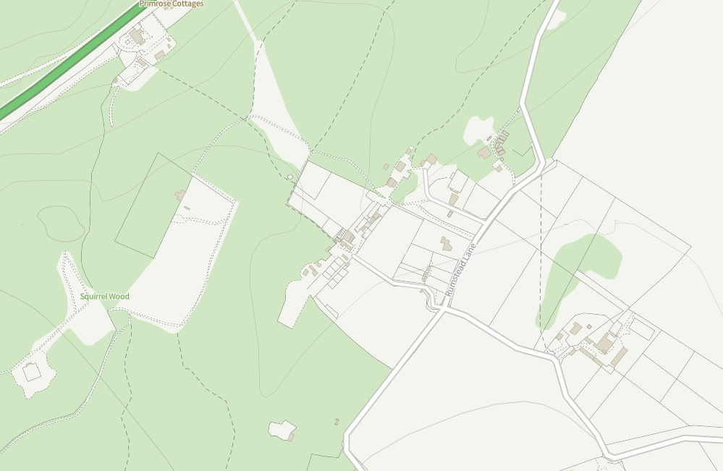

Appendix B: Identified Sensitive Receptor Tables

Table 1 Identified sensitive ecological receptors

Identifier | Receptor | Classification | Type | Direction | Distance (m)
1 | Squirrel Wood | Unclassified | Ecological | W | <10

Table 2 identified sensitive human receptors

Identifier | Receptor | Type | Direction | Distance (m)
2 | - | Residential | NE | <50
3 | - | Residential | NE | 100
4 | - | Residential | E | 275
5 | The Dreys | Leisure | S | 325

Risk assessments for your environmental permit - GOV.UK (www.gov.uk)

