Odour Management Plan
Site details
Site name: ROCHESTER HAZARDOUS WASTE TRANSFER STATION
Site address: MEDWAY CITY ESTATE, ENTERPRISE CLOSE, ROCHETSER, KENT, ME2 4LY
Operator name: GREENWAY ENVIRONMENTAL LTD
Permit number: WP3036ZR
Who this plan is for
- Who should be made aware of this plan?
- GEL Senior Management Team
- GRG Group Directors
- Site Managers and Technical personnel
- EA Office

- How will they be made aware? – Training on the plan will be performed as part of every member of staff’s induction programme upon joining the company. Existing staff will undergo a new induction for the facility.
Document owner
Document author: David Gallagher - Operations Director
Version number: 002

List of revisions

Revision number | Revision authorised by | Date submitted to Environment Agency | Revision owner

Contents
Table of Contents
1. Introduction 4
1.1 Site description 4
1.2 Maintenance and review of the OMP 4
1.3 Relevant sector guidance on which this OMP is based 4
2. Receptors 5
2.1. Receptor List 5
2.2. Wind rose and source of weather data 8
3. Sources of odour and site processes 11
3.1 Odorous materials entering and leaving site 11
3.2 Odorous materials 12
3.3 Overview of odorous processes and emissions 14
4. Control measures and process monitoring 17
4.1 Appropriate measures / BAT 17
5. Odour reporting 20
5.1 Complaints reporting 20
5.2 Community engagement 20
5.3 Pro-active odour monitoring 20
5.4 Reactive odour monitoring 20
6. Abnormal events 21

Introduction

1.1 Site description

- Site will operate as a Hazardous Waste Transfer Station dealing in packaged hazardous, and non-hazardous waste
- Site is located on Medway City Industrial Estate in Kent
- Site will be open Monday to Friday and will be permitted for 24 hour running. In practise operating hours will be between 6am and 6pm. Saturday working hours will be 6am to 5pm but will only be used periodically. Sundays and Public Holidays will be limited to 8am to 2pm

1.2 Maintenance and review of the OMP
- The HSEQ Manager, and the General Manager are responsible for the upkeep, training, and communication of the Odour Management Plan
- The plan will be stored electronically on the company servers
- The plan will be reviewed annually, or in the event of significant changes to the operations of the site
- Fully competent staff will be employed at all levels. Full and specific training will be given within each role, and full inductions will give an in depth understanding of this OMP
- Training will be delivered by the General Manager and the HSEQ Manager in this OMP. Training will be initially upon joining the company, then refreshed upon any changes to the plan.

1.3 Relevant sector guidance on which this OMP is based
- All works on site will be undertaken in line with the BAT conclusions document, the Chemical Waste Appropriate Measures, and Environmental Permitting: H4 Odour Management

Receptors

2.1. Receptor List

Table 2.1. Receptor list
Receptor reference  (A, B, C etc. Use to label Fig 2.1) | Land use e.g. house, school, hospital, commercial | Direction from site (North, South, East, West) | Approximate distance to site  boundary (m) | Sensitivity to odour  Low (e.g. footpath/road)  Medium (e.g. industrial / commercial workplace)  High (e.g. housing / pub / hotel etc.)
A | Industrial/Commercial | All | 10m | Medium
B | Assisted Living Home | North West | 900m | High
C | School | North West | >1km | High
D | Railway Line | South West | >1km | Low
AS PER ROC006 | Mudflats | East | <2km | Low
AS PER ROC006 | Fish Migratory Routes | West/South/East | <2km | Low
AS PER ROC006 | Great Lines Wildlife Site | South East | 2km | Low
AS PER ROC006 | Chattenden Woods | North | 5km | Low
AS PER ROC006 | Medway Estuary Zones 1 & 2, & Marshes | East | 5 | Low
Figure 2.1 Map of site location and receptors

1KM Radius for Sensitive Industrial, Commercial, and Domestic receptors

5KM Radius for Nature and Heritage Conservation Receptors situated as per ROC006

2.2. Wind rose and source of weather data

Figure 2.2. - Wind rose
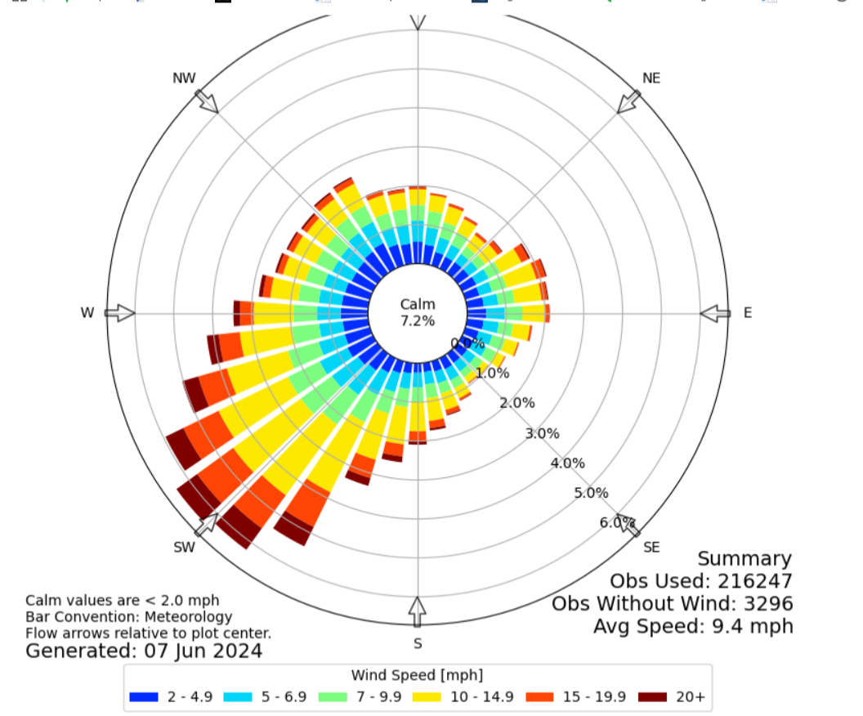

Sources of odour and site processes

3.1 Odorous materials entering and leaving site
- Deliveries are via curtain sided truck, waste is delivered in packages
- Frequency of deliveries could be up to 8 artic loads per day
- Container types consist of IBC’s, 205L barrels, FIBC’s, 25L kegs and smaller. This list is not exhaustive.
- Vehicles curtains are closed for transport, and are opened at the site to enable FLT offloading
- Site does not accept malodorous waste, this will be captured at Pre-Acceptance stage
- Waste not permitted will be rejected as per EA guidelines

3.2 Odorous materials

Table 3.2 Odorous materials
Odorous and potentially odorous material (any solid, liquid or gas) | Odour potential  High Risk / Medium Risk / Low Risk | Maximum quantity on site at any given day (tonnes per day or litres per day) | Maximum time held on site (hours or days) | Location of odorous materials on site | Additional comments
Solvent Waste (including Halogenated Solvents) | High | 90 tonnes | 6 months | Flam Storage Bay | Waste is stored in packages, within a warehouse and is not likely to create an odour on site. Container opening for testing and sampling is brief, and lids are replaced immediately, minimising potential for any odour escape. This is done within an open fronted building upon waste reception, or within an storage warehouse.
Waste Oils | Medium | 30 tonnes | 6 months | Main Warehouse | Waste is stored in packages, within a warehouse and is not likely to create an odour on site. Container opening for testing and sampling is brief, and lids are replaced immediately, minimising potential for any odour escape. This is done within an open fronted building upon waste reception, or within a storage warehouse. Waste is bulked using pumps where possible and practical to avoid containers pouring.
Oil contaminated Rags/PPE/Spill Materials | Medium | 50 tonnes | 6 months | Main Warehouse | Waste is stored in packages, within a warehouse and is not likely to create an odour on site. Container opening for testing and sampling is brief, and lids are replaced immediately, minimising potential for any odour escape. This is done within an open fronted building upon waste reception, or within a storage warehouse. Waste prepared for TFS dispatch is in open top IBC’s but is bagged over the top to prevent odour escape or contamination.
Paint/Adhesive Waste | High | 50 tonnes | 6 months | Flam Storage Bay | Waste is stored in packages, within a warehouse and is not likely to create an odour on site. Container opening for testing and sampling is brief, and lids are replaced immediately, minimising potential for any odour escape. This is done within an open fronted building upon waste reception, or within a storage warehouse.
Chlorine Tablets | High | 500kg | 6 months | Chemsafe | Waste is sealed in packages, within a metal cabinet, and is not bulked on site. It is only re-packaged if the original package has an integrity issue, or if it requires it for HTI disposal requirements. The waste is stored within closed, self-bunded metal containers from which odour will not escape.
Sulphur | High | 10 tonnes | 6 months | Main Warehouse | Waste is stored in sealed packages, within a warehouse, and is not bulked. Opened for a very limited time to confirm acceptance checks and removed from site at the earliest opportunity
Ammonia and Ammonium compound waste streams | High | 10 tonnes | 6 months | Main Warehouse | Waste is stored in sealed packages, within a warehouse, and is not bulked. Opened for a very limited time to confirm acceptance checks and removed from site at the earliest opportunity
Amines | High | 5 tonnes | 6 months | Main Warehouse | Waste is stored in sealed packages, within a warehouse, and is not bulked. Opened for a very limited time to confirm acceptance checks and removed from site at the earliest opportunity
Effluent Treatment sludges and liquids | Medium | 30 Tonnes | 6 months | Main Warehouse | Waste is stored in sealed packages, within a warehouse, and is not bulked. Opened for a very limited time to confirm acceptance checks and removed from site at the earliest opportunity
Rosin Oil and derived Wastes | Low | 5 tonnes | 6 months | Flam Storage Bay | Waste is stored in sealed packages, within a warehouse, and is not bulked. Opened for a very limited time to confirm acceptance checks and removed from site at the earliest opportunity
Fixer Solutions | Medium | 5 tonnes | 6 months | Main Warehouse | Waste is stored in packages, within a warehouse and is not likely to create an odour. Container opening for testing and sampling is brief, and lids are replaced immediately, minimising potential for any odour escape. This is done within an open fronted building upon waste reception, or within a storage warehouse. Waste is bulked using pumps where possible and practical to avoid container pouring.
Hypochlorite derived waste streams | Medium | 10 tonnes | 6 months | Main Warehouse | Waste is stored in packages, within a warehouse and is not likely to create an odour. Container opening for testing and sampling is brief, and lids are replaced immediately, minimising potential for any odour escape. This is done within an open fronted building upon waste reception, or within an storage warehouse. Waste is bulked using pumps where possible and practical to avoid container pouring.
Cyanides and Cyanide bearing waste | Low | 5 tonnes | 6 months | Main Warehouse | Waste is stored in sealed packages, within a warehouse, and is not bulked. Opened for a very limited time to confirm acceptance checks and removed from site at the earliest opportunity

3.3 Overview of odorous processes and emissions
Provide a description (whether text / diagrams or tables) of the site layout and the processes carried out including the information in the bullet points below as a minimum. Use Figure 3.3 as a guide to show the site infrastructure relevant to any odorous processes carried out and the odour emission locations on your site e.g.
- Waste loading and offloading, waste storage takes place within the open fronted reception building, warehouse, and Flam Storage as per site plan
- Loading and unloading areas are marked on the site plan. Waste arrives in packages, meaning no release is possible. Any waste arriving in bulk to be offloaded to packages, will be subject to strict Pre-Acceptance and sampling measures, meaning no odorous material will be accepted in bulk.
- Storage areas are within the Warehouse, and Flam Storage areas marked on the site plan. Both are within enclosed buildings. Any odour release from this activity would be subject to natural dispersion, and at the distances involved, not detectable beyond the site boundary.
- Repackaging takes place under cover, during operational hours
- Bulking is likely to carry the highest risk of odour, but all bulking activities are compatibility tested in advance so as to allow removal of odorous, and incompatible elements. This means the likelihood of odour from this activity is minimal, and odour release from this activity would be subject to natural dispersion, and at the distances involved, not detectable beyond the site boundary. Pumps are used where possible to keep waste contained within containers or pipework.
- Ammonia Waste and Ammonium compounds are not bulked but may be repackaged on safety grounds
- Sulphur Waste is not bulked but may be repackaged on safety grounds
- Chlorine Tablets and similar substances are not bulked but may be repackaged on safety grounds
- Amine streams are not bulked but may be repackaged on safety grounds
- Cyanides streams are not bulked but may be repackaged on safety grounds
- No Odour Emission points on site.
- Risk during bulking is minimised via Risk Assessment and strict use of control measures, activity is therefore low risk
- Clinical Waste treatment activities are to be removed from activities list. This significantly reduces the odour profile of the facility, improving the overall effect of the facility within the area.

Figure 3.3 – Site plan showing odorous process locations / odorous emissions / storage
ATTACHED – SPROC003A SITE PLAN

Control measures and process monitoring

4.1 Appropriate measures / BAT

Table 4.1 Monitoring procedures for appropriate measures/ BAT
Odorous and potentially odorous process / material | Control measures (Appropriate Measure / BAT) | Monitoring frequency | Monitoring procedure and optimum process parameters | Trigger level | Action taken if outside optimum process parameters
Waste storage in reception bay | Waste is removed to storage areas within 24 hours of acceptance – (Appropriate Measures) | Constant – ongoing through shift | Inspection via daily checks from site management | Bay filled, or approaching 24 hour age limit.  Any Odour detection on daily checks | If reception storage is reaching capacity, waste deliveries will be ceased until process back under control.  Odours are investigated and corrective action taken appropriately.
Waste repackaging and bulking | Bulking and repackaging is done within on site RAMS, Appropriate measures, and BAT | Pre-determination of compatibility, monitoring during activity | Compatibility checks prior to activity  Competent person performing tasks ensure constant monitoring during activity | Failure of compatibility testing excludes activity  Adverse event during bulking ceases activity immediately | No bulking takes place if compatibility procedure is not performed, or produces adverse effects
Waste Storage | Waste is kept on site for no more than 6 months, we aim for far less in order to efficiently turn stock levels around. | Daily, recorded on Daily Site Checks within storage areas, and at the site boundary | Monitoring is manual, Management conduct the checks and are trained in odour management and detection. The site checks are a routine start up activity each working day | Any detectable odour | Other work on site ceases, and the source of the odour identified. If this cannot be rectified immediately, the EA are informed. In all events, the odour is recorded on a report form, and in the diary
Waste Spillage | Spills are contained and cleaned immediately, spillage media is then stored in sealed containers and stored in the appropriate hazardous waste storage area | Daily Checks, ongoing work through the day, monitored at all times due to FLT and personnel movements | Inspection via daily checks from site management | Any spill of any size, any detectable leak from stored container | Spillage is contained and cleaned as an immediate priority. Spill is recorded and Management informed. Spillage clean up media is always treated as hazardous waste. It is tested for hazardous properties (as they cannot be diluted, these will almost always be the same as the originally spilled or leaked material) and stored appropriately.

Odour reporting

5.1 Complaints reporting
Any Odour complaints will be reported to the inspecting officer of the Environment Agency within 24 hours. These complaints will be recorded, and all complaints will be investigated, even if an odour cannot be detected by site management.

5.2 Community engagement
Introductory informal meetings with neighbouring businesses have taken place. This will allow ease of approach if neighbours feel a complaint is appropriate.

5.3 Pro-active odour monitoring
Daily Site checks are specifically designed to include detection of odour. Any odours would be recorded, and where necessary, reported to the EA within 24 hours following full investigation. A diary is kept of any odour detection, and the trigger point for any action to be taken is in the detection of an odour.
The source would be identified and appropriate action taken depending on the causes of the odour.

5.4 Reactive odour monitoring
Internal Investigations will be carried out. We would compare any complaint, or detected site odour, against our on recorded historical on-site findings to determine if the odour originated from ourselves. If so, we would identify immediately and take quarantine measures to ensure no further escape. We feel this event to be extremely unlikely.
On-site findings come via internal investigations. This investigation will include the referencing of site records such as the odour diary form, to see what patterns may exist, and give clues to effective preventative measures.
Complaints from the public would then have the investigation results communicated to the complainant, along with a full disclosure of corrective measures taken.

Abnormal events

Table 6.1 Abnormal events
Abnormal event | Recovery steps
Spillage | Spillage procedures enforce cleaning of the spill immediately, and reporting if the spill is at a sufficiently high level. If the spillage creates an odour, this will be recorded, and reported to the Environment Agency

