Fastlay Services Limited
Fire Prevention Plan
April 2022
Version 2.0

Windy Bottom
Sittingbourne Road
Maidstone
Detling
ME14 3ES

Document Control Sheet

Version Reference | Date | Reason for Change | Issued by
1.0 | 15/02/21 | Initial Draft | PD
2.0 | 04/04/22 | Schedule 5 | PD

Approved By | Oliver Gray

CONTENTS
1 Introduction 4
1.1 Roles and Responsibilities 4
1.2 Purpose 4
1.3 Scope 4
1.4 Liaison with Fire Rescue Service (FRS) 4
1.5 General considerations 4
2 Causes of Fire 5
3 Fire Prevention Plan 6
3.1 Site Plan and Receptors 6
3.2 Material Receipt and Storage 6
3.3 Signage 8
3.4 Training, Awareness and Visitors 8
3.5 Security 9
3.6 Planned Preventative Maintenance 9
3.7 Self Combustion 9
3.8 Hot Works 10
3.9 Mechanical Treatment 10
3.10 Hot Exhausts 10
3.11 Additional Actions 10
4 Fire Detection and Management 12
4.1 Fire Detection 12
4.2 Fire Fighting Strategy 13
4.3 Managing Fire Water 14
4.4 Future Actions 16
5 Annex A: Site Layout 17
6 Annex B: Site Drainage 19
7 Annex C: Fire Access, Equipment and Water Supply Plan 20
8 Annex D: Key Receptors 22
9 Annex E: Waste Acceptance Procedures 23
10 Annex F: Fire Risk Checks Form for Fire Prevention 24
11 Annex G: Emergency Contacts 25
12 Annex H: EMS Documents 26
13 Annex J: Firebay Specification 34

- Introduction
  - Roles and Responsibilities
The Site Manager has responsibility for ensuring these procedures are adhered to. The Site Manager is specifically responsible for:
- Ensuring the adequate training of staff and contractors working on site regarding the content of these procedures;
- Ensuring the adequate provision of resources such as personal protective equipment (PPE);
- Ensuring the provision and maintenance of hand held fire extinguishers and other fire fighting equipment at the site is adequate.
  - Purpose
The primary purpose of this Fire Prevention Plan (FPP) is to guide staff and contractors in the prevention of fire for Fastlay Services Limited. This FPP also confirms the actions to be taken in the event of fire in order to minimise any impact on the environment and to control the fire where appropriate.
This FPP will be issued to the Fire Brigade in the event of a fire to aid with fire fighting.
  - Scope
This FPP has been prepared in accordance with Environment Agency guidance.
In addition, all fire prevention measures will meet the stringent insurance requirements for the business.
Annex A shows a site layout plan.
  - Liaison with Fire Rescue Service (FRS)
The FRS will be provided a copy of this FPP in advance of commencing operations.
  - General considerations
The Fastlay Services Limited site is located at Windy Bottom, Sittingbourne Road, Maidstone
Detling, ME14 3ES just north of the M20 and west of the A249 Sittingbourne Rd.

The site is approximately 0.25 Hectares in size. At the time of writing this FPP, the site is currently occupied and operating under waste exemptions as it has done for a number of years; it presently consists of concrete impermeable surface in good order and hard standing. The site’s main activity is inert waste recycling consisting mainly of mixed skip waste and manual sorting of metals & construction and demolition waste. All recycling is conducted in the yard. There is no waste treatment on site.
The surrounding land use is a mix of light industrial, and residential housing.
Fastlay Services Limited operate under an existing Environmental Management System [EMS] which identifies the potential sources of pollution from site activities and controls site operations to eradicate emissions or where that is not possible to minimise their effect on human and environmental health.
This Fire Prevention Plan [FPP] forms part of the EMS.
The individual fire emergency procedures for each part of the site form part of the FPP.
The site has a sealed drainage system with no apparent gullies or drainage outlets.
- Causes of Fire
The following have been identified as potential causes of fire and their relevance to this site, when operational, is given in Table 1
Table 1 Causes of Fire and Applicability to the Fastlay Site
Cause of Fire | Applicability to the Fastlay Services Limited Site
- Arson or vandalism | Yes – see section 3.5 Security
- Self-combustion | Yes – see 3.7 Self Combustion
- Naked lights | No – none on site
- Plant or equipment failure | Yes – see 3.6 Planned Preventative Maintenance
- Electrical faults | No – none on site - occasional
- Discarded smoking materials | No – on site smoking is prohibited
- Hot works | No – see 3.8 Hot works
- Hot exhausts | Yes – see 3.10 Hot exhausts
- Industrial heater | No – none on site
- Open burning (adjacent to site) | No – no likely sources of burning adjacent to site
- Damaged or exposed electrical cables | No – no live cables on the site or to be introduced
- Reactions between incompatible materials | Not - unlikely given the waste types
- Neighbouring site activities | No – no likely sources of risk from neighbouring land use
- Sparks from loading buckets | No – loading buckets will not be required (a grab is used).
- Hot loads deposited at the site | No – not a risk given the types of materials and sources of materials.
Mitigation measures in relation to these activities, where under control of Fastlay Services Limited Limited, are set out in this FPP.
- Fire Prevention Plan
Fastlay Services Limited recognises that the risk of fire cannot be eliminated. However, the site will be operated in accordance with a robust management system. Operational Procedures are listed in the site’s EMS Manual Section 1.6 ‘Operational Control’.
In addition to Operational Procedures, the following reasonable actions will be taken to minimise the risk of fire, in accordance with Environment Agency guidelines.
  - Site Plan and Receptors
A Site Plan is given in Annex A showing the key features of the site relevant to the Fire Prevention Plan including site access, security, vehicle parking, materials storage, drainage and buildings. Annex C is a Fire Fighting Equipment plan including the location of hose reels and hydrants.
A map showing key receptors within 1 km of the site is in Annex D.
  - Material Receipt and Storage
Waste will be collected using the company’s 12 or 40 yard rollonoff containers and skips which will be removed from the customer’s site and returned to Fastlay Services Limited site.
All skips in the yard can be moved by Fastlay’s own machinery and moved if required. They are all accessible on all 4 sides. Skips are covered. The RORO can be moved by Fastlay’s own lorries if required.
Waste acceptance procedures will be followed as set out in Annex E.
Only the waste types and EWC codes named on the bespoke environmental permit will be accepted at the site. Wastes entering the site will be inspected and registered at the site. Non-compliant waste materials not allowed on the permit will be turned away from the site. A record will be made in the site diary.
    - Quarantine area
The site plan shows the Fire Quarantine Area. The Fire Quarantine Area will always be kept clear in case of emergency. The area is located close to a water supply for quenching burning or smouldering material.
The Fire Quarantine Area is a dedicated emergency or quarantine area with a clear area of 6m around it. The rationale for this area is:
- The area is in the middle of the site, so is required to be kept clear, at all times, for access.
- Only small quantities of material would ever be put in this site i.e. those that can be dealt with safely by the staff on the site. Larger fire would be dealt with by the FRS.
- The quarantine area is 2.5x2.5x2m = 12.5M cubed and can easily accommodate at least 50% of the largest waste pile in firebay 1 (18 CUMEC). See appendix A.
- In the event of a fire or observed self-combustion, burning waste, if safe to do so, will be moved to the Fire Quarantine Area.
- The Fire Quarantine Area is signposted.
- Hot loads can be quarantines in this area until such times that they can be stored safely.
- The quarantine area, when made safe, will be emptied immediately. Should it be necessary to moves wastes to an alternative site then that location will be used.

    - Waste storage times
Wastes will be stored on site for a maximum of 3 months. Consideration is given to the likely dry nature of the material and the implications this has for self-combustion. See 3.2.3 (stock rotation and management).
Fastlay Services Limited has key customers for each material. In addition, contingency customers are in place in case of a need to move material off site when the regular customer is not able to receive it. In this way, the stock will not build up to levels over the permitted limits.
    - Stock rotation and management
The company will undertake monthly stock checks which will involve moving the waste within each pile. The purpose of the stock check is:
- To turn wastes in order to ensure the waste is not at risk of self-combustion and any potential hotspots are dissipated;
- To ensure the waste volumes do not exceed those specified in the permit.
- To ensure waste is not kept on site for longer than allowed by the permit
Records will be maintained in the site office of the physical monthly stock checks.
The site manager in charge of stock checking will be vigilant for signs of combustion or hotspots. If any are found, these will immediately be quenched with water and reported to the management team. Stock rotation will be by mechanical means as necessary.
Waste will follow the first in/first out principle as detailed in Annex F points 10/11/12.
    - Waste storage
All combustible waste will be stored inside in concrete firebays (covered), in the yard. This is a 3 sided structure (covered) with an open front to allow forklift/360 access. The site has a security. Inert non combustible C&D waste is stored outside on an impermeable surface. Combustible waste will be stored in fire resistant bays on all 3 sides including the end bays. The main piles are (these are all indicated on the site plan). Note dimensions are given for firebay sizes. Waste piles will be smaller to accommodate a 1m freeboard.
- Plastic waste in firebay 1 = Maximum of 10t over a maximum footprint of 3x3x2m waste height 2m
- Metal waste firebay 2: Maximum of 10t over a maximum footprint of 3mx3mx2m, and maximum waste height 2m
- Wood firebay 3: Maximum of 10t over a maximum footprint of 3mx3mx2m maximum waste height of 2m
- Mixed Skip waste firebay 4: Max of 10t over a footprint of 3mx3mx2m max height waste 2m
- Glass Waste firebay 5: Max of 10t over a footprint of 3mx3mx2m max height 2m
- Plasterboard firebay 6: Max of 10t over a footprint of 3mx3mx2m max height 2m
- Mixed C&D waste bay 7: Max of 10t over a footprint of 3mx3mx2m max height 2m
- Inert soil/stones waste bay 8: Max of 10t over a footprint of 3mx3mx2m max height 2m
- Inert rubble/bricks/tiles bay 9: Max of 10t over a footprint of 3mx3mx2m max height 2m

Waste piles will all be separated by a distance of 6m minimum apart from wastes in the concrete fire-resistant bays in the yard and non-combustible waste. All other wastes will be 6m apart and 6m from site perimeter and buildings.
Other materials stored on site and indicated on the site plan are:
- 2,000l bunded diesel tank for FLT & 360 – see Annex A.
- Should a fire happen in these skips, they can be relocated to the quarantine area or another part of the yard all of which is on an impermeable surface. Skips are all moveable and accessible. See Appendix A & Appendix J.
- Total volumes: No more than 90t at any one time
All containers/skips are individually accessible and moveable
- Fire Bays – These will be made of fire resistant legio blocks as detailed in annex J. These firebays will be inspected and maintained to be kept in good order at all times. A freeboard of 1m will be kept between the top of the waste pile contained within and the top of the bay walls. These will be kept clear and free from waste material to prevent the spread of fire to another bay.
In order to keep the bays in good order, stock rotation will be followed as per 3.2.3 above. In addition temperature checks will be conducted as per section 3.7. Material will be prevented from moving out of the bays by regular daily checks as detailed in 3.7. Firebays and freeboard space will ensure that flame height and radiative heat will not ignite other waste piles. In the event that this does happen the quarantine area will be used to isolate burning waste. This is located close to the bay walls.

  - Signage
Signage will be positioned throughout the facility showing Fire Exits and the position of extinguishers and other relevant fire fighting equipment.
All waste storage areas will be clearly marked to ensure waste throughput timescales are adhered to.
Fastlay Services Limited will reinforce fire prevention messages using signs with key messages for staff.
  - Training, Awareness and Visitors
All staff and contractors working on-site will be aware and understand the contents of this FPP and the site Fire Response Plan. Through site inductions and on-going staff awareness and training, Fastlay Services Limited will ensure that all relevant staff and contractors will:
- Understand what they must do during a fire.
- Know where the fire prevention plan is kept
- Participate in regular exercises to test how well this FPP plan works and to confirm staff understand what to do.
For visitors to the site:
- They will be escorted at all times and signed in.
- They will understand the No Smoking policy for the site.
- When signing in, information on the fire exits and muster point will be provided.
Training records are maintained as required by the site EMS.
Staff will be required to undergo regular fire training as part of the WAMITAB competency requirements. In addition, regular drills (annually) will be undertaken where desktop scenarios are played out and staff will be required to become familiar with this FPP as part of their ongoing competence. Mr Oliver Gray will be responsible for implementing this plan and detailing annual tests and drills.

  - Security
The following security features will reduce fire risks from vandalism and deliberate arson through preventing access to the site by unauthorised people:
- Gates are closed and locked outside of office hours to block access further.
- Regular checks of the Perimeter fencing and gates the premises is secured by fencing. Security fencing is around the perimeter to prevent access to the site and provide total site enclosure. Fencing is approximately 7 feet high. The southern end of the site is bordered by a railway embankment. There are lockable gates to the entrance of the site.
- Only one entrance/ exit point to the site to/ from the public highway is in place, which is secured by means of lockable metal gates to be locked shut at any time the site is left unattended.
- CCTV which can be viewed remotely by the management team covering the whole of the permitted area
- A CCTV system (UKAS approved) with 24 motion detection is employed for nigh time security. This sends alerts to all staff of Fastlay Services Limited and the onsite security 24/7 and would notify the owner if a break in or incident were to happen. These cameras (x2 externally) are marked on annex A.
- Emergency cover is provided by a night watchman who is on site 24/7 and in contact with staff 24/7 if required. Nominated emergency standby staff can be on site within 20 minutes.
- These will send an alarm to the security guard and staff at Fastlay 24.
- At least one member of staff is available 24 hrs/day to respond to incidents. Security alarms can be activated remotely and standby staff would attend in the event of an incident
- The site has a security on site 24/7.

  - Planned Preventative Maintenance
The site has a Planned Preventative Maintenance Programme to ensure all machinery and components continue to remain effective. This will be conducted according to manufacturer’s specifications or annually which ever is the most frequent.
There is a programme of routine planned maintenance is for each item of plant and machinery to manufacturers specifications, as well as the processing equipment in order to prevent breakdown and faults which may pose a fire risk.
Limited Electrical equipment including CCTV, electronics, lights, A PAT certificate will be provided provided to demonstrate that this equipment has been checked by a qualified electrician. A PPM schedule and maintenance contract will be in place to ensure that electrical equipment is fit for purpose and to minimise the risk of ignition sources.
All faults needing corrective action will be reported to the Site Manager to be implemented.
For contingency, Fastlay Services Limited recognises that if needed to ensure a continued material throughput, machinery will be hired from specialists if a significant plant breakdown occurs. This is to ensure continued effective operations and prevent excessive storage of materials which are likely to give rise to the exceeding of permitted waste quantities.

  - Self Combustion
Given the stock rotation throughput times and material type, there is a limited potential for self-combustion. EA Guidance states that the risk increases when wastes are stored over 3 months and that combustible materials must not be stored for more than 6 months.
Daily checks are made on the site as part of the Fire Risk Daily Checks Form (Annex F) and this includes checking for signs of self-combustion and housekeeping issues which may impact on fire risk.
The risk of combustion is medium, as the materials which will be managed on site are not anticipated to be contaminated with oil, however they will be dry. As a result, a regime of turning the waste materials monthly during a stock take will be in place. For details see 3.2.3 Stock Rotation and Management.
Heat will be released from waste before storing in piles.
The company has considered the risk of self-combustion and consider that given the storage times, management procedures in place and materials stored, the waste is unlikely to generate hot spots. However, during operation, if the site records show that hotspots do occur on site regularly, the Site Management will consider further measures such as temperature probes.
In warmer weather waste piles will be sheeted or dampened as required to minimise the effects of external heating. The site benefits from shady areas and natural cover which will be used where possible to keep external waste piles cool. Regular (daily) checks on external waste piles will be made and the results recorded in the site diary.
  - Hot Works

No hot works is conducted at the site.

  - Mechanical Treatment
Mechanical treatment means the use of mobile plant. The plant used on site will be as follows:

- 1x 360 wheeled scrap grab. Kubota 2021.
- All equipment inspected & maintained under PUWER requirements
- Mobile plant parked remotely, secured and key out when site closed (See Fire Risk Daily Checks Form Annex F)
- Trained staff operate equipment
- Mobile plant is stored at least 6m away from combustible waste when not in use.
- Fire extinguishers fitted, equipment switched off when not in use, parked in remote area of site when not in use, keys safely stored

  - Hot Exhausts
During operations, banksmen and site operatives will be vigilant for signs of ignition from operational hot exhausts.
At the end of the working day, vehicles will be parked away from combustible materials as indicated on the site plan. A Daily Site fire watch & Check at the end of the shift will be undertaken by the site manager or his nominee to check that there is no risk of ignition from exhausts. There will be a check for hot exhausts twice daily 12.00 and 5pm. The fire watch will look for signs of smoke, hot spots, burning or other indications of potential fire outbreaks See Fire Risk Daily Checks Form Annex F.

  - Additional Actions
Further actions to mitigate fire risk on site include:
- Overnight parking of vehicles away from processing and storage areas.
- The access route into the waste site is always kept clear and will therefore provide access for emergency vehicles.
- Site walkovers taken each day will identify any accumulations of combustible dust, litter or material which may pose a risk in the areas used by vehicles.
- Litter will be restricted by the site perimeter curb/bunds and buildings to some extent. Visible litter will be picked daily at the end of the shift. Litter off site will be checked and removed at shift start and finish.
- Good housekeeping will be maintained at all times to ensure dust and wastes are prevented from accumulating on site.
- Operational vehicles will be fitted with fire extinguishers
- Any fuel/oil spills from plant or vehicles will be cleaned up immediately with absorbent material and disposed of correctly
- Sources of ignition including non-energy efficient (heat emitting) light bulbs, lit cigarettes, naked flames and storage heaters will not be allowed on site.
- All other sources of ignition will be kept at least 6m from flammable & combustible waste
- Cleaning – The site will be cleaned daily at the end of the operational shift in order to prevent build up of dust, fluff and combustible waste. This will be focused on areas where dust may build up e.g. computer screens flat surfaces, and mobile plant etc. Surfaces will be dusted, wiped and/or jet washed if appropriate. Records will be kept and reviewed at least monthly by site management.
- Mud on roads external to the site is not tolerated and a vehicle washing system is employed on-site to ensure that vehicles coming onto and exiting the site are free of mud. Regular inspections of vehicles and the main roads are made to ensure that no annoyance to other road users and neighbours is apparent
- Activity location benefits from good sound attenuation provided by the remote industrial location & roads on two sides. All plant benefits from noise and dust suppression.
Ensure operations are only conducted within working hours and where practical noise is minimised by using the minimal movements of vehicles and materials onto and from site
- Fire Detection and Management
  - Fire Detection
Fastlay Services Limited will
- provide portable extinguishers
- carry out regular inspections, including at the start and end of every working day
All staff are aware of this FPP and the risk of fire on site and are trained to remain vigilant.
Security staff are trained in actions in case of fire detection.
Fastlay Services Limited has automatic fire detection as per section 3.5, CCTV is within the yard with 24hr monitoring and alerts sent to staff via mobile phones.
See spec below
https://www.amsecurity.co.uk/
https://www.amsecurity.co.uk/fire-alarms/fire_alarms.html

Fire Suppression
The Site Fire Fighting Equipment Plan (Annex C) shows the following items for fire suppression:
- A water tank located on site - with an estimated 6.6l/min flow rate.
- Fire extinguishers are provided at strategic points as well as within each vehicle. The site will be inspected daily by the Site Manager. There are 4 water and 4 form extinguishers on site. 2 at the warehouse entrance and 2 in the office. Staff are trained on their use.
Within the office, handheld fire extinguishers are also provided.
Fastlay Services Limited considers that automatic fire suppression systems are not required as no waste is stored inside a building.

Water Supplies
Table 2 shows the available water on site which can be delivered from the water tank. See Annex C for water supply site plan.

Table 2: Volume of Water Available
Water Tank Delivery (l/min) | 6.6
Tank volume 22,000L | 1
Total Delivery (l/m) | 6.6

Water supplies for fire fighting can come from the water tank the site. This is in addition to one or more FRS water supply truck, if the FRS deems it necessary.
The largest stockpile likely to require water for fire fighting is considered to be the mixed waste pile in firebay 4 ~ 18m³.

  - Fire Fighting Strategy
In the event of a fire being suspected or detected, the following steps will be taken:
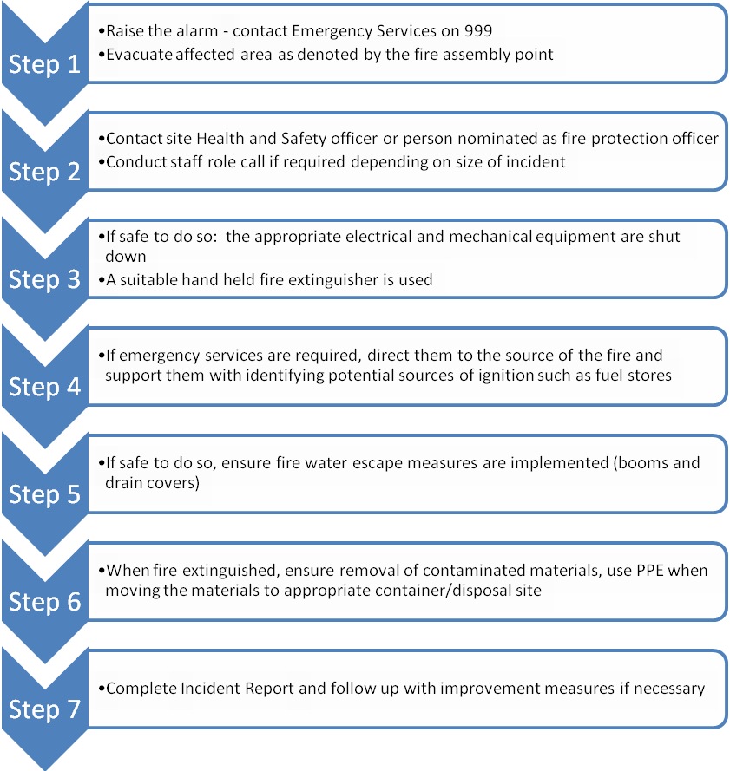
The Site Manager, will liaise with the Emergency Services on their arrival. The Site Manager will clearly identify him/herself to the Emergency Services on their arrival on site and update the FRS on the situation. Prior to arrival of the FRS on-site there are several measures that Fastlay Services Limited can take to help fight fire, assuming there is no risk to life.
- Water bowsers can be deployed to help damp down and spray smaller areas of fire if it is safe to do so. The bowsers are filled from the mains water supply shown in Annex A “Mains TAP” actually a water main. Bowsers are mobile and can be moved by FLT if required. A water pump would enable water from the bowser to address smaller fires.
- A diesel powered water pump is maintained on site in order to deliver water from the bowsers if required. This would provide approximately 50l/min over a 20 min period for smaller fires on site and could be activated by trained staff on site. The small volume of fuel required for 20 minute runs would be stored in Jerry cans or small containers on drip trays in a safe area away from the main warehouse where a fire is most likely.

- Handheld fire extinguishers can be deployed in order to contain fires where possible
- Access to the hydrant located in the road may be used by the FRS if required
- Fire blankets/sheets can be used to smother smaller isolated sources of fire stored in the office area. X6.
- The quarantine area is 2.5x2.5x2M square (12.5 cubic metres) and can easily accommodate at least 50% of the largest waste pile (18 cubic metres). See appendix A.
- In the event of a fire or observed self-combustion, burning waste, if safe to do so, will be moved to the Fire Quarantine Area or alternative designated site.
- Waste can be moved to this area by the addition of FLT scoops or shoves which are stored on site for such purpose. These can move large volumes of waste quickly to the quarantine area.
- The Fire Quarantine Area is signposted.
- The quarantine area, when made safe, will be emptied immediately. Should it be necessary to move or divert wastes to an alternative site then an alternative permitted site will be used. Fastlay Services Limited has an agreement with other waste sites. Vehicles will be directed to this site.
- Neighbours and local businesses downwind will be notified of any potential fire incident by the site operator as soon as possible from the local contact list. This will be completed by telephone and will be completed as soon as it is safe to do so. Local receptors will be notified in order of proximity to the site and prevailing wind direction. Local receptors will be kept updated as to the progress of fire fighting as new information comes to light and fully debriefed at the end of the event.
- Once the fire has been dealt with, post fire de-contamination arrangements will be agreed with the local EA officer
- The site is an impermeable surface and will be scraped clean
- Waste will be removed from site if necessary
- If necessary, soil and groundwater monitoring will be undertaken as agreed with the EA
- Once the local EA officer has agreed that the site is ready to become operational again then operations will recommence.

  - Managing Fire Water
Table 3 shows the potential volume of fire water which may need to be managed on site should the largest waste pile require quenching.

Table 3: Volume of Water Required
l/min/1m³ of waste * | 6.6
Largest Combustible Pile (m³) | 18
Water Required (l/min) | 119
Total Requirement for 3 hours (l) | 21,384
*Based on EA guidance: 2000l of water minute is required for a 300m³ stockpile for three hours

Table 4 shows the volume of fire water which can be contained within the site.
The south & south east boundaries of the site will have kerbing to retain firewater. Inflatable booms will be implemented to seal off the site entrance gateway and building entrance if necessary.
A boom will be deployed across the site entrance to retain water to a height of 10cm as per Annex C.

Table 4: Volume of Firewater Contained within Site
Average Site Length (m) | 50
Average Site Width (m) | 35
Water Depth (m)* | 0.05
Site Volume (m³) | 87.5
Site Volume (l) | 87,500
*minimum height of curb or boom

These tables show that the site would be able to contain the volume of water needed in a worst-case scenario. Therefore, the key receptors in Annex D which could be affected by firewater will be protected. A concrete kerb will be installed prior to permit issue on the lower southern and south eastern boundary of the site (see annex C). This will be lined with waterproof rendering to form a new 50mm retaining kerb.
As can be seen from the surface water flow, the levels slope towards the south/south-eastern boundary (in the yard) slightly so the northern boundary is of less significance. With these boundaries, the site can be isolated (there are no controlled water courses nearby) from the receptors and the surrounding environment.

Booms can be mobilised by two staff and can cover any length but in this instance 20m of booms will be stored at the Fastlay Services Limited depot. The vendors of the booms provide training to staff and this will also be purchased by fastlay. The booms will take approximately 30 mins to fully mobilise and set up if required.
Fire water can be removed as stated below and in annex H.
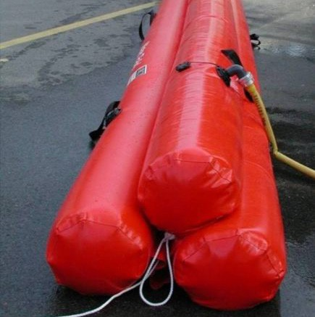

Pollution prevention booms similar to the above will be used to retain firewater if necessary, on the site and warehouse entrance as per annex B. These are inflated with water. They are plastic and inflated with a water pump. Staff will be trained in their use and how to mobilise them.
Specification – Double Tube Flood Barrier
The flood and spill protection boom is a versatile and flexible barrier that can be used on water levels between 30cm and 2 metres over an unlimited distance. It is an ideal system for creating a barrier to protect your premises in the event of a flood warning.
Equipped with standardised fittings and easy to store, set-up, use and dismantle after use the flood protection boom protects traffic routes, industrial, historic or strategic sites.
How it works
This flood protection barrier uses the strength and power of water to keep areas protected from flooding. The barrier is simple and easy to store and can easily be handled by just two people.
The flood protection barrier utilised will be:-
- Double tube
- Diameter - 40cm / 60cm / 80cm
- Length - 10m / 20m / 30m
- Straight & angle fixings available in three diameters

https://www.darcy.co.uk/product/spill-and-flood-barriers/industrial-flood-barriers/

Booms are stored in the office close to the yard and are accessible at all times. They are only required on the western boundary for the entrance areas and as a precaution. Staff are trained in deployment of the booms and are aware of the importance of isolating the site in the event of firewater being used on-site.
Fastlay Services Limited has a contact for emergency spillage response with a company which provides tankers to remove firewater. The company would come to site to remove water from the site using the specified suction point in the yard – Sump Annex A, and remove water from the site contained by the kerb. See Emergency Contacts, Annex G. The yard drainage system is sealed due to concrete surfacing and a gulley in the yard leading to a blind sump.

  - Future Actions
This plan is based on current planned operations. Fastlay Services Limited understand that it is important that this Fire Prevention Plan is maintained up to date and relevant to the business. Therefore, it will be updated accordingly, in collaboration with the Environment Agency as required, should business operations change in the future.
- Annex A: Site Layout

NOTE: All the site is covered with impermeable concrete.

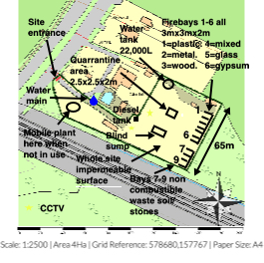
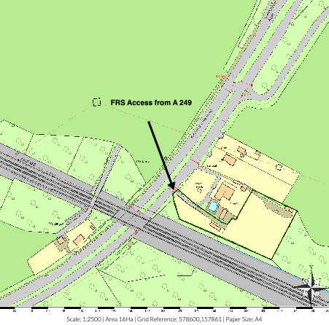A2- Site Access
- Annex B: Site Drainage

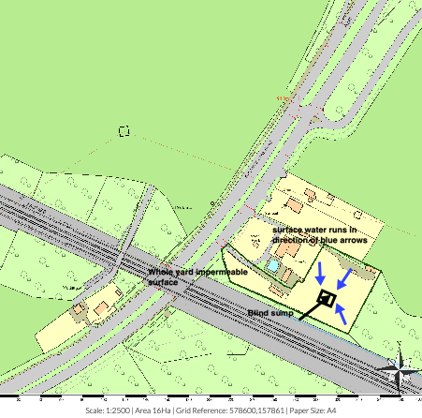

- Annex C: Fire Access, Equipment and Water Supply Plan
Car parking area

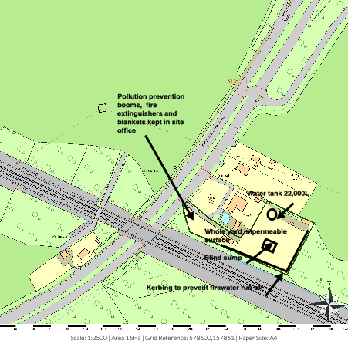C1

- Annex D: Key Receptors
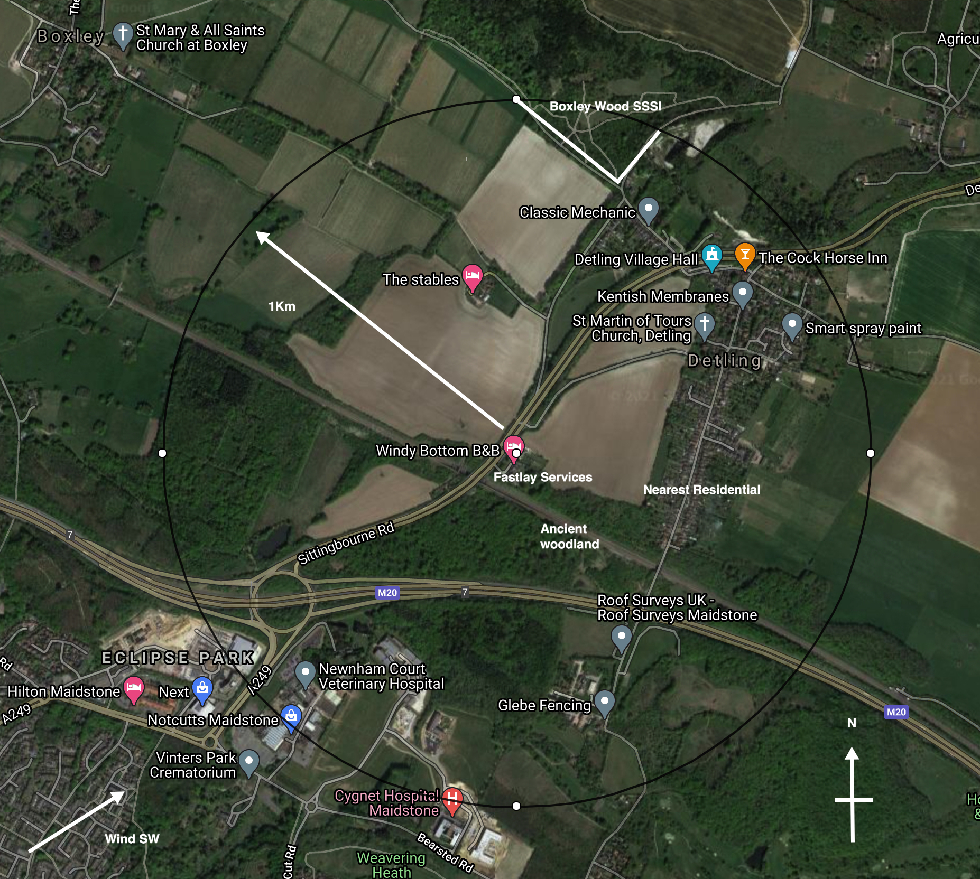 | The receptors shown are within 1km of the site. Sensitive human receptors include areas containing residential properties to the east & NE and a retail pk to the SW.  The site is in on a small industrial/commercial estate which is a rural area surrounded by residential properties and other commercial enterprises. There is Boxley Wood SSSI approximately 900m to the N. Wouldham to Detling Escarpment. As well as ancient woodland to the immediate east.  Key infrastructure includes the M20 to the S and the A249 Sittingbourne Rd to the W.  The nearest Fire Response Service operation is Kent fire & Rescue HQ 2Km S.  The Godlands, Straw Mill Hill, Maidstone ME15 6XB.  Wind Direction  According to the UK Met Office, the prevailing wind direction in the area is South-Westerly. This means the prevailing winds blow over the site to the north east, which is away from the main residential areas and SSSI.

Annex E: Waste Acceptance Procedures
In order to identify non-compliant wastes including any hot loads and incompatible waste types the following Waste Acceptance Procedure is implemented by Fastlay Services Limited.
Waste Acceptance
The procedure that shall be adopted at site is detailed below
1. Waste arrives on site.
2. Documentation is checked at the office & located at the entrance to Fastlay Services Limited site. See annex A2.
3. All vehicles will have their contents examined during unloading and this shall be crosschecked with the documentation presented.
4. Particular emphasis will be placed on ensuring that only the non-hazardous mirror entry EWC codes stated in the permit will be accepted at site. The site will not accept, store or treat any hazardous wastes. See below.
5. Staff will check that the type of waste is acceptable in terms of the waste licence. This will include inspection for hot loads such as smouldering waste. A thermocouple will be used if a hot load is suspected to check internal temperature.
6. If the waste is unacceptable the waste shall be isolated and arrangements put in place for the contractor to remove the waste from site or for the waste to be segregated in the quarantine area until such times that it can be removed.
7. If the person who is checking in the load is suspicious of its contents the driver shall be directed to the waste inspection area near the reception office, where the load shall be sampled and inspected to ensure that it corresponds to the accompanying documentation. In any event compliance testing will be carried out at regular intervals.
8. Assuming the on-site verification is satisfactory, the load is weighed in and directed to the yard as appropriate. Here, the waste will be checked again to verify that the description is correct before tipping is allowed.
Waste Pre-Acceptance Criteria
Guidance: Non-hazardous and inert waste: appropriate measures for permitted facilities July 2020
Fastlay Services Ltd will follow the waste pre-acceptance criteria guidance for inert and non hazardous waste as detailed below.
Prior to acceptance of waste at the site the following information will be gathered to ensure that waste types and condition will meet the permit requirements and those other plans associated with it i.e. fire prevention plan and dust management plan.

Information to be obtained from customer

- Details of the waste producer including their organisation name, address and contact details
- Description of the waste
- European Waste Classification code
- The source of the waste
- Information on the nature and variability of the waste production process
- Information about the history of the donor site if it may be relevant to the classification of the waste
- The waste’s physical form
- The waste’s composition (based on representative samples if necessary)
- a description of the waste’s odour
- The waste’s age, that is when it first became waste
- The type of packaging if any
- Whether the waste is mixed or segregated by List of Wastes code
- An estimate of the quantity y in each load and in a year if applicable
Mirror Entry Codes

All mirror entry codes will only be accepted if they are classed as non-hazardous. If there is clear provenance to demonstrate that the waste is non hazardous and this also meets the visual inspection criteria then the waste will be accepted. If there is doubt then the waste will be rejected or quarantined before being removed from the site.

Sampling

If it is required to test an incoming load then the load will be quarantined and separated from other wastes until such time that sampling and analysis has been conducted using UKAS approved sampling and analysis. The waste will not be formally accepted into the yard until such criteria have been met and all tests passed.

Waste Capacity

Incoming loads will be crossed checked at pre acceptance and acceptance stage to ensure that the site has sufficient capacity to accept the designated quantity. Figures will be cross referenced with stock level checks. If permit capacity is likely to be breached, then the load may be rejected.
N
- Annex F: Fire Risk Checks Form for Fire Prevention
The following regular check has been completed:

Checks to be made
- Security – all security fencing and security equipment is intact (daily)
- Signs of Self Combustion – no smoke visible /potential hot spots identified (daily)
- Storage areas – housekeeping is suitable (daily)
- Storage areas – pile sizes within permitted limits (daily)
- Exhausts – exhausts are cool and located away from combustible materials(daily)
- Fire fighting water – all hose reels and hydrants are accessible(daily)
- Fire extinguishers – all fire extinguishers are in the correct place and intact(daily)
- Fire Quarantine area – clear from waste and signage intact(daily)
- Mobile plant parked remotely, secured and key out when site closed(daily)
- Waste turned when? – recorded on waste inventory in site office(monthly)
- Waste in (t) – recorded on waste inventory weekly in site office. Waste removed in date order
- Waste out (t) – recorded on waste inventory weekly in site office. Waste removed in date order.

Date | Morning check (initials) | Evening Check (Initials) | Issues to Report to Site Manager

- Annex G: Emergency Contacts

Name & Address |  | Telephone Number
Environment Agency | General Enquiries:  Incident Hotline Reporting: | 03708 506 506  0800 80 70 60
Electricity Supplier & mains switch location
Gas supplier & shut off valve location
Water supplier & shut off valve location
Local Authority Emergency Services
Insurance Company and policy number
Nearest Hospital
Emergency Spillage Response company

- Annex H: EMS Documents
Drainage & Bund Checks
- A current site drainage plan will be drawn up and displayed in the office areas for information. The standard colour coding of blue for surface water drainage that discharge to the environment and red for sealed or foul drainage systems will be employed.
- The integrity of impermeable surfaces, the sump and storage areas will be visually inspected by the operator on a monthly basis. To achieve this, it will be necessary to sweep/ wash clean the impermeable surface that form licensed area and clear any earth that has collected in the drain gullies. Where any defects are found, remedial steps will be taken promptly to maintain the integrity of the structure. If, however the integrity of the structure is breached a temporary repair will be made by the end of the working day and a full repair will be made within 10 days.

Area | When Checked | Date | Comments
Yard | weekly | 20/01/20 | Clean no gulping required
Hardstanding | 6 monthly
Oil tank | weekly
Gulleys (non currently on site) | weekly

Site Vehicle and Machinery Maintenance.

- All site vehicles and machinery will be fitted with working exhaust silencing equipment.
- Staff will not continue to operate any piece of machinery or equipment that appears to be visibly or audibly failing.
- All vehicles and machinery operated within the site will undergo regular planned preventive maintenance/ servicing and inspections, at the frequency deemed appropriate by manufacturer or required by legislation. As a minimum, this will be a statutory annual inspection of lifting (LOLER) and work (PUWER) equipment. Maintenance/ Servicing and inspection records will be kept on site for reference.
- Where the necessary maintenance and repair skill do not exist within the company, a contract for these services will be in place, so that the repair of site vehicles and machinery will be undertaken promptly.
- If mobile plant maintenance/ repair will involve the removal/ loss of potentially polluting fluids from the vehicle, if possible, the vehicle should be moved to impermeable concrete area and worked on there, where any spills will land on an impermeable surface. All fluid leaks or drained oils will be collected in a container and removed.
- Where mobile plant must be repaired in the location that it breaks down, if this is on hard standing, drip trays and absorbent mats will be put in place under the vehicle before work begins, to capture any spills of potentially polluting substances and prevent contamination to the earth below.
Plant and Vehicles will be inspected and recorded below;

Equipment | When checked | Date | Comments | signed
Delivery vehicles | weekly
360 | 6 monthly
FLT | Manufacturer’s Specification

Dealing with Spills

Scope: To detail how spills during normal and abnormal operations are dealt with to minimize impact on the environment
Responsibility: Site owner
Background: Spillage of oils and chemicals can have an impact on the soil and groundwater beneath the site.
The site carries quantities of absorbent granules and absorbent booms to mop up small quantities of hydrocarbon and other liquids if spilt. If used these are stored in the hazardous waste container until removed from the site by specialist contractor within a reasonable period of time.

- During normal operations, all staff have been made aware of the requirement to minimise fuel and liquid spills on site
- All staff have had appropriate training on how to deal with a fuel spill in the event of an incident occurring
- Absorbent is used to clean up the spill at source. If it is a larger spill and it is safe to do so, then the source of the spill is curtailed if possible.
- The location of spill kits and absorbent material is identified on the site plan
- Where possible all spills are directed to the sealed drainage system for containment
- A store of general absorbent material will be kept on site in an easily accessible central location known to all site staff. The absorbent material will be hydrocarbon (fuel, oil etc.) absorbent, as this is the most likely material to be spilt on site.
- A boom will be kept on site. Management will know where the boom is stored on site and how it should be deployed so as to be effective. Booms length will be enough to cover the expanse of the entrance to the and to protect the gulley to the Sump.

- Where leakage from any storage container on site is found, actions to remedy the leak will be taken. Any such leakage and remedial action will be recorded in the site diary.
In addition:
- The source of the leak or spill will be investigated, located and stopped.
- If any significant leaks or spills of substances occur, which have the potential to harm the environment or pose a risk to human health; the materials detailed under the section 'site provisions' will be utilized and disposed of appropriately.
- Any pooling leak or spill of a potentially polluting liquid will be soaked up with appropriate absorbent material, such as saw dust, sand or granules. The absorbent material will be cleared from the ground when it has soaked up all free polluting liquid. Where there is the potential to reuse absorbent material because it is not fully saturated, it will be stored in containers labeled 'absorbents for reuse' when fully saturated, absorbents will be placed in containers labeled 'absorbents for disposal'.
- In the event of a significant and/ or on-going leak or spill of a potentially polluting liquid, clay damit mats or suction covers will be applied to drain grills to seal them to prevent (further) liquid from entering the drainage system.
- In the case of a leak or spill of potentially polluting liquid onto hard standing/ earth surfaces, the hard standing/ earth material will be removed and replaced with clean material of a similar nature.
- Covered leak proof containers will be available on site for the segregated storage of contaminated absorbent materials and contaminated hard standing/ earth.
- If any leaks or spills of substances occur, which have the potential to harm the environment or pose a risk to human health escape the site boundary, the management will inform the Environment Agency immediately. Any remedial action specified by the Environment Agency will be under taken, a record of which will be made in the site diary.

Waste Acceptance, Storage and Inspection
To deal with the acceptance, storage & inspection of waste on-site.
Introduction
The company will introduce a system of storage on-site to minimise the potential for cross contamination and potential run off from wastes whilst stored on site.

Waste Types
Only the waste types and EWC codes named on the environmental permit will be accepted at the site. Wastes entering the site will be inspected and registered at the site. Non-compliant waste materials not allowed on the permit will be turned away from the site. A record will be made in the site diary. ELV waste is not accepted at this site.
The total quantity of waste accepted at the site shall be less than
15,000 tonnes a year. There will be no hazardous waste accepted or stored on site

Working Hours

Normal working hours will be 0900-1700 Monday - Friday

Saturday and Sunday – closed

Responsibility
The Environmental Manager is responsible for identifying and highlighting
non-conforming waste. The Environmental Manager is responsible for
inspecting, documenting and safe removal of any non-conforming waste.

Waste Storage
Discreet areas will be nominated on-site for each waste type. These will be labelled and identified on the site plan. The site plan will be updated on a regular basis provide a record of what type of waste and quantity is stored where.

Waste Acceptance
The procedure that shall be adopted at site is detailed below
1. Waste arrives on site.
2. Documentation is checked at the office.
3. All vehicles will have their contents examined during unloading and this shall be crosschecked with the documentation presented.
4. Staff will check that the type of waste is acceptable in terms of the waste licence.
5. If the waste is unacceptable the waste shall be isolated and arrangements put in place for the contractor to remove the waste from site.
6. If the person who is checking in the load is suspicious of its contents the driver shall be directed to the waste inspection area in the reception office, where the load shall be tipped and inspected to ensure that it corresponds to the accompanying documentation. In any event compliance testing will be carried out at regular intervals.
7. Assuming the on-site verification is satisfactory, the load is weighed in and directed to metals yard as appropriate. Here, the waste will be checked again to verify that the description is correct.

Wastes will be stored in accordance with the tables above.

Other waste codes will be added to this table and this procedure updated on a regular basis to ensure a current records of storage activities at the site.

Waste Segregation
Waste will be segregated and stored as per TGN 7.01 although it is recognised that many of the wastes stored at Fastlay Services Limited are not combustibles.
To ensure that the potential for fire is minimised, waste types that are flammable will not be stored close to other flammable types and fire break areas will be maintained between piles.

Waste Area Inspection
As part of the EMS waste areas are inspected routinely, deviations from normal operation conditions, result are logged and acted upon in the site log.

Records
Fastlay Services Limited shall keep records of all waste loads rejected, these records will include;
- Date
- Name of Carrier
- Source of Waste
- Vehicle Registration
- Description of Waste
- EWC code
- Quantity of Waste
- Name of person carrying out inspection
- Destination of Load prior to rejection

- Annex J: Firebay Specification

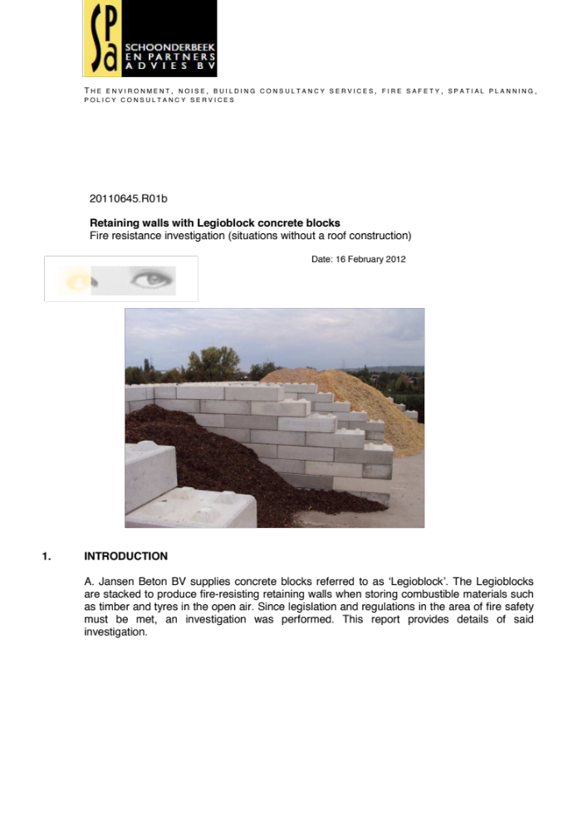

1. INTRODUCTION
A. Jansen Beton BV supplies concrete blocks referred to as ‘Legioblock’. The Legioblocks
are stacked to produce fire-resisting retaining walls when storing combustible materials such
as timber and tyres in the open air. Since legislation and regulations in the area of fire safety
must be met, an investigation was performed. This report provides details of said
investigation.
20110645.R01b
Retaining walls with Legioblock concrete blocks
Fire resistance investigation (situations without a roof construction)
Date: 16 February 2012
T H E E N V I R O N M E N T , N O I S E , B U I L D I N G C O N S U L T A N C Y S E R V I C E S , F I R E S A F E T Y , S P A T I A L P L A N N I N G ,
P O L I C Y C O N S U L T A N C Y S E R V I C E S
- 2 - 20110645.R01b
Bestandsnaam: 20110645.R01b Legioblock in de open lucht.docx
Dateiname: Speicherdatum: 22-2-2012 9:56:00
2. PRINCIPLES AND SCOPE
The investigation is based on the provided data and applicable standards, in particular:
· The standard: DIN EN 13501-1:2007 Klassifizierung von Bauprodukten und Bauarten zu
ihrem Brandverhalten - Teil 1: Klassifizierung mit den Ergebnissen aus den Prüfungen
zum Brandverhalten von Bauprodukten (Fire classification of construction products and
building elements - Part 1: Classification using data from reaction to fire tests; + Blatt A1
2009; Sheet A1 2009);
· The standard: DIN EN 13501-2:2008 Klassifizierung von Bauprodukten und Bauarten zu
ihrem Brandverhalten; Klassifizierung mit den Ergebnissen aus den Feuerwiderstandsprüfungen
(Fire classification of construction products and building elements - Part 2: Classification
using data from fire resistance tests, excluding ventilation services; + Blatt A1
Entwurf 2007; Sheet A1 Layout 2007);
· DIN EN 1363-1 Einheitstemperaturzeitkurve (Standard fire curve);
· Eurocode 2 Teil 1-2 (EN 1992-1-2) Bemessung und Konstruktion von Stahlbeton- und
Spannbetontragwerken – Teil 1-2 Allgemeine Regeln – Tragwerksbemessung für den
Brandfall (Design of concrete structures – Part 1-2: General rules – Structural fire design);
· Fire Recyclinghof Essen, 26 January 2011;
· Fire Kost Bochum, 16 July 2007.
The principles have been explained by the customer.
The most important objective with regard to the classification in storage sections separated
by concrete retaining walls is to prevent fire propagation. This mainly applies to fire propagation
towards the adjacent premises of third parties but also the adjacent storage sections and
buildings on the organisation's own business site. In addition, health and environmental risks
play a role as does the risk involved in fighting fire.
The concrete blocks are made of grade C25/30 concrete (no reinforcement) and their dimensions
(length x width x height) are 1.6 m x 0.8 m x 0.8 m or 1.6 m x 0.8 m x 0.4 m with the
related accessories. The concrete blocks are stacked on top of each other using studs and
holes that fit together. The blocks have chamfered edges that measure 10 mm. The thickness
of the retaining wall measures 0.8 m.
The concrete Legioblocks are incombustible and fall within the highest A1 class in accordance
with the DIN EN 13501-1 standard.
The present investigation is related to the following application area:
· Combustible materials such as timber, rubber and PVC. No combustible materials with a
specific energy higher than 35 MJ/kg. No liquid fuels or explosion hazardous materials.
· Retaining walls in the open air without a roof construction.
· Retaining walls up to a height of 6 metres.
· Retaining walls up to a height of 8.8 metres with combustible storage material up to 1.6
metres below the level of the retaining wall.
· Retaining walls higher than 6 metres where the vertical gap openings between the Legioblocks
(insofar as they are wider than 5 mm) are sealed to be fire-resistant.
· No covering of the storage materials (this may contribute towards fire movement through
the open seams of the retaining wall). No storage of large horizontal sheets (sheet width
>1 metres).
· Vertical retaining walls on one, two, three or all sides of the storage material.
- 3 - 20110645.R01b
Bestandsnaam: 20110645.R01b Legioblock in de open lucht.docx
Dateiname: Speicherdatum: 22-2-2012 9:56:00
· An appropriate structural stability of the retaining wall in accordance with the EN 1990 and
EN 1991-1 standards.
3. FIRE RESISTANCE ANALYSIS
A link with current standards such as the DIN EN 13501-2 standard has been sought as
much as possible when assessing the fire resistance of the Legioblock retaining walls. The
fire resistance is expressed in minutes where the criteria for Tragfähigkeid (R; Load-bearing
capacity), Raumabschluss (E; Integrity) and Wärmedämmung (I; Thermal insulation) have to
be met. The REI120 classification, for example, represents a structure that will meet these
three criteria for 120 minutes. The fire resistance of a retaining wall is determined by the following:
· The temperature behaviour and heat radiation on the cold side of the wall (§ 3.1).
· Spalling: decay of the concrete surface because of heat (§ 3.2).
· Fire-tightness.
· Open seams between the concrete blocks.
· Structural aspects: the wall may not collapse.
3.1. Temperature behaviour and heat radiation
Calculations have been made with regard to the temperature distribution in the concrete
based on the DIN EN 13501-2:2008 standard regarding the fire resistance of concrete. The
retaining wall has been represented schematically as a solid concrete wall with a temperature
of 1200 °C on the fire side. Temperature calcu lations have been made using the finite
element method. The following principles were used when making the calculations:
· Heat conductivity coefficient of the concrete: 2.0 W/mK
· Specific heat: 840 J/kgK
· Contact resistance on the fire side: 0 m2K/W
· Contact resistance on the protected side: 0.20 m2K/W.
The calculated temperature behaviour is shown in Figure 1. It shows that the calculated surface
temperature on the other side is less than 22 °C after 4 hours. The radiation heat is,
therefore, less than 1 kW/m2.
- 4 - 20110645.R01b
Bestandsnaam: 20110645.R01b Legioblock in de open lucht.docx
Dateiname: Speicherdatum: 22-2-2012 9:56:00
3.2. Concrete decay: 'spalling’
An internal pressure is created when concrete is heated quickly because the moisture present
is converted into steam in a short period of time of which the volume increases considerably
and quickly and the external layer can be compressed. This is referred to as 'spalling'.
Spalling has been taken into account when dimensioning concrete structures based on current
structural standards such as Eurocode 2. The spalling is factored into a reduced residual
cross section of the concrete wall. It must be concluded that the decay (‘spalling’) of the nonreinforced
concrete blocks is limited to the surface and does not have a considerable impact
on fire resistance based on Eurocode 2 regarding the fire resistance of concrete structures. It
has also been observed that the spalling was limited to the corners of the concrete blocks in
outdoor fires that have occurred during the last few years. This decay does not affect fireresisting
performance and the Legioblock retaining wall will remain erect during a fire for at
least 4 hours.
3.3. Seams/gaps
The blocks are stacked on top of each other using studs and holes that fit into each other.
Despite careful stacking, gap openings between the stacked blocks are unavoidable both
horizontally and vertically:
· The horizontal gaps between the blocks stacked on top of each other can be a few millimetres
wide. The gap widths specified here are related to the net (aerodynamic) passage
opening of the gap. It can be concluded that flashover does not occur based on the dimensions
(height and width) of the gaps.
· The dimensions of the vertical gaps between the blocks placed next to each other are
related to the flatness of the substrate and are often limited to a few millimetres. A single
exceptionally wide gap may be unavoidable locally up to a width of 30 mm. The probability
that there will be fire movement through a vertical gap up to 30 mm has been further considered
below. Heat radiation, air movements and air pressure differences as a result of
fire have been taken into account.
3.3.1. Heat radiation
The vertical gap can offer a 'view' of the seat of a fire from the compartment to be protected.
A 30 mm gap offers a view factor of at most 0.02. Based on a seat of a fire with a radiation
intensity of 100 kW/m2, the radiation intensity on the receiving side will be 0.02 x 100 = 2
kW/m2. This radiation intensity is so slight that flashover is excluded.
3.3.2. Air movements
The movements of air, hot flue gases and flames through an open gap are determined by the
air pressure difference between both sides of the gap. This pressure difference is determined
completely by the fire when there is no wind: air (oxygen) is suctioned through the gap in the
direction of the fire. Hot flue gases will not reach the other side of the retaining wall.
‘Cold’ smoke can already penetrate up to the other side of the retaining wall when the wind is
weak. There is no source of ignition here so that fire cannot occur.
The situation where fire and flames are immediately against the retaining wall with a gap
opening immediately above the seat of a fire when the wind is strong perpendicular to the
- 5 - 20110645.R01b
Bestandsnaam: 20110645.R01b Legioblock in de open lucht.docx
Dateiname: Speicherdatum: 22-2-2012 9:56:00
retaining wall has been further considered. The combustible flue gases can only penetrate to
the other side of the retaining wall when the wind pressure on the retaining wall is higher
than the thermal pressure. The thermal pressure will depend on the height of the seat of the
fire + flames (chimney effect). The surrounding buildings and the storage material reduce the
wind pressure on the retaining wall (when compared to the wind pressure in the open field
with a wind pressure coefficient of 0.8). On balance, hot smoke can only reach the other side
of the retaining wall under extreme theoretical conditions (a storm exactly perpendicular to
the retaining wall or a narrow stack of material immediately against the retaining wall).
Flames do not penetrate through the gap to the other side of the retaining wall.
3.3.3. Conclusion regarding seams/gaps
Flashover through the open gaps between the Legioblocks has been excluded sufficiently
based on the above when considering the favourable factors specified below.
3.4. Other fire resistance aspects
The fire resistance of building structures is generally determined based on fire tests, for example,
in accordance with the DIN EN 13501-2:2008 standard. The present storage situations
are essentially more favourable than the standard situation:
· The lapse of time of the local thermal load of the retaining wall is less favourable than the
‘standard’ fire curve from these standards.
· The room exposed to fire has an overpressure during the fire test while the room exposed
to fire has an underpressure in the open air as a result of thermally driven air movements.
· Cotton buds are used to assess the fire resistance (fire-tightness) during the fire test.
These cotton buds combust shortly after being exposed to heat. The present materials
combust less easily as a result of the higher heat capacity, specific mass and chemical
composition.
The relevant literature mentions the release of oil when rubber burns. Should this be the
case at all, it would involve a small quantity. Oil and fire-extinguishing water can seep
through to the other side of the retaining wall. The oil will be cooled down and there is no
source of ignition so that flashover cannot occur.
The structural stability of the retaining wall is important. The structure of the retaining walls is
generally dimensioned based on the worst case scenario where storage material is present
on one side with a large safety margin. The load combination during a fire (and possibly a
strong wind) does not form a factor of any significance. The retaining wall will, therefore, not
collapse should there be a fire.
The favourable behaviour during a fire has been confirmed based on fires that have occurred
during the past years.
- 6 - 20110645.R01b
Bestandsnaam: 20110645.R01b Legioblock in de open lucht.docx
Dateiname: Speicherdatum: 22-2-2012 9:56:00
4. CONLUSION REGARDING FIRE RESISTANCE
Insight has been obtained into the fire-resisting properties of Legioblock concrete retaining
walls as partitions for the storage of combustible materials in the open air based on the
investigation. It can be concluded based on the investigation that the retaining walls have
fire-resisting properties at the level of the REI 120 classification. This applies under the
application conditions described in Section 2.
Schoonderbeek en Partners Advies BV
Ing. C.A.E. Rijk.

Fire Prevention Plans, Version 3 January 2021
Provision and Use of Work Equipment Regulations 1998 (PUWER)
http://www.metoffice.gov.uk/climate/uk/regional-climates/

