Fastlay Services Limited
Dust & Emissions Management Plan
CONTENTS
1. INTRODUCTION 1
Roles and Responsibilities 1
Site Description 1
Site Plan 2
2. SOURCES, PATHWAYS, RECEPTORS 2
Source Materials - Inventory 2
Pathways 3
Receptors and Wind Direction 3

3. PRIMARY Emission CONTROL MEASURES 4
Releases 4
Impacts 4
Management of Releases 5
4. Monitoring & Trigger Levels 6
Introduction 6
Communication 7
Complaints procedure 7
5. Incidents and Emergencies 8
Appendix A Site Plan 9
Appendix B Emission Survey Form 10
Appendix C Complaint Form 12

- INTRODUCTION
  - This document provides the Emissions Management Plan prepared in accordance with Environment Agency Guidance in support of environmental permit application For a waste facility at Fastlay Services Limited, Sittingbourne Rd, ME14 3ES.
  - It relates to the waste recycling facility proposed to be operated by Fastlay Services Limited which is currently under construction and due to be operational late 2022.

  - The overall responsibility for this procedure is the Environmental Manager. The Environmental Manager will be responsible for ensuring the all staff are trained in this procedure.

  - The Site Manager is responsible for ensuring that the day-to-day operations are carried out in accordance with this procedure.
  - All staff are responsible for implementing this procedure and have a duty to carry out their roles to prevent emissions.
  - This plan aims to identify dust emission points as part of the waste recycling process process. These are identified in table 1 below. It must be noted that these are not continuous emissions but intermittent emissions as part of the proposed operation. However on occasion dust emissions may emanate from this source and it is for that reason this DEMP has been drafted.

Site Description
  - The site is located north of the M20 and just east of the A249 NE of Maidstone approx. 0.5Km. The site is approximately 0.5 Hectares and mainly impermeable concrete/hardstanding. The site is surrounded by rural countryside and agriculture. There re are no SSSI’s or AONB’s within 500m but there is ancient woodland close to the site and SSSI’s within 1KM. The neareast AQMA is approx. 100m S. However wind is also SW/WSW.
The site is in a remote rural setting just north of the M20. There are immediate residential properties but these are owned by the site owner. The site is proposed to be an inert waste transfer station with manual sorting only. No treatment. The site will be based on an impermeable surface with a sealed drainage system and layout as per Annex A. Combustible waste will be stored in firebays. The site will be fenced and not visible from the road. The site will be bordered by security fencing and concrete panels. The site will be tree lined with netting to prevent the egress of dust. Waste will be kept 1m below firebay wall as per FPP guidance. There are no free standing piles. There is no picking station or conveyor.
All bays will be covered (with sides) to prevent dust emissions and wind whipping.

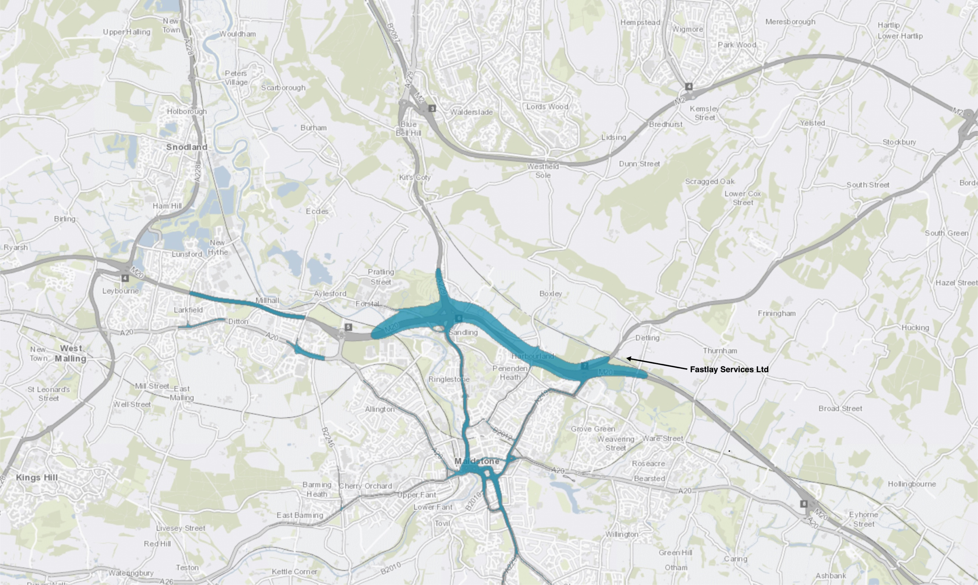
AQMA on M20 corridor.

  - Site operation includes the delivery, storage of inert and non hazardous waste by manual sorting.

Site Plan
  - A basic site layout is provided in Appendix A.
  - The company Environmental Management System (EMS) will be updated and revised accordingly as a living document as environmental management develops
- SOURCES, RELEASES, IMPACTS
  - This section sets out the protection sources of emissions, potential release points and receptors and abatement
  - Waste is stored in covered firebays externally and treated within the building.

Source Materials - Inventory
  - Given the materials used in the process, it is considered that those which are most likely to give rise to emissions are those in Table 1.
Emission source | Activity Description | Storage Technique | Emissions & Abatement
Yard | Loading/Unloading | Stored in concrete firebays (covered) | Covered storage bays. Damping if required
Loading/unloading | Waste delivery | sheeted | sheeting on delivery removal.
Sorting | sorting | covered | Enclosed in covered firebays
Table 1 Source Materials
  - It is anticipated that the likelihood of dust being emitted from these materials is medium on delivery or movement.
  - It is anticipated that the likelihood of mud being emitted from these materials is medium on delivery or movement
  - It is anticipated that the likelihood of mud & dust being generated from on-site activities is low.

Pathways
  - The pathways by which the emissions from the sources identified above may impact upon a receptor are primarily:
- Air Movement of dust through air, particularly relevant on a site which will store waste.
- Mud via vehicle wheels onto and off of site
3. Direct exposure. Particularly for staff, they will be exposed immediately to any dusts from the handling on site.

Receptors and Wind Direction
  - The site is on an open rural estate which means key receptors sensitive to dust are staff and visitors to the businesses which surround the site as well as environmental receptors. There are no SSSI’s 500m but there are ancient woodlands close to the site. The area is one of light industrial/agricultural activity with one immediate residential neighbour.
  - The nearest residential properties are located on the immediate North boundary of the site owned by the operator.
  - The key receptors are shown in Figure 1 below.
  - The prevailing wind direction in the area, where the site is located, is South-Westerly towards immediate neighbours.
  - The source Pathway Receptor Model can be seen in appendix D

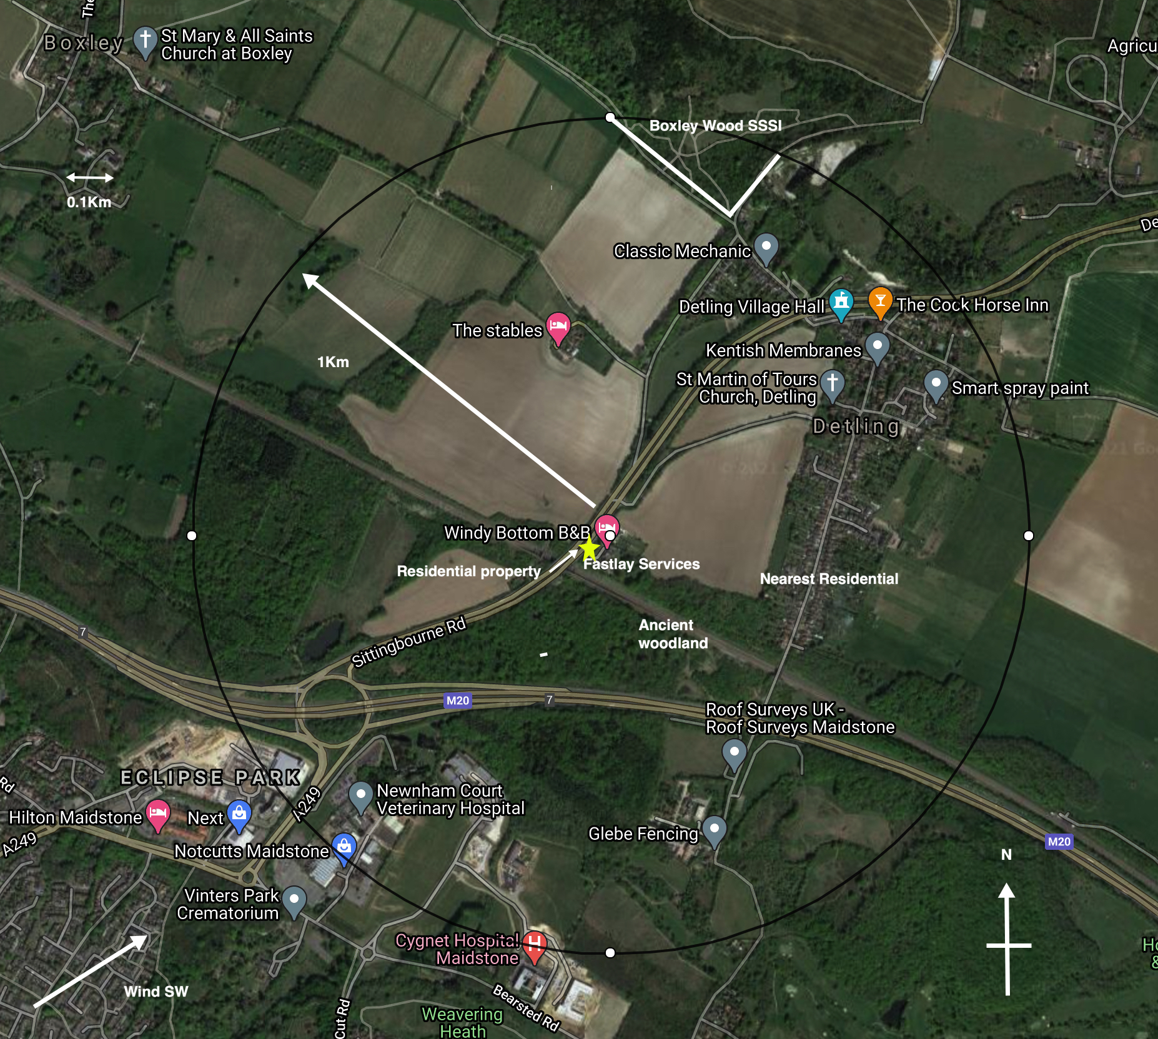

Figure 1: Site and Key Receptors
Wind direction as per figure above is predominantly SW/WSW and the wind rose from the UK met office shows 100 occurrences of wind gusting 20-25Kmh over the past year.
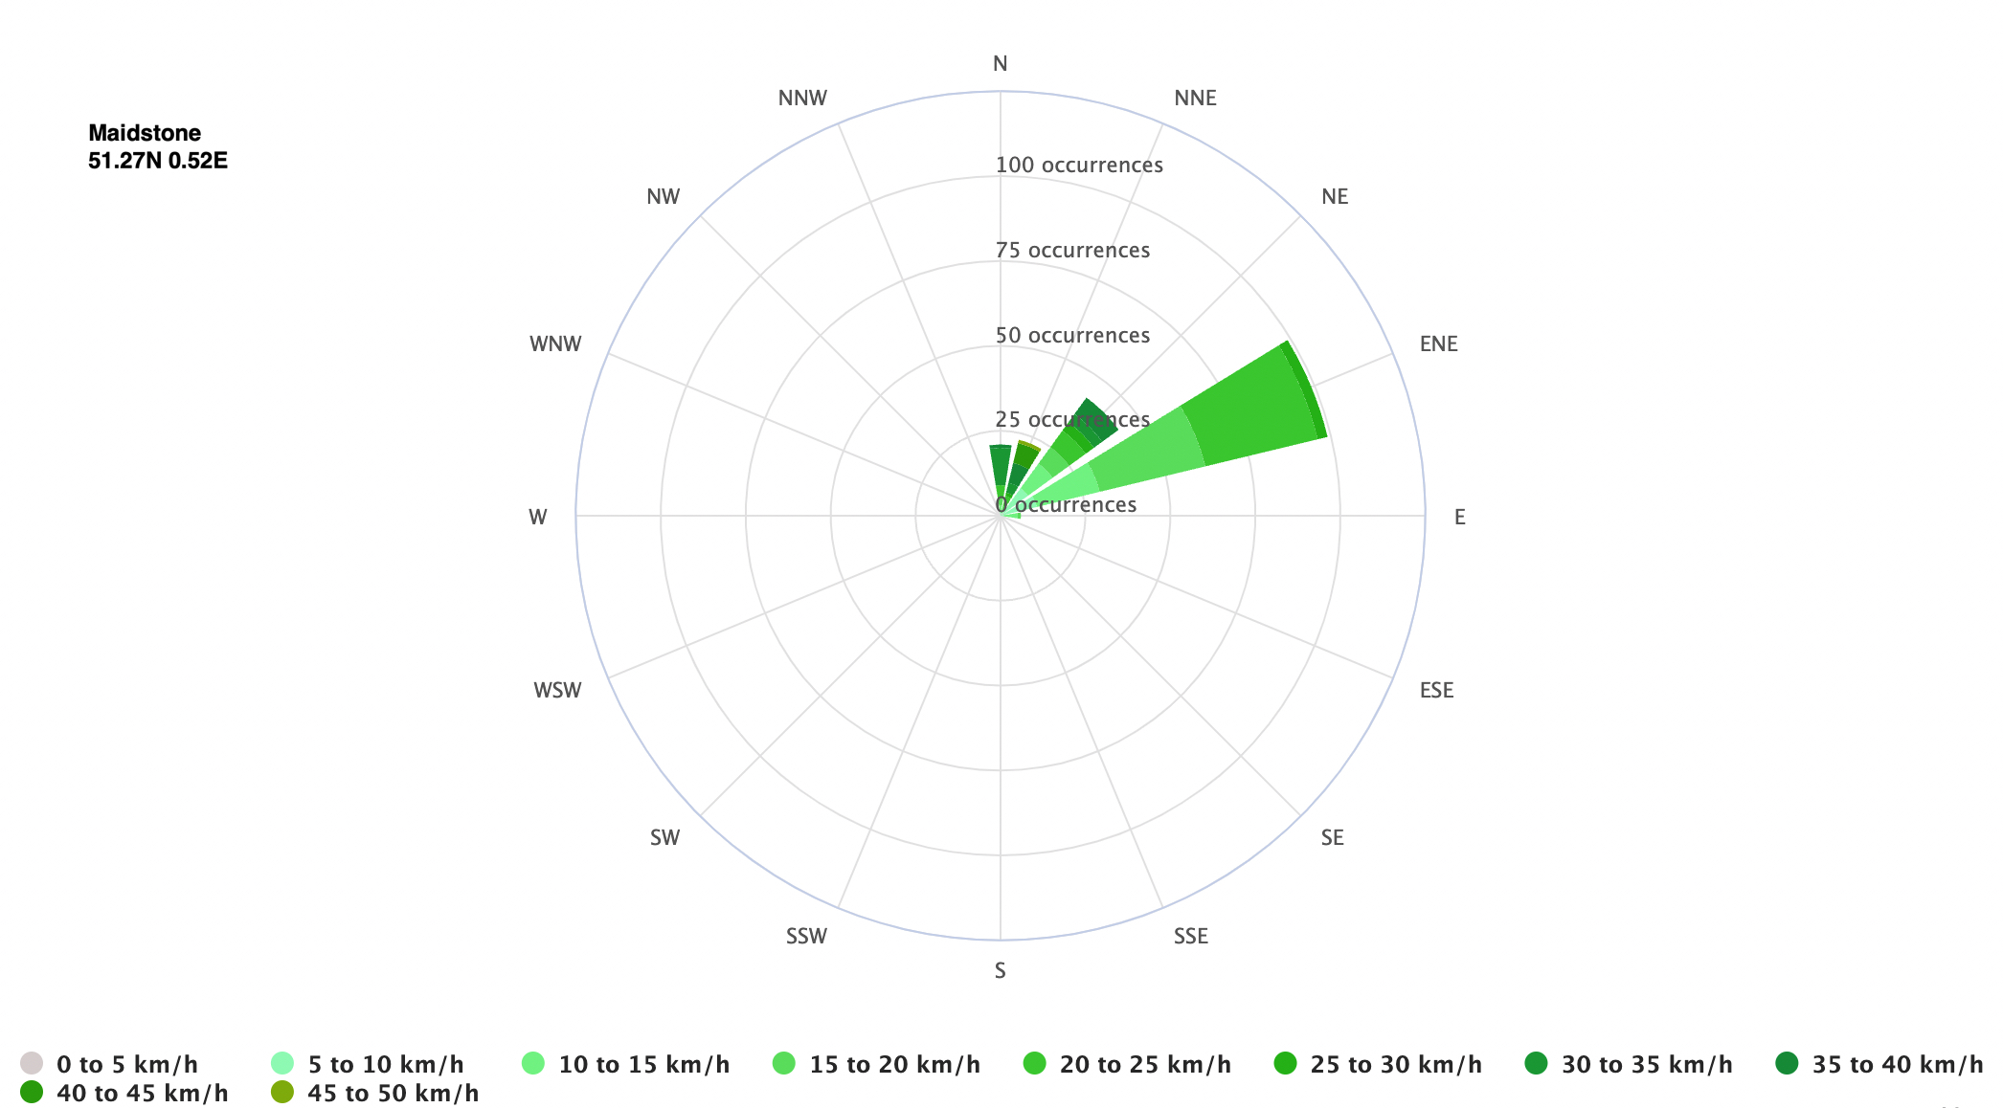

Receptor | Distance  from Site | Description | Direction
Boxley Wood | 900m | SSSI | NE
M20 | 100 | Motorway/AQMA | S
Ancient Woodland | 70 | Woodland | SE
Site owners Residential property | 20 | Site owners residential | W
Table of receptors.

- PRIMARY EMISSION CONTROL MEASURES
  - The control measures set out in this EMP are commensurate with the medium mud/dust potential for the wastes.
  - Dust can only cause an impact when it is received at a receptor site. This EMP has identified that the key opportunities for release of mud/dust are anticipated to be:
- When wastes are delivered to site and trandferred into 2.
- When dust is emitted from waste handling and transfer into bays.
3. When waste is handled on site
3. When product is loaded and removed from site

Dust Suppression
The site has access to a water supply, and this can be used for for dust suppression if required in the yard areas. Water tanks will be monitored regularly for water levels and topped up as required. Water will be recycled where possible. In drought conditions levels will be checked daily and topped up if required.
Drop heights are minimised when handling waste. Damping down hoses and nozzles will be place around the rear of the waste bays and a wheel wash will be sited at the entrance. The damping system will cover the whole site where dusty waste are stored. A mobile wheel wash system similar to the below link will be employed at the site.
https://kkewash.com/en-gb/portable-wheel-wash-systems/
IBC’s (1000L) will also be fitted with nozzles and be portable to be lifted by a fork lift enabling mobilisation on site where dust suppression may be needed.
Road sweeping will be by contract on an as needed basis but at least daily in dry and dusty periods. Other dust suppression measures will include;
    - damping down of surfaces using mobile water bowser, particularly during dry weather;
    - potentially dusty activities located away from boundaries closest to residential receptors;
    - stock piles to be covered, where practicable;
    - stock piles to be kept a minimum of 0.5m below top of the storage bay;
    - effective cleaning methods and where possible hard surfacing for site haulage routes, these and the highway (Sittingbourne Rd) will be part of the cleaning contract mentioned above.
    - all loads entering and leaving site to be covered;
    - drop heights to be minimised during loading and unloading of materials and waste;
    - immediate clean-up of spillages of dusty materials;
    - wet brushing techniques will be used for cleaning;
    - regular checks for visual observation of dust and soiling from the site;
    - routine visual monitoring of dust at the site boundary and sensitive receptors; and
no vehicle/ plant idling on site at anytime.

Handling
Handling is minimised by careful loading, handling and unloading. This minimises dust emissions but also protects the machinery from adverse wear and tear and is an integral part of the waste process.

Impacts
  - The impacts of any emissions released as a result of Fastlay Services Limited activities will be linked to the receptors identified in Section 1, although dust is more likely to cause annoyance to neighbours rather than any lasting environmental impact due to it’s inert nature.
  - The receptors are more likely to be impacted upon by emissions in the following conditions:
- Prevailing wind direction is towards receptors; and
- Local weather conditions. Warm weather will contribute to the increased dust levels, although wind would act as the main transport agent.
- Wet weather will damp down dust but contribute to increased levels of mud on surfaces
- Cumulative impacts. It is anticipated that cumulative impacts will be minimal. The site is not in an area dominated by facilities which may cause additional mud/dust.

  - The impacts of emissions from the site are anticipated to be minimal, given the nature of the material being handled and the location within a rural industrial setting. However, this will be confirmed regularly with monitoring and communication with neighbours. Visual monitoring is considered sufficient given prevailing wind direction and distance from sensitive receptors. The site daily log will record wind direction & strength and not any visible dust blows and act accordingly.

Management of Emissions
  - If emission monitoring or complaints indicate a problem, Fastlay Services Limited will respond appropriately. Management measures to control releases will include:
- Reducing the handling time on site of materials. As part of the site’s Management System, information on the materials on site will be recorded via a ticketing system, including arrival time on site. The Site Manager is responsible for ensuring the residence time of materials site does not exceed that set out in the permit and therefore is able to identify how long each material is on site. Minimal handling will ensure that raw material & product are not moved too frequently and dust propagation is minimised

If the Site Manager deems that emissions are causing a disturbance, the Site Manager will log this as an incident, using the appropriate forms from the Management System and will take corrective action

The site management will liaise with the waste producers and transport contractors, with a view to minimising the storage and transport periods for the waste being delivered to the site;

- Unanticipated Emissions. Any unexpected emissions will be recorded as to composition, date and time noted at site and cause.

- Containment and abatement. Given the nature of the material handled on site, it is not considered necessary to implement containment and abatement techniques, other than those mentioned above. However, this is a ‘live’ document and as such will adapt if emissions arise which are not managed by the actions in this EMP. As standard damping down, wheel washes and sheeting will be employed in any case.

- Monitoring & Trigger Levels

Introduction
  - To ensure that the emissions control measures set out in Section 3 are being effective, Fastlay Services Limited will ensure monitoring is in place and communication with potential receptors is maintained. The site will have comprehensive CCTV coverage and continuous monitoring as part of the fire prevention guidance. This will also monitor dust and other parameters outside of working hours.
  - The following monitoring activities are regularly undertaken to ensure continuous improvement:
- Site inspections by the site manager (as outlined below)
- Site audits conducted by the company’s management;
- Site audits and inspections by the Environment Agency.

  - All site personnel will be responsible for reporting any dust/mud emission problems immediately to the site manager (or deputy).

Emissions monitoring
  - The Site Manager will ensure that regular inspections are made of the site and its perimeter in order to identify any sources of emissions and to establish whether any dust/mud is discernible at the perimeter and thus likely to impact upon receptors and neighbours or other road users.
  - In the event that mud/dust is detected at the site boundary, additional monitoring will be undertaken at the sensitive receptors in accordance with Appendix B.
  - An inspection will also take place in response to complaints. The surveyor will undertake the survey at the location of the complaint and at potentially sensitive receptor locations in the vicinity downwind from the site. At each location observations are made concerning the intensity of the dust/mud, its persistence and character (these details will be logged in the pro forma, see Appendix C).
  - The surveyor may be the site manager or alternatively a staff member from the office or external person who is not used to the emissions on the site.
  - Trigger Levels. If emissions are detected at the assessment location and is judged to be a moderate or unacceptable, as defined in reference Table A - Appendix B, then the Site Manager and Management Team will be informed immediately, and corrective actions will be determined and implemented.
  - Monitoring Frequency will be in accordance with Table 2
Technique | Frequency
Dust/mud Monitoring visible inspection | Daily & Weekly at site perimeter.  Positive Detection will lead to receptor monitoring.  Increase frequency in response to complaints
Complaints system | Continuous (24 hours) via telephone reporting system to Environment Agency  Direct complaints to site in operational hours
Table 2 Monitoring Frequency

Communication
  - Liaison with neighbours. If emissions are anticipated on site or weather conditions predicted indicate dust/mud will increase, the Site Manager will liaise with neighbours and ensure they are aware of the situation, how long it is expected to last and how to make a complaint.
  - Signboard. The site will have a legible signboard giving contact details for the Environment Agency and the operator. These numbers can be used in order to make a complaint.

Complaints procedure
  - All complaints, whether direct from people in the neighbourhood, or via the Environment Agency will be treated seriously by Fastlay Services Limited and recorded in the Complaints Form in Appendix C.
  - Trigger Levels. The operator recognise that persistent dust/mud can be a concern for neighbours and residential areas. Every complaint is a trigger for management to take action to investigate the cause of a complaint, as set out in the complaints form.
Incidents and Emergencies

  - This section of the DEMP relates to potential incidents or emergencies which may impact on the ability of Fastlay Services Limited Limited to control emissions from its site and waste acceptance criteria.
If any loads are identified as a potential for being dusty during the unloading process they are to stop as soon as identified. If following assessment it is identified that the load is too dusty, the load should be rejected. If the load can be unloaded, but suspect dust emissions could cause a nuisance, then the mobile dust suppression unit should be located near the material being unloaded to control emissions. Staff will regularly be trained on how to identify dusty loads via tool box talks to ensure consistency. Records will be kept of this training.
In unfavourable conditions e.g. high winds or high rainfall the throughput of waste and processes will be limited according to prevailing conditions to minimise dust emissions. Procedures including limiting deliveries, tipping and load movements will be implemented by the site manager. Tool box talks detailing such eventualities and scenarios will be run through as staff training so that they can be implemented when necessary.

NOTE: The site will only serve Fastlay Services Ltd own facilities not the general public so only waste of known provenance and type is accepted at the premises.

  - Potential incidents which may impact on mud/dust are outlined as follows:
Potential Incident | Actions
Delivery of material which meets the requirements of the permit but which is unexpectedly awkward to handle and dusty | The Site Manager will:  - Refuse to accept the material if it is deemed inappropriate for the site.  - If the material can be managed on site, an appropriate storage area will be used or a suitable area undercover will be used  - Record the incident in the site diary and using the appropriate management system forms and records.
High wind/still conditions | If monitoring detects a problem, the site manager will:  - Ensure handling is kept to a minimum  - Record the incident in the site diary and using the appropriate management system forms and records.

Appendix-A

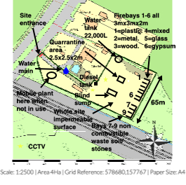

Appendix B Emissions Survey Form

Emissions Survey Recording Form |  | Reason for Survey | Mud/dust detected at boundary? Y/N  Complaint Y/N  Other
Name of Surveyor |  | Job Title
Date |  | Time of Survey Start/Finish
Air Temp. ºC |  | Wind Direction
Survey Results
Location | Mud/dust Intensity  See Reference Table A | Mud/dust Extent  See Reference Table B | Description of emission  e.g. intermittent, ongoing?

Reference Table A: Emission Intensity
Intensity | Description
1 | No detectable emissions
2 | Slight dust noticeable (barely detectable, need to stand still and look into wind)
3 | Moderate dust (easily detectable while walking, possibly offensive)
4 | High dust levels (bearable, but intrusive and affects eyesight)
5 | Very high dust/mud

Reference Table B: Emission Extent
Extent | Description
1 | Local and not persistent (only detected during brief periods when wind blows)
2 | Not persistent as above, but detected away from site boundary
3 | Persistent but fairly localised
4 | Persistent and pervasive up to 50m from site boundary
5 | Persistent and widespread (detected >50m from site boundary)

Appendix C Emissions Complaint Form
Complainant Details
Time and Date of Complaint
Complainant Name & Address
Complainant Phone Number/ Email address
Emission Details
Date noticed
Time noticed
Location of emission (if not address above)
Wind Direction (e.g. From South West)
Complainants Description of Emission:
-What does it look like
-Intensity (see reference Table A, Appendix B)
Duration – how long was it detected for
Constant/intermittent in this period
Complainant comments/observations
Additional Information
Are there other complaints from this area?
Is Fastlay Services Limited the likely source?
What was happening on site when the emission occurred?
Corrective Actions
Actions Required
Deadline for Actions
Person Responsible for implementing actions
Form completed by
-Name and Role
Date
Signature

Appendix D Source/Pathway/Receptor Model

Source | Pathway | Receptor | Type of impact | Where relationship can be interrupted
Mud | Tracking dust on wheels and vehicles, then mud dropping off wheels/vehicles when dry | Residential housing, road network | Visual soiling, also consequent resuspension as airborne particulates | Remove mud before vehicles leave site by wheel washing. Need for a road sweeper to be on site every day
Dust | Blown off material  piles and from vehicle movements | Residential housing, road network | Visual dust deposition on vehicles/housing | Cover lorries before leaving site. Bowsers can damp down dust and sprinklers keep dust on the ground
Tipping, storage and sorting of material | Atmospheric dispersion | Residential housing, road network | Visual dust deposition on vehicles/housing | Minimise dust emissions by handling in low wind conditions and damping. Sheet vehicles.
Dust | Atmospheric dispersion | Residential housing, road network | Wind direction predominantly towards residents | Minimise dust emissions by handling in low wind conditions and damping. Sheet vehicles.
Vehicle exhaust emissions | Atmospheric dispersion | Residential housing, road network | Airborne particulates | Regulatory controls and best-practice maintenance measures to minimise source strength
Non-road going machinery exhaust emissions | Atmospheric dispersion | Residential housing, road network | Airborne particulates | Regulatory controls and best-practice maintenance measures to minimise source strength

Appendix 1 Complaints & Neighbourly Relations

EP7 Complaints & Neighbourly Relations
- Any abnormal emission to the environment evident, such as mud on roads or dust will be recorded in the site diary.
- Any complaints received by the site, concerning emissions to the environment, will be recorded in the site diary. Any complaint made by an external source will be documented and dealt with in accordance with this procedure. It will be the responsibility of management to arrange for the complaint to be investigated, take any remedial action necessary and respond to the complaint if appropriate. Any written documents concerning the complaint will be kept for at least 2 years.
- The complainant will be updated on investigations of the complaint within 5 working days
- If several complaints are made simultaneously then work will be suspended pending further investigation
- If it is visually evident that substances (mud, dust) are being tracked out of the site onto the public highway, steps will be immediately taken within the site to prevent further transfer of material and the public highway will be cleaned by the end of the working day. Any such event will be recorded in the site diary.
- The site boundary will be visually inspected weekly by management for dust and debris; this would be in conjunction with the weekly boundary security inspection. If any material has fallen over/ outside the boundary it will be cleared as soon as practically possible, but within a week of discovery and so prior to the next weekly inspection. Litter will be cleared on the day of discovery. The weekly checks will be recorded in the site diary.

Appendix 2 Dust and Mud checks

Scope: To detail how mud and dust during normal and abnormal operations are dealt with to minimize impact on the environment
Responsibility: Site owner
Background: Mud on roads and dust emissions can cause annoyance to neighbours and can have an impact on surface water and other sensitive receptors.
The site carries quantities of water in tanks & bowsers which are used to damp down the work area in very dry conditions. Daily checks are made of dust levels and recorded in the site logbook and note is taken of any impacts to nearby neighbours and receptors
Mud on roads external to the site is not tolerated and a vehicle wheel washing system is employed on-site to ensure that vehicles coming onto and exiting the site are free of mud. Regular inspections of vehicles and the main roads are made to ensure that no annoyance to other road users and neighbours is apparent.
- During normal operations, all staff have been made aware of the requirement to minimise dust and mud distribution
- All staff have had appropriate training on how to minimise dust and mud distribution on site
- In the event of a larger incident or dust blow the Environment Agency is notified as per permit reporting requirements and an incident log completed.

Action | Action Taken? | When? | Who? | Date completed & comments
Daily site sweeping/cleaner | Surface cleaning | daily | contractor | When site commences operations
Visual inspection | Visible monitoring of wind strength and direction. Record dust blows | Daily | Environmental Manager | xx
Damping down | IBC loaded onto FLT | Dry periods | Site manager | xx
Inspection of load bays  - Sheeting  - Bays covered  - Freeboard level of at least 0.5m | Load bay check | daily | Environmental manager | xx
Inspection of water tanks | Check levels | Weekly or more in dry periods | Environmental manager | Xx
Inspection of sprinkler system over bays | Check nozzles and hoses | Daily | Environmental manager | xx
Check haul roads and highway | Mud on roads | daily | Environmental manager | Xx
Inspect all incoming loads for sheeting & unusually dusty loads | Load check | Every load | Environmental manager | xx

Appendix 3 – Waste Codes

The codes below are those proposed to be accepted at Fastlay Services Ltd. All will be treated as the potential to produce dust.

17 01 concrete, bricks, tiles and ceramics
17 01 01 Concrete
17 01 02 Bricks
17 01 03 tiles and ceramics
17 01 07 mixtures of concrete, bricks, tiles and ceramics other than those mentioned in 17 01 06
17 02 wood, glass and plastic
17 02 01 Wood
17 02 02 Glass
17 02 03 Plastic
17 03 bituminous mixtures, coal tar and tarred products
17 03 02 bituminous mixtures other than those mentioned in 17 03 01,
17 04 metals (including their alloys)
17 04 01 copper, bronze, brass
17 04 02 Aluminium
17 04 03 Lead
17 04 04 Zinc
17 04 05 iron and steel
17 04 06 Tin
17 04 07 mixed metals
17 04 11 cables other than those mentioned in
17 04 10 17 05 soil, stones and dredging spoil
17 05 04 soil and stones other than those mentioned in 17 05 03
17 05 08 track ballast other than those mentioned in 17 05 07
17 06 insulation materials and asbestos-containing construction materials
17 06 04 insulation materials other than those mentioned in 17 06 01 and 17 06 03
17 08 gypsum-based construction material
17 08 02 gypsum-based construction materials other than those mentioned in 17 08 01
17 09 other construction and demolition wastes
17 09 04 mixed construction and demolition wastes other than those mentioned in 17 09 01,
17 09 02 and 17 09 03.

All of the waste above have the potential to create dust with the metal codes to a lesser degree. i.e.

17 04 01 copper, bronze, brass
17 04 02 Aluminium
17 04 03 Lead
17 04 04 Zinc
17 04 05 iron and steel
17 04 06 Tin
17 04 07 mixed metals
17 04 11 cables other than those mentioned in

Waste Handling

All of the following apply to all of the codes above regardless of dust emission potential

- All incoming loads will be sheeted
- All incoming loads will be inspected
- All incoming loads will be sprayed on arrival prior to tipping
- All loads will have their handling minimised
- All drop heights will be minimised
- All loads are stored in firebays with a roof covering and sprinkler system for the provision of damping down when needed in dryer conditions
- damping down of surfaces using mobile water bowser, particularly during dry weather;
- potentially dusty activities located away from boundaries closest to residential receptors;
- stock piles to be covered, where practicable;
- stock piles to be kept a minimum of 0.5m below top of the storage bay;
- effective cleaning methods and where possible hard surfacing for site haulage routes, these and the highway (Sittingbourne Rd) will be part
of the cleaning contract mentioned above.
- all loads entering and leaving site to be covered;
- drop heights to be minimised during loading and unloading of materials and waste;
- immediate clean-up of spillages of dusty materials;
- wet brushing techniques will be used for cleaning;
- regular checks for visual observation of dust and soiling from the site;
- routine visual monitoring of dust at the site boundary and sensitive receptors; and
- no vehicle/ plant idling on site at anytime.

http://www.metoffice.gov.uk/climate/uk/regional-climates/so

