It is proposed by OEL to install a new reinforced impermeable reinforced concrete pad on land adjacent (NE) & connected to the current site, the perimeter of the concrete pad will then have installed reinforced concrete tertiary bunding to form total containment to the yard in the event of an incident/ fire. Within this concrete pad will be built a bunded waste storage bay offering secondary containment to 110% the largest capacity of receptacle stored within which would be an IBC @ 1000ltrs.

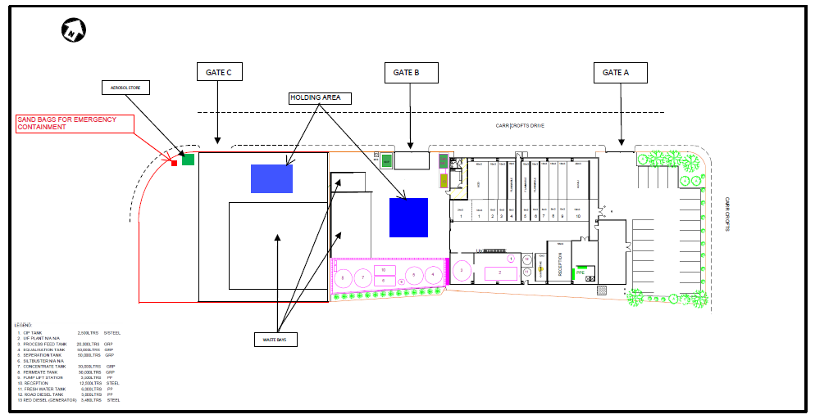
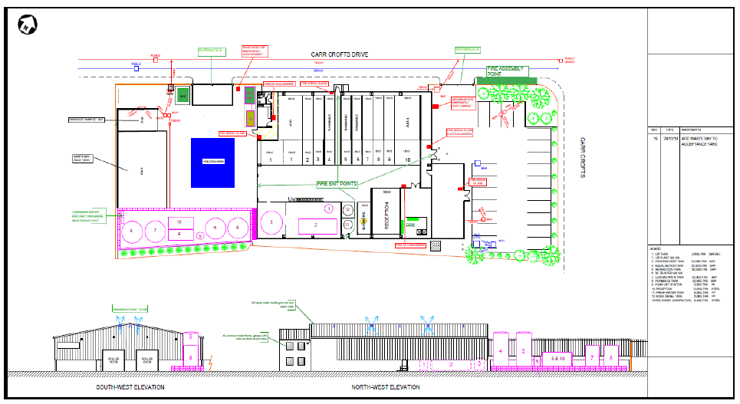

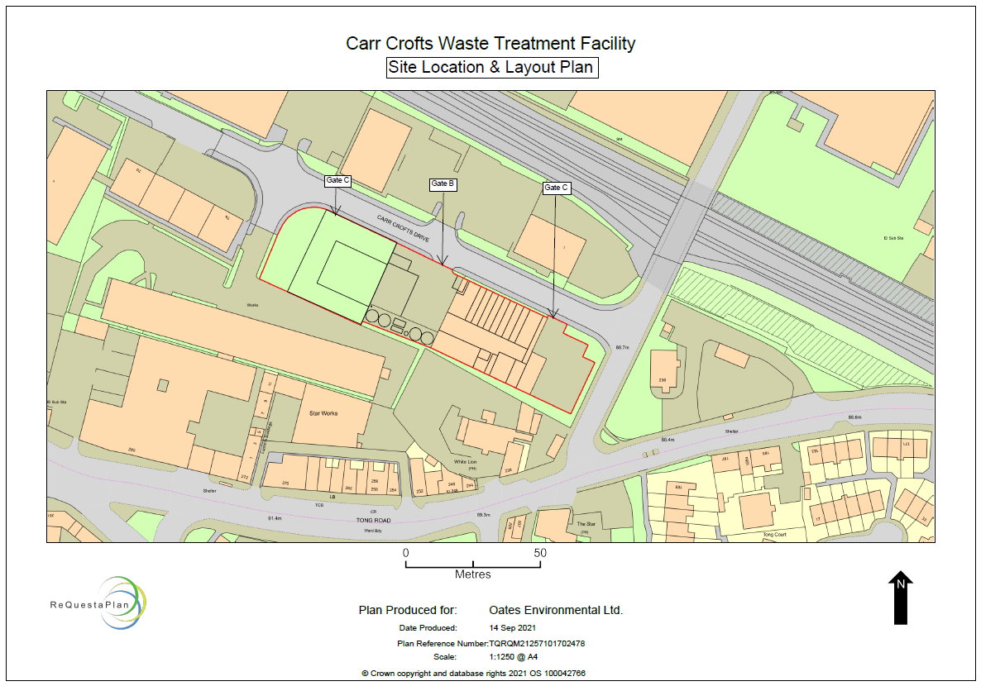
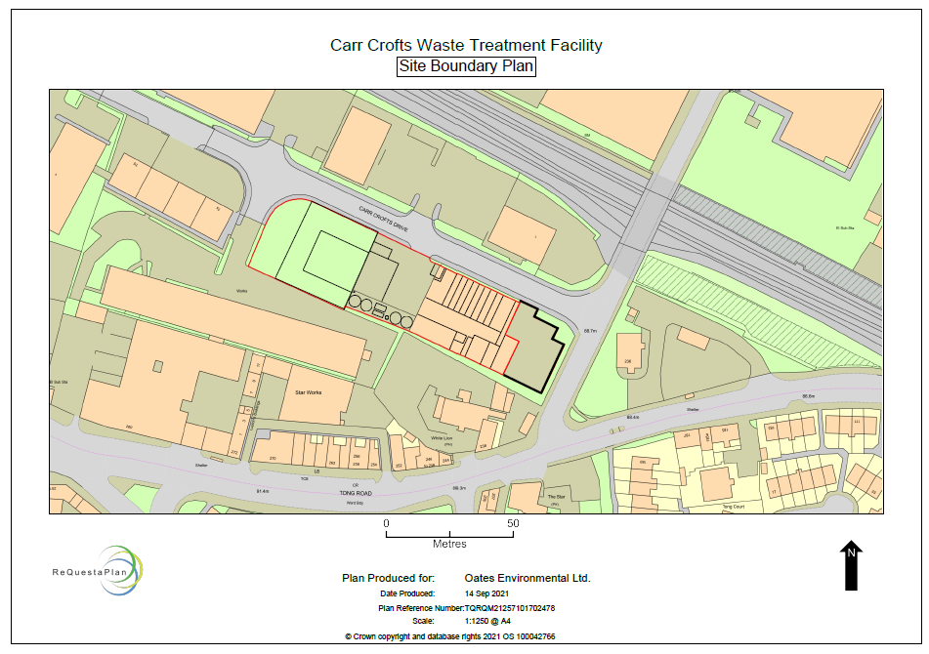

Two existing manholes (MH12 & 13A) will be raised to the new concrete pad level & will be topped with HD manhole covers, these manholes will then have a bund erected (@250mm (High)) around the circumference similar to that already approved & in place around MH8 in Yard 1 this will then intern create a sealed & contained drainage system(to prevent the escape of any contaminated effluents to sewer or roadside etc.)

Two further manholes (MH9C & MH13) will be capped off with concrete during the levelling & regrading for the concrete slab construction & will no longer exist once the new concrete slab is installed preventing the possibility of any effluent reaching the drainage system from these points

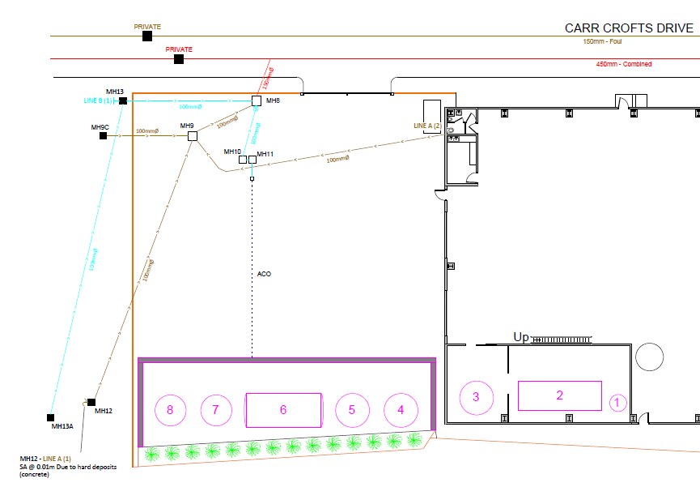

The perimeter of the concrete slab will have constructed 250mm (H) x 200mm (W) reinforced concrete upstands that will be drilled & doweled to the new pad to create fully sealed tertiary containment to the slab area (As per currently approved & in use on-site elsewhere)

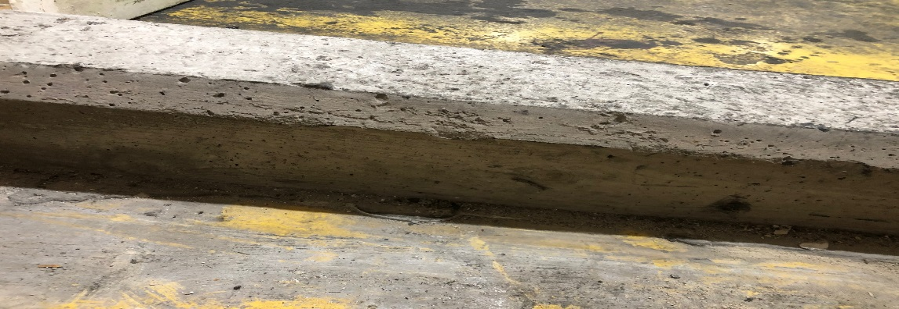

Within this enclosed concrete pad area an 8m x 18m waste storage bay will be constructed with the installation of concrete sleeping policeman 100mm (H) x 800mm (W) to facilitate secondary containment for any waste(s) stored within (As per currently approved & in use on-site elsewhere)

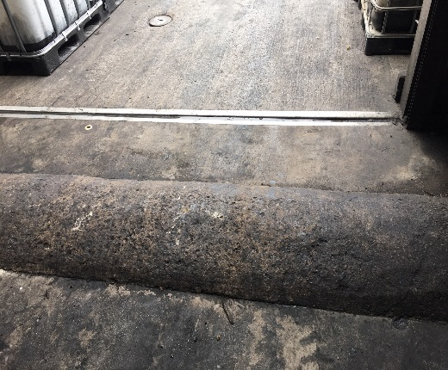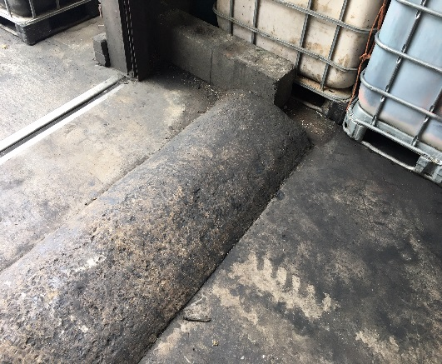

There will be a small fall in the slab from the SW corner to the NE corner to facilitate the collection of rainwaters etc. towards the 18m run of dished drain channel leading to a small sump installed within the concrete slab, there will also be a collection sump within the waste bay & the south corner of the concrete slab.

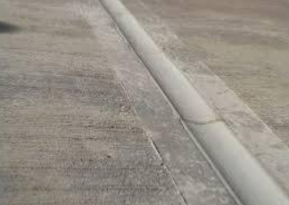

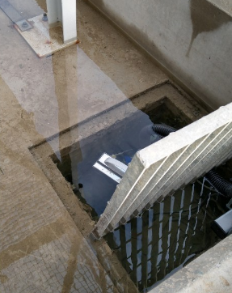

(x3) small rainwater collection sumps 400mm x 400mm x300mm Deep

As the concrete slab will be fully contained with a sealed drainage system any rainwaters & or spillages will be collected from the sumps by means of on-site pumps/ vacuum tankers & be re-cycled on-site via the Ultrafiltration Plant.
Part C2 – 5c Non-Technical Summary
Oates Environmental Ltd. propose a variation to their bespoke installation permit EPR/YP3832WS at Carr crofts Waste Treatment Facility to allow an increase in the sites boundary & to allow further storage outdoors of previously agreed & permitted Low Level Hazardous Waste(s) (i.e. No Flammable, Toxic, Corrosive or Oxidising Waste(s)).Storage capacity for Non-hazardous wastes will remain at 670 tonnes and for Hazardous wastes 670 tonnes both within the warehouse & outside the warehouse in designated purpose built bunded storage bays built to the same specifications as the existing approved waste storage bays & in accordance with the latest sector guidance ‘Chemical Waste: appropriate measures for permitted facilities’
Part C2 – 2b Table 1 Changes or additions to existing activities
Table S1.1 activities
Activity reference | Activity listed in Schedule 1 of the EP Regulations | Description of specified activity and WFD Annex I and II operations | Limits of specified activity and waste types
A1 | Section 5.6 Part A(1)(a)  Temporary storage of hazardous waste with a total capacity exceeding 50 tonnes. | D15/R13 storage pending treatment on site or transfer off site. | Including storage of wastes from treatment activities.  Hazardous wastes types as specified in Schedule 2 table S2.2.
A2 | Section 5.3 Part A(1)(a)  Disposal or recovery of hazardous waste with capacity exceeding 10 tonnes per day involving one or more of the following activities: | (iii) blending or mixing prior to submission to any other activities listed in this Section or in Section 5.1;  R12/D13 | Hazardous wastes types as specified in Schedule 2 table S2.2.

Part C2 – 3d EMS Summary of Management System changes
13. Waste Segregation & Mixing
Ref: ISO14001 2015
In accordance with Chemical Waste: appropriate measures for segregation & mixing, Oates Environmental Permit, Only similar specifically authorised hazardous wastes will be blended or mixed with other similar wastes using the BAT for further recovery or disposal operations.

All Blending & repackaging activities will take place within the dedicated fully bunded Warehouse & within thin the fully bunded ‘Blending & Repackaging Area’ (Ref. Appendix 25 Site Plan) with self-contained drainage & LEV’s

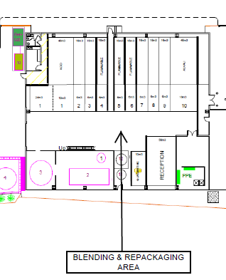

All waste will have undergone Pre-Acceptance analysis, Acceptance analysis plus Compatibility analysis before blending or mixing & only then under direct authorisation & supervision of the Site Chemist will this take place.

Risk assessments will be in place to cover all compatibility testing to ensure that bulked wastes will not react with each other or with the container in to which they are to be placed.

Where possible/ practicable the use of dip pipes & mechanical equipment will be utilised during all mixing & blending operations i.e. FLT’s with rotators & or mobile pumps.

All IBC’s & Drums etc. will be re-labelled to enable full traceability of the wastes origins through the electronic waste tracking system.

14.3.Storage of Packaged Waste on Site
Various types of packaged liquid & solid wastes contained within IBC’s & drums & sealed lockable containers/skips will be stored both inside the warehouse building & outside the warehouse within dedicated purpose-built waste bays built upon an impervious surface with self-contained drainage to prevent any spillages escaping off site & or to drain.

The warehouse building & storage yards will also have full tertiary containment at all entry & exit points as well as to the full site perimeter creating a fully contained site to prevent any escapes of waste(s) from site.

Storage of Hazardous & Non-hazardous packaged waste within the rear waste acceptance yards (Ref. appendix 25 Site plan) will also take place & will be removed within 3 months of arrival & the given deadline for removal of any waste stored above their permitted levels.

Wastes housed both within the warehouse & outside the warehouse will be stored at ground level and a maximum of 2 containers high.

No Flammable, Toxic, Corrosive or Oxidising waste(s) will be stored outside the warehouse building & must be stored within the dedicated waste bays within the warehouse building (Ref. appendix 25 Site plan)

The storage areas will be clearly marked and signed with the hazardous characteristics of the wastes stored

All of the containers will be clearly labeled at the acceptance stage with the date of arrival, relevant code, chemical identity and composition of the waste and a unique reference number or code enabling identification, through stock control and cross reference to pre-acceptance and acceptance records held within the computerized data-base stock control system.

All waste(s) within & outside the warehouse will be segregated according to class, waste type and any hazardous properties & were necessary in line with HSG71 as outlined below:

Flammable waste(s) up to a total capacity of 66m3 will be stored within dedicated bays within the warehouse & will have in place a compartmental 2-sided firewall in accordance with HSG 51 alongside fire suppression provided by auto. powder fire extinguishers suspended above the bays. (Ref. appendix 25 Site plan)

Further separation of Acid’s/ Alkalis/ Corrosives will be maintained within dedicated waste bays at opposing ends of the warehouse to further aid segregation & separation distances. (Ref. appendix 25 Site plan)
The warehouse will be equipped with extractor fans to minimize buildup of any fugitive emissions.

All Asbestos Waste(s) will be Double Bagged & stored within the warehouse or outside the warehouse in a secure lockable container/ enclosed lockable skip. There will be No Treatment of asbestos waste(s) on-site.

The maximum amount of asbestos received at site shall not exceed 10 Tonnes per day & the maximum amount of asbestos stored on-site shall not exceed 10 Tonnes

18.Emergency Preparedness and Response

18.1.Purpose
Ref: ISO14001 2015
In dealing with issues of waste and environmental management there is the potential for emergencies and accidents to arise. If these incidents are not responded to adequately, they can result in breaches of legislation, policy requirements, contractual obligations and sector guidance and have a significant impact on the environment. Also refer to Oates Fire Prevention Plan (FFP) doc OATESFPP06

18.2.Dealing with an Environmental Incident / Accident
- If you suspect an incident has occurred, investigate at once but do not take risks and stay calm
- Raise the alarm by informing the nearest supervisor/ manager
- If it is safe to do so, try to control the incident by isolating plant/equipment and closing off any valves etc. Obtain help if necessary - but do not put yourself or others at risk
- Direct all non-essential people away from the affected area
- Activate the nearest fire alarm call point if an evacuation of the premises is required (also ref to doc OATESFPP06)
- It may be possible to deal with small incidents/spills using the appropriate spill response kit and by closing doors/covering drains etc. to confine the emissions/discharges as far as possible (refer to 12 Steps to Spill Control in Section 18.2.2)
- For larger incidents, it may be necessary to inform the fire brigade, Environment Agency, Local Authority and/or Sewage Undertaker, depending on its nature (refer to Emergency Numbers in section 18.4)
- For all minor and major incidents and accidents complete an Environmental Incident Record (ref to Appendix 35)
- The Environment Agency shall also be notified without delay in line with OEL's Environmental permit conditions
- Periodically review and, where necessary, revise the emergency preparedness and response procedures, in particular, after the occurrence of accidents or emergency situations.
- Periodically test procedures where practicable
- Conduct mock drills to reinforce training and get feedback on the effectiveness of site plans/procedures

18.2.1.Spillage Kits/ Sand Bags (Containment)
Spill kits will be located around site in areas where oils and liquids are stored or where spillages are likely to occur. Spillage kits must be fit for purpose and appropriate to the nature of the material being stored.
Pallets of Sand bags for emergency containment are strategically located within the front car-park & rear waste acceptance yard (Ref. appendix 25 Site plan) these will be deployed in an emergency to create containment lagoons.

Plate 9: Examples of a Sand Bags (Containment) & Spillage Kit
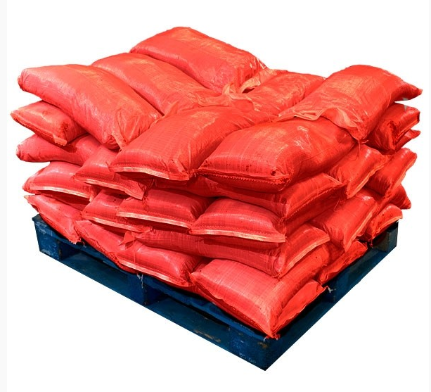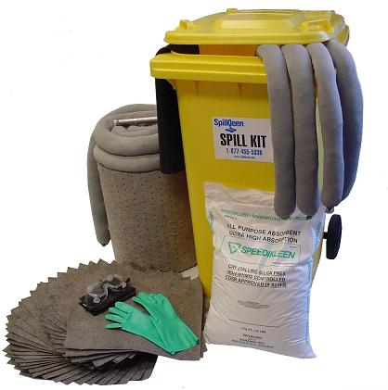

The spillage kits & sand bags will be checked on a regular basis & during the environmental site inspections (Appendix 32) & to ensure that adequate materials and PPE are available. Spillage kits should never be used for any other purpose other than as a spillage kit. Spillages should never be hosed down and all minor and major spillages must be reported. Consider various scenarios and how the ‘Steps to Spill Control’ may occur in different sequences depending on the type of spill that has occurred on site (Section 16.2.2)

18.2.2. Steps to Spill Control (Warehouse & Acceptance Yard - Temporary Storage)
Please adhere to the following procedure in the event of a spill inside or outside the warehouse building;
- Be vigilant at all times during your activities/ duties & look for the potential for any possible spills
- Upon detection of any spill cut off the source of the spillage to prevent further escape if it is immediately safe & possible to do so
- Raise the alarm and ensure everyone is aware a spill has occurred
- Evacuate personnel & any visitors using the appropriate escape routes
- Close the site drainage penstock control valve
- Ensure medical assistance is sought if someone has been injured
- Identify the spilled material
- Identify and use the appropriate PPE to deal with the spill
- Contain the spill using an appropriate spill kit & or emergency sand bags
- If the spill has caused pollution to the environment / watercourse follow OEL's permit requirements (Appendix 33)
- Clean up the spill using the spill kit & any other necessary equipment i.e. pump/ tanker etc.
- Dispose of spilled material to the correct waste stream. (Ensure the correct documentation is used)
- Restock spill kit immediately
- Complete the Environmental Incident Report Form in Appendix 35, investigate the cause of the spill and implement control measures identified.

A spill response team should be appointed and they should carry out a mock spill at regular intervals by pouring tap water only (never use any other liquids) onto made ground and get the group to respond to the spill as if it were a real live event. The mock spill can be a planned or non-planned event. The outcome of the ‘Mock Drill’ should be recorded on the Mock Drill Form (Appendix 34). Record of the Spill Response Team training should be recorded onto individual 'Employer Training Record' (Appendix 1).

18.2.3.Spillage Procedure (Warehouse & Acceptance/ Temporary Storage Yard)

Part C2 general – varying a bespoke permit
5 Supporting information
5b Site Report (for extra land) Doc. Ref. SCR REPORT-FINAL 2015
Oates Environmental Ltd. originally commissioned a Site Condition Report in 2015 for the site at 10 Carr Crofts Drive, LS12 3AL for its first bespoke permit application & after consulting the originators of this report are in agreement with them that the additional section of land approx. 40m x30m adjacent/ attached to the west of the site was covered by this report as the search area covered was 750m & therefore can be considered in all aspects as the same piece of land & thus all search results will be the same as on the original report.
The consultant’s report further that there have not been any significant changes made within the area checked within the original report & that all the original baseline parameters for Geology, Environmental Considerations, Ground Investigation & Ground conditions remain the same & as this is “good quality existing data” in line with the H5 Guidance Oates Environmental Ltd accept these baseline results & accept the risk that we may be required to clean up any pre-existing contamination when surrendering the permit.
With regards to Emissions Monitoring (Permit 3.1.3) a systematic appraisal of the risk of contamination to water, air or land has been adopted with regular reviews of all risk assessments & pollution control measures during documented Environmental Management System (EMS) & ISO:14001 reviews. As all activities take place on an impermeable concrete surface with sealed drainage secondary & tertiary containment OEL believe periodic monitoring of groundwater & soils should not be a condition of the environmental permit & again Oates Environmental Ltd accept the risk that we may be required to clean up any pre-existing contamination when surrendering the permit.

The additional piece of land has lay dormant for a considerable number of years since the original development of the site in the mid 1990’s from the original use of occupied railway sidings in the 1800’s. This section of the site has been completely sealed off by security fencing & an earthworks bund preventing any access or use of the land since then.

The site has now been cleared of all the overgrown shrubbery & weeds etc. in preparation for the building works to commence.
Full Planning permission for the development has been sought & approved by Leeds City Council 1st November 2021
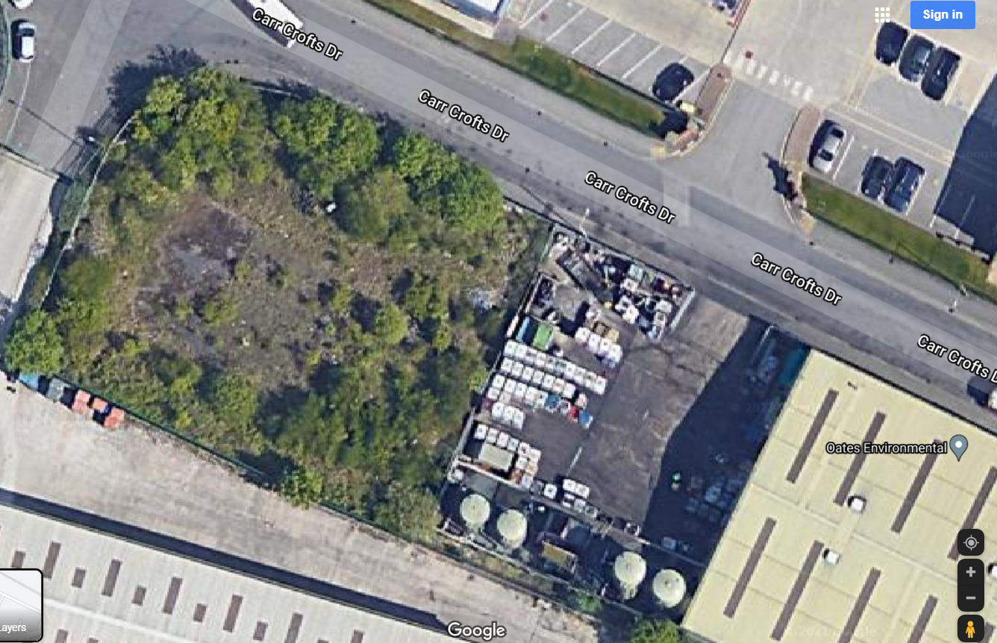

5d Risk of fire from sites storing combustible waste
5e Will your variation increase the risk of a fire occurring or increase the environmental risk if a fire occurs
Doc. Ref. - Appendix 4 Environmental Risk Assessment STORAGE OF WASTE OUTSIDE THE BUILDING (2022 VARIATION).
OEL do not perceive an increased risk of fire occurring within the waste storage bay of Yard2 as no flammable or combustible waste(s) will be stored in this area as in the other outdoor waste storage bay in Yard1. Recently approved on a variation August 2020. Despite this OEL have carried out a further updated risk assessment for the ‘Storage of waste outside the warehouse building’ Ref. OELFPP06 Fire Prevention Plan 2022.

Part C3 – Table 1a Types of activities (To vary)
Schedule 1 listed activities
Installation name | Schedule 1 references | Description of Activity | Activity capacity | Annex I (D codes) and Annex II (R codes) and descriptions | Hazardous waste treatment capacity (if this applies)(See note 3) | Non‐hazardous waste treatment capacity (if this applies) (See note 3)
Carr Crofts Waste Treatment Facility | A1 | Section 5.6 Part A(1)(a)  Temporary storage of hazardous waste with a total capacity exceeding 50 tonnes. | 670 Tonnes | D15/R13 storage pending treatment on site or transfer off site. | 200 Tonnes/Day | 200 Tonnes/Day
Directly associated activities (See note 4)

A5 | Storage of Non-Hazardous waste
 | Total storage capacity |  |  |  |  |  | 670.00
 | Annual throughput (tonnes per year) |  |  |  |  |  | 20,000.00

Part C3 - Table 1b
Additional EWC Codes to add to Table S2.2 Permitted waste types & quantities for Storage
Waste Code & Description of waste
01 03 07* other wastes containing hazardous substances from physical and chemical processing of metalliferous minerals
05 01 13 boiler feedwater sludges
05 01 14 wastes from cooling columns
06 03 13* solid salts and solutions containing heavy metals
06 03 14 solid salts and solutions other than those mentioned in 06 03 11 and 06 03 13
05 06 04 waste from cooling columns
06 07 04* solutions and acids, for example contact acid
08 04 17* rosin oil
11 01 15* eluate and sludges from membrane systems or ion exchange systems containing hazardous substances
11 01 98* other wastes containing hazardous substances
11 03 02* other waste
12 01 12* spent waxes and fats
16 09 02* chromates, for example potassium chromate, potassium or sodium dichromate
16 09 04* oxidising substances, not otherwise specified
17 06 01* insulation materials containing asbestos
17 06 03* other insulation materials consisting of or containing hazardous substances
17 06 04 insulation materials other than those mentioned in 17 06 01 and 17
06 03
17 06 05* construction materials containing asbestos
17 08 01* gypsum-based construction materials contaminated with hazardous substances
18 01 06* chemicals consisting of or containing hazardous substances
18 01 07 chemicals other than those mentioned in 18 01 06
18 01 10* amalgam waste from dental care
19 02 05* sludges from physico/chemical treatment containing hazardous substances
19 02 06 sludges from physico/chemical treatment other than those mentioned in 19 02 05
19 02 08* liquid combustible wastes containing hazardous substances
19 02 11* other wastes containing hazardous substances
19 03 04* wastes marked as hazardous, partly stabilised other than 19 03 08
19 03 05 stabilised wastes other than those mentioned in 19 03 04
19 03 06* wastes marked as hazardous, solidified
19 03 07 solidified wastes other than those mentioned in 19 03 06
19 04 04 aqueous liquid wastes from vitrified waste tempering
19 06 03 liquor from anaerobic treatment of municipal waste
19 06 05 liquor from anaerobic treatment of animal and vegetable waste
19 08 08* membrane system waste containing heavymetals
19 09 02 sludges from water clarification
19 09 03 sludges from decarbonation
19 11 01* spent filter clays
19 11 02* acid tars
19 11 04* wastes from cleaning of fuel with bases

Table 1b
Additional EWC Codes to add to Table S2.3 Permitted waste types & quantities for Phase Separation & Filtration
Waste Code& Description of waste
04 02 15 wastes from finishing other than those mentioned in 04 02 14
05 01 10 sludges from on-site effluent treatment other than those mentioned in 05 01 09
05 01 13 boiler feedwater sludges
06 03 13* solid salts and solutions containing heavy metals
06 03 14 solid salts and solutions other than those mentioned in 06 03 11 and 06 03 13
06 04 05* wastes containing other heavymetals
07 06 11* sludges from on-site effluent treatment containing hazardous substances
07 07 11* sludges from on-site effluent treatment containing hazardous substances
11 01 15* eluate and sludges from membrane systems or ion exchange systems containing hazardous substances
11 01 98* other wastes containing hazardous substances
11 02 07* other wastes containing hazardous substances
13 08 01* desalter sludges or emulsions
13 08 02* other emulsions
16 03 03* inorganic wastes containing hazardous substances
16 03 04 inorganic wastes other than those mentioned in 16 03 03
16 03 05* organic wastes containing hazardous substances
16 03 06 organic wastes other than those mentioned in 16 03 05
16 05 07* discarded inorganic chemicals consisting of or containing hazardous substances
16 05 08* discarded organic chemicals consisting of or containing hazardous substances
16 05 09 discarded chemicals other than those mentioned in 16 05 06, 16 05 07 or 16 05 08
19 02 03 premixed wastes composed only of non-hazardous wastes
19 02 04* premixed wastes composed of at least one hazardous waste
19 02 05* sludges from physico/chemical treatment containing hazardous substances
19 02 06 sludges from physico/chemical treatment other than those mentioned in 19 02 05
19 02 11* other wastes containing hazardous substances
19 04 04 aqueous liquid wastes from vitrified waste tempering
19 08 08* membrane system waste containing heavymetals

EWC Codes to add to Table S2.4 Permitted hazardous waste types & quantities for Blending & Mixing
07 01 01* aqueous washing liquids and mother liquors
07 01 03* organic halogenated solvents, washing liquids and mother liquors
07 01 04* other organic solvents, washing liquids and mother liquors
07 01 07* halogenated still bottoms and reaction residues
07 01 08* other still bottoms and reaction residues
07 02 01* aqueous washing liquids and mother liquors
07 02 03* organic halogenated solvents, washing liquids and mother liquors
07 02 04* other organic solvents, washing liquids and mother liquors
07 02 07* halogenated still bottoms and reaction residues
07 02 08* other still bottoms and reaction residues
07 02 14* wastes from additives containing hazardous substances
07 03 01* aqueous washing liquids and mother liquors
07 03 03* organic halogenated solvents, washing liquids and mother liquors
07 03 04* other organic solvents, washing liquids and mother liquors
07 03 07* halogenated still bottoms and reaction residues
07 03 08* other still bottoms and reaction residues
07 04 01* aqueous washing liquids and mother liquors
07 04 03* organic halogenated solvents, washing liquids and mother liquors
07 04 04* other organic solvents, washing liquids and mother liquors
07 04 07* halogenated still bottoms and reaction residues
07 04 08* other still bottoms and reaction residues
07 05 01* aqueous washing liquids and mother liquors
07 05 03* organic halogenated solvents, washing liquids and mother liquors
07 05 04* other organic solvents, washing liquids and mother liquors
07 05 07* halogenated still bottoms and reaction residues
07 05 08* other still bottoms and reaction residues
07 06 01* aqueous washing liquids and mother liquors
07 06 03* organic halogenated solvents, washing liquids and mother liquors
07 06 04* other organic solvents, washing liquids and mother liquors
07 06 07* halogenated still bottoms and reaction residues
07 06 08* other still bottoms and reaction residues
07 06 09* halogenated filter cakes and spent absorbents
07 07 01* aqueous washing liquids and mother liquors
07 07 03* organic halogenated solvents, washing liquids and mother liquors
07 07 04* other organic solvents, washing liquids and mother liquors
07 07 07* halogenated still bottoms and reaction residues
07 07 08* other still bottoms and reaction residues
08 01 11* waste paint and varnish containing organic solvents or other hazardous substances
08 01 17* wastes from paint or varnish removal containing organic solvents or other hazardous substances
08 01 19* aqueous suspensions containing paint or varnish containing organic solvents or other hazardous substances
08 01 21* waste paint or varnish remover
08 03 12* waste ink containing hazardous substances
08 03 14* ink sludges containing hazardous substances
08 03 16* waste etching solutions
08 03 17* waste printing toner containing hazardous substances
08 03 19* disperse oil
08 04 09* waste adhesives and sealants containing organic solvents or other hazardous substances
08 04 15* aqueous liquid waste containing adhesives or sealants containing organic solvents or other hazardous substances
08 04 17* rosin oil
09 01 01* water-based developer and activator solutions
09 01 02* water-based offset plate developer solutions
09 01 03* solvent-based developer solutions
09 01 04* fixer solutions
10 02 11* wastes from cooling-water treatment containing oil
10 03 27* wastes from cooling-water treatment containing oil
10 05 08* wastes from cooling-water treatment containing oil
10 06 09* wastes from cooling-water treatment containing oil
10 07 07* wastes from cooling-water treatment containing oil
10 08 19* wastes from cooling-water treatment containing oil
10 09 15* waste crack-indicating agent containing hazardous substances
10 10 15* waste crack-indicating agent containing hazardous substances
11 01 05* pickling acids
11 01 06* acids not otherwise specified
11 01 07* pickling bases
11 01 11* aqueous rinsing liquids containing hazardous substances
11 01 13* degreasing wastes containing hazardous substances
11 01 98* other wastes containing hazardous substances
11 02 07* other wastes containing hazardous substances
11 03 02* other waste
12 01 06* mineral-based machining oils containing halogens (except emulsions and solutions)
12 01 07* mineral-based machining oils free of halogens (except emulsions and solutions)
12 01 08* machining emulsions and solutions containing halogens
12 01 09* machining emulsions and solutions free of halogens
12 01 10* synthetic machining oils
12 01 12* spent waxes and fats
12 01 19* readily biodegradable machining oil
12 03 01* aqueous washing liquids
12 03 02* steam degreasing wastes
13 01 04* chlorinated emulsions
13 01 05* non-chlorinatedemulsions
13 01 09* mineral-based chlorinated hydraulic oils
13 01 10* mineral based non-chlorinated hydraulic oils
13 01 11* synthetic hydraulic oils
13 01 12* readily biodegradable hydraulic oils
13 01 13* other hydraulic oils
13 02 04* mineral-based chlorinated engine, gear and lubricating oils
13 02 05* mineral-based non-chlorinated engine, gear and lubricating oils
13 02 06* synthetic engine, gear and lubricating oils
13 02 07* readily biodegradable engine, gear and lubricating oils
13 02 08* other engine, gear and lubricating oils
13 03 06* mineral-based chlorinated insulating and heat transmission oils other than those mentioned in 13 03 01
13 03 07* mineral-based non-chlorinated insulating and heat transmission oils
13 03 08* synthetic insulating and heat transmission oils
13 03 09* readily biodegradable insulating and heat transmission oils
13 03 10* other insulating and heat transmission oils
13 04 01* bilge oils from inland navigation
13 04 02* bilge oils from jetty sewers
13 04 03* bilge oils from other navigation
13 05 06* oil from oil/water separators
13 05 07* oily water from oil/water separators
13 05 08* mixtures of wastes from grit chambers and oil/water separators
13 07 01* fuel oil and diesel
13 07 03* other fuels (including mixtures)
13 08 02* other emulsions
14 06 02* other halogenated solvents and solvent mixtures
14 06 03* other solvents and solvent mixtures
16 01 13* brake fluids
16 01 14* antifreeze fluids containing hazardous substances
16 03 03* inorganic wastes containing hazardous substances
16 03 05* organic wastes containing hazardous substances
16 05 06* laboratory chemicals, consisting of or containing hazardous substances, including mixtures of laboratory chemicals
16 05 07* discarded inorganic chemicals consisting of or containing hazardous substances
16 05 08* discarded organic chemicals consisting of or containing hazardous substances
16 06 06* separately collected electrolyte from batteries and accumulators
16 07 08* wastes containing oil
16 07 09* wastes containing other hazardous substances
16 08 06* spent liquids used as catalysts
16 10 01* aqueous liquid wastes containing hazardous substances
16 10 03* aqueous concentrates containing hazardous substances
18 01 06* chemicals consisting of or containing hazardous substances
19 02 04* premixed wastes composed of at least one hazardous waste
19 02 07* oil and concentrates from separation
19 02 08* liquid combustible wastes containing hazardous substances
19 02 11* other wastes containing hazardous substances
19 03 04* wastes marked as hazardous, partly stabilised other than 19 03 08
19 07 02* landfill leachate containing hazardous substances
19 08 10* grease and oil mixture from oil/water separation other than those mentioned in
19 08 09
19 11 03* aqueous liquid wastes
19 11 04* wastes from cleaning of fuel with bases
19 13 07* aqueous liquid wastes and aqueous concentrates from groundwater
remediation containing hazardous substances
20 01 13* solvents
20 01 14* acids
20 01 15* alkalines
20 01 17* photochemicals
20 01 19* pesticides
20 01 26* oil and fat other than those mentioned in 20 01 25
20 01 27* paint, inks, adhesives and resins containing hazardous substances
20 01 29* detergents containing hazardous substances

Part C3 – 3a1 Superseded Documents
Permit Schedule 7 – Site Boundary Plan changed to – FPP APPENDIX 7 BOUNDARY PLAN 2022
Permit Schedule 7 – Site Layout Plan changed to – EMS APPENDIX 25 SITE PLAN 2022
OatesFPP005 Fire Prevention Plan changed to – OELFPP006 Fire Prevention Plan 2022

Activity | Aspect | Impacts | Receptor | Overall Risk | Controls Measures
Blending or Mixing of Hazardous Waste(s) | Escape of contaminated effluents  Cross contamination of wastes  Fire / explosion / reactions  Odours  Fugitive Emissions | Pollution to land  Pollution to surface and groundwater  Effects on human health, flora and fauna | Neighbouring businesses less than 20 meters away  Yorkshire Water sewer / drainage system  Surface water drains / gullies  Leeds & Liverpool  Canal SSSI 1.5 km north  Farnley Hall  Fishpond LNR 1.9 km south-west  Farnley Reservoir  and Silver Royd Hill LNA 1.1 km south-west  Kirkstall Valley LNA 1.5 km north | Medium | - Only permitted wastes can be accepted onto site (ref to Appendix 33)  - Pre acceptance and waste acceptance procedures including compatibility testing (Ref to Sections 10 & 11 of EMS) (HSE Compatibility Testing Guidance for Bulking Operations in the Waste Industry  - Only waste(s) of a similar characteristics will be mixed/ blended  - Direct Chemist Authorisation & Supervision  - Blending/ mixing will take place only undercover within the warehouse with full containment & sealed drainage  - Where possible/ practicable the use of dip pipes & mechanical equipment will be utilised  - Mixed/ Repackaged waste labelled with contents including tracking waste reference number (WRN)  - Wastes segregated according to class, waste type and hazardous properties in compliance with HSG 51(ref to Sections 13 & 14)  - Fire wall installed where flammable wastes are stored in compliance with HSG 71  - Fire extinguishers and spill kits located in high-risk areas and in accordance with hazardous properties  - LEV extractor fans within warehouse  - All wastes stored on impervious surfaces in bunded areas  - Environmental inspections (ref to Appendix 32)  - Staff training (ref to Section 8 of EMS)  - Site locked when not in use  - CCTV located round site  All wastes will be stored for no longer than 3 months and maximum quantity stored at any one time will be 670 tonnes from a combination of hazardous & non hazardous waste

ACTIVITY  Storage of waste | ASPECT  Incorrect storage  Contaminated run off  Cross contamination of wastes  Fire / explosion / reactions  Odours  Fugitive Emissions | IMPACTS  Pollution to land  Pollution to surface and groundwater  Effects on human health, flora and fauna | RECEPTOR  Neighbouring dwellings and businesses less than 20 meters away  Yorkshire Water sewer / drainage system  Surface water drains / gullies  Leeds & Liverpool  Canal SSSI 1.5 km north  Farnley Hall  Fishpond LNR 1.9 km south-west  Farnley Reservoir  and Silver Royd Hill LNA 1.1 km south-west  Kirkstall Valley LNA 1.5 km north | Overall Risk  High | CONTROL MEASURES  - Only permitted wastes can be accepted onto site (ref to Appendix 33)  - Pre acceptance and waste acceptance procedures (Ref to Sections 10 & 11 of EMS)  - Wastes segregated according to class, waste type and hazardous properties in compliance with HSG 51(ref to Sections 13 & 14)  - Fire wall installed where flammable wastes are stored in compliance with HSG 71  - Fire extinguishers and spill kits located in high risk areas and in accordance with hazardous properties  - LEV extractor fans within warehouse  - Aerosols stored in a large well ventilated container with mesh missile protection  - All wastes stored on impervious surfaces in bunded areas  - Environmental inspections (ref to Appendix 32)  - Staff training (ref to Section 8 of EMS)  - Site locked when not in use  - CCTV located round site  - All wastes will be stored for no longer than 3 months and maximum quantity stored at any one time will be 670 tonnes from a combination of hazardous & non hazardous waste  - All Asbestos Waste(s) will be Double Bagged & stored within the warehouse or outside the warehouse in a secure lockable container/ enclosed lockable skip. There will be No Treatment of asbestos waste(s) on-site.  - The maximum amount of asbestos received at site shall not exceed 10 Tonnes per day & the maximum amount of asbestos stored on-site shall not exceed 10 Tonnes
ACTIVITY  Storing Hazardous & Non-hazardous waste(s) outside the warehouse building | ASPECT  Escape of contaminated effluents  Cross contamination of wastes  Fire / explosion / reactions  Odours  Fugitive Emissions | IMPACTS  Pollution to land  Pollution to surface and groundwater  Effects on human health, flora and fauna | RECEPTOR  Neighbouring businesses less than 20 meters away  Yorkshire Water sewer / drainage system  Surface water drains / gullies  Leeds & Liverpool  Canal SSSI 1.5 km north  Farnley Hall  Fishpond LNR 1.9 km south-west  Farnley Reservoir  and Silver Royd Hill LNA 1.1 km south-west  Kirkstall Valley LNA 1.5 km north | Overall Risk  High | CONTROL MEASURES  - All wastes will be stored for no longer than 3 months with the most dated wastes removed first  - Pre-acceptance and waste acceptance procedures (Ref to Sections 10 & 11 of EMS) to be adhered to at all times  - Only permitted wastes types will be accepted onto site (ref to Appendix 33)  - Wastes segregated according to class, waste type and hazardous properties in compliance with HSG 51(ref to Sections 13 & 14)  - No storage of Flammable, Toxic, Corrosive or Oxidising waste(s) outside the warehouse building  - All waste containers will be stored at ground level and a maximum of 2 containers high  - The waste bay will have a 2.4mtr high firewall running the full length of the bay & will be 1mtr from the perimeter fence line & adjacent land (occupied by OEL also)  - The storage areas will be clearly marked and signed with the hazardous characteristics of the wastes stored  - All of the containers will be clearly labelled at the acceptance stage with the date of arrival, relevant code, chemical identity and composition of the waste and a unique reference number or code enabling identification, through stock control and cross reference to pre-acceptance and acceptance records held within the computerized data-base stock control system.  - Fire extinguishers and spill kits located in high risk areas and in accordance with hazardous properties  - Aerosols stored in a large well-ventilated container with mesh missile protection & fire suppression  - Full site yard tertiary containment  - All wastes stored on impervious surfaces  - Site drainage penstock isolation valve to be closed immediately upon detection of an incident  - Site tertiary bunding to be raised upon detection of an incident using site emergency sand bags  - Containment lagoons to be constructed at Car park & Carr Crofts Drive  - Environmental inspections (ref to Appendix 32)  - Staff training (ref to Section 8 of EMS)  - Site locked when not in use  - CCTV located round site  - All Asbestos Waste(s) will be Double Bagged & stored within the warehouse or outside the warehouse in a secure lockable container/ enclosed lockable skip. There will be No Treatment of asbestos waste(s) on-site.  - The maximum amount of asbestos received at site shall not exceed 10 Tonnes per day & the maximum amount of asbestos stored on-site shall not exceed 10 Tonnes

