Carr Crofts Waste Treatment Facility

Fire Prevention Plan

Storage of Hazardous & Non-hazardous Waste(s) within the Warehouse & Waste Acceptance Yard(s)

Plan version: OATESFPP06

Date of plan: November 2022
Review Date: November 2023
Site details
Site name: Carr Crofts Waste Treatment Facility
Site address: 10 Carr Crofts Drive Leeds LS12 3AL
Operator name: Oates Environmental Ltd.

Who this plan is for:

Company Directors
General Manager
Site Manager
Operations Manager
Facility Technical Manager
Site Chemists
Lab. Technicians
Site Supervisor
Site Operatives
Plant Operatives
Driver/ Operatives
Any other OEL employee/ temporary worker
Site Contractors
Government Agency Officers
Fire Brigade Officers
YW Technicians

1.Site Plan.

A site plan (Ref. to FPP Appendix 6- Site Plan (Appendix 25 EMS) is available which identifies:

- General layout of the building
- Site Entrance main access routes ‘A’, ‘B’ & ‘C’
- Location of Packaged Waste Bays
- Location of Bulk Liquid Effluent Storage Tanks
- Location of Aerosol Store
- Location of Fuel Tanks
- Holding/ Fire Quarantine Area
- Drainage systems, foul, surface drains, direction of flow and outfall pipe
- Location of PPE and pollution control equipment
- Site parameter and bunding

Compass rose showing North
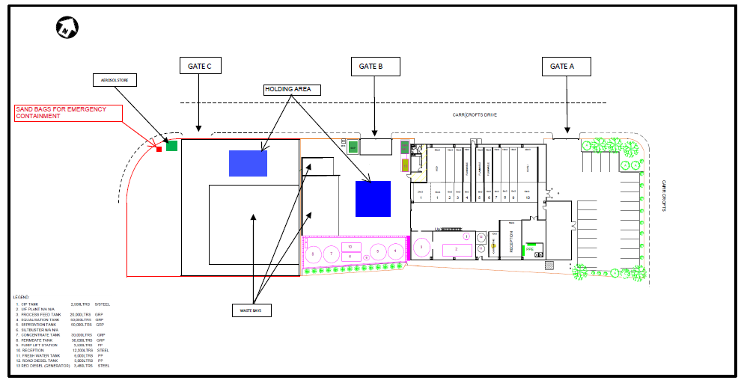

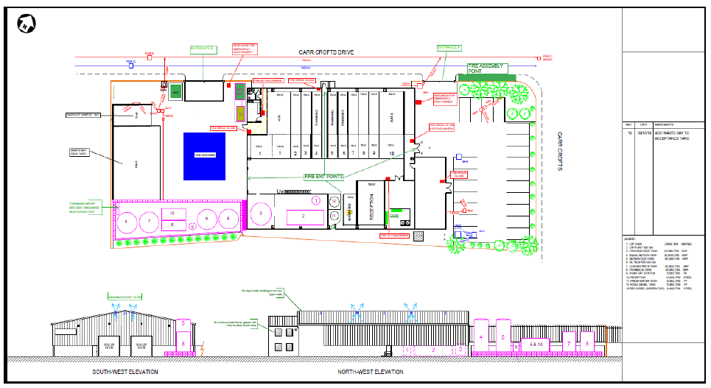
2.Storage
The maximum site storage capacity for
Non- hazardous waste(s) = 670 T. & Hazardous waste(s) = 670T.
Bulk Liquid Effluent Storage (In Tanks) = 170T (Tanks 4,5,7,8 &10)
Yard1 – Low Haz. / Non-Hazardous Non-Combustible Waste (IBC’s/ Drums) (Outside Yard Storage Area) = 100m3.
Yard2 – Low Haz. / Non-Hazardous Non-Combustible Waste (IBC’s/ Drums) (Outside Yard Storage Area) = 200m3.
Flammable Packaged Waste Storage (IBC’s/ Drums) (Warehouse Only-Bays 4,5,6) = 66m3.
Acidic Packaged Waste (IBC’s/ Drums) (Warehouse only Bay 1) = 90m3.
Alkali Packaged Waste (IBC’s/ Drums) (Warehouse only Bay 10) = 66m3.
Non-Hazardous/ Hazardous Waste (IBC’s/ Drums) (Warehouse Only-Bays 2,3,7,8,9) = 110m3
Reception Bay (IBC’s/ Drums) (Warehouse only) = 56m3
Quarantine Bay (IBC’s/ Drums) (Warehouse only) = 10m3

3. Site Maps
Appendix 7 Site Boundary Plan
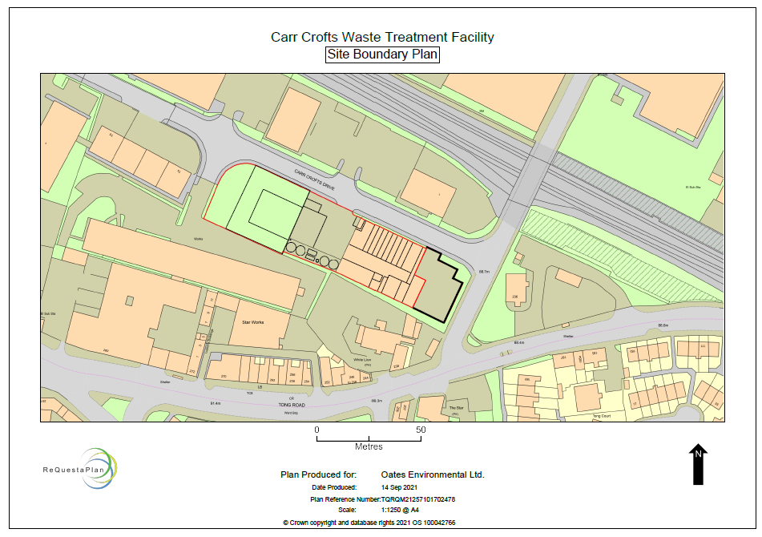

Appendix 8 Site Location Maps (FPP)

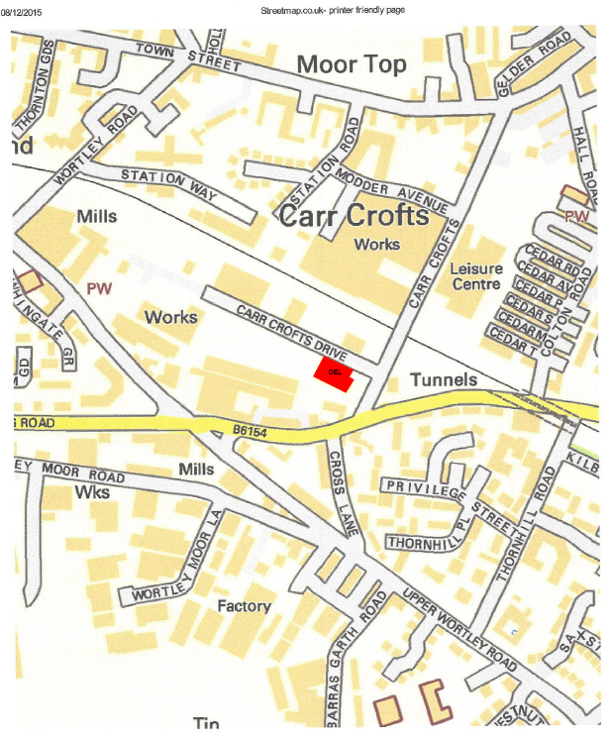
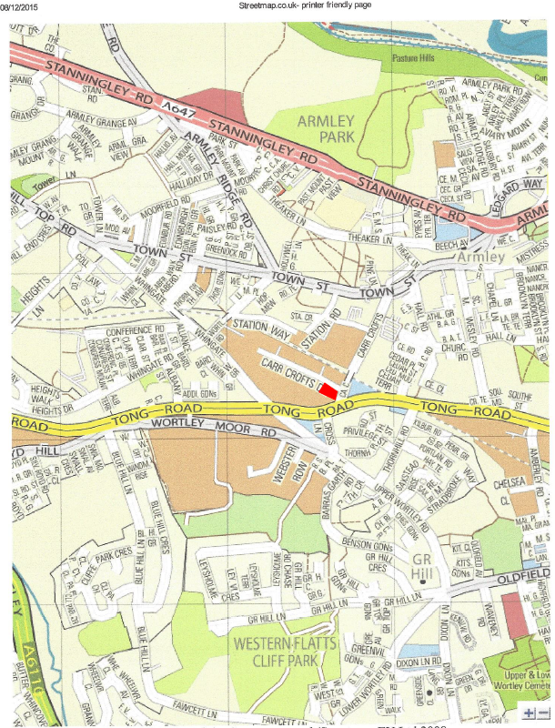

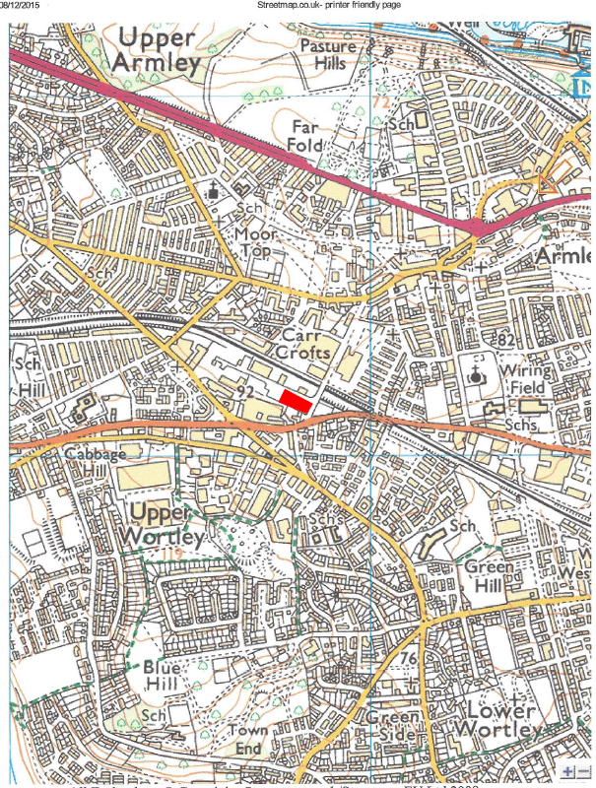

3. Water Supplies
Appendix 9 Fire Hydrants for Carr Crofts Drive
(The prevailing wind direction from site is South West)
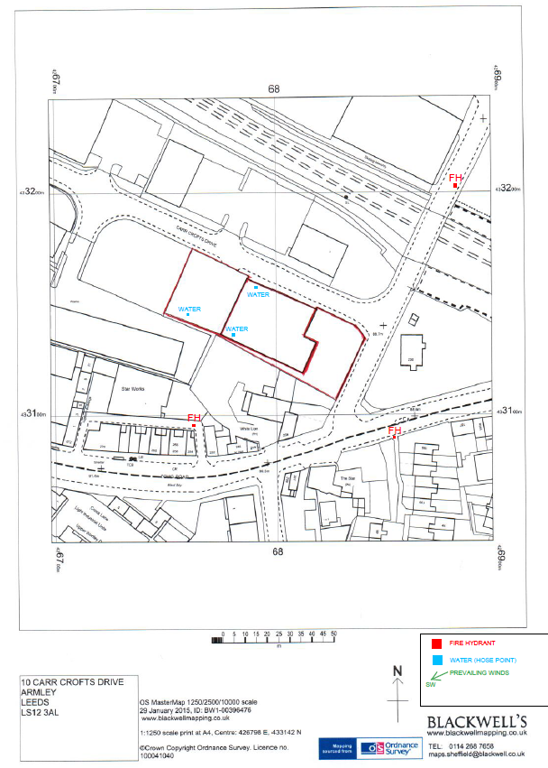
4. Key Receptors & Location Maps
A risk assessment was completed that identified the key receptors closest to site to be as follows:

A) Neighbouring businesses less than 20 meters away Ref. Appendix 7 Site Boundary Plan
B) Yorkshire Water public sewer / drainage system Ref. Appendix 17 Yorkshire Water public sewer system
C) OEL Surface water drains / gullies Ref. Appendix 18 Drainage Plan

D) Leeds & Liverpool Canal SSSI 1.5 km north Ref. Appendix 19 Key Receptors Map

E) Farnley Hall Fishpond LNR 1.9 km south-west

F) Farnley Reservoir and Silver Royd Hill LNA 1.1 km south-west
G) Kirkstall Valley LNA 1.5 km north

Appendix 7 Site Boundary Plan (A) - Neighbouring businesses less than 20 meters away
Appendix 17 – (B) - Yorkshire Water public sewer / drainage system (Yorkshire Water supplied drawings)

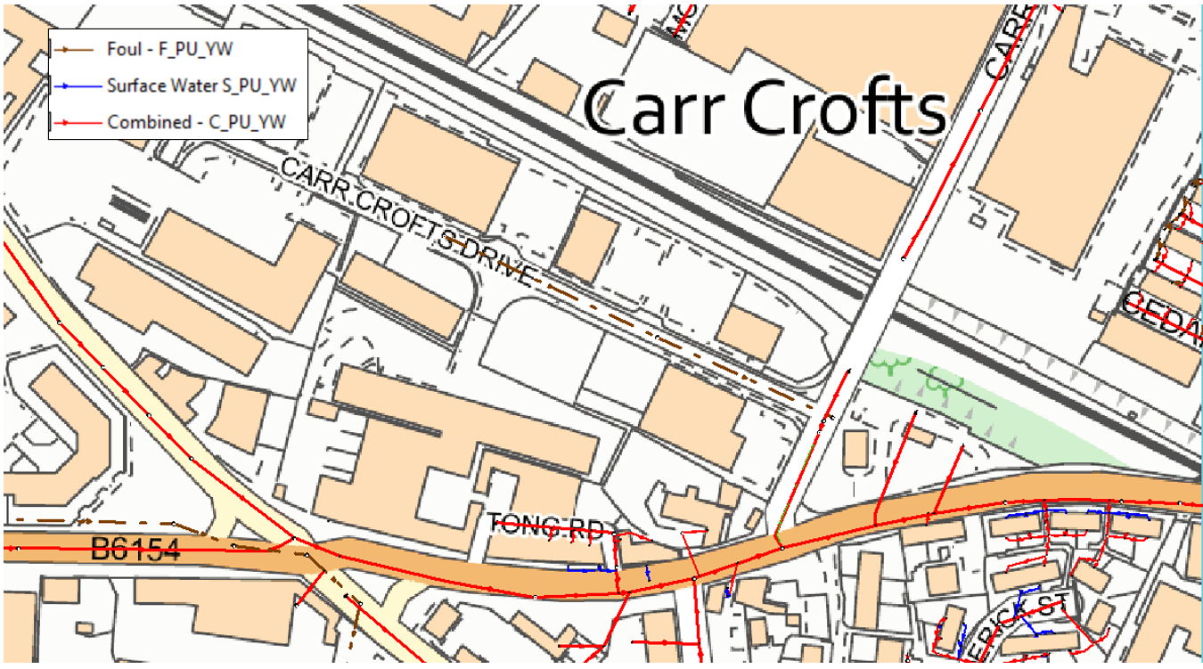

Appendix 18 (C) - OEL Surface water drains / gullies – Drainage Plan

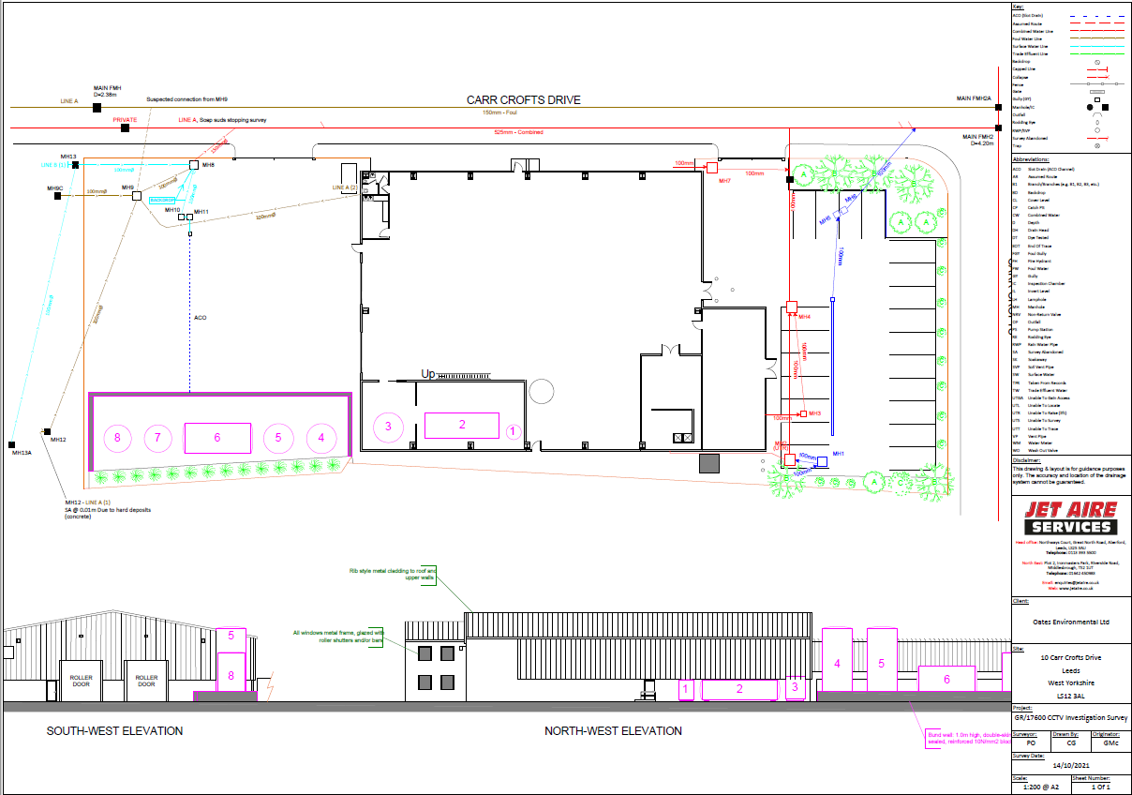

Appendix 19 Leeds & Liverpool Canal SSSI 1.5 km north/ Farnley Hall Fishpond LNR 1.9 km south-west/ Farnley Reservoir and Silver Royd Hill LNA 1.1 km south-west/ Kirkstall Valley LNA 1.5 km north

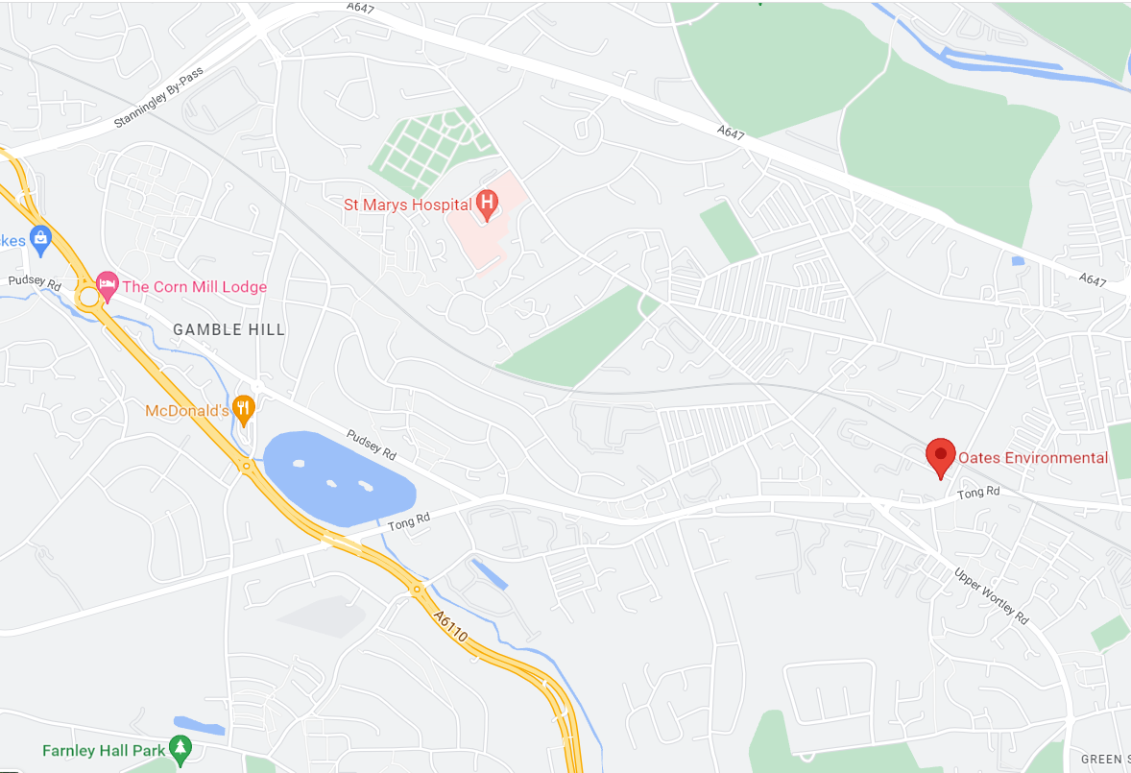
(E) Farnley Fish Pond
(F) Farnley Reservoir
(D) Leeds & Liverpool Canal
(G) Kirkstall Valley

BLANK PAGE

5.Fire Prevention Plan Objectives
This Fire Prevention Plan (FPP) has been designed to:
- Minimise the likelihood of a fire spreading
- Aim for any fire to be extinguished within 4 hours
- Minimise the spread of fire within the site & to neighboring sites

In the event of a fire, nearby fire hydrants and water supplies (Ref. to Appendix 10 Fire Hydrants for Carr Crofts Drive) and key receptors (Ref. to Appendix 8 Site Maps (FPP) & Appendix 11 Location Maps Key Receptors) have been identified in order to assist the Fire Service and other interested parties.

6.Site Activities
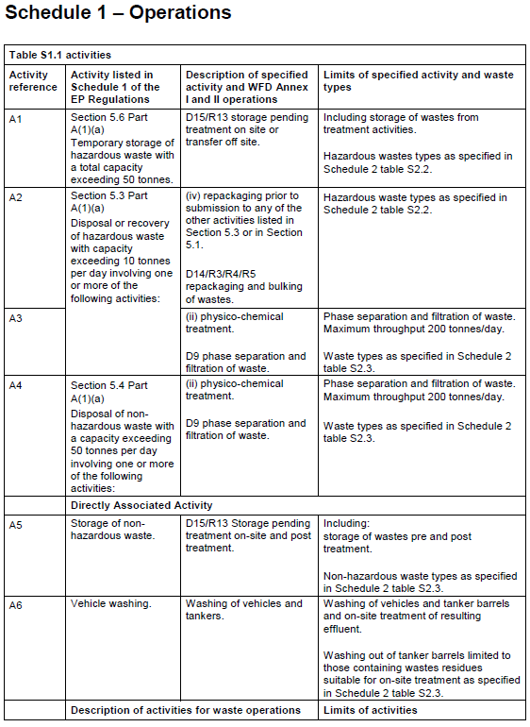

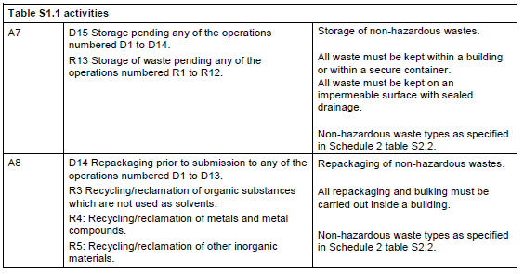

7.Preventing/ Managing common causes of Fire
A full fire risk assessment has been conducted to minimise the risk of a fire on site
(Ref. to Appendix 1 Fire Risk Assessment).

We will also implement the following steps to manage the common causes of fire & reduce the potential sources of ignition:

- Control sources of ignition such as heating pipes, naked flames & light bulbs
- Reinforce fire prevention messages using signage around the site
- Ensure staff and contractors follow safe working practices when undertaking hot working, such as welding and cutting
- Ensure all visitors follow the correct safety and fire prevention procedures and are made aware of these via our H&S induction upon signing in to site
- Apply a no smoking policy throughout site
- Introduce regular maintenance and inspection of equipment and site operations and activities (Ref. to EMS Appendix 29, Maintenance Schedule, Appendix 30 Maintenance Record and Appendix 32 Environmental Site Inspection of the Environmental Management System)
- Minimise fibre and paper in buildings and around the site
- Adopt Site security measures (e.g. security fencing, intruder alarms and CCTV) to prevent arson and vandalism (including outside normal working hours)
- Have site vehicles fitted with fire extinguishers
- Implement a fire-watch programme
- Make sure separation distances are observed between plant and material when the site is not staffed
- Segregate wastes in accordance with their hazardous properties and waste type
- Protect wastes from the elements by ensuring waste areas and containers / bins are covered where applicable
- Only accept wastes as specified in our permit
- Adhere to our Pre-acceptance and Acceptance Procedures as outlined in Sections 10 and 11 of the Environmental Management System

8.Combustible & Self Combustible Materials
The site chemists will conduct analysis of all waste at the pre- acceptance and acceptance stages to ensure compliance with the environmental permit before accepting to site.

Combustible waste(s) such as;
- Paper or cardboard packaging
- Plastics/ plastic packaging
- Rags & textiles
- Scrap metals contaminated or mixed with oils or plastics
- Mixed waste containing combustible wastes
- Wood/ packaging or pallets
- WEEE

will only be accepted & stored on-site within containers i.e. IBC’s/ Drums or the general waste site skip.
Used pallets will be stored/ isolated away from the warehouse building & any other potentially combustible waste(s).

There will be no storage of any type of waste (combustible or not) in loose piles or stacks on site, all waste(s) will be stored in containers with secondary & tertiary containment.

The following activities will not take place on site:

- Burning of any type of waste
- Bailing/ shredding activities
- Storing stacks of bales of any type of waste
- Storing any ‘Combustible’ waste(s) in bales in volume

The maximum storage time for all waste(s) will be 3 months with the most aged stocks treated or removed first.

Flammable waste(s) accepted on site will be stored only within the warehouse & within dedicated compartmentalised ‘Waste Bays’ (22m3) designed specifically for storage of ‘Flammable’ waste(s) & will have two-sided concrete ‘Firewalls’ 2.5m high constructed in accordance with HSG51, HSG71 & S5.06 (Ref. to Appendix 5 Reinforced Concrete Wall Specs.)

Hazardous & non-hazardous liquid effluents treated via the Ultrafiltration Plant (UFP) will have no ‘flammable’ or 'combustible' properties due to the high-water content of these effluents (>90%). Therefore, the possibility for the Ignition of these effluents very is low.

The effluents will be stored in dedicated storage tanks the biggest being 50m3 & have secondary containment of 64m3 (CIRA,736 110% rule applied) with further yard tertiary containment of 90m3.

9.Manage Waste Piles
Non-hazardous combustible waste(s) as mentioned in section (8.) of the FPP will be stored within containers (IBC’s/ Drums) & within bunded bays with secondary & tertiary containment.
To minimise the risk of self-combustion & limit the scale of a fire if one breaks out, the maximum pile size of any of these materials will be 22m3
(22m3 is equivalent to 22 IBC’s/ pallets of drums stacked no more than 2 high equaling one full waste bay section within the warehouse building) (Ref. to FPP Appendix 6- Site Plan (Appendix 25 EMS)
There will be no loose piles or stacks/ bales of waste(s) on-site.

10.Seperation Distances
Separation distances between that of the stored combustible Non-hazardous waste(s) & that of other hazardous/ flammable waste(s) are reduced & mitigated by the presence of waste bays constructed with fire wall protection housing the other combustible waste(s) (Ref. to FPP Appendix 6- Site Plan (Appendix 25 EMS)

Hazardous Packaged Waste(s) will be segregated in accordance with HSG71 compatibility guidance separating Acid & Alkali wastes at opposing ends of the warehouse building & having further separation between them & flammable waste(s) stored in dedicated compartmentalized waste bays with reinforced concrete fire walls

11.Using Bays and Walls

Separation distances between combustible & or incompatible waste(s) have been reduced by the construction of re-enforced concrete fire walls & have been designed to: (REF. Appendix 5-Reinforced Concrete walls)
- resist fire (both radiative heat & flaming)
- have a fire resistance period of at least 120 mins to allow other waste(s) to be isolated/ removed.

12.Procedures for storing waste in bays

(Storage of Packaged Waste on Site - 14.3 EMS)
Various types of Hazardous & Non-hazardous packaged liquid & solid wastes contained within IBC’s & drums will be stored inside the warehouse building & outside the building
All waste(s) will be removed within 3 months of arrival on-site using good stock rotation methods utilizing the on-site “Electronic Waste tracking Data-Base”

Wastes housed both within the warehouse & outside the warehouse will be stored at ground level and a maximum of 2 containers high.

Storage will be within dedicated purpose-built waste bays built on an impervious surface with self-contained drainage to prevent any spillages escaping off site & or to drain.
(Ref. Appendix 25 Site plan)

The warehouse building & site perimeter will have also full tertiary containment at all entry & exit points providing further containment

No Flammable, Toxic, Corrosive or Oxidising waste(s) will be stored outside the warehouse building & must be stored within the dedicated waste bays within the warehouse building (Ref. appendix 25 Site plan)

The storage areas will be clearly marked and signed with the hazardous characteristics of the wastes stored

All of the containers will be clearly labeled at the acceptance stage with the date of arrival, relevant code, chemical identity and composition of the waste and a unique reference number or code enabling identification, through stock control and cross reference to pre-acceptance and acceptance records held within the computerized data-base stock control system.

All hazardous waste(s) within & outside the warehouse will be segregated according to class, waste type and any hazardous properties & were necessary in line with HSG71 as outlined below:

Flammable waste(s) up to a total capacity of 66m3 will be stored within 3 dedicated flammable bays within the warehouse & will have in place a compartmental 2-sided firewall in accordance with HSG 51 alongside fire suppression provided by auto. powder fire extinguishers suspended above the bays. (Ref. appendix 25 Site plan)

Further separation of Acid’s/ Alkalis/ Corrosives will be maintained within dedicated waste bays at opposing ends of the warehouse to further aid segregation & separation distances. (Ref. appendix 25 Site plan)

The warehouse will be equipped with extractor fans to minimize buildup of any fugitive emissions.

13. Quarantine Area
There are (x2) 8m2 areas marked “Holding Area” on the FPP Appendix 6- Site Plan (Appendix 25 EMS) that are available at all times for the placing of any potentially burning wastes to extinguish them & also to move unburnt wastes into to quarantine them
(8m2 will hold over 50% of the largest pile of Non-hazardous combustible waste held on-site)

14.Detecting and Suppressing Fires
A documented daily Site Fire Watch & Security Inspection will be completed by the Site Foreman or appointed person after a walk round inspection of the site.
(Ref. to Appendix 48 of the EMS)
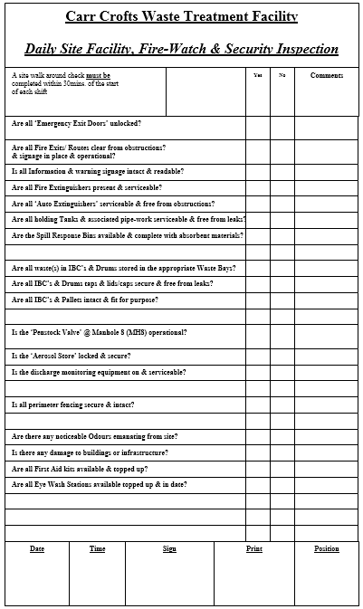

Fire detection/suppression devices will be suspended above the compartmentalised Flammable waste bays to cover the square meter volume of the waste bay using ‘Automatic Powder Fire Extinguishers’ (Ref to Appendix 7 Auto Extinguishers).

Portable Fire extinguishers will also be located around site and the appropriate type and quantity of such equipment will be determined by the size of the building and the nature of the materials stored and used on site.

Fire extinguishers will be inspected by a third party on a regular basis, to ensure that they are fit for purpose and are still suitable for the site and its activities.

A fire alarm system is installed throughout the site and will be tested on a regular basis
(Ref. to Appendix 3 Fire Alarm Test Record).

Fire doors are installed in the office areas to minimise the spread of fire.

Fire exist points have been identified on site and a full fire emergency evacuation procedure will be adopted and recorded (Ref. to FPP Appendix 6- Site Plan (Appendix 25 EMS)

15.Containing and Mitigating Fires
Active firefighting will be made possible on-site through the following measures:
- Design/ layout of site
- Full unrestricted access to three sides of the site
- Front & rear large access gates
- Several HD FLT’s to move waste around site
- Staff available at short notice
- Several identified Fire Hydrants close by to site
- Finances available
- Waste bays built on an impervious surface with self-contained drainage to prevent any spillages escaping off site & or to drain
- Full waste bay secondary containment
- Full Tank Farm secondary containment
- Full site tertiary containment
- Emergency containment sand bags/ drain seals
- Staff emergency preparedness training

Wastes housed both within the warehouse & outside the warehouse will be stored at ground level and a maximum of 2 containers high.

Further tertiary containment to the full warehouse building is constructed with sleeping policemen curb stones at entry & exit points plus additional full site tertiary containment provided by the bunding of the site perimeter
(Ref. to FPP Appendix 6- Site Plan (Appendix 25 EMS).

Waste Bays are constructed from insitu reinforced concrete to create self-contained bunds with the extra protection of 2.5m ‘Firewalls’ (ref to section 1.1.3) to the compartmentalised flammable bays within the warehouse building

The waste bays within the waste acceptance/ despatch yards are constructed also to the same specification as to those constructed & approved within the warehouse with the addition of a 2.4m high fire wall at the back running the full length of the bay adjacent to & 1m from the perimeter fence line offering protection from any potential fire spread to the neighbouring land & waste storage bay

(No Flammable, Toxic or Corrosive waste(s) will be stored outside the warehouse building)

Secondary containment within the waste bays internally & externally will have adequate containment ranging from 1800ltrs to 14400ltrs
(Ref. to FPP Appendix 6- Site Plan (Appendix 25 EMS).

Waste ‘Aerosol / Gas Canisters’ are stored outdoors & within a dedicated & lockable
“Aerosol Store” 20ft container with missile protection and aeration windows
(Ref. to FPP Appendix 6- Site Plan (Appendix 25 EMS) .

Fire suppression is provided by Auto Powder Fire Extinguishers suspended above all flammable compartmentalised waste bays within the warehouse building plus the Aerosol Store outside.

There are also (x2) designated quarantine areas of 8m2 each available at all times to aid separation and management of waste during any incident within the waste acceptance yard & despatch areas
(Ref. to FPP Appendix 6- Site Plan (Appendix 25 EMS)

Waste will be stored for no longer than 3 months & the most aged waste(s) on-site will be removed first with good stock rotation applied.

A full electronic ‘Waste Tracking System’ from cradle to grave will be adopted via our pre- acceptance and acceptance procedures which can be found in Sections 10 and 11 of our Environmental Management System.

All records generated at pre-acceptance and acceptance stages will be backed up with an electronic register of all waste(s) on site facilitating an instant record of the specific amount, type & location of each batch of waste on site to aid the fire service.

16.Fire Water Management
Run off generated from a fire can cause serious environmental problems (e.g. damage to flora and fauna), if it enters nearby watercourses, drains or land. Therefore, it is important that the following is adopted to ensure risks are managed in the event of a fire.

- Source: Contaminated Fire Water Run Off

- Pathway: Concrete Hard Standing of the Transport Yard & Staff Car Park

- Receptor: Public Foul Sewer/Public Surface Water Drains at Carr Crofts Drive

Several Fire Hydrants close by to site have been identified in section (3) & are referenced on
Appendix 10 Fire Hydrants for Carr Crofts Drive.
Section (9) has stated that the maximum pile size of non-hazardous combustible waste on-site will be 22m3

At this maximum pile size, it is estimated that the fire would be extinguished within the 3-4 hours stated as a goal within the guidance.

17.Managing Fire water.
The containment of fire cooling waters during an incident will be controlled by means of insitu control measures via secondary containment provided within the warehouse from self-contained waste bays with further tertiary containment provided within the warehouse by means of curbstones at entry/exit points.
The waste acceptance/ dispatch yards also have further tertiary containment by means of perimeter bunding plus curbstones at all entry/exit points.
An additional storage lagoon can be created by the sealing of the drainage & bunding of the car park using the on-site containment sand bags etc. this procedure will be instigated immediately upon detection of a fire.
In the event of a prolonged fire, any fire waters used can be further contained on site via the raising of the bunding of the warehouse, car park lagoon, site perimeter & raising of the site sewer discharge point at MH8 (Ref. to FPP Appendix 6- Site Plan (Appendix 25 EMS) using the on-site emergency containment sand bags

In the unlikelihood of any fire water escaping to Carr Crofts Drive, OEL will instigate the sealing off of the road gullies & man hole covers in that vicinity with drain seals & use sand bags to create further low-lying containment.

A further 80,000ltr capacity would be available from Oates Environmental Ltd.’s fleet of vacuum tankers if required plus OEL have finance available & accounts in place with several other local tanker fleets that are available to assist with any off-site transfer of any cooling waters

Depending on the nature of the fire & if any hazardous waste(s) were to catch fire there is also capacity for fire waters to be re-cycled via the on-site Ultrafiltration plant pumped via the onsite sump.

The diesel storage tank within the warehouse will have bunded tertiary containment so that no running pool fires will be able to reach it.

Bulk Liquids stored within tanks at the rear westerly Tank Farm within the yard have bunded containment allowing for a minimum of 110% rule capacity for cooling waters. There is also further containment from perimeter bunding & kerbing of the hard standing.

Any rainfall before & or during any fire incident can be removed from any uncovered containment area via means of on-site pumps, OEL’s fleet of vacuum tankers & or
sub-contracted tanker fleets

Additional storage of waste(s) up to approx. 300T. within the waste acceptance/despatch yard(s) has been assessed & considered not to have a detrimental factor on a potential fire on-site as the waste stored outside awaiting treatment or off-site transfer will not be of a flammable nature & will be stored approx. 35mtrs from any other potentially combustible waste(s) stored within the warehouse building & further protected by the compartmentalised flammable waste bays with reinforced concrete firewalls & fire suppression equipment, secondary & tertiary containment to the warehouse perimeter.

A total storage footprint within the warehouse building of 66m3 for flammable waste(s) is possible at the facility via three dedicated compartmentalised flammable waste bays & using the “Sandoz” method of compartmentalising this waste via means of fire wall containment & further mitigating circumstances of the addition of fire suppression & distancing from other waste(s) means that for every 1 tonne of flammable waste stored 3m3 retention volume would be required totalling 198m3 of retention volume required.

Cooling water retention capacity available on-site:
(Capacity can be increased with the raising of the bunding in the event of a
worst case scenario & prolonged fire)
Warehouse – 30-50m3 (Dependant on location of the fire)
Yard 1. – 90-100m3 (Dependant on location of the fire)
Yard 2. – 300-325m3 (Dependant on location of the fire)
Car-Park – 132m3 (Dependant on location of the fire)
Further containment lagoon (if required)
Carr Crofts Drive – 40-60m3 (Dependant on location of the fire)

Removal of Contaminated Fire Water
Maintaining the Fire Water Run-Off capacity will be achieved by the effluent being tankard away using OEL’s fleet of vacuum tankers that are parked within the vicinity of the transfer station & have drivers on call 24/7 365/y & which have a capacity for around 80m3, & or via a sub-contractors for disposal at a suitably accredited disposal site.

This procedure will be run in relays between our site and the waste disposal facility for as long is required by the Environment Agency, Yorkshire Water & the West Yorkshire Fire Service.

18.During/ After an Incident
Upon detection of a fire a member of OEL staff will notify any nearby businesses or residents affected by the fire
Customers booked incoming waste(s) to-site will be re-diverted to alternative sites.
Finances will be made available to decontaminate the site & clear any waste affected by the fire to a suitable approved waste disposal outlet
An Environmental Incident Record (refer to Appendix 35 of the Environmental Manual) will be completed in the event of a fire of and any immediate actions that have been taken to mitigate/rectify the situation. Any further action which may also be required as a result of the incident must also be recorded. Actions must also be logged on the Environmental Action Plan in Appendix 36 of the Environmental Manual.
Ref to Section 18.5 of the Environmental Manual for full details.

20.Emergency Contact Numbers
EMERGENCY SERVICES | Office Hours | Out of hours
Emergency | 999 | 999
Medical: | 999 | 999
Police: | 999 | 999
Fire: | 999 | 999
REGULATORS | Office Hours | Out of hours
Health and Safety Executive (HSE) | 03453009923
Local Authority: | 0113 222 4444
Environment Agency (Local) | 0870 850 6506 | 0870 850 6506
EA (24-hour emergency hotline) | 0800 80 70 60 | 0800 80 70 60
UTILITY / KEY SERVICES | Office Hours | Out of hours
Yorkshire Water | Customer Services 08451242424  Report a leak 0800 573553 | Customer Services 08451242424  Report a leak 0800 573553

