14.3.Storage of Packaged Waste on Site
Various types of packaged liquid & solid wastes contained within IBC’s & drums will be stored inside the warehouse building within dedicated purpose-built waste bays built on an impervious surface with self-contained drainage to prevent any spillages escaping off site & or to drain.

The warehouse building will have also have full tertiary containment at all entry & exit points.

Storage of Hazardous & Non-hazardous packaged waste within the rear waste acceptance yards (Ref. appendix 25 Site plan) will also take place & will be removed within 3 months of arrival & the given deadline for removal of any waste stored above their permitted levels.

Wastes housed both within the warehouse & outside the warehouse will be stored at ground level and a maximum of 2 containers high.

No Flammable, Toxic, Corrosive or Oxidising waste(s) will be stored outside the warehouse building & must be stored within the dedicated waste bays within the warehouse building (Ref. appendix 25 Site plan)

The storage areas will be clearly marked and signed with the hazardous characteristics of the wastes stored

All of the containers will be clearly labeled at the acceptance stage with the date of arrival, relevant code, chemical identity and composition of the waste and a unique reference number or code enabling identification, through stock control and cross reference to pre-acceptance and acceptance records held within the computerized data-base stock control system.

All waste(s) within & outside the warehouse will be segregated according to class, waste type and any hazardous properties & were necessary in line with HSG71 as outlined below:

Flammable waste(s) up to a total capacity of 66m3 will be stored within dedicated bays within the warehouse & will have in place a compartmental 2-sided firewall in accordance with HSG 51 alongside fire suppression provided by auto. powder fire extinguishers suspended above the bays. (Ref. appendix 25 Site plan)

Further separation of Acid’s/ Alkalis/ Corrosives will be maintained within dedicated waste bays at opposing ends of the warehouse to further aid segregation & separation distances. (Ref. appendix 25 Site plan)
The warehouse will be equipped with extractor fans to minimize buildup of any fugitive emissions.

18.Emergency Preparedness and Response

18.1.Purpose
Ref: ISO14001 2015
In dealing with issues of waste and environmental management there is the potential for emergencies and accidents to arise. If these incidents are not responded to adequately, they can result in breaches of legislation, policy requirements, contractual obligations and sector guidance and have a significant impact on the environment. Also refer to Oates Fire Prevention Plan (FFP) doc OATESFPP06

18.2.Dealing with an Environmental Incident / Accident
- If you suspect an incident has occurred, investigate at once but do not take risks and stay calm
- Raise the alarm by informing the nearest supervisor/ manager
- If it is safe to do so, try to control the incident by isolating plant/equipment and closing off any valves etc. Obtain help if necessary - but do not put yourself or others at risk
- Direct all non-essential people away from the affected area
- Activate the nearest fire alarm call point if an evacuation of the premises is required (also ref to doc OATESFPP06)
- It may be possible to deal with small incidents/spills using the appropriate spill response kit and by closing doors/covering drains etc. to confine the emissions/discharges as far as possible (refer to 12 Steps to Spill Control in Section 18.2.2)
- For larger incidents, it may be necessary to inform the fire brigade, Environment Agency, Local Authority and/or Sewage Undertaker, depending on its nature (refer to Emergency Numbers in section 18.4)
- For all minor and major incidents and accidents complete an Environmental Incident Record (ref to Appendix 35)
- The Environment Agency shall also be notified without delay in line with OEL's Environmental permit conditions
- Periodically review and, where necessary, revise the emergency preparedness and response procedures, in particular, after the occurrence of accidents or emergency situations.
- Periodically test procedures where practicable
- Conduct mock drills to reinforce training and get feedback on the effectiveness of site plans/procedures

18.2.1.Spillage Kits/ Sand Bags (Containment)
Spill kits will be located around site in areas where oils and liquids are stored or where spillages are likely to occur. Spillage kits must be fit for purpose and appropriate to the nature of the material being stored.
Pallets of Sand bags for emergency containment are strategically located within the front car-park & rear waste acceptance yard (Ref. appendix 25 Site plan) these will be deployed in an emergency to create containment lagoons.
Plate 9: Examples of a Sand Bags (Containment) & Spillage Kit
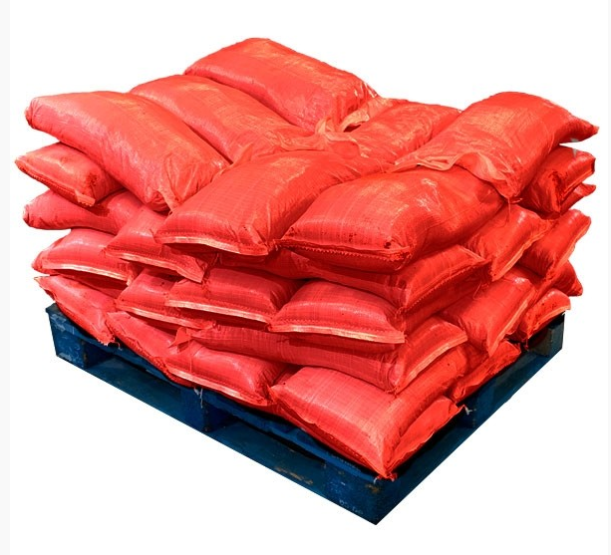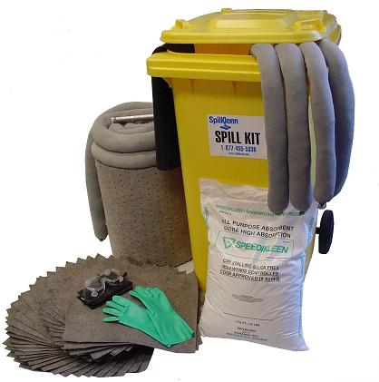

The spillage kits & sand bags will be checked on a regular basis & during the environmental site inspections (Appendix 32) & to ensure that adequate materials and PPE are available. Spillage kits should never be used for any other purpose other than as a spillage kit. Spillages should never be hosed down and all minor and major spillages must be reported. Consider various scenarios and how the ‘Steps to Spill Control’ may occur in different sequences depending on the type of spill that has occurred on site (Section 16.2.2)

18.2.2. Steps to Spill Control (Warehouse & Acceptance Yard - Temporary Storage)
Please adhere to the following procedure in the event of a spill inside or outside the warehouse building;
- Be vigilant at all times during your activities/ duties & look for the potential for any possible spills
- Upon detection of any spill cut off the source of the spillage to prevent further escape if it is immediately safe & possible to do so
- Raise the alarm and ensure everyone is aware a spill has occurred
- Evacuate personnel & any visitors using the appropriate escape routes
- Close the site drainage penstock control valve
- Ensure medical assistance is sought if someone has been injured
- Identify the spilled material
- Identify and use the appropriate PPE to deal with the spill
- Contain the spill using an appropriate spill kit & or emergency sand bags
- If the spill has caused pollution to the environment / watercourse follow OEL's permit requirements (Appendix 33)
- Clean up the spill using the spill kit & any other necessary equipment i.e. pump/ tanker etc.
- Dispose of spilled material to the correct waste stream. (Ensure the correct documentation is used)
- Restock spill kit immediately
- Complete the Environmental Incident Report Form in Appendix 35, investigate the cause of the spill and implement control measures identified.

A spill response team should be appointed and they should carry out a mock spill at regular intervals by pouring tap water only (never use any other liquids) onto made ground and get the group to respond to the spill as if it were a real live event. The mock spill can be a planned or non planned event. The outcome of the ‘Mock Drill’ should be recorded on the Mock Drill Form (Appendix 34). Record of the Spill Response Team training should be recorded onto individual 'Employer Training Record' (Appendix 1).

18.2.3.Spillage Procedure (Warehouse & Acceptance/ Temporary Storage Yard)

