Solid Floor/ Natural Ventilation

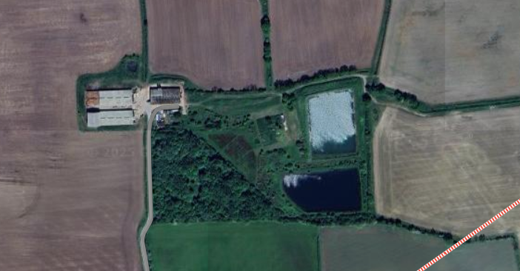

N

1

2

3

3a

4

Covered slurry lagoon

Muck pad

Irrigation reservoirs

Muck pad

Managers Residence

Deadstock store

Feed bins