

**DUST & EMISSION MANAGEMENT PLAN**

**For: West Lindsey Operational Services Depot**

**Caenby Corner**

**Market Rasen**

**LN8 2AR**

|  |  |
| --- | --- |
| Version: 1 | Author: Rob Gilliot |
| Date: 11/02/2021 | Review interval: Annual |

**Document History:**

|  |  |  |  |
| --- | --- | --- | --- |
| **Version** | **Issue Date** | **Author** | **Description** |
| 1 | 02/09/2021 | RG | New permit submission |
|  |  |  |  |
|  |  |  |  |
|  |  |  |  |
|  |  |  |  |
|  |  |  |  |
|  |  |  |  |

**Contents**

|  |  |
| --- | --- |
| **Section** | **Page** |
| **1.0 Introduction** | **1** |
| 1.1 General | **1** |
| 1.2 Waste Operation Overview | **1** |
| 1.3 Waste Types and Quantities | **1** |
| 1.4 Site Management | **1** |
| **2.0 Primary Dust Control Measures** | **2** |
| 2.1 Source Materials | **2** |
| 2.2 Releases | **3** |
| 2.3 Impacts | **3** |
| **3.0 Monitoring** | **3** |
| 3.1 Process Monitoring | **3** |
| 3.2 Dust Monitoring | **3** |
| 3.3 Complaints Monitoring | **3** |
| 3.4 Dispersion | **4** |
| **4.0 Contingency Control Measures** | **4** |
| 4.1 Contingency Plans | **4** |
| **5.0 Incidents and Emergencies** | **4** |
| 5.1 Incidents or emergencies which might adversely affect the control of odour | **4** |
| **6.0 Management of DMP** | **5** |
| 6.1 Document Maintenance | **5** |
| **App A** | **6** |
| **App B** | **6** |
| **App C** | **7** |
|  |  |

1. **Introduction**

**1.1General**

1.1.1 West Lindsey District Council have prepared this Odour Management Plan (OMP) for their waste transfer operation at West Lindsey Operational Services Depot, Caenby Corner, Market Rasen, LN8 2AR. The site will be operated as a Waste Transfer Station: Household, Commercial and Industrial under a bespoke environmental permit.

1.1.2 The site is operated in accordance with an Environmental Management System (EMS) and Fire Prevention Plan (FPP), Odour management plan (OMP) along with this DMP.

1.1.3 This objective of the DEMP will allow West Lindsey District Council to prevent the migration of dust and particulates beyond the site permit boundary, to control dust within the site to reduce associated potential health risks and the likelihood of off-site migration and ensure the necessary actions are implemented and recorded as required.

**1.2 Waste operation overview**

1.2.1 The site will operate under the conditions of a Bespoke Environmental Permit.

1.2.2 The Environmental Permit is required for the storage of waste prior to removal to a disposal facility. It does not include the treatment of waste on site.

**1.3 Waste Types and Quantities**

1.3.1 The waste types accepted on site will be those defined in the Environmental Permit. These include, but are not limited to, fly tipped wastes such as tyres, mattresses, rubble and road sweepings.

1.3.2 The maximum amount of waste to be stored on site at one time along with maximum storage times for each waste type is shown in Table 1 of the Environmental Management System. All waste storage locations are shown on the site plan in the Fire Prevention Plan and is attached in appendix 3 of this document.

1.3.3 If the maximum storage capacity of the site is reached, no further waste will be accepted onto site until some has been removed to a suitable disposal site.

**1.4 Site Management**

1.4.1 The site will be supervised by a Technically Competent Manager (TCM) as identified in the site’s EMS. They will be responsible for the management of the site including the acceptance and storage of any potentially malodourous waste.

1.4.2 West Lindsey District Council will ensure that at least one other officer is competently trained in the site management documentation and relevant procedures to act as a deputy should the TCM be absent.

1. **Primary Dust Control Measures**

**2.1 Source Materials**

2.1.1 Table 2.1 below is an inventory of all materials with the potential to create dust.

|  |  |  |  |
| --- | --- | --- | --- |
| Waste Code | Description | Max quantity held on site | Max duration on site |
| 20-03-03 | Road sweepings | 150tonnes in open bay | 6 months |
| 17-01-07 | Mixed rubble | 5tonnes in an open skip | 2 months |

2.1.2 The remaining waste and materials which will be stored are considered to be of low risk in respect of dust emissions, however, storage times are short to ensure the risk is further mitigated.

2.1.3 In order to ensure minimum dust is produced by the source materials identified in Table 2.1, the quantity stored on site and the length of time for which it is stored before removal for disposal is controlled. These limits are shown in Table 2.1. The materials are delivered on site by either caged vehicle (rubble) or mechanical road sweeper (road sweepings). They pull up to the respective deposit locations and handball into skip (rubble) or tipped mechanically for the road sweeper. See site plan for locations APP A

2.1.4 The mixed municipal waste and fly tipping collected by the street cleaning operatives is directly delivered to the disposal point, if for any reason they are called out to clear a fly tip out of hours when the WTS is not open, this will be held on the vehicle (fully caged vehicle so no debris will be lost through high winds) overnight and delivered to the WTS within a 24 hour period.

2.1.5 The mixed municipal waste that is collected on the kerbside household collection rounds is delivered to the disposal point before the refuse collection vehicles return to site. Therefore, this waste does not have an impact on site.

2.1.6 On occasion an RCV may break down while it contains mixed municipal waste. In these cases, the vehicle is likely to be recovered back to the site and consequently the waste will be on site until the vehicle can be repaired and emptied. If it is anticipated that the vehicle cannot be repaired within a few days then, if possible, the load will be ejected onto the tarmacked area of the yard and loaded onto another vehicle for disposal. This will only be done in severe circumstances and when there is little or no wind, operatives will be on standby for the immediate removal of all/any litter that may escape.

2.1.7 Road sweepings have a low risk of causing dust when being offloaded from the sweeper due to being damped whilst collected.

2.1.8 The road sweeper is the primary source in clearing the dust on a regular basis on entry and exit to the site and within all accessible areas within.

**2.2 Releases**

2.2.1 In order to reduce evaporation to air of the water from street cleaning residues, the site has a fully enclosed drainage system.

**2.3 Impacts**

2.3.1 Land uses surrounding the site are mainly farming but there are a few residential properties and industrial/commercial properties. The nearest residential property is over 100 metres away from the north-eastern boundary fence of the area of the site on which the road sweepings are stored. On all other sides of the site the land use is agricultural. See location map APP B

1. **Monitoring**

**3.1 Process Monitoring**

3.1.1 The processes in place on site to ensure minimal dust release will be monitored to ensure that it is complied with.

3.1.2 Monitoring will be carried out by the TCM and or any other responsible officer of the council and logged daily on the site diary Appendix C.

3.1.3 Monitoring will involve the routine checking of the types and levels of waste in the designated storage points, checking of whole permitted area (including boundary fencing), whilst unloading waste types in table 2.1 and checking of documentation showing how often the waste has been removed for disposal.

**3.2 Dust monitoring**

3.2.1 Monitoring of dust particulates will be carried out during site inspections by the TCM or by other responsible officers of the council.

3.2.2 Monitoring will be by visual means and will be recorded on the Site Inspection Record sheet an example of which is in Appendix 1. These recording sheets will be stored in the site office and be available for inspection by the Environment Agency.

3.2.3 The site office and car park are sited between the skip storage area and the house on the southern side of the site. Therefore, should any dust particulates occur at any time staff are on site, depot staff will make the TCM aware.

**3.3 Complaints monitoring**

3.3.1 The council has a complaints process in place for all aspects of its work. Customers who need to make a complaint about odour from the Caenby Corner site will be able to do so via this complaints system using the website or the telephone.

3.3.2 All dust complaints will be investigated promptly and appropriate remedial action will be taken if the complaint is valid.

**3.4 Dispersion**

3.4.1 The prevailing wind on the site is from the south west. As the highest impact land use is to the south/south east of the site the likelihood of these properties being affected by dust from the site is minimal

1. **Contingency Control Measures**

**4.1 Contingency plans**

4.1.1 Contingency plans are in place for incidences where site processes and monitoring have failed to keep dust within acceptable limits.

4.1.2 If a complaint of excessive dust is received or excessive dust is noticed by site staff the TCM will be notified and the source of the dust identified.

4.1.3 Should the source be on site, the cause of the dust release will be identified and the most appropriate solution taken to remove the build-up of dust. This is likely to usually involve the immediate call in of our road sweeper to fully sweep the permitted area and/or removal of the waste from site to the disposal site.

4.1.4 A record of the cause of the incident and the actions taken will be made and consideration given as to whether the incident is likely to recur and therefore require amendments to site processes.

4.1.5 Monitoring will be carried out to ensure that the actions taken have removed the dust.

4.1.6 Should the incident have arisen as a result of unfavourable meteorological conditions such as extreme air movement, site processes will be adjusted to mitigate the increase in dust production until the conditions become more favourable. This is likely to be through an increase in frequency of site clearances (via road sweeping and dampening sources with water.

1. **Incidents and Emergencies**

**5.1 Incidents or emergencies which might adversely affect the control of dust pollution**

5.1.1 Table 5.1 below records the incidents and emergencies which might adversely affect the control of dust pollution and the remedial action that would be taken in each instance.

|  |  |  |
| --- | --- | --- |
| **Incident or Emergency** | **Preventive Action** | **Remedial Action** |
| Fire on site | See Fire Prevention Plan | Extinguish Fire/Call Fire Brigade |
| Road sweeper breakdown down | Maintain vehicle properly | WLDC have 2 mechanical sweepers if they are both broken down then a rental will needed to be sourced immediately (which is part of the lease/maintenance contract) |
| Sweeper driver absent | Train a number of drivers | Use alternative driver |
| High winds | No unloading of materials in these conditions | Contact disposal authority and find alternative location to tip if over 24hours. Continue to monitor weather forecasts to ascertain whether this action will need to occur |
| Build-up of dust around permitted site | Good housekeeping and visual checks will negate this type of incident | Recorded site checks by TCP |

**Table 5.1** Incidents or emergencies requiring action

**6.0 Management of DMP**

**6.1 Document maintenance**

6.1.1 This document will be reviewed annually to ensure it remains current.

6.1.2 Should the site processes change, this document will be reviewed to ensure it is still relevant.

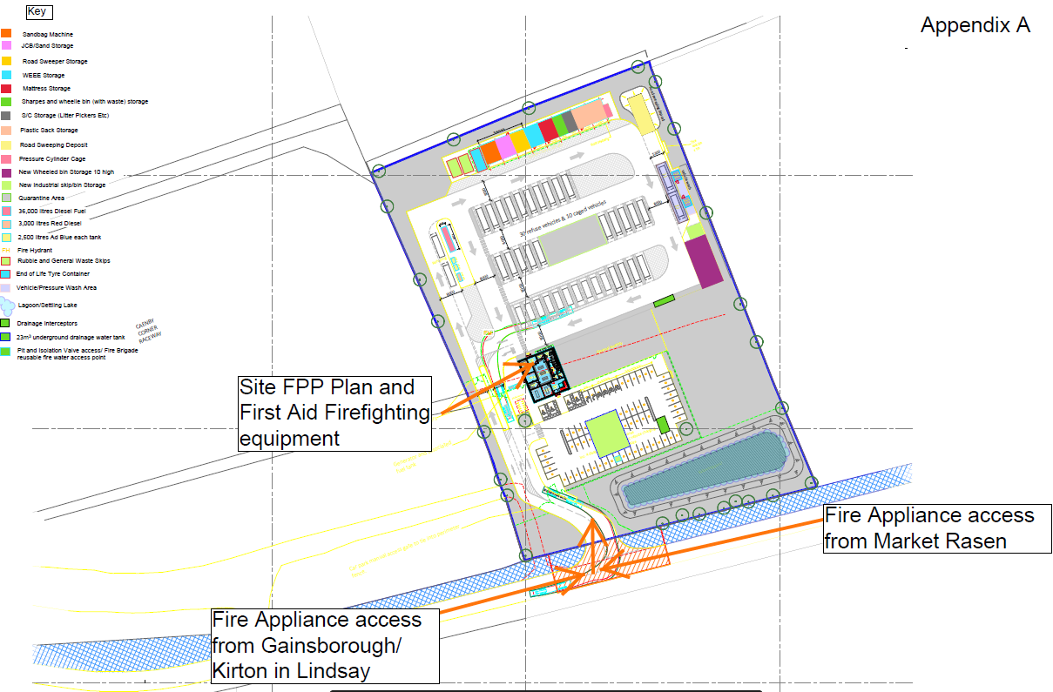

APP B



**Appendix C**

**SITE DIARY DOCUMENTS (this will be an electronic document and be in a bigger format (usable))**

|  |  |  |  |  |  |  |  |  |  |  |  |  |  |  |  |
| --- | --- | --- | --- | --- | --- | --- | --- | --- | --- | --- | --- | --- | --- | --- | --- |
| **Date** | **TCP Name** | **Sign** | **Odour** | **Temp of sweepings pile** | **Sweepings**  **Bay** | **Drain** | **Scrap** | **Fridges** | **Rubble** | **Fence** | **Asbestos** | **Tyres** | **Sharps** | **Dust** | **Comments** |
|  |  |  |  |  |  |  |  |  |  |  |  |  |  |  |  |
|  |  |  |  |  |  |  |  |  |  |  |  |  |  |  |  |
|  |  |  |  |  |  |  |  |  |  |  |  |  |  |  |  |
|  |  |  |  |  |  |  |  |  |  |  |  |  |  |  |  |
|  |  |  |  |  |  |  |  |  |  |  |  |  |  |  |  |
|  |  |  |  |  |  |  |  |  |  |  |  |  |  |  |  |
|  |  |  |  |  |  |  |  |  |  |  |  |  |  |  |  |
|  |  |  |  |  |  |  |  |  |  |  |  |  |  |  |  |
|  |  |  |  |  |  |  |  |  |  |  |  |  |  |  |  |
|  |  |  |  |  |  |  |  |  |  |  |  |  |  |  |  |
|  |  |  |  |  |  |  |  |  |  |  |  |  |  |  |  |