##### Noise Management Plan

**Farm name: Whittons Farm**

**Operator:** L J Fairburn & Son Ltd

**Permit number:**

**Date: April 2025**

**Prepared by:** E Marshall

**Introduction**

This bespoke Noise Management Plan has been prepared to support the overall Environmental Management System in place at Whittons Farm. The plan has been prepared in accordance with in accordance with Appendix 5 of guidance IPPC Technical Guidance Note (publishing.service.gov.uk) and Noise and vibration management: environmental permits - GOV.UK  
([www.gov.uk](http://www.gov.uk/)). The overriding principle of this plan is to ensure the day-to-day activities are carried out in accordance with this document to help minimise the overall environmental impact.

There are three sensitive receptor within 100m distance of the installation boundary one of which is a farmhouse residence and agricultural buildings which are owned by the operators of the site. There are also 4 other sensitive receptors within 400m distance of the installation boundary which are a combination of farm and residential properties.

There have been no previous issues relating to odour, dust, noise or flies in relation to the farm.

**Setting**

The surrounding area is mainly large arable fields with field boundary hedgerows. The landscape is relatively flat to gently undulating. The village of Farlesthorpe is located approximately 280m to the south-east of the installation, Bilsby is located approximately 530m to the west of the installation.

Figure 1 shows the location of the installation and of the receptors within 400m which have been considered in this noise management plan.

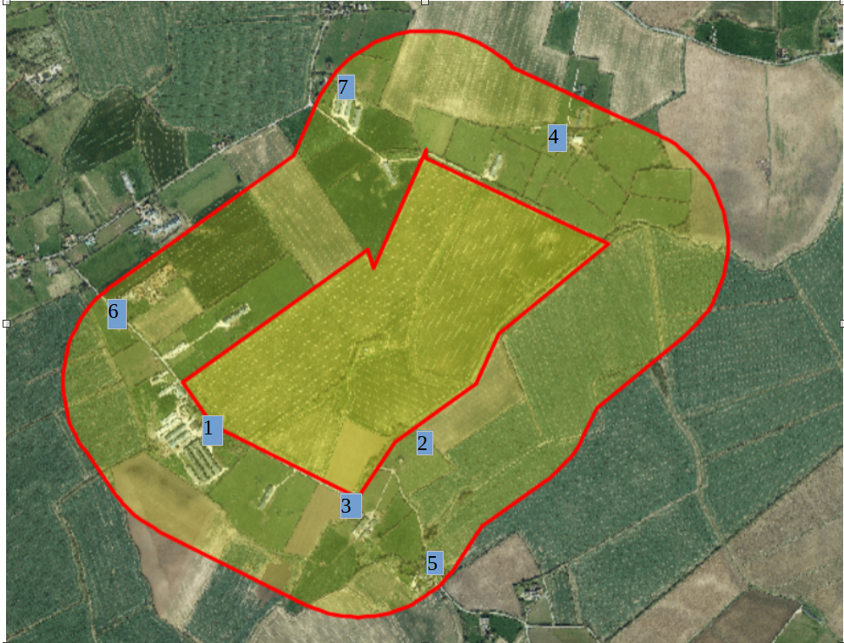

Table 1: Sensitive Rectors and distance of Sensitive Receptors from Installation Boundary to nearest point of domestic curtilage

|  |  |  |  |  |  |
| --- | --- | --- | --- | --- | --- |
| Reference | Description | Address | National Grid Reference | Orientation from installation | Distance (m) to nearest point of domestic curtilage |
| 1 | Ivy House Farmhouse (operator occupied) | Farlesthorpe Road, Bilsby, Alford, Lincolnshire LN13 9PL | TF 46636 74749 | SW | 17m |
| 2 | North Cottage | Farlesthorpe Road, Bilsby, Alford, Lincolnshire LN13 9PL | TF 47260 74642 | SE | 45m |
| 3 | Kindesella House/North Farm | Farlesthorpe Road, Bilsby, Alford, Lincolnshire LN13 9PL | TF 47151 74436 | SE | 89m |
| 4 | Property at Ancroft Fen (School House?) | Thurlby Road, Bilsby East, Lincolnshire, LN13 9JJ | TF 47716 75752 | N | 230m |
| 5 | Home Farm/ North Farm Cottages | Farlesthorpe Road, Bilsby, Alford, Lincolnshire LN13 9PH | TF 47348 74323 | SE | 280m |
| 6 | Glebe Farm residence | Farlesthorpe Road, Bilsby, Alford, Lincolnshire LN13 9PL | TF 46322 75178 | W | 290m |
| 7 | Property at Junction of Ancroft Fen Lane and Back Lane (The Grange) | Back Lane, Bilsby East Lincolnshire LN13 9PT | TF 47012 75902 | NW | 360m |

The purpose of this Noise Management Plan is to:

* Establish the likely source of noises arising from the farm
* Set out procedures at the farm in order to mitigate or minimise the risk of noise
* Formalise an effective method of dealing with any noise complaints quickly and efficiently.

This plan will be reviewed in the light of any building and management changes, and on the outcome of investigations into the cause of any future noise complaints, if any occur.

Any noise complaints will be recorded and investigated using the Noise Complaint Report Form contained within Technical Guidance Note IPPC SRG 6.02 (Farming) Noise Management at Intensive Livestock Installations. See copy in Appendix 1 of this document.

**Potential sources of noise**

|  |  |  |  |
| --- | --- | --- | --- |
| **No. ref** | **Noise Problem** | **Actions taken to prevent or minimise noise** | **Completion Date** |
| 1 | Feeding Poultry | Sealed building and sealed feed systems. Low noise, well maintained equipment. Ad-lib system, so no spikes in noise and poultry activity due to feeding times. | In place. |
| 2 | Feed delivery | Blower and vacuum type delivery vehicles fitted with low noise units. | In place |
| 3 | Feed preparation | No milling and mixing operations carried out on site. All bought-in feed. | In place |
| 4 | Poultry moving | No movements between sheds. Free access by poultry to range areas during daylight hours. Birds handled gently and quietly where necessary to reduce stress on animals and likelihood of noise from the birds. | In place |
| 5 | Poultry loading, in and out | Few movements as possible. Short duration. Aim to minimise animal stress. All-in-all-out batch system means that loading in and out is not on a continuous basis through the year. | In place |
| 6 | Bedding buildings | Fully littered floor and litter is kept loose and friable. Loader used for transport, engine revs kept low, effective silencer. Mainly during working day, limited at weekends/bank holidays. | In place |
| 7 | Mucking out and clean out | Working within sealed buildings to remove muck, blow down surfaces and fans and to wash and disinfect. Mainly during working day, limited at weekends/bank holidays. Clean out occurs within sealed buildings between the hours of 08:00 and 16:00. | In place |
| 8 | Wash water tanker filling and emptying | Tanker filling only when necessary and appropriate. All equipment regularly serviced and operated to current standards and optimum efficiency. | In place |
| 9 | Litter loading/transport and spreading | Manure belt runs quietly and receives regular maintenace to ensure that remains the case. Operation of the manure belt is typically within the hours of 08:00 to 16:00.  All equipment regularly serviced and operated to current standards. Litter is not stored at the installation so litter is exported from the installation to local agricultural land. | In place |
| 11 | Delivery of supplies and materials | Typically small deliveries during normal working hours by arrangement. Low perceived impact. | In place |
| 12 | Ventilation | Fans well maintained and cleaned at every turnaround. Tree planting provides a buffer to the North, East and South of the poultry sheds.  Ventilation fans are checked daily to identify noise problems. If a problem is identified it would be reported to the operators and the internal maintenance team would be instructed to rectify the problem within 24 hours. | N/A |
| 13 | Vehicles operating within installation boundary | Operations mainly carried out during normal working hours. Vehicles maintained in accordance with manufacturer's recommendations, and defective silencers replaced. Audible reversing signals required for safety purposes.  Yards and drives maintained to repair holes. | In place |
| 14 | Alarms | All sheds are connected to an alarm system which rings given telephone numbers alerting any possible problem to the designated person without delay. There is also an audible alarm on site. Alarm testing is very short duration once per week and during sociable hours. In the event of the alarm sounding due to an emergency/ system failure, it would be shut off with minimal delay. The combination of audible alarm and phone call system ensures the problem is alerted to all relevant personnel and can be dealt with swiftly. | In place |
| 15 | Generator | The generator is located towards the back of the poultry sheds, which themselves provide a barrier. Tree planting on the same side of the buildings, buffers the noise emissions from reaching receptors to the East. During noise monitoring, when the generator has been used, you can not hear the sound from the entrance to the site, which is nearer than the closest sensitive receptors. | In place |

**Noise monitoring**

Noise monitoring is required by BAT Conclusion 9 if there are sensitive receptors located within 400 metres of the installation boundary.Noise levels are assessed by operators or their staff at the boundaries of the installation nearest sensitive receptors, as and when there is potential for elevated noise levels. The frequency of monitoring would be increased in the event that a complaint was received.

**Summary**

We have always worked hard to minimise our impact on our closest receptors and as a result have not had any complaints about noise in relation to this installation. We continually assess management techniques to improve our control of noise pollution.

This plan will be reviewed at least **annually** and in the light of any building and management changes, and on the outcome of investigations into the causes of any future substantiated complaints, if any occur.

Any noise complaints will be reported to the operators who will log and investigate causes of all complaints; identifying the source of the noise issue and monitoring noise levels at the site boundary as part of the investigation. The complaint details and subsequent investigation will be recorded on the site complaint form and a copy will be kept in the site office.

**T**his document has been prepared by the applicant using the AHDB template. While the Agriculture and Horticulture Development Board, seeks to ensure that the information contained within this document is accurate at the time of printing, no warranty is given in respect thereof and, to the maximum extent permitted by law, the Agriculture and Horticulture Development Board accepts no liability for loss, damage or injury howsoever caused (including that caused by negligence) or suffered directly or indirectly in relation to information and opinions contained in or omitted from this document.

**Appendix 1**

