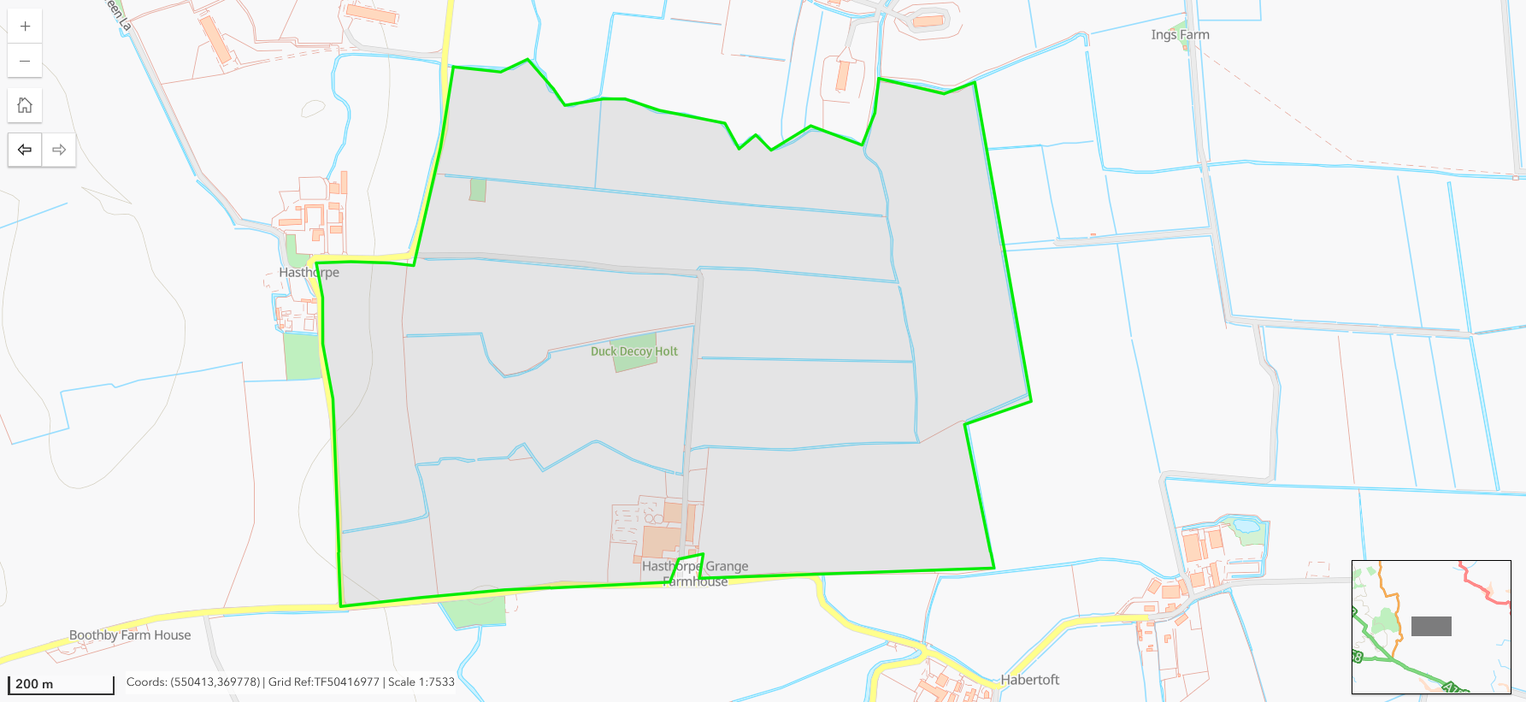
1
2
Free Range Layer House 32,000 places
Rearing House 16,000 places

