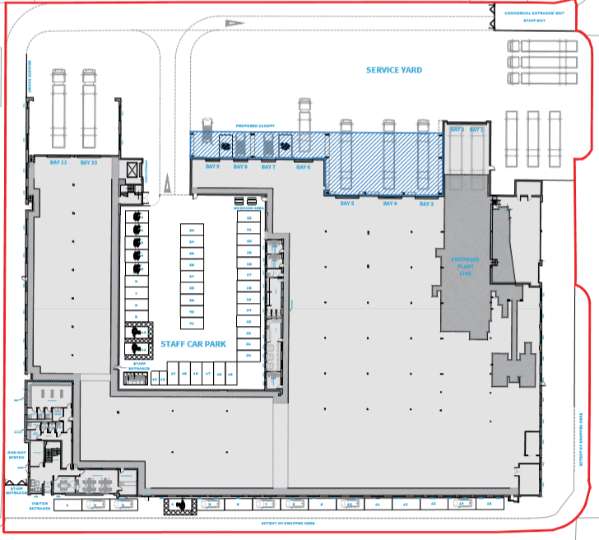

A7

A3

A2

A1

A5

S1

A4

A6

Site boundary

A7 – Wastewater Treatment plant exhaust

S1 – foul sewer discharge point

A4-A6 – boiler exhausts

A1-A3– treatment plant exhausts

Permit boundary