C3.2 Emissions to Air, Water and Land

Schedule 3 to Environmental Permit EPR/CP3507PJ identifies the point source emission points to air (table S3.1), to water (table 3.2) and to sewer / off-site disposal (table S3.3) as set out in the permit extract shown below.

There are no emission limits or monitoring requirements set for releases to air which are derived from the natural gas fired water boiler / heater and gas fired pig singeing plant, vessel etc emergency pressure relief vents and general air extraction from working areas.

There are no limits or monitoring requirements set for uncontaminated surface and roof water run off releases to water except for the requirement that there be no visible oil and grease based on weekly observation.

There are no limits set in the permit for releases to sewer / off-site disposal (disposal of process derived waste water discharged to off-site lagoons and stored pending spreading on land for agricultural benefit) although quarterly monitoring based on 24 hour composite samples is required for a number of analytes and continuous flow monitoring is required. Monitoring conditions relating to flow (instantaneous and cumulative daily rate), pH, chemical oxygen demand, biological oxygen demand, nitrate, phosphate, ammonia and suspended solids are set.

There are no direct emissions from the process to groundwater or to land.

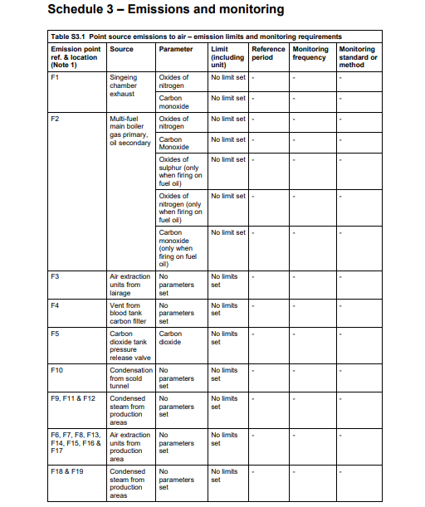
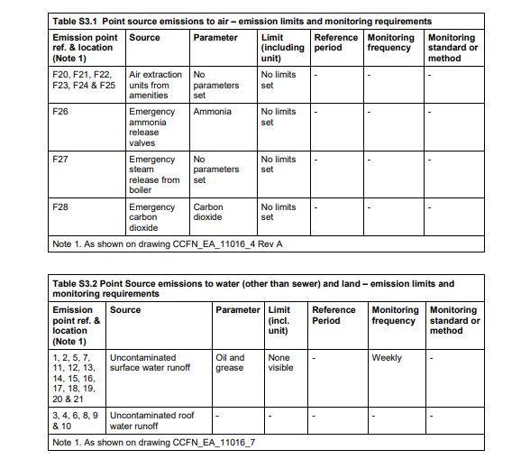

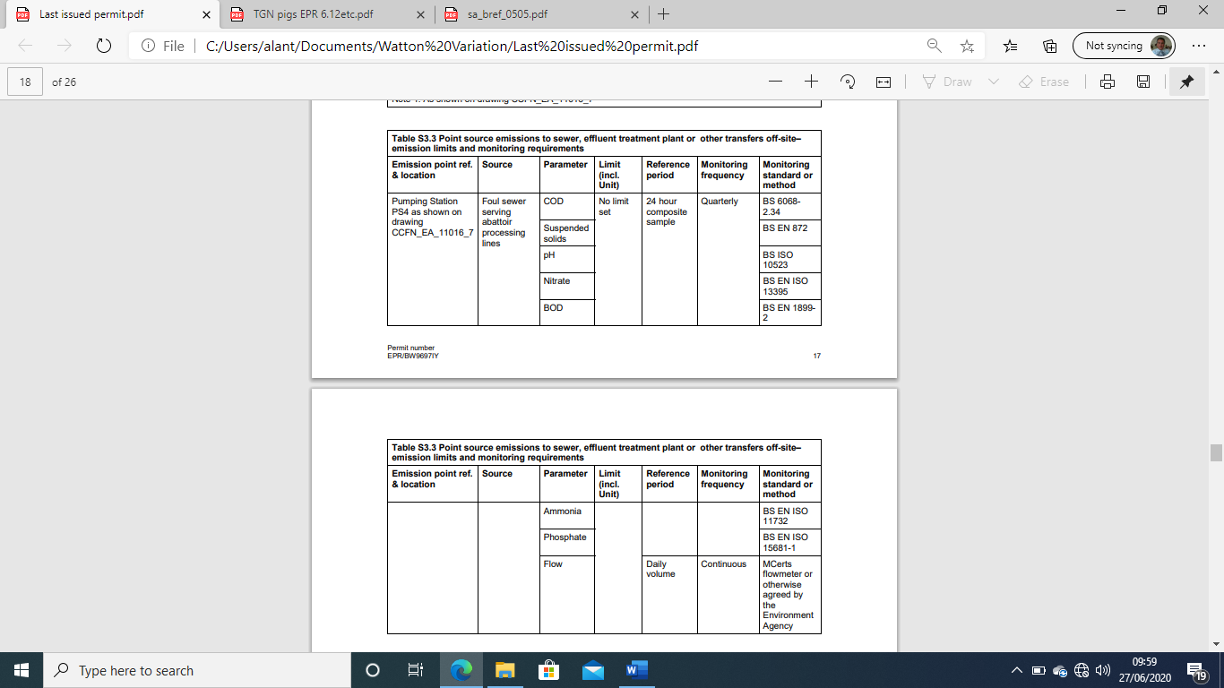

The proposed effluent treatment plant installation, as described elsewhere in this permit variation application, will introduce a new point source emission point to surface water (the effluent treatment plant discharge to Watton Brook designated W22).
The proposed effluent treatment plant installation will introduce a new point source emission point to air (air extraction from the new effluent treatment plant building designated F29).
There will be two further emission points to air introduced in the form of vent points from two enclosed storage tanks, one tank being an emergency diversion storage tank for waste water (vent release point designated F30) and the other being a buffer storage tank for waste bio-sludge prior to dewatering (vent release point designated F31). The emissions from these vessels are not continuous as the tanks are not designed for continuous use.
The emergency diversion tank is designed to hold raw effluent on a temporary basis in circumstances when the ETP if off line (eg.in the event of a breakdown or for maintenance purposes) or to hold treated effluent which fails to meet the required discharge quality standard and therefore requires reprocessing or removal from site. The tank is fitted with aeration diffusers to prevent stagnation of the contents when the tank is in service. The maximum air displacement rate from the tank is 2200 m³/hour
The sludge buffer tank is designed to hold waste bio-sludge on a temporary basis where direct feed to the dewatering plant is not possible (eg. if the decanting centrifuge is offline due to a breakdown or for maintenance purposes).
There are no release points associated with other large vessels which form part of the ETP (eg. denitrification – aeration tank, sand and activated carbon tertiary treatment tanks) which are of open top construction.
There will be no changes to or removal of existing emission point locations to air or water as a result of the ETP installation and the quantity and composition of emissions from the existing emission points will be unchanged.
The emission point to sewer / off-site disposal described in table S3.3 will be removed and waste water currently disposed of via this route will be treated in the proposed effluent treatment plant.
The replacement steam raising boiler is now used as the primary boiler and will typically operate for around 8400 hours per year at an annual average 33% load. The location of the boiler and associated combustion gas exhaust flue remains unchanged (air emission point F2 in the environmental permit). The boiler exhaust gases are vented to atmosphere via a 13m high 450 mm diameter chimney stack.
The new point source emission points are located as shown on the site plans reference 19-L27-IP006 (releases to water) and 19-L27-IP007 (releases to air) provided at Section C2.5a (Site Plans) of the permit variation application.
Existing emission points to air and water are shown on the site plans Existing Air Emissions Points Plan Ref AEPP and Existing Water Emissions Points & Drainage Plan Ref WEPP which are also included in Section C2.5a, Site Plans, of the permit variation application.
The tables below identify all additional and changed point source emission points to air, water and sewer by reference to the locations indicated on the above drawings along with the source of each emission. Where relevant the tables show the substances which will be emitted, the anticipated concentration and/or mass release rate of each substance emitted and the units in which the concentrations and/or mass release rates will be measured.
Where emissions from a particular point source emission point are controlled using abatement equipment, “abated” is entered into the column headed “expected emission concentration and/or mass release rate including unit of measurement”
The concentrations / mass release rates are also used, where relevant, as input data for the H1 environmental risk screening assessment included in Section C2.6 (Environmental Risk Assessment) of the application.

New / Changed Point Source Emissions to Air
Emission point reference | Source | Substances emitted / parameter measured | Worst case emission concentration and/or mass release rate including unit of measurement
F2 | Exhaust flue from replacement boiler (continuous release) | CO, NO, NO₂ | CO = 5 mg/m³ S/T, 1.7 mg/m³ L/T  NO = 50 mg/m³ S/T  NO₂ = 50 mg/m³ S/T, 33 mg/m³ L/T
F29 | Air extraction from ETP Building (continuous release) | H₂S, NH₃, VOC | H2S - 2.5 mg/m³ S/T  NH3 – 1.5 mg/m³ S/T  VOC – 6 mg/m³ S/T  Abated (activated carbon adsorption)
F30 | Emergency diversion tank vent (infrequent and sporadic release) | H₂S, NH₃, VOC (possible) (dealt with as fugitive odour emission sources) | (unspecified due to non-continuous and sporadic nature of release)
F31 | Sludge buffer tank vent (occasional and sporadic release) | H₂S, NH₃, VOC (possible) (dealt with as fugitive odour emission sources) | (unspecified due to non-continuous and sporadic nature of release)

Table notes
F2 – CO emission concentrations reflect actual measured values.
F2 – NO and NO₂ emission concentrations reflect maximum short term allowable concentrations, with 100% conversion of NO to NO₂ and taking into account boiler plant annual loading rate for long term values.
F2 – Methane used as a surrogate for VOC’s in H1
F29 – Based on actual measured worst case values for similar application at a sister plant
F30 / F31 – dealt with as fugitive sources and monitored in accordance with odour management plan due to non-continuous and sporadic nature of release.

Further details relating to monitoring of releases into air are provided in Section C3.4a, Emissions Monitoring, of the permit variation application.
Further details relating to the control and monitoring of odorous emissions are provided in section C3.3b (General Requirements) of the permit variation application.

New / Changed Point Source Emissions to Water
Emission point reference | Source | Substances emitted / parameter measured | Worst case emission concentration and/or mass release rate including unit of measurement
W22 | New effluent treatment plant discharge to Watton Brook | C.O.D.  B.O.D.  Suspended solids  Total Iron  Total Phosphorus  Ammoniacal Nitrogen  TKN  Free oil and grease  Chloride (3)  Sulphate (3)  Alkyl dimethyl amine oxide (1)  Alcohol ethoxylates (1)  N(3-aminopropyl)-N-dodecylpropane-1,3-diamine (1)  dodecan-1-ol (1)  Sodium alkyl ether sulphate (1)  5-Chloro-2-Methyl-4-isothiazolin-3-one (1)  Sodium 4(or 5)-methyl-1H-benzotriazolide (1)  Bronopol (2-bromo-2-nitro-1,3-propanediol) (1)  Polymer of epichlorohydrin and dimethylamine (1)  Cadmium (2)  Mercury (2) | 40 mg/l (max ref ETP spec)  10 mg/l (max ref ETP spec)  15 mg/l (max ref ETP spec)  2 mg/l (max ref ETP spec)  2 mg/l (max ref ETP spec)  3 mg/l (max ref ETP spec)  20 mg/l (max ref ETP spec)  5 mg/l (max ref ETP spec)  400 mg/l (calculated)  139 mg/l (calculated)  58 ug/l (calculated)  14 ug/l (calculated)  510 ug/l (calculated)  240 ug/l (calculated)  580 ug/l (calculated)  14 ug/l (calculated)  52 ug/l (calculated)  117 ug/l (calculated)  117 ug/l (calculated)  0.0030 ug/l (calculated)  0.0034 ug/l (calculated)

Table foot note 1 : These materials are contained in hygiene chemicals and boiler water chemicals used at the site. Values are based on an annual effluent discharge rate of 290,000 m³ and maximum annual usage rates of hygiene / boiler water chemicals (see supporting document entitled Hygiene and Boiler Chemicals etc Impact Assessment ref WIAW).
Table foot note 2 : Cadmium and mercury present adventitiously in hygiene chemicals (see document reference WIAW)

As part of the development the site intends to install automatic sampling equipment at the ETP outfall and, in addition to in house sampling and analysis for process control purposes, will routinely send effluent samples to a third party specialist water analysis laboratory for release limit compliance testing purposes. The auto-sampling equipment may be set to operate on a 24 hour flow proportional or timed basis. Routine samples taken for release limit compliance purposes will be flow proportional based.
Further details relating to monitoring of emissions to water are provided in Section C3.4a, Emissions Monitoring, of the permit variation application.

In addition to releases from point sources, fugitive releases may occur for example, as a result of accidents and incidents, failure or maloperation of equipment and infrastructure during the course of normal operations, and incorrect actions taken during process upsets and during maintenance operations. Fugitive releases are prevented as far as possible and otherwise reduced to the lowest possible level by;
- designing plant, equipment and infrastructure to appropriate standards in order to minimise the risk of failure
- designing plant, equipment and infrastructure including operating systems so as to avoid failure due to human error
- ensuring that all staff who manage, operate and maintain plant, equipment and infrastructure are competent to do so
- implementing operating techniques including documented management systems that are consistent with best available techniques as defined in TGN EPR 6.12 (The Red Meat(Cattle, Sheep and Pigs) Sector) issued by the Environment Agency and relevant parts of the European BAT reference document for Slaughterhouses and Animal By-products Industries, including techniques to prevent uncontrolled releases where possible and to limit their escalation and mitigate their consequences if they do occur.
Further information relating to plant, equipment and infrastructure design standards is provided in Section C3.1 (Activities to be Varied) of the permit variation application. Further information relating to management systems and operating techniques is provided in Sections C2.3d (Management Systems) and C3.3/C3.3a1a (Operating Techniques and Technical Standards) of the application. Further information relating to monitoring for the purpose of detecting the effects of fugitive emissions (in particular odour and noise emissions) is provided in Section C3.3b (General Requirements) of the application.

