Project No: 312192

Non-Technical Summary (SUN_NTS[TH])

Prepared for:

Stowmarket Skips Ltd T/A Sun Skips
Alpha 3
The Buntings
Cedar Park
Stowmarket
Suffolk
IP14 5GZ

Contents Amendment Record

This report has been issued and amended as follows:

Revision | Description | Date | Signed
1.0 | Final | February 2023 | Graeme Kennett

Acknowledgement

This report has been prepared for the sole and exclusive use of Stowmarket Skips Limited (t/a Sun Skips) in accordance with the scope of work presented in Mabbett & Associates Ltd (Mabbett) Letter Agreement (312192/LA/GK), dated 21 October 2023. This report is based on information and data collected by Mabbett. Should any of the information be incorrect, incomplete or subject to change, Mabbett may wish to revise the report accordingly.

This report has been prepared by the following Mabbett personnel:

MABBETT & ASSOCIATES LTD

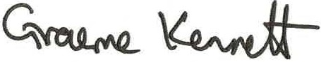
___________________________________
Graeme Kennett, BSc (Hons)., MSc., MBPR (FACTS)
Principal Environmental Consultant

This report has been reviewed and approved by the following Mabbett personnel:

MABBETT & ASSOCIATES LTD

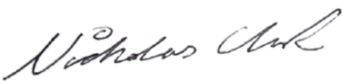
___________________________________
Nicholas Clark, MEng, AMIChemE
Environmental Engineer

Table of Contents
Section 1.0: Introduction 1
Section 2.0: About the Facility 3
2.1 The Site 3
2.2 The Operation 4
Section 3.0: Summary of Permitted Waste Types 5
3.1 Permitted Waste Types 5
Section 4.0: Proposed Activities 6
4.1 Crushing 6
4.2 Screening/Sorting 6
4.3 Handling Equipment 6
4.4 Storage (Pre-Treatment) 6
4.5 Storage (Post Treatment) 7
Section 5.0: Operating Techniques 8
5.1 Operating Techniques 8
5.1.1 Operational management procedures will ensure that: 8
Section 6.0: Impact on the Environment 9
6.1 Noise 9
6.2 Dust 9
6.3 Drainage System 10
Section 7.0: Site Management 11
Section 8.0: Site Condition Report 12
Appendix A: Proposed Waste Types 13
Appendix B: Aggregate Quality Protocol (AQP) Waste Types 16
Appendix C: Permit Boundary 18
Appendix D: Process flow 19
Appendix E: Technical Competence 20

Introduction

Stowmarket Skips Limited (Sun Skips), ‘the operator’, has instructed Mabbett & Associates Ltd to prepare a bespoke permit application, under the Environmental Permitting (England and Wales) Regulations 2016 (as amended), for an Inert Recycling Site (IRS) at:

THETFORD RECOVERY SITE
5C Burrell Way
Thetford
Norfolk
IP24 3RW
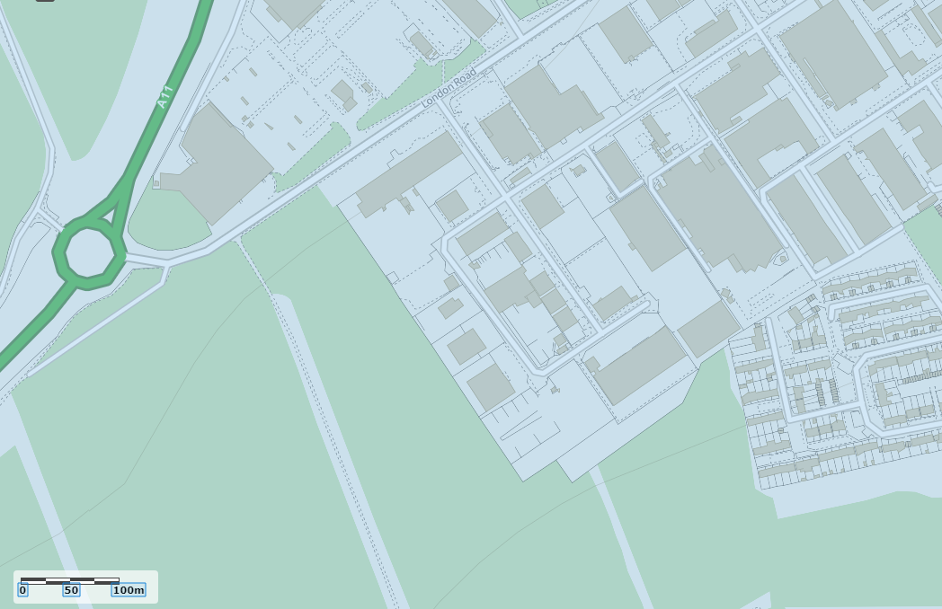

TL 85370 81893

(c) Crown Copyright and database rights 2022. Ordnance Survey 100022861.

Figure 1 Site Location

Sun Skips are proposing to operate a waste operation at the site for the processing of;
- Inert materials
- Soils
- Trommel fines
The processing will consist of the following activities;
- Screening (trommeling)
- Crushing
- Washing

The activity does not fall under a Standard Rules permit due to;
- Proximity to a sensitive receptor [Breckland Forest SSSI (1008292)]
- Annual tonnage
- Activities. i.e., washing
- Additional EWC codes

This Non-Technical Summary explains the application, in non-technical language as far as possible and using images where appropriate, to provide an overview of the proposed operation and its surroundings. This document should be read in conjunction with the rest of this application which also contains:
- Application Forms (submitted on-line)
- Supporting Information
- Operating Techniques Document
- Environmental Risk Assessment.

A more detailed explanation of the activity is provided in the accompanying documents along with a site-specific risk assessment. Information is also provided in the application concerning the key technical standards and control measures that will be used at the site to minimise the environmental risks identified in the risk assessment.

About the Facility

The Site
Thetford Recovery Facility, centred at Ordnance Survey grid reference TL 85370 81893, is located on a busy industrial estate to the south-east of Thetford in Norfolk. Thetford is a market town and civil parish in the Breckland District of Norfolk on the A11 road between Norwich and London, just east of Thetford Forest.

The site is a former skip and compactor manufacturing business and consists of a large clear span portal framed building and an impermeable surface. Improvements to be made to the drainage system include the installation of surface water gutters and a large capacity sump for the collection of surface water. The surface water will be used in the aggregate washing plant and dust suppression equipment after suitable treatment. Excess water will either be tankered off for treatment or released to the combined sewer via a Trade Effluent Consent from Anglian Water.

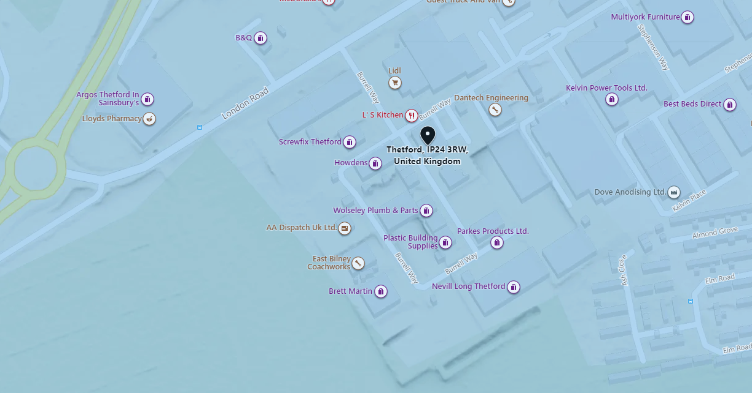

Figure 2 Site location and nearby receptors

The site is bounded by:
- a busy industrial estate to the south and east, subject to a variety of uses including waste management operation;
- a retail park and the main A11 to the north, and
- Breckland Forest SSSI approximately 10 m to the west of the site.

The site lies within:
- a Drinking Water Safeguard Zone for Groundwater (GWSGZ0003); and
- a groundwater Source Protection Zone 1 .

There are no identified surface waters within 1 500m of the site.

The permitted activities are carried out within 500 metres of a Site of Special Scientific Interest (SSSI) but are not within a specified Air Quality Management Area (AQMA).

The permitted activities are not carried out within:
- 10 m of any watercourse;
- 50 m from any spring or well, or from any borehole not used to supply water for domestic or food production purposes;
- 50 m from any well, spring or from any borehole used for the supply of water for human consumption, including private water supplies;
- 250 m within the presence of Great Crested Newts, where it is linked to the breeding ponds of the newts by good habitat;
- 50 m of a site that has relevant species or habitats protected under the Biodiversity Action Plan that the Environment Agency considers at risk to this activity; and
- 50 m of a National Nature Reserve (NNR), Local Nature Reserves(LNR), Local Wildlife Site (LWS), Ancient Woodland or Scheduled Ancient Monument.

The Operation
The permit will allow Stowmarket Skips Limited as the operator, to store waste at the Thetford Recycling Site and treat it to produce soil, soil substitutes and aggregate. The permitted wastes do not include hazardous wastes and it is proposed that the total quantity of waste that can be stored and subsequently treated at the site under the permit does not exceed 100,000 tonnes annually.

The recovery operations do not include the burning of any wastes, either in the open, inside buildings or in any form of incinerator.

The Thetford Recovery Facility will process suitable incoming waste materials for either:
- Production of products, in line with the relevant Aggregate Quality Protocol (AQP);
- Despatched from site as a waste for use by third parties under a suitable exemption/waste management operation, or
- As a material conforming to RPS190 Use of manufactured topsoil: RPS 190 - GOV.UK (www.gov.uk).

Summary of Permitted Waste Types

Permitted Waste Types
Unless stated otherwise, all waste shall be stored and treated on an impermeable surface with a sealed drainage system.

The waste types, listed in Appendix A of this Non-Technical Summary, reflect those listed in Standard Rules permits SR2010_No12 (v6.0) and SR2015_No4 (v2.0) with an additional EWC code highlighted.

Proposed Activities

The activities carried out at the site as defined under Annex II of the Waste Framework Directive can be summarised as follows:

Table 1 Proposed waste activities

Activity | Code
Blending | R3 - Recycling or reclamation of organic substances which are not used as solvents.
Crushing | R5 – Recycling or reclamation of other inorganic materials.
Screening | R5 – Recycling or reclamation of other inorganic materials.
Sorting | R5 – Recycling or reclamation of other inorganic materials.
Washing | R5 – recycling or reclamation of other inorganic materials.
Storage | R13 – storage of wastes pending any of the operations numbered R1 to R12.

Crushing
This will be carried out using a mobile crusher (example image below).

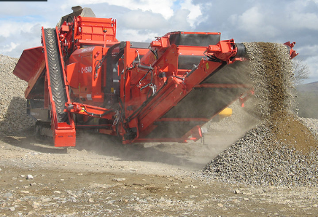

Figure 2 Mobile crusher

Screening/Sorting
This will be carried out using screening equipment (example images below).
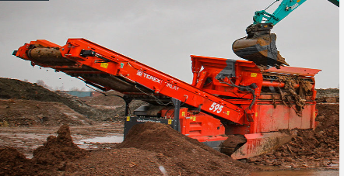

Figure 3 Screening equipment

Wash plant
This will consist of the following

- Hopper fitted with double deck live head
- Feed conveyor
- AggReclaim wet system
- Sand conveyor
- Effluent sump & pump
- Water tank with supply pump
- Two refurbished metal settlement tanks (roll on roll off type)
- Clarified water return pump
- Fines Reclaim unit
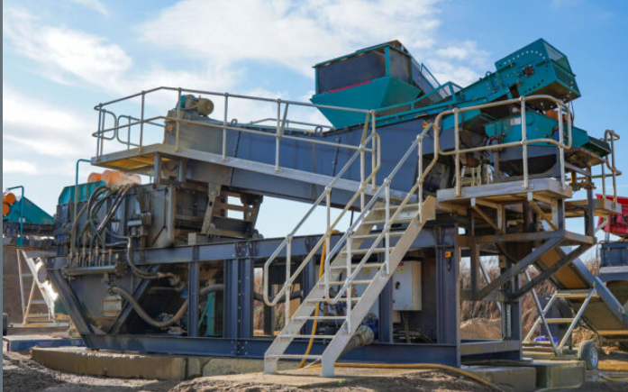

Handling Equipment
This will be carried out using handling equipment (example images below).
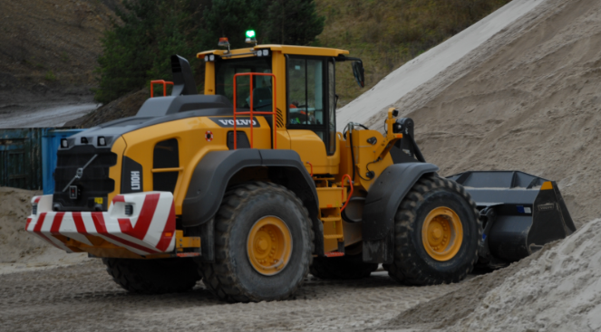

Figure 4: Loading shovel
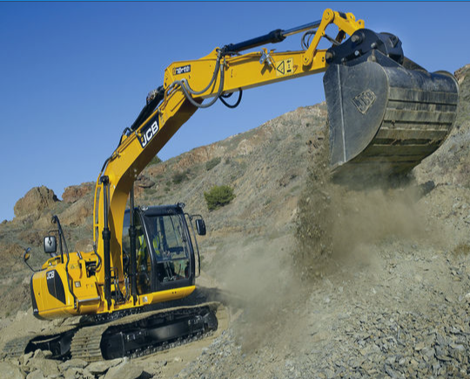

Figure 5: 360 excavator

Storage (Pre-Treatment)
Prior to processing, the incoming waste materials will be stored within the permit boundary in designated storage areas. Waste shall be stored and treated on an impermeable surface with a sealed drainage system.

Storage (Post Treatment)
After processing, the recovered materials will be stored awaiting dispatch from site. Materials that are Aggregate Quality Protocol (AQP) compliant do not need to be stored within the permit boundary.

Operating Techniques

Operating Techniques
The site will be operated in accordance with the Operating Techniques document which has been drafted to satisfy the requirements of EA Guidance, and details the following:
- Operational management procedures;
- site operations;
- emissions and monitoring; and
- information.

Operational management procedures will ensure that:
- the risks that the activities pose to the environment are identified;
- the measures that are required to minimise the risks are identified;
- the activities are managed in accordance with the management system and operating techniques document;
- performance against the management system is audited at regular intervals; and
- compliance with the environmental permit.

The risk management and mitigation measures employed at the site and identified in the environmental risk assessment are detailed in the sites operating techniques document.

In summary, the rules and operating procedures employed at the site will ensure the following with respect to the specified waste management activities:
- Unless stated otherwise, all waste will be stored and treated on an impermeable surface with sealed drainage system.
- Concrete surfacing falls towards drainage channels ensuring that potentially contaminated runoff is contained on site and directed to the sump.
- Strict waste acceptance procedures will be adhered to, to ensure only permitted wastes are accepted on site.
- The site manager will ensure that regular inspections are made of the site. If necessary, remedial measures will be arranged as soon as possible.

Impact on the Environment

An environmental risk assessment (ERA) has been carried out to assess the environmental risks posed by the proposed activity.

There are no point source emissions to land, air, surface or groundwater from the proposed facility.

Operational procedures at the site will monitor and manage amenity and accident risks from the proposed activities and includes provision for the monitoring of odour, noise, and fugitive emissions.

As the management measures detailed in the risk assessment will be in place at permit issue, the conclusion has been reached that the proposed waste materials and treatment activities, are unlikely to result in a significant accident risk or risk to the local environment, including from odour and noise, or pollution of surface or ground waters.

Noise
A noise assessment has been carried out that has shown that the rated level of noise generated by the soil washing plant and crusher does not exceed the typical background sound level at the closest residential receptor during the proposed operating hours.

The assessment has shown that, following installation of an acoustic fence on the western Site boundary with the SSSI, the change in ambient noise level will not exceed the permissible change of +2.9dB.

The predicted level of noise from the Development is sufficiently low enough at the closest residential dwelling and at the SSSI to accord with the ‘No Observed Adverse Effect Level’ as detailed in the PPG and as such noise should not be deemed to be a determining factor in the granting of planning permission for this Site.

Dust
A Dust Assessment was undertaken to evaluate potential impacts and specify the requirement for any mitigation.

The risk of potential effects because of fugitive dust emissions from the facility during the operational phase was assessed using the IAQM methodology. This included consideration of the source emission potential, pathway effectiveness and sensitivity of relevant receptors in the vicinity of the site. The results of the assessment indicated the overall effects as a result of the development were predicted to be not significant.
Based on the assessment results, air quality issues are not considered a constraint to planning consent for the proposed development.

Drainage System
Drainage infrastructure is in place so that all potentially contaminated run-off is captured.

Run-off is directed via a drainage system, consisting of concrete impermeable pavement with falls towards concrete drainage channels. The drainage channels capture all liquids and direct them to a sealed, underground tank. ensuring that potentially contaminated runoff is contained on site.

Site Management

Site management will comprise of the following staff members:
- A Technically Competent Manager (TCM); who will manage the operation and regularly attend site in compliance with the defined attendance requirement.
- A site supervisor; who will be responsible for the ongoing operation who may also undertake office and plant operation duties; and
- Other trained plant operators as required.

Site Condition Report

A Site Condition Report (SCR) has been produced for this application.

The facility will operate with due regard to the conditions of the environmental permit and all relevant environmental legislation to ensure that land and groundwater is protected during the lifetime of the site and that the land is in a satisfactory state when the permit is eventually surrendered.

The possibility of any significant releases to the ground occurring during the lifetime of the permit is limited. Minor spillages, if they occur, are dealt with immediately by trained staff using appropriate spill response procedure and spill kits located around the site.

Appendix A: Proposed Waste Types

01 | WASTES RESULTING FROM EXPLORATION, MINING, QUARRYING AND PHYSICAL AND CHEMICAL TREATMENT OF MINERALS
01 04 | wastes from physical and chemical processing of non-metalliferous minerals
01 04 08 | waste gravel and crushed rocks other than those mentioned in 01 04 07
01 04 09 | waste sand and clays
02 | WASTES FROM AGRICULTURE, HORTICULTURE, AQUACULTURE, FORESTRY, HUNTING AND FISHING, FOOD PREPARATION AND PROCESSING
02 02 | waste from preparation and processing of meat, fish and other foods of animal origin
02 02 02 | shellfish shells from which the soft tissue or flesh has been removed only
02 04 | wastes from sugar processing
02 04 01 | soil from cleaning and washing beet
03 | WASTES FROM WOOD PROCESSING AND THE PRODUCTION OF PANELS AND FURNITURE, PULP, PAPER AND CARDBOARD
03 01 | wastes from wood processing and the production of panels and furniture
03 01 01 | waste bark and cork
03 03 | wastes from pulp, paper and cardboard production and processing
03 03 01 | waste bark and wood
10 | WASTES FROM THERMAL PROCESSES
10 01 | waste from power stations and other combustion plants
10 01 01 | bottom ash and slag only
10 01 02 | pulverised fuel ash only
10 01 03 | fly ash from peat and untreated wood
10 01 05 | gypsum (solid) only
10 01 07 | gypsum (sludge) only
10 01 15 | bottom ash and slag only from co-incineration other than those mentioned in 10 01 14
10 01 24 | sands from fluidised beds
10 11 | wastes from manufacture of glass and glass products
10 11 12 | clean glass other than those mentioned in 10 11 11
10 12 | wastes from manufacture of ceramic goods, bricks, tiles and construction products
10 12 08 | waste ceramics, bricks, tiles and construction products (after thermal processing)
10 13 | wastes from manufacture of ceramic goods, bricks, tiles and construction products
10 13 14 | waste concrete only
15 | WASTE PACKAGING
15 01 | packaging
15 01 07 | glass packaging
17 | CONSTRUCTION AND DEMOLITION WASTES (INCLUDING EXCAVATED SOIL FROM CONTAMINATED SITES)
17 01 | Concrete, bricks, tiles and ceramics
17 01 01 | concrete
17 01 02 | bricks
17 01 03 | tiles and ceramics
17 01 07 | mixtures of concrete, bricks, tiles and ceramics other than those mentioned in 17 01 06
17 02 | Wood, glass and plastic
17 02 02 | glass
17 03 | Bituminous mixtures, coal tar and tarred products
17 03 02 | bituminous mixtures other than those mentioned in 17 03 01
17 05 | Soil (including excavated soil from contaminated sites), stones and dredging spoil
17 05 04 | soil and stones other than those mentioned in 17 05 03
17 05 06 | dredging spoil other than those mentioned in 17 05 05
17 05 08 | track ballast other than those mentioned in 17 05 07
17 08 | gypsum based construction material
17 08 02 | gypsum only other than that mentioned in 17 08 01
17 09 | other construction and demolition wastes
17 09 04 | mixed construction and demolition wastes other than those mentioned in 17 09 01, 17 09 02 and  17 09 03
19 | WASTES FROM WASTE MANAGEMENT FACILITIES, OFF SITE WASTEWATER TREATMENT PLANTS AND PREPARATION OF WATER INTENDED FOR HUMAN CONSUMPTION / INDUSTRIAL WASTE
19 01 | wastes from incineration or pyrolysis of waste
19 01 12 | bottom ash and slag other than those mentioned in 19 01 11
19 05 | wastes from aerobic treatment of solid waste
19 05 03 | compost from source segregated biodegradable waste only
19 08 | wastes from wastewater treatment plants not otherwise specified
19 08 02 | washed sewage grit (waste from desanding) free from sewage contamination only
19 08 99 | stone filter media if free from sewage contamination only
19 09 | wastes from the preparation of water intended for human consumption or water for industrial use
19 09 02 | sludges from water clarification
19 12 | wastes from the mechanical treatment of wastes
19 12 05 | clean glass only
19 12 09 | minerals (for example sand, stones)
19 12 12 | other wastes (including mixtures of materials) from mechanical treatment of wastes other than those mentioned in 19 12 11
19 12 12 | treated bottom ash including IBA and slag other than that containing dangerous substances only
19 13 | wastes from soil and groundwater remediation
19 13 02 | solid wastes from soil remediation other than those mentioned in 19 13 01
19 13 04 | sludges from soil remediation other than those mentioned in 19 13 03
20 | MUNICIPAL WASTES (HOUSEHOLD WASTE AND SIMILAR COMMERCIAL, INDUSTRIAL AND INSTITUTIONAL WASTES) INCLUDING SEPARATELY COLLECTED FRACTIONS
20 01 | separately collected fractions (except 15 01)
20 01 02 | clean glass only
20 02 | garden and park wastes (including cemetery waste)
20 02 02 | soil and stones
20 03 | Other municipal wastes
20 03 03 | street cleaning residues (including gully wastes)

Appendix B: Aggregate Quality Protocol (AQP) Waste Types

EWC | Waste description | Comments
01 04 08 | Waste gravel and crushed rocks other than those mentioned in 01 04 07 | May include excavation from mineral workings
01 04 09 | Waste sand and clays | Must not include contaminated sand
10 11 03 | Waste glass-based fibrous materials | Allowed only if:  - Wastes without organic binders
15 01 07 | Glass packaging
17 01 01 | Concrete | May not include concrete slurry
17 01 02 | Bricks
17 01 03 | Tiles and ceramics
17 01 07 | Mixtures of concrete, bricks, tiles and ceramics, other than those mentioned in 17 01 06
17 02 02 | Glass | Must not include fibreglass or glass fibre
17 03 02 | Bituminous mixtures other than those mentioned in 17 03 01 | Allowed only if:  - Bituminous mixtures from the repair and refurbishment of the asphalt layers of roads and other paved areas (excluding bituminous mixtures containing coal tar and classified as waste code 17 03 01).  - Must not include coal tar or tarred products.  Must not include freshly mixed bituminous mixture
17 05 04 | Soil and stones other than those mentioned in 17 05 03 | Must not contain and contaminated soil or stone from contaminated sites.
17 05 06 | Dredging spoil other than those mentioned in 17 05 05 | Allowed only if:  • Inert aggregate from dredgings.  • Must not contain contaminated dredgings.  • Must not contain fines.
17 05 08 | Track ballast other than those mentioned in 17 05 07 | Allowed only if:  • Does not contain soil and stoned from contaminated sites.
17 09 04 | Mixed construction and demolition wastes other than those mentioned in 17 09 01, 17 09 02 and 17 09 03 | Allowed only if:  - The waste is generated from utilities trenchings.  - The waste consists of sub-base aggregates i.e., granular material.  The waste contains only materials that would be described by entries 17 01 01, 17 03 02 and 17 05 04 in this if the waste was not mixed.
19 12 05 | Glass | Does not include glass from cathode ray tubes
19 12 09 | Minerals (for example sand, stones) | Must not contain contaminated concrete, bricks, tiles, sand, stone or other gypsum from  recovered plasterboard
20 01 02 | Glass | Must not include fibreglass or glass fibre

Appendix C: Permit Boundary

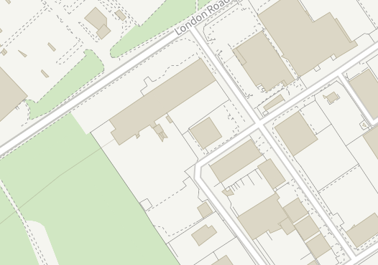

Appendix D: Process flow

Appendix E: Technical Competence

Legal operator and competence requirements: environmental permits - GOV.UK (www.gov.uk)
SSSI detail (naturalengland.org.uk)
LIT_8709_c60600.pdf (publishing.service.gov.uk)
The Resource Framework for Aggregates, that will replace the AQP, is currently under discussion.
Non-hazardous and inert waste: appropriate measures for permitted facilities - Guidance - GOV.UK (www.gov.uk)

