Project No: 312192

Environmental Risk Assessment (SUN_ERA[TH])

Prepared for:

Stowmarket Skips Ltd T/A Sun Skips
Alpha 3
The Buntings
Cedar Park
Stowmarket
Suffolk
IP14 5GZ

Contents Amendment Record

This report has been issued and amended as follows:

Revision | Description | Date | Signed
1.0 | Final | February 2023 | Graeme Kennett

Acknowledgement

This report has been prepared for the sole and exclusive use of Stowmarket Skips Limited (Sun Skips) in accordance with the scope of work presented in Mabbett & Associates Ltd (Mabbett) Letter Agreement (312192/LA/GK), dated 21 October 2023. This report is based on information and data collected by Mabbett. Should any of the information be incorrect, incomplete or subject to change, Mabbett may wish to revise the report accordingly.

This report has been prepared by the following Mabbett personnel:

MABBETT & ASSOCIATES LTD

___________________________________
Graeme Kennett, BSc(Hons)., MSc., MBPR (FACTS)
Principal Environmental Consultant

This report has been reviewed and approved by the following Mabbett personnel:

MABBETT & ASSOCIATES LTD

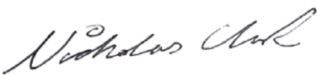

___________________________________
Nicholas Clark, MEng, AMIChemE
Environmental Engineer

Table of Contents
Section 1.0: Introduction 1
1.1 Site Setting 1
1.2 Operational Background 1
1.3 The Operation 2
1.4 Risks from the Site 2
1.5 Risks from noise and vibration 3
1.6 Identify risk of accidents 3
1.7 Identify Receptors 3
Section 2.0: Summary of key parameters 5
Section 3.0: Summary List of Environmental Receptors 6
Section 4.0: Summary List of Sensitive Receptors 8
Section 5.0: Risk Criteria Rating 9
Section 6.0: Impact on the Environment 19
Section 7.0: Site Management 20
Section 8.0: Site Condition Report 21
Section 9.0: Sources of information 22
Appendix A: Sensitive Ecological Receptor Plan 23
23
Appendix B: Identified Sensitive Receptor Plan 24
24

Introduction

Stowmarket Skips Limited (Sun Skips), ‘the operator’, has instructed Mabbett & Associates Ltd to prepare a bespoke permit application, under the Environmental Permitting (England and Wales) Regulations 2016 (as amended), for the proposed Inert Recovery Site (IRS) at;
THETFORD RECOVERY FACILITY
5C Burrell Way
Thetford
Norfolk
IP24 3RW

Site Setting
Thetford Recycling Site, centred at Ordnance Survey grid reference TL 85370 81893, is located on a busy industrial estate to the south-east of Thetford in Norfolk. Thetford is a market town and civil parish in the Breckland District of Norfolk on the A11 road between Norwich and London, just east of Thetford Forest.

The site is a former skip and compactor manufacturing business and consists of a large clear span portal framed building and an impermeable surface.

Operational Background
The recycling site will process construction and demolition, and other suitable producers’ waste materials for either:
- Production of saleable product in accordance with the Aggregate Quality Protocol (AQP);
- Production of saleable product in accordance with RPS190; or
- Despatch from site as a waste for use by third parties under a suitable exemption/ waste management operation.

There are no other waste related activities taking place on the site.

The proposed operation has the potential to cause air quality impacts because of fugitive dust emissions associated with the operation of the facility, as well as road traffic exhaust emissions from vehicles travelling to and from the site. An Air Quality Assessment (AQA) was therefore undertaken to determine baseline conditions and consider potential effects because of the proposals. The potential effects and control measures are contained in the following risk assessment and the separate Dust & Emissions Management Plan (DEMP) document.

The Operation
The proposed WRF will process suitable incoming demolition and excavation materials for, either;
- Production in the Aggregate Quality Protocol (Resource Framework).
- Despatched from site as a waste for use under a suitable exemption/waste management operation.

Related activities taking place at the entire site are:
- The wash plant will also process ‘trommel fines’ to remove any soily/silty particles entrained within the fines.

This qualitative environmental risk assessment followed these steps;
- Identified and considered risks for the proposed site, and the sources of those risks.
- Identified the receptors (people, animals, property and anything else that could be affected by the hazard) at risk from the site.
- Identified the possible pathways from the sources of the risks to the receptors.
- Assessed risks relevant to the specific activity and checked that they are acceptable and can be screened out.
- States the measures in place to control risks if they are too high.

A copy of the risk assessment is contained within the management system.

Risks from the Site
The risk assessment identifies whether any of the following risks could occur and what the environmental impact could be:
- any discharge, for example sewage or trade effluent to surface or groundwater accidents;
- odour;
- noise and vibration;
- uncontrolled or unintended (‘fugitive’) emissions, e.g., dust, litter;
- visible emissions, e.g., visible dust plumes.

Where these are not considered to be significant risks, this is stated in the permit application.

For each risk that applies, each actual or possible hazard was identified and stated:
- the hazard, e.g., dust, litter, type of visible emission.
- the process that causes the hazard, e.g., screening and crushing inert waste.
- the receptors, e.g., people, animals, property and anything else that could be affected by the hazard.
- the pathways, i.e., how the hazard may get to a receptor.
- the measures that will be taken to reduce any risks.
- Probability of exposure, for example whether a risk is unlikely or highly likely.
- consequences, i.e., what harm could be caused.
- what the overall risk is, based on what has already been stated in the table, e.g., ‘low when management techniques are applied’.

Risks from noise and vibration
An assessment of predicted noise levels from the proposed following activities has been carried out for the planning permission and covered the following on-site operations;
- Washing,
- Crushing,
- Temporary storage of materials;

Identify risk of accidents
Examples of possible accidents include:
- Spillages during the transfer of substances, e.g., loading or unloading vessels.
- overfilling vehicle fuel tanks.
- plant or equipment failure, e.g., over pressurised tanks and hydraulic pipework.
- vandalism
- flooding
- inadequate bunding around tanks.

The risk of accidents was assumed that operator error will occur at least once every 100 times an operation is carried out, e.g.
- drop or damage a drum from a forklift.
- have a spillage from a tanker.

Identify Receptors
All the receptors that are potentially at risk from the site have been identified.

The main receptors that are potentially at risk were given the main focus, e.g., any groundwater beneath the site, and any other ecological and human receptors near the site were also considered.

These receptors included:
- protected sites and species
- anywhere used to grow food or to farm animals or fish
- drain and sewer systems
- factories and other businesses
- fields and allotments used to grow food
- footpaths
- groundwater beneath the site
- homes, or groups of homes (such as villages or housing developments)
- playing fields and playgrounds
- private drinking water supplies
- regionally important geological sites
- schools, hospitals and other public buildings
- water, e.g., ponds, streams, rivers, lakes or the sea
- conservation and habitats protected areas and areas of scientific interest (SSSIs, SPA, SAC, RAMSAR sites)

The risk assessment includes a scale plan (included in Appendix A) that shows:
- the site
- all the nearby receptors

Summary of key parameters

Table 1: Summary of Key Parameters
Parameter | Details
Facility | Thetford Recovery Facility
Operator | STOWMARKET SKIPS LIMITED (SUN SKIPS)
Permit ref | EPR/WE1138AC
Location | 5C Burrell Way  Thetford  Norfolk  IP24 3RW
NGR | TL 85370 81893
what3words | culling.love.trifling
Location of key environmental sites | See section 3.0
Risk assessment carried out by | Graeme Kennett
Date | February 2023
Risk Criteria Summary
Parameter 1 | The site operates crushing, screening, and washing plant to produce a range of aggregates for use in construction projects and substitute soils.  Waste is stored (R13) prior to and post-treatment.
Parameter 2 | Quantity of waste accepted at the facility <100,000 tonnes per annum.
Parameter 3 | All waste will be stored and treated on an impermeable surface with a sealed drainage system.
Parameter 4 | There are no point source discharges to controlled waters.
Parameter 5 | The activities are carried out within a groundwater source protection zone (SPZ)1, but not within 500 m of any well, spring, borehole used for the supply of water for human consumption, including private water supplies.
Parameter 6 | The treatment process is carried out within 250 m of the nearest sensitive receptor.
Parameter 7 | The treatment activity is carried out within 500 m of a European Site or a Site of Special Scientific Interest (SSSI).

Summary List of Environmental Receptors

Table 2:List of Environmental Receptors
Site name/description | Distance from site | Details
Designated and non-designated habitats and wildlife sites
Breckland Forest SSSI | <10 | An 18,126-hectaare biological and geological SSSI in many separate areas between Swaffham in Norfolk and Bury St Edmunds in Suffolk. It is part of the Breckland Special Protection Area under the EU Directive on the Conservation of Wild Birds. It contains two Geological Conservation Review sites, Beeches Pit, Icklingham and High Lodge.
Thetford Golf Course & Marsh SSSI | 1100 | A 122.3-hectare biological SSSI on the western outskirts of Thetford. It is a Nature Conservation Review site, Grade 2, and part of the Breckland Special Area of Conservation (SAC) and Special Protection Area (SPA).
Barnhamcross Common SSSI | 1200 | A 69.1-hectare biological SSSI on the southern outskirts of Thetford. It is owned by Thetford Town Council and is registered common land. It is also a Local Nature Reserve (LNR) and a Nature Conservation Review site, Grade 1. It is part of the Breckland SAC and SPA.  This grassland and heath common have diverse habitats and rich flora, including several nationally rare plants. There are nearly a hundred species of birds, including sixty which breed on the site, and a wide range of invertebrates.
Thetford Heaths SSSI | 1000 | A 270.6-hectare biological and geological SSSI. It is a Nature Conservation Review site, Grade I, and parts of it are a national nature reserve, and a Geological Conservation Review. It is part of the Breckland SAC and SPA. A large part of this dry heathland site is calcareous grassland, and some areas are grazed by sheep or rabbits. There are several nationally rare plants and an uncommon heathland bird, and many lichens and mosses.
Elm Road Field SSSI | 525 | A 5-hectare biological SSSI on the southern outskirts of Thetford.  This area of open space has grassland with a rich flora. There are several uncommon plants, including the nationally endangered field wormwood and the nationally scarce sickle medick and tower mustard. There are two mature Scots pine hedges.
Breckland SPA | <10 | A 39,433-hectare SPA under the EU Directive on the Conservation of Wild Birds. The SPA partly overlaps the 7,544-hectare Breckland SAC. As a landscape region it is an unusual natural habitat of England. It comprises the gorse-covered sandy heath that lies mostly in the south of the county of Norfolk but also in the north of Suffolk. An area of considerable interest for its unusual flora and fauna, it lies to the east of another unusual habitat, the Fens, and to the southwest of the Broads. The typical tree of this area is the Scots pine. Breckland is one of the driest areas in England.
Breckland SAC | 925 | As above
Priority habitat inventory
 |  | None
Groundwater and abstractors
 |  | N/A
Groundwater vulnerability
 |  | High (Soluble rock risk)
Source Protection Zones
 |  | SPZ I
Water protection zone and status
 |  | Drinking Water Safeguard Zones (Groundwater)
Soil classification
 |  | Freely draining sandy Breckland soils
Surface water
 |  | None within 1400m
Flood risk
 |  | Very low risk.
Air Quality Management Area (AQMA)
 |  | The site does not lie in an AQMA

Summary List of Sensitive Receptors

Table 3: Identified Environmental Receptors
# | Receptor | Type | Direction | Distance (m)
1 | Breckland Forest SSSI | Ecological | W | <10
2 | Thetford Golf Course & Marsh SSSI |  | N | 1100
3 | Barnhamcross Common SSSI |  | E | 1200
4 | Thetford Heaths SSSI |  | S | 1000
5 | Elm Road Field SSSI |  | SE | 525
6 | Breckland SPA |  | W | <10
7 | Breckland SAC |  | E | 925

Table 4: Identified Sensitive Human Receptors
# | Receptor | Type | Direction | Distance (m)
1 | Sainsbury’s | Retail | NW | 125
2 | Pets At Home | Retail | E | 250
3 | 2 Sisters | Commercial/Industrial | NE | 400
4 | Precision Refrigeration | Commercial/Industrial | E | 510
5 | East Bilney Coachworks | Commercial/Industrial | S | 150
6 | FCC Waste Transfer Station | Commercial/Industrial | SSE | 125
7 | FCC Waste Transfer Station | Commercial/Industrial | S | 225
8 | Ash Close | Residential | SE | 400
9 | Elm Road | Residential | E | 500

Risk Criteria Rating

Risk ratings are based on the likelihood of an event occurring multiplied by the severity of potential impact. Ratings are made of residual risk following implementation of preventative measures on site. The following scale is applied to rate these parameters:
Table 5: Calculated Risk Criterium
Severity |  | Likelihood
1 | No environmental harm arising | 1 | Very unlikely to happen
2 | Fleeting localised impacts | 2 | Low probability/occasional
3 | Localised impacts medium term | 3 | Likely to occur
4 | Wider scale impacts of a fleeting nature, or localised impacts of a more persistent nature | 4 | Highly likely to occur
5 | Widespread/persistent impacts on high amenity/sensitive sites | 5 | Inevitable

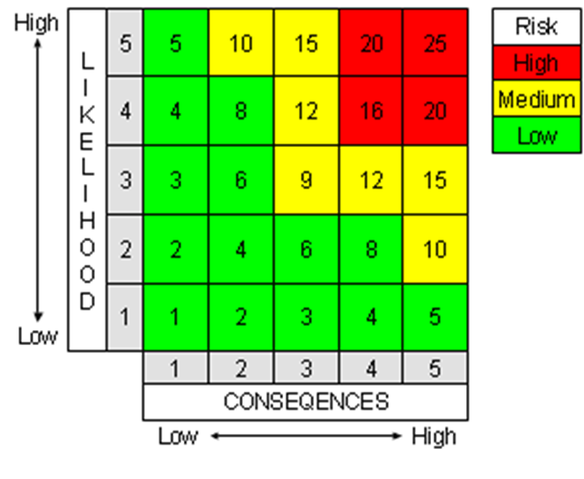
Figure 1: Risk Assessment Matrix

Table 6: Final Calculated Risk Levels
What do you do that can harm and what could be harmed? |  |  | Managing the risk | Assessing the risk
Hazard | Receptor | Pathway | Risk Management | Probability of exposure | Consequence | What is the overall risk?
What has the potential to cause harm? | What is at risk? What do I want to protect? | How can the hazard get to the receptor? | What measures will you take to reduce the risk? Who is responsible for what? | How likely is contact (1-5) | What is the harm that can be caused? (1-5) | What is the risk that still remains?  (Likelihood x Severity)
Release of dust (crushing) | Local human population | Air – windblown dispersion in the atmosphere | The crushing plant will be operational for an average of 4-hours a day to minimise dust generating activities.  The crushing plant will house spray bars to dampen down all areas of dust generation.  All personnel employed on site will undertake visual monitoring for dust throughout the working day. Any observed problems will be reported to the Site Manager (SM) who will investigate the cause and implement any necessary remedial action. | Very unlikely to happen  1 | Nuisance – dust on cars, clothing and inhalation of dusts  1 | Very low  1
Release of dust (screening) | Local human population | Air – windblown dispersion in the atmosphere | The screening plant will house spray bars to dampen down all areas of dust generation.  All personnel employed on site will undertake visual monitoring for dust throughout the working day. Any observed problems will be reported to the SM who will investigate the cause and implement any necessary remedial action. | Very unlikely to happen  1 | Nuisance – dust on cars, clothing and inhalation of dusts  1 | Very low  1
Dust from the movement of vehicles to and from the site | Local human population | Air – windblown dispersion in the atmosphere | Provision of an impermeable surface for the entire site and between Burrell Way and the operational area.  Site will have an imposed speed limit of 10mph.  Regular dampening down of all vehicle routes will be undertaken; | Very unlikely to happen  1 | Nuisance – dust on cars, clothing and inhalation of dusts  1 | Very Low  1
Mud on roads from the movement of vehicles to and from the site | Local human population | Deposited on the ground by vehicles entering and exiting the site | Provision of an impermeable surface for the entire site and between Burrell Way and the operational area.  Site will have an imposed speed limit of 10mph.  Regular dampening down of all vehicle routes will be undertaken; | Very unlikely to happen  1 | No environmental harm arising  1 | Low  1
Release of particulate matter from input material deliveries to, stored and despatched from site. | Local human population | Air – windblown dispersion in the atmosphere | Material arrives as inert wastes and are unlikely to generate dust.  All vehicles using the facility will ensure their loads are adequately sheeted or otherwise contained. Dampening down of stockpiles will be undertaken during loading periods, if required. | Very unlikely to happen  1 | Nuisance – dust on cars, clothing and inhalation of dusts  2 | Low  2
Input material may contain litter. | Local human population | Air – windblown dispersion in the atmosphere | Trommel fines may contain litter, material will be kept damp at all times to reduce the effects of litter being blown off-site.  Any office waste generated on site will be stored in sealed bins and removed from site on a regular basis to ensure that volumes of all types of waste do not accumulate on site.  Any litter is cleared from any affected areas outside the site as soon as possible. | Very unlikely to happen  1 | Nuisance – dust on cars, clothing and inhalation of dusts  1 | Low  1
 | Adjacent land
Odour from delivered input material | Local human population | Air – windblown dispersion in the atmosphere | Input material has a low propensity to produce, or release, odour. | Odours are unlikely to impact on local receptors as materials are non-odourous.  1 | Localised impacts medium term  1 | Low  1
Odour from the treatment process | Local human population | Air – windblown dispersion in the atmosphere | Treatment process has a low propensity to produce, or release, odour. | Odours are unlikely to impact on local receptors as materials are non-odourous.  1 | Localised impacts medium term  1 | Low  1
Odour from storage of input material in the process | Local human population | Air – windblown dispersion in the atmosphere | Input material has a low propensity to produce, or release, odour.  Trommel fines will not be stored for long periods of time before treatment. | Odours are unlikely to impact on local receptors as materials are non-odourous.  1 | Localised impacts medium term  1 | Low  1
Flies in waste | Local human population | Air | The input material is not susceptible to fly infestation. | Flies are unlikely to impact on local receptors as waste is not susceptible to fly infestation.  1 | Nuisance – unlikely  1 | Low  1
Rodent infestation | Local human and wildlife population | Over land | The input material is not it susceptible to rodent infestation. | Rodents are unlikely to impact on local receptors as waste is not susceptible to infestation.  1 | Nuisance – unlikely  1 | Low  1
Scavenging birds and animals | Local human and wildlife population | Over land and through the air | The input material is not it attractive to scavengers. | Scavengers are unlikely to impact on local receptors as waste is not attractive.  1 | Nuisance – unlikely  1 | Low  1
Noise from vehicle  movements/ deliveries | Users of highway,  local workplaces, and local dwellings. | Air | Vehicle movements are scheduled to occur Monday to Friday during normal working hours.  The SM is responsible for ensuring vehicles are turned around efficiently, with least impact on the neighbouring properties and that vehicles are removed from the surrounding roads quickly.  Plant (and site surfaces) to be maintained in good order and operated in a manner conducive to not generating unnecessary noise.  Reversing alarm sounders on site-based mobile plant to be of the non-tonal type, unless otherwise dictated by health & safety considerations. | Site located close to the A11 with good access to main routes. Location has good access for the highway.  Infrequent impact  to neighbours to  cause nuisance  2 | Nuisance from noise.  Duration should  be short as vehicle movements  reduced  1 | Low  2
Noise/vibration  from plant | Local human and wildlife population | Air | Plant (and site surfaces) to be maintained in good order and operated in a manner conducive to not generating unnecessary noise. | Very unlikely to happen  1 | Nuisance – from noise vibration  1 | Low  1
Delivery of input materials | Ground/groundwater/  surface water | Spillage  through ground | All deliveries will be supervised and will take place during normal working hours.  The input material is restricted to non-hazardous and inert wastes.  Deliveries take place only on a sealed, impermeable concrete area.  State of repair of the surface is monitored on a regular basis, and proactive maintenance carried out if necessary.  No liquid wastes accepted. | Low as supervised delivery procedure in place  .  1 | Pollution of  watercourse/  groundwater/land  3 | Low  3
Chemical  delivery | Ground/groundwater/  surface water | Spillage during  delivery to  drain/ground | Chemicals only stored with secondary containment.  No drains within building.  Low volumes kept on site.  No access to surface or ground water.  Risk of spillage/response to spillage dealt with in incident response plan. Tailored spill kit to be kept on site in the locality of deliveries. | Very unlikely to happen  1 | Pollution of  watercourse/  groundwater/land  4 | Low  4
Storage of small  volumes of  chemicals | Local environment | Spillage during  use or transferring | All chemicals are stored with lids or caps secured.  All chemicals are stored to ensure substances are not exposed to conditions that could cause a reaction and spillages are contained.  Chemicals are segregated as appropriate and stored in secondary containers to catch any small spillages. | Very low  volumes are kept  on site  Storage is  contained and  indoors  1 | Harm to local  environment and  animal health  2 | Low  2
Flooding of site | Local human  population and local  environment | Contaminated  flood waters | Permitted waste types are non-hazardous so any waste washed off site will add to the volume of the local post-flood clean-up workload, rather than the hazard.  Site is in an area at very low risk of flooding (Zone 1). | No history of  flooding in the  area. Site is within an area identified at very low risk of flooding.  1 | Contamination  of  buildings /  natural  habitats  downstream  1 | Low  1
Spillage of liquids, leachate from waste, contaminated rainwater run-off from waste with high organic content. | All surface waters close to and downstream of site. | Direct run-off from site across ground surface, via surface water drains, ditches etc. | All processing operations are carried out entirely within sealed surfaces within the site.  Any liquids kept in containers and provided with secondary containment.  Permitted waste types do not include sludges or liquids. | Very unlikely to happen  1 | Pollution of  watercourse/  land  4 | Low  4
Spillage of liquids, leachate from waste, contaminated rainwater run-off from waste with high organic content. | Groundwater | Transport through soil/groundwater then extraction at borehole. | All processing operations are carried out entirely within sealed surfaces within the site.  Any liquids kept in containers and provided with secondary containment.  Permitted waste types do not include sludges or liquids. | Very unlikely to happen  1 | Pollution of  groundwater/land  4 | Low  4
Accidental fire causing the release of polluting materials to air (smoke or fumes), water or land. | Local human  population and local  environment | Air transport of  smoke.  Firewater runoff  from site. | Input materials are not considered flammable.  Permitted activities do not include the burning of waste.  All plant and equipment are modern and are fitted with fire suppression systems. | Negligible  1 | Respiratory  irritation, illness  and nuisance to  local population.  Injury to staff,  firefighters or  vandals.  Pollution of water  or land.  3 | Low  3
Unauthorised  access to site | Bodily injury to person or animal entering site | Direct physical  contact | The site is located within a busy industrial estate and surrounded by perimeter fencing and a lockable gate to the entrance.  Site office entrance is security controlled and kept locked when staff are not present on site.  The site is fitted with remote 24/7 CCTV system so staff are alerted to the presence of intruders.  All vehicles/people entering the site will be received by the main reception operator who will be present in the area while the site is open. | Low as site is  locked and fenced when not manned  Access to the site is controlled during operating hours.  1 | Bodily  injury/damage to  plant  3 | Low  3
Arson and / or  vandalism causing the release of polluting material  to air (smoke or  fumes), water or  land. | Local human  population, staff,  firefighters, vandals or local environment. | Air transport of  smoke.  Firewater runoff  from site. | The site is located within a busy industrial estate and surrounded by perimeter fencing and a lockable gate to the entrance.  Site office entrance is security controlled and kept locked when staff are not present on site.  The site is fitted with remote 24/7 CCTV system so staff are alerted to the presence of intruders.  All vehicles/people entering the site will be received by the main reception operator who will be present in the area while the site is open. | Site is secure  1 | Respiratory  irritation, illness  and nuisance to  local population.  Injury to staff,  firefighters or  vandals.  Pollution of water  or land.  3 | Low  6
Harm to protected site through nutrient enrichment, leachate, contaminated surface water run-off, smothering, disturbance or predation. | Protected sites - European sites and SSSIs protected species/habitats and other nature conservation sites (LWS)(LNR). | Any | Sites are protected as the processing only takes place on an impermeable surface.  Fencing will be installed in order to provide a barrier between dust emissions and sensitive receptors. | Very unlikely to happen  1 | No environmental harm arising  1 | Low  1

Impact on the Environment

This environmental risk assessment (ERA) has been carried out to assess the environmental risks posed by the proposed activity.

There are no point source emissions to land, air, surface or groundwater from the proposed facility.

The proposed facility will have drainage infrastructure in place at the site so that all potentially contaminated site drainage is captured and directed via a sealed system, consisting of concrete impermeable pavement with falls towards the drain channels that captures all liquids and directs it to a sealed tank.

Operational procedures at the site will monitor and manage amenity and accident risks from the proposed activities and includes provision for the monitoring of odour, noise, and fugitive emissions.

The impact of the proposed development on surrounding human and environmental receptors has been assessed in the ERA.

As the management measures detailed in the risk assessment will be in place from commencement of operations, the conclusion has been reached that the proposed waste materials and treatment activities, are unlikely to result in a significant accident risk or risk to the local environment, including from odour, noise, or pollution of surface or ground waters.

Site Management

Site management will comprise of the following staff members;
- A Technically Competent Manager (TCM); who will manage the operation and regularly attend site in compliance with the defined attendance requirement.
- A site supervisor; who will be responsible for the ongoing operation who may also undertake office and plant operation duties.
- Other trained plant operators as required.

Site Condition Report

The Site Condition Report (SCR), produced as a part of this application for the proposed operation will be limited in its scope as the current area will be excavated during the proposed sand and gravel extraction operation.

However, the proposed facility will operate with due regard to the conditions of the environmental permit and all relevant environmental legislation to ensure that land and groundwater is protected during the lifetime of the site and that the land is in a satisfactory state when the permit is eventually surrendered.

The possibility of any significant releases to the ground occurring during the lifetime of the permit is therefore limited. Minor spillages, if they occur, will be dealt with immediately by trained staff using appropriate spill response procedure and spill kits located around the site.

Sources of information

- Dust Assessment - Burrell Way, Thetford [Redmore Environmental Ltd December 2022 (5856r2)]
- Noise Impact Assessment Proposed Soil Washing Facility – Burrell Way, Thetford [Professional Consult Limited October 2022 (22.080.1.R3)]
- Site Solutions Combined 5C, Burrell Way, Thetford [Argyll Environmental (31172437_SSC/293733385)]

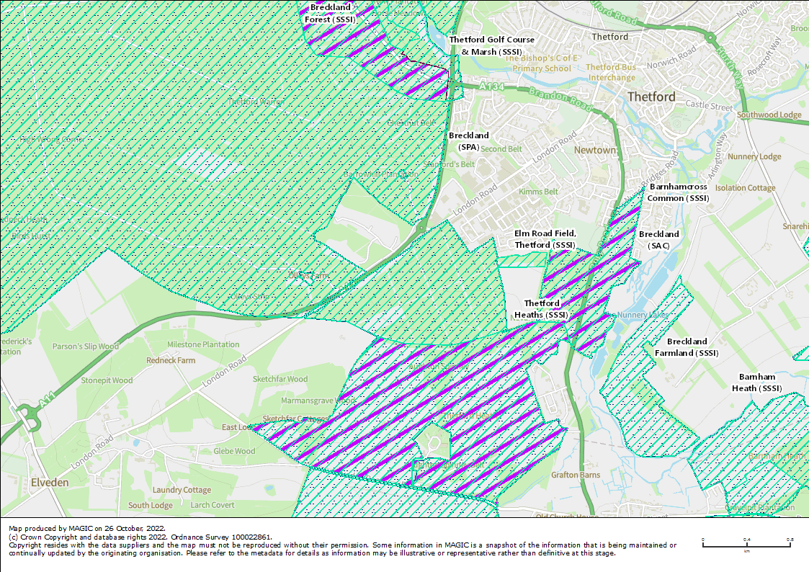
Appendix A: Sensitive Ecological Receptor Plan

Appendix B: Identified Sensitive Receptor Plan

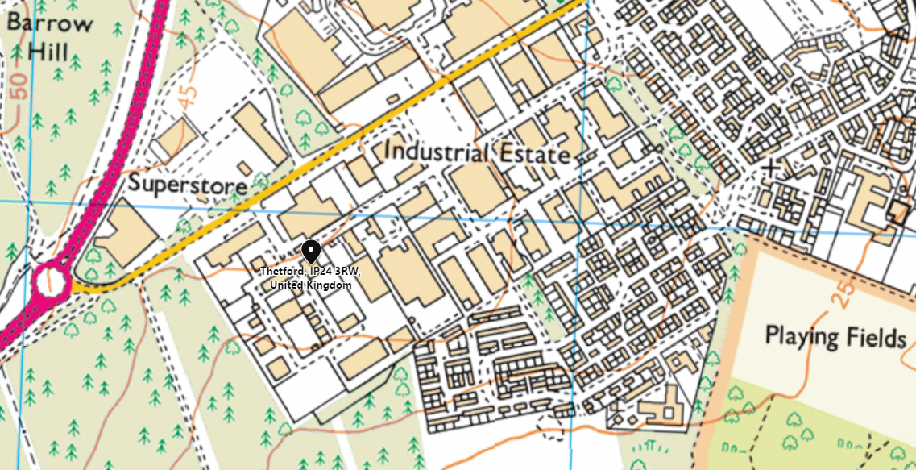

Use of manufactured topsoil: RPS 190 - GOV.UK (www.gov.uk)
Risk assessments for your environmental permit - GOV.UK (www.gov.uk)

