Project No: 311465

Environment Management System Summary

Prepared for:

Brockley Wood Ventures Ltd
Copdock Enterprise Park
Old London Road
Copdock, Suffolk
England
IP8 4JW

Contents Amendment Record

This report has been issued and amended as follows:

Revision | Description | Date | Signed
1.0 | Final | March 2023 | Graeme Kennett

Acknowledgement

This report has been prepared for the sole and exclusive use of Stowmarket Skips Limited (t/a Sun Skips) in accordance with the scope of work presented in Mabbett & Associates Ltd (Mabbett) Letter Agreement (312192/LA/GK), dated 21 October 2023. This report is based on information and data collected by Mabbett. Should any of the information be incorrect, incomplete or subject to change, Mabbett may wish to revise the report accordingly.

This report has been prepared by the following Mabbett personnel:

MABBETT & ASSOCIATES LTD

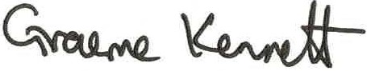
___________________________________
Graeme Kennett, BSc(Hons)., MSc., MBPR (FACTS)
Principal Environmental Consultant

This report has been reviewed and approved by the following Mabbett personnel:

MABBETT & ASSOCIATES LTD
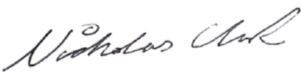

___________________________________
Nicholas Clark, MEng, AMIChemE
Environmental Engineer

Table of Contents

Section 1.0: Introduction 3
Section 2.0: About the Facility 4
2.1 The site 4
2.2 The Operation 5
Section 3.0: Management 6
3.1 General management 6
3.2 Accident Management Plan 6
3.3 Site security 6
3.4 Site notice board 6
Section 4.0: Proposed Activities 7
4.1 Storage (pre-treatment) 7
4.2 The site boundary 7
4.3 Waste acceptance 7
Section 5.0: Emissions and Monitoring 8
5.1 Operating techniques. 8
5.2 Fugitive emissions of substances 8
5.2.1 Storage areas of liquids 8
5.2.2 Inspection and maintenance of engineered containment 9
5.3 Odour 9
5.4 Noise and vibration 9
5.5 Pests, scavenging animals and birds 9
5.6 Control of mud and debris and loose waste 9
5.7 Control, monitoring and reporting of dust, fibres and particulates 9
5.8 Control of litter 9
5.9 Leaks and spillages 9
5.10 Control of Water 10
5.11 Fires on the site 10
Section 6.0: Impact on the Environment 11
Section 7.0: Site Management 12
Section 8.0: Site Condition Report 13
Section 9.0: Information 14
9.1 Reporting 14
9.2 Notifications 14
Appendix A: Proposed Waste Types 15

Introduction

Stowmarket Skips Limited (Sun Skips), ‘the operator’, has instructed Mabbett & Associates Ltd to prepare a bespoke permit application, under the Environmental Permitting (England and Wales) Regulations 2016 (as amended), for an Inert Recycling Site (IRS) at:

THETFORD RECOVERY SITE
5C Burrell Way
Thetford
Norfolk
IP24 3RW
Figure 1 Site location
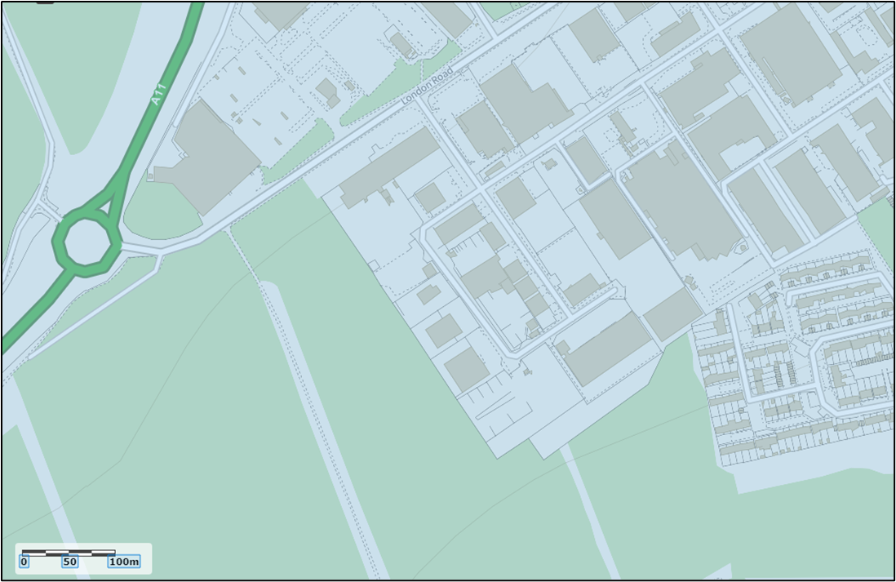
(c) Crown Copyright and database rights 2022. Ordnance Survey 100022861.

This Environment Management System (EMS) Summary is a high-level document which describes the requirements and processes of the full Environmental Management System to be in place at the time of permit issue.

The EMS will cover the company's EMS procedures, key EMS records and the standard operational procedures for all activities undertaken at the site.

About the Facility

The site
Thetford Recovery Facility, centred at Ordnance Survey grid reference TL 85370 81893, is located on a busy industrial estate to the south-east of Thetford in Norfolk. Thetford is a market town and civil parish in the Breckland District of Norfolk on the A11 road between Norwich and London, just east of Thetford Forest.

The site is a former skip and compactor manufacturing business and consists of a large clear span portal framed building and an impermeable surface. Improvements to be made to the drainage system include the installation of surface water gutters and a large capacity sump for the collection of surface water. The surface water will be used in the aggregate washing plant and dust suppression equipment after suitable treatment. Excess water will either be tankered off for treatment or released to the combined sewer via a Trade Effluent Consent from Anglian Water.

The site is bounded by:
- a busy industrial estate to the south and east, subject to a variety of uses including waste management operation;
- a retail park and the main A11 to the north, and
- Breckland Forest SSSI approximately 10 m to the west of the site.

The site lies within:
- a Drinking Water Safeguard Zone for Groundwater (GWSGZ0003); and
- a groundwater Source Protection Zone 1 .

There are no identified surface waters within 1 500m of the site.

The permitted activities are carried out within 500 metres of a Site of Special Scientific Interest (SSSI) but are not within a specified Air Quality Management Area (AQMA).

The permitted activities are not carried out within:
- 10 m of any watercourse;
- 50 m from any spring or well, or from any borehole not used to supply water for domestic or food production purposes;
- 50 m from any well, spring or from any borehole used for the supply of water for human consumption, including private water supplies;
- 250 m within the presence of Great Crested Newts, where it is linked to the breeding ponds of the newts by good habitat;
- 50 m of a site that has relevant species or habitats protected under the Biodiversity Action Plan that the Environment Agency considers at risk to this activity; and
- 50 m of a National Nature Reserve (NNR), Local Nature Reserves(LNR), Local Wildlife Site (LWS), Ancient Woodland or Scheduled Ancient Monument.

The operation
The permit will allow Stowmarket Skips Limited as the operator, to store waste at the Thetford Recycling Site and treat it to produce soil, soil substitutes and aggregate. The permitted wastes do not include hazardous wastes and it is proposed that the total quantity of waste that can be stored and subsequently treated at the site under the permit does not exceed 100,000 tonnes annually.

The recovery operations do not include the burning of any wastes, either in the open, inside buildings or in any form of incinerator.

The Thetford Recovery Facility will process suitable incoming waste materials for either:
- Production of products, in line with the relevant Aggregate Quality Protocol (AQP);
- Despatched from site as a waste for use by third parties under a suitable exemption/waste management operation, or
- As a material conforming to RPS190 Use of manufactured topsoil: RPS 190 - GOV.UK (www.gov.uk).

Management

General management
As the site will operate as a dedicated inert and non-hazardous waste processing facility the number of staff will be small.
Site management will comprise of the following staff members;
- A Technically Competent Manager (TCM); who will manage the operation and regularly attend site in compliance with the defined attendance requirement.
- A site supervisor; who will be responsible for the ongoing operation who may also undertake office and plant operation duties.
- Other trained plant operators as required.
Each TCM is subject to a two-year continuing Competence test to ensure they remain competent. Toolbox talks will be held regularly to ensure staff competence is maintained.

Accident Management Plan
An Accident Management Plan (AMP) is to be initiated at permit issue at the site and will be reviewed every 4 years or as soon as practicable after an accident. Any identified changes will be implemented after the review.
Staff will be regularly briefed upon its contents.

Site security
The site can only be accessed via the security-controlled gates at the site entrance. No entry to the site will be available outside operating hours.
The whole of the site has perimeter fencing and CCTV.

Site notice board

At the point of the permit issue, a site notice board, made of durable material, will be placed in a prominent position at the entrance to the site. The board will provide key staff and regulator contact details, along with details of the authorisations, permits and consents applicable to the site’s operations.

Proposed Activities

Treatment in the WRF will consist only of sorting, separation, blending, washing, screening or crushing of waste into different components for recovery.
The activities carried out at the site as defined under Annex II of the Waste Framework Directive can be summarised as follows:

Table 1: Proposed waste activities
Activity | Code
Crushing | R5 – Recycling or reclamation of other inorganic materials.
Blending | R3 – recycling and reclaiming organic substances which are not used as solvents.  R5 - Recycling or reclamation of other inorganic materials.
Screening | R3 – recycling and reclaiming organic substances which are not used as solvents.
Sorting | R3 – recycling and reclaiming organic substances which are not used as solvents.
Washing | R5 - Recycling or reclamation of other inorganic materials.
Storage | R13 – storage of wastes pending any of the operations numbered R1 to R12.

Storage (pre-treatment)
Prior to processing, the incoming waste materials will be stored within the permit boundary in designated storage areas. Waste shall be stored and treated on an impermeable surface with sealed drainage system or on hardstanding.

The site boundary
The activities on site shall not extend beyond the site boundary.

Waste acceptance
Only permitted wastes as specified by the permit will be accepted.
The total quantity of waste accepted shall not exceed 100 000 tonnes per annum.

Emissions and Monitoring

Operating techniques.
The site will be operated in accordance with the Operating Techniques document which has been drafted to satisfy the requirements of EA Guidance, and details the following:
- management;
- site operations;
- emissions and monitoring; and
- information.
Operational management procedures will ensure that:
- the risks that the activities pose to the environment are identified;
- the measures that are required to minimise the risks are identified;
- the activities are managed in accordance with the management system and operating techniques document;
- performance against the management system is audited at regular intervals; and
- compliance with the environmental permit.
The risk management and mitigation measures employed at the site and identified in the environmental risk assessment are detailed in the sites operating techniques document.
- In summary, the rules and operating procedures employed at the site will ensure the following with respect to the specified waste management activities:
- Unless stated otherwise, all waste shall be stored and treated on an impermeable surface with sealed drainage system or on hardstanding.
- Concrete surfacing falls towards drainage channels ensuring that potentially contaminated runoff is contained on site;
- Strict waste acceptance procedures will be adhered to, to ensure only permitted wastes are accepted on site;
- The site manager will ensure that regular inspections are made of the site. If necessary, remedial measures will be arranged as soon as possible.

Fugitive emissions of substances

The site infrastructure and operations are managed in such a way that the risk of fugitive emissions to ground and groundwater shall not cause pollution.

Storage areas of liquids

All liquid wastes produced on site as part of the process will be stored in secure bunded containers and subject to regular inspections.

Inspection and maintenance of engineered containment

All areas will be inspected at least monthly to ensure the continuing integrity and fitness for purpose of their construction.

Odour

The type of materials accepted in the recovery facility (e.g., inert aggregates) and the processes operated therein will inherently minimise the potential for odours to be released from the site.

Noise and vibration

The proposed treatment facility is being fitted with new modern equipment designed to comply with all relevant modern noise criteria.

Pests, scavenging animals and birds

The permitted waste types accepted on site are unlikely to encourage scavenging animals, birds and other pests.

Control of mud and debris and loose waste

Internal roads are designed, constructed and maintained to ensure they are adequate for traffic usage. The site surface is entirely constructed of concrete/asphalt so that mud will not be a problem.

Control, monitoring and reporting of dust, fibres and particulates

It is likely that the operations will cause dust and particulates. However, procedures are in place to ensure that any emissions are within the specified limits.

Control of litter

It is unlikely that the operations will cause the generation of litter, however, the site will monitor litter on site and litter pick where necessary.

Leaks and spillages

Environmental incidents are often the result of mechanical breakdown of plant and vehicles. All areas will be inspected at least monthly to ensure the continuing integrity and fitness for purpose of their construction.
A system is in place to ensure that all machinery is correctly serviced and used servicing oils etc. are not stored on site.

Control of water

The wash plants’ operation is self-contained, and all water will be reused wherever possible.

Fires on the site

Please see Accident Management Plan.

Impact on the Environment
An environmental risk assessment (ERA) has been carried out to assess the environmental risks posed by the proposed activity.
There are no point source emissions to land, air, surface or groundwater from the proposed facility.
The proposed facility will have drainage infrastructure in place at the site so that all potentially contaminated site drainage is captured and directed via a sealed system, consisting of concrete impermeable pavement with falls towards the drain channels that captures all liquids and directs it to a sealed tank.
Operational procedures at the site will monitor and manage amenity and accident risks from the proposed activities and includes provision for the monitoring of odour, noise, and fugitive emissions.
The impact of the proposed development on surrounding human and environmental receptors has been assessed in the ERA.
As the management measures detailed in the risk assessment will be in place at permit issue, the conclusion has been reached that the proposed waste materials and treatment activities, are unlikely to result in a significant accident risk or risk to the local environment, including from odour and noise, or pollution of surface or ground waters.

Site Management
Site management will comprise of the following staff members;
- A Technically Competent Manager (TCM); who will manage the operation and regularly attend site in compliance with the defined attendance requirement.
- A site supervisor; who will be responsible for the ongoing operation who may also undertake office and plant operation duties.
- Other trained plant operators as required.

Site Condition Report

A Site Condition Report (SCR) has been produced for this application.

The facility will operate with due regard to the conditions of the environmental permit and all relevant environmental legislation to ensure that land and groundwater is protected during the lifetime of the site and that the land is in a satisfactory state when the permit is eventually surrendered.

The possibility of any significant releases to the ground occurring during the lifetime of the permit is limited. Minor spillages, if they occur, are dealt with immediately by trained staff using appropriate spill response procedure and spill kits located around the site.

Information

All records required by the permit are retained for a minimum of 6 years.

Reporting
A record of waste types and quantities removed from, and accepted at, the site, monitoring of wastewater and records of any abnormal operating conditions will be kept and made available for inspection by the Regulator.

Notifications

The Regulator will be notified should any machinery, breakdown or failure of equipment cause significant pollution or prolonged interruptions in site operation.

Appendix A: Proposed Waste Types

01 | WASTES RESULTING FROM EXPLORATION, MINING, QUARRYING AND PHYSICAL AND CHEMICAL TREATMENT OF MINERALS
01 04 | wastes from physical and chemical processing of non-metalliferous minerals
01 04 08 | waste gravel and crushed rocks other than those mentioned in 01 04 07
01 04 09 | waste sand and clays
02 | WASTES FROM AGRICULTURE, HORTICULTURE, AQUACULTURE, FORESTRY, HUNTING AND FISHING, FOOD PREPARATION AND PROCESSING
02 02 | waste from preparation and processing of meat, fish and other foods of animal origin
02 02 02 | shellfish shells from which the soft tissue or flesh has been removed only
02 04 | wastes from sugar processing
02 04 01 | soil from cleaning and washing beet
03 | WASTES FROM WOOD PROCESSING AND THE PRODUCTION OF PANELS AND FURNITURE, PULP, PAPER AND CARDBOARD
03 01 | wastes from wood processing and the production of panels and furniture
03 01 01 | waste bark and cork
03 03 | wastes from pulp, paper and cardboard production and processing
03 03 01 | waste bark and wood
10 | WASTES FROM THERMAL PROCESSES
10 01 | waste from power stations and other combustion plants
10 01 01 | bottom ash and slag only
10 01 02 | pulverised fuel ash only
10 01 03 | fly ash from peat and untreated wood
10 01 05 | gypsum (solid) only
10 01 07 | gypsum (sludge) only
10 01 15 | bottom ash and slag only from co-incineration other than those mentioned in 10 01 14
10 01 24 | sands from fluidised beds
10 11 | wastes from manufacture of glass and glass products
10 11 12 | clean glass other than those mentioned in 10 11 11
10 12 | wastes from manufacture of ceramic goods, bricks, tiles and construction products
10 12 08 | waste ceramics, bricks, tiles and construction products (after thermal processing)
10 13 | wastes from manufacture of ceramic goods, bricks, tiles and construction products
10 13 14 | waste concrete only
15 | WASTE PACKAGING
15 01 | packaging
15 01 07 | glass packaging
17 | CONSTRUCTION AND DEMOLITION WASTES (INCLUDING EXCAVATED SOIL FROM CONTAMINATED SITES)
17 01 | Concrete, bricks, tiles and ceramics
17 01 01 | concrete
17 01 02 | bricks
17 01 03 | tiles and ceramics
17 01 07 | mixtures of concrete, bricks, tiles and ceramics other than those mentioned in 17 01 06
17 02 | Wood, glass and plastic
17 02 02 | glass
17 03 | Bituminous mixtures, coal tar and tarred products
17 03 02 | bituminous mixtures other than those mentioned in 17 03 01
17 05 | Soil (including excavated soil from contaminated sites), stones and dredging spoil
17 05 04 | soil and stones other than those mentioned in 17 05 03
17 05 06 | dredging spoil other than those mentioned in 17 05 05
17 05 08 | track ballast other than those mentioned in 17 05 07
17 08 | gypsum based construction material
17 08 02 | gypsum only other than that mentioned in 17 08 01
17 09 | other construction and demolition wastes
17 09 04 | mixed construction and demolition wastes other than those mentioned in 17 09 01, 17 09 02 and  17 09 03
19 | WASTES FROM WASTE MANAGEMENT FACILITIES, OFF SITE WASTEWATER TREATMENT PLANTS AND PREPARATION OF WATER INTENDED FOR HUMAN CONSUMPTION / INDUSTRIAL WASTE
19 01 | wastes from incineration or pyrolysis of waste
19 01 12 | bottom ash and slag other than those mentioned in 19 01 11
19 05 | wastes from aerobic treatment of solid waste
19 05 03 | compost from source segregated biodegradable waste only
19 08 | wastes from wastewater treatment plants not otherwise specified
19 08 02 | washed sewage grit (waste from desanding) free from sewage contamination only
19 08 99 | stone filter media if free from sewage contamination only
19 09 | wastes from the preparation of water intended for human consumption or water for industrial use
19 09 02 | sludges from water clarification
19 12 | wastes from the mechanical treatment of wastes
19 12 05 | clean glass only
19 12 09 | minerals (for example sand, stones)
19 12 12 | other wastes (including mixtures of materials) from mechanical treatment of wastes other than those mentioned in 19 12 11
19 12 12 | treated bottom ash including IBA and slag other than that containing dangerous substances only
19 13 | wastes from soil and groundwater remediation
19 13 02 | solid wastes from soil remediation other than those mentioned in 19 13 01
19 13 04 | sludges from soil remediation other than those mentioned in 19 13 03
20 | MUNICIPAL WASTES (HOUSEHOLD WASTE AND SIMILAR COMMERCIAL, INDUSTRIAL AND INSTITUTIONAL WASTES) INCLUDING SEPARATELY COLLECTED FRACTIONS
20 01 | separately collected fractions (except 15 01)
20 01 02 | clean glass only
20 02 | garden and park wastes (including cemetery waste)
20 02 02 | soil and stones
20 03 | Other municipal wastes
20 03 03 | street cleaning residues (including gully wastes)

Legal operator and competence requirements: environmental permits - GOV.UK (www.gov.uk)
LIT_8709_c60600.pdf (publishing.service.gov.uk)

