Ford Farms (Suffolk) Ltd
South Green EYE Suffolk IP23 7NW
Farm plan including drainage

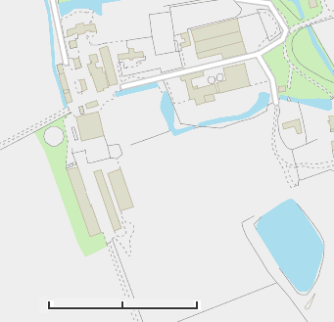
Ditch
Soakaway
Installation Boundaries
Generator and Medical Store
Incinerator
Public Right of Way
0
140
m
70
Red House Lodge
Red House Farmhouse
X
Feed Bins
Fuel store
X
Borehole
5
2
1
Muck pad
Slurry store
Dirty Water Lagoon
Dirty Water Lagoon
Muck pad
4
3

Building | Ventilation | Flooring | Pig places
1 | Side (left) fans - 5 | Fully slatted | 480
2 | Natural | Straw bedded | 300
3 | Side fans -18 | Fully slatted | 1,000
4 | Natural | Fully slatted | 720
5 | Roof fans - 5 | Fully slatted | 600

