Noise Management Plan

Farm name: Red House Farm, South Green, EYE, Suffolk
Operator: Ford Farms (Suffolk) Ltd
Permit number: EPR/xxxxxxx
Date: September 2023
Prepared by: L Bentley

Introduction
This bespoke Noise Management Plan (NMP) has been prepared to support the overall Environmental Management System in place at Red House Farm. The overriding principle of the NMP is to ensure the day-to-day activities are carried out in accordance with this document to help minimise the overall environmental impact. There are no residential sensitive receptors within the installation boundary. There are two adjacent properties and a number of other properties within 400m of the installation boundary. There is no history of complaints. The nearest receptors to the installation boundary is the farmhouse for Red House Farm lived in by the operator and Red House Farm Lodge occupied by the operator’s father. The nearest neighbours are nearby housing to the south-east occupied by third parties.
Setting
The installation is located at National Grid Reference TM 17363 74950. Please refer to Appendix 4.

Figure 1: 400m buffer zone and sensitive receptors
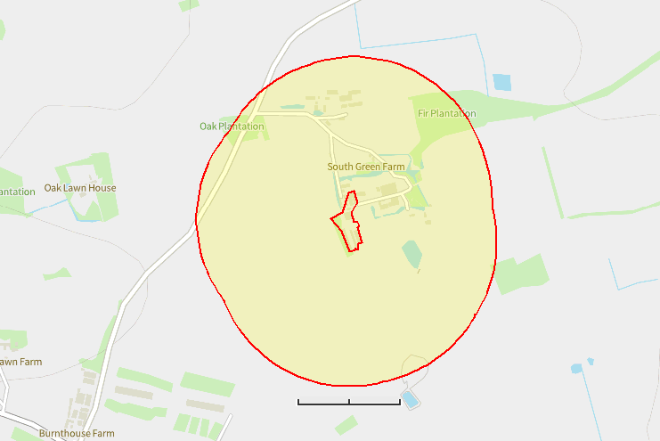
m
300
150
0

Table 1: Sensitive Receptor Locations and distance from Installation Boundary to nearest point of domestic curtilage.

Receptor | Type of Receptor | Distance from nearest housing (m) | Direction to Receptor
Farmhouse adjacent to installation boundary – property owned by C Ford and occupied by farm staff | House | Adjacent | E
Red House Farm Lodge – owned and occupied by C Ford | House | Adjacent | N
South Green Farm | Farm | 75 | NE
Ash Lodge/Gissing Farm House/Gissing Farm/Gissing Farm Cottages/Cork Oak Barn/Mertle Cottages | Farm and Residential | <250 | N
Minor Road – (no-through road leading to neighbouring properties) | Public road | Adjacent | W
Hoxne Brick Pit | SSSI | 1,600 | N
Remains of medieval fishponds at the Leys | Scheduled Monument | 1,250 | E
Denham College Moated Site | Scheduled Monument | 1,700 | E
Remains of Eye Priory at Abbey Farm | Scheduled Monument | 1,960 | SW
The Pennings, Eye | Local Nature Reserve | 2,380 | SW
Gypsy Camp Meadows, Thrandeston | SSSI | 6,220 | NW
Mellis Common | Local Nature Reserve | 7,230 | W

The purpose of this Noise Management Plan is to:
- Establish the likely source of noises arising from the farm
- Set out procedures at the farm in order to mitigate or minimise the risk of noise
- Formalise an effective method of dealing with any noise complaints quickly and efficiently.

This plan will be reviewed in the light of any building and management changes, and on the outcome of investigations into the cause of any future noise complaints, if any occur.

Any noise complaints will be recorded and investigated using the Noise Complaint Report Form contained within Technical Guidance Note IPPC SRG 6.02 (Farming) Noise Management at Intensive Livestock Installations.

No. ref | Noise Problem | Actions taken to prevent or minimise noise | Completion Date
1 | Feeding Pigs | Ad-lib system, so no spikes in noise and pig activity due to feeding times. | In place.
2 | Feed delivery | Blower and vacuum type delivery vehicles fitted with low noise units. | In place
3 | Feed preparation | No milling and mixing operations carried out on site. All bought-in feed. | In place
4 | Pig moving | Pigs only moved during the day and maintained in stable batches | In place
5 | Pig loading, in and out | Only approved and trained personnel.  Scheduled loading so that pigs are quickly loaded onto trailers and removed from site once complete.  Main movement passages in interior of buildings.  Staff trained to move pigs with least stress in optimum width races.  Pigs grouped ready to load onto transport before vehicle arrival.  Pigs maintained in stable batches. No shouting. Suitable and gentle handling aids in accordance to Red Tractor assurance standards – i.e. pig boards and rattle paddles or bags; no electric prods. | In place
6 | Bedding pens | Loader used for transport, engine revs kept low, effective silencer. Mainly during working day, limited at weekends/bank holidays. Only one shed bedded. | In place
7 | Mucking out | Loader used for scraping and transport, engine revs kept low. Mainly during working day, limited at weekends/bank holidays. Only one shed is solid floor. | In place
8 | Slurry tanker filling and emptying | Tanker filling only when necessary and appropriate. All equipment regularly serviced and operated to current standards and optimum efficiency. | In place
9 | Manure loading/transport and spreading | High output equipment reduces working hours. Engine revs kept low where possible. All equipment regularly serviced and operated to current standards. | In place
11 | Delivery of supplies and materials | Typically small deliveries during normal working hours by arrangement. Low perceived impact. | In place
12 | Ventilation systems and operational techniques  Noise created from worn fan motors and bearings. | Fans with automatic controllers set to maintain optimum environmental conditions within buildings. Efficient, quiet, fan types selected. Regular maintenance and cleaning takes place. No obstructions above outlets. | In place
13 | Vehicles operating within installation boundary | Operations mainly carried out during normal working hours. Vehicles maintained in accordance with manufacturer's recommendations, and defective silencers replaced. Audible reversing signals required for safety purposes.  Yards maintained to repair holes. | In place
14 | Noise from incinerator in operation | Low risk of noise nuisance. Intermittent activity.  Incinerator shielded from nearest receptors by pig buildings. | In place
15 | Prolonged or/and frequent alarms | Alarm system rings key personnel as well as emitting audible alarm on site. This increases the likelihood of prompt action should the alarm system be triggered. And the fact that off-site personnel are also contacted, reduces the chance of continual sounding of the alarms when staff are not present on site e.g. overnight.  Systems kept well serviced and maintained to reduce risk of system failure. | In place
Last reviewed September 2023

Summary
Noise levels are assessed daily by operators or their staff. One operator lives on site.

We have always worked hard to minimise our impact on our closest receptors and as a result have not had any complaints about noise in relation to Red House Farm. We continually assess management techniques to improve our control of noise pollution.

This plan will be reviewed in the light of any building and management changes, and on the outcome of investigations into the causes of any future complaints, if any occur.

Any noise complaints will be reported to the operators who will log and investigate causes of all complaints; identifying the source of the noise issue and monitoring noise levels at the site boundary as part of the investigation. The complaint details and subsequent investigation will be recorded on the site complaint form and a copy will be kept in the site office.

This document has been prepared by the applicant using the AHDB template. While the Agriculture and Horticulture Development Board, seeks to ensure that the information contained within this document is accurate at the time of printing, no warranty is given in respect thereof and, to the maximum extent permitted by law, the Agriculture and Horticulture Development Board accepts no liability for loss, damage or injury howsoever caused (including that caused by negligence) or suffered directly or indirectly in relation to information and opinions contained in or omitted from this document.

Appendix 1
