Appendix 2: Non-technical Summary
Red House Farm, (previous permit ref EPR/QP3636UD)
Red House Farm, South Green, Suffolk, IP23 7NW

Red House Pig Farm is owned and run by Ford Farms (Suffolk) Ltd. This site has been permitted since 2007, under the operator name Godfrey Ford Ltd.
Godfrey Ford Ltd had been trading for a number of years and on 1 April 2010 its trade, together with that of R G Ford (Farms) Ltd, was merged so that from this date the trade was carried on by a new company, Ford Farms (Suffolk) Ltd.
Whilst, therefore, Godfrey Ford Ltd stopped its activities on 31 March 2010, its trade has continued through the new company and it has complied with all the regulations previously met by Godfrey Ford Ltd. As transfer of the permit to the new legal entity was not accomplished within the required timeframe, and it is not possible to restore the dissolved company in this case, we are required to apply for a replacement permit.
The Environment Agency has stated the following (Appendix 2b: previous correspondence, email from Christabel Carr dated 22 June 2023): “Permit Ref. QP3636UD is considered to be lapsed and so no longer exists. This means that at the moment you are operating the pig unit without the necessary Environmental Permit. Therefore you need to apply for and be granted a new permit as soon as possible. The Environment Agency will allow you to carry on operating as long as you get an application submitted for a new Permit by 30 September 2023. We also require that you continue to comply with the conditions of the old Permit (as if it were still in existence) in order to maintain standards and prevent pollution risk. We may remove this position if an actual pollution were to occur or if we felt there was a risk of pollution”.
As part of this application for a replacement permit, we are required to describe all changes since the original permit issue in 2007.

New permit proposal
The new application is for a permit to cover 3,100 >30kg production pig places across 5 buildings (an increase of 800 pigs from the originally permitted number). The places per shed are as follows:
Shed 1. 480
Shed 2. 300
Shed 3. 1000
Shed 4. 720
Shed 5. 600
Shed 5 was added to the site and original permit as per a variation issued in 2015, which brought the permitted pig numbers to 2,900. The current proposal is up to 3,100 pig places to future proof. All pigs are on fully slatted floor (FSF) systems with frequent vacuum removal of slurry, except for Shed 2 which is solid floor and straw bedded.
Schedule 1 operations would also include the directly associated activity of carcass incineration in an incinerator approved by the APHA for <50kg/hr capacity. Please refer to the site plan to see how this would be achieved on the site.
Slurry is removed from each building by tanker and stored in one above ground circular tank on site, before being spread on operator owned land. Manure is stored within the installation on hard-standing with a collection system to contain effluent. This is also spread on operator owned land.

Management of the site
Pigs arrive in at circa 30kg and leave at circa 110kg. The site operates a continuous flow system and runs at circa 80% occupancy.
The system will be slurry-based and slurry will be removed from pits under fully slatted floors by frequent vacuum removal via tankers in to the on-site storage tank. There is no pipework connecting the pits directly to the tank. Slurry levels will not exceed the 800mm threshold due to the frequency of removal, i.e. at <10 weeks intervals. The remaining capacity is for freeboard plus continency margin.
The above ground slurry store has a capacity of 1900m3 (41,800 gallons) – which is the net volume allowing for 300mm freeboard required by BS5502. This store has a rigid cover and the dirty water/effluent lagoons have a floating cover (clay ball).
The surface areas of these stores are as follows:
- Above ground circular tank = 283.5 m2
- Effluent/Dirty water lagoon (on pig site) = 72 m2
- Effluent/dirty water lagoon (separate from pig site) = 200 m2
A maximum of 150t is stored at any one time on the muck pad associated with Shed 2. There is a plan to roof over this area and the effluent/dirty water lagoon adjacent. Muck is removed when conditions and regulations allow for application to land.
A maximum of 200t is stored at any one time on the second muck pad removed from the main site. This muck pad is owned and used by the operators, but does not take muck from this installation, instead storing exported muck for a separate site which operates under permitting thresholds.
Three of the FSF buildings have fan ventilation (two with side ventilation and one – the most recent building addition - with roof fans). The remaining FSF building has natural ventilation.
- Building at North end has 5 side fans on West side (FSF)
- Solid floor building in centre (North of muck pad) has Natural Ventilation
- Shed at South West end has 18 side fans total (3 per room)
- The South end central building is FSF and NV
- The "new build" to the South East of the installation has 5 roof fans (1 per room) and the spec for these fans is 12" diameter and 1370 rpm. As the height above ground of the roof fan emission is 4 metres, height alone would categorise these roof fans in the medium velocity column for screening purposes (over 3.5m but under 5.5m).
The site surfacing is stone. There is a soakaway at the northern end of Shed 1 taking uncontaminated water from roof and yard areas associated with Shed 1. Uncontaminated water from roof areas (via gutters and downpipes) from sheds 2, 3, 4 & 5 and yard areas (via drain inlets and pipework) ultimately drains into the nearby drainage ditch located on the western boundary of the installation.
Please refer to Appendix 4 site layout for locations of emission points and areas.
All contaminated water, including wash water from the loading area and spent footbath water containing disinfectant, is directed to the slurry pits, or effluent/dirty water stores as appropriate.
Slurry is applied to land owned and managed by the operator by dribble bar or injection to reduce creation of bioaerosols. A Manure Management Plan is in place and is in line with best practice and NVZ regulations.
Feed rations are pelleted and delivered in, with diets formulated to match the growth stage of the pigs and fed ad lib.
Water will be from borehole (with Mains supply available as backup) and will be supplied in nipple drinkers. Location of borehole is shown on the site layout plan in Appendix 4. It lies outside of the installation boundary and is housed.
All deadstock is stored in a lockable container before being incinerated on site in an APHA approved unit, included within the installation boundary. Incinerator ash is incorporated in to FYM before application to land, under a U15 waste exemption.
There is one 5000 litre fuel store within the installation boundary (diesel). This store conforms with SSAFO regulations and has a bund with capacity of 110%. Its primary use is for the arable enterprise. The only use for diesel on site for vehicle/equipment primarily used for the pig enterprise is for the muck tractor, used to muck out Shed 2.
There is a heat alarm system in case of power cuts or other reason for ventilation failure. The fixed generator is located outside of the installation boundary in building adjacent to Shed 1 (pig building at North end of installation). Being tractor driven, it does not have its own fuel storage. The generator is not primarily used for the pig enterprise, but as back-up for the whole farm.
The pressure washer is electric.
There are plans to potentially have solar panels located to the East of the installation, which would feed in to the farm electric with excess generation feeding back in to the grid. LED lighting will be installed.
The above activities are managed in accordance with the Environmental Management Plan (Summary in Appendix 3) which describes control measures and management procedures for all above operations at the site and provides Action Plans to address potential accident and emergency situations, and other non-operational occurrences.
A pre-application request form has been submitted to the EA and we are awaiting advice and screening results.

Site location
The installation is located in Eye in Suffolk at Grid Reference TM 17363 74950.
There is one Site of Special Scientific Interest located within 5k of the installation. This is Hoxne Brick Pit located 1600m away to the North. Last assessed in 2009, the main habitat is listed as Earth Heritage i.e, it is the geological features for which the site is protected.
Pennings Eye Local Nature Reserve (LNR) is 2.4km to the South West of the installation and is situated along the River Dove. Much of this site is managed as hay meadow.
There are other SSSI designated sites, and another two LNRs (Melling Common and Royden Fen), over 5km and within 10km in the North West quarter of the buffer zone from the installation; and one further SSSI within the same distance range to the South West of the site.
There are no RAMSAR, SPA or SAC designations within 10km.
The installation is within the River Waveney NVZ for surface water, and a Drinking Water Safeguard Zone for surface water (SWSGZ1020) and Source Protection Zone (Zone III Total Catchment).
Figure 1: 10km buffer zone (Source: Defra Magic Maps, accessed Sep 2023)
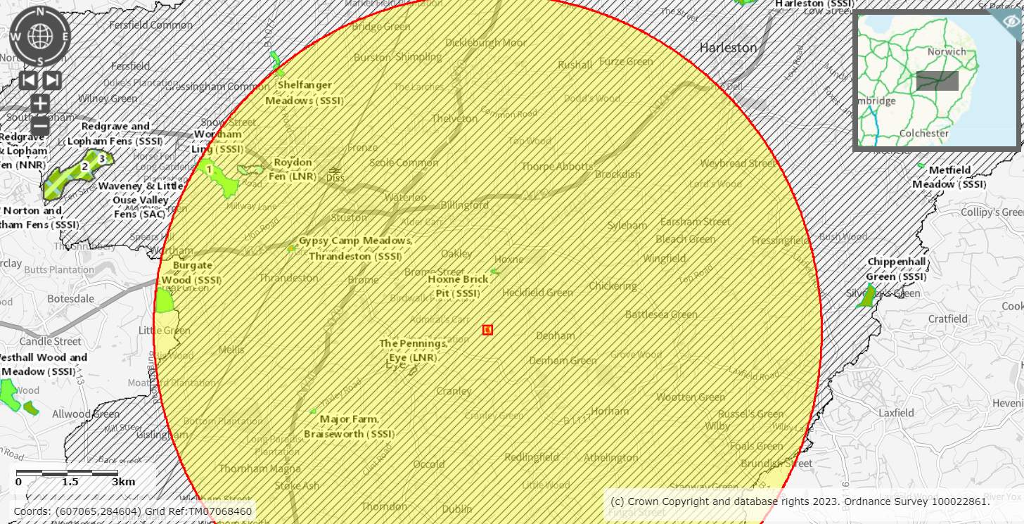
Sensitive receptors, all falling within the address of South Green and under the same postcode, are mainly to the North of the pig unit, with a few residences to the East. Gissings Farm to the North is within 400m of the installation. There are three residences within 100m, South Green Farm, and two residences belonging and inhabited by the operators, Red House Lodge and Red House Farm.
Please refer to the sensitive receptor maps in Appendices 8, 9 and 10. There have been no previous issues relating to odour, dust, noise or flies in relation to the farm. However, due to the proximity of the nearest sensitive receptors we have produced Odour (8), Noise (9) and Bio-aerosol (10) Management Plans to mitigate any risks of nuisance or risks to health.
The installation benefits from existing farm access roads from the public highway. The combination of the low height of the buildings and well established trees and hedgerows, is such that the buildings are not visually prominent within the landscape and effects of odour, noise and bioaerosol creation will be mitigated. The landscape is flat to gently undulating and the farm is surrounded predominantly with arable fields with woodland to the North East.
The site can be accessed only via the existing farmyard and there are site security measures in place (see Appendix 3). There is a public footpath through the site, and precautions are taken to maintain security and biosecurity of the installation.
The site is mostly considered to be at “very low risk” of flooding, though the areas closer to the adjacent ponds may be considered “low risk”.
There are no known pollution incidents at the site and within a 1 km radius. Historic maps indicate that the site has had no known prior site uses other than agriculture. No prior site investigations have been conducted.
There have been no notifiable pollution incidents at the site during the operation of the permit (issued in 2007).

Appendix 2(a) BAT-AEL Review
Referring to the IRPP BAT Conclusions document, published on the 21st February 2017, we can confirm that we will be able comply with all relevant BAT conclusions, including the revised BAT Associated Emission Levels (BAT-AEL).

BAT conclusions 3 and 4:
We adopt a nutritional strategy to reduce the levels of nitrogen (N) and phosphorus (P) excretion and can demonstrate we are meeting the BAT associated excretion levels given in table 1.1 and table 1.2. Feed dockets and a current generic statement can be provided to demonstrate a reducing protein (N) and phosphorus (P or total P) diet over the whole life cycle.
BAT conclusion 24:
We will use manure analysis to estimate total N and P content in manure and will report this to you annually.
BAT conclusion 25:
We will monitor ammonia emissions and demonstrate emission levels through use of emission factors.

BAT conclusion 27:

We will monitor and demonstrate dust emissions from each animal house, by use of emission factors.

BAT conclusion 30:
- BAT 30 (a –e) Techniques used:
Fully slatted system over pit (managed within 800mm depth), operating frequent slurry removal (a minimum of every 10 weeks). Collection of slurry is by sealed system via tanker to above ground slurry store with fixed cover. Slurry removed from storage, through sealed system to tanker, and applied to operator owned land.
For the solid floor, straw bedded system, the bedding is kept clean and dry. FYM is transferred to a bunded muck pad within the installation and is removed typically annually (when regulations, weather, crop and ground conditions allow) to apply to operator owned land. Maximum storage of FYM within the installation is 350t. Area of contaminated concrete minimised.
Effluent, dirty water, wash water and used footbaths are all captured in the slurry system or lagoons. Lagoons have floating covers.
These measures reduce the ammonia emitting surface and risks of bioaerosol creation.
- BAT AEL(s)
Solid floor – straw bedded system, using the emission factors in Annex 1 the BAT AELs for finisher stage is 2.97 (compared to threshold 5.65). You can apply the emission factor of 2 for production pigs on straw, based on AHDB Pork trials.
Fully slatted floor - frequent vacuum removal, emission factor for finisher stage currently listed at 3.11 and, to meet the new requirements, the emission per pig must not exceed 2.6kg NH3/animal place /year. An emission factor of 2 is currently being used based on AHDB Pork trials.

Running at 80% occupancy, the total emissions calculated for the number of pig places on site can be reduced by 20% (assuming the AHDB suggested factor does not already include reductions for occupancy/downtime).

