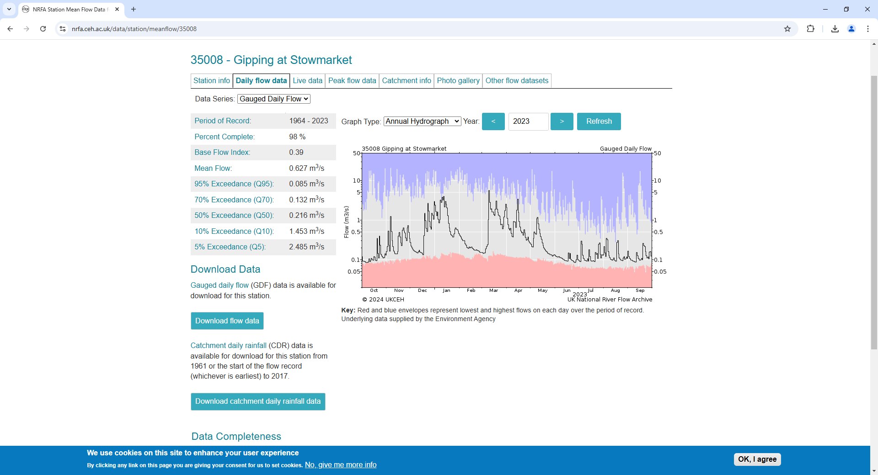

https://nrfa.ceh.ac.uk/data/station/otherDatasets/35008

