C2.5b SCBR - Site Condition / Baseline Report

1.Introduction
Cranswick Convenience Foods Limited operates on a site at Helsinki Road, Sutton Fields Industrial Estate, Hull HU7 0YW.
Activities at the site are undertaken in accordance with the conditions of Environmental Permit EPR/KP3733AN which authorises Cranswick Convenience Foods to receive raw meat and to process the meat by mincing, slicing, mixing and blending etc including cooking (using natural gas fired cooking equipment), together with other food ingredients, to produce ready to eat meat-based products with a production capacity of greater than 75 tonnes per day. The raw meat ingredients include fresh and frozen pork, beef and chicken.
The site was authorised under the Environmental Permitting Regulations in June 2015. The permit was varied in September 2020 to to include a warehouse, office block and a new operational area to accommodate slicing and packing/labelling equipment and a new chiller area. Some older water heaters were also replaced, and a new “grill” cooking facility installed. The remaining operations were unchanged.
It is now intended to add a new production line to process raw chicken meat together with other non-meat food ingredients to produce cooked, ready to eat packaged products. The development will introduce new, additional incoming raw materials receipt and storage areas (including refrigerated storage), raw materials processing and cooking areas and finished product packaging, storage and despatch areas (including refrigerated storage) together with office and amenity accommodation for staff. The new cooking plant will include a continuous fryer which uses hot vegetable oil, and a proportion of the fried products will be further cooked on an oven line. Heat for cooking is provided by a gas fired thermal oil heater and a gas fired steam / hot water boiler. Further technical details relating to the new processing line plant and equipment including new / additional ancillary plant and equipment such as refrigeration plant, gas fired boiler / hot water plant, gas fired thermal oil heater and cooking plant are provided in Section C3.1 (Activities to be Varied) of the permit variation application.
Introduction of the new processing line and associated plant and equipment will not require the existing site to be extended as the process will be housed within a building at the northern end of the site currently used for engineering / general storage purposes which is located within the existing permit area boundary as shown on the map below. The building will be largely demolished and subsequently extended to accommodate the new processing plant and associated equipment.

As such it is not necessary to produce a new site condition baseline report in connection with the proposed development. Further, the development will not result in the addition or removal of EPR Schedule 1 listed activities or directly associated activities identified in the existing Environmental Permit.

A permit variation application of which this document forms part has been prepared and submitted to allow the extension of the existing authorised operations and associated activities. For the sake of completeness, this document provides a summary of information previously relied upon to establish baseline conditions for the site as a whole and new information generated in relation to the development site.
The document focusses primarily on risks to ground, groundwater and surface water posed by the proposed development, and the protection measures which will be implemented as part of the development to ensure that the condition of the site and the identified receptors will not be adversely affected by the newly introduced activities. To that end, both a Phase I and Phase II site investigation were conducted in April 2021 in relation to the proposed development site only. Copies of the Phase I and Phase II reports are provided at Appendix 3 to this supporting document folder C2.5b, Site Condition-Baseline Report.

A completed up to date H5 template is provided at Appendix 1 to this supporting document folder C2.5b, Site Condition-Baseline Report.

2. Site Setting
2.1 – Site Location
Cranswick Convenience Foods Limited operates on a site at Helsinki Road, Sutton Fields Industrial Estate, Hull HU7 0YW (N.G.R. TA 09649 32335) as shown on the site location map document reference SLM 01 contained in supporting document folder reference C2.5a (Site Plans) of the permit variation application and reproduced below. The Sutton Fields Industrial Estate supports a wide range of Commercial and Industrial undertakings.
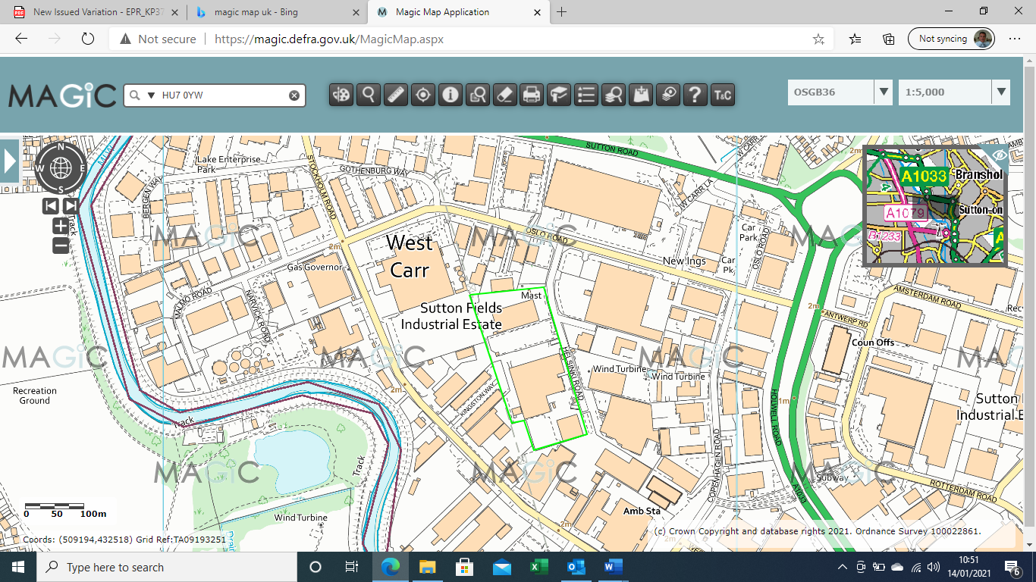

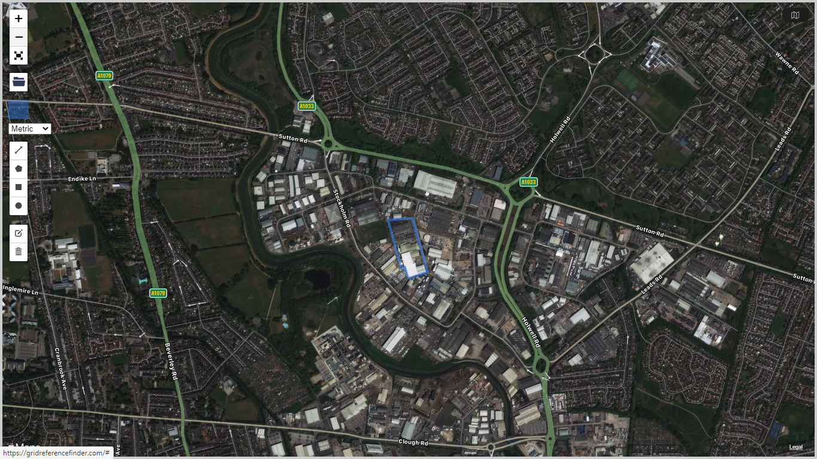
The permitted site occupies a parcel of land covering an area of approximately 3.2 Hectares located approximately 3km north of Hull city centre, 3.5km north of the River Humber Estuary and 300m to the east of the River Hull. The development site occupies an area of around 0.8 Hectares situated at the northern end of the wider site as shown on the map below.
The nearest residential areas are situated around 400m to the north and north east of the site. The site elevation is around 1.0m A.O.D. and the site itself is essentially flat with minor engineered falls to promote efficient drainage.
2.2 – Site Historical Uses
Ordnance survey maps show that the area of the site and its immediate surroundings were largely undeveloped agricultural land until the 1980’s.
The 1885 Ordnance Survey map shows the area around the Sutton Fields site as being open agricultural land. From 1885 until 1984 the site itself remained largely unchanged as open agricultural land. However, land surrounding the site was being developed for industrial purposes and by 1984 Helsinki Road is indicated with some limited development shown at the northern end of the Cranswick Sutton Fields site. The 1992/93 Ordnance Survey sheet shows further industrial development taking place on and close to the site with the areas surrounding Helsinki Road becoming significantly developed. The 1999 and 2006 Ordnance Survey sheets show continuing development of the Sutton Fields Industrial Estate and the erection and extension of buildings on the Cranswick Sutton Fields site. The 2014 Ordnance Survey sheet shows the site to be fully developed. During the period of Cranswick’s occupation of the site since 1992, the site has not supported activities or handled materials likely to pose a significant risk to environmental receptors on or in the vicinity of the site.
2.3 Geology, Hydrogeology and Hydrology
The British Geological Survey maps below show the superficial deposits and bedrock geology in the vicinity of the Sutton Fields site.
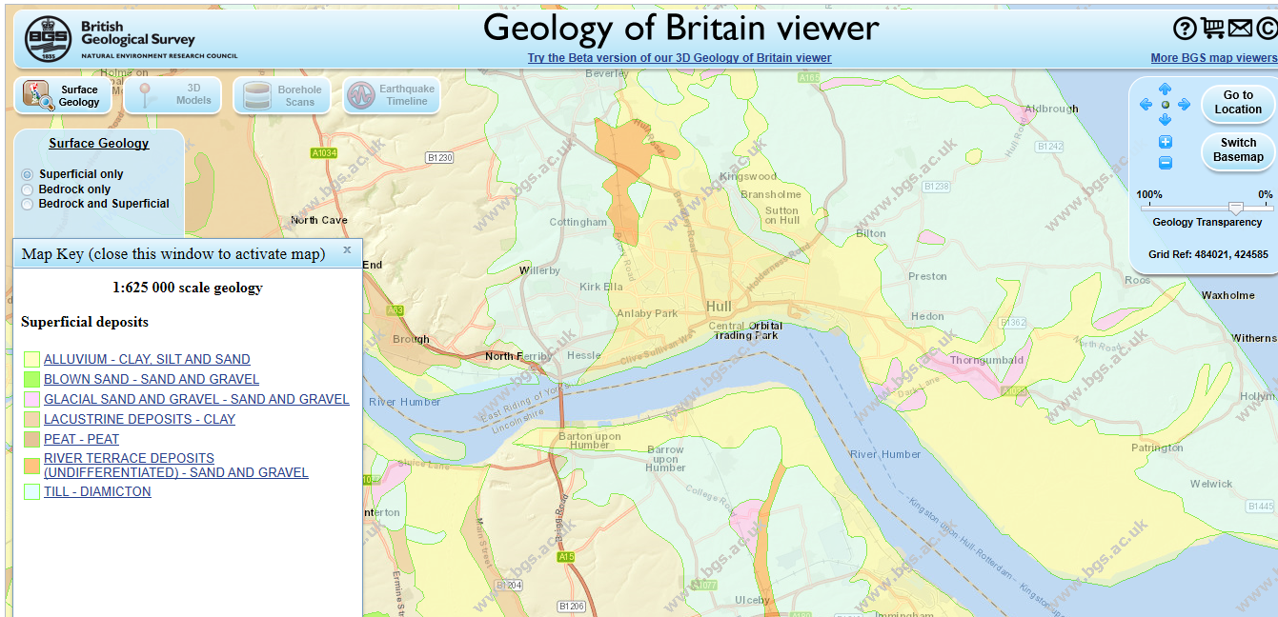

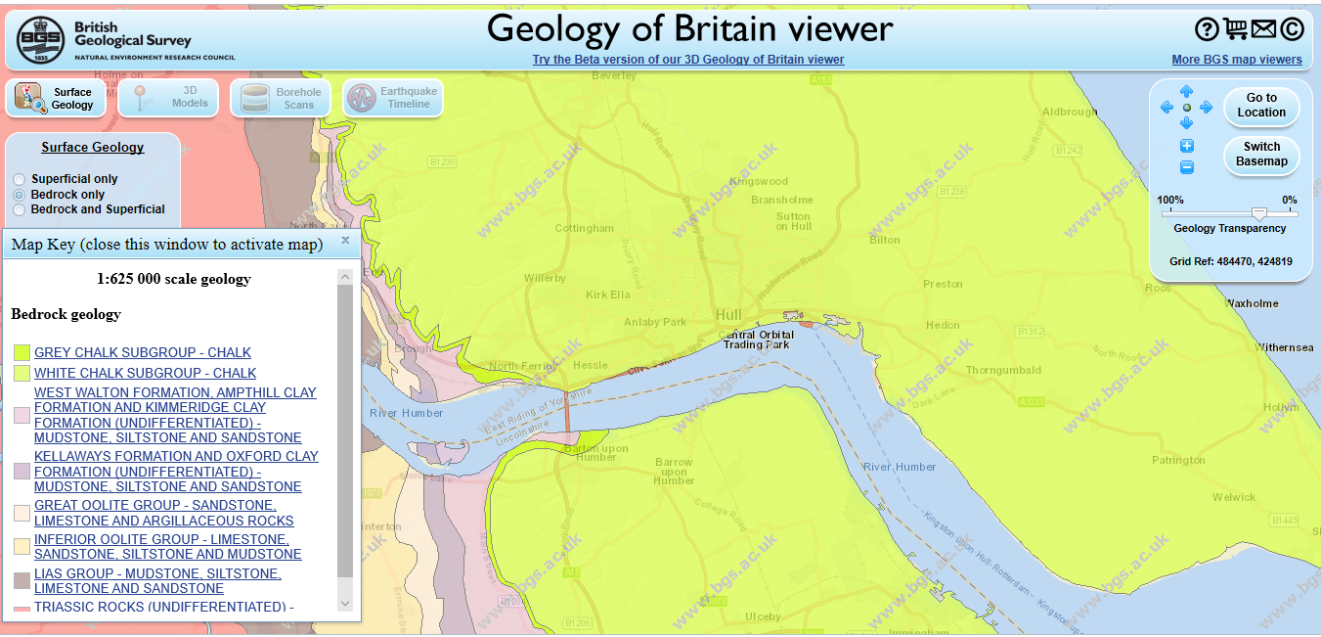

Near surface geology consists of Quaternary deposits which are predominantly alluvium and tidal flat deposits comprising clay, silt and sand. They overlay Upper Cretaceous Chalk of the Flamborough formation.

The near surface geology has been confirmed by several borehole and trial pitting surveys which have taken place on or close to the site during the period of development of the Sutton Fields Industrial Estate. The surveys typically show a layer of topsoil / made ground at the surface supported by soft to firm brown clay with softer brown clay with light grey inclusions, organic matter and occasional shell fragments. These brown clay layers give way to soft and very soft dark grey silty clay (alluvial deposits) which becomes slightly stiffer after around 7.0 metres below ground level when the clay begins to contain sand with fragments of chalk, coal and gravel. With increasing depth, the clay becomes stiff boulder clay beneath which is found the chalk layers.
The chalk beds are a principal aquifer, and the site sits above a groundwater source protection zone III (total catchment) as shown by the map below. The area is designated a nitrate vulnerable zone.

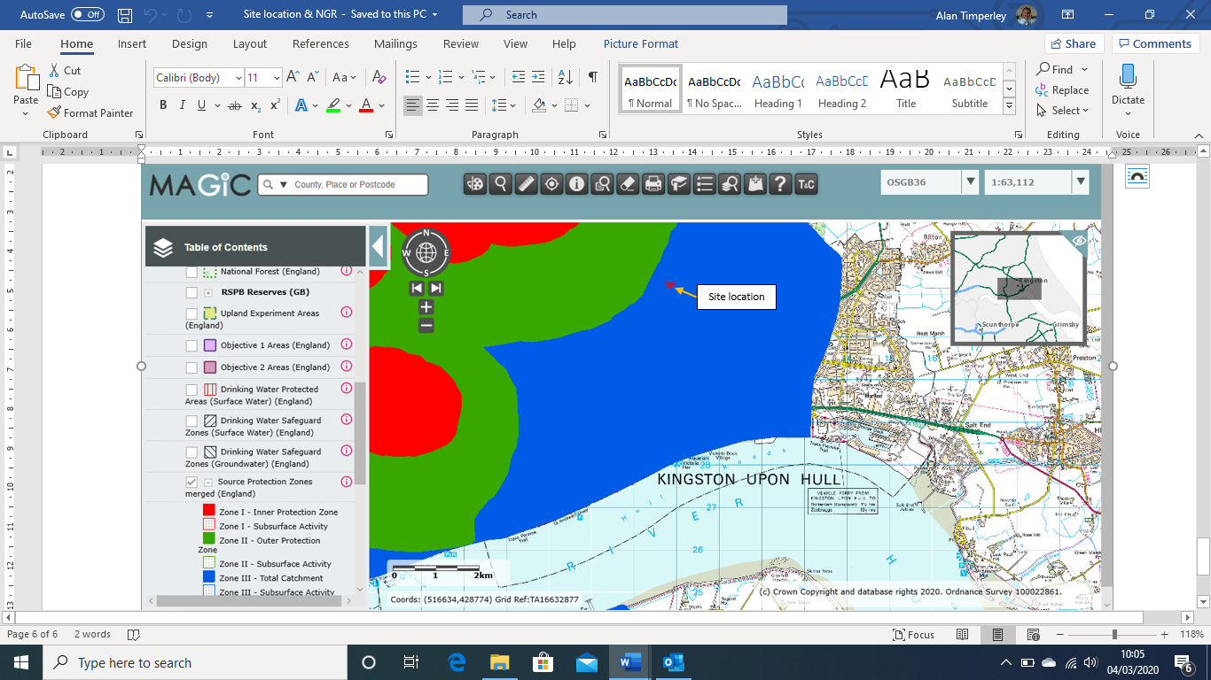

The surveys conducted in the area have been fairly consistent in finding some minor water ingress between 2.1m and 2.4m below ground level. More significant inflows did not happen until much greater depths when the chalk layers were penetrated. The shallow water “strikes” are likely to be perched groundwater sitting in discontinuous pools above the clay layer which provides a barrier to vertical migration of any contaminants into the principal aquifer below. The inferred direction of flow of the perched groundwater is westwards towards the River Hull although without a driving head to promote such flow the lateral migration of any contaminants present in soils is unlikely to present a significant risk.
The nearest surface water feature to the site is the River Hull which meanders to the west and south of the site, the nearest approach being around 300m to the west of the site. The site is considered to be at medium risk of flooding from seas and rivers and at low risk of flooding from surface water. Further details relating to flood risk are provided in Section B2.6, Environmental Risk Assessment, of the permit variation application.
There are sensitive receptors in the vicinity of the site. The Humber Estuary 3.5km to the south of the site, is designated a Special Area of Conservation (SAC), Special Protection Area (SPA) and Ramsar location. There is a local nature reserve approximately 1km to the south east of the site and several local wildlife sites within 2km of the site, the nearest being approximately 500m to the west immediately beyond the River Hull. The River Hull and the Humber Estuary and their immediate environs support fish and non-fish protected species. Further details relating to sensitive receptors are provided in Section B2.6, Environmental Risk Assessment, of the permit variation application.
The environmental sensitivity of the site location with regards to shallow groundwater is considered to be low to medium as the shallow groundwater may be in hydraulic continuity with the local surface water course but there is little or no driving force to promote the flow and the superficial deposits are not classified as productive strata. The environmental sensitivity of the site with regard to deeper groundwater is considered to be low to medium due to the Principal Aquifer beneath the site and several groundwater abstractions in the vicinity. However, neither the existing permitted site nor the proposed development will store or handle environmentally hazardous substances in quantities which pose a significant risk to ground or groundwater. The environmental sensitivity of the site location with regards to surface water is considered to be low as there are no pathways by which contaminants from the site are likely to reach surface water receptors in the vicinity.

- Information obtained from Site / Area Investigations
As mentioned in section 2 above, several borehole and trial pit surveys including surveys conducted by Holmpress Piles Ltd, Soil Mechanics Ltd and TLP Ground Investigations have been undertaken in the past in the area in which the Sutton Fields site is located.
There is no mention in any of the borehole records provided by Holmpress Piles Ltd, Soil Mechanics Ltd, or TLP Ground Investigations of any contaminants being discovered during the drilling operations.
The information provided in the Envirocheck Report commissioned in connection with the application for the site’s original environmental permit also indicates an absence of any contamination beneath the site or of the presence close to the application site of any factories or other facilities likely to generate contaminants which may migrate towards and beneath the Sutton Fields site.
Phase I and Phase II Site Investigations were conducted in April 2021 by Consultants T.L.P Ground Investigations Limited in relation to the proposed development area of the site only. The results from the investigations confirm the conclusions reached from previous studies, namely that any contaminants present are at concentrations well within the relevant guidelines for commercial use development and represent low risk to ground and groundwater. A conceptual model for the proposed development site can be found at Section 8 of the T.L.P Phase II report.
There are no known changes to activities in the vicinity of the site that have taken place since the environmental permit was issued in 2015 that are considered likely to have impacted on the quality of ground or groundwater beneath the Sutton Fields site.

- Current and Proposed Site Activities, Hazardous Materials Inventories and Pollution Prevention Measures
The main function of the site is to receive raw fresh and frozen meat and to process the meat, together with other food ingredients, to produce packaged meat products for human consumption. Processing includes cooking using natural gas fired cooking plant. The raw meat ingredients include pork, beef and chicken. Other food ingredients include, for example, coatings (eg. breadcrumb), marinades, herbs, spices, glazes and other seasonings etc.
Raw materials are delivered to site by road, the majority in refrigerated vehicles, and offloaded into a refrigerated goods reception area where they are checked for quality before being transferred into refrigerated storage pending processing. Depending upon required product specifications, the raw meat and other ingredients are prepared according to specific recipes and then cooked and packaged to produce ready to eat products. The packaged products are placed into refrigerated storage pending dispatch from site to clients.
The main raw materials handled on site are raw food products which do not pose a significant pollution risk to ground or groundwater. The site also handles small quantities of potentially hazardous substances, for example cleaning agents / disinfectants used to maintain the food hygiene standards required in such facilities and engineering related materials such as lubricants, sealants, surface coatings etc which, if inadvertently released, could pose a risk to ground and groundwater.
The site generates waste water from three sources - process derived waste water, rainwater and domestic waste water from offices and amenities on site, all of which are disposed of by discharge to foul sewer. The releases occur at three locations identified in the environmental permit and designated S1, S2 and S3 in the Environmental Permit.
Contaminated water flows through internal drainage systems which are fitted with traps to intercept gross solids and prevent drainage system blockages, and through an interceptor before being released to sewer. All surface and roof water falling on the site is currently collected by external drainage systems and together with domestic effluent, also discharged to sewer. Discharge to surface water or via soakaways has been assessed and found not to be viable. The sewer discharge is authorised via three separate Trade Effluent Consents issued by the sewerage undertaker, Yorkshire Water. The waste water collected and discharged to sewer does not pose a significant pollution risk to ground or groundwater. There is no credible pathway by which the waste water can reach any surface water features.

It is intended to add a new production line to process raw chicken meat together with other non-meat food ingredients to produce cooked, ready to eat packaged products. Further technical details relating to the new processing line plant and equipment including new / additional ancillary plant and equipment such as refrigeration plant, cooking plant and gas fired boiler plant are provided in Section C3.1 (Activities to be Varied) of the permit variation application.
With the exception of the introduction of vegetable oil which will be used in the new continuous frying process, the main raw material types handled on site will not change significantly in nature or properties, but the quantities of raw materials handled will increase as a result of the development. Vegetable oil will be used at a rate of up to 3500 tonnes per year. Additional storage locations will also be introduced in the development area for incoming raw materials and outgoing products. Section C3.3c, Raw Materials, of the permit variation application sets out in detail the types and quantities of raw materials currently handled at the site and projected to be handled at the site once the development is completed and the plant is operating at full design capacity.

The relevant hazardous substances included in those raw materials are identified in the table below along with their properties, the total quantity of each projected to be used annually and the quantity likely to be stored on site at any one time.

Substance Name | Properties – CLP Classification | Total Projected Annual Use (tonnes) | Maximum Stored on Site (tonnes)
Hygiene Chemicals (all in liquid form)

Active – Disinfectant. | H314 Skin corrosive cat 1A  H318 Eye damage cat 1  H373 STOT RE cat 2  H400 Aq toxic acute cat 1  H411 Aq toxic chronic cat 2 | 14.3 | 5
Cold Shield – Fridge plant evaporator detergent. | H226 Flammable liquid cat 3  H302 Acute toxic cat 4  H315 Irritant cat 2  H318 Eye damage cat 1  H400 Aq toxic acute cat 1  H412 Aq toxic chronic cat 3 | 0.5 | 0.5
Chlorpress - alkaline chlorinated detergent | H314 Skin corrosive cat 1A  H318 Eye damage cat 1  H400 Aq toxic acute cat 1  H411 Aq toxic chronic cat 2 | 10.2 | 5
Maxifoam Acid – acidic detergent | H314 Skin corrosive cat 1B  (note included as contains component classified H400 but below concentration threshold to affect classification of formulation) | 4.5 | 3
Maxichlor - detergent | H314 Skin corrosive cat 1B  H318 Eye damage cat 1  H400 Aq toxic acute cat 1  H412 Aq toxic chronic cat 3 | 20.0 | 5
Impact - detergent | H315 Skin irritant cat 2  H318 Eye damage cat 1  H400 Aq toxic acute cat 1  H411 Aq toxic chronic cat 2 | 7.5 | 3
Sodium Hypochlorite | H314 Skin corrosive cat 1B  H318 Eye damage cat 1  H400 Aq toxic acute cat 1  H411 Aq toxic chronic cat 2 | 5.2 | 2

The pollution prevention measures implemented at the development site are set out below. They fall into two main categories, those relating to hardware designed to prevent the escape of potentially polluting substances to ground, groundwater or surface water, and those relating to operating techniques and operator competence.
- Primary containment
All vessels used for the storage and handling of both hazardous and non-hazardous substances in liquid form are designed and constructed from materials to ensure that they are fit for the duties on which they are used. Where appropriate vessels are fitted with monitoring and control equipment to prevent loss of containment of the vessel contents (eg. tank contents level indication and control equipment, over / under pressure relief devices etc).
The majority of relevant hazardous substances are received and stored in portable containers with a maximum capacity of 1m³. Only Active and Maxichlor are received and stored in bulk storage tanks, each of 5000 litres capacity and integrally bunded.
Portable containers holding liquid materials are inspected on receipt and periodically whilst held in storage to ensure that the packages are not leaking or damaged to the extent that their integrity could be compromised. The total storage capacity for liquid relevant hazardous substances in small containers is around 30 m³.
Pipelines carrying fluids are designed and constructed from materials to ensure that they are fit for the duties on which they are used and installed to ensure their integrity is not compromised by vibration or stress induced degradation. Material transfer pumps are similarly specified. Fixed pipework is used wherever possible to avoid the unnecessary use of flexible hoses with the associated risk of hose and joint leakage or failure.
- Secondary Containment
Bulk storage tanks for liquid relevant hazardous substances are integrally bunded. All liquid relevant hazardous substances in portable containers are stored in bunded areas. The bunds are constructed from materials which are resistant to the substances with which they may come into contact (typically reinforced concrete). There are no drains installed in the bunds. The storage bunds for packaged liquid relevant hazardous substances are located within covered buildings.
- Tertiary containment
All operational areas of the site have made up surfaces. All surfaces within operating plant areas are constructed from reinforced concrete with sealing materials applied to the joints between adjacent concrete slabs. Roadways on site used by large vehicles delivering materials into site and collecting materials from site are surfaced with asphalt in non-operational areas. Elsewhere roadways on site used by mobile plant etc in operational areas are constructed from reinforced concrete. Edge protection in the form of raised concrete sills or highway type kerbing is installed around the periphery of the operating site with the exception of the main vehicle access / egress routes. Surface water from all external areas of site is collected via a combination of highway type gullies and slotted surface drains and flows through a subsurface drainage network which ultimately discharges to foul sewer along with process and domestic effluent from the site.
Process derived waste-water is collected by internal drainage systems including traps to remove gross solids, and flows via an interceptor to foul sewer.
All discharges of trade effluent to sewer are made in accordance with the conditions of three Trade Effluent Consents issued by Yorkshire Water.
Maintenance and inspection of pollution prevention plant, equipment and infrastructure is conducted in accordance with a computerised maintenance management system (CMMS). Records of maintenance activities, inspections and remedial actions taken as a result are retained within the CMMS.
- Documented Management System
The site operates in accordance with a documented management system. The documented management system includes Corporate Policy documents, Company-wide procedures and codes of practice through to site specific operating procedures, risk assessments, technical documents etc. The documented management system covers all aspects of the site’s activities including for example process operations, maintenance and inspection of plant, equipment and infrastructure, incident response, recovery, and clean-up.
- Site Staff and Third-Party Staff Competence
The site operates a basic staff competence system to ensure that all individuals having responsibility for any activity on site receive appropriate training and demonstrate adequate competence to undertake the tasks they are required to perform.
The Company operates a third-party approval system which applies to all third parties engaged in work on site with the exception of visiting vehicle drivers delivering materials to or collecting materials from site. The approval process requires an assessment of the third- party staff against the relevant competencies required to undertake the work in question and a positive assessment outcome.

- Pollution Events and Other Potential Sources of Ground or Groundwater Pollution
There have been no accidents or incidents at the site with the potential to cause pollution of the ground or groundwater beneath the site since the environmental permit was issued in 2015.
There are no known accidents or incidents that have occurred in the vicinity of the site with the potential to cause pollution of the ground or groundwater beneath the site since the environmental permit was issued in 2015.
The Envirocheck Report to which reference is made in Section 3 above, identifies 24 pollution incidents to controlled waters, 3 of which were within 500m of the site. It is not considered feasible that any of these events would have impacted on the condition of the ground or groundwater beneath the site.
The Envirocheck Report identifies 2 events from the significant pollution event register. Whilst one of these involved a large fire with significant contaminated fire-fighting water run- off, it occurred in 2009 at a location more than 650m from the site and it is considered extremely unlikely that the event would have impacted on the condition of the ground or groundwater beneath the site.
The Envirocheck Report identifies 5 historic landfill sites within 1km of the site. However, the nearest is over 400m from the site and it is considered extremely unlikely that any of the sites have impacted or are impacting significantly on the condition of the ground or groundwater beneath the site.
The Envirocheck report identifies 31 Local Authority recorded landfill sites within 1km of the site, two listed as on the site and one around 50m from the site. However, there are no details available to confirm whether or not the sites were ever operated, what if any types of waste were accepted etc. hence no conclusions can be drawn from these entries.

- Ongoing Monitoring
Given the conclusions reached from the desktop site investigation conducted as part of the original permit application submitted in 2015, the nature of the operations undertaken at the site since that time, the materials handled at the site and the pollution prevention measures in place, there has been no direct monitoring of ground or groundwater conducted since permitted operations began at the site. However, a substantial amount of relevant monitoring is conducted both on a routine and frequent basis and on a periodic basis as described below.
- Effective operation of the documented management system
Site operations are audited periodically to confirm that the documented management system is operating as intended. Audits will be conducted by independent third parties as the site moves towards formal certification under the ISO14001 environmental, ISO 45001 health and safety and ISO 50001 energy management Standards.
- Accident / Incident response and recovery drills
Accident / incident response and recovery drills are conducted on a quarterly basis as both desk-top and live exercises to confirm that prepared emergency response plans are either fit for purpose or to identify any weaknesses, and to confirm that individuals having assigned responsibilities under the response plans are aware of and able to fulfil their duties.
- Routine ongoing inspection of pollution prevention infrastructure
In addition to routine plant, equipment and infrastructure checks made during the course of normal operations, formal visual inspections are conducted by site personnel on a daily basis. Formal inspection results are recorded in the shift log. Any defects observed are reported and remedial work is then managed via the site’s CMMS (computerised maintenance management system).

- Periodic inspection of pollution prevention infrastructure
Primary containment vessels are inspected in accordance with written schemes of examination (WSE’s). WSE’s are designed to take into account, amongst other things, vessel design and construction data, typical nature of the vessel contents and mode of use, the environment in which the vessel operates, the results of previous in service and out of service inspections and information relating to any defects or repairs previously found and remedied.
Critical pipelines are likewise inspected in accordance with written schemes of examination.
Vessel and pipeline inspections and evaluations are conducted by a combination of competent in-house engineering staff and competent third parties. The results of inspection and fit for purpose evaluations including details of any repairs undertaken are recorded and retained in the WSE’s which form part of the site asset register maintained within the site’s CMMS.
Bunds, pavements, surface water drainage systems and tertiary containment systems are inspected periodically by competent third parties. Inspection frequency recommendations are made by the third party depending upon inspection findings (ie. the number and severity of defects found and the rate at which structures are expected to degrade in normal use). However, additional inspections may be conducted at the request of the site if considered necessary. Defects identified are generally categorised by the third party into those requiring urgent attention, those where repairs are recommended to prevent further deterioration but are not otherwise urgent and those which should be kept under observation but do not require intervention in the shorter term. Records of all such inspections and any actions taken in response are kept in the CMMS.

- Risk Assessment
This section of the site condition report contains an assessment of the risk of the relevant hazardous substances identified above adversely impacting the ground and groundwater beneath the Sutton Fields development site. The qualitative risk assessment is conducted in two stages. The first stage takes into account the activities undertaken on the development site, the quantities and nature of the relevant hazardous substances handled and/or stored, the mechanisms and likelihood of significant loss of containment events involving the hazardous substances, which may occur during the course of normal operations, and the pollution prevention, control and mitigation measures in place, in order to derive the resulting residual risks associated with each event. The assessment uses a set of guidewords for event consequences and frequencies as described in Appendix 2 of Section C2.5b Site Condition – Baseline Report, of the permit variation application. The second stage uses the source – pathway – receptor approach and broadly follows the Tier 1 risk screening methodology set out in Environment Agency guidance for the assessment of risks to groundwater.
These steps constitute stages 1 to 3 (parts 5.1, 5.2 and 5.3) of the guidance on baseline reports (site condition reports) as required by the Industrial Emissions Directive.

- Risk Assessment Stage 1 - Release Mechanisms, Pollution Prevention Measures and Residual Risks
Relevant hazardous substance, activity and location | Events resulting in unplanned release of significant quantities of relevant hazardous substances | Pollution prevention, control and mitigation measures | Estimate of Residual Risk
Hygiene chemicals bulk storage tanks – materials receipt and storage. | Vessel overfill during offloading. Vessel failure resulting in uncontrolled release of tank contents (5m³ maximum)  Frequency : Cat 6 - Occasional | Storage tanks integrally bunded.  Tanks fitted with level indication and control equipment to prevent overfill.  Tank filling supervised.  Spillage control and recovery procedures and emergency response procedures in place. | Consequences : Cat 2 – Significant on-site effects.  Residual risk is Broadly acceptable.
Hygiene chemicals storage areas (IBC’s and other small packages) – receipt, storage and removal from storage for use | Failure / puncture of container during handling (maximum release contents from 1m³ IBC).  Frequency : Cat 9 – Expected | Competent FLT Operators.  All packages inspected on receipt and whilst in storage to identify any weaknesses which may result in failure or leakage during handling.  Packaged materials stored in secondary containment bunds.  Internal roadways etc around which packaged waste moved are served by drainage systems which can be isolated if necessary should a spillage occur.  Spillage control and recovery procedures and emergency response procedures in place (as above) | Consequences : Cat 1 – Minor on-site effects  Residual risk is Upper ALARP
Other - Fire | Large fire resulting in release of fire-fighting water to soils and shallow groundwater, and via surface water drainage system to sewer.  Frequency : Cat 6 - Occasional | Vast majority of materials handled on site not classified as flammable. However, significant quantities of combustible materials (eg. packaging materials) are stored and used on site and the production process involves heat treatment using gas fired cooking plant.  Fire detection and suppression system installed.  Operational storage areas are bunded and remaining site areas are covered with impermeable surfaces with edge protection to prevent run-off to unmade ground.  Surface water drainage system can be isolated if required.  Contaminated fire-fighting water not likely to have significant pollution potential due to nature of materials handled on site.  Emergency response procedures in place. | Consequences : Cat 3 – Minor off-site effects.  Residual risk is Lower ALARP.

  - Risk Assessment Stage 2 - Source-Pathway-Receptor Risk Screening
The source – pathway – receptor risk screening process broadly follows the Tier 1 risk screening methodology set out in Environment Agency guidance for the assessment of risks to groundwater.
The process follows the principles set out in the tables below.
Pollution Sources
Details of the individual substances which are either classified as environmentally hazardous under CLP Regulations or which are considered to have the potential to adversely impact ground, groundwater or surface water receptors if released in sufficient quantities, are provided in Section 4 of this Site Condition Report document. The stage 1 risk assessment table in this section of the document provides details of the mechanisms by which the relevant substances may be released in significant quantities and therefore pose a risk to ground and groundwater, along with the pollution prevention, control and mitigation measures in place.

Pollution Pathways
The table below sets out, for each of the relevant hazardous substance / activity / location scenarios identified in the stage 1 risk assessment table, the likelihood of the ground and groundwater receptors being impacted (ie. the pathway effectiveness) by the materials released. The likelihood categorisations are based on the stage 1 risk assessment record with the key selection criteria summarised in the final column of the table.

Scenario | Receptor Impact Likelihood | Key Factors
1. Hygiene Chemicals storage etc | Unlikely | Limited size releases may occur (up to 5m³ from bulk storage tank or 1m³ from IBC) but effective containment including impermeable surfacing in all operating areas, and spillage response actions minimise potential impacts on receptors. The materials which may be released are not highly dangerous to the environment. The principal aquifer beneath the site is protected from vertical migration of contaminants by a substantial layer of impermeable boulder clay. There is no driving head of water to induce contaminants released into soils / shallow groundwater to mobilise and migrate laterally to off-site surface water features.
2. Other - Fire | Moderate | Generation of large volumes of fire-fighting water with potential to exceed site containment capacity unlikely due to small inventory of combustible materials and reduced by installation of fire detection system in relevant locations. Any contaminated fire-fighting water escaping site confines likely to run to sewer initially and not likely to have significant ground or groundwater pollution potential given nature of materials handled on site if flow exceeds sewer capacity.

Receptors
The receptors are the ground and groundwater beneath the site. Deep groundwater associated with the principal aquifer is considered separately from the shallow groundwater beneath the site as the sensitivities of the two groundwater bodies are different. For the purposes of this assessment the sensitivity of the ground and the shallow groundwater is taken to be the same.
In accordance with the Tier 1 methodology and selection criteria set out above:
Deep Groundwater – Principal Aquifer
The sensitivity of the receptor is categorised as High.
The potential magnitude of impact is categorised as Low.
The potential significance of effect is therefore Moderate.
For scenario 2 in which the receptor impact likelihood is moderate, the residual risk is Low
For scenario 1 in which the receptor impact likelihood is unlikely, the residual risk is Very Low
Shallow groundwater / soils
The sensitivity of the receptor is categorised as Medium.
The potential magnitude of impact is categorised as Low.
The potential significance of effect is therefore Minor.
For scenario 2 in which the receptor impact likelihood is moderate, the residual risk is Very Low
For scenario 1 in which the receptor impact likelihood is unlikely, the residual risk is None

- Conclusions
- The Sutton Fields site is situated in an area which records show to be open agricultural land until the 1980’s when the area began to be developed as an industrial estate for a range of commercial and industrial undertakings. The land on which the Sutton Fields site is located was first developed in the late 1980’s / early1990’s..
- Previous investigations into the condition of the site (desktop and intrusive) have found no evidence of significant land or shallow groundwater contamination. Recently conducted Phase I and Phase II investigations conducted in relation to the proposed development site have confirmed these findings.
- Even taking a pessimistic view of pathway effectiveness (ie. assuming that pollution prevention measures in place provide only limited receptor protection) and ignoring the very small inventories of relevant hazardous substances held on site, risks to groundwater associated with the principal aquifer beneath the site are assessed as being low or very low and risk to shallow groundwater and soil beneath the site are assessed as being very low.
- There are no current or proposed activities undertaken at the site considered to have significant ground / groundwater pollution potential provided the pollution prevention measures in place are maintained in good operating condition. Consequently, it is not intended to undertake routine groundwater or soil samples for analysis. Inspection and maintenance records of pollution prevention infrastructure will be kept in connection with this Site Condition Report.
- The Site Condition Report document will be reviewed in accordance with the site’s management system review policy to ensure that it is maintained and updated as necessary. The H5 template included at Appendix 1 to the Site Condition Report will be similarly reviewed and updated as necessary.

