C2.6 Environmental Risk Assessment
As described in other sections of this permit variation application, the changes to which it relates do not fundamentally alter the nature of the permitted activities currently carried on at the site which in broad terms comprise the receipt and chilled storage of raw meat (pork, beef and chicken) and other food ingredients, the preparation of the ingredients for processing, including cooking, to generate food products to meet client specifications, product packaging and chilled storage, and product dispatch from site.
The proposed development will introduce a new production facility to process raw chicken meat together with other non-meat food ingredients to produce cooked, ready to eat packaged products. The development will include new, additional incoming raw materials receipt and storage areas (including refrigerated storage), raw materials processing and cooking areas and finished product packaging, storage and despatch areas (including refrigerated storage) together with office and amenity accommodation for staff.
Introduction of the new processing line and associated plant and equipment will not require the existing site or permit area boundary to be extended as the processing plant will be housed within an existing building (albeit largely demolished, extended and remodelled internally) at the northern end of the site currently used for engineering / general storage purposes, which is located within the existing permit area boundary as shown on the ordnance survey map below.
As the building which will house the proposed new process is physically separated from the existing production plant by a car park, the development site will be constructed, in most respects, as a “stand alone” unit with its own goods inwards, processing areas and service equipment such as boiler and refrigeration plant, despatch, offices and amenities etc.
The introduction of the new processing line, plant and equipment required for processing and cooking the raw materials and for packaging and storing the finished products, does not require changes or additions to the schedule 1 listed activity contained in the current environmental permit KP3733AN.
Changes are required to the directly associated activities listed in the current environmental permit to reflect the following:
- The introduction of new, additional natural gas fired 3.6 MWh steam / hot water generating boiler plant.
- The introduction of new, additional natural gas fired 2.9 MWh thermal oil heating plant.
- The introduction of new, additional continuous hot oil heated fryers (3 x 605kW units) and additional hot oil/steam heated oven (1 x 900kW unit) with heat being supplied by the additional natural gas fired steam / hot water boiler and via heat exchangers fed with hot oil from the thermal oil heater plant described above.
Both the new natural gas fired steam boiler and thermal oil heater fall within the scope of the Medium Combustion Plants Directive (MCPD) as new medium combustion plant and hence will comply with all requirements of the Directive from the commencement of operations on the newly installed facility.
The site processing capacity will increase as a result of the development from 100 tonnes /day equivalent to 35,000 tonnes per year rising to a maximum of 260 tonnes/day equivalent to 91,000 tonnes per year
Full details of the changes to plant, equipment and infrastructure are provided in Section C3.1, Activities to be Varied, of the permit variation application.

Whilst the Sutton Fields site is located on an industrial estate populated by a wide range of commercial and industrial undertakings which are low to medium sensitivity receptors in relation to issues such as visual impact, noise, odour etc., there are sensitive receptors in the vicinity of the site. The Humber Estuary 3.5km to the south of the site, is designated a Special Area of Conservation (SAC), Special Protection Area (SPA) and Ramsar location. There is a local nature reserve approximately 1km to the south-east of the site and several local wildlife sites within 2km of the site, the nearest being approximately 500m to the west immediately beyond the River Hull. The River Hull and the Humber Estuary and their immediate environs support fish and non-fish protected species. A copy of maps showing the locations of these sensitive receptors is provided in this supporting document folder C2.6, Environmental Risk Assessment. The site sits above a groundwater source protection zone 3 (total catchment) on shallow made ground above alluvium deposits containing clay, silt, and sand to a depth of around 7m. At greater depth the clay becomes stiffer and denser before giving way to underlying chalk bedrock, a principal aquifer.
However, extension of the site and the introduction of the new process line along with associated ancillary plant, equipment and infrastructure will not significantly change the environmental risk profile of the site and its current operations.

Extension of the site and the existing food production activities carried on there, will result in a number of risks to the environment at the construction stage, subsequently during commissioning of plant, equipment, infrastructure and ancillary systems and finally once the extended site becomes fully operational. These risks have been addressed as far as possible at the project concept and design stages and will otherwise be addressed during construction and on a continuing basis following the commencement of operations at the extended site.
During the construction phase, environmental and other risks will be managed in accordance with a Construction Management Plan produced by the project main contractor to address, amongst other things, road cleaning and vehicle wheel washing, traffic management, dust suppression and drainage management. The construction phase of the project falls within the scope of the Construction (Design and Management) Regulations and will be managed in accordance with their requirements.

Whilst the proposed changes will not impact on the nature of the planned point source emissions to air and sewer from the facility (there are no current or proposed emissions to surface water, ground water or land from the facility), the changes will result in the introduction of new point source release points to air and increased release quantities to both air and sewer.
Of the 38 new air emission points introduced, a large proportion (14 in total), as at present, will be associated with ventilation systems which operate in general working areas inside the process buildings. One new release point will be associated with new natural gas fired boiler / hot water generation plant and one new release point will be associated with the natural gas fired thermal oil cooking plant. Six release points will be associated with exhaust vents from the three continuous frying units. Three release points will be associated with the exhaust vents from the thermal oil / steam heated oven. Three release points will be associated with pressure relief vents on liquified carbon dioxide and nitrogen storage tanks (one CO₂ and one N₂ storage tank for modified atmosphere packaging gases and one N₂ storage tank for chilling “soft mixer” meat contents). The new refrigeration plant, which is ammonia and glycol based, will be located in a new dedicated plant room. For safety reasons, the new plant room will be fitted with ammonia leak detection equipment capable, in the event of a serious leak, of automatically shutting down the refrigeration plant and starting emergency ventilation fans to extract and safely vent the ammonia vapour to atmosphere. Pressure relief outlets and valve stations are similarly extracted and vented to atmosphere in the unlikely event of an ammonia release occurring. The associated release points (8 in total) will only be active should such an emergency situation arise. The site has reviewed and amended its operating procedures to reflect the risks associated with the introduction of ammonia. The introduction of new refrigeration equipment using ammonia does not cause the installation to fall within the scope of the Control of Major Accident Hazards (COMAH) Regulations. The site has taken into account the flammable and toxic properties of ammonia when conducting risk assessments and making provisions to satisfy the requirements of the Dangerous Substances and Explosive Atmospheres Regulations (DSEAR) and Control of Substances Hazardous to Health (CoSHH) Regulations.

All process derived and domestic effluent along with site surface and roof water will continue to be collected by internal and external drainage systems pending discharge to foul sewer via discharge points S1, S2 and S3 as identified in the current Environmental Permit and under Consent from Yorkshire Water. Waste water from the proposed development will be discharged to sewer via release point S3. Discussions with the sewerage undertaker, Yorkshire Water, have taken place and applications have been submitted requesting changes to the existing trade effluent discharge consent conditions relating to daily cumulative discharge rates in order to accommodate the discharge from the proposed development.
The possibility of discharging clean uncontaminated surface and/or roof water run-off to surface water or via “soakaways” has been revisited but is still considered not to be viable, the former due to the distance to the nearest surface water feature (River Hull) and the latter due to the underlying site geology. High C.O.D. process derived waste water is sent to disposal by anaerobic digestion with energy recovery and plans are being developed to harvest rainwater for use in offices and amenities on site where non-potable water supplies are suitable.
All newly created working surfaces will be sealed and, where appropriate, incorporate drainage systems to aid collection and prevent pooling of contaminated and/or uncontaminated water, and edge protection to prevent the flow of water onto unmade ground.
Further details relating to emissions from point sources to air and to sewer are provided in Sections C3.2 Emissions to Air, Water and Land and C2.6, Environmental Risk Assessment, of the permit variation application. The proposed development will not introduce any discharges to water or to land.
The impacts of the changed emissions to air and sewer have been assessed using the H1 risk screening tool. A copy of the revised / updated H1 assessment is provided in this supporting document folder, C2.6 Environmental Risk Assessment. The H1 assessment predicts that NO and NO₂ emissions may not be insignificant hence detailed air dispersion modelling has been undertaken to determine the impacts of these species. The dispersion assessment report states in conclusion that:
“In summary, it can be concluded that the predicted short term and long term PECs at the sensitive human and ecological receptors are ‘not significant’, and are therefore unlikely to be a significant contributor to or cause an exceedance of an EAL (or upper critical load / level). For these reasons, it is acceptable for the EA to issue a Permit for this site when comparing the impacts against their assessment criteria”.
A full copy of the dispersion modelling report is provided in this (C2.6) supporting document folder (Isopleth ADM Report 210723 01.0192.003).

In absolute terms, the extended operation will consume more energy, water and raw materials compared with current operations as the total site capacity will increase by up to around 160 %. However, the development will use energy and process efficient technology to minimise raw materials, fuel and other energy use, for example L.E.D. lighting, lighting operated by passive infra red detectors in appropriate areas, heat recovery from refrigeration plant to provide office heating and to pre-heat boiler feed water, reductions in packaging use, energy efficient boiler plant, energy efficient / variable speed drive motors on plant and equipment, heat recovery air handling units capable of recovering more than 60% of the heat in exhaust air from offices etc. The site currently operates under a climate change agreement (CCA reference BMPA/F00182) which will continue and will apply to the extended operation.
Further details relating to the use of raw materials, water and energy are provided in Sections B3.3c Raw Materials and B3.6a/B3.6b Energy Efficiency and Changes in Energy Use of the permit variation application.
In relation to noise, existing operations are not a significant source, and the site has no history of noise related issues or noise complaints. There are no sensitive noise receptors in the vicinity of the site. The existing activities themselves including the operation of plant and equipment are not inherently noisy and all process activities are undertaken within the confines of enclosed buildings. The most significant sources of noise on site are items of mobile plant and LGV’s delivering raw materials to and collecting finished products from the site. This will continue to be the case for the extended operation albeit the typical daily number of vehicle movements into and out of the site will increase by around 10 per day (ie. 20 movements per day), an increase of around 60% on the current typical 30 LGV movements per day. However, given the location of the site on a commercial / industrial estate and the level of traffic movements on the local main traffic routes, the noise impact of the additional LGV traffic will be insignificant. The site currently conducts routine noise monitoring exercises and keeps a record of all monitoring results. The regime will continue following completion of the development.

In relation to traffic movement, the number of LGV movements into and out of the site will increase by around 10 per day (ie. 20 movements per day in total). However, given the location of the site, impacts on the industrial estate and neighbouring area traffic routes will be negligible. Staff numbers employed at the site will increase from the current typical level of around 750 (around 900 at peak times) to around 900 (1050 at peak times). Additional car parking facilities are incorporated into the development to accommodate this increase. Impacts from traffic emissions associated with the development will be negligible and are not considered to be significant in relation to the immediate and more distant sensitive receptors.

In relation to odour, existing operations are not a significant source, and the site has no history of odour related issues or odour complaints. There are no sensitive odour receptors in close proximity to the site. The activities themselves including the operation of plant and equipment are not a source of significant odour given the strict food hygiene measures in place, the control and rapid removal from site of food based and any other putrescible waste, and the fact that all process activities are undertaken within the confines of closed buildings. Whilst the extended operation will introduce additional raw material cooking facilities, experience of existing cooking operations undertaken on site and of similar operations at other locations indicates that the additional activity will not be a significant source of odour likely to cause offense beyond the site boundary.
Further details relating to noise and to odour are provided in Section C3.3b General Requirements, of the permit variation application. The information provided includes full copies of noise and odour / air quality impact assessments undertaken on behalf of Cranswick Convenience Foods by Sharps Redmore and Redmore Environmental Ltd in support of the Planning application submitted in connection with the proposed development.

In relation to pest control, whilst food production activities may attract pests, adherence to strict hygiene regimes and the use of a pest control Contractor will continue to prevent pests from becoming established at the extended facility.

In relation to flood risk, as shown in the diagrams below, the site is considered to be at medium risk in relation to flooding from seas and rivers and at low risk in relation to flooding from surface water. The proposed development has taken into account the risk and likely extent of flooding in its infrastructure and drainage design.
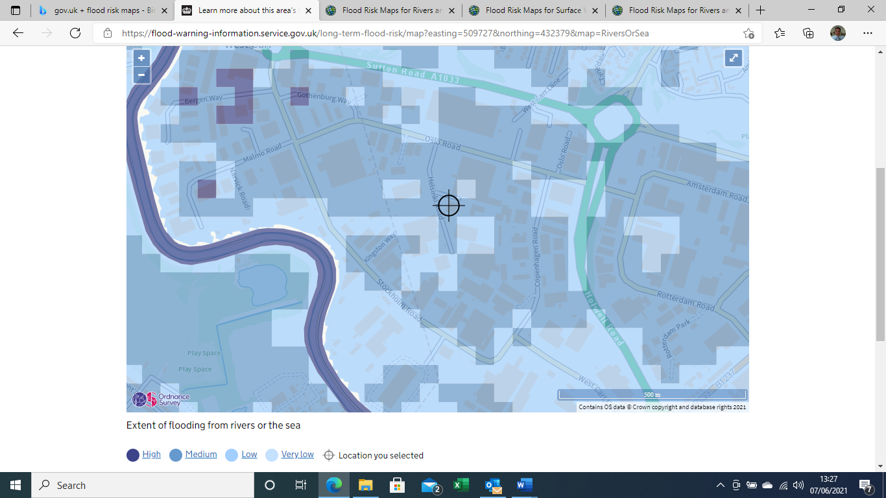

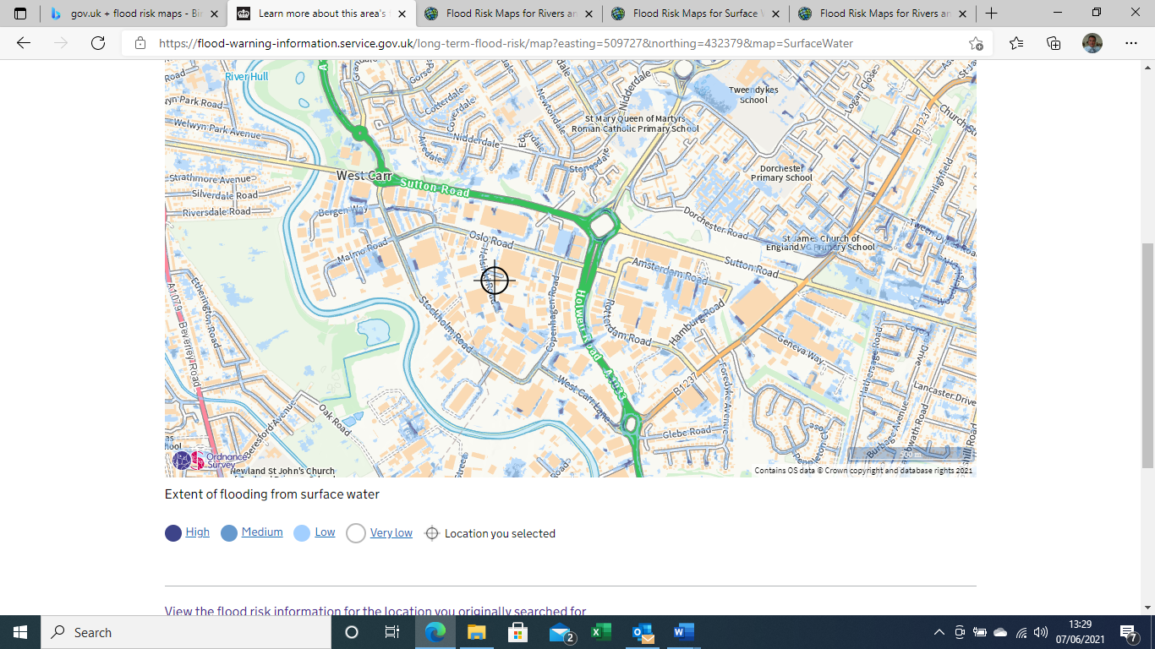

The site maintains a flood risk management plan as part of its documented management system.

In relation to visual impact, the new development will result in only minor changes to the external appearance of the facility given that the new processing plant will be accommodated within a modified existing building. External modifications and additions to the building and changes or additions to structures and equipment located within the building service areas will follow the general design characteristics of existing Cranswick and neighbouring buildings and associated structures on the industrial estate. Changes to external lighting schemes will be designed to prevent as far as possible light spill onto neighbouring properties.

In relation to landscape and ecology, the extended site already forms part of the Sutton Fields Industrial Estate and is currently owned and used by Cranswick for Commercial / Industrial purposes hence there are no impacts on flora or fauna to consider.

In relation to waste, the existing activities follow a zero waste to landfill philosophy and ensure that re-use, recycling and recovery of materials is adopted as far as possible to ensure that the production of waste is minimised. For example, animal by-product waste is disposed of to rendering, carboard, plastic, paper, wood etc is baled where possible and sent for recycling, and general waste is disposed of to RDF production. Ongoing discussions with product distributors / consumers aim to minimise the quantity and maximise the simplicity of product packaging used. These measures will continue and evolve following completion of the development in line with the site’s continuous improvement philosophy. For example, disposing of waste vegetable oil to recovery, diverting high organic containing waste-water to anaerobic digestion with energy recovery and rainwater harvesting which is being implemented to provide the site with water where potable water quality is not essential.
Further details relating to waste are provided in Section C3.6e, Waste Avoidance, of the permit variation application.

Qualitative environmental risk assessments have been conducted in relation to existing food processing operations at the site. Learning from these assessments together with consideration of the requirements of the relevant parts of the European BAT reference document (BREF) for the Food, Drink and Milk Industries (and the recently withdrawn Technical Guidance Note EPR 6.10 (The Food and Drink Sector) issued by the Environment Agency), have been used in the design and specification of plant, equipment, infrastructure and the operating techniques which will be implemented at the extended site. Once commissioning work for the extended site is completed and subsequently when normal operations are established, the risk assessments will be reviewed periodically to take into account routine monitoring results, operational changes, and findings from accident and incident investigations etc. A pre-operational environmental risk assessment conducted in relation to the proposed extended facility as a whole is set out in the tables at the end of this document.

In addition to the foregoing and prior to the commencement of commissioning works at the site, Cranswick, together with relevant contractors and equipment suppliers, will generate commissioning plans for plant, equipment and infrastructure. The plans will take into account the potential for accidents and incidents which could lead to adverse environmental impacts and will include measures to be taken to prevent such accidents and incidents from occurring and, if they do occur, to limit escalation and mitigate their consequences.

Before the extended site becomes operational, the Operator will review all relevant aspects of its documented management system to ensure, amongst other things, that all appropriate environmental protection measures are in place including accident prevention, response and mitigation measures, and plans for protecting and monitoring pollution prevention equipment and infrastructure.
Further information relating to management systems and operating techniques are provided in Sections C2.3d, Management Systems and C3.3/3.3a1 Operating Techniques and Technical Standards, of the permit variation application.

Cranswick Sutton Fields Facility Extension – Pre-operational Environmental Risk Assessment
Table Notes:
- Event frequency categories selected from continuous, frequent (eg. daily), occasional (eg. monthly) and infrequent (eg < annually)
- Unmitigated and mitigated risk categories are selected from low, low/medium, medium, medium/high and high based on event frequency and consequences, mitigated risk taking into account the stated prevention, control and mitigation measures
Hazard | Source | Pathway | Receptor | Event Frequency | Unmitigated risk | Prevention / Control Measures | Mitigation Measures | Mitigated Risk (very low / low / medium / high)
Emissions to air from point sources | NO_{x}, CO, CO₂ from natural gas fired steam / hot water boilers / heaters and thermal oil heater | Direct releases to atmosphere via boiler exhaust flues / stacks | Other businesses located on wider Sutton Fields Industrial Estate, residential areas to north and north-east of site and sensitive receptors in wider environment beyond. | Continuous | Low | Small (total installed capacity 11.25 MWh thermal input) natural gas fired steam / hot water boilers / thermal oil heater / gas fired cooking plant operated only to meet site demand.  Planned preventative maintenance to reduce risk of equipment malfunction and ensure boilers operating efficiently to meet design emission standards.  Newly installed steam boiler plant and thermal oil heating plant meets MCPD requirements, | Periodic emissions monitoring to confirm plant operating within design release parameters.  Site not located in AQM zone. | Very low  (See foot note 1)
Emissions to air from diffuse sources | Odour from air extraction points located in food processing building rooves. | Releases to atmosphere via air extraction fans | Other businesses located on wider Sutton Fields Industrial Estate, residential areas to north and north-east of site. | Continuous | Medium | Food processing and cooking operations inherently low odour and undertaken within building confines. Potentially odour generating putrescible waste materials stored in sealed containers in temperature-controlled environment and removed from site frequently to avoid odour due to degradation. | Weekly odour monitoring undertaken by site staff at specified locations on site and periodic odour monitoring undertaken by independent third party if required. Site located on industrial estate and not in close proximity to sensitive odour receptors. | Low
Fugitive emissions to air | Odour from raw materials receipt, storage, processing and dispatch operations. | Release to atmosphere from building openings | Other businesses located on wider Sutton Fields Industrial Estate, residential areas to north and north-east of site. | Occasional | Low | All putrescible potentially odorous raw materials delivered to site in refrigerated vehicles and offloaded to refrigerated storage pending processing. Materials unsuitable for processing rejected. All processing operations conducted within confines of processing plant buildings. Finished products placed into sealed packaging and held in refrigerated storage pending dispatch | Weekly odour monitoring undertaken by site staff at specified locations and periodic odour monitoring undertaken by independent third party if required. Site located on industrial estate and not in close proximity to sensitive odour receptors. | Very low
Fugitive emissions to air | Odour from waste materials storage and dispatch operations. | Release to atmosphere from building openings | Other businesses located on wider Sutton Fields Industrial Estate, residential areas to north and north-east of site. | Frequent | Medium | All potentially odorous waste materials stored in sealed / covered containers within enclosed buildings.  Waste materials removed from site frequently on demand to prevent odorous releases due to degradation. | Weekly odour monitoring undertaken by site staff at specified locations and periodic odour monitoring undertaken by independent third party if required. Site located on industrial estate and not in close proximity to sensitive odour receptors. | Low / medium
Fugitive emissions to air | NH₃ from refrigeration plant | Release to atmosphere from building openings due to equipment failure / accidental release during maintenance | Other businesses located on wider Sutton Fields Industrial Estate, residential areas to north and north-east of site. | Infrequent | Medium | Multi-point NH₃ leak detection system installed in refrigeration plant room with automatic plant shutdown and emergency plant room ventilation systems if significant release occurs.  Planned preventative maintenance of equipment to reduce risk of failure / malfunction. | Emergency plant shutdown and plant room ventilation designed to ensure sufficient dilution of NH₃ release from a safe exposure perspective. Odour may be detected outside plant room if emergency venting occurs. | Low / medium
Noise | Noise from LGV and mobile plant use on site.  Noise from food processing and associated equipment. | Direct “line of sight” between source and receptor | Other businesses located on wider Sutton Fields Industrial Estate, | Continuous | Medium | Majority of LGV movements occur during normal daytime hours.  Processing plant highly automated to minimise need for mobile plant. All food processing operations undertaken within confines of respective buildings. Equipment capable of generating high noise levels located in noise attenuating enclosures (eg. refrigeration plant compressors,).  LGV’s, mobile plant and fixed plant maintained to ensure correct functioning. | Site located on industrial estate and not in close proximity to sensitive noise receptors.  Weekly noise monitoring undertaken by site staff at specified locations on site and periodic noise monitoring undertaken by independent third party if required | Low
Emissions to surface water | Contaminated water from food processing activities. Potentially polluting liquid materials stored in storage tanks and containers. | Accidental release flowing direct via surface drainage systems on site into off-site surface water drainage network. | Local network of surface water drains flowing into local surface water courses (eg. R. Hull) | Continuous | Medium | All food processing activities undertaken within confines of buildings served by sealed drainage systems which direct contaminated water flow via an interceptor to consented discharge to foul sewer.  All potentially polluting fluids (eg. vegetable oil) held in bunded storage tanks fitted with overfill protection devices. Potentially polluting fluids held in small containers stored inside buildings either in bunds or in areas served by sealed drainage systems.  All surface and roof water flows via separate external drainage systems to consented discharge to foul sewer. Surfaces are provided with edge protection to prevent run-off to adjacent areas.  There are no potentially polluting materials stored or handled in areas likely to result in accidental release and contamination of otherwise clean surface water run-off.  There are no direct linkages between on- site drainage systems and off-site surface water drains and no direct routes available to surface water features. | Discharge of all process derived contaminated waste water can be stopped if necessary and sewerage undertaker informed of accidental release.  Local surface drains are combined sewer and surface water drains. | Very low
Emissions to surface water due to flooding | Potentially polluting materials held on site. | Potentially polluting materials carried off site due to on-site surface water drainage systems being overwhelmed due to site flooding | Local network of surface water drains flowing into local surface water courses (eg. R. Hull) | Infrequent | Low | Surface drainage network on site designed to accommodate 1 in 100 year storm conditions.  Potentially polluting materials stored within buildings and within bunds or in areas served by internal sealed drainage systems which flow via an interceptor to foul sewer.  There are no direct linkages between on-site drainage systems and off-site surface water drains and no direct routes available to surface water features. | Site is located in area at medium risk of flooding from seas and rivers and at very low / low risk of flooding from surface water.  Contingency in form of flood management plan established at site. | Very low
Emissions to sewer | Potentially polluting liquid materials held in storage tanks and containers. | Accidental release of potentially polluting fluids into internal or external on-site drainage systems | Yorkshire Water operated STW at Saltend which discharges treated water into the River Humber Estuary. | Occasional | Medium | All potentially polluting fluids (eg. unused and waste vegetable oil) held in bunded storage tanks fitted with overfill protection devices. Potentially polluting fluids held in small containers (eg. hygiene chemicals, maintenance materials) stored inside buildings either in bunds or in areas served by sealed drainage systems.  All surface and roof water flows via separate external drainage systems to foul sewer. There are no potentially polluting materials stored or handled in areas likely to result in accidental release and contamination of otherwise clean surface water run-off. | Discharge of all process derived contaminated waste water can be stopped if necessary and sewerage undertaker informed of accidental release. | Low
Emissions to ground / groundwater | Contaminated water from food processing activities. Potentially polluting liquid materials stored in storage tanks and containers. | Spills / leaks from storage vessels and containers, damaged drainage systems. | Ground / groundwater beneath the site. | Occasional | Medium / High | Drainage systems cleaned and inspected to prevent blockages and confirm integrity.  Liquid storage vessels located in bunds and fitted with overfill protection.  Potentially polluting fluids held in small containers stored inside buildings either in bunds or in areas served by sealed drainage systems  Vessels and bunds inspected / tested periodically to confirm integrity.  All processing activities undertaken in areas having impermeable surfaces and served by sealed drainage systems. | Site protection and monitoring procedures in place to ensure that protection measures remain intact or are repaired without delay if deterioration or damage occurs. | Low
Emissions to air, ground, groundwater, surface water | Accidental / unplanned releases due to equipment failure, maloperation or during maintenance | Spills / leaks resulting from unplanned release. | Release of substances directly into air, into drainage systems or into ground / groundwater beneath the site. | Infrequent | Medium | PPM scheme to ensure plant and equipment appropriately maintained.  All maintenance undertaken by site staff and third party contractors controlled via Permit to Work system.  Staff training / competence to ensure appropriate operating and maintenance procedures followed.  Third party contractor competence verification performed before any work on site permitted. | Incident response and management procedures in place. | Very low
Visual impact | New raw materials reception, food processing and product dispatch building areas. | Direct “line of sight” between source and receptor. | Other businesses located on wider Sutton Fields Industrial Estate. | Continuous | Medium | Buildings constructed to blend in with surroundings as far as possible and to have an appearance consistent with other buildings already present on wider Industrial Estate. | Site located on industrial estate designated in local plans as area for industrial / commercial development.  No nearby residential or other sensitive visual impact receptors | Very low
Visual impact | Light spill beyond site boundaries from lighting in areas outside processing plant buildings. | Direct “line of sight” between source and receptor. | Other businesses located on wider Sutton Fields Industrial Estate. | Frequent | Medium | External lighting scheme designed to minimise off site impact including lighting type, intensity, colour, location direction and timing. | Site located on industrial estate designated in local plans as area for industrial / commercial development.  No nearby residential or other sensitive visual impact receptors | Very low
Impact on wildlife / habitat | Displacement of flora and fauna as result of construction of extended facility. | Removal of habitat to facilitate construction | Established wildlife and plant populations. | Continuous | Medium | Development includes partial demolition of an existing building and subsequent extension and remodelling to accommodate new process line. All development located on land currently owned and operated by Cranswick for non-permitted commercial / industrial activity situated adjacent to existing permitted food production site.  Development area does not currently support established wildlife or plant populations. | Site located on industrial estate designated in local plans as area for industrial / commercial development. | None

Note 1: Assessment of the impact of emissions into air using the H1 tool have shown that NO and NO₂ releases from natural gas fired boiler plant are not insignificant. Detailed modelling to examine the wider impacts of the projected emissions has been completed. The modelling report is provided in full in this (C2.6) supporting document folder (Isopleth ADM Report 210723 01.0192.003).

