C 3.4b Air Emissions Sampling
Environmental permit EPR/FP3131WE does not specify any requirements for sampling point source emissions to air hence no formal sampling is currently undertaken for the purpose of monitoring and reporting on the quality of emissions to air.
However, gas fired boiler / water heating plant to which the release points A3, A4, A5 and A6 relate, are checked on an annual basis as a minimum by a competent third party to ensure that the plant is working safely and efficiently.
This will continue to be the case and the same regime will apply to the additional natural gas fired steam / hot water boiler and the natural gas fired thermal oil heater to be installed as part of the development.
The exhaust gas flues serving the new steam / hot water boiler plant and the thermal oil heating plant incorporate sampling points from which representative samples of the exhaust gases can be taken during service and performance checks without the need for specialist access equipment.

The picture below shows the location at which samples of exhaust flue gas are taken from the Cochran ST23 steam boiler vent flue.

The diagram below shows the location at which samples of exhaust flue gas are taken from the Babcock Wanson thermal oil heater vent flue.

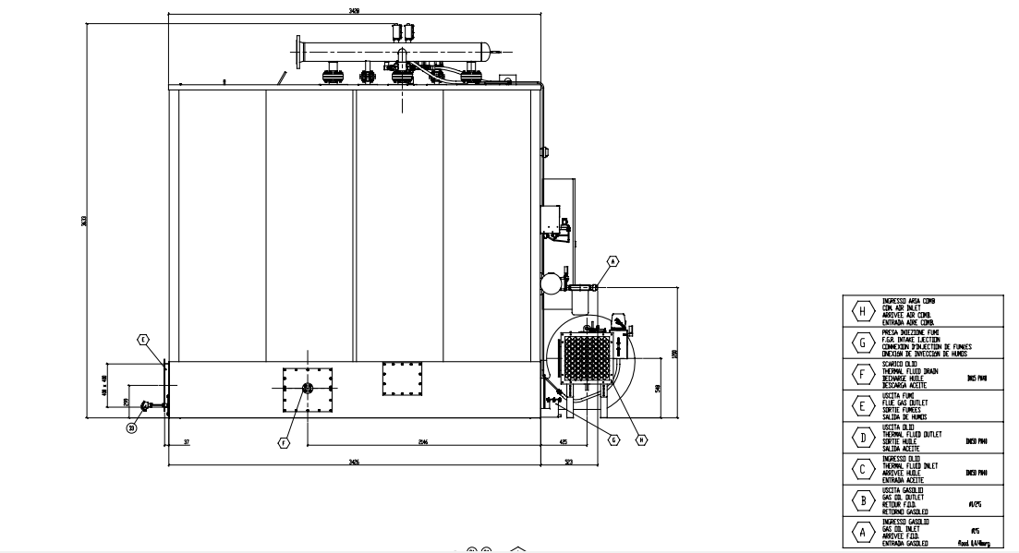
Thermal oil heater exhaust gas sampling point

As described in the response to question C3.1, Activities to be Varied, continuous monitoring equipment is provided in the refrigeration plant room to detect and provide early warning of fugitive ammonia refrigerant releases.
No other monitoring of point source releases into air is undertaken or proposed.

