C2.5c Non-technical Summary
Cranswick Convenience Foods Limited carries on a food manufacturing operation on a site situated at Helsinki Road, Sutton Fields Industrial Estate, Hull HU7 0YW (N.G.R. TA 09649 32335) as shown on the site location map document reference SLM 01 contained in supporting document folder reference C2.5a (Site Plans) and in the aerial photographs below.

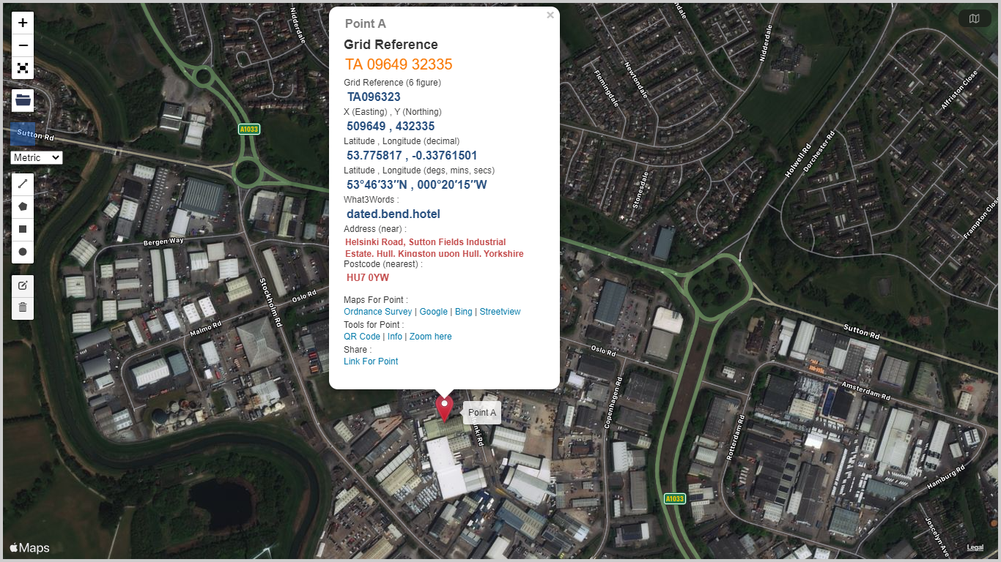
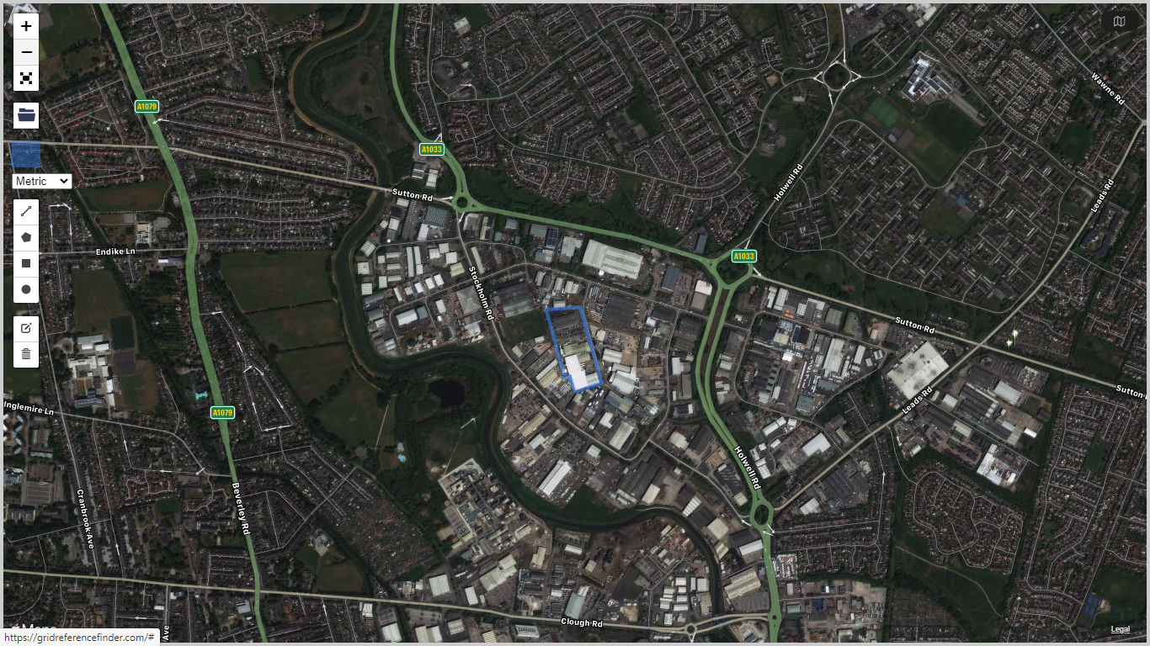 Denotes boundary of current Cranswick Convenience Foods Limited permitted site
The photographs show that the site, which occupies an area of around 3.2 hectares is located in an area developed to accommodate commercial and industrial undertakings, the nearest residential areas being around 400m to the north and north-east of the site. The River Hull is situated approximately 300m to the west of the site. Hull city centre is situated approximately 3km south of the site with the River Humber Estuary a little further beyond.
There are sensitive receptors in the vicinity of the site. The Humber Estuary 3.5km to the south of the site, is designated a Special Area of Conservation (SAC), Special Protection Area (SPA) and Ramsar location. There is a local nature reserve approximately 1km to the south-east of the site and several local wildlife sites within 2km of the site, the nearest being approximately 500m to the west immediately beyond the River Hull. The River Hull and the Humber Estuary and their immediate environs support fish and non-fish protected species. The site sits above a groundwater source protection zone 3 (total catchment) on shallow made ground above alluvium deposits containing clay, silt, and sand to a depth of around 7m. At greater depth the clay becomes stiffer and denser before giving way to underlying chalk bedrock.
However, there are no pathways by which uncontrolled emissions to water or land can reach these receptors as all site working surfaces are sealed with reinforced concrete or other impermeable surfaces and served by drainage systems designed to collect process derived waste water and site surface/ roof water for controlled discharge to sewer. Aerial emissions from the process, primarily exhausts from natural gas fired steam / hot water boilers / heaters and cooking plant, are incapable of impacting significantly on the receptors.
The main function of the site is to receive raw fresh and frozen meat and to process the meat by mincing, slicing, mixing and blending etc, together with other food ingredients, to produce packaged meat products for human consumption. Processing includes cooking using natural gas fired cooking plant. The raw meat ingredients include pork, beef and chicken. Other food ingredients include, for example, coatings (eg. breadcrumb), marinades, herbs, spices, glazes and other seasonings etc.

The site also provides office and amenity accommodation and car parking facilities for around 750 staff which may rise to around 900 at peak product demand times.
Activities at the site are undertaken in accordance with the conditions of Environmental Permit EPR/KP33733AN which authorises EPR Schedule 1 listed activity 6.8A1(d)(i) (treatment and processing of animal raw materials with a production capacity greater than 75 tonnes per day) along with five directly associated activities as shown in the permit extract below.
However, whilst the EPR Schedule 1 listed activity description 6.8A(1)(d)(i) was correct at the time when the permit was issued, it no longer reflects the activities carried on at the site due to changes to the Environmental Permitting Regulations made to implement the Industrial Emissions Directive. For the reasons set out below, the correct listed activity description should be 6.8A(1)(d)(iii).
At the time when permit EPR/KP3733AN was issued in June 2015 under the Environmental Permitting Regulations 2010, part d of part A1 to chapter 6.8 contained only two options, (d)(i) for animal raw materials and (d)(ii) for vegetable raw materials. Given the large predominance of animal raw materials the permit correctly described the activity as 6.8A(1)(d)(i). The Regulations subsequently changed and in the Environmental Permitting Regulations 2016, and a third option, 6.8A(1)(d)(iii), was added to allow animal and vegetable combinations to be accommodated in the Regulations in a more appropriate fashion and reflecting I.E.D. requirements.
This discrepancy was discussed with the site’s Environment Agency Regulatory Officer on 24 February 2021, and it was agreed that the listed activity should be amended to 6.8A(1)(d)(iii) as part of the process of determining this permit variation application and that the Operator should not incur additional permit variation costs associated with the correction of the discrepancy (ie. the Operator does not need to vary the permit to add a 6.8A(1)(d)(iii) activity because this activity description should already be contained in the permit instead of the 6.8A(1)(d)(i) activity. Further explanatory details are provided in Section C2.2b (Changes or Additions to Existing Activities) of the permit variation application.
The permit does not specify a cumulative annual production capacity limit although the introductory note to the permit mentions a production rate of around 200,000 tonnes of finished products per year. Typical annual production from the existing facility is currently around 30000 tonnes per year. The current site processing capacity is 100 tonnes/day equivalent to 35,000 how many tonnes per year.
Raw materials are delivered to site by road, the majority in refrigerated vehicles, and offloaded into a refrigerated goods reception area where they are checked for quality before being transferred into refrigerated storage pending processing. Depending upon required product specifications, the raw meat and other ingredients are prepared according to specific recipes and then cooked and packaged to produce ready to eat products. The packaging process may take place under modified atmosphere (carbon dioxide / nitrogen) conditions if required by the client. The packaged products are placed into refrigerated storage pending dispatch from site to clients.

The current production processes result in point source releases to air from natural gas fired combustion plant comprising two 1.3 MWh steam boilers, three 250kWh water heaters, and cooking plant consisting of a grill and two oven lines. The aggregated thermal input for the facility is 4.75 MW.
The releases occur at four locations designated A3, A4, A5 and A6 in the environmental permit. A3 and A4 are associated with the two steam boiler vent stacks, A5 with the common exhaust from the three hot water boilers and A6 with the vents from the cooking plant. There are point source releases from roof mounted air extraction fans which provide general ventilation throughout the processing plant areas. These release points are not specifically identified in the environmental permit.
The current production processes result in point source releases to sewer consisting of process derived waste water, roof and surface rainwater run off and domestic waste water from offices and amenities on site. The vast majority of the process derived waste water arises from the wash down and cleaning of food processing equipment and working areas using detergents and disinfectants formulated specifically for use in meat based food production applications. Consequently, the waste water contains only light meat and other food ingredient contamination. The releases occur at three locations identified in the environmental permit and designated S1 (West Discharge), S2 (East Discharge) and S3 (Aquarius Discharge). Contaminated water flows through internal drainage systems which are fitted with traps to intercept any gross solids present and prevent drainage system blockages, and through an interceptor before being released to sewer. All surface and roof water falling on the site is currently collected by external drainage systems and together with domestic effluent, also discharged to sewer. The sewer discharge is consented via three trade effluent discharge consents issued by the sewerage undertaker, Yorkshire Water. The possibility of discharging clean surface and roof water run off either to surface water or via “soakaways” has been investigated but found not to be viable.
There are no emission limits set in the permit in relation to releases from A3, A4, A5, A6, S1, S2 or S3. The trade effluent discharge consents contain limits set by the sewerage undertaker for flow (instantaneous and cumulative daily rate), temperature, pH, chemical oxygen demand and settleable solids.
There are no releases from the processes directly to land, surface water or groundwater. Further details relating to process emissions are provided in Section C3.2 (Emissions to Air, Water and Land) of the permit variation application.

Whilst the raw materials handled on site are putrescible and therefore potentially odorous, the strict hygiene conditions applied to all aspects of the production operation from raw materials receipt through processing, packaging and storage pending dispatch and including routine thorough cleaning regimes for all plant, equipment and infrastructure in production areas, effectively eliminate the potential for odorous releases from these sources. Raw materials delivered to site and packaged products awaiting dispatch are held in refrigerated storage to prevent degradation. Potentially odorous waste materials (primarily Category 3 Animal By-product wastes) are collected, placed in sealed containers and taken directly to dedicated storage on site pending removal. Removal is on demand and typically occurs twice each week. In addition, all food processing and associated activities are undertaken within closed buildings.

It is intended to add a new production facility to process raw chicken meat together with other non-meat food ingredients to produce cooked, ready to eat packaged products. The development will introduce new, additional incoming raw materials receipt and storage areas (including refrigerated storage), raw materials processing and cooking areas and finished product packaging, storage and despatch areas (including refrigerated storage) together with office and amenity accommodation for staff.

A summary of the proposed food manufacturing processes is as follows:
• Chilled and frozen chicken meat and other raw ingredients such as breadcrumbs, batter mixes and fillings, will be delivered to the facility in Large Goods Vehicles (LGVs) and unloaded into the material intake area.
• Vegetable oil will be delivered to the site in road tankers and transferred into one of three vertical bulk storage tanks located within a fenced compound. The oil will be pumped into processing vessels via sealed pipelines when required.
• Chicken meat will be minced, mixed and formed into various products. The meat will be coated in a batter followed by breadcrumbs.
• The breaded meat products will be cooked in thermal oil heated continuous fryers (three units) filled with vegetable oil.
• An additional processing line will be used to further cook a proportion of the fried products using a thermal oil / steam heated oven.
• The cooked products will be chilled and then packaged and labelled prior to despatch from the site.

The introduction of the new processing line, plant and equipment required for processing and cooking the raw materials and for packaging and storing the finished products, does not require changes or additions to the schedule 1 listed activity contained in the current environmental permit.

As the building which will house the proposed new process is physically separated from the existing production plant by a car park, the development site will be constructed, in most respects, as a “stand alone” unit with its own goods inwards, processing areas and service equipment such as boiler and refrigeration plant, despatch, offices and amenities etc.

Changes are required to the directly associated activities listed in the current environmental permit to reflect the following:
- The introduction of new, additional natural gas fired 3.6 MWh steam / hot water generating boiler plant.
- The introduction of new, additional natural gas fired 2.9 MWh thermal oil heating plant.
- The introduction of new, additional continuous hot oil heated fryers (3 x 605kW units) and additional hot oil/steam heated oven (1 x 900kW unit) with heat being supplied by the additional natural gas fired steam / hot water boiler and via heat exchangers fed with hot oil from the thermal oil heater plant described above.

Both the new natural gas fired steam boiler and thermal oil heater fall within the scope of the Medium Combustion Plants Directive (MCPD) as new medium combustion plant and hence will comply with all requirements of the Directive from the commencement of operations on the newly installed facility.
Further technical details relating to the new food processing line and cooking plant and equipment including new / additional ancillary plant and equipment such as refrigeration plant, product packaging and labelling plant, gas fired boiler plant and thermal oil heating plant, service areas and infrastructure are provided in Section C3.1 (Activities to be Varied) of the permit variation application.

The site processing capacity will increase as a result of the development from 100 tonnes /day equivalent to 35,000 tonnes per year rising to a maximum of 260 tonnes/day equivalent to 91,000 tonnes per year
Introduction of the new processing line and associated plant and equipment will not require the existing site or permit area boundary to be extended as the processing plant will be housed within an existing, albeit extended and modified, building at the northern end of the site currently used for engineering / general storage purposes, which is located within the existing permit area boundary as shown on the aerial photograph and ordnance survey map below.

Further technical details relating to the building in which the processing plant will be installed and the associated service areas including infrastructure, drainage, lighting, noise attenuation measures etc. are provided in Section C3.1 (Activities to be Varied) of the permit variation application. Site plans showing the revised site layout and identifying the main features of the extended site, drainage systems, emission point locations etc. are provided in Section C2.5a (Site Plans) of the permit variation application. A Plan showing the permit area boundary is also provided in Section C2.5a of the application.
Extension of the site and the introduction of the new process line along with associated ancillary plant, equipment and infrastructure will not significantly change the environmental risk profile of the site.
All process derived and domestic effluent along with site surface and roof water will continue to be collected by internal and external drainage systems pending discharge to foul sewer via discharge points S1, S2 and S3 as identified in the current Environmental Permit and under Consent from Yorkshire Water. Waste water from the proposed development will be discharged to sewer via release point S3. Discussions with the sewerage undertaker, Yorkshire Water, have taken place and applications have been submitted requesting changes to the existing trade effluent discharge consent conditions relating to daily cumulative discharge rates in order to accommodate the discharge from the proposed development.
The possibility of discharging clean uncontaminated surface and/or roof water run-off to surface water or via “soakaways” has been revisited but is still considered not to be viable, the former due to the distance to the nearest surface water feature (River Hull) and the latter due to the underlying site geology. High C.O.D. process derived waste water is sent to disposal by anaerobic digestion with energy recovery and plans are being developed to harvest rainwater for use in offices and amenities on site where non-potable water supplies are suitable.
All newly created working surfaces will be sealed and, where appropriate, incorporate drainage systems to aid collection and prevent pooling of contaminated and/or uncontaminated water, and edge protection to prevent the flow of water onto unmade ground.
New point source air emission points will be introduced. Of the 38 new air emission points introduced, a large proportion (14 in total), as at present, will be associated with ventilation systems which operate in general working areas inside the process buildings. One new release point will be associated with new natural gas fired boiler / hot water generation plant and one new release point will be associated with the natural gas fired thermal oil cooking plant. Six release points will be associated with exhaust vents form the three continuous frying units. Three release points will be associated with the exhaust vents from the thermal oil / steam heated oven. Three release points will be associated with pressure relief vents on liquified carbon dioxide and nitrogen storage tanks (one CO₂ and one N₂ storage tank for modified atmosphere packaging gases and one N₂ storage tank for chilling “soft mixer” meat contents). The new refrigeration plant, which is ammonia and glycol based, will be located in a new dedicated plant room. For safety reasons, the new plant room will be fitted with ammonia leak detection equipment capable, in the event of a serious leak, of automatically shutting down the refrigeration plant and starting emergency ventilation fans to extract and safely vent the ammonia vapour to atmosphere. Pressure relief outlets and valve stations are similarly extracted and vented to atmosphere in the unlikely event of an ammonia release occurring. The associated release points (8 in total) will only be active should such an emergency situation arise. The site has reviewed and amended its operating procedures to reflect the risks associated with the introduction of ammonia. The introduction of new refrigeration equipment using ammonia does not cause the installation to fall within the scope of the Control of Major Accident Hazards (COMAH) Regulations. The site has taken into account the flammable and toxic properties of ammonia when conducting risk assessments and making provisions to satisfy the requirements of the Dangerous Substances and Explosive Atmospheres Regulations (DSEAR) and Control of Substances Hazardous to Health (CoSHH) Regulations.
Further details relating to emissions from point sources to air and to sewer are provided in Sections C3.2 Emissions to Air, Water and Land and C2.6, Environmental Risk Assessment, of the permit variation application. The proposed development will not introduce any discharges to water or to land.

In absolute terms, the extended operation will consume more energy, water and raw materials compared with current operations as the total site capacity will increase by up to around 160 %. However, the development will use energy and process efficient technology to minimise raw materials, fuel and other energy use, for example L.E.D. lighting, lighting operated by passive infra red detectors in appropriate areas, heat recovery from refrigeration plant to provide office heating and to pre-heat boiler feed water, reductions in packaging use, energy efficient boiler plant, energy efficient / variable speed drive motors on plant and equipment, heat recovery air handling units capable of recovering more than 60% of the heat in exhaust air from offices etc. The site currently operates under a climate change agreement (CCA reference BMPA/F00182) which will continue and will apply to the extended operation.
Further details relating to the use of raw materials, water and energy are provided in Sections B3.3c Raw Materials and B3.6a/B3.6b Energy Efficiency and Changes in Energy Use of the permit variation application.

In relation to noise, existing operations are not a significant source, and the site has no history of noise related issues or noise complaints. There are no sensitive noise receptors in the vicinity of the site. The existing activities themselves including the operation of plant and equipment are not inherently noisy and all process activities are undertaken within the confines of closed buildings. The most significant sources of noise on site are items of mobile plant and LGV’s delivering raw materials to and collecting finished products from the site. This will continue to be the case for the extended operation albeit the typical daily number of vehicle movements into and out of the site will increase by around 10 per day (ie. 20 movements per day), an increase of around 60% on the current typical 30 LGV movements per day. However, given the location of the site on a commercial / industrial estate and the level of traffic movements on the local main traffic routes, the impact of the additional LGV traffic will be insignificant. The site currently conducts routine noise monitoring exercises and keeps a record of all monitoring results. The regime will continue following completion of the development.

In relation to odour, existing operations are not a significant source, and the site has no history of odour related issues or odour complaints. There are no sensitive odour receptors in close proximity to the site. The activities themselves including the operation of plant and equipment are not a source of significant odour given the strict food hygiene measures in place, the control and rapid removal from site of food based and any other putrescible waste, and the fact that all process activities are undertaken within the confines of closed buildings. Whilst the extended operation will introduce additional raw material cooking facilities, experience of existing cooking operations undertaken on site and of similar operations at other locations indicates that the additional activity will not be a significant source of odour likely to cause offense beyond the site boundary.
Further details relating to noise and to odour are provided in Section C3.3b General Requirements, of the permit variation application. The information provided includes full copies of noise and odour / air quality impact assessments undertaken on behalf of Cranswick Convenience Foods by Sharps Redmore and Redmore Environmental Ltd in support of the Planning application submitted in connection with the proposed development.
In relation to noise, the report concludes:
“In summary, this technical note assessment indicates that delivery activity and fixed plant equipment noise can be controlled such that the proposal, to extend the existing Cranswick County Foods production facility, would comply with the objectives of paragraph 180 of the NPPF and avoid significant adverse impact”.

In relation to odour and air quality, the reports conclude:
“Based on the findings of the Risk Assessment, overall odour effects associated with the proposed development are predicted to be not significant …….. The Risk Assessment predicted the odour effect significance to be slight at two receptors and negligible at ten locations. The IAQM guidance17 states that only if the impact is greater than slight, the effect is considered significant. As such, impacts are considered not significant, in accordance with the stated methodology”, and
“During the construction phase of the development there is the potential for air quality impacts as a result of fugitive dust emissions from the site. ……. Assuming good practice dust control measures are implemented, the residual significance of potential air quality impacts from dust generated by earthworks, construction and trackout activities was predicted to be not significant.
During the operational phase of the development there is the potential for air quality impacts as a result of combustion emissions associated with the operation of proposed energy plant. A risk assessment was therefore undertaken. ………. The results of the assessment indicated the predicted effect significance was negligible at sensitive locations. Following consideration of the relevant factors, overall effects as a result of combustion emissions associated with the operation of proposed energy plant were predicted to be not significant.
During the operational phase of the development there is also the potential for air quality impacts as a result of road vehicle exhaust emissions associated with traffic generated by the scheme. Information provided by the applicant indicated staff car and HGV flows from the site will be unchanged as a result of the proposals. Impacts were therefore considered to be not significant, and no further assessment was required”.

In relation to pest control, whilst food production activities may attract pests, adherence to strict hygiene regimes and the use of a pest control Contractor will continue to prevent pests from becoming established at the extended facility.
In relation to visual impact, the new development will result in only minor changes to the external appearance of the facility given that the new processing plant will be accommodated within a modified existing building. External modifications and additions to the building and changes or additions to structures and equipment located within the building service areas will follow the general design characteristics of existing Cranswick and neighbouring buildings and associated structures on the industrial estate. Changes to external lighting schemes will be designed to prevent as far as possible light spill onto neighbouring properties.
In relation to waste, the existing activities follow a zero waste to landfill philosophy and ensure that re-use, recycling and recovery of materials is adopted as far as possible to ensure that the production of waste is minimised. For example, animal by-product waste is disposed of to rendering, carboard, plastic, paper, wood etc is baled where possible and sent for recycling, and general waste is disposed of to RDF production. Ongoing discussions with product distributors / consumers aim to minimise the quantity and maximise the simplicity of product packaging used. These measures will continue and evolve following completion of the development in line with the site’s continuous improvement philosophy. For example, disposing of used vegetable oil to recovery, diverting high organic containing waste-water to anaerobic digestion with energy recovery and rainwater harvesting which is being implemented to provide parts of the site with water where potable water quality is not essential.
Further details relating to waste are provided in Section C3.6e, Waste Avoidance, of the permit variation application.
Operating techniques at the site meet the requirements of the relevant parts of the European BAT reference document (BREF) for the Food, Drink and Milk Industries (and the recently withdrawn Technical Guidance Note EPR 6.10 (The Food and Drink Sector) issued by the Environment Agency). The BREF explains and provides examples of best available techniques to be used by Operators. The operating techniques are set out in writing and form part of the Company’s safety, health, environmental and quality management systems which form the foundation on which the sites continuous improvement philosophy is built and provide the basis of training and competence assessment for operating staff. Changes are required to operating techniques as a result of the equipment additions and changes described above but there are no fundamental changes to the nature of the operations undertaken at the site (ie. receipt of raw meat and other food ingredients and processing of those raw materials to produce packaged food products for human consumption) as a result of the proposed development.
Further details relating to operating techniques are provided in Section C3.3 / C3.3a1, Operating Techniques and Technical Standards, of the permit variation application.
The site currently operates its own documented management system which is not independently audited or certificated. The site was previously certificated under the ISO 14001:2004 Standard by a non-UKAS accredited certification body but this certification has been allowed to lapse. There are plans in place to obtain independent certification through an accredited certification body under the current ISO 14001 Environmental, ISO 50001 Energy and ISO 45001 Occupational Safety and Health Management Standards and it is anticipated that these plans will be significantly progressed during the course of 2021 with the aim of achieving certification under the ISO 14001 and ISO 45001 Standards by December 2021 and the ISO 50001 Standard certification following in due course. The site hosted a formal stage I ISO 14001 audit in May 2021 and a stage II audit is scheduled for September 2021 following which it is anticipated that the site will be recommended for certification under the ISO 14001:2015 Standard.
Further details relating to management systems are provided in Section C2.3d, Management Systems, of the permit variation application.
The site, through its continuous improvement programme, strives to better its operational and commercial performance whilst at the same time improving its safety, health, environmental and quality performance. This environmental permit variation application is made as a consequence of the site implementing its continuous improvement programme. The environmental permit variation application, of which this document forms part, is made to reflect relatively minor changes to operations and operating techniques at the site as described above. There are no fundamental changes proposed for the site which currently receives raw meat and other food ingredients and processes them to produce meat-based food products for human consumption.

