C2.2b Changes or Additions to Existing Activities
Environmental permit EPR/KP3733AN issued under the Environmental Permitting Regulations 2010 authorises Cranswick Convenience Foods Limited to receive raw meat and to process the meat by mincing, slicing, mixing and blending etc including cooking (using natural gas fired cooking equipment), together with other food ingredients, to produce ready to eat meat-based products. The raw meat ingredients include fresh and frozen pork, beef and chicken. The food manufacturing process operates under the name Cranswick Convenience Foods at premises located on the Sutton Fields Industrial Estate in Kingston upon Hull at National Grid Reference TA 09649 32335 as shown in the aerial photographs below.
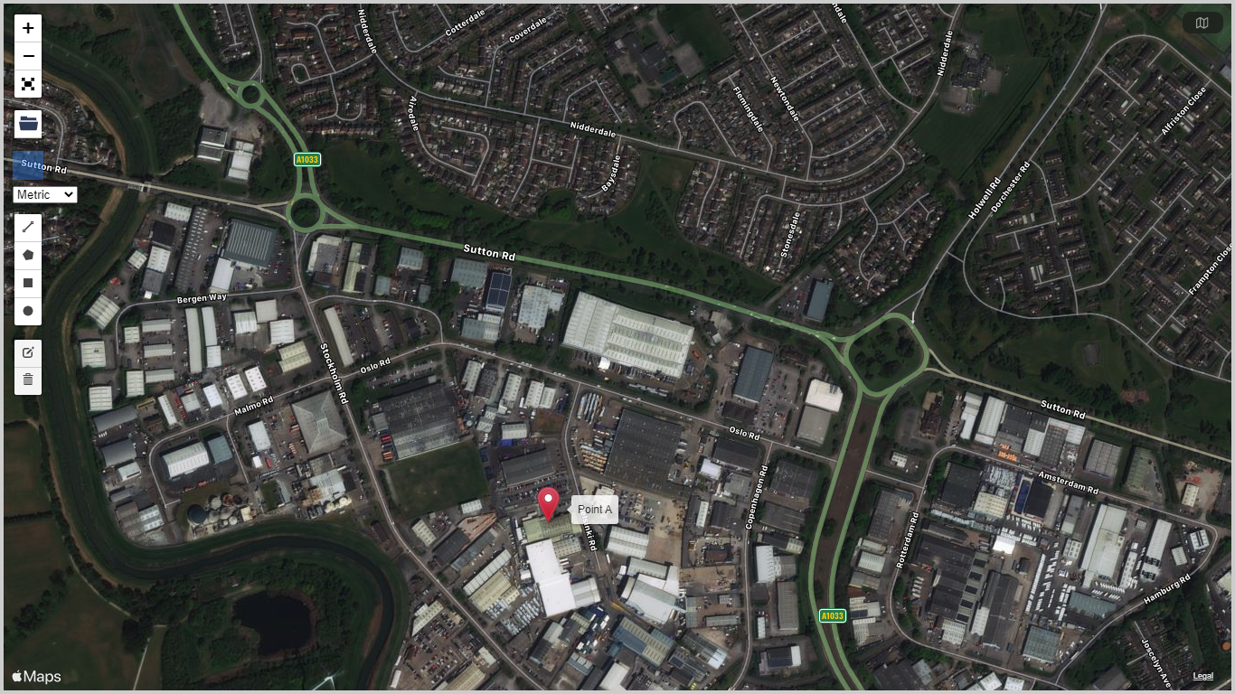
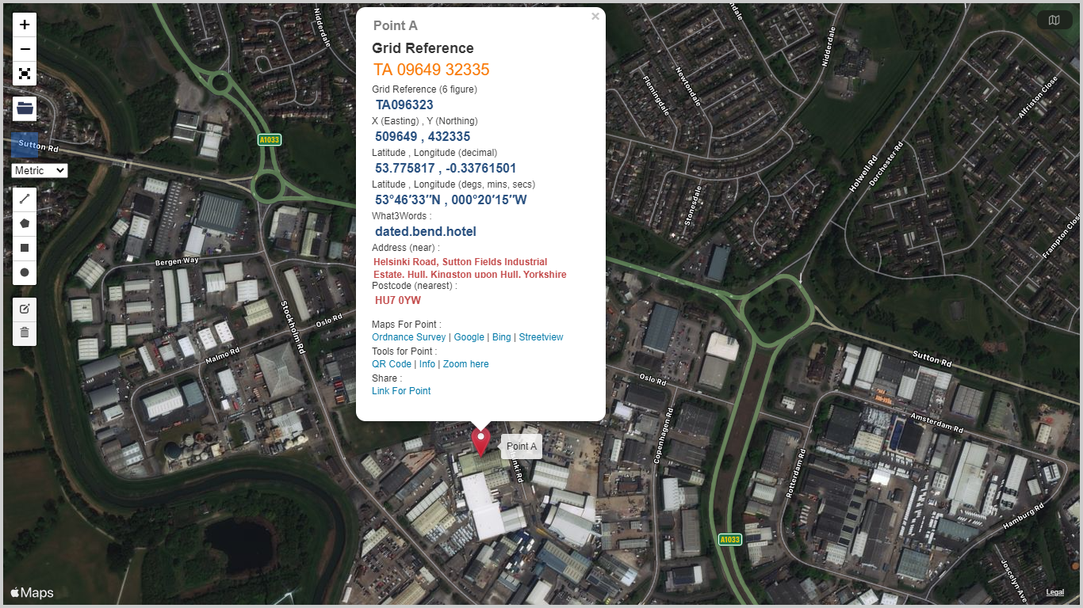
Schedule 1 to the permit refers to one EPR Schedule 1 listed activity 6.8A1(d)(i) and five directly associated activities covering all aspects of the current operation (see permit extract below).

Whilst the EPR Schedule 1 listed activity description 6.8A(1)(d)(i) was correct at the time when the permit was issued, it no longer reflects the activities carried on at the site due to changes to the Environmental Permitting Regulations made to implement the Industrial Emissions Directive.
For the reasons set out below, the correct listed activity description should be 6.8A(1)(d)(iii).
At the time when permit EPR/KP3733AN was issued, part d of part A1 to chapter 6.8 contained only two options, (d)(i) for animal raw materials and (d)(ii) for vegetable raw materials (see extract from 2010 Regulations highlighted below). Given the large predominance of animal raw materials the permit correctly described the activity as 6.8A(1)(d)(i).
However, the Regulations subsequently changed and a third option, (d)(iii), was added to allow animal and vegetable combinations to be accommodated in the Regulations in a more appropriate fashion and to reflect I.E.D. requirements (see extract from 2016 Regulations highlighted below).

EPR Regulations 2010
Part A(1)
(a)
Tanning hides and skins at a plant with a treatment capacity of more than 12 tonnes of finished products per day.
(b)
Slaughtering animals at a plant with a carcass production capacity of more than 50 tonnes per day.
(c)
Disposing of or recycling animal carcasses or animal waste, other than by rendering or by incineration falling within Section 5.1, at a plant with a treatment capacity exceeding 10 tonnes per day of animal carcasses or animal waste or both in aggregate.
(d)
Treating and processing materials intended for the production of food products from—
(i)
animal raw materials (other than milk) at a plant with a finished product production capacity of more than 75 tonnes per day; or
(ii)
vegetable raw materials at a plant with a finished product production capacity of more than 300 tonnes per day (average value on a quarterly basis).
(e)
Treating and processing milk, the quantity of milk received being more than 200 tonnes per day (average value on an annual basis).
(f)
Processing, storing or drying by the application of heat the whole or part of any dead animal or any vegetable matter (other than the treatment of effluent so as to permit its discharge into controlled waters or into a sewer unless the treatment involves the drying of any material with a view to its use as animal feedstuff) if the processing, storing or drying—
(i)
does not fall within any other Section, or Part A(2) of this Section, and is not an excluded activity; and
(ii)
may result in the release into water of any substance in paragraph 7 of Part 1 of this Schedule in a quantity which, in any 12-month period, is greater than the background quantity by more than the amount specified in relation to the substance in that paragraph.
EPR Regulations 2016
Part A(1)
(a)Tanning hides and skins at a plant with a treatment capacity of more than 12 tonnes of finished products per day.
(b)Slaughtering animals at a plant with a carcass production capacity of more than 50 tonnes per day.
(c)Disposing of or recycling animal carcasses or animal waste, other than by rendering in a small waste incineration plant, at a plant with a treatment capacity exceeding 10 tonnes per day of animal carcasses or animal waste or both in aggregate.
(d)Treatment and processing, other than exclusively packaging, of the following raw materials, whether previously processed or unprocessed, intended for the production of food or feed (where the weight of the finished product excludes packaging)—
(i)only animal raw materials (other than milk only) with a finished product production capacity greater than 75 tonnes per day;
(ii)only vegetable raw materials with a finished product production capacity greater than 300 tonnes per day or 600 tonnes per day where the installation operates for a period of no more than 90 consecutive days in any year;
(iii)animal and vegetable raw materials (other than milk only), both in combined and separate products, with a finished product production capacity in tonnes per day greater than—
(aa)75 if A is equal to 10 or more, or
(bb)300-(22.5 x A) in any other case,
where ‘A’ is the portion of animal material in percent of weight of the finished product production capacity.
(e)Treating and processing milk, the quantity of milk received being more than 200 tonnes per day (average value on an annual basis).

This discrepancy was discussed with the site’s Environment Agency Regulatory Officer on 24 February 2021, and it was agreed that the listed activity should be amended to 6.8A(1)(d)(iii) as part of the process of determining this permit variation application and that the Operator should not incur additional permit variation costs associated with the correction of the discrepancy (ie. the Operator does not need to vary the permit to add a 6.8A(1)(d)(iii) activity because this activity description should already be contained in the permit instead of the 6.8A(1)(d)(i) activity.

It is intended to add new processing plant and equipment to produce cooked, ready to eat chicken meat products. Further technical details relating to the new processing line plant and equipment including cooking plant and new / additional ancillary plant and equipment such as refrigeration plant, natural gas fired boiler plant and natural gas fired thermal oil heating plant, are provided in Section C3.1 (Activities to be Varied) of the permit variation application.

Introduction of the new processing line and associated plant and equipment will not require the existing site to be extended as the processing plant will be housed within a modified building situated at the northern end of the site and currently used for engineering / general storage purposes, which is located within the existing permit area boundary as shown on the aerial photograph and ordnance survey map below. The building will be largely demolished and then extended and undergo substantial internal alterations to accommodate the new processing plant and associated equipment.

Building to be used for proposed new processing line
Existing site with blue line showing permit area boundary

Proposed development site including building to be used for proposed new processing line with red line showing development area boundary

Existing site with green line showing permit area boundary

Further plans showing the site location, permit area boundary and existing and proposed site layout etc details are provided in Sections C2.5a, Site Plans, of the permit variation application.
Further details relating to the condition of the site are provided in Section B2.5b (Site Condition – Baseline Report) of the permit variation application.

The introduction of the new processing line, plant and equipment required for processing, and cooking the raw materials and for packaging and storing the finished products, together with associated service areas / infrastructure, does not require changes or additions to the schedule 1 listed activity contained in the current environmental permit.

However, as the building which will house the proposed new process is physically separated from the existing production plant by a car park, the development site will be constructed in most respects as a “stand alone” unit with its own goods inwards, processing areas and service equipment such as boiler and refrigeration plant, despatch, offices and amenities etc. Existing activities at the site will be unaffected by the proposed development.

Changes are required to the directly associated activities listed in the current environmental permit to reflect the following:
- The introduction of new, additional natural gas fired 3.6MWh steam / hot water generating boiler plant.
- The introduction of new, additional natural gas fired 2.9MWh thermal oil heating plant.
- The introduction of new, additional continuous hot oil heated fryers (3 x 605kW units) and additional hot oil/steam heated oven (1 x 900kW unit) with heat being supplied by the additional natural gas fired boiler and thermal oil heater plant described above.
Whilst new, additional refrigeration plant and other food processing and ancillary plant and equipment will also be introduced, the additions do not require changes or additions to the directly associated activities listed in the current permit.
Further technical details are provided in Section C3.1. Activities to be Varied, of the permit variation application.
Changes are required to operating techniques as a result of the equipment additions and changes described above but there are no fundamental changes to the nature of the operations undertaken at the site (ie. receipt of raw meat and other food ingredients and processing of those raw materials to produce packaged food products for human consumption) as a result of the proposed development. Further details relating to amended operating techniques are provided in response to questions C3.3 / C3.3a.1 and C3.3b of the permit variation application.

