

Document Ref: B203
Members of the Energy Systems Trade Association ESTA
Inenco Limited – Registered in England No. 2790570
Inenco Group Ltd - Registered in England No. 2435678
Inenco
Petros House
St Andrews Road North
Lytham St Annes
Lancashire
FY8 2NF
t: 01253 785000
f: 01253 785001
www.inenco.com

Application Site Report

for PPC Application

at

Tryton Foods Ltd
Freightliner Road
Kingston Upon Hull
Hull
East Yorkshire
HU3 4UW

Prepared by: Simon Farley

Environmental Consultant

Reference Nº: 168940 20040726 SF/JAC Revision 1

Date: 26 July 2004
CONTENTS

1.0 INTRODUCTION … … … … … … … … … … … 5
1.1 Site Location … … … … … … … … … … … 6
1.2 Details of Installation … … … … … … … … … 7
2.0 OBJECTIVES … … … … … … … … … … … … 8
3.0 SITE SETTING AND SOURCES OF DESK STUDY INFORMATION … … 9
3.1 Introduction … … … … … … … … … … … 9
3.2 Environmental Consents, Licences, Authorisations, Permits
and Designations for the Site and Surrounding Area … … … … 9
• Integrated Pollution Control (IPC) and Air Pollution Control
Authorisations … … … … … … … … … … 10
• Enforcement and Prohibition Notices … … … … … … 10
• Waste Management Sites … … … … … … … … 10
• Control of Major Accident Sites (COMAH) … … … … … 11
• Planning Applications and Consents … … … … … … 11
• Previous Pollution Incidents … … … … … … … … 11
• Proximity of Protected or Sensitive Habitats or Species … … … 11
3.3 Geological, Hydro Geological and Hydrological Data … … … … 13
3.4 Site Operational Records, Emergency Response Records and
Records of any Land Pollution Incidents in the Vicinity of the Site … 14
3.5 Existing Site Investigation and Assessment Reports … … … … 15
3.6 Other Information … … … … … … … … … … 16
4.0 Site Reconnaissance … … … … … … … … … 17
4.1 Introduction … … … … … … … … … … … 17
4.2 Storage Tanks and Associated Pipework … … … … … … 17
4.2.1 Bulk Vegetable Oil Tanks … … … … … … … 18
4.2.2 Bulk Egg Storage Tanks … … … … … … … 18
4.2.3 Bulk Road Tanker Unloading Area … … … … … … 18
4.2.4 Waste Storage Area … … … … … … … … 18
4.2.5 Waste Oil Storage Tank … … … … … … … … 19
4.2.6 Caustic Wash Tank … … … … … … … … 19
4.2.7 Electrical Transformers … … … … … … … … 19
4.2.8 Effluent Treatment Works … … … … … … … 19
4.3 Hard-standing and Bunds … … … … … … … … … 20
4.4 Vegetation … … … … … … … … … … … 20
4.5 Surface Water Features … … … … … … … … … 20
4.6 Nature of the Storage and Handling of Materials … … … … … 20
4.7 Surface Water and Foul Drainage … … … … … … … 21
4.8 Other Observations … … … … … … … … … … 21
5.0 ASSESSMENT OF LAND POLLUTION POTENTIAL … … … … … 22
5.1 Polluting Substances and Relevant Activities … … … … … 22
5.2 Preventative Measures … … … … … … … … … 22
5.3 Assessment of the Likelihood of Land Pollution … … … … … 22
6.0 Conceptual Site Model … … … … … … … … … 24
6.1 Geology and Hydrogeology … … … … … … … … 24
6.2 Surface Water Features … … … … … … … … … 25
6.3 Results of Previous Investigations/Assessments … … … … … 26
6.4 Other Receptors … … … … … … … … … … 26
6.5 Land Pollution History … … … … … … … … … 26
6.6 Site Zoning … … … … … … … … … … … 26
6.7 Summary Conceptual Site Model (CSM) … … … … … … 27
6.7.1 Introduction … … … … … … … … … … 27
6.7.2 Graphical Representation of the CSM … … … … … 27
6.7.3 Uncertainties in the CSM … … … … … … … 28
7.0 Conclusions … … … … … … … … … … … 29
References
Appendix A – Figures and Maps
Appendix A1 – Site Location Plans
Appendix A2 – Geological Maps and Cross Sections
Appendix A3 – Site Layout Plans
Appendix A4 – Site Drainage Plans
Appendix A5 – Plans Showing the Location of Sensitive Receptors
Appendix A6 – Plans Showing the Location of Contamination Sources
Appendix A7 – Plans Showing Zones
Appendix B – Site Reconnaissance
Appendix B1 – Figures
Appendix B2 – Plates
Appendix B3 – Relevant Test Certificates
Appendix C – Desk Study Information
Appendix C1 – Environmental Consents, Licences, Authorisations & Permits
for Site and Surrounding Area
Appendix C2 – Geological and Hydrological Data
Appendix C3 – Hydrological and Hydrogeological Data
Appendix C4 – Site Operational Records, Records of any Land Pollution on
Site
Appendix C5 – Existing Site Investigation, Assessment and Remediation
Records
Appendix C6 – Other Information
Appendix D – Data Assessment
Appendix D1 – Potentially Polluting Substances
Appendix D2 – Assessment of Land Pollution Potential
Appendix E – Conceptual Site Model
Appendix E1 – Tabular
Appendix E2 – Graphical

Disclaimer:

The information service of the ‘Landmark EnviroCheck’ search database has been relied upon for the production, in part of this report. Inenco will consider and analyse all information provided to it in the context of Inenco’s knowledge, experience and all other relevant information known to Inenco. To the extent that the information provided to Inenco is not inconsistent and/or incompatible therewith, Inenco shall be entitled to rely upon and assume, without independent verification, the accuracy and completeness of such information.

1.0 INTRODUCTION

This document has been produced by Inenco and represents the Application Site Report for Tryton Foods Ltd submitted as part of an application to the Environment Agency for a permit to operate an installation under Regulation 10 of the Pollution Prevention and Control (England and Wales) Regulations 2000.

Tryton Foods is a facility involved in the ‘Treating and processing of materials intended for the production of food products from animal raw materials (Yorkshire pudding). Records of the site and surrounding areas have been reviewed along with operational site records in order to describe the condition of the site and, in particular, to identify any substance in, on or under the land that may constitute a pollution risk to the land. Pollution prevention measures have been identified and an assessment of pollution potential to land has been undertaken.

The application site report is divided into several sections:-

Section 1 – Introduction.
Section 2 – Objectives; identifying the key aims of the application site report.
Section 3 – Site Setting and Sources of Desk Study Information; detailing geological, hydrogeological and hydrological data including the history of the site.
Section 4 – Site Reconnaissance; describing environmental aspects identified as part of the site description.
Section 5 – Assessment of land pollution potential; identifying polluting substances and activities, which have the potential to cause land pollution.
Section 6 – Conceptual Site Model; Data Interpretation; Explanation of any data including the implications of the model.
Section 7 – Conclusions of the Application Site Report.
Appendices

1.1 Site Location

The installation is located at Tryton Foods Limited, Freightliner Road, Kingston Upon Hull, Hull, East Yorkshire. Tryton Foods Limited, hereafter referred to as the site, is situated approximately 3.2 km west-southwest of Hull town centre. The centre of the site is at National Grid Reference 506830 427130. The proposed permitted installation occupies a total area of approximately 3.17 hectares and can be seen in Figure 1 of Appendix A1.

The site is situated approximately 0.5 km north of the River Humber. The site lies between the east coast railway line, which forms the north-eastern boundary and Freightliner Road which forms the south-eastern boundary of the proposed installation.

The main land use surrounding the area in which the proposed installation is sited was identified to be predominantly industrial. The site is situated within a designated industrial area with industrial units located immediately adjacent to the proposed installation; Trans European Port Services, Greens The Signmaker, Chaucer Foods Ltd, Godfrey Auto Parts and Hygena Components. The closest residential neighbours are located 300 m north west of site.

The current surrounding land uses are:

- North – Immediate industrial neighbours include Hygena Components and Dairycoates
- South – The main gate located to the south grants access to the whole site from Freightliner Road.
- East – Located immediately east of site are small industrial units, with retail outlets approximately 400 m to the east and south
- West – The Leeds-Hull railway line forms the western boundary of the site. The railway line passes in a northeast – southwest orientation.

1.2 Details of Installation

Tryton Foods is a producer of value added food products including; Ready to Bake Yorkshire Puddings, Baked Yorkshire Puddings, Meat Pies, Stuffing and Dumplings. Further information relating to specific details of the process can be found in Section 2 of the main application.

Associated with the process areas of the site are a number of storage areas, drains and underground tanks. These are listed below and considered in Section 4 – Site Reconnaissance.

• Above and below ground effluent tanks
• Bulk mineral oil storage tanks within the factory
• Transformers (oil)
• Waste storage area
• Surface water ‘soak-away’
• Flour silos.

For the purpose of this application, the installation covers all activities and directly associated activities (DAAs) involved in the production of value added food products.

As far as practical this report reflects the operations undertaken at the Tryton site. Inenco has not been made aware of any major changes to the operation described within this report.

2.0 OBJECTIVES

The main objectives of this Application Site Report are to satisfy the requirements of the PPC Regulations at time of permitting by:

- Establishing a point of reference (baseline), against which later determinations can be compared;

- Identifying the environmental setting; physical attributes, vulnerability and land pollution history of the Installation to aid the understanding of the nature, extent and behaviour of any contamination that may be present;

- To collate sufficient information to allow the development of a conceptual model for the site and its environs;

- Identifying any substance in, on or under the land that may have arisen from materials currently used or produced by the activities under the Permit (or are likely to be used or produced in the future that may lead to land pollution);

- Identifying and assessing the preventative measures that are in place to protect the land;

- Be sufficient to form the basis of the Operator’s Site Protection and Monitoring Programme of impact to land to be conducted during the life of the permit; and

Assessing whether there is:

1. Little likelihood that land pollution or leaks to land will occur during the future life of the installation;

or there is:

2. A reasonable possibility that there is potential for current or future land pollution of the land from the installation.

3.0 SITE SETTING AND SOURCES OF DESK STUDY INFORMATION

3.1 Introduction

This report has been prepared based on the collation and review of all readily available information to allow the identification and characterisation (as far as practical) of any contamination, which may be present at the site.

The following sources of information have been consulted as part of the compilation of this report:

• Historical Data and plans from of the site
• Search Data Bases; Landmark Envirocheck
• Interviews with Tryton Foods staff.

The following sections detail the sources of desk study information searched in order to describe the condition of the installation and, in particular, to determine the potential for substances to be present in, on or under the land associated with present and past uses of the site and its surrounding areas.

3.2 Environmental Consents, Licences, Authorisations, Permits and Designations for the Site and Surrounding Area

Public register information was obtained from a search of the Landmark Envirocheck database. Records were supplied of any Discharge Consent, Waste Management Licences, Abstraction Licences, IPC Authorisations, PPC Permits and Land Drainage Consents for the site and within 1 km of the site boundary. The Landmark information is reproduced within Appendix C6. Records relating to the site and local area that have implications for pollution are also described below.

A copy of the current trade effluent discharge consent is included in Appendix C1. GIS data sets provided by English Nature detailed any Nature Conservation Designations for the site and within 10 km of the site boundary. The locations of Designated Sites within the vicinity of the proposed installation are shown in Figure 1, 2 and 3 of Appendix A5.

- Integrated Pollution Control (IPC) and Air Pollution Control Authorisations

The database search report identified one further IPC authorisations beyond Tryton Foods Ltd within one kilometre; Caradon Bathrooms Plc – 4.2 A (B) Manufacture and use of Organic Chemicals within the Chemical Industry.

There are twenty-five air pollution controls within 1 km of the site. The closest of which are the immediate industrial units of Greens, located 50 m east of site and Hygena Components, 50 m northeast of site.

The site is not located within any Air Quality Management Areas – Kingston upon Hull City Council has completed the review and not declared any Air Quality Management Areas.

- Enforcement and Prohibition Notices

There are no identified enforcement and prohibition notices relating to Tryton Foods Ltd or within a one kilometre radius of the proposed installation.

- Waste Management Sites

The ‘Envirocheck’ database search of the Environment Agency (North East Regions Ridings Area) identified one licensed waste management transfer facility 552 m east of site. There are several historical local authority (Kingston Upon Hull City Council) recoded landfill sites; Newington Street, 519 m north of site, West Dock Street 604 m east of site, Workshops, Hawthorn Avenue 797 m north of site, Amy Johnson School – Plowden Road 851 m north of site, West Dock Avenue. Kingston Upon Hull City Council were contacted regarding these historical sites. However no details could be provided.

- Control of Major Accident Sites (COMAH)

There is one active site holding COMAH status recorded within l km of the site; Birds Eye Walls Ltd – lower tier site located 150 m northwest of site. There is one historical record relating to Calor Gas Ltd, 728 m west of site.

- Planning Applications and Consents

There is one recorded planning hazardous substance consent within 1km of Tryton. This is relates to Hull Calor Gas Centre 89 m northwest of site.

- Previous Pollution Incidents

The database search has revealed one prosecution incident relating to controlled water, this was a category 3 minor pollution incident. There is one prosecution incident relating to authorised processes; ‘trying to dispose of special waste under a non hazardous waste transfer note at a site not licensed to accept it.’

- Proximity of Protected or Sensitive Habitats or Species

Designated Sites:-

SSSI – A Site of Special Scientific Interest (SSSI) is the land notified as an SSSI under the Wildlife and Countryside Act (1981), as amended. Sites notified under the 1949 Act only are not identified.

1.2 km west southwest – Humber Flats and Marshes; Upper Humber (Biological – mudflats; TA059263)
5.1 km southwest – Humber Flats & Marshes; Barton and Barrow clay pits (Biological – flooded clay workings & intertidal mudflats; TA038232)
6.6 km east southeast – Humber Flats and Marshes; The Grues (Biological – Salt Marsh; TA133252)
9.8 km southwest – South Ferriby Chalk Pit (Geological – Jurassic and lower cretaceous rocks; TA001201)

NNR – A National Nature Reserve (NNR) is the land declared under the National Parks and Access to the Countryside Act 1949 or Wildlife and Countryside Act (1981), as amended.

5.1 km southwest – Humber Flats & Marshes; Barton and Barrow clay pits (flooded clay workings and intertidal mudflats; TA038232)
6.6 km east southeast – Humber Flats and Marshes; The Grues (Salt Marsh; TA133252)

Ramsar – A “Ramsar site” is the land listed as a Wetland of International Importance, under the Convention on Wetlands of International Importance Especially as Waterfowl Habitat (the Ramsar Convention) 1973. Sites identified have the status of “Listed”.

5.1 km southwest – Humber Flats and Marshes; Barton and Barrow clay pits (flooded clay workings and intertidal mudflats; TA038232)
6.6 km east southeast – Humber Flats and Marshes; The Grues (Salt Marsh; TA133252)

Natura 2000 Sites – A term created under the Habitats and Species Directive, which encompasses both the SPA and SAC designations. Natura 2000 sites are sometimes also referred to as ‘European Sites’ or occasionally shortened to ‘N2K’ sites.

SAC – A Special Area of Conservation (SAC) is the land designated under Directive 92/43/EEC on the Conservation of Natural Habitats and of Wild Fauna and Flora. Sites identified have the status of “Candidate”. There are no sites located in the vicinity; 10 km of Tryton Foods.

SPA – A Special Protection Area (SPA) is the land classified under Directive 79/409 on the Conservation of Wild Birds. Sites identified have the status of “Classified”.

5.1 km southwest – Humber Flats and Marshes; Barton and Barrow clay pits (flooded clay workings and intertidal mudflats; TA038232)
6.6 km east southeast – Humber Flats and Marshes; The Grues (Salt Marsh; TA133252).

3.3 Geological, Hydro Geological and Hydrological Data

Geological and hydro geological information for the site was obtained from the following sources and is reproduced in Appendix C2, and a geological map is included as Figure 1 of Appendix A2.

BGS Sheet E[080]EF Kingston upon Hull 1 to 50000 Scale map
Environment Agency Groundwater Vulnerability Map Sheet (Landmark)
Environment Agency Source Protection Zone Map Sheet
Archive Borehole Data for a boreholes located around the centre of the site
Environment Agency Indicative Floodplain (Landmark)
Ordnance Survey Explorer, 1:250,000, Sheet 293, Kingston Upon Hull & Beverly.
Archive Data obtained from Phase 1 Environmental Risk Assessment.

Hydrological data was obtained from the Landmark search database for the watercourses within 1000 m of the installation. This is reproduced in Appendix C3. The site is generally flat and unsloping 4 m above Ordnance Datum (m aOD). Falls have been incorporated all hard-standing to allow surface water drainage.

It is likely that areas of made ground is present immediately beneath the site, associated with the foundations, and buried services. This can be up to a few metres in thickness and typically comprises variable proportions of clay, silt, sand gravel and ash with brick and concrete rubble. Based on the 1:50000 BGS Solid & Drift Geology plan the site is underlain by drift deposits of estuarine alluvium, lacustrine and glacial deposits.

The bedrock beneath the site comprises of cretaceous upper chalk measures; welton chalk; 40 – 50 m and ferriby chalk with reduced basal beds; 40–50 m. This in turn is underlain by upper jurassic measures; ancholme clay groups; 20–30 m and brantingham formations; 5–10 m. These in turn are underlain by middle and lower jurassic measures.

The layer of made ground is likely to be highly varied in its permeability due to its variable composition. Thus depending on the nature of materials, it is likely that any infiltratrating water will percolate through to remain perched on the lower permeability lenses or any boulder clay present in the underlying veneer of quaternary age drift deposits.

As a unit the overlying drift measures are classified by the environment agency as a Non Aquifer (Negligibly permeable) – formations which are generally regarded as containing insignificant quantities of groundwater. However, groundwater flow through such rocks, although imperceptible, does take place and needs to be considered in assessing the risk associated with persistent pollutants, see Appendix C3 Figure 1. The site does not fall within an inner, outer or total source protection zone see Appendix C2. The closest groundwater abstraction Smith & Nephew Medical Ltd is 1.8 km east of site. The environmental sensitivity of the surface water is low to medium due to underlying strata and distance of surface water features.

3.4 Site Operational Records, Emergency Response Records and Records of any Land Pollution Incidents in the Vicinity of the Site

No operational site records or procedures relating to spillages or accident investigation were made available for inspection onsite. Thus, an identification and assessment of significance of historical events could not be conducted. The site does not have a documented spill procedure.

Land pollution records were provided by the Landmark information group for incidents within 1 km of the site boundary. Contaminated land entries/local authority recorded landfill sites have been identified by Kingston Upon Hull City Council. The locations of these sites are included in Figures 1 and 2 of Appendix C4, there are 10 entries within 1 km of site, these are detailed in Section 3.2.

Site operational layout plans, including the location and nature of underground services and pipelines are shown on Figures 1 in Appendix A3. The majority of underground structures located on site are limited to utility services. There are no sumps located on site. The effluent treatment works contains several above and below ground storage tanks. There is one ‘soak-away’ located on site which drains uncontaminated surface water (roof water) to land.

The location of bulk storage tanks and raw materials/product storage areas are shown on Figure 1 in Appendix A6. Those chemicals that are potentially polluting have been identified, a list is provided in the main body of the application. The locations of waste storage areas are shown on Figure 1 in Appendix A6. Site foul and surface water drainage plans are included as Figures 1 and 2 in Appendix A4.

3.5 Existing Site Investigation and Assessment Reports

During the preparation of the application site report an ‘Environmental Risk Assessment’ was identified. The assessment was undertaken in June 2002 and is reproduced in Appendix C5. The assessment was under taken F2 building, previously owned Hygena components. This building was previously used for the manufacture of UPVC windows and doors, see Figure 1 of Appendix C5.

3.6 Other Information

An assessment of the site history and use was conducted to indicate the nature of possible ground and groundwater contamination. The relevant information is summarised in the following paragraphs and copies of the historical maps are reproduced in Appendix C6. A historical land use report identifying potentially contaminative industry, land use, tanks etc are also included in Appendix C6.
An assessment of the site history and use was conducted to determine the likelihood and nature of possible contaminants. The earliest map available is dated 1856. The site existed as Greenfield land adjacent to the ‘electric telegraph’ railway line. Surrounding land use is limited to ‘Dairy Coates.’

By 1890/1893 part of the site has been split by railway lines. A gas works is also recorded 2.5 km southeast of site. An area recorded as dockland is located 6.8 km southeast of site. There are three sites recorded as brickworks, 7.3 km, 9.5 km and 11.3 km north of site respectively.

By 1910 the majority of the site is covered by railway lines/sidings. The land use of the site and the surrounding site remains largely unaltered until 1980. By 1938 an asphalt works is recorded on the former brickworks site 7.5 km north of Tryton.

By the late 1970s/early 1980s the majority of the railway lines/sidings have been removed from the site and surrounding area.

4.0 Site Reconnaissance

4.1 Introduction

The site reconnaissance was undertaken on 21 November 2003 by Inenco. The area subject to reconnaissance is shown on Figure 1 of Appendix B1. The purpose of the reconnaissance was to inspect the site and surrounding area for indicators of potential land pollution. Site infrastructure was visually inspected to assess its competence and potential to cause or have caused releases to land. No intrusive investigation has been undertaken as part of this investigation.

The following site features were visually inspected and as a result any indicators of potential areas of land pollution are shown on Figures 2 to 9 of Appendix B1. Photographs of features are included in Appendix B2.

4.2 Storage Tanks and Associated Pipework

Storage tanks/structures that have been highlighted as part of the site reconnaissance include;

• Bulk mineral oil storage
• Bulk egg storage
• Road Bulk tanker unloading area
• Waste storage areas
• Waste oil storage tank
• Caustic wash tank
• Electrical Transformers
• Effluent treatment works.

4.2.1 Bulk Vegetable Oil

Located within the ‘F1’ building are two bulk above ground vegetable oil storage tanks each with a capacity of 15 tonnes. No integrity testing or maintenance records are available for any of the tanks. The two tanks are contained within a designated area of the F1 building where secondary containment (bunding), is provided by the fabric of the building. Tertiary containment is limited to hard standing of apparent chemical resistance. The tank and surrounding area shows no evidence to indicate a loss of integrity or spillage. Fill lines are located underground from the adjacent external tanker unloading bays.

4.2.2 Bulk Egg Storage Tanks

Also located within the ‘F1’ building are bulk egg above ground storage tanks. Eggs are unloaded from adjacent tanker unloading bays with underground fill lines.

4.2.3 Bulk Road Tanker Unloading Area

Located between the ‘F1’ and ‘F2’ buildings is the tanker unloading area, see plate 1 of Appendix B2. There are two unloading bays filling the associated above ground storage tanks in the adjacent ‘F1’ building. Tertiary measures installed in the unloading bay include hard standing comprising of reinforced concrete slabs with a sealed construction joints. No drip trays are located in-situ. No surface water drains or features are located within the immediate facility.

4.2.4 Waste Storage Area

The waste storage area is located at the southern end of the site adjacent to the main entrance. Contained in this area is a compactor, two general waste skips, a dilute caustic wash tank and waste oil storage tanks see Plate 2 of Appendix B2.

The area is constructed from reinforced concrete slabs with sealed construction joints. There are two surface water drains located within this storage area both drain to the combined sewer.

There is a secondary waste storage area associated with the ‘F1’ production building, see Plate 3 of Appendix B2. Located in this area is a compactor adjacent to the building. A surface water drainage channel/gully has been filled-in to prevent any contaminated surface water entering the surface drainage. The area surrounding the waste compactor shows signs of recent spillage. Twelve part filled IBCs containing batter mixture are located opposing the compactor. No surface water drainage is located in the vicinity. This area also contains general waste skips. All areas are covered with hard-standing with a fall towards surface water drainage on the adjacent Hygena Components site. This infrastructure relates to the previous ownership of the building by Hygena Components.

4.2.5 Waste Oil Storage Tank

Waste oil is currently stored in an enclosed waste oil skip/tank Plate 4 of Appendix B2. No secondary containment is provided. Within the immediate vicinity of the tank, staining is evident indicating a loss of integrity and also spillage of waste oil from material transfers and/or handling. Inenco were informed that this temporary storage measure is due to be replaced with a permanent facility.

4.2.6 Caustic Wash Tank

The dilute caustic wash tank located within this waste storage area is used for cleaning purposes Plate 5 of Appendix B2. The tank and surrounding area shows no evidence to indicate a loss of integrity. However recent signs of spillage were observed in the area.

4.2.7 Electrical Transformers

There are three bunded transformers adjacent to the ‘F1’ building. No evidence to indicate spillage or integrity loss was observed for any of the transformers.

4.2.8 Effluent Treatment Works

An on site effluent treatment works is located between the ‘F1’ and ‘F2’ buildings. All process effluent passes through the onsite treatment facility. The treatment facility consists of several above and below ground structures/tanks, with final discharge to combined sewer.

4.3 Hard-standing and Bunds

The entire site is covered by concrete hard-standing providing a barrier to the downward percolation of substances. The hard-standing consists of reinforced concrete slabs with sealed construction joints, each incorporating a fall to facilitate surface water drainage. All hard-standing was noted as being in good condition with no remediation required. A temporary un-bunded waste oil tanks is located in the F1 waste storage area. Inenco were informed that this tank is a temporary measure and a permanent facility is due to be installed.

4.4 Vegetation

Hard-standing extends to cover the majority of the site. The only notable area not covered with hard-standing are areas of landscaping, adjacent to the main entrance and offices. The limited vegetation contained on site shows no visually obvious signs of distress.

4.5 Surface Water Features

There is no surface water feature located on site. The closest feature is the River Humber located 0.5 km south of the site.

4.6 Nature of the Storage and Handling of Materials

It is not believed that there are any activities or procedures that may lead to a loss of substances to land. All process areas are covered with hard-standing with no vehicle refuelling, storage or washing facilities located on site.

4.7 Surface Water and Foul Drainage

There are no inspection or maintenance records relating to the surface, foul and process effluent systems located on site. Surface water from the ‘F2’ building (uncontaminated roof water), drains to land via a soak-away located between the building and the surrounding rail line. The majority of the remaining surface water drains to the effluent treatment works before being discharged to the combined sewer.

4.8 Other Observations

It was observed that surface water may drain in the area of general waste storage to the adjacent Hygena Components site due to the fall of the concrete slabs in this area.

5.0 Assessment of Land Pollution Potential

5.1 Polluting Substances and Relevant Activities

A list of all substances used, stored, manufactured (or waste by-products from the manufacturing process) is contained in Appendix D1 Table 1. An assessment of their pollution potential has been made based upon their properties, toxicity and volume stored, used or manufactured. Those substances thus identified in Appendix D1 Table 1 have been taken forward to Section 5.2 below.

From the desk study data compiled (including historical maps and the DoE Industry Profile; Animal and Animal Processing Works), it is believed that substances may already be in or under the land. These substances are identified in appendix D1 Table 2.

5.2 Preventative Measures

The pollution prevention measures (physical infrastructure and those relating to testing, inspection and maintenance) for each relevant activity associated with the potentially polluting substances have been identified and their extent and condition assessed. The results of this work are shown in Appendix D2. Plans showing the location of these activities are shown in Appendix A6 and A7.

5.3 Assessment of the Likelihood of Land Pollution

Appendix D2 contains an assessment of the likelihood of land pollution from the installation. The assessment has identified relevant activities where there is a reasonable possibility that there is or will be current or future pollution of the land from the installation. Reference Data will be collected and reported within six months of the issue of a permit for the installation.

The site has been divided into a series of zones based upon the site setting and the possible (and actual) location of potentially polluting substances. These zones are shown on Figure 1 of Appendix A7. Pollutant sources within each zone are shown as Figures 1 of Appendix A7. Table 2 of Appendix D2 has been split up on the basis of these zones.

6.0 Conceptual Site Model

The conceptual model incorporating all of the aspects; sources, pathways and receptors for the potential generation and movement of contaminated ground water is summarised in Appendix E2 Figure 1. Figure 2 graphically shows a schematic cross section through the site for potential releases. The majority of the site is covered by buildings or external hard surfacing which forms a barrier to the potential contamination of the ground and/or groundwater under abnormal or emergency conditions (spills or leaks).

6.1 Geology and Hydrogeology

The geological sequence beneath the site is assumed from archive borehole records obtained from BGS to be as follows:

  - Top soil / Made Ground; Loose sand, ash and rubble fill (1 – 1.8 m)
  - Clay; Very soft to soft or firm grey brown mottled silty (2.1 – 2.2 m)
  - Silt; Very soft grey brown silt (4.2 – 5.5 m)
  - Peat; Very soft silty peat (0.5 – 1.1 m)
  - Sand; Loose/compact grey fine sand with occasional narrow clay bands (1.4 – 2 m)
  - Boulder Clay; dark brown boulder clay ( 3.5 – 4 m)
  - Clay; Firm to very stiff medium brown silty laminated clay (16.5 – 17 m)
  - Chalk; Sand and chalk gravel to very compact chalk (boreholes terminated in very compact chalk)
  - (Water struck at 6.5, 8.2 and 9 m).

This can be seen in plan form in Figure 1 and in cross-section in Figures 2 in Appendix A2. The borehole records are reproduced in Appendix C5.

It is anticipated that diffuse mobile contaminants (liquids or solids leached by rainwater) upon entering the ground will migrate downwards will little attenuation until groundwater is encountered at approximately 8.5 m.
An area of made ground is present immediately beneath the site, due to the variable composition (proportions of clay, silt, sand gravel and ash with brick and concrete rubble), it is likely that any infiltratrating water or diffuse mobile contaminants (liquids or solids leached by rainwater) upon entering the ground will migrate downwards through the estuarine alluvium, lacustrine with little attenuation until groundwater is encountered at approximately 8.5 m. Contaminants reaching groundwater will form a plume which will compromise free and dissolved product (depending on the contaminants). Both will migrate away from the site down gradient, although their rates of movement will differ. In the absence of monitoring data, the gradient of the measures water table is assumed to be south towards the River Humber.

It is presumed that groundwater beneath the site is likely to be in hydraulic continuity with the River Humber. Superficial measures beneath are classed as a Non Aquifer (Negligibly permeable) – Formations that are generally regarded as containing insignificant quantities of groundwater, see groundwater vulnerability map Appendix C3. The majority of surface water drains to combined sewer. However there is one soak-away located on site.

6.2 Surface Water Features

There are no immediate surface water features in the vicinity of the site. Uncontaminated surface water (roof water) drains to land via a soak-away. The closest surface water feature is the River Humber located 0.5 km south of site.

Three of the five surface water features surrounding the subject site are subject to General Quality Assessment (GQA). Holderness Drain – Foredyke Stream to River Humber (2.5 km east) – Grade D, River Hull West Beck – Beverly Beck to Sutton Road Bridge (3 km northeast) – Grade C and Beverly and Barmston Drain – Beverly Beck River Hull (4.5 km northeast) – Grade F. The potential for surface water contamination from site is on average moderate, in light of the majority of surface water draining to combined sewer and the soak-away. No surface water features or culverted features have been identified within the proposed installation boundary.

6.3 Results of Previous Investigations/Assessments

The previous environmental risk assessment concluded ‘Although the environmental sensitivity of the site and its surroundings, as well as the potential for contamination from the sites most recent land use is considered to be low, the area’s former land use for railway sidings, which spans almost 100 years, may have resulted in widespread ground contamination.’

6.4 Other Receptors

Further sensitive environmental receptors identified include residential dwellings located 250m northwest; see Appendix C4 Figures 1 & 2.

6.5 Land Pollution History

No details relating to land and/or groundwater pollution events have been identified through desk study research/site reconnaissance associated with the activities of the site.

However it is believed that the site previous historical land use as a railway siding is likely to have cause wide spread ground contamination. Contaminants that are most likely to be present are hydrocarbons – oils, grease and diesel.

6.6 Site Zoning

The site has been divided into a series of zones based upon the site setting and the possible (and actual) location of potentially polluting substances. These zones are shown on Figure 1 of Appendix A7. Pollutant sources within each zone are shown as Figures 1 of Appendix A7. Table 2 of Appendix D2 has been split up on the basis of these zones.

6.7 Summary Conceptual Site Model (CSM)

6.7.1 Introduction

The findings of the desk study and site reconnaissance (detailed above) have been used to develop the conceptual site model (CSM) for the site. Uncertainties in the CSM are identified and their significance discussed.

6.7.2 Graphical Representation of the CSM

Graphical representations of the CSM have been produced and are shown in Appendix E2. A graphical conceptual site model for the potential generation and movement of contaminated groundwater is shown in Figure 1. Figure 2, details a graphical conceptual site model through a cross section through the site.

There are three scenarios where potential contamination may enter the ground/ groundwater at the site. Firstly, via a spill where a liquid drains directly to the ground or drainage system. Secondly, where leaks from underground tanks or pipe work (drainage system) occur undetected over a long period of time. Finally, where leaks and/or spillages enter the foul drainage system, with pollutants either passing unaltered through a sewage treatment works or affecting the performance of the works, resulting in further environmental damage.

There is the potential at a few locations where chemicals and waste containers are stored/handled in close proximity to open drains for contamination to enter the ground. The pathway could be via a ‘leaky’ drainage system as there is no maintenance or integrity testing currently carried out on site.

The waste oil storage tank in its present format does not meet the requirements of the Control of Pollution (Oil Storage) Regulations 2001.

6.7.3 Uncertainties in the CSM

In developing the conceptual model for the site the following assumptions have been made

- Archive borehole data is available for site, assumptions have been made based on the available data for the underlying strata and height of groundwater.

- Literature sources for environmental parameters have been used rather than determining site specific information. Subsequently the fate and behaviour of substances identified within this report has been based on this information.

7.0 Conclusions

In accordance with the Agency’s change in policy on the requirements for Application Site Reports under the PPC regime, it is the conclusion of this desk based study that the assessment has identified relevant activities where there is a reasonable possibility that there is or will be current or future pollution of the land from the installation. It is the conclusion of this report that reference data will be collected and reported within six months of the issue of a permit for the installation

In summary, the areas of the site where the assessment indicates there is the reasonable possibility of land pollution are:

- Unbunded Waste Oil Tank
- Vegetable Oil Tanks & Underground Fill Lines
- Waste Storage Areas
- Caustic Wash tank
- Effluent Treatment Plant.

The site has been divided into a series of zones based upon the site setting and the possible (and actual) location of potentially polluting substances. A list of the potentially contaminative substances already present is included in Table 1 of Appendix D1. Appendix D2 contains an assessment of the future likelihood of land pollution from relevant activities undertaken at the installation. Pollutant sources within each zone are shown as Figures 1 of Appendix A7, with zones shown in Figure 1 of Appendix A7.

There is a reasonable possibility of future pollution from the waste oil storage tanks. It is recommended that these storage facilities are upgraded to comply with the requirements of the Control of Pollution (Oil Storage) (England) Regulations 2001. It is recommended that inspection and preventative maintenance programme should be introduced with regards to above ground storage tanks and areas of hard surfacing onsite. It is also the recommendation of this report that the integrity of the drainage system is inspected.

References
- Pollution Prevention and Control (England and Wales) Regulations 2000, SI 1973. The Stationary Office, 2000 (as amended).

- Technical Guidance Note H7; Guidance on the Protection of Land Under the PPC Regime. The Environment Agency, 2003.

- British Geological Survey, Sheet No 80, Kingston upon Hull. 1964 – 77.

- Environment Agency Regulatory Guidance Series No. 5; Interpretation of Installation’ in the PPC regulations.

- Environment Agency; Policy and Practice for the Protection of Groundwater.

- Industry Profile, Animal and animal products processing works. Department of the Environment, 1995.

Appendix A
Figures and Maps

Appendix A1 – Site Location Plans
Figure 1
SITE LOCATION

Date: November 03

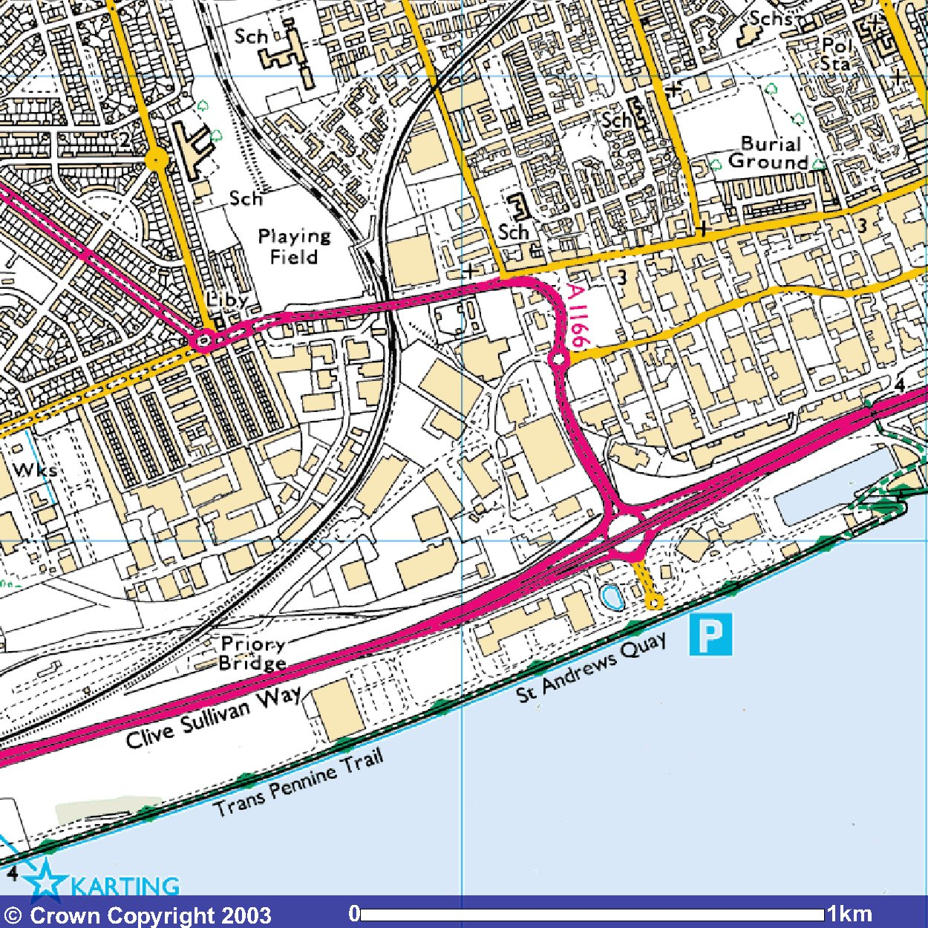
© Crown Copyright. All rights Reserved. Licence Number 100010976
Site

Appendix A2 – Geological Maps and Cross Sections
BGS Sheet 80 Kingston upon Hull 1 to 50 000 Series

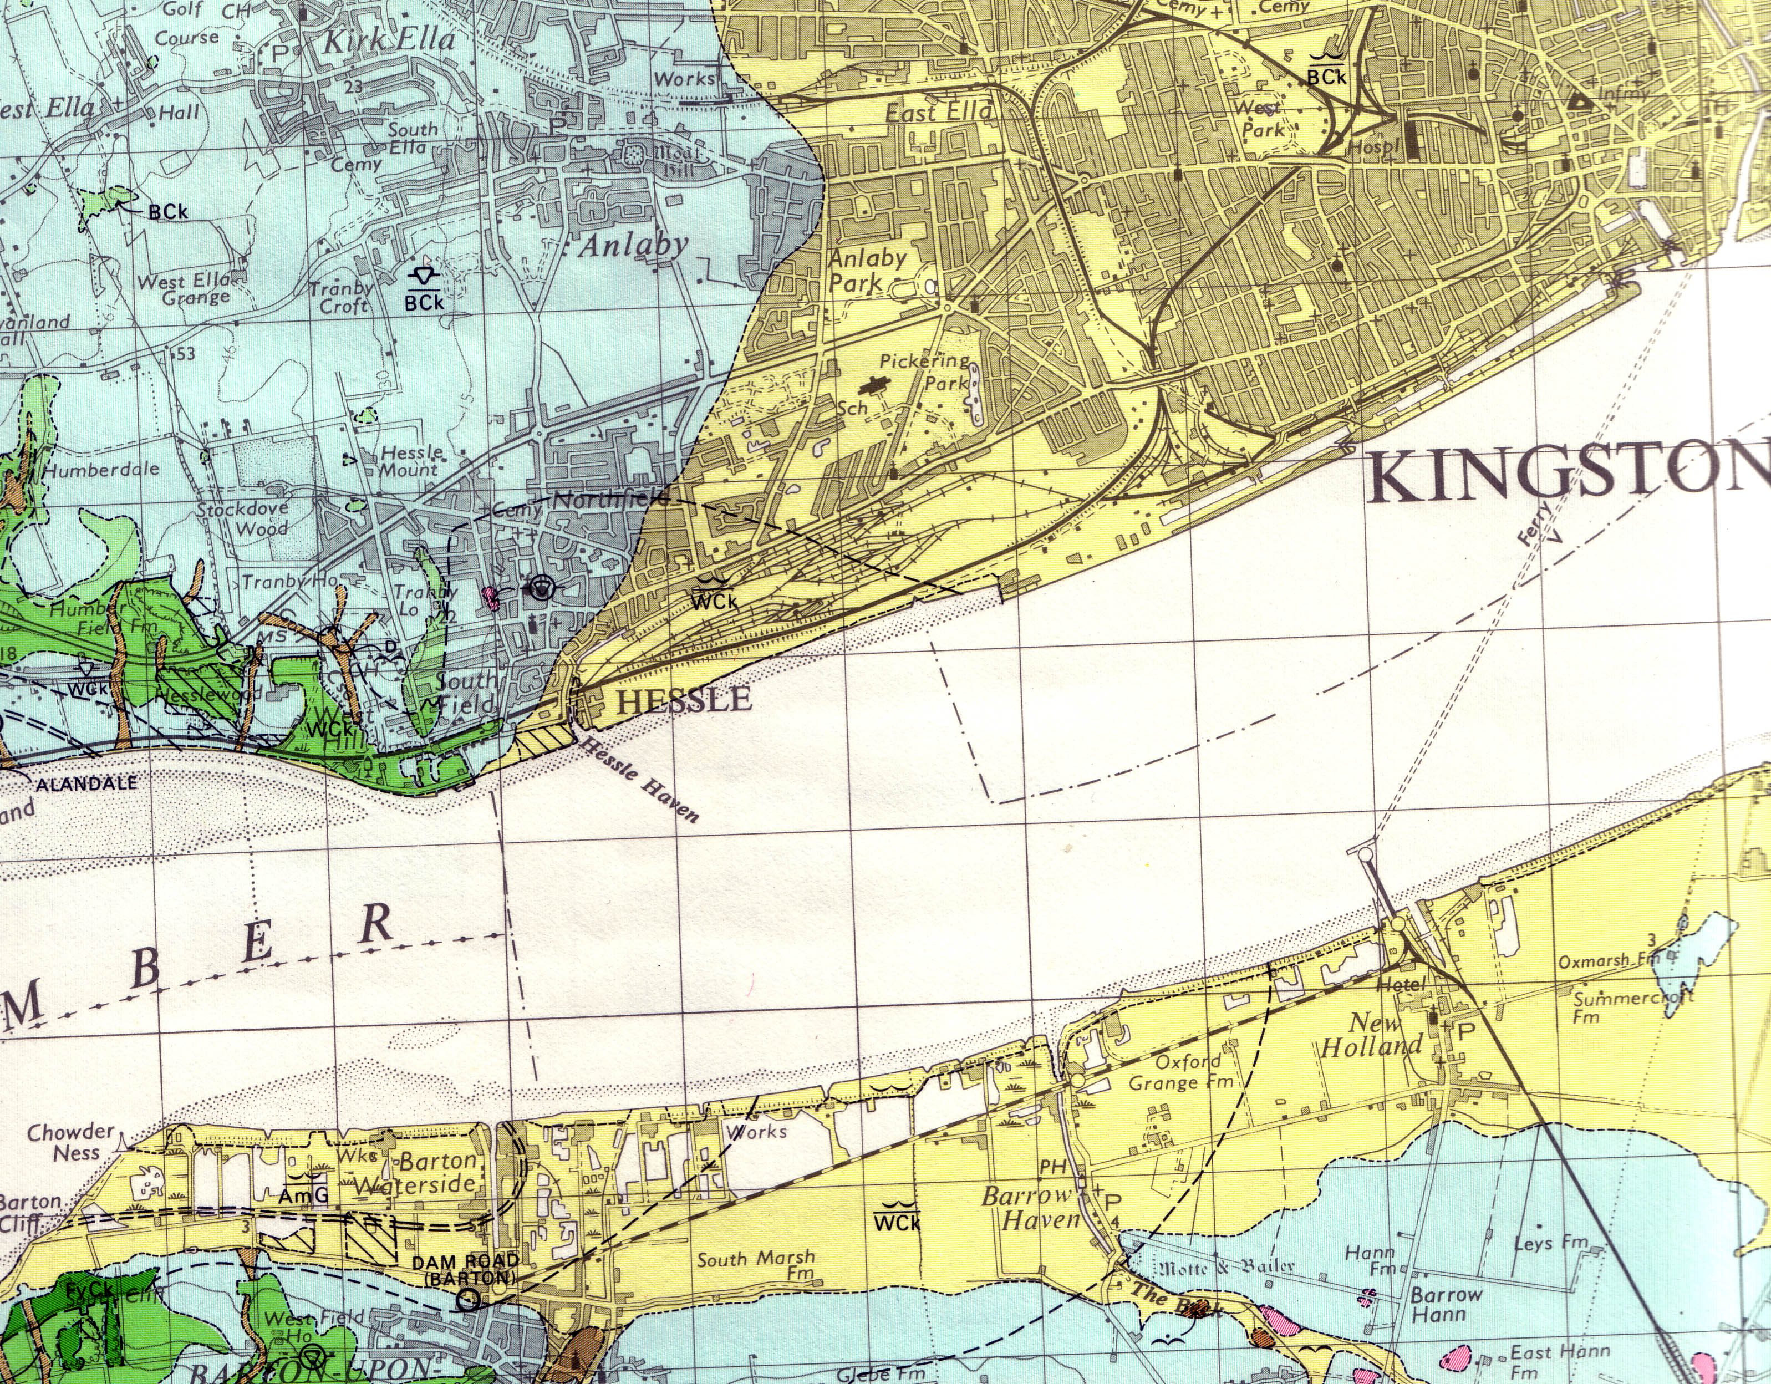
Tryton Foods

Figure 2 – Cross Section (BGS Sheet 80 Kingston Upon Hull)

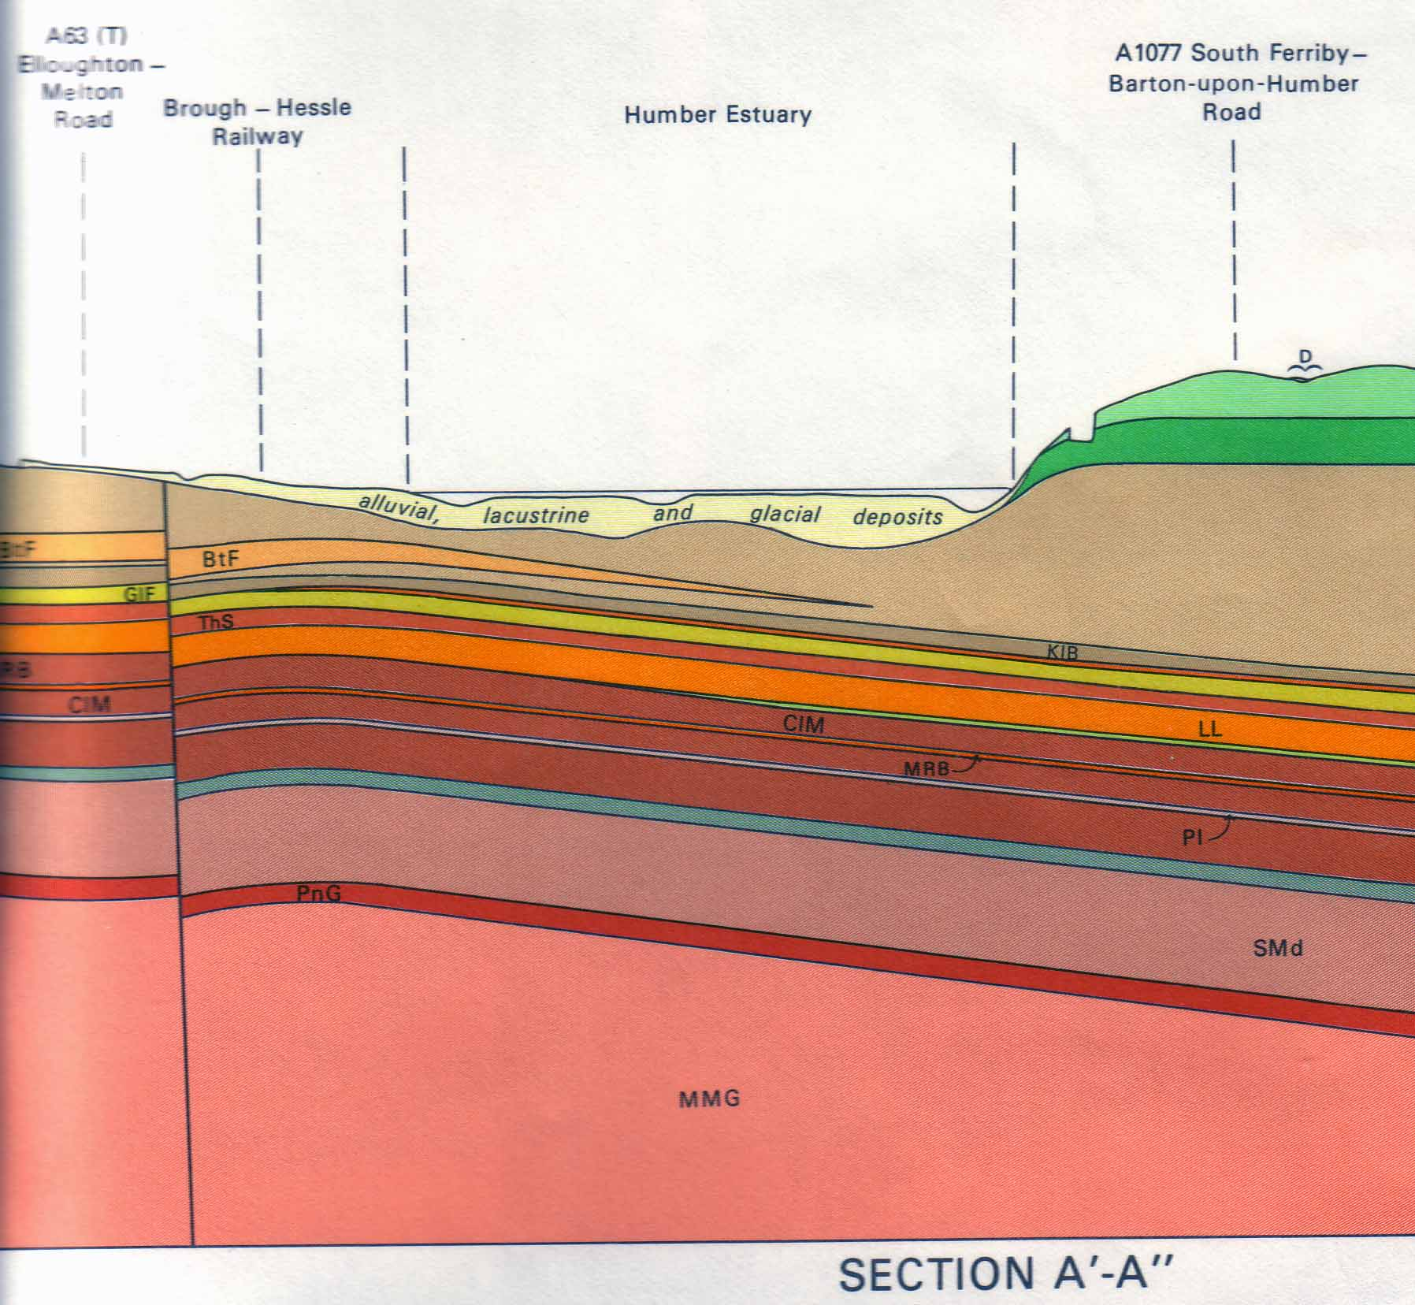

Appendix A3 – Site Layout Plans
Figure 1 – Operational Layout Plans

Appendix A4 – Site Drainage Plans

Appendix A5 – Plans Showing the Location of Sensitive Receptors
Figure 1 –Drainage Plan

Appendix A5 – Plans Showing the Location of Sensitive Receptors
Figure 1 – Location of Designated Sites
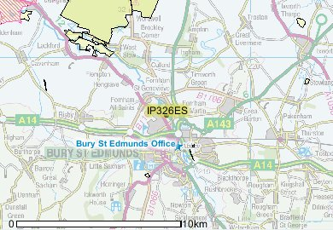
© Crown Copyright. All rights Reserved. Licence Number 100010976

Figure 2 – Landmark 1 km Sensitive Receptor Map
Figure 3 – Landmark 1 km Flood Map

Appendix A6 – Plans Showing the Location of Contamination Sources
Figure 1 – Bulk Storage Tanks, Raw Materials and Product Storage Areas

Appendix A7 – Plans Showing Zones
Figure 1 –Site Zoning

Appendix B
Site Reconnaissance

Appendix B1 – Figures
Figure 1 – Area Subject to Site Reconnaissance

Figure 2 – Potential Areas of Land Contamination - 4.2.1 Bulk Vegetable Oil, 4.2.2 Bulk Egg Storage Tanks and 4.2.3 Bulk Road Tanker Unloading Area

Figure 3 – Potential Areas of Land Contamination – 4.2.4 Waste Storage Areas

Figure 4 – Potential Areas of Land Contamination – 4.2.5 Waste Oil Storage Tank and 4.2.6 Caustic Wash Tank

Figure 5 – Potential Areas of Land Contamination – 4.2.8 Effluent Treatment Works

Appendix B2 – Plates
Plates

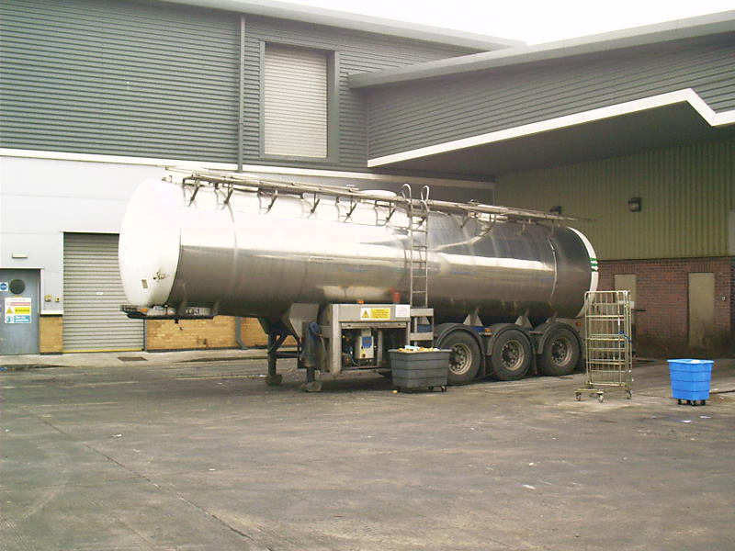
Plate 1 – Tanker unloading bays

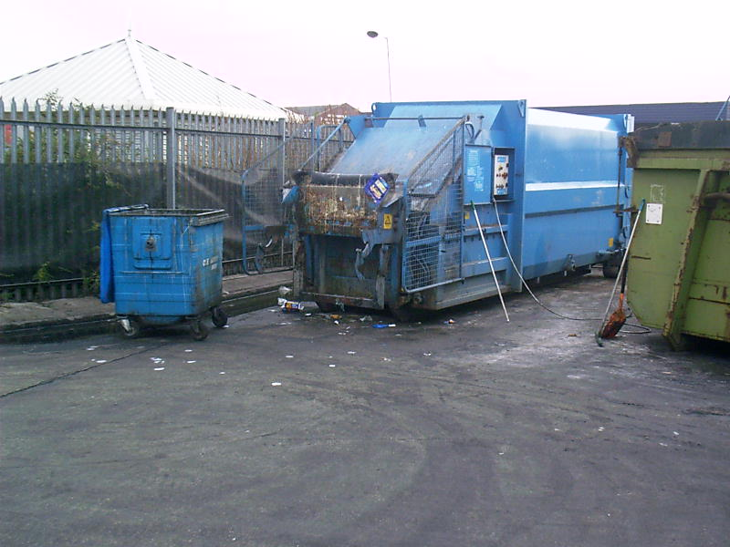
Plate 2 – F1 Waste compactor

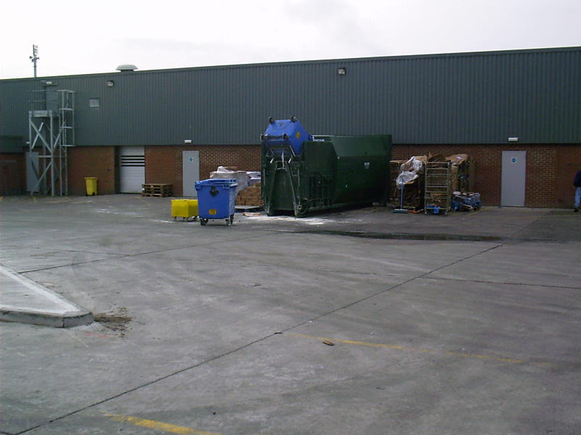
Plate 3 – F2 Waste compactor
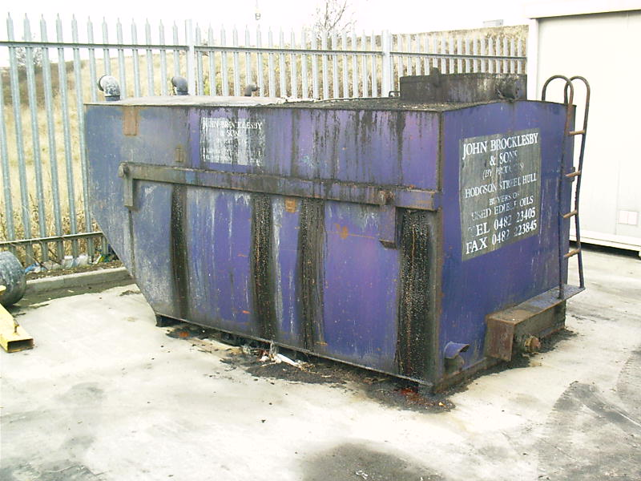
Plate 4 – Waste Oil tank

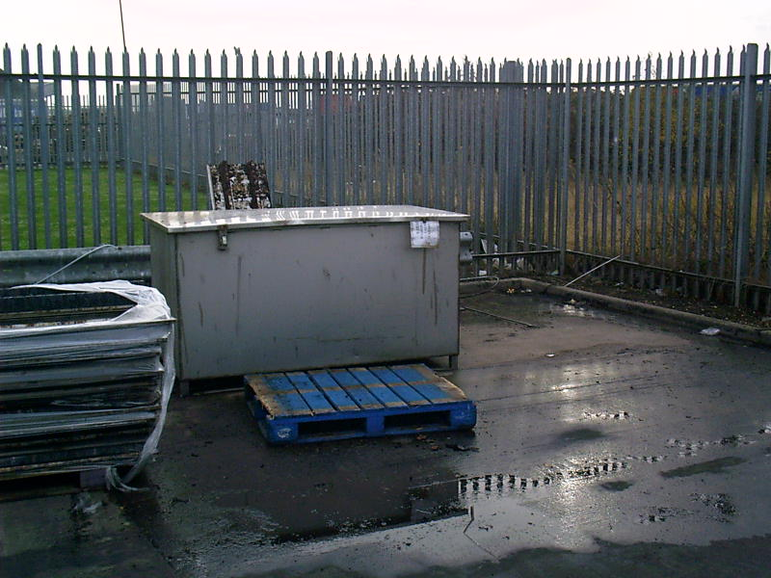
Plate 5 – Dilute caustic wash tank

Appendix B3 – Relevant Test Certificates

Appendix C – Desk Study Information

Appendix C1 – Environmental Consents, Licences, Authorisations and Permits for Site and Surrounding Area
Discharge Consent

Appendix C2 – Geological and Hydrological Data
Source Protection Zone Map

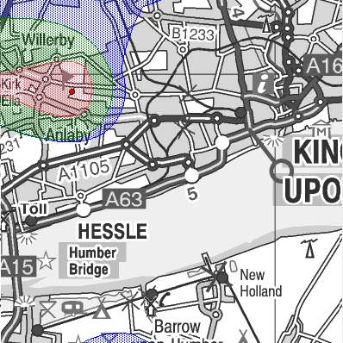
Tryton Foods
Key;
- Inner Zone - Outer Zone - Total Catchment - Special Interest
- Zone I (Inner Protection Zone) - This zone is defined by a travel time of 50-days or less from any point within the zone at, or below, the water table. Additionally, the zone has as a minimum a 50-metre radius. It is based principally on biological decay criteria and is designed to protect against the transmission of toxic chemicals and water-borne disease.
- Zone II (Outer Protection Zone) - This zone is defined by the 400-day travel time, or 25% of the source catchment area, whichever is larger. The travel time is derived from consideration of the minimum time required to provide delay, dilution and attenuation of slowly degrading pollutants.
- Zone III (Total catchment) - This zone is defined as the total area needed to support the abstraction or discharge from the protected groundwater source.
- Zone of Special Interest - For some groundwater sources an additional Zone of Special Interest may be defined. These zones highlight areas (mainly on non-aquifers) where known local conditions mean that potentially polluting activities could impact on a groundwater source even though the area is outside the normal catchment of that source.

Appendix C3 – Hydrological and Hydrogeological Data
Water Abstractions

Hull Fish Meal & Oil Company Ltd – 391 m South, NGR: 507000 426700
T.J Smith & Nephew Ltd – 1794 m East, NGR: 508660 427850
Smith & Nephew Medical Ltd – 1796 m East, NGR: 508660 427850

Groundwater Vulnerability

Geological Classification – Non Aquifer (Negligibly permeable). Formations which are generally regarded as containing insignificant quantities of groundwater. However, groundwater flow through such rocks, although imperceptible, does take place and needs to be considered in assessing the risk associated with persistent pollutants (Sheet 13 – Humber Estuary, 1:100,000)

Drift Deposits – None

Fluvial Indicative Flood Plains –

Tidal Indicative Flood Plains – The site is located within a coastal indicative flood plain, See Flood Map.

River Quality

Holderness Drain – Foredyke Stream River Humber – Grade D
River Hull West Beck – Beverly Beck Sutton Road Bridge – Grade C
Beverly and Barmston Drain – Beverly Beck River Hull – Grade F

Figure 1 – Extract from Groundwater Vulnerability Map Sheet 13 Humber Estuary, 1:100,000 (Landmark)

Appendix C4 – Site Operational Records, Records of any Land Pollution on Site
Figure 1 – 250m Record Map (Landmark)
Figure 2 – 1000m Record Map (Landmark)

Appendix C5 – Existing Site Investigation, Assessment and Remediation Records
Figure 1 – Environmental Risk Assessment – Respective Area

Appendix C6 – Other Information
Regulatory Search Data Base Provided By Landmark
Historical Land Use Report Provided By Landmark
Historical Maps Provided By Landmark

Appendix D
Data Assessment

Appendix D1 – Potentially Polluting Substances
Table 1 – Potential Contaminants - Substances Used, Stored, Produced on Site

Potential Contaminants – Substance Used / Stored / Produced | Material Type | Annual Consumption / Production  (tonnes) | Quantity Stored  On-site | Substance may already be Present Under the Land
Waste Batter (from TE plant) | Waste | 60 | Not Supplied
Vegetable oil | Raw Material | Not Supplied | 108,500 litres
Caustic | Waste | Not Supplied | Not Supplied
Leachate from general factory waste | Waste | 2,500 | N/A
Waste Oil | Waste | Not Supplied | Not Supplied
Baked Non Animal By-products | Waste | 275 | Not Supplied
Ready to bake product waste | Waste | 120 | Not Supplied

Extract from Department of the Environment Industry Profile – Animal and animal products processing works; ‘4.1.1 Leaking tanks, pipework or storage chambers, together with construction joints in floor slabs and permeable surfaces outside buildings, may allow leakage of liquid wastes containing pathogens. Leakage may also occur from waste water treatment systems such as tanks and aeration ponds’

Potential Contaminants – | Activities
Pathogens | Pathogens that might occur at slaughterhouses include a variety of bacteria, viruses, protozoal parasites and the eggs and cysts of parasites. Specifically, unfit meat from animals may be infected by agents causing anthrax, tetanus, swine fever, pneumonia, tuberculosis, actinomycosis, glanders, brucellosis, meningitis and BSE (bovine spongiform encephalopathy). Orgaisms such as Clostridium perfringens, actinobacillus, Various round worms, cystic forms forms of doy and human tapeworm and liver flukes.
Solvents | Used in historical rendering plants in fat separations processes
Detergents and Bleaches | All premises which handle fats as either products or wastes may use or have used (historically) caustic detergents, disinfectants or bleaches for cleaning purposes
Fuel oils | Various grades of fuel oil may have been used for the generation on steam

Appendix D2 – Assessment of Land Pollution Potential

Appendix D2 Assessment of the Likelihood of Land Pollution
Table D2A Assessment of the Likelihood of Land Pollution
Site Operation or Site Zone | Substance | Relevant Activity | Potential for Pollution from the Relevant Activity | 1. Records of Pollution | 2. Existence of Pollution Measures | Nature of Primary Containment | Testing and Inspection of Primary Containment | Nature of Secondary Containment | Columns continue on to Table 2B
Batter production | 1. Mineral Oil | A. Delivery by road tanker to installation | Spillage from road tanker on installation roads entering road surface water drainage system | Localised staining observed. No records of spills or leaks | Yes | Road Tanker | Compliant to British  Standard and DOT  Regulations | N/A
 |  | B. Road tanker offloading | Spillage from road tanker or delivery pipework to land | Localised staining observed. No records of spills or leaks | Yes | Road Tanker | Compliant to British  Standard and DOT  Regulations | N/A
 |  | C. Storage | Failure of containment leading to spillage to land | No evidence/records of spills or leaks | Yes | Two 15 ton stainless steel aboveground storage tanks. | None - inspection to be incorporated into PPM / EMS | Bunding – Fabric of the building.
 |  | D. Under-ground fill lines | Failure of underground pipeline between the fill lines and oil storage tank leading to loss of product to land | No evidence/records of spills or leaks | No | Underground steel fill lines | None - inspection to be incorporated into PPM / EMS | None
 | 2. Eggs | A. Delivery by road tanker to installation | Spillage from road tanker on installation roads entering road surface water drainage system | Localised staining observed. No records of spills or leaks | Yes | Road Tanker | Compliant to British  Standard and DOT  Regulations | N/A
 |  | B. Road tanker offloading | Spillage from road tanker or delivery pipework to land | Localised staining observed. No records of spills or leaks | Yes | Road Tanker | Compliant to British  Standard and DOT  Regulations | N/A
 |  | C. Storage | Failure of containment leading to spillage to land | No evidence/records of spills or leaks | Yes | Stainless Steel above ground storage tanks | None - inspection to be incorporated into PPM / EMS | Bunding – Fabric of the building.
Site Operation or Site Zone | Substance | Relevant Activity | Potential for Pollution from the Relevant Activity | 1. Records of Pollution | 2. Existence of Pollution Measures | Nature of Primary Containment | Testing and Inspection of Primary Containment | Nature of Secondary Containment | Columns continue on to Table 2B
 |  | D. Under-ground fill lines | Failure of underground pipeline between the fill lines and oil storage tank leading to loss of product to land | No evidence/records of spills or leaks | No | Underground steel fill lines | None - inspection to be incorporated into PPM / EMS | None
Waste storage (adjacent to main gate) | 3. General waste storage | A. Waste storage | Failure of containment leading to spillage to land | Localised staining observed. No records of spills or leaks | Yes | Skip | Maintained by external, appropriately licensed waste contractor | None
 |  | B. Skip removal | Spillage from skip removal and / or spillage on installation roads entering road surface water drainage system | Localised staining observed. No records of spills or leaks | Yes | Skip | Maintained by external, appropriately licensed waste contractor | None
 | 4. Compactor | A. waste product bin emptying | Failure of containment leading to spillage to land. Spillage from bin emptying to compactor | Localised staining observed. No records of spills or leaks | Yes | Skip | Maintained by external, appropriately licensed waste contractor | None
 |  | B. Waste storage | Failure of containment leading to spillage to land | No evidence/records of spills or leaks | Yes | Skip | Compliant to British  Standard and DOT  Regulations  Not compliant to oil storage regulations | None
 |  | C. Skip removal | Spillage from skip removal and / or spillage on installation roads entering road surface water drainage system | Localised staining observed. No records of spills or leaks | Yes | Skip | Maintained by external, appropriately licensed waste contractor | None

Site Operation or Site Zone | Substance | Relevant Activity | Potential for Pollution from the Relevant Activity | 1. Records of Pollution | 2. Existence of Pollution Measures | Nature of Primary Containment | Testing and Inspection of Primary Containment | Nature of Secondary Containment | Columns continue on to Table 2B
 | 5. Waste Oil Tank / contained skip | A. Waste storage | Failure of containment leading to spillage to land | Localised staining observed. No records of spills or leaks  Temporary skip / storage measure. Permanent measure to be installed | Yes | Skip | None - inspection to be incorporated into PPM / EMS | None
 |  | B. Tank / Skip removal | Spillage from skip removal and / or spillage on installation roads entering road surface water drainage system | No evidence/records of spills or leaks  Temporary skip / storage measure. Permanent measure to be installed | Yes | Skip | Maintained by external, appropriately licensed waste contractor | None
Waste storage (adjacent to F1 building) | 6. General waste storage | A. Waste storage | Failure of containment leading to spillage to land | Localised staining observed. No records of spills or leaks | Yes | Skip | Maintained by external, appropriately licensed waste contractor | None
 |  | B. Skip removal | Spillage from skip removal and / or spillage on installation roads entering road surface water drainage system | Localised staining observed. No records of spills or leaks | Yes | Skip | Maintained by external, appropriately licensed waste contractor | None
 | 7. Compactor | A. Waste product bin emptying | Failure of containment leading to spillage to land. Spillage from bin emptying to compactor | Staining observed from bin emptying. No records of spills or leaks | Yes | Skip | Maintained by external, appropriately licensed waste contractor | None
 |  | B. Waste storage | Failure of containment leading to spillage to land | No evidence/records of spills or leaks | Yes | Skip | Compliant to British  Standard and DOT  Regulations  Not compliant to oil storage regulations | None

Site Operation or Site Zone | Substance | Relevant Activity | Potential for Pollution from the Relevant Activity | 1. Records of Pollution | 2. Existence of Pollution Measures | Nature of Primary Containment | Testing and Inspection of Primary Containment | Nature of Secondary Containment | Columns continue on to Table 2B
 |  | C. Skip removal | Spillage from skip removal and / or spillage on installation roads entering road surface water drainage system | Localised staining observed. No records of spills or leaks | Yes | Skip | Maintained by external, appropriately licensed waste contractor | None
 | 8. IBC - Waste Batter Storage | A. Waste storage | Failure of containment leading to spillage to land | No evidence/records of spills or leaks | Yes | IBC | Compliant to British  Standard and DOT  Regulations  Not compliant to oil storage regulations | None
 |  | B. IBC removal | Spillage from IBC removal and / or spillage on installation roads entering road surface water drainage system | Localised staining observed. No records of spills or leaks | Yes | IBC | Maintained by external, appropriately licensed waste contractor | None
Production | 9. Effluent Plant | Effluent treatment Tanks | Failure of containment leading to spillage to land | No evidence/records of spills or leaks | No | HDPE ASTs & USTs | None - inspection to be incorporated into PPM / EMS | None
 | 10. Caustic Wash Tank | Cleaning | Failure of containment leading to spillage to land | Localised staining observed. No records of spills or leaks | No | Stainless Steel AST | None - inspection to be incorporated into PPM / EMS | None

Table 2B Assessment of the likelihood of land pollution, continued

Continued from table 2A | Testing and Inspection of Secondary Containment | Nature of Tertiary Containment | Testing and Inspection of Tertiary Containment | 3. Adequacy of pollution prevention measures  Yes/No | 4. Are the proposed Integrity testing of pollution prevention measures Adequate Yes/No | 5. Is there an adequate documented management system to demonstrate operator management and competence with the relevant activity? | Little Likelihood of pollution? | Reasonable Possibility of pollution?
1. A, B, C, D | None - inspection to be incorporated into PPM / EMS | Concrete hard-standing. | None | Yes | No – documented inspection / integrity test and surfacing requirements to be incorporated into the EMS | No – the operator commits to the development of a documented management system | -
2. A, B, C, D | None - inspection to be incorporated into PPM / EMS | Concrete hard-standing. | None | Yes | No – documented inspection / integrity test and surfacing requirements to be incorporated into the EMS | No – the operator commits to the development of a documented management system | -
3. A, B | None - inspection to be incorporated into PPM / EMS | Concrete hard-standing. | None | Yes | No – documented inspection / integrity test and surfacing requirements to be incorporated into the EMS | No – the operator commits to the development of a documented management system | -
4. A, B, C | None - inspection to be incorporated into PPM / EMS | Concrete hard-standing. | None | Yes | No – documented inspection / integrity test and surfacing requirements to be incorporated into the EMS | No – the operator commits to the development of a documented management system | -
5. A, B | None - inspection to be incorporated into PPM / EMS | Concrete hard-standing. | None | No – unbunded waste oil tank. Not compliant with the Oil storage regs | No – documented inspection / integrity test and surfacing requirements to be incorporated into the EMS | No – the operator commits to the development of a documented management system | -
Continued from table 2A | Testing and Inspection of Secondary Containment | Nature of Tertiary Containment | Testing and Inspection of Tertiary Containment | 3. Adequacy of pollution prevention measures  Yes/No | 4. Are the proposed Integrity testing of pollution prevention measures Adequate Yes/No | 5. Is there an adequate documented management system to demonstrate operator management and competence with the relevant activity? | Little Likelihood of pollution? | Reasonable Possibility of pollution?
6. A, B | None - inspection to be incorporated into PPM / EMS | Concrete hard-standing. | None | Yes | No – documented inspection / integrity test and surfacing requirements to be incorporated into the EMS | No – the operator commits to the development of a documented management system | -
7. A, B, C | None - inspection to be incorporated into PPM / EMS | Concrete hard-standing. | None | Yes | No – documented inspection / integrity test and surfacing requirements to be incorporated into the EMS | No – the operator commits to the development of a documented management system | -
8. A, B | None - inspection to be incorporated into PPM / EMS | Concrete hard-standing. | None | Yes | No – documented inspection / integrity test and surfacing requirements to be incorporated into the EMS | No – the operator commits to the development of a documented management system | -
9. A | None - inspection to be incorporated into PPM / EMS | Concrete hard-standing. | None | Yes | No – documented inspection / integrity test and surfacing requirements to be incorporated into the EMS | No – the operator commits to the development of a documented management system | -
10. A | None - inspection to be incorporated into PPM / EMS | Concrete hard-standing. | None | Yes | No – documented inspection / integrity test and surfacing requirements to be incorporated into the EMS | No – the operator commits to the development of a documented management system | -

Appendix E
Conceptual Site Model

Appendix E1 – Tabular
Conceptual Site Model – Table 1

Matrix showing potential contaminants from the proposed installation;

Potentially Contaminative Activity | Source of Potential Contamination | Potential Contaminants | Potential pathway and Evidence of Spill | Potential for Ground Contamination | Uncertainties in  CSM
Steam generation / boiler plant, waste oil tank | Spillage during delivery, wagon offloading or containment loss | Hydrocarbons | Containment breach or failure - not compliant with the Control of Pollution (Oil Storage) (England) Regulations 2001. Spillage during transfer. Product lost to land and / or on installation roads. Spillage entering surface water drainage system.  Evidence of spillage observed | High potential for release to ground. Moderate potential for release to ground from drain leakage / underground draw line leakage or damaged hard-standing | Geology – underlying strata & thickness  Water Table – Orientation & unsaturated zone  Hydro-geological Parameters – Underlying strata
Waste storage | Diffuse pollution from waste storage / emptying. | Waste batter, waste oil, food stuffs | Containment breach or failure. Spillage during transfer. Product lost to land and / or on installation roads. Spillage entering surface water drainage system. | Moderate to high potential for release to ground; only if drain leakage or damaged hard-standing | Geology – underlying strata & thickness  Water Table – Orientation & unsaturated zone  Hydro-geological Parameters – Underlying strata
Effluent treatment | Spillage during emptying or containment loss | Fats, oils, grease, organic and inorganic compounds used with effluent treatment | Containment breach or failure. Spillage during transfer. Product lost to land and / or on installation roads. Spillage entering surface water drainage system. | Moderate potential for release to ground; only if drain leakage or damaged hard-standing | Geology – underlying strata & thickness  Water Table – Orientation & unsaturated zone  Hydro-geological Parameters – Underlying strata

Appendix E2 – Graphical

Figure 1: Conceptual Site Model for Potential Generation and Movement of Contaminated Groundwater

River Receptors
Public Water Supply
River Ecosystem
General Amenity
Groundwater Receptors
Public Water Supply
River Humber
River Ecosystem
Loss by Evaporation / Transpiration
Rainfall
Surface Water Run-on

Potential Releases from Permitted Activities to Ground
Contamination of groundwater
River Humber
Effluent Treatment Works
Seepage
Drainage System
Potential Leakage from drains
Direct
Infiltration

Figure 2:

Conceptual Site Model - Cross-Section through the Site

For Indication Purposes Only Not to Scale

v
West
GW > 8.5 m bgl
North
Made Ground / Topsoil , Clay, Silty Sand, Clay
Boulder Clay, Chalk
Boulder Clay, Chalk
Waste Storage Area
F2 Compactor / General Waste
Vegetable Oil AST’s
Effluent Works
F1 Waste Bin Holding Area
Caustic Wash tank

Waste Egg Bins & Pallets
Waste Oil Tank

Waste Batter IBCs
F1 Compactor / General Waste
Flour Silos
F2 Compactor / General Waste
F2 Building
F1 Building
F1 Compactor / General Waste
Caustic Wash tank

Waste Oil Tank

F1 Building
Waste Egg Bins & Pallets
Effluent Works
Vegetable Oil AST’s
Flour Silos
F2 Building
Waste Storage Area
Plan View
Site Boundary
High Potential Contamination Migration Pathway to soil and Groundwater
Medium Potential Contamination Migration Pathway to soil and Groundwater
Low Potential Contamination Migration Pathway to soil and Groundwater
Located Behind Building
Located in front of building
GL
Site Boundary
East
South
Site Boundary
GL
GW > 8.5 m bgl
Site Boundary
Made Ground / Topsoil, Clay, Silty Sand, Clay

