DOC Ref: B202 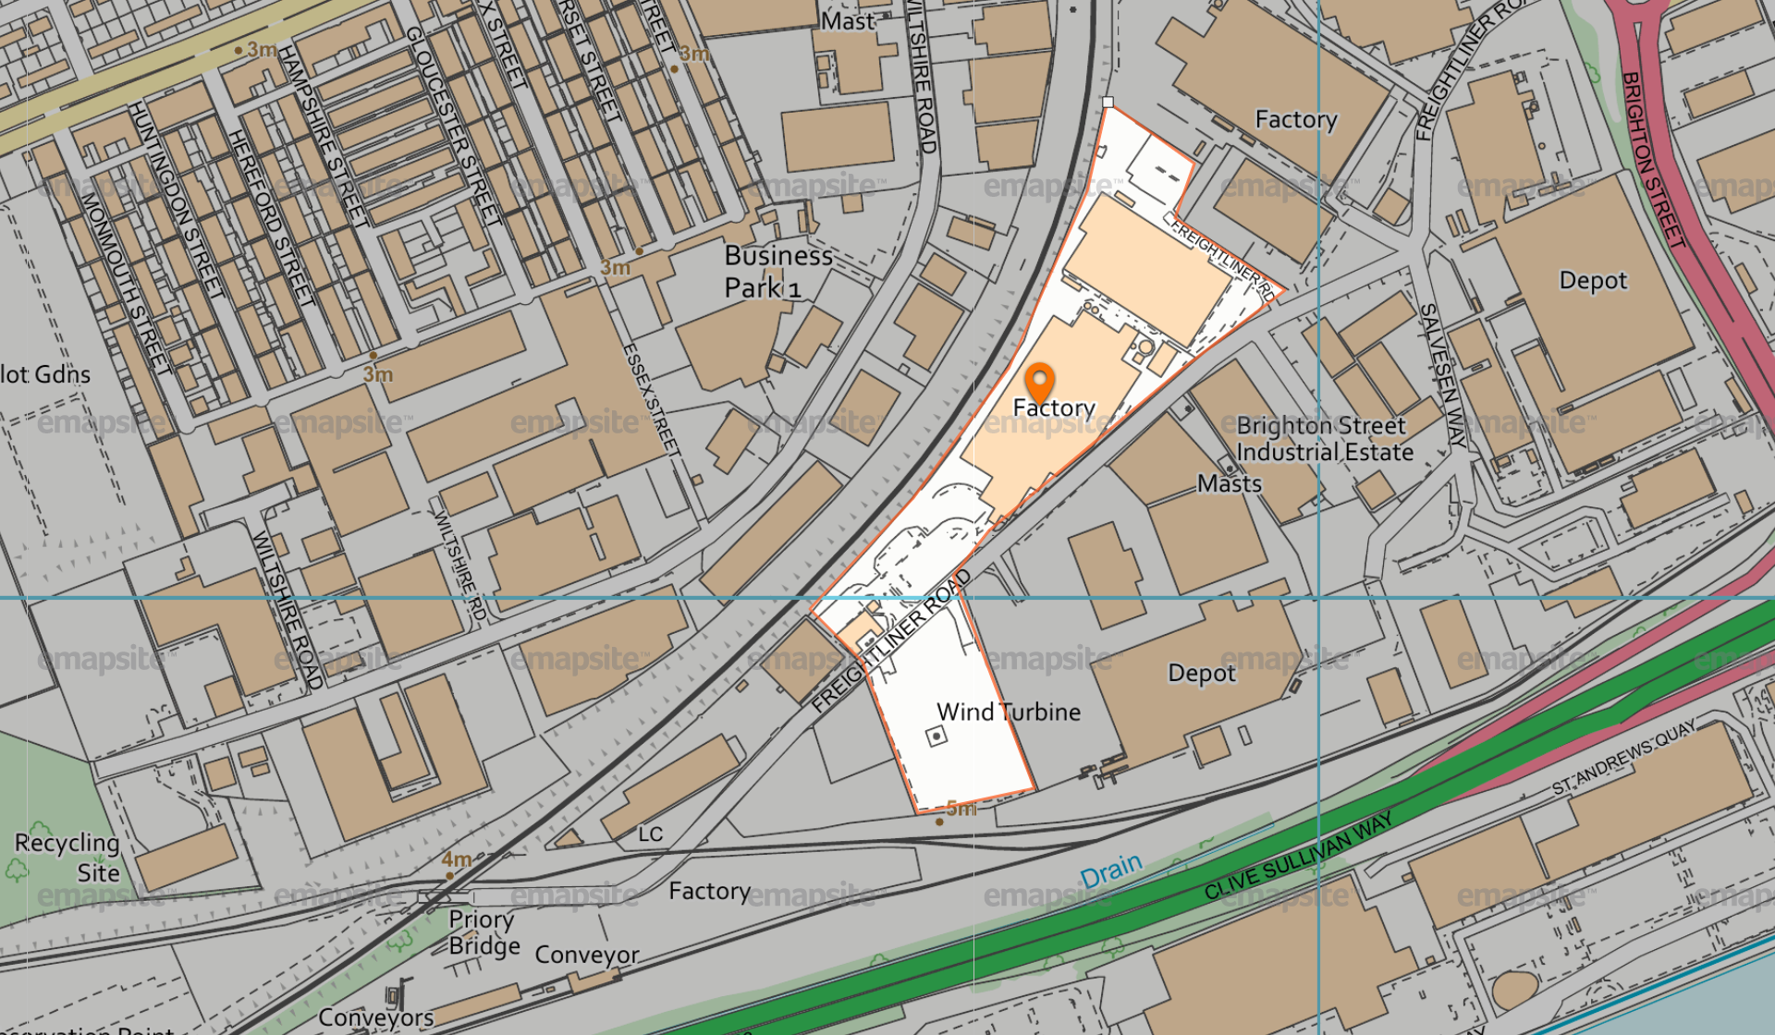
Operator: Birdseye Limited
Site Name: Aunt Bessies
National Grid ref: 506830427130
Date: 09.06.2021

