APPLICATION FOR AN ENVIRONMENTAL PERMIT UNDER THE ENVIRONMENTAL PERMITTING (ENGLAND AND WALES) REGULATIONS 2016 (AS AMENDED)

NOISE MANAGEMENT PLAN

ECO-POWER ENVIRONMENTAL (HULL) LIMITED,
GIBSON LANE, MELTON, HULL, HU14 3HH

Ref: Eco 17.02.2022/NMP
Version: Issue 3
February 2022
TABLE OF CONTENTS

1. INTRODUCTION 1
1.1. Requirement for a Noise Management Plan 1

2. DESCRIPTION OF THE SITE AND PROCESS 4
2.1. Site Location and Setting 4
2.2. Description of the Process 4

3. POTENTIAL NOISE SOURCES, MATERIALS AND PROCESSES 7
3.1. Sources of Noise 7

4. POTENTIAL RECEPTORS 8
4.1. Considerations for Identifying Sensitive Receptors 8

5. OPERATIONAL AND PROCESS CONTROLS 10
5.1. Noise Managements Strategy 10
5.2. Noise Control Measures 10

6. NOISE MONITORING 15
6.1. Monitoring Schedule 15

7. EMERGENCY SCENARIO CONTINGENCY 17
7.1. Introduction 17
7.2. Emergency Scenarios and Contingency Measures 17

8. COMPLAINTS 18
8.1. Community Liaison 18
8.2. Response to Complaints 18
8.3. Records 20

9. NMP REVIEW 21
LIST OF APPENDICES

Appendix I Drawings
Appendix II Site EMS Day Diary Checks Form
Appendix III Planned Preventative Maintenance Regime
Appendix IV Daily Site Monitoring Check Sheet
Appendix V Environmental Noise Assessment
LIST OF FIGURES

Figure 1: Process Flow Diagram 6
Figure 2: Assessed NSR Locations 9
Figure 3: NMP Strategy 10
Figure 4: Site Layout 11
Figure 5: Indicative Noise Monitoring Locations 15

LIST OF TABLES

Table 1: Summary of Surrounding Land Uses 4
Table 2: Proposed Schedule 1 Activity 4
Table 3: Proposed Wastes to be Accepted at the Installation 5
Table 4: Existing Receptor Locations 8
Table 5: NMP Risk Assessment and Control Measures 12
Table 6: Measured Application Site Noise Levels (L_{Aeq,T}) 15
Table 7: Emergency Scenario Contingency Measures 17

ACRONYMS / TERMS USED IN THIS REPORT

BAT Best Available Techniques
BREF Best Available Techniques Reference Documents
CCTV Closed Circuit Television
EA Environmental Agency
Eco-Power Eco-Power Environmental (Hull) Limited
EMS Environmental Management System
EP Regulations Environmental Permitting (England and Wales) Regulations 2016 as amended
EP Environmental Permit
NGR National Grid Reference
NMP Noise Management Plan
PPMR Planned Preventative Maintenance Regime
RDF Refuse Derived Fuel
SRF Solid Recovered Fuel
Transwaste Transwaste Recycling and Aggregates Limited

INTRODUCTION

Requirement for a Noise Management Plan

A Noise Management Plan (“NMP”) has been produced for Eco-Power Environmental (Hull) Limited (“Eco-Power”) as part of the Environmental Permit (“EP”) application at Gibson Lane, Melton, Hull, East Yorkshire, HU14 3HH. The NMP will form part of Eco-Power’s Environmental Management System (“EMS”); new and updated text within this document is highlighted in blue, including clarifications provided in response to the Environment Agency request for further information in relation to application reference EPR/MP3107PP/A001.

This version of the noise management plan has been supplemented by an assessment of noise undertaken by Tetra Tech Limited which identifies both on-site noise-generating sources and baseline noise levels at nearby sensitive receptor locations and presents an assessment of operational noise. The noise assessment is presented in Appendix V of this document which has been used to supplement the noise management process at the site detailed within this NMP; the following steps have been undertaken which reflect the recently issued Environment Agency Noise and vibration management: environmental permits published on 23rd July 2021:
- Step 1: noise-generating sources located on-site have been identified as part of the NMP and nearby sensitive residential and ecological noise sensitive receptors (NSR) have been identified within the assessment, including their distance from the site and descriptions of the ambient noise climate.
- Step 2: an off-site monitoring survey has been undertaken to establish ambient and background noise levels in the vicinity of the site and NSR locations during the hours of operation of the site; to ensure representative baseline data were measured, monitoring was undertaken at locations where operational noise associated with the application site was not audible. Site noise was not readily discernible above contributions from surrounding industrial and commercial premises at nearby NSR locations during the off-site survey.
- Step 3: source noise monitoring within the application site was undertaken (including fixed and mobile plant and vehicle movements within the application site) and the results of the source noise monitoring used to propagate noise levels to nearby NSRs using CADNA noise modelling software. The results of the BS 4142 noise assessment and separate assessment of noise levels at ecologically-sensitive NSRs (presented within Appendix V) demonstrate that operational noise rating levels are below representative background noise levels during the daytime and no greater than 2 dB above background noise levels during the hours night-time period and therefore, taking into account the context of the site which is surrounded by existing industrial and commercial premises, operational noise is expected to have a low impact.
- Step 4: this document outlines a large number of mitigation measures and best available techniques (BAT) that have been identified as part of the NMP process which relate to controls for the handling of materials, vehicle movements, record keeping and complaints handling. Following the assessment process, operational noise levels at nearby sensitive receptors are shown to be no greater than 46 dB L_{Aeq} at the closest sensitive receptor locations and no additional mitigation measures have been identified within this document.

Transwaste Recycling and Aggregates Limited (“Transwaste”) currently operate a waste facility plant at Melton Waste Park under a waste facility Environmental Permit issued by the Environment Agency (“EA”) (EPR/BP3792LD, issued 17/01/2017). Eco-Power wish to obtain a section of the permitted land with the intention of operating a Waste Recovery Facility. Transwaste will surrender the permit for the area and Eco-Power will hold an EP for the area once the application is approved.

The proposed activity is the production of fuel from waste via physical, mechanical and thermal treatment. Residual waste from waste management facilities is shredded and run through a number of separation systems (trommel, magnetic, ballistic, infrared) before being placed on a drying floor. Waste heat from biomass boilers provides heat to reduce the moisture content of the residual waste Solid Recovered Fuel (“SRF”). The dried SRF is then pelletised (heat applied and material is passed through an extruder), cooled and stored prior to transfer off site for use as fuel.

All unprocessed SRF will be stored within the site buildings ready for rapid processing.

Approximately 250,000 tonnes per annum of residual waste from waste management facilities will be accepted.

    - As detailed in EA online guidance – ‘Control and monitor emissions for your environmental permit’ (updated in February 2020, accessed in March 2020), an NMP must form part of the bespoke Environmental Permit application as Eco-Power are proposing to carry out activities, such as shredding, tromelling and unloading/loading of waste materials, which have the potential to generate noise emissions.

    - The Compliance Director will be responsible for overseeing the effective implementation of the NMP and ensuring compliance is maintained.

    - This NMP has been written to meet the requirements of the following:
- Environment Agency’s (“EA”) online guidance – ‘Control and monitor emissions for your environmental permit’ (updated in February 2020, accessed in March 2020);
- Noise and vibration management: environmental permits, 23 July 2021
- EA Sector Guidance IPCC S5.06 ‘Guidance for the Recovery and Disposal of Hazardous and Non-Hazardous Waste’ (Issue 5, May 2013); and
- The Best Available Techniques Reference Document (“BREF”) for Waste Treatment (October 2018) which contains the Best Available Techniques (“BAT”) Conclusions applicable to Installations associated with a number of waste treatments, including recovery and disposal of waste.

    - The NMP addresses the following issues:
- the materials and/or activity which could produce noise and the potential point(s) of noise emissions;
- identification of potential sensitive receptors;
- process controls and procedures;
- monitoring regime;
- emergency scenarios;
- potential corrective actions;
- complaints procedure; and
- record keeping.

    - The NMP provides information on the potential noise impacts from the Installation and the mitigation measures to be implemented. These measures are linked to the Installation’s EMS and will include operational and control measures for normal, as well as abnormal conditions.

    - The NMP also provides a management framework comprising of proactive and reactive measures to manage and control potential noise from the Installation. This proactive approach will facilitate the ongoing development of operational procedures and controls as part of an on-going commitment to improving environmental performance. Reactive procedures will also be established within the NMP for the logging, evaluation and implementation of corrective actions in the unlikely event of any noise related complaints being received.

DESCRIPTION OF THE SITE AND PROCESS

Site Location and Setting

    - Eco-Power is located on Gibson Lane, Melton, Hull, HU14 3HH and is centred on National Grid Reference (“NGR”) 496792 425410. The exact location of the proposed Installation is indicated on Site Location Plan (Drawing 01) contained in Appendix I which shows the Installation within the Environmental Permit boundary as a green outline. As the Installation is located on the Transwaste Melton Waste Park, their site boundary has also been outlined in red. This NMP relates only to the activities proposed at the Installation within the green boundary.

    - The Installation is situated within Transwaste’s Melton Waste Park and a summary of the surrounding land uses is provided in Table 1. At present, the closest human receptors are the neighbouring Transwaste employees and contractors. Eco-Power will operate from within their site boundary and will have shared access.

Table 1: Summary of Surrounding Land Uses
Boundary | Description
North | Railway line, industrial units, A63 road network, residential housing and South Hunsley School and Sixth Form College in Melton, Melton Park, open fields, agricultural land and Melton Bottom Chalk Pit, Melton Bottom Local Wildlife Site.
East | Transwaste Melton Waste Park, industrial units, agricultural land and  North Ferriby Ings.
South | Open field, industrial units and the Humber Estuary.
West | Agricultural land, Welton Waters Adventure Centre, Welton Water Sports Club,  Field Welton Water and Brough Aerodrome.

Description of the Process

Eco-Power propose to operate under the listed activity detailed in Table 2 under the Environmental Permitting (England and Wales) Regulations 2016 as amended (“EP Regulations”).

Table 2: Proposed Schedule 1 Activity
Activity listed in Schedule 1 of the EP Regulations | Description of Specified Activity
Section 5.4 A(1)(b)(ii) | Recovery or a mix of recovery and disposal of non-hazardous waste with a capacity exceeding 75 tonnes per day (or 100 tonnes per day if the only waste treatment activity is anaerobic digestion) involving one or more of the following activities, and excluding activities covered by Council Directive 91/271/EEC – (ii)pre-treatment of waste for incineration or co-incineration.

    - Eco-Power wish to accept an annual throughput of up to 250,000 tonnes of waste. Only 2 no. waste codes are proposed as part of this permit application. These are detailed in Table 3.

Table 3: Proposed Wastes to be Accepted at the Installation
Waste Code | Description
19 | WASTES FROM WASTE MANAGEMENT FACILITIES, OFF SITE WASTE TREATMENT PLANTS AND THE PREPARATION OF WATER INTENDED FOR HUMAN CONSUMPTION AND WATER FOR INDUSTRIAL USE
19 12 | Waste from the mechanical treatment of waste (for example sorting, crushing, compacting, pelletising) not otherwise specified
19 12 10 | Combustible waste (refuse derived fuel)
19 12 12 | Other wastes (including mixtures of materials) from mechanical treatment of waste other than those mentioned in 19 12 11

    - The waste processing at the Installation will consist of:
- shredding;
- separating;
- drying; and
- pelletising.

    - The waste management operations to be carried out at the site as specified in Annex I and Annex II of the Waste Framework Directive 2008, and specified in the existing Environmental Permit, are detailed below:
- R13: Storage of waste pending any of the operations numbered R1 to R12 (excluding temporary storage, pending collection, on the site where the waste is produced);
- R3: Recycling/reclamation of organic substances which are not used as solvents (including composting and other biological transformation processes);
- R4: Recycling/reclamation of metals and metal compounds;
- R5: Recycling/reclamation of other inorganic materials;
- D9: Physico-chemical treatment not specified elsewhere which results in final compounds or mixtures which are disposed of by an of the operations numbered D01 to D12;
- D15: Storage pending any of the operations numbered D1 to D14 (excluding temporary storage, pending collection, on the site where it is produced);
- D14: Repackaging prior to submission to any of the operations numbers D1 to D13.

    - An overview of the proposed activities is provided in Figure 1 and location of processing plant and equipment is shown on the Site Layout Plan (Drawing 02) provided in Appendix I.

Figure 1: Process Flow Diagram

POTENTIAL NOISE SOURCES, MATERIALS AND PROCESSES

Sources of Noise

Waste treatment at the Installation will consist of the following:
- sorting, shredding, separating and screening of waste types mechanically;
- drying waste to improve fuel quality to reduce the moisture content of the waste outputs; and
- pelletising to compress material into pellets ready for export from site.

    - The waste processing equipment will be housed within the main processing building and will consist of the following:
- 1 x shredder;
- 2 x trommels;
- 1 x density separator;
- 1 x ballistic separator;
- 1 x magnetic separator;
- 1 x eddy current separator;
- 1 x near infra red titech laser
- 1 x Perry Belt Drier (drying floor); and
- 1 x pelletising machine.

Processing equipment within the building operates simultaneously and continuously, as such sound power or sound pressure level data for the individual items of equipment listed above cannot be isolated. However, as part of the noise assessment presented within Appendix V (and repeated in Table 6 within this NMP), measurements of reverberant sound pressure levels within processing areas of the application site and external vehicle movements are summarised. The measured noise level data have been used to calculate sound pressure levels from noise breakout at nearby residential and ecological receptor locations.

    - The potential sources of noise emissions from the Installation include:
- movement of transport vehicles to and from the Installation;
- tipping of waste materials which can give rise to beeping during vehicle reversing, intermittent for 10-20 seconds as required for the health and safety of personnel;
- operation of mechanical equipment, which have the potential to give rise to a ‘clatter’ sound; and
- loading of finished product ready for dispatch from site.

As noted above, measurements of on-site equipment and vehicles have been undertaken by Tetra Tech Limited as part of the noise assessment presented in Appendix V. Within the noise assessment, descriptions of the existing noise climate at nearby sensitive receptor locations are provided which did not identify any readily distinguishable features attributable to the application site. The results of the assessment identify that operational noise is expected to have a low impact when considering the guidance presented within BS 4142.

POTENTIAL RECEPTORS

Considerations for Identifying Sensitive Receptors

To determine the level of noise impact which may arise from the Installation, the sensitivity of the receiving environment and potential receptors must be considered.

    - The degree of sensitivity in a particular location is based on the characteristics of the land use, including the time of day and the reason why people are at the particular location (e.g. for work, recreation or residence).

    - Another factor which influences noise emissions is the distance from the noise source - the closer the receptor is to the source, the higher the noise emissions will be at that location.

    - A summary of the immediate environmental setting is provided in Table 1. Potential sensitive receptors in the vicinity of the Environmental Permit boundary are shown on the Sensitive Receptors Plan (Figure 2) contained in Appendix V and repeated below.

    - The table below summarises receptor locations that have been selected to represent worst-case residential receptors with respect to direct noise from the site within the noise assessment. Ground and first floor facades of nearest properties have been represented. Ecological receptors have also been assessed at the Welton Water site and along the River Humber to represent waterbirds in the area. The locations of the receptors are shown on Figure 2 below.

Table 4 Existing Receptor Locations
Ref. | Description | Approximate Distance from Site
Residential Receptors
R01 | 67 Riverview Avenue | 1440m
R02 | 46 Plantation Drive | 1275m
R03 | 23 Brickyard Lane | 840m
R04 | 54 Gibson Lane | 715m
R05 | 100 Gibson Lane | 240m
R06 | Lowcroft Farm, Lowfield Lane | 790m
R07 | Low Field Farm, Lowfield Lane | 680m
R08 | Consented Bellway Development (Ref 20/01027/STREM) | 975m
Ecological Receptors
EC01 | Welton Water | 735m
EC02 | Welton Water | 775m
EC03 | River Humber | 880m
EC04 | River Humber | 790m

Figure 2: Assessed NSR Locations
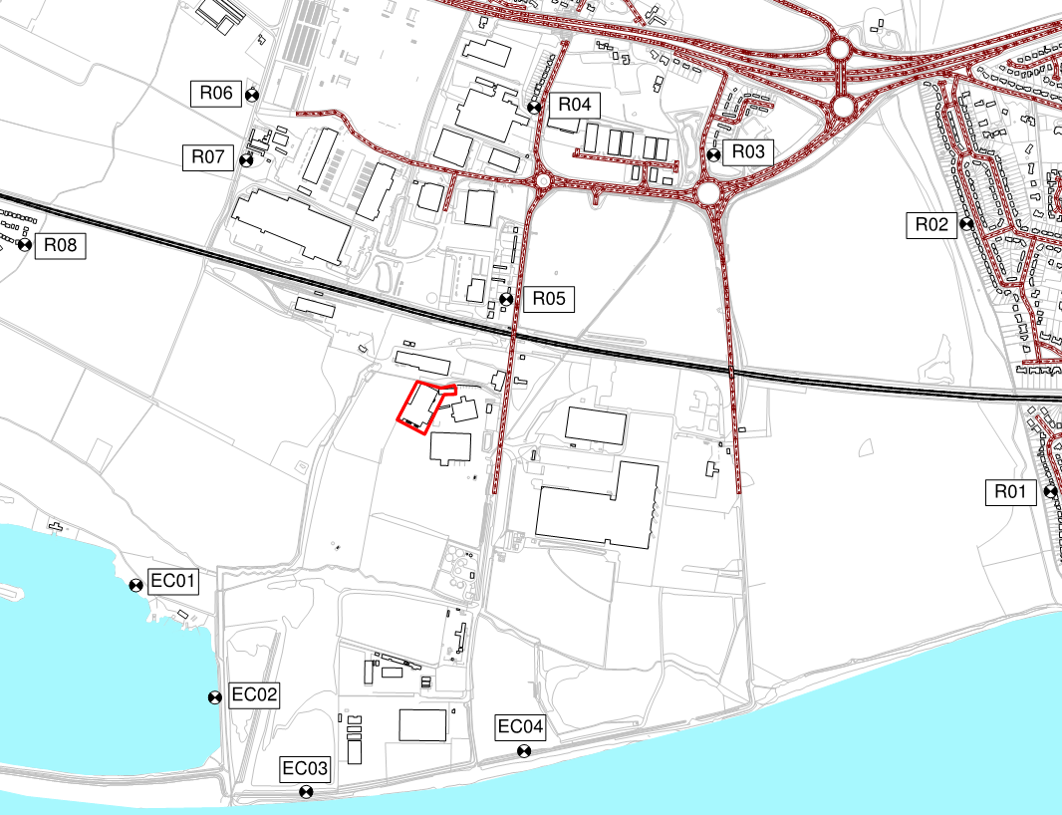
Not to scale

OPERATIONAL AND PROCESS CONTROLS

Noise Managements Strategy

    - Eco-Power’s NMP strategy is to minimise any releases through good working practices and the use of suitable process control measures which represent BAT. A strategy based on the hierarchical structure shown in Figure 3 will be used at the Installation.

Figure 3: NMP Strategy

Noise Control Measures

The following general management techniques are employed at the Installation:
- staff will be suitably trained in the operation of all equipment and the conditions of the Environmental Permit and EMS;
- the buildings have been appropriately sited and designed to reduce the potential for noise emissions to travel beyond the Environmental Permit boundary; Figure 4 below highlights the intrinsic design measures that are incorporated within the site layout to reduce noise levels at off-site locations;
- the condition and integrity of the infrastructure is inspected and maintained as part of the Installation’s EMS and recorded on the Site EMS Day Diary Checks Form contained in Appendix II;
- all processing equipment is appropriately inspected and maintained as per Eco-Power’s Planned Preventative Maintenance Regime (“PPMR”) which is contained in Appendix III. This will prevent any equipment malfunctions which could give rise to clatter sounds. The equipment is regularly lubricated to ensure good working condition.

    - Table 5 details the environmental risk assessment undertaken in regards to potential noise arising from the Installation. It can be observed that the control measures implemented reduce the overall risk to low.

Figure 4: Site Layout 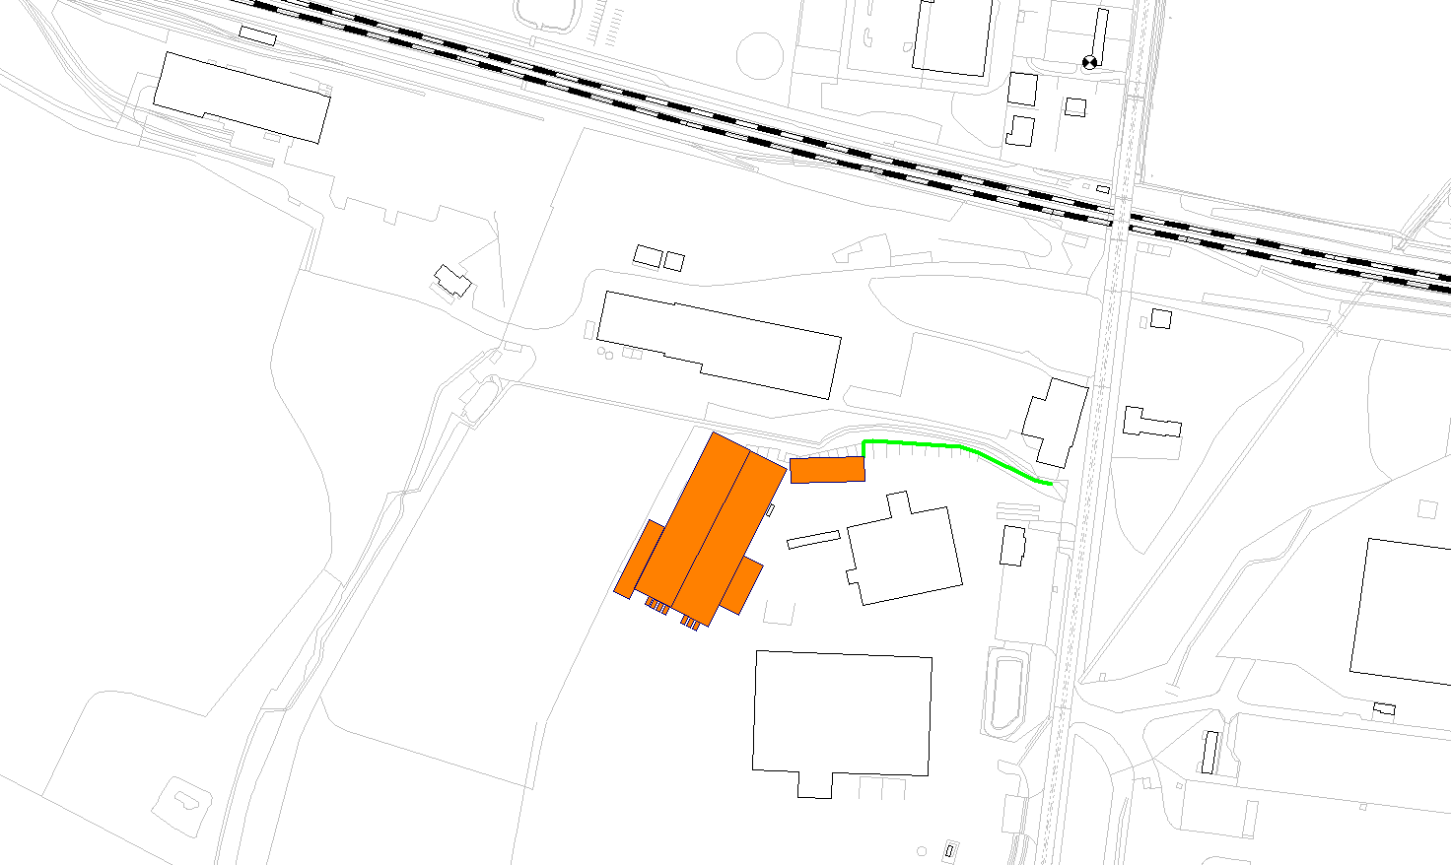
Externally-located sited on south of building to maximise the screening provided by the structure relative to closest properties
Openings on building oriented towards non-sensitive industrial uses.

Vehicle movements within yard screened by structures and unloading of vehicles within structures minimises noise breakout.
Acoustic Barrier screens noise from storage area/vehicle movements
Storage area features solid walls to north, east and west and roof to minimise noise breakout
Noise sources housed within processing building, no openings to north or west thereby minimising noise breakout towards closest properties.
Closest dwellings
Table 5: NMP Risk Assessment and Control Measures
Potential Source or Pathway | Identified  Receptor(s) | Pathway | Control Measures | Probability of  Exposure | Consequence | Overall  Risk
Movement of vehicles transporting waste to and from the Installation | Human population in surrounding area | Releases to Air  Site is close enough to receptors for noise to be potentially audible | The logistics department will ensure that transport vehicles use the most direct and efficient route to the Installation. Logistics planning will ensure vehicle movements are equally distributed throughout the working day to prevent excessive number of vehicles on the local road network at any one time.  Site vehicles will be kept to a minimum with all vehicles limited to 5 mph on site. | Medium.  Control measures should prevent any noise or vibration nuisance from reaching the identified receptors. | Noise or vibration nuisance | Low
Tipping of waste material | Human population in surrounding area | Releases to Air  Site is close enough to receptors for noise to be potentially audible | All delivery vehicles will be required to use the designated Transwaste route to deliver to Eco-Power which will reduce the need for vehicular movements on site and hence reduce the intermittent beeping generated during reversing manoeuvres required for the health and safety of all workers.  Any tipping activity will be supervised by an Eco-Power competent person with drop heights controlled to 2m during all tipping of waste materials to reduce the generation of noise. The waste will be tipped using walking floors or ejector trailers.  Material will only be offloaded in the dedicated internal storage areas to reduce any noise and vibration emissions which may reach sensitive receptors. | Medium.  Control measures should prevent any noise or vibration nuisance from reaching the identified receptors. | Noise or vibration nuisance | Low
Table 5: NMP Risk Assessment and Control Measures (Cont.)
Potential Source or Pathway | Identified  Receptor(s) | Pathway | Control Measures | Probability of  Exposure | Consequence | Overall  Risk
Proposed waste recovery activities e.g. shredding, separating; drying; and pelletising. | Human population in surrounding area | Site is close enough to receptors for noise to be potentially audible | All proposed waste activities will be undertaken internally. The building is constructed of plastisol coated steel profile sheeting and concrete panels which will provide noise attenuation to reduce any noise emissions which may reach sensitive receptors.  The process building and associated machinery will be located a significant distance from the nearest identified sensitive receptors with the benefit of screening from existing buildings and trees in the surrounding area; the accompanying noise assessment in Appendix V identifies that average noise levels at existing sensitive receptor locations are below 46 dB L_{Aeq} and have a negligible contribution to existing ambient noise levels associated with the existing operations at the Melton Waste Park and surrounding industrial and commercial premise in the surrounding area.  The openings of the building which are located on the east / south-eastern façade of the building will be kept closed when practicable to reduce noise breakout from the building.  Operating hours will be governed by the Installation’s planning permission. It is anticipated that operational hours will be 06.00-18.00 Mon-Fri, 06.00-16.00 Saturdays and 08.30-15.00 Sundays and Bank Holidays.  Essential repairs and maintenance of plant and equipment on site shall be permitted outside of these hours until 20.00. | Medium.  Control measures should prevent any noise or vibration nuisance from reaching the identified receptors. | Noise or vibration nuisance | Low

Table 5: NMP Risk Assessment and Control Measures (Cont.)
Potential Source or Pathway | Identified  Receptor(s) | Pathway | Control Measures | Probability of  Exposure | Consequence | Overall  Risk
Proposed waste recovery activities e.g. shredding, separating; drying; and pelletising. | Human population in surrounding area | Site is close enough to receptors for noise to be potentially audible | Only experienced Eco-Power personnel will be responsible for operating equipment and supervising the activities. Site machinery will be subject to plant pre-use checks prior to commencing operations each working day.  All site plant and equipment will be covered by the Installation’s PPMR contained in Appendix III. This ensures adequate maintenance of any parts of the plant or equipment whose deterioration may give rise to increases in noise. Additionally, vital spare parts will be held on site to aid rapid repairs to ensure all machines are operating in good working order.  Eco-Power will also comply with The Control of Noise at Work Regulations 2005.  All personnel will be trained in noise management and the prompt reporting of any abnormal noise so that it can be rectified. | Medium.  Control measures should prevent any noise or vibration nuisance from reaching the identified receptors. | Noise or vibration nuisance | Low

NOISE MONITORING

Monitoring Schedule

    - Daily inspections will be undertaken to monitor for any increase levels of noise occurring as a result of the Installation activities. This monitoring will be undertaken by the Operations Manager or nominated deputy.

    - The indicative noise monitoring locations are shown as yellow symbols in Figure 5.

Figure 5: Indicative Noise Monitoring Locations
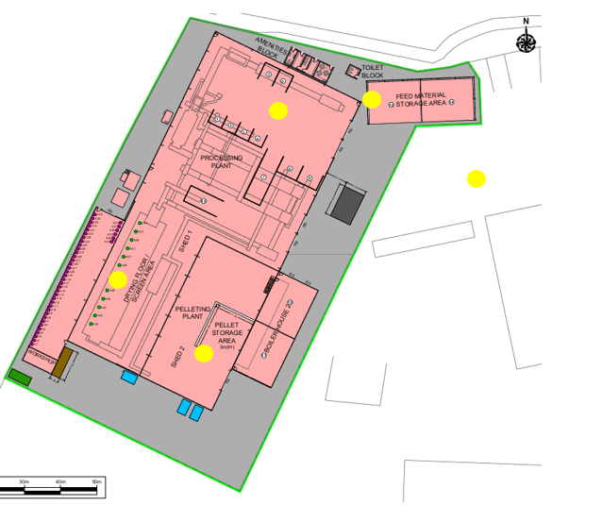

    - Noise monitoring will be recorded on the Daily Site Monitoring Check Sheet, a blank example of which is provided in Appendix IV of this NMP. Table 6 below identifies the noise levels measured at corresponding locations during the source noise survey; ongoing noise monitoring of average noise levels within the application site will be compared against these values.
Table 6: Measured Application Site Noise Levels (L_{Aeq,T})

Description | Single Figure (dBA L_{Aeq})
Noise from conveyer belt, drying room and pelletising shed (SN16)  Reverberant sound pressure level in centre of space | 88.8
Noise within boiler room  Reverberant sound pressure level in centre of space | 74.5
Waste unloading from HGV  Sound Pressure Level @1m distance | 75.7
Extraction Plant on East Façade  Sound Pressure Level @ 1m | 85.2
Generators South Façade  Sound Pressure Level @ 1m | 80.4

    - If increased levels of noise are identified, the source of noise will be investigated and determined and the corrective and preventative control measures implemented as a result will be recorded. Follow up noise monitoring will enable the effectiveness of the control measures to be established. This will identify whether the actions can be closed our or if further measures are required.

EMERGENCY SCENARIO CONTINGENCY

Introduction

The extensive control measures outlined in Section 5.2 should prevent any noise emissions from reaching the identified receptors. However, this section considers the potential for accidents (or incidents) which would result in noise nuisance from being experienced having an unacceptable short term impact on the sensitive receptors located nearby.

Emergency Scenarios and Contingency Measures

    - The contingency measures for each identified emergency scenario are detailed in Table 7.

Table 7: Emergency Scenario Contingency Measures
Emergency Scenario | Contingency Measures
Plant and Equipment Breakdown | Eco-Power’s PPMR (See Appendix III should prevent any unplanned breakdown of equipment or machinery. However, if this is to occur unexpectedly, the following contingency measures will be implemented.  Waste will not be accepted at the site until operations re-commence.  Eco-Power will refuse acceptance of waste at the site from its suppliers.  Where possible, spare parts will be held on site to undertake repairs as soon as possible. If spare parts need to be outsourced, this will be the responsibility of the Maintenance Team and if required, specialist contractors will be contacted to undertake any complex repair work.  Start-up of equipment will be undertaken gradually by trained personnel to ensure optimal performance of equipment prior to full commencement of waste activities.
Staffing Issues | Eco-Power has assigned responsible persons and deputies in the case of staff absence.  At the start of each working day, the Operations Manager will instruct the deputy in the case of staff absence to ensure all measures outlined in this NMP are undertaken, such as supervision of unloading and loading of materials and suitably trained personnel being responsible for the operation of processing equipment.  Senior Managers are fully trained in the NMP and are available to attend site out of normal working hours (8am-6pm).

COMPLAINTS

Community Liaison

Eco-Power is committed to achieving an open and transparent relationship with the local community. If required, site personnel will attend local community meetings in order to be informed of any concerns which community members may have and to outline the robust measures outlined in this NMP to address these concerns. This will help to prevent noise complaints in the first instance.

Contact details are provided on the company website for all Eco-Power sites including Gibson Lane, as well as an email address for general enquiries. Eco-Power welcome correspondence using these provided methods of communication.

Response to Complaints

Initial Response – Data Gathering

      - If a noise complaint is received at the Installation or if increase noise levels are identified as part of the noise monitoring regime, a full investigation will be undertaken within 8 working hours.

      - Eco-Power will request as much information as possible from the complainant, such as:
- date and time problem first identified;
- location of complainant;
- detail of the problem;
- frequency or intensity of problem; and
- description of the noise.

      - This information will then help inform and structure the investigation which will be undertaken on site.

Noise Complaint Investigation

    - The investigation will include the following:
- undertaking a site inspection to establish whether any noise can be observed at the present time;
- viewing Closed Circuit Television (“CCTV”) footage to determine if tipping, waste processing or vehicle movements were occurring at the time to try and establish the potential origin of the noise;
- speaking with operators at the Installation at the time of the event who may be able to provide further information regarding the occurrence or the noise;
- reviewing the Daily Site Monitoring Check Sheet to confirm checks have been completed and to note whether any abnormal activities or observations were recorded; and

- discussions with operators to establish any changes to normal operating conditions.

      - Corrective and preventative measures will be implemented if the complaint is substantiated. The type and level of corrective and preventative measures will be dependent on the root cause and scale of the noise source. Dependent on the cause of a complaint, examples of mitigation measures include, but would not be limited to the following:
- reducing number of vehicles entering and leaving the Installation;
- reducing the drop height from 2m to 1m*;
- implementing a closed door policy;
- reviewing operational hours and undertaking processing only during normal working hours.
- avoiding the use of defective machinery causing excessive noise until maintenance or replacement plant can be sourced.

*It should be noted that minimising drop heights is identified within BS 5228 (section 8.2.1) as a general measure that can be adopted to reduce noise levels at source; indeed, Table B1 of BS 5228 identifies that noise levels from materials handling can be reduced by up to 15 dB through a combination of minimising drop heights and localised screening such as the structures located on site.

As such, taking into account the tolerances with respect the dimensions of machinery on site, in order to avoid increasing the risk of creating additional impact noise when handling materials, the minimum drop height of 1m is included within this NMP as a best-practice measure (although materials will be lowered wherever practical to avoid dropping materials).

Timescales

      - The timescales associated with the complaint procedures are as follows:
- investigate complaint – within 8 working hours; and
- corrective and preventative measures proposed and implemented within 1-3 working days.

Feedback to the EA and Complainants

      - Eco-Power recognise that offering credible reassurance and demonstrating that complaints are taken seriously can be extremely advantageous. Eco-Power will discuss with the EA and complainant(s) the investigation findings and the associated corrective and preventative actions which have been implemented to address any complaints.

Escalating Complaints

      - If complaints are received daily from multiple complainants over the period of 5 days and Eco-Power have undertaken an investigation which determines the Installation is categorically the source of the noise problem, Senior Managers will hold an emergency meeting to discuss and agree on the ceasing of operations until the problem can be rectified. The EA will be informed of this decision. However, the robust measures outlined in this NMP should prevent this from being necessary.

Records

NMP records are kept in accordance with the procedures established as part of the EMS.

Information which must be recorded will include but not limited to:
- an overview of the complaint received or increase noise level recorded by Eco-Power;
- investigation findings and associated actions raised;
- sensitive receptors in particular the type of receptors, location relative to the suspected source and an assessment of the impact of noise on receptors;
- identification of any circumstances which compromise the ability to prevent noise nuisance;
- timescales associated with the complaint; and
- follow up to ensure close out of any preventative and corrective measures.

Any external/internal non-conformances raised against the requirements of the Environmental Permit or other relevant legislation, are recorded and followed up by the Compliance Director or Operations Manager, as appropriate, to address the concern identified and to prevent occurrence or re-occurrence. The records are reviewed as part of Management Review meetings.

NMP REVIEW

The continuing effectiveness of the NMP will be reviewed by the Company Director annually or immediately if a substantiated complaint is received and it is clear control measures have failed.

The reviews will take into account compliance records, complaints history, site records and any recent sensitive developments on neighbouring land. The plan will be amended as necessary, including any changes or additions to the detailed control measures.
APPENDIX I
DRAWINGS
Figure I.I Site Location Plan
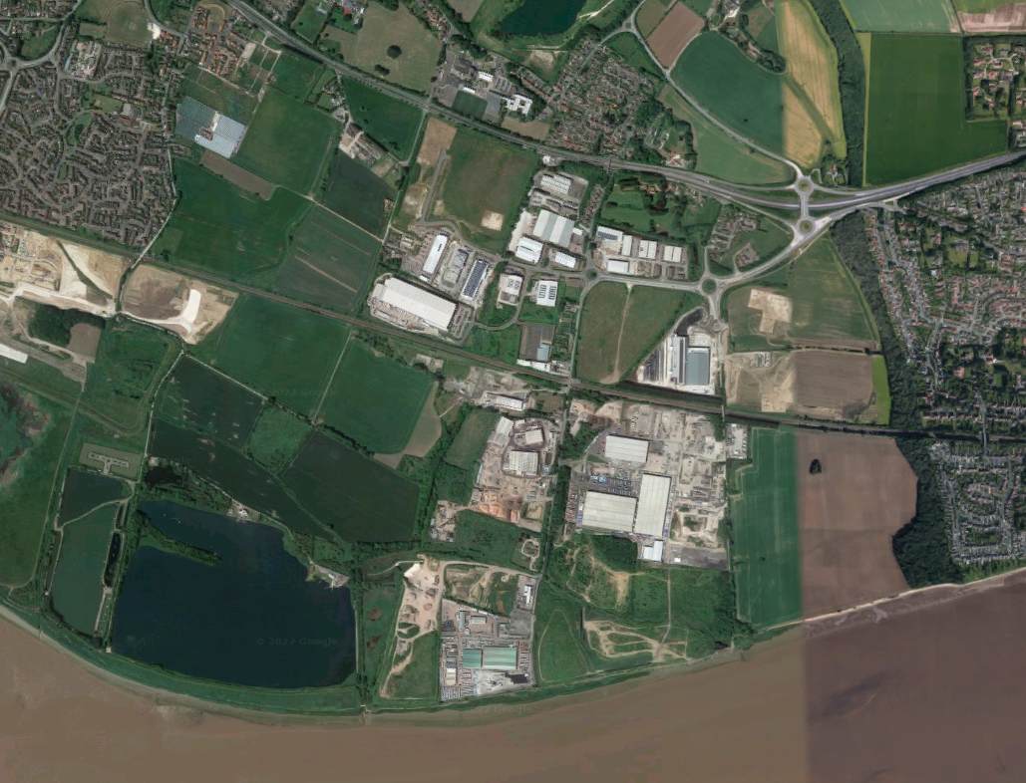
Approximate Site Boundary
River Humber
Welton Water
A63
Melton
Brough
North Ferriby
Figure I.II Site Layout
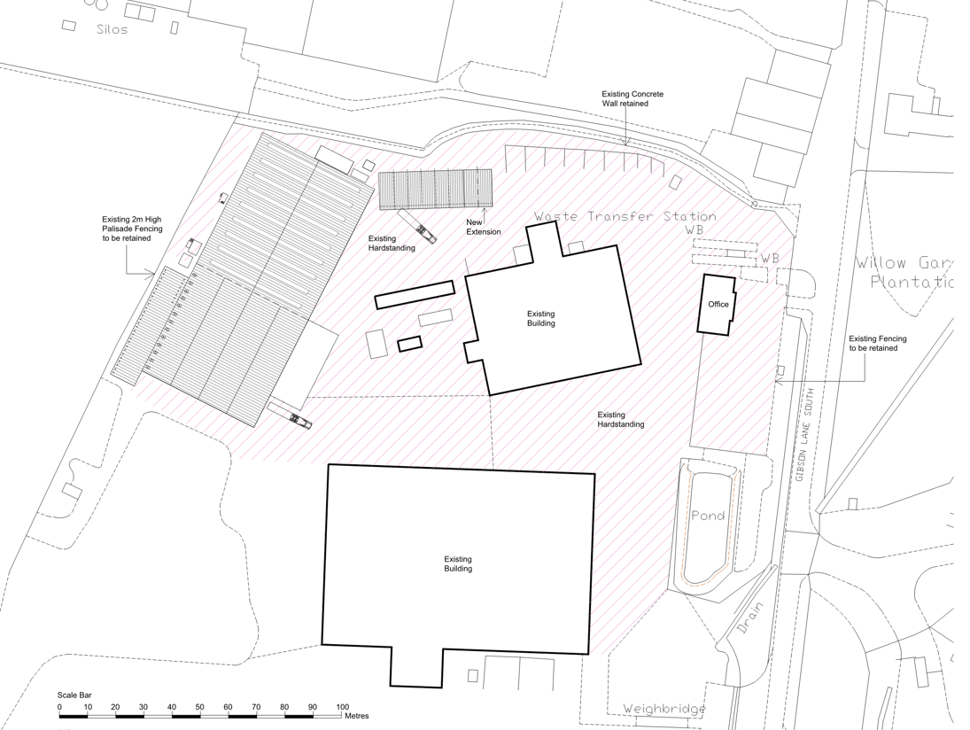

APPENDIX II
SITE EMS DAY DIARY CHECKS FORM

APPENDIX III
PLANNED PREVENTATIVE MAINTENANCE REGIME

APPENDIX IV
DAILY SITE MONITORING CHECKSHEET

Date
Name
Monitoring
Location(s)
Observations
Actions
Signature

APPENDIX V
Environmental Noise Assessment

Eco-Power Environmental Limited Company Website ‘Contact Us’ webpage: http://ecope.co.uk/contact/, accessed September 2021.

