Issued By | Name | Electronic Signature | Date Version Issued
Issued By | Agustina Espinola | 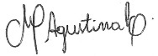 | 27/03/2026
Approval
Department | Manager | Electronic Signature | Date of Approval of Latest Version
Production Laboratory | Andrew Brown | 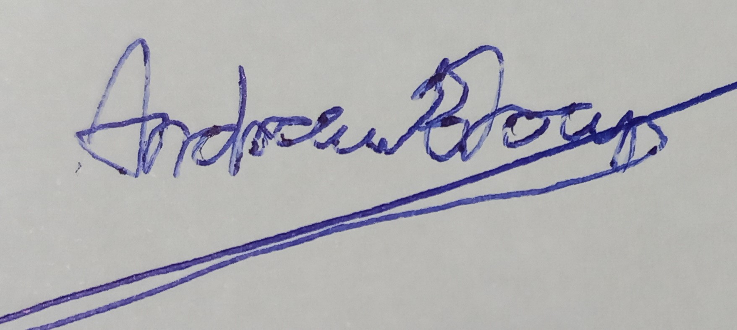 | 24/03/2026
Health, Safety & Environment | Darren Lilley |  | 24/03/2026
Technical | Lucia Moreno |  | 27/03/2026

ROLES TO CARRY OUT THIS TASK
Department | Job Role
Health, Safety & Environment | Environmental & Sustainability  Co-ordinator
Health, Safety & Environment | HS&E Team Member
Production Laboratory | Technicians
Technical | Team Member

List Latest Changes: | - Expanded identification of key hazards  - Clarified sampling methodology  - Introduced compulsory, optional, and “only when contaminated” sampling points  - Updated testing requirements and limits for regulatory compliance
Reminder: If a process change, will require re-training.
Version | 4 | Re-training required | Yes

DOCUMENTS NEEDED TO PERFORM THE TASK | TOOLS
- GRA.TEC.001.04 – Sampling and Inspection of the Wetland & Reed Bed System  - E13 Effluent Analysis  - WIL 013 Use of Hach Spectrophotometer  - 049 Wetland & Brooks Sampling Locations Map 2025  - Wetland Sampling Locations List 2025 Spreadsheet | - Long handled Sampling stick (HS&E)  - Sampling pots (Production Lab)  - Permanent Pen  - Isothermal carrier bag  - Disposable gloves  - Disposable plastic bag  - Alcohol hand sanitiser / sanitary wet wipes  - Mobile phone

PERSONAL PROTECTIVE EQUIPMENT

 |  |  |  |  |  |  |  |  |  | 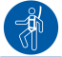 |  |  |  | Other:
KEY HAZARDS – Ticked when applicable to this task

Slip / Trip hazard / uneven floor / obstruction |  |  |  |  |  | x | Buried / Overhead services
Manual Handling / Repetitive handling |  |  |  |  |  | x | Flammable substances
Moving machine parts / nip points |  |  |  |  |  |  | Explosion Hazards
Contact with electricity / electrical discharge |  |  |  |  |  |  | Noise
Falls from height |  |  |  |  |  |  | Fumes / Dust
Energy Sources – air / gas / liquid / vapour |  |  |  |  |  |  | Traffic / Vehicles / FLT |  |  |  |  |  | x
Impact / struck by ejecting objects / parts |  |  |  |  |  | x | Sharp edges / cuts etc.
Confined Spaces |  |  |  |  |  |  | Lone Working |  |  |  |  |  | x
Falling objects / parts |  |  |  |  |  |  | Vibration
Excavation Hazards |  |  |  |  |  |  | Hot Surfaces / Liquids
Harmful Substances |  |  |  |  |  | x | Adverse Weather |  |  |  |  |  | x
Fire Hazards |  |  |  |  |  |  | Environmental Risk
Lifting Equipment Failure |  |  |  |  |  | x | Hot / Cold / Work Environment
Lighting / visibility |  |  |  |  |  |  | Radiation
PRECAUTIONS / PERSONAL SAFETY (KEY POINTS)

1. Always follow the correct Health & Safety procedures – do not take short cuts – report any issued to your supervisor
2. Do not perform any task that you have not been trained on – if you think the task is not possible for you to do for any reason e.g. weight – speak to your supervisor
3. Before you start – check your machine or equipment – if you have any doubts – do not use it and inform you supervisor immediately
4. Never try and fix your own machinery – report to a supervisor immediately
5. All machines / equipment must be switched off, isolated and locked off before clearing blockages
6. Be aware of floor conditions – caution signs, damage, liquid or spills on the floor – clean as you go and report damage
7. When you move something – always check the area around before you move it to avoid hitting anyone and check wheels too
8. Always wear the correct PPE for your task and never mess around when working
9. Job rotation is mandatory where there is a frequent repetition of the same task

Purpose:

This work instruction is used to monitor the physical and chemical performance of the wetlands and reed bed system. The results are used to inform irrigation practices and ensure compliance with discharge consent and reservoir requirements.

WORK INSTRUCTION
Work  Seq. | Operation | Critical Areas  Safety, Ease of Operation, Quality
A | Conduct effluent sampling
A1 | Every fortnight (minimum twice per month), 2 members of the Health, Safety & Environment Department will visit the Wetland and Reedbed System to monitor performance and conduct water sampling and analysis.  Sampling pots must be arranged for collection in advance with the Production Laboratory to ensure they are ready for use.  Personnel must also be equipped with the sampling stick, an isothermal carrier bag, and disposable gloves. | If only one member of the HS&E team is available, a Laboratory or Technical team member may accompany them.
A2 | Once the sample has been collected, it must be labelled to indicate the exact point of collection. It is recommended that the names and locations specified in map 049 Wetland Brooks Sampling Locations available in IMS are used.  The naming convention indicates whether samples originate from D (Ditches), B (Brooks), W (Wetlands), or RB (Reed Bed). The numbering allows the exact sampling location to be precisely identified. This information must be recorded on the sampling pot; for example, W-08 or RB-11. | IMS Site Maps - 049 Wetland Brooks Sampling Locations Map 2025
A3 | There are three types of sampling locations: compulsory, optional, and ‘only when contaminated’. These have been defined based on historical events and regulatory requirements.  Compulsory locations must be sampled during every visit to the wetland and reedbed system, as they are required to meet legal obligations.  Optional locations should be sampled when requested due to recent site conditions or production activities that may lead to contamination, or when required to assess improvements in effluent quality.  ‘Only when contaminated’ locations are used for areas where contamination may be observed or is known to commonly occur. If the water in these areas appears darker than normal or if any unusual conditions are observed, samples shall be collected.  If a new location requiring this type of sampling is identified and is not currently shown on the map, it must be reported to the HS&E Department so that the map can be updated accordingly. | Compulsory sampling points:  W-08 Slip Flow Chamber  RB-11 First Reed Bed Inlet  B12 Pre V-notch Discharge  RB-13 V-notch Discharge  W-16 Brook Post V-notch Discharge  W-18 Pond 9  B-21 Caerswall Brook
A4 | Once all samples have been collected, ensure the sampling stick is thoroughly rinsed to prevent any microbiological residues remaining on the equipment.  Remove your gloves, place them in a disposable plastic bag, and clean your hands using alcohol-based hand sanitiser or sanitary wet wipes.  Dispose of the plastic bag upon returning to site and wash your hands thoroughly with water and antibacterial soap.
A5 | Take the sample pots to the laboratory so testing can begin immediately. If there will be a delay, store them in the fridge. Inform the laboratory technicians of the appropriate test kit ranges for each sample.  For ditches and brooks, use the low-range COD test kit unless there are clear signs of contamination, in which case a medium or high range kit may be appropriate.  Where high-range COD test kits are used, assume that other analytical parameters will also require high-range test kits. | Always contrast previous E13 report results with visual checks to confirm which test kit ranges should be applied.

WORK INSTRUCTION
Work  Seq. | Operation | Critical Areas  Safety, Ease of Operation, Quality
B | Review results, compile the E13 report and archive records
B1 | Once the lab results are available, you must complete the E13 Effluent Analysis Form as part of the routine check. After the report is uploaded to SharePoint, it is distributed by email to the Manufacturing, Process, and Health, Safety & Environment teams.  Any other internal stakeholders who have requested inclusion may also be added to the distribution list. | IMS Master form – E13 Effluent analysis form
B2 | Photographs may be added to the final email to clarify comments on the report.  Upload photographs to SharePoint ensuring they are stored in the folder for the relevant year and month and annotated with the date of the visit. | Environment & Sustainability > Effluent Testing > Chemical Analysis > Wetland Analysis - E13 > E13 Wetland Sampling.
B3 | The V-notch discharge and any brook samples will need to be below the discharge consent levels:  - COD: 100 mg/l  - Total Phosphorus (as P): 1 mg/l  - Ammoniacal Nitrogen (as N): 5 mg/l  - pH: 6 to 9 (minimum and maximum)  - Visible oil or grease: No significant trace | If the results are above the consent limits, an additional sample will be taken immediately, and the V-notch will be closed until levels fall below the consent discharge limits.

B4 | From beginning of 2026, fortnightly monitoring of the following parameters started on V-notch samples to establish a baseline and ensure compliance with BAT-AELs:  - Total Nitrogen: No limit established  - Total Suspended Solids: 10 mg/l (measured after drying at 105oC)  The following parameters must be monitored monthly, by outsourcing samples to an approved supplier laboratory:  - ATU-BOD (as O2): 11 mg/l  - Total Organic Carbon: No limit established  - Chloride: No limit established  Samples will be collected by Health, Safety & Environment staff and sent to an external laboratory for analysis. Each sample will be correctly taken, clearly labelled, and then transported in a cool box with two ice packs to maintain sample integrity and prevent errors in the results.
B5 | Records of the sample results along with the E13 reports must be kept for at least 6 years from the date when the records were made.

