Issued By | Name | Electronic Signature | Date Version Issued
Issued By | Darren Lilley |  | 16/07/2026

Approval
Department | Manager | Electronic Signature | Date of Approval of Latest Version
Health, Safety & Environment | Darren Lilley |  | 16/07/2026
Site Safety & Security | Mark Yemm |  | 17/07/2026
Process | Steve Rooke |  | 16/07/2026
Production | Giles Goodwin | 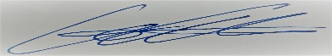 | 16/07/2026
Farm | Tom Churchill | 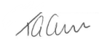 | 18/07/2026

ROLES TO CARRY OUT THE TASK IN THIS PROCEDURE
Department | Job Role
Health, Safety & Environment | Head of Health, Safety, Environment & Sustainability
Health, Safety & Environment | Environmental & Sustainability Coordinator
Site Safety & Security | Site Safety & Security Manager
Process | Process Manager
Process | Wastewater Treatment Operative
Production | Head of Production

List Latest Changes: | - Template updated  - Drain colour coding updated  - Responsibility transferred from Technical Department to HS&E Department
Reminder: If it is a process change, it will require re-training.
Version | 6 | Re-training required | Yes

WHAT THE ROLE NEEDS TO CARRY OUT TASK IN THIS PROCEDURE
DOCUMENTS NEEDED TO PERFORM THE TASK | INFORMATION NEEDED BEFORE STARTING THE TASK
- Drainage and Effluent Management Map  - Prescribed Form of Record for a High-Risk Reservoir Book  - OP49 Spillage Procedure  - OP13 Document Control Record Retention Procedure  - OP42 Site and Plant Development Procedure  - WI WWT 001 Wastewater Treatment  - WI WWT 002 Maintaining the V-Notch  - WI WWT 003 Downloading Flow Chamber Date  - WI WWT 004 Downloading the V-Notch Data  - WI WWT 005 Handling Chemicals in DAF and MBR  - WIL 035 Analysis of Effluent V4  - WIL 036 Sampling and Analysis of the Wetland and Reed Bed System  - E13 Effluent System Monitoring Record | - Reservoir Act 1974 and amendments  - Discharge Consent EPR/FP3429GD/V002  - MCERTS Certificate
TOOLS | H&S Requirements –
- Sampling equipment (insulated bag, ice pack, sample pots, sample stick)  - Water thermometer  - Ambient thermometer  - Meta Sphere platform login (for flow monitoring)  - Nijhuis MWS platform login (for chemical monitoring) | - PPE

RESPONSIBLITIES

Head of Health, Safety and Environment | Health, Safety and Environment (H&S, E)  - Responsible of ensuring that legal requirements and any changes are identified and communicated.  - Responsible of ensuring that the Health, Safety & Environment Department monitor the performance of the Effluent Treatment System, Reed Bed and Wetlands and compliance against the discharge consent.

Health, Safety & Environment Staff | Health, Safety and Environment (H&S, E)  - Responsible for logging the fortnightly Reservoir meter board readings in the Prescribed Form of Record for a High-Risk Reservoir book.  - Responsible for monitoring the conditions of the reservoir and the overall wellbeing of the wetlands and reed beds system.

Site Safety & Security Manager | Health, Safety and Environment (H&S, E)  - Responsible for the maintenance of the drainage system.  - Responsible for overseeing maintenance of the Wetlands and Reed Beds - including lawn mowing, vegetation cutting and removal of invasive tree species, and the function of V-notch pond ultrasound device - carried out at appropriate times so as not to affect biodiversity.

Farm Manager | Health, Safety and Environment (H&S, E)  - Responsible for maintaining the irrigation network.

Process Manager | Health, Safety and Environment (H&S, E)  - Responsible for managing and maintaining the Effluent Treatment Plant.

Wastewater Treatment Operative | Health, Safety and Environment (H&S, E)  - Responsible for downloading data from the V-Notch Outlet 1 and Slip Inn chamber outstations, and notifying the Health, Safety & Environment department of any non-compliance with discharge consent.  - Responsible for checking Pond 9 (spillway) volumes daily via the Reservoir meter board and reporting these through the DAF Daily Report.

Head of Production | Health, Safety and Environment (H&S, E)  - Responsible for the overall management of the Effluent Treatment System, Reed Beds and Wetlands facility.

Reservoir Engineer | Health, Safety and Environment (H&S, E)  - Responsible for providing advice on the Wetlands safety as a Reservoir, under the Reservoirs Act 1975 Regulation.

Purpose:

The purpose of this procedure is to ensure that our Effluent Treatment System operates effectively so that the treated effluent being discharged is compliant with all Legislative requirements in both discharge to water course and reservoir storage to prevent pollution of controlled waters and land.

Work  Seq. | Operation | Critical Areas  Safety, Ease of Operation, Quality
A | DRAINAGE AND EFFLUENT TREATMENT | .
A1 | An electronic version of the site’s Drainage and Effluent Management Map is held on the Integrated Management System. | 031 - Water Drainage & Effluent Management 2026.pdf
A2 | Trade Effluent Drainage  All Trade Effluent from the manufacturing process drains through YELLOW DRAINS and is treated by the Effluent Treatment System. | 031 - Water Drainage & Effluent Management 2026.pdf
A3 | Surface Water Drainage  Most site surface water drains (BLUE DRAINS) into a central culvert and then to the local stream. Only uncontaminated rainwater is permitted down these drains. | 031 - Water Drainage & Effluent Management 2026.pdf
A4 | Sewage Drainage  Effluent from toilets, sinks, and showers drains into RED DRAINS which carry it to underground sewage treatment systems. The red drains collect flow from the outlets at each location and feed it into these submersible systems, located specifically at the back of the Orchard Tank Farm, behind the Engineering workshop, and near the site entrance gate leading to the Visitor Centre/Shop. | 031 - Water Drainage & Effluent Management 2026.pdf
A5 | Effluent Treatment System  The Wastewater Management flowchart in Appendix 1 provides an overview of how the wastewater is managed on-site.
A6 | Primary Treatment (Sieves and DAF Units)  All Effluent flows to the upstream side of the Applegarth weir and through a vee notch, to capture the quantity of effluent entering the wastewater treatment plant (WWTP) after which it starts its primary treatment when it is pumped to two Balance tanks, with a total storage capacity of 685 m³, via a sieve which removes any debris (twigs, stones caps etc.). After removal the debris is passed to the sludge trailer.  The sieved effluent is then pumped to two DAF (Dissolved Aeration Flotation) units to complete its primary treatment. The water is pH corrected before dosing with a coagulant to start the flocculation process. The flocculated material is suspended by saturated air with lighter particles being scraped off the top, and heavier solids settling at the bottom, of hoppers before both are pumped to a sludge holding tank.  The sludge is then dewatered, in a centrifuge. The drier sludge is passed to the sludge trailer, which is regularly taken away to a digester, with any residual water flowing to the downstream side of the weir in Applegarth and then by gravity to the wetlands. Analysis of the DAF water is carried out to optimise chemical use and ensure correct treatment.
A7 | Secondary Treatment (MBR Unit)  The secondary treatment process is by Activated Sludge (AS) and Membrane Bioreactor (MBR). The treated water from the DAF is pumped through an Anoxic tank which reduces nitrogen oxides. Nutrient is dosed at the inlet to the AS tank if the effluent is deficient in both P and NH4 and this helps micro-organisms break down organic matter further before it passes to the MBR which filters out the micro-organisms & any other small particles.  The effluent then passes into a Permeate Tank before being released to the Reed Beds for tertiary treatment.
A8 | Tertiary Treatment (Reed Beds)  Effluent from the Permeate tank flows down to the Reed bed system, a series of seven treatment cells that further treat the water before it is discharged into the brook. The effluent sampled at the Permeate Tank already meets the quality parameters specified in our Discharge Consent (see Appendix 2).  The series of reed beds provides additional removal of phosphates and nitrates from the effluent when required, in the event that these parameters exceed consent limits in the Permeate Tank sample results.  Further sampling analysis is carried out at the V Notch to ensure the final effluent water satisfies all the parameters of the discharge consent as shown below prior to discharge. Should any of the consent limits for emissions be exceeded then the V notch must be shut down immediately and the Health, Safety & Environment Team informed, so they can notify the Environment Agency. Similarly, the discharge permit also stipulates that the maximum volume of treated Effluent discharged per day is 200m³ and should this limit be reached then the V notch must be shut down immediately and the Health, Safety & Environment Team informed.
A9 | Wetlands  The Wetlands Ecosystem is designed to treat effluents through a series of ponds which contain specific plant species and bacteria to reduce the COD loading (and other parameters) of the effluent and acts as a reservoir (covered by the Reservoir Act), where the final pond serves as a source for Irrigation.  The wetlands receive wastewater through the following scenarios:  - Most commonly, wastewater that has been through the WWTP in full but either exceeds the consent emissions, volume, or limits stipulated in the discharge permit. The usual mechanism for this is that the V-Notch in the reed beds (Outlet 1) is closed and the water is diverted to pond 1 of the wetlands where it is progressively cleaned as it gradually flows through to the last pond, where it can be used for irrigation.  - Occasionally, due to a breakdown in the MBR plant, wastewater that has received primary treatment is discharged into pond 1 of the wetlands system for the wet system to continue its natural treatment process where it is progressively cleaned as it gradually flows through to the last pond, where it can be used for irrigation.  - If an unexpected event occurs such that the existing buffer storage in the system is likely to be overwhelmed then the wetlands can be used as a buffer storage for the excess effluent, until the issue has been resolved, by closing the valve between ponds 3 and 4 of the wetlands. Subsequently the untreated water contained in ponds 1-3 is recirculated through the WWTP, or alternatively, arrangements are made to have it taken off site by road tanker. | Outlet 1 Monitoring Point NGR SO 65159 33258

Work  Seq. | Operation | Critical Areas  Safety, Ease of Operation, Quality
B | MONITORING AND REPORTING | .
B1 | Monitoring & Measuring of the Effluent Treatment Plant, the Reedbeds and the Wetlands  To ensure compliance with the discharge consent limits on emissions, and volumes, and to optimise the performance of wastewater management, whilst also monitoring usage, measurements, monitoring and analysis of the effluent is carried out at various stages throughout the treatment process by trained Lab and F&M staff as detailed in work instructions WIL035, WIL036 and on E13.  Performance data and analytical results are distributed daily and reported through the company meeting structure (OP1) where any actions required are determined and responsibilities and timescales agreed.  Monitoring records must be maintained, and original records kept against consent, volumes and notifications for 6 years. These are accessed either in hard copy or electronic files.
B2 | Flow data is collected by the Wastewater Treatment Operatives manually, from flow meters in the DAF system and by downloading data from the v notch and slip inn chamber.
B3 | The Wastewater Treatment Operatives must check the volumes in the last pond of the Wetlands daily using the Reservoir meter board and record them in the DAF Daily Report, in order to prevent spillway overflow.
B4 | Visual inspections of reedbed, wetlands and watercourses in the vicinity are carried out fortnightly by the Health, Safety & Environment Team personnel using report form E13.  Total daily volume being discharged through the V-notch is recorded via Adcon Telemetry software (Meta Sphere) and is reviewed daily by the F&M operator. The Health, Safety and Environment staff audits the flow data to ensure compliance with MCERTS.  The Environment Agency also monitors the discharge consent by taking their own samples on a regular basis to ensure Westons Cider is compliant.
B5 | Reed bed Inspection and Maintenance  Vegetation maintenance includes monitoring for any Invasive Species or species covered under The Wildlife and Countryside Act, 1981, Schedule 9 (Part II) (2010), on a fortnightly basis. Any plants found under these categories should be removed immediately and disposed of following legislative guidelines.
B6 | Wetlands Inspection & Maintenance  The Wetlands is also maintained in accordance with the requirements of the Reservoir Act and regular inspections carried out as a minimum annually by a Supervising Engineer approved by the Environment Agency.  The ‘Prescribed Form of Record for a High-Risk Reservoir Book’ is maintained and held by the Health, Safety & Environment Team. Any required remedial action will be agreed with the Managing Director, Head of Health, Safety, Environment & Sustainability and other individuals from the Leadership Team as appropriate.
B7 | Emergency situations/ Spillages  Breaches to discharge consent which includes any discharge from the wetlands must be reported to the Environment Agency.  In the event of abnormal discharges to the drainage system, either surface or trade effluent drainage system, the spillage procedure OP49 must be followed, and an E19 Environmental Incident Investigation Report must be sent to the Health, Safety and Environment Team.
B8 | Reporting to the Environment Agency  Any breaches in consent, either chemical or flow limits, must be reported to the Environment Agency by the Health, Safety & Environment Team.  Any malfunction, breakdown or failure of equipment or techniques, accident, or emission of a substance not controlled by an emission limit within our Effluent Discharge Consent, which has caused, is causing or may cause significant pollution, must be notified to the Environment Agency as soon as reasonably practicable following detection. The supporting information required under Schedule 5, Part A(a) of the permit must be provided within 7 days of detection.  Any breach of a limit specified in the Schedule 3, Table S3.1 of our Effluent Discharge Consent will be notified to the Environment Agency within 14 days of detection, with the supporting information required under Schedule 5, Part A(b).  Where an incident involves the Reservoir, this falls under the separate Reservoirs Act 1975 regime and the Environment Agency's Reservoir team must also be informed by email at reservoirs@environment-agency.gov.uk

Work  Seq. | Operation | Critical Areas  Safety, Ease of Operation, Quality
C | IRRIGATION, RECIRCULATION AND FLOW CONTROLS | .
C1 | Irrigation System  The orchards are served by a fixed irrigation system that abstracts water from the final pond of the wetland system (Pond 9), also referred to as the irrigation pond. Water is transferred from Pond 9 to Irrigation Pond 1 or Pond 2, according to the orchard being irrigated, and then distributed through irrigation pipes positioned at the base of each tree trunk, drip-feeding water directly to the trees.  The orchards served by this system are specifically: Ox Park, Pear Orchard, 11 Acres, Sheep Wash, Hazerdine, Joiners, Marcle Meadow, Big Walta.  The irrigation system is entirely maintained and managed by the Farm Department. | 031 - Water Drainage & Effluent Management 2026.pdf
C2 | Recirculation in Wetland Ponds  The site has a recirculation system designed to keep effluent within a closed loop unless intentionally removed via irrigation or tankering.  Pond 9 to Pond 3: Pond 9 recirculates back into Pond 3, allowing the effluent to re-enter the biological treatment system.  Pond 9 also functions as the irrigation pond during summer when weather conditions require it, directing the effluent to our surrounding farms (specifically Ox Park, Pear Orchard, 11 Acres, Sheep Wash, Hazerdine, Joiners, Marcle Meadow, Big Walta shown on the Irrigation Map).  Pond 9 to Balance Tank / Recirculation: The effluent can also be diverted back into the Balance Tanks through the wastewater treatment plant, where it is able to undergo the full physicochemical treatment process again. | 030 - Irrigation Map 2017.pdf
C3 | Manual Isolation and Stop Controls  Slider gates (flow isolators) between ponds: Flow between ponds can be physically closed off using sliders. Even when closed, a reduced passive flow through the banks may still occur but the primary route is fully isolatable.  Manual valves: There are valves to allow manual intervention to stop, direct, or divert flows, as shown in Water Drainage and Effluent Management Map.  Valve 1 – Redirect Flow to Top Orchard Pond for Irrigation  Coordinates: 51°59'53.2"N 2°30'37.7"W  Valve 2 – Recirculate Flow Back to Pond 3  Coordinates: 51°59'55.1"N 2°30'28.8"W  Valve 3 – Redirect Flow to Balance Tank WWTP  Coordinates: 51°59'55.2"N 2°30'28.0"W  Valve 4 – Redirect Flow to Big Walta for Irrigation  Coordinates: 51°59'56.1"N 2°30'22.4"W

Appendix

Appendix 1 – Effluent Treatment System

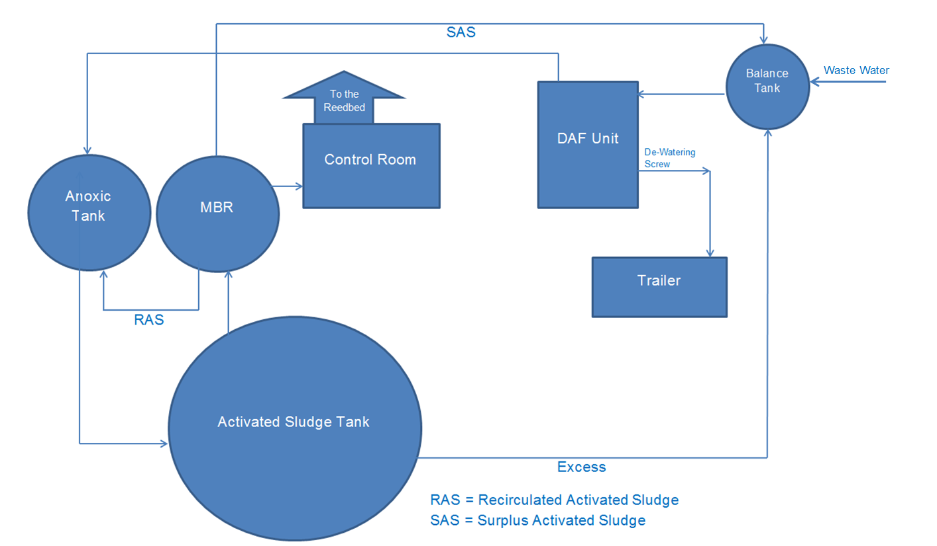

Appendix 2 – Discharge Consent EPR/FP3429GD/V002

