Hergest Camp Farm, Kington, HR5 3ER
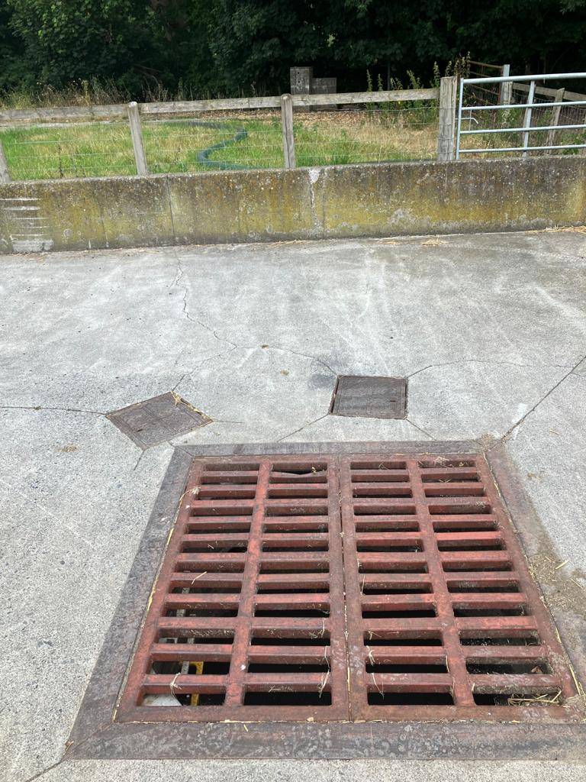
Picture 1 Grid over settlement chamber, NE of House 1 taking the water off the yard.
The 2 small metal covers at the top of the picture is where the 2 diverters are located.
The one on the left allows clean water to run to another settlement chamber before going to the river. This is completely shut off when we are washing down the site.
The one on the right allows dirty water to flow into the dirty water tank at turnaround.
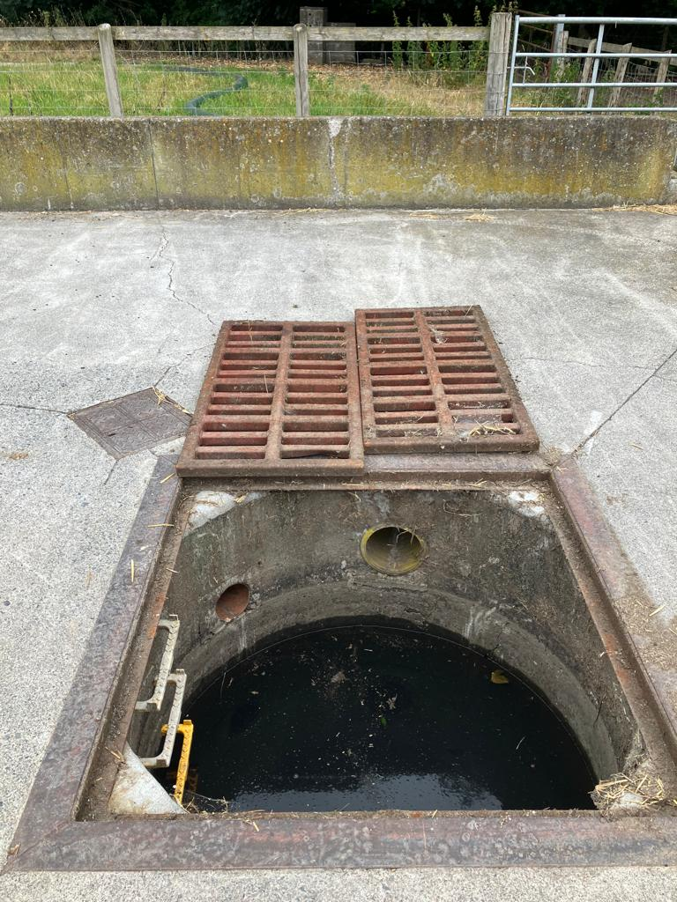
Picture 2 – This shows the same as above with the grids removed.
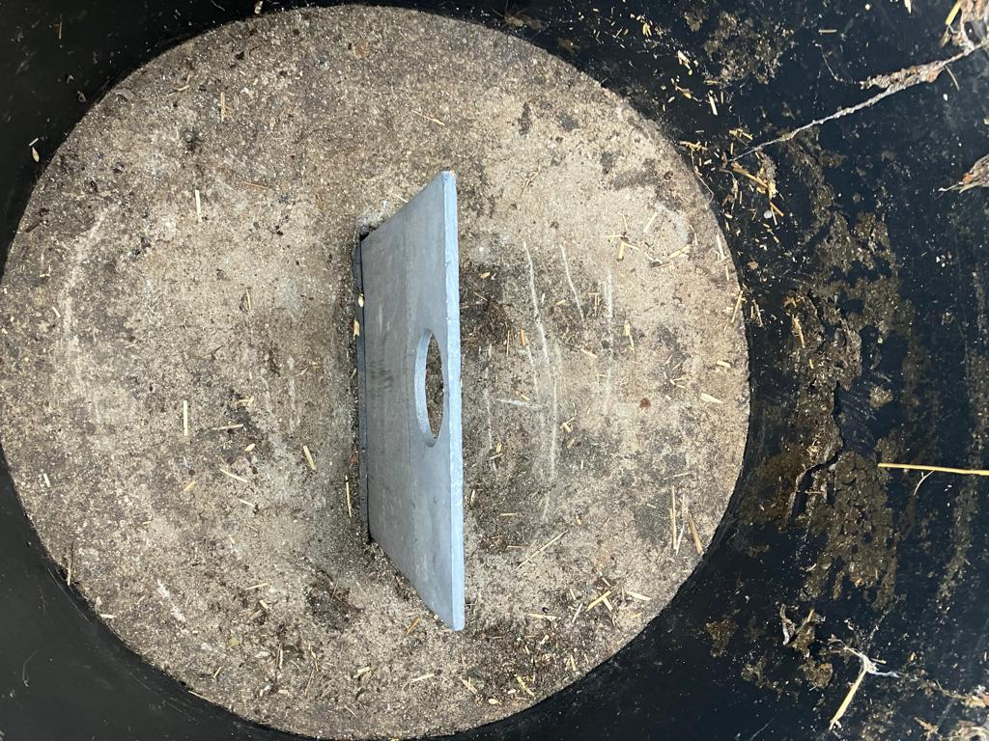
Picture 3 – This is the left diverter (with metal yard cover open). The diverter is open position in this photo and to close it, it is pushed down and the pipe is completely blocked off.

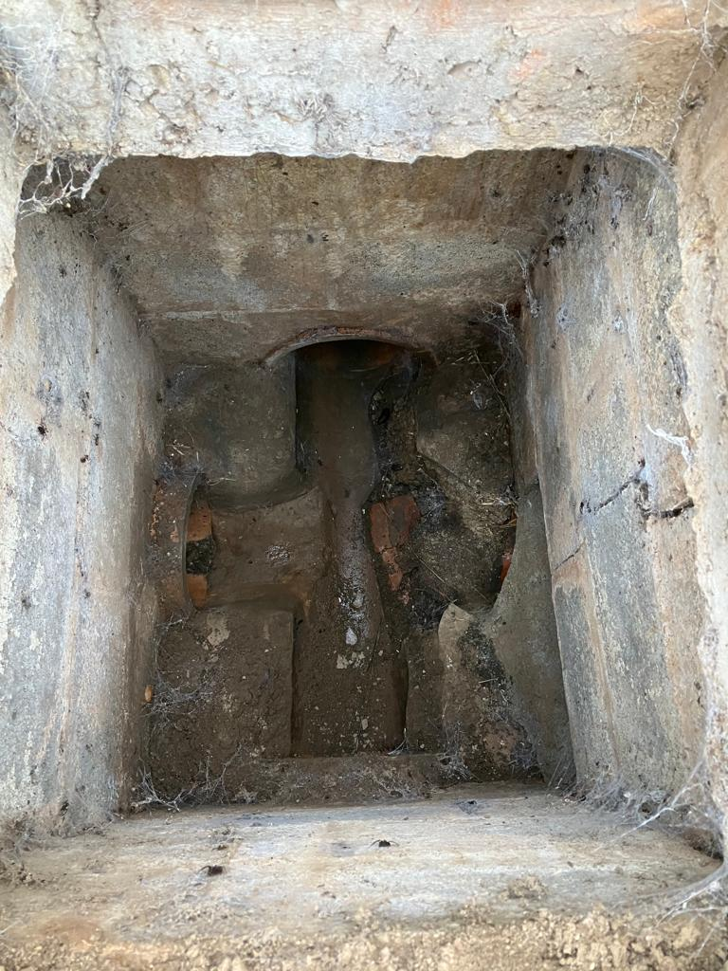
Picture 4 – This is the first inspection chamber on the North corner of House 1 where the clean water from the above photo’s 1, 2 and 3 comes in, as well as the under-ground roof water pipes from Houses 1 to 4.
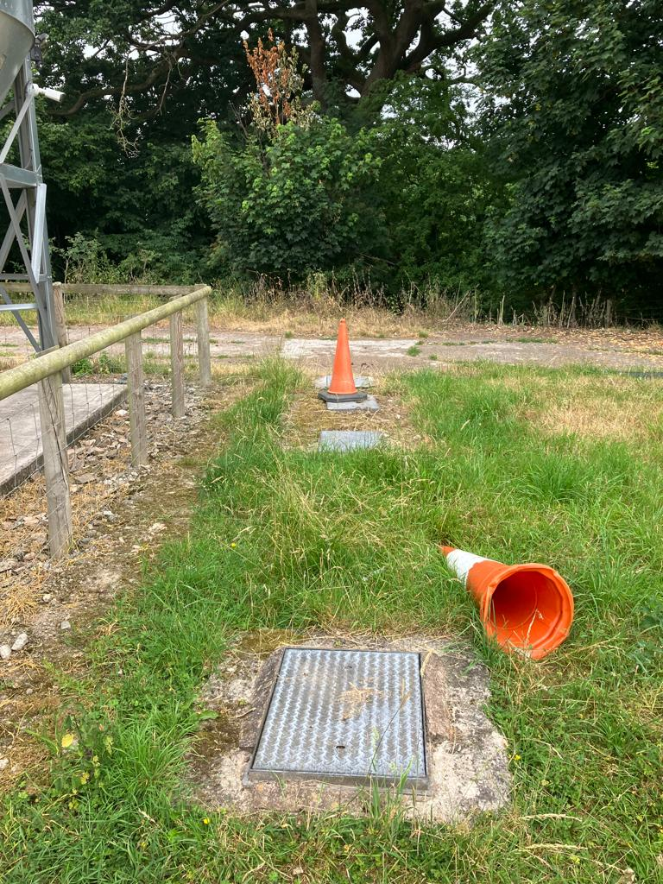

Picture 5 – This shows the covers of 2 Inspection Chambers and 2 settlement chambers on the North corner of House 1 before the clear water flows to the river Arrow.
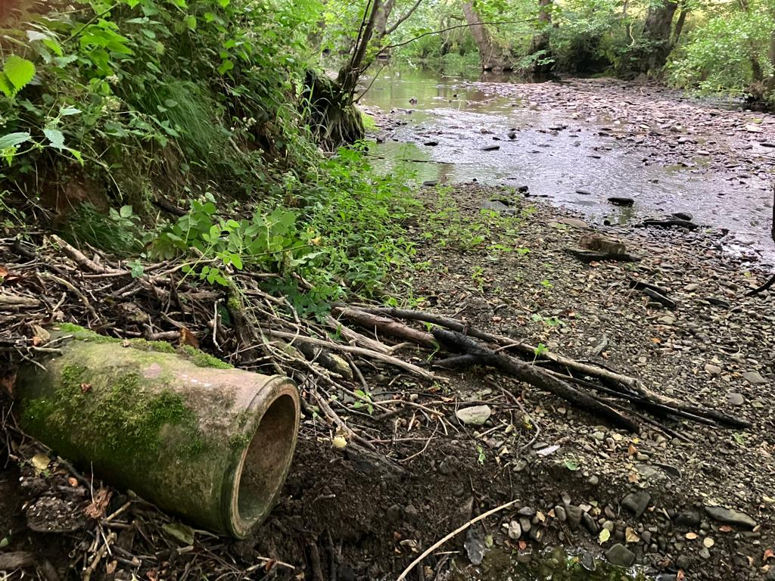

Picture 6 – This is the out fall pipe beside the river Arrow

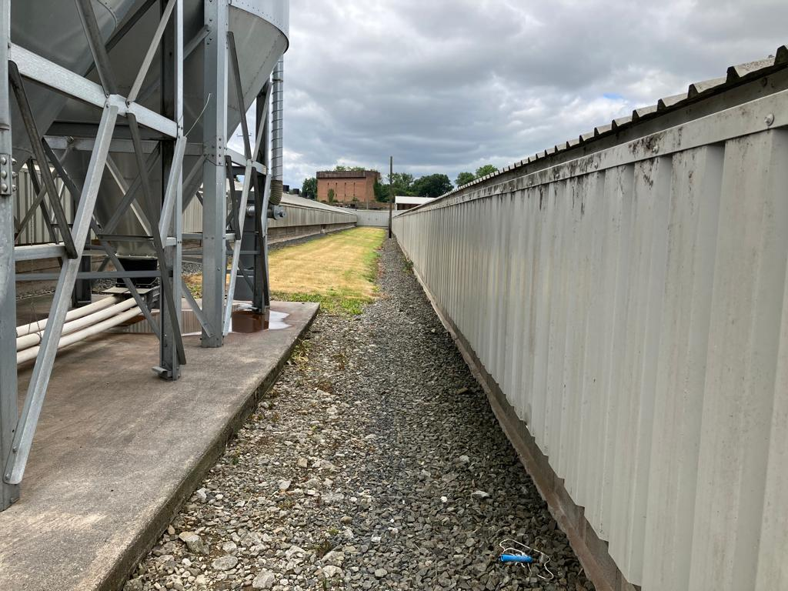
Picture 7 French Drains between Houses 2 & 3
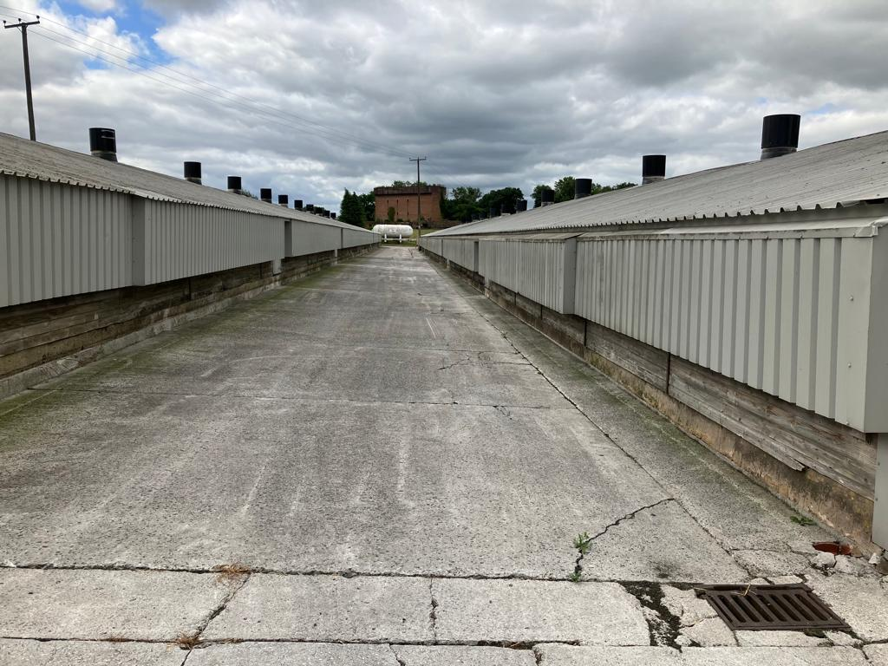
Picture 8 Concrete slope between Houses 3 & 4. Falling into the drain bottom right by house 3.

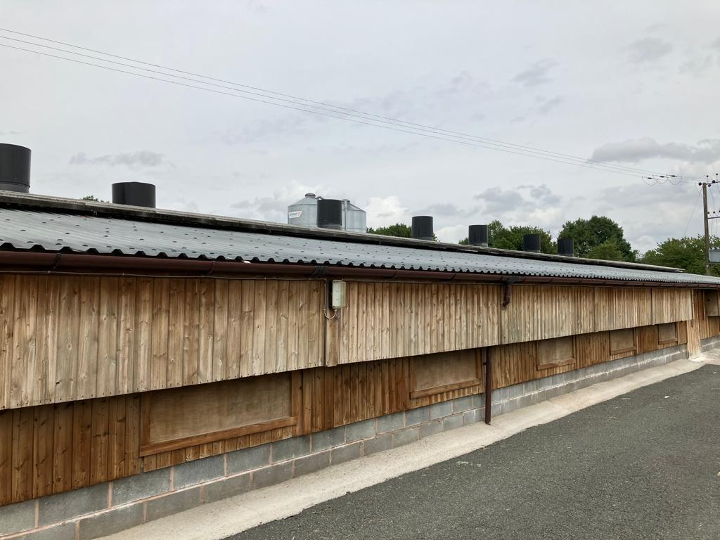
Picture 9 - Gutters on Houses 5 & 6. Down pipe feeds into clean water drain.

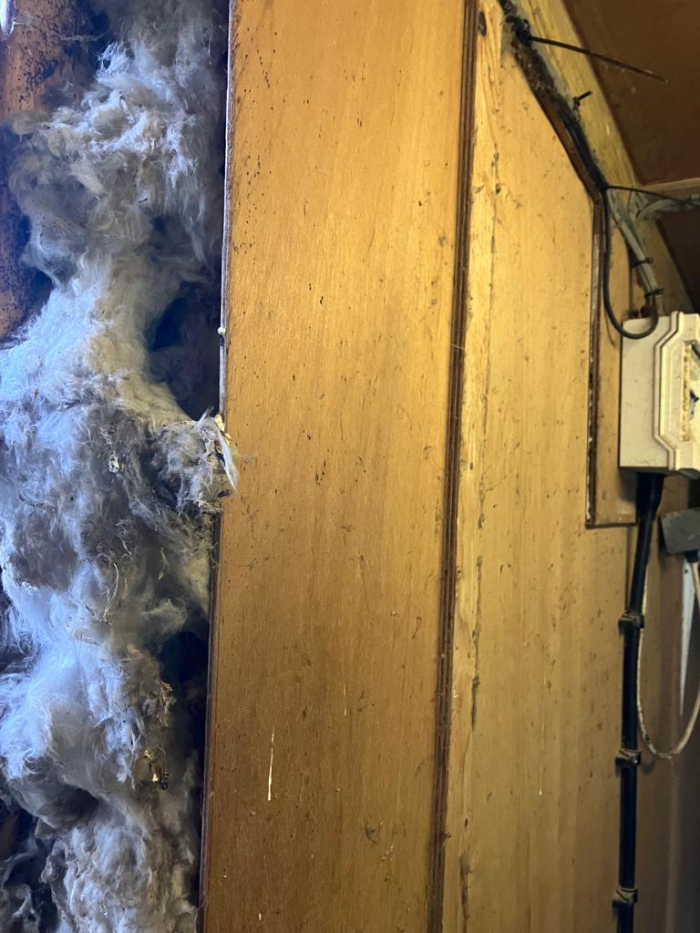
Picture 10 – This shows the 6 inches of insulation between the external tin and the internal wooden ply wall of the Generator shed giving excellent sound reduction.

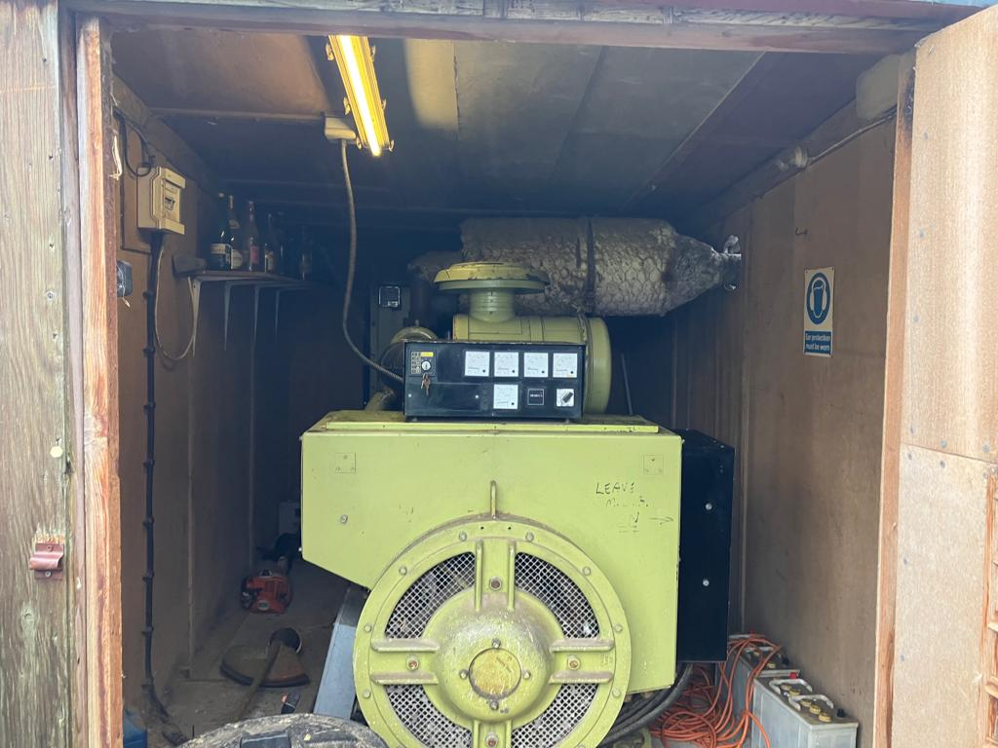
Picture 11 - Generator House with the door open for this picture.

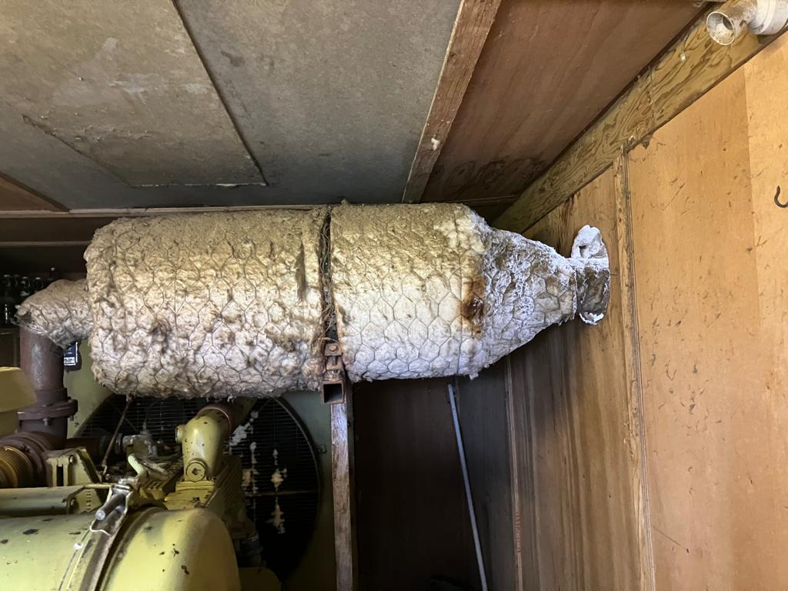
Picture 12 - Generator Exhaust insulted

