Hergest Camp Farm, Kington, HR5 3ER
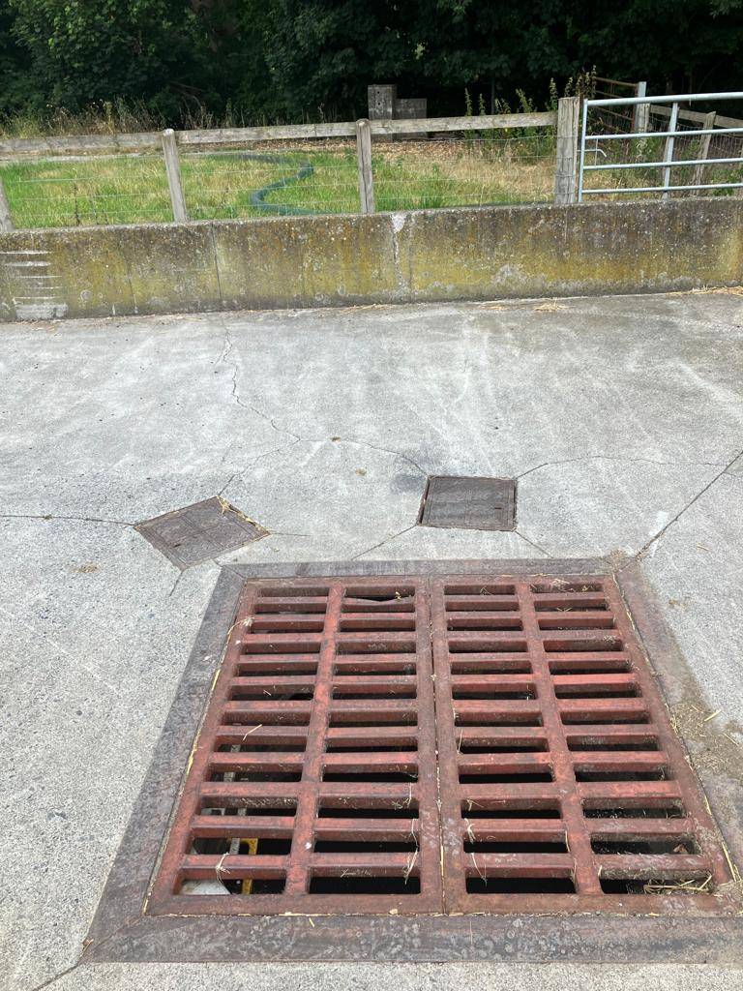 Picture 1 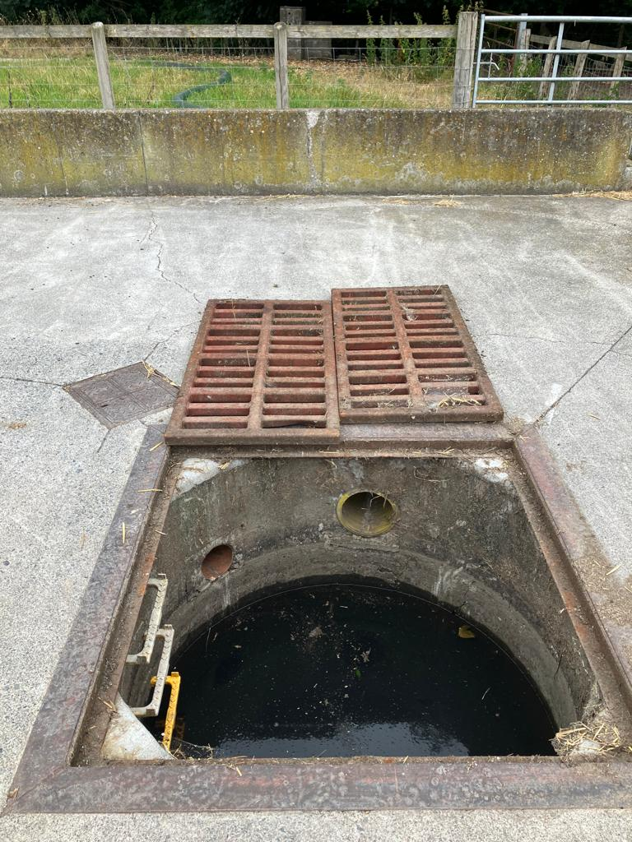Picture 2
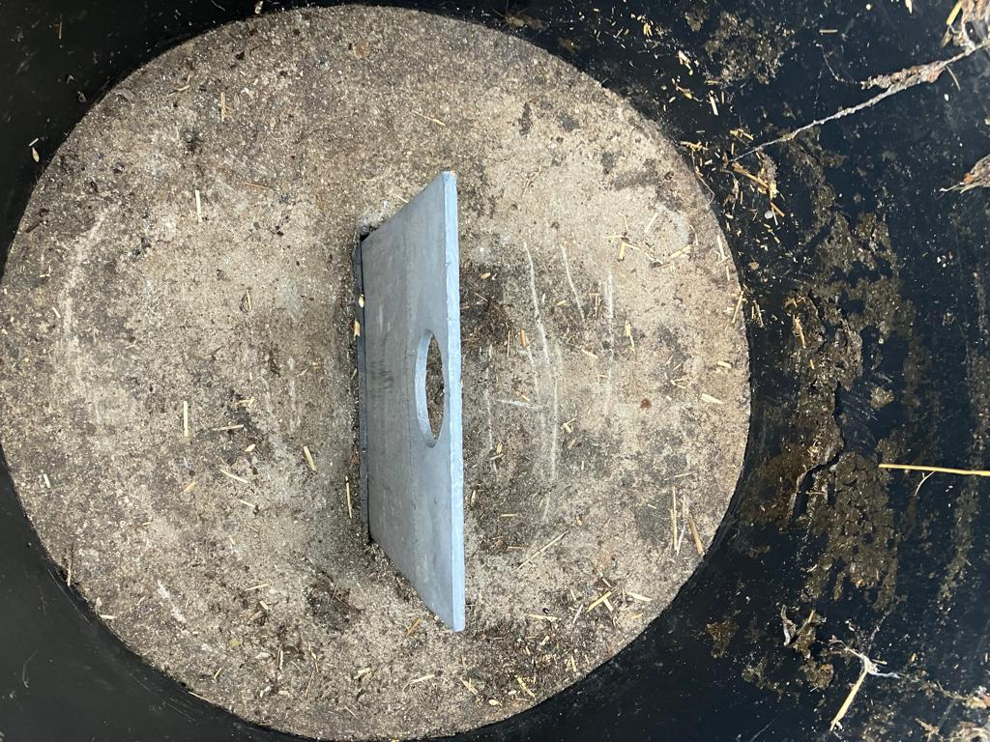Picture 3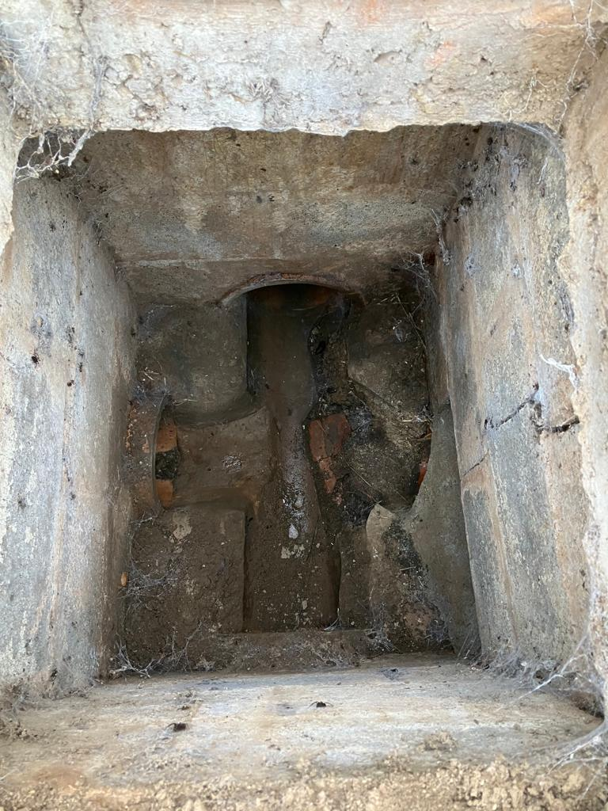Picture 4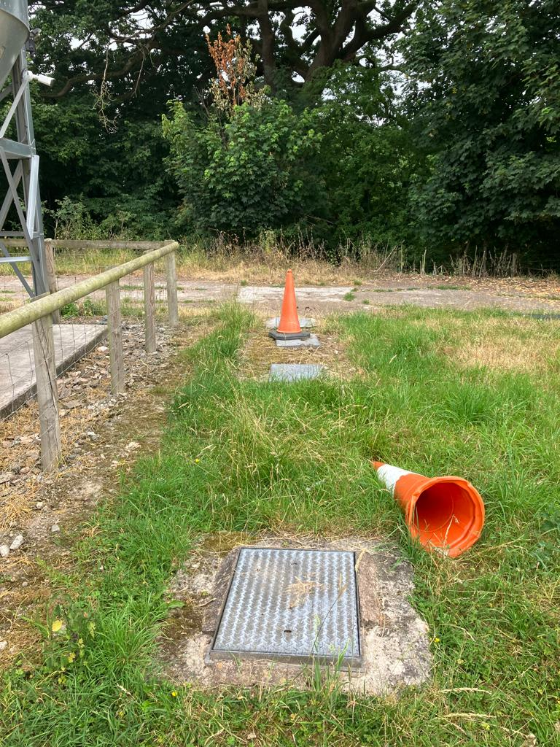 Picture 5
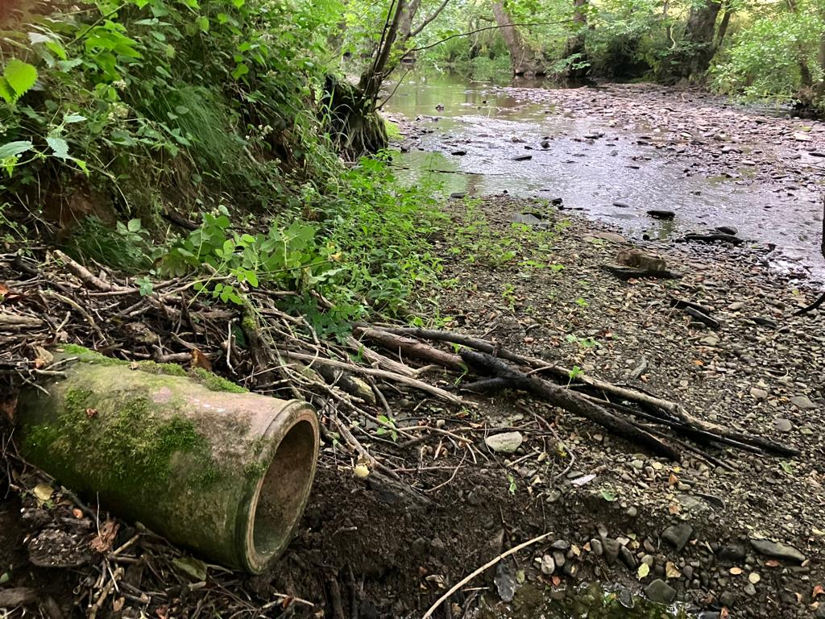Picture 6

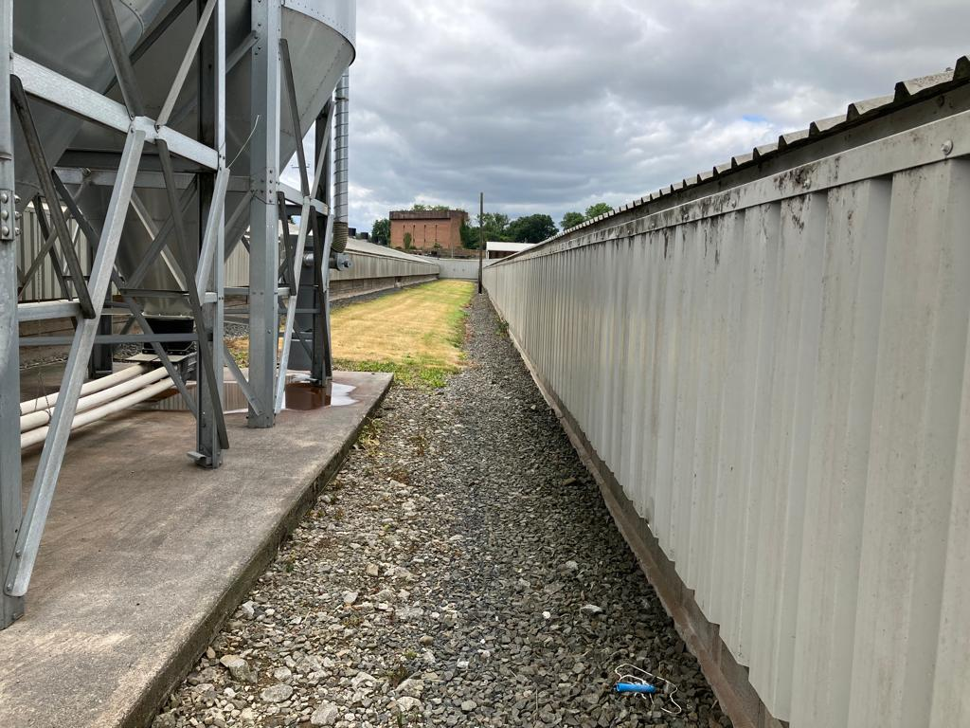Picture 7 French Drains between Houses 2 & 3
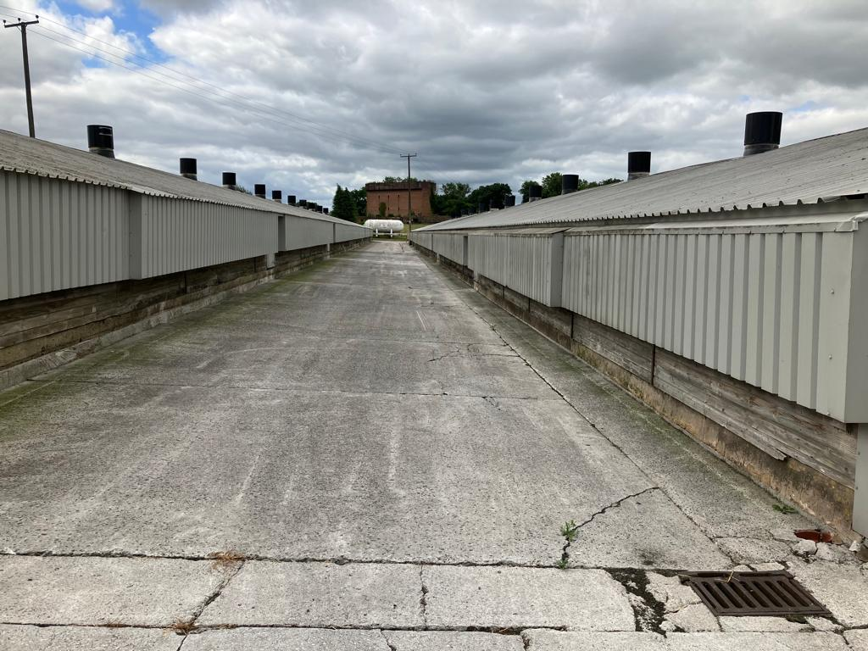Picture 8 Concrete slope between Houses 3 & 4. Falling into the drain bottom right by house 3.

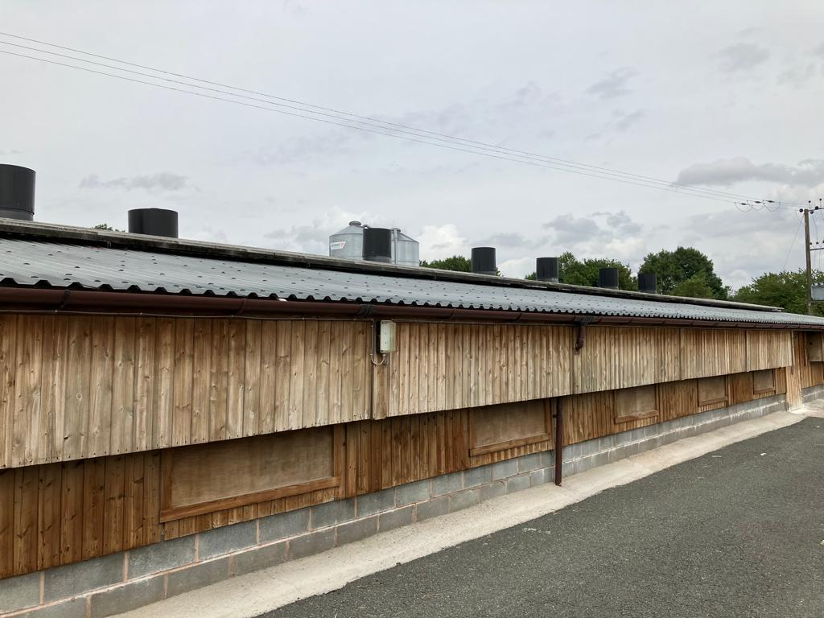Picture 9 Gutters on Houses 5 & 6. Down pipe feeds into clean water drain.

