Odour Management Plan – Deighton WwTW Tankered Trade Imports
Site details
Site name: Deighton Wastewater Treatment Works
Site address: Ashgrove Road, Deighton HD2 1FE
Operator name: Yorkshire Water Services Limited
Permit number: To be confirmed
Who this plan is for:
- All YW colleagues who work or visit site, contractors working or visiting site, Environment Agency officers
- This document will be stored on YW’s IMS and be available on site.
Document owner
Document author: Katherine Jowsey
Version number: 1

List of revisions

Revision number | Revision authorised by | Date submitted to Environment Agency | Revision owner
1 | Kevin Spink | 09.06.2022 | Kevin Spink

Contents
Contents
1. Introduction 3
1.1 Site description 3
1.2 Process Overview 4
1.3 Maintenance and review of the OMP 5
2. Receptors 7
2.1. Receptor List 7
2.2. Wind rose and source of weather data 8
3. Sources of odour and site processes 9
3.1 Site Processes and Proposed Permit Boundary 9
3.2 Odorous materials 10
3.3 Inventory of odorous materials 11
4. Odour reporting 12
4.1 Complaints reporting 12
4.2 Community engagement 12
4.3 Pro-active odour monitoring & olfactometry monitoring 12
4.4 Reactive odour monitoring 13
5. Abnormal events 14
6. Appendix 1 15

Introduction
This Odour Management Plan (OMP) is a live working document that forms part of the operational management system of tankered trade imports to Deighton WwTW only. It has been submitted to the Environment Agency in support of the environmental permit application for tanker trade waste imports to Deighton WwTW. Following an environmental risk assessment, it has been determined that the odour risk from this activity is low.
The OMP demonstrates how odours shall be managed and controlled to prevent odour impacts from activities during normal operation and during abnormal events.
The OMP provides sufficient detail to allow operators and maintenance staff to clearly understand the operational procedures for both normal and abnormal conditions. It is intended to be used as a reference document by operational staff on a day-to-day basis.
This OMP has been prepared using the following guidance:
- Environment Agency Odour Management Plan Template and Guidance
- Environmental Permitting: H4 Odour Management Guidance

This OMP also forms part of Yorkshire Water’s (YW) ISO 14001 Environment Management System (EMS). The Technically Competent Manager (TCM) for the site will be responsible for this OMP, its implementation and regular review. This OMP will be reviewed annually and more frequently where there are valid odour complaints.

Site description
The Deighton Waste water Treatment Works (WwTW) is situated in the East of the town of Deighton, approximately 3.5km north-east of Huddersfield, the closest city. The site is constrained on all sides by watercourses, the River Colne and the Huddersfield Broad Canal. There are three main residential areas within 1km of the site. Deighton is situated ~310m to the north-west, Bradley is ~450m to the north-west and Kirkheaton is ~750m to the south-east.
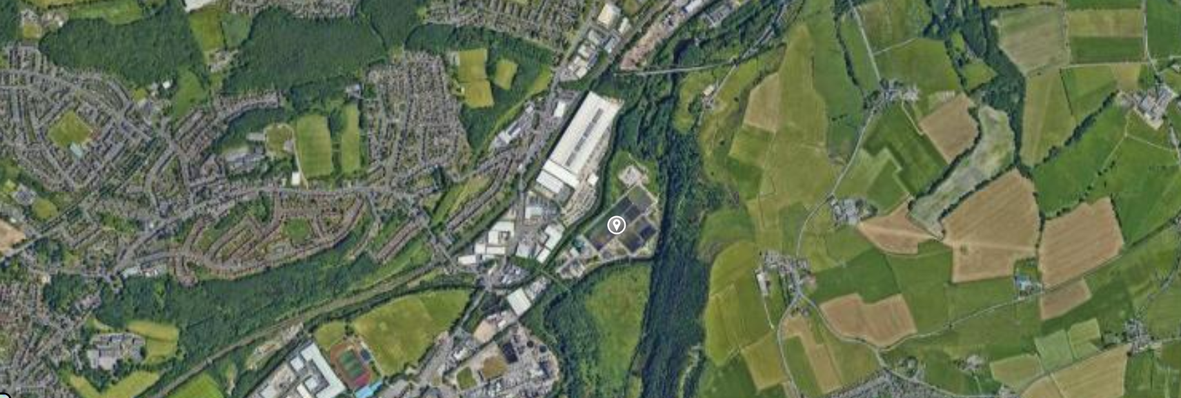
Figure 1 - Site location plan
The far north and far west sides of the site lie within Flood Zone 2 with a medium probability of flooding from rivers (1:100 – 1:1000 annual probability of flooding). The rest of the site lies within Flood Zone 3 with a high probability of flooding from rivers (>1:100 annual probability of flooding). The site benefits from flood defences that run from the north-east down to the south, along the river. The risk of surface water flooding on the site is low.
Deighton WwTW treats domestic and industrial waste. The OMP for Deighton WwTW is stored on YW IMS.

Process Overview
This OMP covers the import of tankered trade waste to Deighton WwTW (see figure 2 and 3). YW are applying for a bespoke waste Environmental Permit for Deighton WwTW which relates to the acceptance and storage of tankered waste prior to discharge into the main WwTW. The scope of this application covers the delivery to site and offloading of effluents by road tanker for treatment at the WwTW in a mixture with UWWTD materials.
Liquid wastes are transported to Deighton WwTW by road in sealed tankers. At import point one, on delivery, effluents are discharged from the tanker, using sealed coupling hoses via a dedicated tanker offloading point, directly into the ‘head of the works’ for full treatment. Effluents discharged to the ‘head of the works’ are mixed within the incoming sewer delivered urban wastewater directive (UWWTD) main flow, prior to full treatment. The offloading process takes 15 minutes to complete. There is rapid mixing (0-2 minutes) with the incoming flow at the inlet.
YW intends to construct a new storage tank at Deighton by August 2023. Once this tank has been installed, all effluents directed to import point two will be tankered into site in a sealed road tanker and discharged from the tanker, using sealed coupling hoses via a dedicated tanker offloading point, directly into the sealed storage tank. The storage tank is an enclosed tank, designed to hold approximately 300m³ (equivalent to the content of approximately 11 tankers). The flow will be continuously fed via gravity into the works at a reduced rate to minimise the risk of excessive storage periods. The storage tank will hold waste for a maximum of 24 hours before it is discharged into the inlet. At import point two, effluent from the storage tank will discharge via an above ground double contained pipe to a site chamber which connects to the WwTW primary tanks. The chamber connects to the effluent flow to the primary tanks where the effluent is mixed with the UWWTD flow for full treatment.
The tanker import points are located on impermeable surfaces to minimise the impact of any spillages on the wider environment. At import point one any spillages will be washed into the nearest site drain which joins the inlet flow. At import point two, any spillages will fall to the nearest site drain which connects to the primary tanks. The bund will have a sump and a pump to connect the bund contents back into the tank, therefore bund water will connect with the WwTW flow via the above ground pipework which connects to a chamber which then flows to the primary tanks.
The tanker offloading points are fixed and equipped with appropriate tanker coupling hoses to reduce the risk of poor tanker connection. The tanker offloading points are also equipped with key fob-controlled data loggers, which measure the volume discharged, as well as the origin of the waste. Offloading is only possible once the data logger has been activated.
All loads are subject to robust pre-acceptance checks to determine their suitability for the processes on site, including an assessment of their variability over time. All loads are pre-booked into the works, to ensure that there is sufficient capacity within the works, and if necessary, loads are diverted to other appropriately permitted facilities. Once a load has been assessed and determined to be acceptable for treatment at the site, the producer is issued an appropriate key fob to access the data logger and offloading point at the works. The data logger is interlocked with the offloading point to ensure that only authorised loads are accepted. The offloading point is covered by CCTV camera and prior to offloading, the control centre for the works must approve the offloading. Loads are subject to random sampling and inspection prior to offloading.

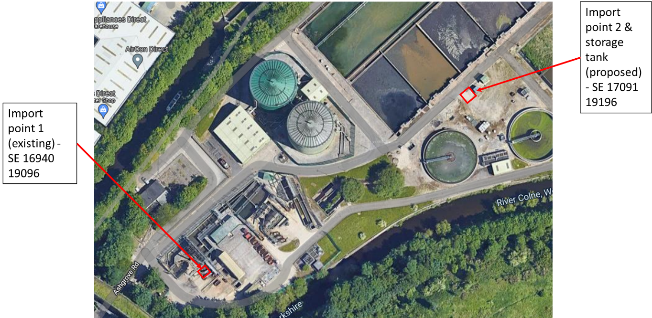
Figure 2 - Existing and proposed import points at Deighton WwTW

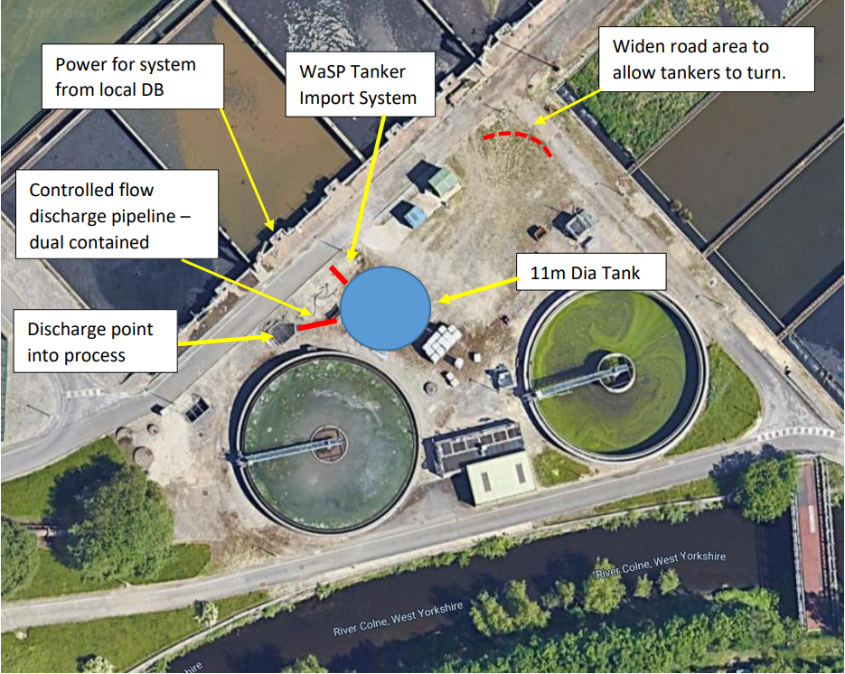
Figure 3 - Location of new storage tank at Deighton WwTW.
The site is permitted to receive 5,000,000 tonnes of tankered waste per annum. The site is operational 24 hours a day, throughout the year. Whilst there are currently no time restrictions on deliveries to site, YW will endeavour to accept waste during working hours in order to minimise the potential for odour nuisance to surrounding receptors. The types of accepted tankered waste are specified in the permit application.

Maintenance and review of the OMP
The OMP is stored electronically and is accessed via the YW IMS.
Assessment of competence and identification of individual training needs is carried out through mutual discussion between the individual and their manager as part of the company performance management process, a fundamental part of which is the competency framework and progression plans which are available for every role in the organisation. All YW employees receive IMS awareness training, delivered online at induction and periodically thereafter. This includes awareness of the environmental policy and understanding key environmental hazards and risks and the need to comply with IMS requirements. Toolbox talks are used to provide information and training to site staff, including information about environmental requirements/activities and legislative and compliance requirements. Training records for programmes and courses managed centrally are held on the company Learning Management System. Records for specific training managed locally at site is held by individual managers and/or on the Leaning Management System.
The training requirements for key staff at Deighton WwTW are displayed in Table 1 below.

Table 1 - Training requirements for Deighton WwTW Tankered Trade Imports OMP
Post | Training Requirement
Product and Process Site Manager (PPM) | - Awareness of the responsibilities for avoiding odour nuisance.  - Procedures for abnormal conditions.  - Requirements of the OMP and Environmental Permit.
Product and Process Engineer (PPE) | - Awareness of the responsibilities for avoiding odour nuisance.  - Procedures for abnormal conditions.  - Requirements of the OMP and Environmental Permit.

Receptors

2.1. Receptor List

Table 2.1. Receptor list
Receptor reference | Land use e.g., house, school, hospital, commercial | Approximate distance and direction to site boundary | Sensitivity to odour  Low (e.g., footpath/road)  Medium (e.g., industrial / commercial workplace)  High (e.g., housing / pub / hotel etc.)
1 | Dalton Bank (LNR) | 50m E | Low
2 | Denby Grange Colliery Ponds (SAC) | 10km SE | Low
3 | Residential Receptors | 310m NW, 450m NW, 510m SW, 410m SE, 750m SE, 880m SE, 680m NE, 910m NE. | High
4 | Schools | 930m NW, 960m SE. | Medium
5 | Sports Grounds | 665m NW, 735m NW, 345m SE | Low
6 | Secondary A Aquifers (Bedrock and Superficial) | N/A | Low
7 | River Colne | 8.5m SE | Low
8 | Huddersfield Broad Canal | 16m NW | Low

2.2. Wind rose and source of weather data
In the UK, the prevailing wind directions are commonly from the west and south-west. The wind direction and speed will impact the dispersion of odour emissions from site. There is currently no wind station on site to measure meteorological conditions.
Bradford meteorological station is the closest representative station for Deighton WwTW. The meteorological station is located approximately 20km north of the site and is to be considered comparable to the meteorological conditions on site.

Figure 2.2. - Wind rose (source: - Meteo Blue)
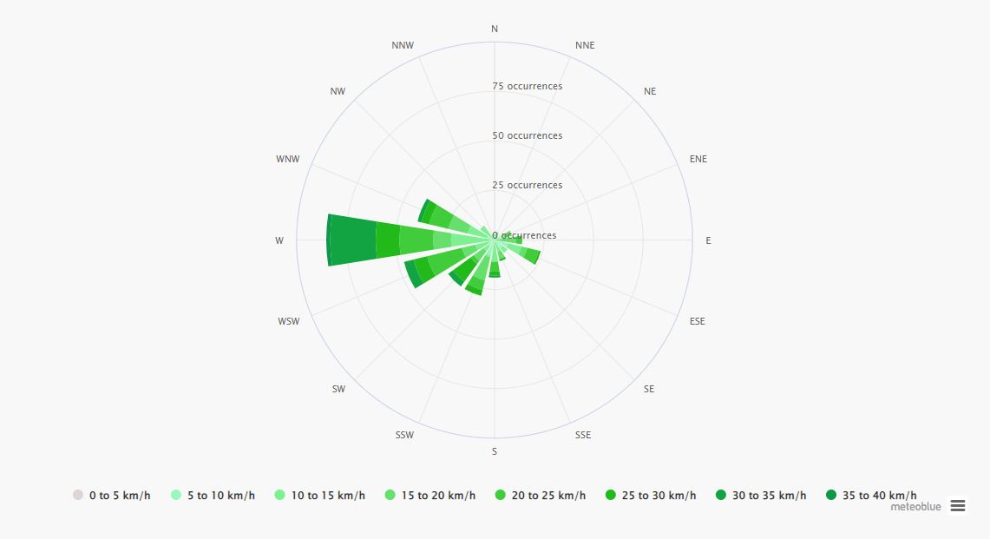

Sources of odour and site processes

3.1 Site Processes and Proposed Permit Boundary
Please refer to section 1.2 for details of the process.

Rejection Procedure
When a waste is deemed unacceptable due to not meeting the requirements stated above, or the load is too malodourous it will be rejected by operational colleagues on site. The waste will be managed as outlined below:

- Waste identified as unacceptable due to odour or failing to pass pre-acceptance checks
- Tanker is directed away from offloading point and is quarantined in separate area of tanker offloading area
- The waste supplier is contacted and is informed of the rejection and reason for rejection
- Waste supplier requested to remove waste tanker from site if deemed unacceptable for discharge

3.2 Odorous materials
A complete list of waste types that are accepted at Deighton WwTW can be found in the permit application. The risk of odour has been deemed low due to pre-acceptance checks which will minimise odour risk. All tankered wastes are imported into site in sealed tankers and are offloaded into either the inlet through sealed coupling hoses or to the sealed storage tank. As outlined in section 3.1, rejected loads which are not suitable for treatment directed back to the site of origin.

Inventory of odorous materials

Table 3.1 - Inventory of odorous materials
Table 3.1 provides an inventory of wastes which may cause increased odour on site and their mitigation measures.
Source | Source Type | Storage capacity (m³) | Average retention time | Frequency of operation |  | Odour risk before mitigation | Mitigation | Odour risk after mitigation
Wastewater treatment works inlet works | Liquid imports (see EWC list in permit for full list of imported waste types) | 0 | Offloading of waste from tanker takes approximately 15 minutes but retention time is 0 – 2 minutes due to rapid mixing with main works flow. | Intermittent  Daily | Low – sewage dilutes other wastes. |  | Pre-acceptance checks screen out highly odorous material.  Tankers and offloading coupling hoses are both sealed. | Low
Proposed tanker waste storage tank | Liquid imports (see EWC list in permit for full list of imported waste types) | 300 | Maximum storage time is 24 hours. | Intermittent  Daily | Low – sewage dilutes other wastes |  | Pre-acceptance checks screen out highly odorous material.  Waste is not stored for more than 24 hours.  Storage tanks are fully sealed  Pipes transporting waste from tanks to the inlet are fully sealed and have secondary containment where appropriate. | Low

Odour reporting

4.1 Complaints reporting
External odour complaints are received by Loop, which is the external company YW uses for all customer contacts. The call handler will work with the caller to understand the source of the issue. They will explore where the caller experienced the odour, whether it is a repeat or a singular issue, when and where it’s most noticeable, what site the odour may be coming from, a description of the smell and if it’s the first time it’s been noticed. Loop record all complaints on the ICE system and contact the appropriate site owner to manage the complaint. ICE is a computer program used to record and manage customer contacts.
If the PPE or any YW staff identify an abnormal odour release, the PPE will undertake an investigation using the Operator Site Checklist and complete any actions the investigation suggests. The PPE should then put a note in the site diary and the odour site diary and inform the Technical Optimiser and Site Manager of their findings.

4.2 Community engagement
Customers are at the heart of what we do at YW. In the event of an odour issue affecting multiple customers within the community, YW’s communication team will decide the level of response that is required. This could include, but not be restricted to, stakeholder liaison (communication through local councillors, MPs and affected businesses), local media liaison and/or community meetings to discuss the issues and actions that will be undertaken to rectify the issue. Customer engagement events would be held if the odour severity dictated this level of response. Customers may be encouraged to keep an odour diary to record when odour is perceived to be a greater issue.

4.3 Pro-active odour monitoring & olfactometry monitoring
A pre-acceptance procedure is in place to screen out highly odorous effluent.
Sniff testing is recognised by YW as a useful technique to build up a picture of the impact the odour has on the surrounding environment over time. Sniff testing shall be used to support profiling site odour impact, investigate odour complaints and to introduce temporary odour mitigation measures. Monthly sniff tests shall be carried out by non-site-based staff the Technically Competent Manager who is not adapted to site odours. In the event of odour complaints being received, site operators shall undertake a sniff test including off-site sniff testing local to the complaint location(s). A copy of the sniff test form can be found in Appendix 1.

4.4 Reactive odour monitoring
If any receptors reported an odour complaint, YW would review import data to understand the loads imported around the time that the odour was observed. These loads would then be assessed via an odour test at the next import and if deemed necessary, hours of acceptance would be restricted to times less likely to cause nuisance. Alternatively, the import would be directed to another YW site less sensitive to odour (with no odour sensitive receptors). If an import was found to be causing a significant, repeated odour issue, the waste would no longer be accepted by YW.

Abnormal events
If an abnormal event were to occur that would put pressure on operations at Deighton WwTW, the acceptance of tankered trade waste would be halted until such a time that imported waste could be accepted again without compromising the WwTW operation.

Appendix 1

Sniff Testing Record Sheet
Test by |  | Start Time
Date |  | End Time
Weather Condition |  | Temperature
Wind Strength |  | Wind Direction

Location No. / Name | Nearest Receptor Sensitivity | Intensity | What does it smell like? | Frequency of odour? | Is the source evident | Other comments / observations
Tankered trade import point one / two | Low / Medium / High | 0 No odour  1 Very faint  - Faint odour  - Distinct odour  - Strong odour  - Very strong odour  - Extremely strong odour |  | Constant / Intermittent | Yes / No  Source area / name to be provided. Might be that maintenance work is occurring and you can detect increased odours due to that activity. | Are there odours detected from other sources? Farm / Landfill / other industry etc

