SECTION 4

Maintenance Instructions

Index
Plant Maintenance 2
4.1. General 2
4.2. Tanks & mechanically operated lids 2
4.3. Eductor Agitation System 3
4.4. Water top-up and level control systems 4
4.5. Heating System 4
4.6. Pumps & Filters 5
4.7. Temperature sensor 6
4.8. Level sensors 6
4.9. Extraction duct……………………………………………………………………….....6/7
4.10. Electrical controls 7
4.11. Transporter System 7
4.12 Carbolux unit…..…………………………………………………………………………8
4.13. Dissolution tank……………………………………………………………………...…...9
4.14. Chiller ………….…………………………………………………………………………9
4.15. Rectifiers………………………………………………………………………………....10
4.16. Ph & Conductivity probes…………………………………………………………….…10

Maintenance Schedule 10
4.14. Plant Maintenance 10
4.14.1. Daily……………………………………………………………………………...…10
4.14.2. Weekly…………………………………………………………………………...…11
4.14.3. Monthly……………………………………………………………………………..11
4.14.4. 3 Monthly 11
4.14.5. 6 Monthly 12
4.14.6. 12 Monthly 12

Plant Maintenance

General

The line should be kept clean with each operator responsible for cleaning the plant before the end of each shift and handover to the next operator.

Walkways should be kept clear of obstruction – trailing leads/hoses etc.

Care should be taken to avoid overfilling the tanks or causing ingress of liquid into the extraction system when washing down or washing off the work. Liquid introduced into the extraction system could result in an unauthorised discharge to atmosphere of contaminated material. NEVER open access doors to extraction fans or ductwork without the fan isolator being locked off.

The tanks should not be subjected to temperatures outside their normal operating range. The temperature controllers are adjustable to limit temperature settings between allowable maximum and minimum limits. Where tanks are provided with solution agitation this should always be used when the heating is on to avoid heat build-up due to layering.

Tanks & mechanically operated lids
The external walls of the tanks should be inspected (where possible) at weekly intervals for damage, as a split in the outer skin could cause solution penetration into the lagging etc., resulting in deterioration of the tank inner walls. Tanks should be wiped down externally at weekly intervals with a damp cloth, ensuring that care is taken not to put direct water onto any electrics, junction boxes etc. Inner tank walls should be inspected each time the solution is changed to ensure no mechanical or chemical damage has occurred. Internal checks of chemical tanks should be carried out in line with the client’s insurance company requirements or as a minimum annually following confined H&S space assessment & full risk assessment of the task. Flight bars should be cleaned and maintained oxide free to ensure sufficient current flow density is maintained during process. Anode plates in station 20 should be inspected quarterly. Anode plates can be mechanically removed for cleaning or replacing when they come to the end of their lifetime by using the process line transporters. The transporter can be manually driven using the handheld HMI into the station during “maintenance mode” and aligned with the Anode plate pick up points on each side of the tank (See fig 1)

4.2 – Continued:

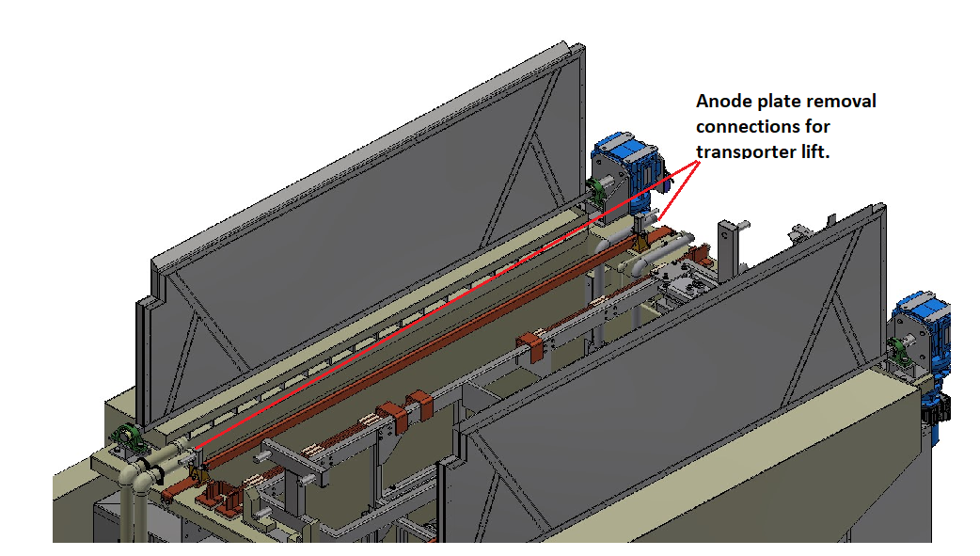Figure 1

Stations 1,12,15,16,17, & 20 are fitted with mechanically operated lids. The operation of the lids will be observed regularly by operation of the station. However, the lid motors/gearboxes, lids themselves and the associated switches should be checked for operation at least every six months. This checking can be done by operating the lid opening from the HMI and then checking the resultant inputs at the PLC/HMI. The motors and switches should be checked for wear and any other adverse condition at least every six months or more frequently if thought necessary. Full details of the operation and maintenance of the lid motors can be found in the OEM section 5 of the O & M manual under (5.20 Motovario). Full details of the operation and maintenance of the limit switches can be found in the OEM section 5 of the O & M manual under (5.6 CAPPS- Siemens).

Eductor Agitation System

Eductor pumped agitation is supplied to stations 2,3,6,12,13,14,15,16,17,18,19,20,21 via electric pumps. The pump should be checked periodically for flow and to ensure no blockages have occurred by checking the pressure gauges. Eductor nozzles can be replaced by unscrewing them from their pipe sockets once the tank is emptied and cleaned. Tank access must be risk assessed before carrying out maintenance task.

Water top-up and level control systems

DI water top up is provided to all process tanks except stations 4,5,7,8,9,10,11,20A,22. Level probe assembly is fitted into the process tanks to provide high- & low-level protection. At weekly intervals, the probes should be tested. Any build- up of salts must be removed. Manual top up valves & actuated shut-off valves should be checked monthly for operation & leaks.

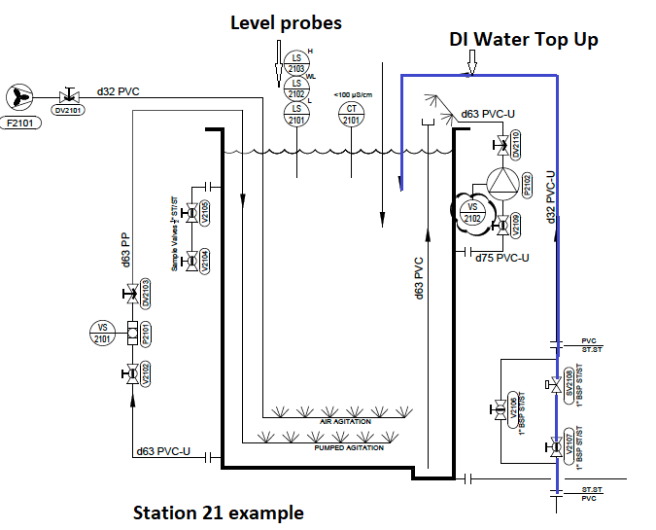Figure 2

Heating System –

Stations 1 &12 have 316 Stainless steel immersion heaters and stations 15 & 20 have 3 x PVDF Galvatherm immersion heaters. All Electric immersion heaters should be checked and regularly cleaned to avoid build-up of residues on the heating element. For detailed information regarding Galvatherm immersion heaters see section 5 of this O&M manual (section 5.11 GMF) and section (5.11 STS) for stainless steel immersion heaters. Temperature control sensor functionality should be checked regularly, and probes cleaned of any residues.

Pumps & Filters-

Periodic inspections of all pumps are recommended to substantiate the condition of the internal parts. It is advisable the pump is flushed and neutralised a minimum of once in every 12 months. Flow meters should be checked to establish if pumps are achieving the correct running rate when set. Details of the magnetic coupled process pumps & air operated diaphragm pumps can be found in section 5 of this O&M manual (5.8 Empire Pumps). Before carrying out maintenance on the filter units (See Fig 3) care must be taken to ensure any residual pressure in the filter has been dissipated by checking the pressure gauge attached to the unit and that isolation of the unit has been carried out properly. Correct PPE must be worn during opening and flushing of the filter unit. See filtration unit O&M manual in section 5 of this O&M manual (5.8 Empire Pumps).

Figure 3

Temperature sensor -

Each heated tank is fitted with two temperature probes of type TPA 3 -1000; one probe is used to control the tank temperature via the plc, the other acts as an over temperature ‘policeman’ directly through a temperature controller. The sensors should be checked for accuracy and calibrated weekly. Any build-up of salts or chemicals should be removed.

Level sensors -

Level sensors are fitted to all process tanks. Depending on location they are used to protect against overfilling, overflowing or as low-level protection for heating coils and agitation pumps. At weekly intervals, the probes should be inspected. Any build-up of salts or chemical deposits must be removed.

Extraction duct & Fan –

The lip extraction ducts should be externally inspected on a weekly basis and cleaned if required. Clean out hatches are provided on the rear wall of the lip ducts. These should be opened, and the internals inspected and cleaned every 3 months. Manual dampers are fitted to the lip extraction ducts and are set on commissioning. They must not be moved unless the whole extract system is being re-balanced. Actuated Kinetrol damper units and an external bleed damper adjust the extraction when the process tank lids are either open or closed. The bleed damper adjusts to increase the extraction when lids are open and decrease the extraction when lids are closed. The Kinetrol damper & Bleed damper operation should be checked monthly for functionality.

The fan shaft bearings should be checked for excessive noise or vibration. On a yearly basis the bearings should be stripped down and inspected/replaced. This consists mainly of keeping all the bearings correctly lubricated, drives correctly adjusted, the impeller free from foreign matter and all metal surfaces painted. (See section 5 (5.7 Central Fans) for fan specific technical information.

Certain types of pillow blocks are supplied pre-packed with grease, which will normally last the life of the bearings provided that there is no excessive loss of lubricant due to over-heating – in which case the cause of the over-heating should be determined. When the fan operates in dirty, wet hot and/or corrosive conditions, lubrication periods should be shorter than normal. In any case, clean lubricant should be kept in all bearings and couplings (if of the grease type) at all times. In certain cases, the motor may be provided with sealed bearings, if so, no additional lubrication will be necessary.

If the fan impeller operates in corrosive, erosive or dirty conditions, check periodically for signs of wear, build up etc. and treat as required. An impeller that is very dirty will eventually go out of balance resulting in excessive wear on the inner bearings.

4.9 Extraction duct & Fan – Cont.:

Where metal surfaces have been treated with paint, rust preventative – or any other kind of finish – damage to this finish should be avoided but should it occur, re-treat the appropriate part immediately. This will prolong the life of your unit and keep it in good working order.

It is good practice to strip down bearing assemblies once a year during holiday shutdown periods and inspect for wear. Replace parts if necessary.

Electrical controls -

All major control equipment is housed within the main control panel & Allwater Technologies control panel. All indicating lights should be checked on a weekly basis. Failed bulbs should be replaced immediately.

On a 6-monthly basis:

The outside and inside of the main panel should be cleaned. Contactors, relays, overloads, switches, and cable terminations should be tested for correct operation, mechanical wear, and tear. Check operation of the temperature controllers. Check all trunking, conduit, flexible conduit, connection boxes and wiring for damage.

Transporter System -

The process line has 3 x fully motorised transporter systems. The transporter uses a series of steel wheels to traverse down the track and Polyurethane wheels to keep it square in relation to the frame. Theses drive and guide wheels should be checked on a monthly period. The traverse drive and hoist mechanism are control by a variable speed high efficiency motor and gearbox. The gearboxes require the oil levels checking and replenishing as required. We recommend that the gearboxes are checked on a 6-monthly period or as prescribed by the manufacturer manual. The shaft bearings are sealed units and require no routine maintenance, however they should be inspected for play / wear every 6 months.
The lifting beam is fitted with polypropylene guides and flat lifting belts. A general inspection on the condition of these belts and alignment of the guides should be done on a monthly basis. Hoisting (lift) positions and traverse positions are controlled by inductive proximity switches. There are mechanical limit overrun and slack belt switches, and anti-lower photo-electric sensors fitted to the transporter. We would recommend a general inspection to see if the switches are operational and that there are no signs of damage on a weekly basis. The laser guidance system of the transporter uses reflectors which need to be cleaned periodically.

Note: It is a statutory requirement that as the transporter is classed as lifting equipment, it should be load tested and certified by an authorised company on a yearly basis as required under the L.O.L.E.R regulations.

4.12 Carbolux Unit -

The Carbolux unit (Fig 4) is positioned adjacent to station 20A Dissolution tank.

Weekly checks:

- Clean carbonate residues from the cooling collector.
- Visual inspection of piping and pumps for any leaks.
- Cleaning the level probes and belt filters with hot water

Monthly checks:

- Check the condenser of the cooling unit for dirt (dust - heat insulator). If necessary, clean it.
- Depending on the operating times, possible emptying of the collecting tank by means of a flux pump.
- Check belt filter band and rubber flap for defective spots.
- Check fan cover of motors for dirt.
- Remove the belt filter Visual inspection of the collecting vessel. If crystals are present, rinse with hot water.

Figure 4

Further specific information for the unit can be found in section 5 OEM Supplier manuals (5.30 Tecga).

Dissolution Tank -

Level sensors - These should be checked weekly for build up of residues and cleaned.
Mechanical mixer – local start/stop controls should be checked, and shaft bearings checked for undue noise or vibration during operation on a monthly basis.
Extraction – air flow indicators should be checked for operation and that air flow rate is within set extraction limits. Build up of salts or residues should be cleaned.
Dosing pumps – Pumps should be checked for leaks and any signs of undue vibration. Flow rates should be checked in case of blockages.
Zinc basket lift – Overhead hoist should be checked under LOLER regulations annually by independent specialist.

  - ICS Chiller Unit -

When it is necessary to discharge waste material do not pollute water pipelines, groundwater, or watercourses. Avoid the combustion of materials that could produce fumes that are toxic and harmful when released into the atmosphere. Protect the environment by using only approved methods of disposal. Keep a written record of all work carried out on the unit and the auxiliary equipment. The frequency and the nature of the work required over a period can reveal adverse operating conditions that should be corrected.
ATTENTION
Use only the refrigerant specified on the data plate of the unit. Make sure that all instructions concerning operation and maintenance are strictly followed and that the complete unit, with all accessories and safety devices, is kept in good working order. The accuracy of pressure and temperature gauges must be regularly checked. If values are discovered that exceed the permissible tolerances, the gauges must be replaced.
ATTENTION
Do not perform welding procedures or other operations that can produce heat in the vicinity of elements containing oil or flammable liquids. Systems which may contain oil, or flammable liquids must be completely purged and cleaned, e.g., with steam, before carrying out such operations. Components in the vicinity must be protected with non-inflammable material and, if the operation is to be performed close to parts of the lubrication system or in the vicinity of components that may contain oil or inflammable liquids, the system must first be purged. Never use an open flame as a light source to inspect parts of the unit. For all units establish a suitable time interval for cleaning procedures. If replacement parts are needed use only original spares. Take care not to damage pressure limiting devices. All guards must be refitted after carrying out repair or maintenance work.
ATTENTION
Check the direction of rotation of the motors (the pump, if installed) when starting the unit for the first time and after work has been performed on the electrical connections or on the power supply sectioning device. (See ICS operation & Maintenance manual in section 5(5.15) of this manual for further information).

  - – Rectifier maintenance

The maintenance intervals depend on the amount of fouling, moisture, etc. the rectifier is exposed to. The following maintenance must be done yearly:

▪ Clean heat sink with compressed air
▪ Check fans for correct operation and any undue noise & replace if necessary.
▪ Check/cleaning of the contact surfaces of the output busbars.
▪ Check that bolts are tight
▪ Clean any filters that are fitted

Specific details of maintenance & operation can be found in section 5 OEM supplier manuals (5.18 Kraft Rectifiers) within this manual.

4.16 – Ph & Conductivity Probes

The main monitoring units are largely maintenance free, however they should be cleaned regularly, and electrical connection checked periodically. The Ph & Conductivity probes positioned within the chemical tanks should have their connections checked and any build up of residues cleaned off using soft cloth. The Ph probes have a service life of 9-12 months but this is dependant of the type of chemistry they are submerged in. It is recommended to hold a stock of these probes.

Maintenance Schedule

- Daily checks of pH levels and temperature should be made by operators.
- pH probes & temperature probes should be cleaned monthly.
- High & low liquid level probes should be cleaned and inspected monthly.
- Pipe work and pumps should be checked for leaks and cleaned on regular basis.

Plant Maintenance

Daily

Hose down floor as required.
(Caution signs to be deployed around wet area).
Protect the integrity of the floor if chemicals spillages occur.

Maintenance Schedule – Cont.

Weekly

- Tanks should be inspected (where possible) for damage.
- Level probes should be tested. Any build-up of salts or chemical deposits must be removed. All temperature probes should be checked for signs of damage / corrosion.
- Check pit / bund integrity. Check the lifting beams & load station.
- Check operation of the drench safety shower and flush through to prevent legionnaire’s disease.

Monthly

- Check all pipe work for leaks.
- Check all panel indicator lamps / neon’s to ensure that they are operational. Replace, as necessary.
- Inspect fan bearings and drives.
- Clean and re-buffer pH probe.
- Inspect transporter for signs of wear on the wheels. Check guide wheels are running smoothly down the track and there is no crabbing.

    - 3 Monthly -

Check extraction fan motor for the following: -
  - No visible signs of damage.
  - No accumulation of dust, fibres, or foreign matter on the frame or around the fan cowl.
  - No excessive vibration.
  - No loose fasteners.
  - Cables and earths are sound.
  - Sealing of the motor and gland plate is in good condition.
  - Insulation resistance adequate, imperative this is checked if motor has been shut down for a prolonged spell. Put a mega test through the windings. Do not switch on if the reading is more than 20 mega.
  - Bearing condition should be checked.

Maintenance Schedule – Cont.

6 Monthly

- Clean air agitation coils and inspect for signs of damage.
- Check all trunking, conduit, flexible conduit, connection boxes and wiring for damage, Repair, as necessary.
- Clean the inside and outside of the control panels.
- Check contactors, relays, overloads, switches and cable terminations for correct operation, mechanical wear and tear and tighten all connections. Replace faulty units and effect repairs where necessary.
- Check operation of temperature controllers and reset.
- Calibrate temperature sensors, ph probes, conductivity probes.
- Check oil level of the transporter’s gearbox. Check for signs of leaks.

12 Monthly

- Strip extraction fan bearing assemblies and inspect.
- Test the fume extraction system.
- Internal inspection of tank linings.
- Clean copper bars (including flight bars) in all electrolytic tanks from any debris or oxides residues build-up from the process.

