Additional information.
Area information:
The Isle of Axholme is a low lying land that is kept dry by the use of over 60 pumping station and drainage ditches. Due to the nature of the area water does not flow readily around the area hence the need for the pumping stations. There are two main Pumping stations that drain the area, these are Keadby pumping station and West Stockwith pumping station. The majority of the land it drains is high grade agricultural land.
The Snow Sewer watercourse and the Drain Head pumping station are being transferred to the Isle of Axholme and North Nottinghamshire Water Level Management Board at the end on 2018. This is because they are best placed to manage the water within the area. The local IDB has responsibility for looking after the environment but also the provision of water.
The EA are applying for this licence as during 2018 we have had to transfer water from the River Trent into the Snow Sewer to prevent a fish mortality but to also help out the local rural economy by allowing abstraction of water once the water course has been topped up.
The licence:
We want to transfer water from the River Trent into the Snow Sewer watercourse to prevent fish mortality. During prolonged weather the water levels reduce significantly as the snow sewer is not fed by any other watercourses and is a carrier drain. This occurred in 2015 were the water level dropped to 0.8m and 2018 when it dropped to 1.1m, at this point the bottom end of the watercourse had dried up and this is where the fish go to spawn. Due to the prolonged dry weather and the potential for this to be reoccurring we would also like to ensure that there is enough water available for the local farmers to irrigate their crops as the areas main economy is food production such as potatoes. There are currently 7 abstractors along the snow sewer that could benefit from this transfer of water.
The hands off limit for some of the abstraction licences is 1.22m. The abstractors will not be allowed to abstract again until we notify them and this will be when there is a sustainable amount of water in the snow sewer. The snow sewer is 10.3km in length so it takes time after the transfer of water for it to get to the bottom of the watercourse so we need to ensure the watercourse has equalised before we allow abstractors to continue. Due to the Trent water containing Brown Rot Bacteria some of the abstractors will not abstract during this time to prevent any damage to their crops. They will be notified in advance of this happening. During the 2018 low water level incident we met with the abstractors to ensure a sustainable use of water i.e not all abstract at the same time, abstract during the evening. This will continue when we are in incident mode moving forward to ensure a sustainable use of water.
The trigger limit for letting water back in will be about 1.3m to ensure that we proactively let in water before the bottom end of the watercourse dries up and causes fish to become distressed. The levels at the Drain head pumping station are higher than the lower reaches of the watercourse, which is smaller in width and contains a lot of silt.
There is a pumping station which discharges the water from the snow sewer into the Trent and during these weather conditions all gates/sluices are closed to prevent water escaping the snow sewer. The water will be put back into the snow sewer from the Trent using the existing asset at the drain head pumping station, namely the culvert inlet. No pumps will be used. We will only abstract from the Trent during a normal tide that is going back out to ensure low salinity. The Trent Water tide needs to be over 3m to allow for the water to enter the culvert and flow into the snow sewer. This is classed as a favourable tide. The water levels are monitored at the pumping station both on the Trent side and the Snow Sewer side. This is how we measure how much water is within the snow sewer. It also tells us how high the Trent is so we know when to transfer the water back into the snow sewer, when it is above 3m. The water levels are monitored to ensure that when the tide has dropped below 3 meters we close the Trent gate to ensure water does not flow back out into the Trent. We will monitor the levels in the snow sewer in the same way. We do not know how much water could be let in at any tide so we monitor the levels to see if and when we need to transfer water from the Trent on another tide. We will aim to get the water levels back up to 1.8m. The tides are not always favourable so it could be a week between the transfer of water from the Trent.
The water doesn’t really have any salinity in it as it is too far from the sea. The Trent does contain brown rot bacteria so we would notify abstractors and inform them before we abstracted from the Trent to prevent damage to any crops. They will not ask for compensation.
The summer retention level in the snow sewer is 1.8m so we will need to transfer at various favourable tides to allow the water to get back to this level. This is the optimum water level for the watercourse to be healthy in the summer and to ensure there is enough water for abstractor and for the fish. This is the water level that we will try to get to by allowing water back into the snow sewer. Once the water gets to this level we will stop the transfer of water.
We are not able to carry out fish rescues due to the amount of silt in the watercourse and there is limited access.
We own all the land along the snow sewer including the water course itself. I have attached map showing the abstraction point at the Trent and the inlet point on the snow sewer (red abstraction, green inlet).
I have attached the map of the water course to show where the abstracted water will be used.
Photographs:
Picture of the culvert on snow sewer side
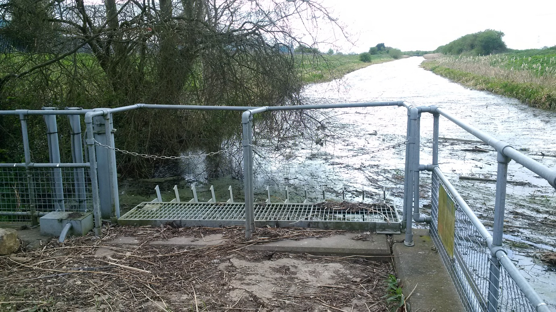
Picture of the culvert where the water is let back in. small black hole right hand side
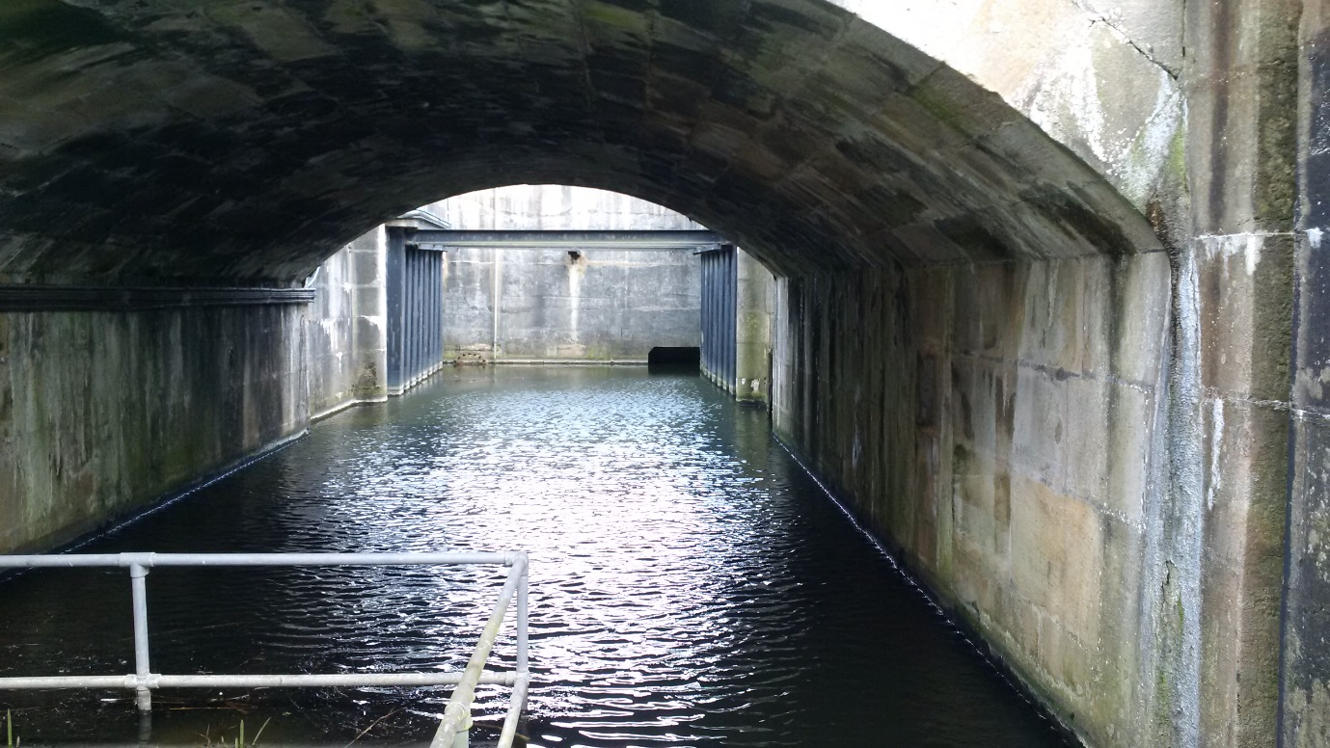
Picture of snow sewer watercourse at normal water level
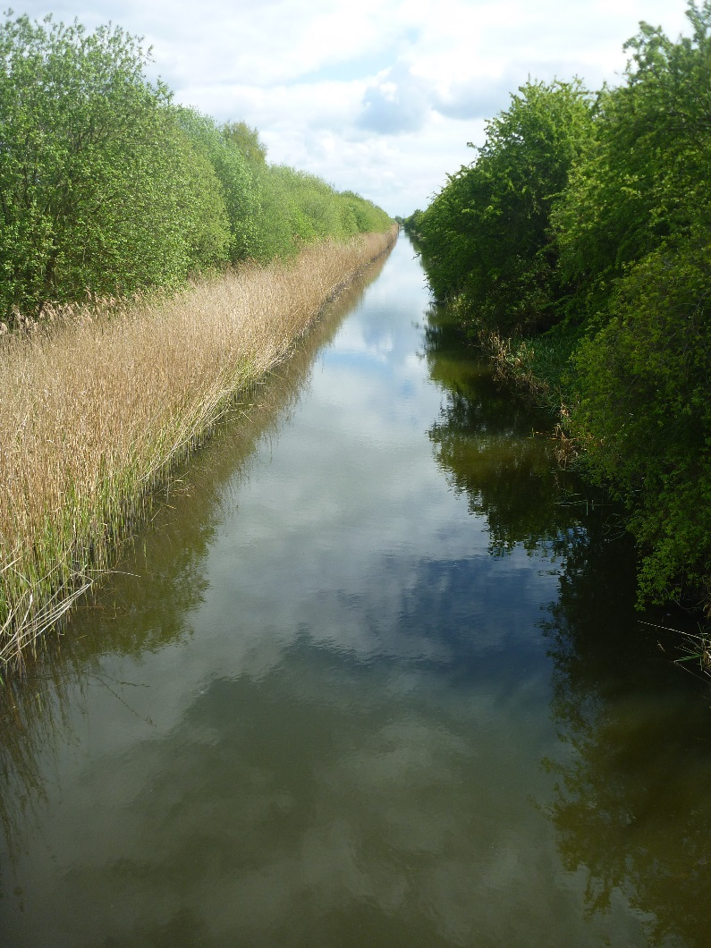

Picture of snow sewer at low water levels


