Mereway Weir Replacement and Fish Pass
Technical Note for Water Transfer Licence

Background
Mereway Weir is at the end of its operational life and is to be replaced. The present weir prevents fish passage. The new weir is to include a fish pass but this will need to be a separate arrangement, due to the design of the replacement weir. The fish pass will be located between the Duke of Northumberland and the River Crane around 2 metres north of the weir in Mereway Nature Reserve.

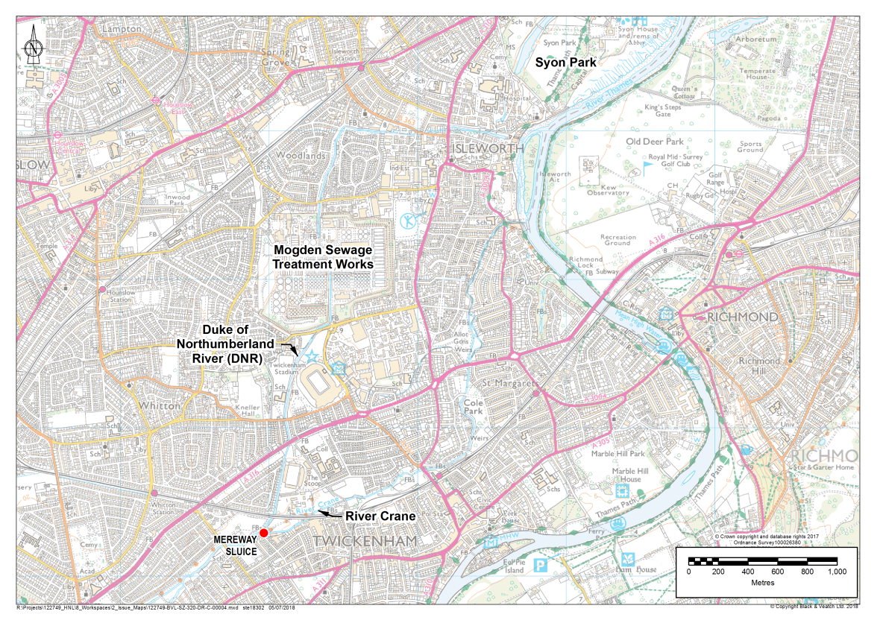
The weir is located on the River Crane in Twickenham, approximately 1km south of Twickenham Rugby Stadium and 2.5km east of Hounslow Heath as shown in Figure 1. The River Crane is a tributary of the River Thames and is approximately 13.5km long. It flows from Hayes southeast past Heathrow and Hounslow Heath then east through Twickenham before joining the Thames at Isleworth.
Fish Pass

Figure 1: Location Plan for Mereway Sluice and Fish Pass

The case for change
The present weir is a barrier to fish passage and prevents fish migration from/to the Lower River Crane. The fish pass will remove this particular barrier and assist in re-connecting the river system. This will contribute towards the aims set out in the Thames River Basin Management Plan. This is to create through local measures a natural looking and functioning river, rich in habitats and wildlife. This proposal could act to encourage further riverside habitat changes to improve the natural bankside environment.
The Water Framework Directive (WFD) requires all waterbodies to achieve a ‘good’ ecological status (or potential) by 2027. The River Crane has been classed as having ‘poor’ ecological. The ‘fish’ quality element is currently classified as ‘moderate’ and is not currently achieving ‘good’ status. This is due to the presence of flood protection structures and barriers to movement causing ecological discontinuity. This fish pass will allow fish and eel passage and will contribute towards moving the fish quality element from moderate to good.

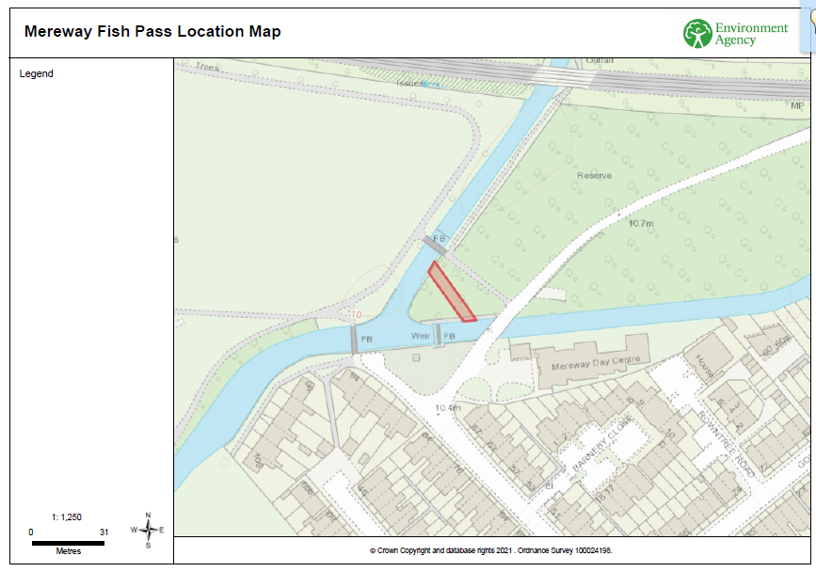
Design of the fish pass
Figure 2: Location of the fish pass
The type and location of the fish pass was decided and influenced through engagement with Richmond Borough Council and the local community groups that work in the area (Friends of Kneller Gardens, Friends of the River Crane and Crane Valley Partnership).
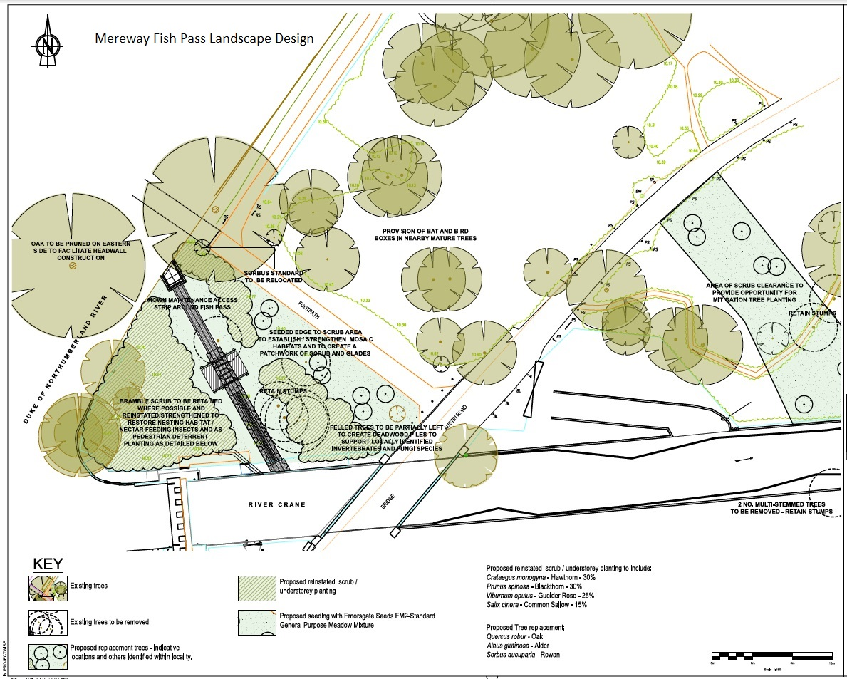
Figure 3: Fish Pass Outline design
Planning permission was granted for this fish in November 2021. Details can be found here on London Borough of Richmond upon Thames webpage.

Hydraulic Considerations
Hydraulic modelling was undertaken to calculate the keys flows needed to maintain the fish pass and offset from the current levels set for the automated weir. We are currently maintaining levels behind the weir on the river Crane and for the Duke of Northumberland River as there are pre-set levels required for Mogden Sewage Works further downstream on the Duke of Northumberland. There is also an Act of Parliament still in place requiring flows for a location called Syon Place for the lake there, so there needs to be appropriate levels of water in place for the Duke of Northumberland to service these locations as well.
The table below denotes the exceedance being used as the main determination for flow down the fish pass. Mereway Hydraulic spreadsheet (Appendix A) contains the key information used to calculate this.

Flow (m³/s)
Exceedance | Flow (m3/s) | R. Crane | DNR | DNR to Mogden | Fish pass | Eel pass | Total (FP+EP)
Q1 | 6.239 | 5.743 | 0.497 | 0.354 | 0.142 | 0.006 | 0.148
Q10 | 1.817 | 1.432 | 0.385 | 0.266 | 0.119 | 0.003 | 0.122
Q20 | 1.093 | 0.790 | 0.303 | 0.193 | 0.110 | 0.002 | 0.112
Q30 | 0.826 | 0.455 | 0.371 | 0.253 | 0.117 | 0.003 | 0.120
Q40 | 0.696 | 0.388 | 0.308 | 0.198 | 0.111 | 0.002 | 0.113
Q50 | 0.600 | 0.256 | 0.344 | 0.230 | 0.115 | 0.002 | 0.117
Q60 | 0.505 | 0.212 | 0.294 | 0.184 | 0.109 | 0.002 | 0.111
Q70 | 0.420 | 0.101 | 0.318 | 0.207 | 0.112 | 0.002 | 0.114
Q75 | 0.379 | 0.086 | 0.293 | 0.184 | 0.109 | 0.002 | 0.111
Q80 | 0.340 | 0.016 | 0.324 | 0.212 | 0.112 | 0.002 | 0.114
Q85 | 0.309 | 0.008 | 0.301 | 0.191 | 0.110 | 0.002 | 0.112
Q90 | 0.285 | 0.000 | 0.285 | 0.176 | 0.109 | 0.002 | 0.111
Q95 | 0.258 | 0.000 | 0.258 | 0.151 | 0.107 | 0.002 | 0.109
Q98 | 0.230 | 0.000 | 0.230 | 0.124 | 0.106 | 0.002 | 0.108
Q99 | 0.219 | 0.000 | 0.219 | 0.113 | 0.106 | 0.002 | 0.108
Q99.9 | 0.187 | 0.000 | 0.187 | 0.081 | 0.106 | 0.002 | 0.108

Therefore, maximum flow is 148l/s
 | 3600 | 24 | 365
0.148 | 532.80 | 12,787.20 | 4,680,115.2
m3/s | m3/h | m3/day | m3/year

Abstraction Point
The abstraction point of the fish pass is located on the Duke of Northumberland at National Grid Reference TQ 14964 73319.

Figure 4: Location of Abstraction Point

The Duke of Northumberland River is owned by the Environment Agency as seen in the official title plan (Title TGL252198) attached to this Technical Report in Appendix B.
This immediately adjoins (and is contiguous to) the land registered to the London Borough of Richmond upon Thames under title TGL289588. Figure 2 and 4 show the abstraction point and fish pass which is to be constructed under Notice.
A copy of the Notice dated the 15.11.21 is also included with this technical report in Appendix C. The Agency is exercising its powers under; Section 172 of and Schedule 20 to the Water Resources Act 1991, Section 10 of the Salmon and Freshwater Fisheries Act 1975 and Section 37 the Environment Act 1995 to enter the Council's land and undertake various works relating to the construction of the fish pass.
Legal advice has been provided by the Agency's legal team that the condition set out in S35 (2) Water Resources Act 1991 is satisfied by the Agency's land ownership and/or alternatively by the exercise of the statutory powers referred to above.

Maintenance of the Fish Pass
The Environment Agency has agreed with the London Borough of Richmond upon Thames (LBRuT) that we will use our permitted powers to complete the construction works. Future maintenance work arrangements are stated in the Notice of Entry dated 15.11.21 (see Appendix C). This will allow us access to the full asset including the abstraction and discharge points. The maintenance agreement has been agreed by the landowner (LBRuT) as well as all other external stakeholders, this agreement can be seen in Appendix D.

Appendix A Mereway Hydraulic Spreadsheet

Appendix B Duke of Northumberland Official Title Plan and Copy

Appendix C Notice of Intended Entry Mereway Fish Pass 15.11.21

Appendix D Mereway Fish Pass MAINTENANCE AGREEMENT

