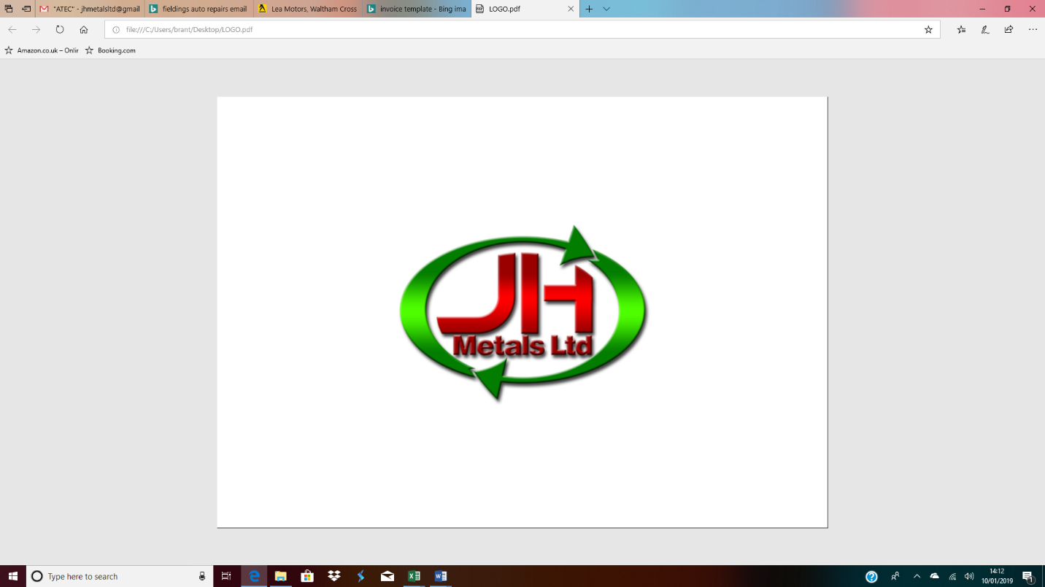  Fire PREVENTION Plan | JH METALS LTD  SITE ADDRESS: BRIDGEWORKS, NORMANDY WAY, HODDESDON, EN110EW  DATE COMPLETED: MARCH 2022

Table of Contents

Content | Page(s)
Statement of intent | 2
Introduction and scope | 3
Using this Fire Prevention Plan | 3,4
Assignment of Responsibility | 4,5
Plan Implementation | 6,7
Combustible materials | 7,8
Monitoring and Review | 8
Hazards/ Managing Common Causes of Fires | 8 - 11
Detecting Fires | 11
Supressing Fires | 11,12
Preventing self-combustion | 12,13
Maximum pile sizes | 14,15
Prevent fire spreading | 16
Quarantine area | 16
During and after an incident | 16-18
Firefighting techniques | 18
Water supplies | 18,19
Managing fire water | 20,21

Appendix | Content | Page(s)
Appendix 1 | Fire safety management strategy | 22
Appendix 2 | Fire safety maintenance checklist | 23,24
Appendix 3 | Site layout plan | 25

Statement of Intent

JH Metals Ltd believes that ensuring the health and safety of staff, visitors, service users and all relevant persons is essential to our success. This fire prevention plan is used as a management System to ensure the below commitments can be met. Employee of JH Metals Ltd must play their part in the creation of a safe and healthy working environment for all.

JH Metals Ltd commits to:

- Prevent accidents and work-related ill health by identifying materials that are potential fire hazards. Procedures for handling and storage are followed to control materials that are potential ignition sources.
- Identify the individuals responsible for maintaining all systems in place to control ignition of fires on site and ensure the requirements are obeyed.
- Ensure risks are assessed and controls are in place to control
- Providing a safe and healthy working and learning environment.
- Ensuring safe working methods and providing safe working equipment.
- Providing effective information, instruction, and training.
- Consulting with employees and their representatives on health and safety matters.
- Monitoring and reviewing our systems and prevention measures to ensure their effectiveness.
- Setting targets and objectives to develop a culture of continuous improvement.
- Ensuring adequate welfare facilities exist throughout the premises
- Ensuring adequate resources are made available for health and safety issues, so far as is reasonably practicable.

This document is to be kept in the Fire-log folder, located in the site office.

Introduction and Scope

Fire is a hazard in every part of the premises. Its consequences include the threat to the lives or health and safety of relevant persons, damage to or loss of property and severe interruption to normal business activities or opportunities. Managing the risk of fire demands fire safety precautions based on a combination of appropriate prevention and protection measures.

This fire prevention plan applies to the premises – Bridgeworks, Normandy way, Hoddesdon, EN110EW, which are to any extent under the control of JH Metals Ltd. Its requirements extend to all persons at the premises which includes staff, visitors/ contractors whether permanently or temporarily.

The arrangements for fire safety and maintenance will be coordinated, communicated, and documented, which is approved by all relevant persons.

JH Metals Ltd will, so far as is reasonably practicable, and in accordance with legal obligations and standards, in regards to the premises – EN110EW, will:
- provide and maintain passive and active fire prevention, protection, and measures according to the purpose of the site,
- provide understandable and relevant information to staff and others, through the provision and availability of emergency instructions or fire safety plans and the risks identified by relevant risk assessments,
- carry out and keep under review a fire risk assessment to identify fire risks, the existing preventive, and protective measures and to identify areas for improvement,
- have in place a programme of works to improve or maintain the existing fire safety specifications,
- initiate the fire evacuation procedure to relevant persons
- where appropriate, to prepare and keep under review risk assessments in relation to the use, storage, handling, disposal, and transportation of dangerous substances and ensure that the risks associated with dangerous substances are reduced or controlled.

Objectives
The fire prevention measures within this document have been designed to meet 3 main objectives, to minimise the possibility of a fire occurring and prevent environmental harm.
The objectives are:
- minimise the likelihood of a fire happening
- aim for a fire to be extinguished within 4 hours
- minimise the spread of fire within the site and to neighbouring sites

Using this Fire Prevention Plan

This procedure is a major part of JH Metals Ltd.’s management system. It sets out the fire prevention measures and procedures you must put in place and use on your site. This fire prevention plan is an individual document within the management system, allowing members of staff at JH Metals Ltd to be able to refer back to it with no difficulty, especially during an incident, if safe and convenient to do so. Employees and other individuals on site must understand the contents of the Fire Prevention Plan, so they are knowledgeable of:
- preventing a fire occurring
- what to do if a fire occurs

Training
All staff at JH Metals Ltd take part in ongoing training and mock emergencies will be created to adequately prepare them for emergencies and keep up to date with their knowledge of fire action, when deemed necessary and practical by the Director. This training will be conducted and the results of training will be recorded. For example, once a month a fire drill will take place and details are recorded including:
- Date
- Time
- Weather Conditions
- Number of persons involved
- Additional comments (improvements etc.)

Also, the site manager visually observes members of staff during daily work activities to ensure they are working properly (preventing fire). This allows the site manager to make employees aware if they are making mistakes and resolve as soon as possible. These regular exercises help to test how well this fire prevention plan works, in addition to staff having full understanding of the fire evacuation drill in place.

The site manager and deputy management representative ensure that all documents including this fire prevention plan are regularly reviewed and updated when necessary. This document may be revised if:
- there is reason to suspect it no longer meets the objectives of the guidance
- a fire occurs or a near miss of a fire takes place
- work activities change
- the environment you are operating in changes (local development etc)
- the Environment Agency request to review it (due to concern over the risk caused by site operations)

If this fire prevention plan has had amendments, it must be sent to the Environment Agency for them to approve. Of course, this means that employees must be made aware of these changes, in which the approved latest plan will be implemented, as mentioned below.

Assignment of responsibility

All employees at JH Metals Ltd are made aware that they are all responsible for fire safety. All employees are knowledgeable of how to prevent fires during daily work activities and actions they should take when responding to fires. Understanding that they are responsible for adhering to company policy regarding fire emergencies is vital. To ensure that employees have a clear understanding of these policies, the site manager and deputy management representative request for signatures of receipt. Employees then have the opportunity to question if unsure.

Management
Management will provide adequate controls to provide a safe workplace and will provide sufficient resources and training to its employees to encourage fire prevention and the safest possible response in a fire emergency.

The deputy management representative will manage the Fire Prevention Plan for JH Metals Ltd and will maintain all records relating to the plan. This includes:
- The development of the fire prevention awareness
- Ensuring that fire control equipment is properly maintained
- Fuel source hazards are controlled
- Fire alarm systems and drills are maintained
- Regular meetings with staff are conducted to engage in ideas of preventions etc.

The competent personnel on site (site manager- director/deputy management representative) ensures:
- There are effective arrangements in place when contacting the emergency services if a fire occurs and ensure they are made aware of any significant hazards on site e.g. storage of petrol, batteries etc.
- To assist and support with the preparation and review of fire safety risk assessments
- To implement control measures for any outcomes of the Fire Risk Assessment
- To prepare and review the emergency plan issued to all staff
- To ensure information on fire safety arrangements is available to individuals on site
- To arrange and review fire drills monthly
- To monitor the fire alarm systems including fire extinguishers, ensuring they are appropriately and regularly maintained
- To keep the fire-log book or equivalent up to date.

Employees must:
- ensure they are familiar with the emergency plan and co–operate by participating in fire evacuation/drill procedures and by observing practical fire safety arrangements
- report to their manager if they have any concerns about fire safety
- be familiar with all escape routes
- not wedge fire doors open, nor block or obstruct them
- be aware of the action to be taken on discovering a fire, hearing an alarm, for raising the alarm (including the location of fire alarm call points) and calling the fire and rescue service
- promptly evacuate the premises, in accordance with the emergency plan, to a place of safety without putting themselves and others at risk
- comply with the No Smoking legislation.

Testing the plan and staff training
All employees will take part in required training, conduct operations safely to limit fire risk,
report potential fire hazards and follow the fire emergency procedures in place. Fire evacuation drills will be carried out monthly with the purpose of educating staff on site in how to vacate in the correct manner. Each drill will be documented including date, time, weather conditions and any additional comments (issues etc.), which will be addressed with staff. On site, an air horn is used to alert individuals of the fire drill.

Plan Implementation

JH Metals considers management actions, ensuring fire precautions in place to create a safe working environment for all individuals on site. It is vital these plans are implemented and there is concern and procedures in place regarding physical conditions within the premises, which are designed to facilitate containment of potential fire by the design and layout, effective communication, and safe evacuation.
Implementation includes:
- Specification and appropriate quantity of materials on site
- The consideration of design and construction of buildings, fire doors and escape routes
- The consideration of individual’s needs (staff, public, those with disabilities, contractors etc.)
- Appropriate safe and secure location of the buildings on site
- Good housekeeping
- Fire safety signage for escape routes, fire action notices etc. in conformity with the Health and Safety (Safety Signs and Signals) Regulations 1996
- Training of staff in fire safety arrangements, in particular evacuation procedures and drills, which are documented
- The maintenance of portable fire extinguishers (CHUBB) which are documented
- Premises fire safety inspection will be carried out annually and documented
- Fire Risk Assessment to be reviewed annually and kept up to date if changes occur
- Fire maintenance contractors (CHUBB) ensure safe work practices and are fully qualified to carry out maintenance on fire safety systems.
- The following are considered: warning system, emergency lighting, emergency routes and exits, fire safety signs and notices and portable electrical appliances (PAT) and premises installation testing.

The fire risk assessment considers those who could be affected, e.g. numbers involved, their location and physical and mental capabilities. The significant findings of the fire safety risk assessment will be made known to the appropriate responsible persons – the director and deputy management representative.

A fire safety logbook will be kept in the site office as a record of all the details of tests on passive and active preventative and protective measures, as well as training and fire drills.

The fire prevention plan document is issued annually to all employees in which a signature of understanding and receipt is required. Other individuals – visitors etc, have access to the document, as well as other procedures and the premises fire risk assessment, that are all located in the appropriate folder within the site office, as labelled. By giving individuals access to documentation, it allows them to be informed what to do in the event of fire and particularly safe evacuation.

It is important that housekeeping is kept up to date, this involves:
- minimising storage of combustible materials
- making sure doors and exit routes are free of obstructions
- flammable materials being used and stored in well-ventilated areas away from ignition sources and at a distance from each other
- using only non-flammable cleaning products
- equipment is kept in good working order
- inspection of electrical wiring and appliances regularly and keep motors and machine tools free of dust and grease
- heating units are safeguarded
- spillages are cleaned immediately
- work areas kept tidy and free of clutter
- electrical equipment is turned off when not in use and not kept running idle

Combustible Materials

The director and deputy management representative will regularly evaluate the existence of combustible materials on site at JH Metals Ltd (see Appendix D). Certain types of substances can ignite at relatively low temperatures or pose a risk of catastrophic explosion if ignited. Such substances obviously require special care and handling.

Class A combustible materials
These include common materials such as: wood, paper, cloth, rubber, and plastics, that can act as fuel and are found in non-specialised areas, such as offices. It is ensured by the site manager that these wastes are kept to a minimal

Handling Class A combustibles safely includes:
- Disposing of waste daily
- Keeping waste in metal bins that are emptied every day (do not need to be covered)
- Keeping work areas clean and free of fuel paths that could allow a fire to spread
- Storing paper in metal cabinets and keeping stock to a minimal
- Frequently inspecting areas where combustibles are kept.

Class B combustible materials
These include flammable and combustible liquids (oils, greases, tars, oil-based paints, and lacquers), flammable gases, and flammable aerosols.

Handling Class B combustibles safely includes:
- Using only approved pumps to dispense liquids from tanks and drums
- Storing/handling/using Class B combustibles only in approved locations where vapors are prevented from reaching ignition sources, such as heating or electric equipment, open flames, or mechanical or electric sparks
- Do not weld, cut, grind, or use unsafe electrical appliances or equipment near Class B combustibles.
- Do not generate heat, allow an open flame, or smoke near Class B combustibles
- Know the location of and how to use the nearest portable fire extinguisher rated for Class B fire

Do not use water to extinguish Class B fires caused by flammable liquids. Water can cause burning liquid to spread, making the fire worse.

Both CO2 and foam extinguishers are stored on site (see image).

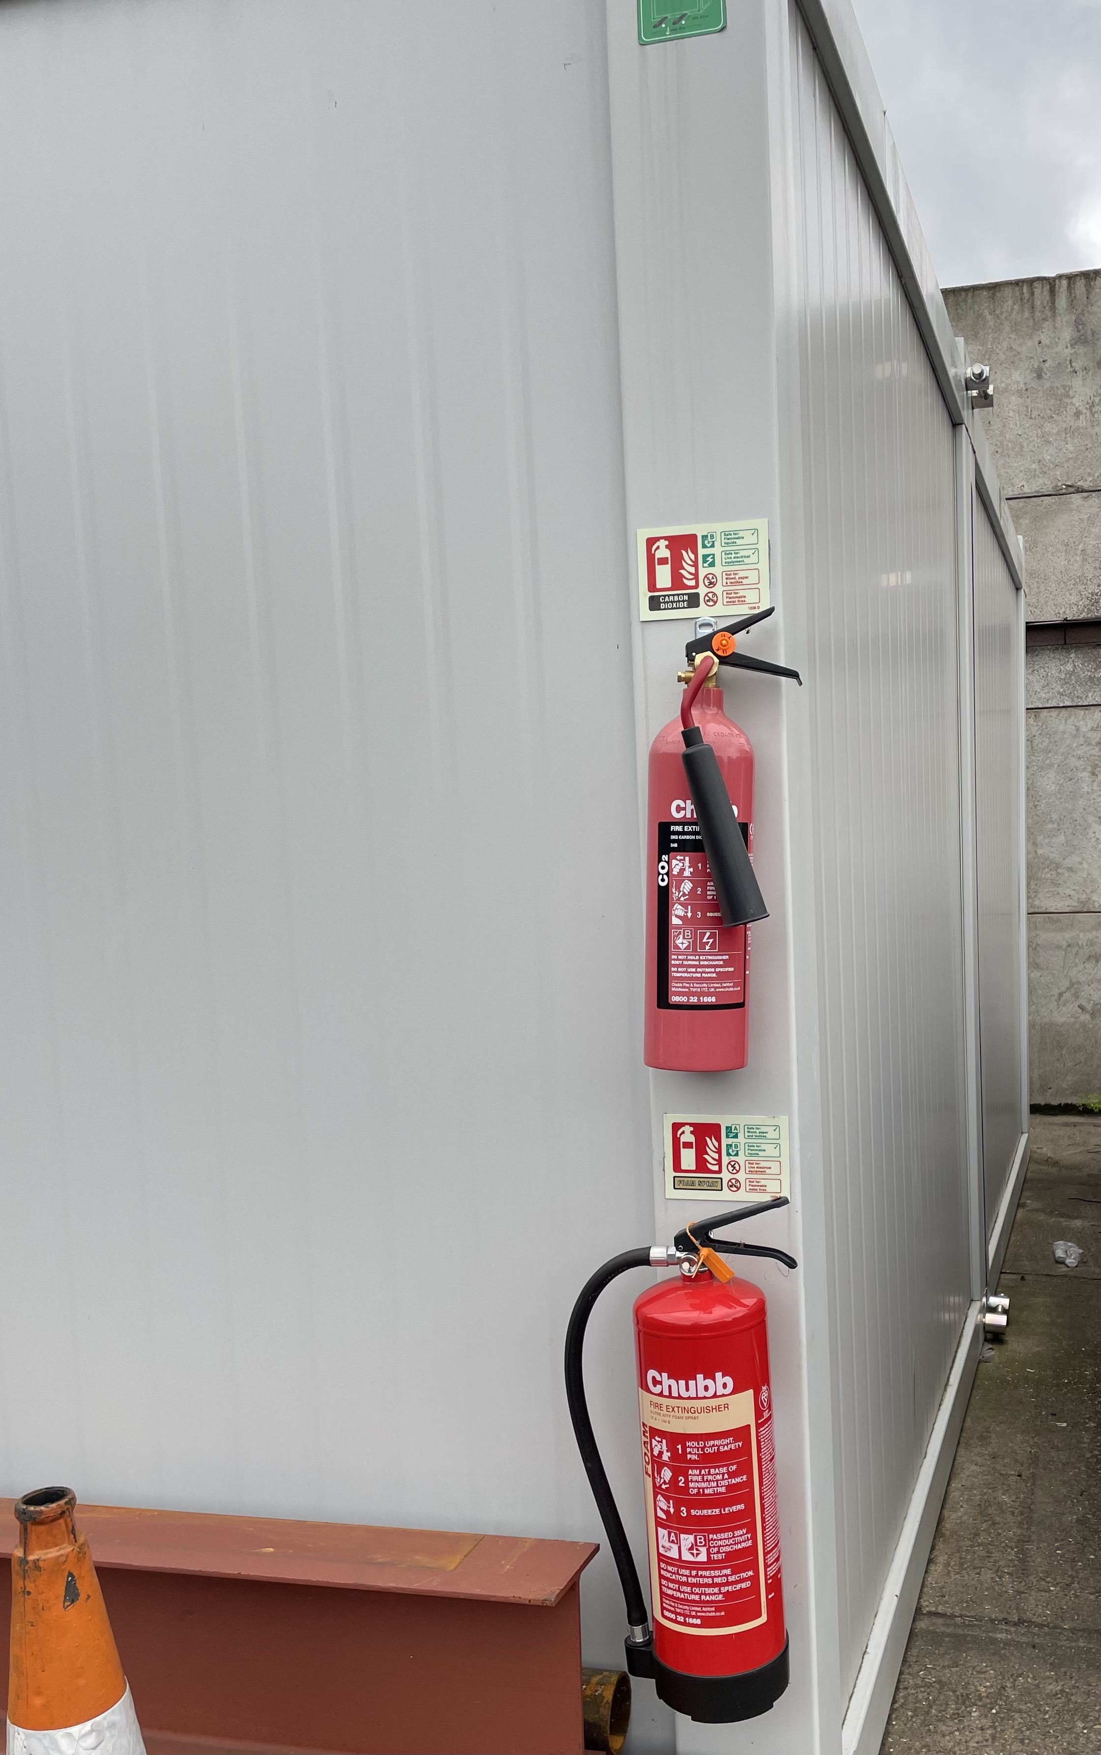
CO2: A carbon dioxide fire extinguisher works on a Class B fire by expelling CO2 to suffocate the fire, removing the oxygen necessary to keep it burning. It also helps with removing the heat, as the discharge is very cold.
Foam: These extinguishers work on both Class A and B fires. The foam agent works on Class B fires by separating the fuel and the oxygen by creating a seal on the surface of the flammable liquid.

Smoking is prohibited throughout the whole site at JH Metals Ltd. The areas where smoking is prohibited outdoors are identified by ‘NO SMOKING’ signs.

Monitoring and Review

It is important that alongside the fire prevention plan in place, there is a continual system of monitoring and reviewing, as well as other documentation that is necessary. This supports an effective and safe working environment for all personnel on JH Metals Ltd.’s premises.

Monitoring
The following Key performance Indicators will be used to monitor the effectiveness of the FPP:
- The number of fires recorded annually / number of fire related incidents / number of call outs to the fire brigade
- Achieving set schedules (evacuation drills and audits)
- The number and nature of enforcement, alterations, or prohibition notices from statutory authorities
- Regular premises inspections and meetings to ensure actions and progress are made (monthly/quarterly/annually)
- Annual audit of all fire systems by the managing director.

Review
- Annual audit of all fire systems by the managing director to determine compliance with not only statutory provisions but with this FPP
- Reactive reviews will take place following a fire safety event occurring
- A review will also be undertaken following a fire, changes to the premises construction and facilities, new procedures, new equipment, new materials and changes in staff numbers and roles

Hazards/ Managing common causes of fire

The following address the major workplace fire hazards at JH Metals Ltd facilities and the procedures in place for controlling these hazards.

Electrical Fire Hazards
Electrical system failures and the misuse of electrical equipment are leading causes of workplace fires. Fires can result from weak ground connections, wiring with frayed insulation, or overloaded fuses, circuits, motors, or outlets.

To prevent electrical fires, employees will:
- make sure worn wires are replaced
- use only appropriately rated fuses
- never use extension cords as substitutes for permanent wiring
- only use approved extension leads
- check wiring in hazardous locations where the risk of fire is especially high
- check electrical equipment to ensure it is properly grounded or double insulated
- PAT testing kept up to date and a qualified electrician conducts acts when needed

Portable Heaters
A portable heater may only be plugged into a wall outlet and never into an extension cord or cubicle outlet. Allow adequate clearance between the heater and combustible furnishings or other materials at all times. Only oil- filled heaters are in used within the site office.

Office Fire Hazards
To prevent office fires, employees must:
- avoid overloading circuits with office equipment
- turn off and unplug nonessential electrical equipment, at the end of each workday
- keep workspace clean and tidy of clutter
- ensure that extension leads are not placed under carpets
- ensure that waste and paper set aside for recycling is removed regularly and does not accumulate.

Arson
JH Metals Ltd.’s premises is safeguarded with high fencing and locked gates. CCTV cameras are located around the site and a security guard on watch out of hours.

Plant and equipment
Plant on site includes a forklift and grab handler (crane) which are switched off when not in use and are not kept running idle.

Smoking
Smoking is prohibited throughout the whole site at JH Metals Ltd, identified by ‘NO SMOKING’ signs.

Batteries
Once batteries are removed from end-of-life vehicles, they are stored in appropriate boxes in a dry area (under the canopy), until collected for onward processing. The site manager ensures an appropriate quantity and no accumulation, this reduces risk of fire caused by the incorrect storage and disposal of batteries. All batteries are collected by an authorised company in which they are disposed of and processed correctly.

Batteries in end-of-life vehicles (ELVs)
As soon as end-of-life vehicles are delivered to the site, the first process is to disconnect and remove the battery, which is then moved to the appropriate storage area. The site manager ensures this is done by checking before the next process take place. As mentioned above, batteries are stored in boxes while awaiting collection.

Leaks and spillages of oils and fuels
The yard staff including the site manager are responsible for ensuring that sufficient spill response materials are always available on site. This includes absorbent granules and mats. It is vital to ensure yard staff have received training on how to react if a spill occurs in their area of responsibility. The importance of an emergency response procedure involves testing which the results are reported.
Fluids are stored in tanks with spill trays that hold more than the necessary amount. Spill pallet has four-way entry with a sump capacity of 1150 litres – cube holds 900 litres (250 litres more).
- Please see Spill procedure (v0.01)

Cutting with use of tools
The site manager will ensure the following:
- Cutting is performed by approved personnel in designated areas whenever possible
- Adequate ventilation is provided
- Eye protection and protective clothing is used as appropriate
- Cutting or welding is prohibited in areas where explosive atmospheres of gases, vapours, or dusts could develop from residues or accumulations in confined spaces

Build-up of loose combustible waste, dust, and fluff
The site manager visually inspects the site at all times during the day to ensure a safe environment and partakes in a thorough sweep and clean of the yard at the end of each working day. If the site manager notices a build-up of loose combustible waste/ dust etc. during the day, then a sweep will take place. This prevents any hazards occurring and waste to be kept under control.

Reactions between wastes
JH Metals Ltd have procedures in place for the acceptance and rejection of wastes. All fuel delivery vehicles will enter the site via the main entrance and drive directly into the yard when instructed to from the site manager, who will inspect the waste and will then communicate with the driver and office to disclose whether it can be accepted. Any wastes that do not meet with the above description and requirements, will be refused entry to the site, which will be recorded in the site diary. If the site manager is suspicious about the waste’s contents, the waste must be rejected if it does not conform with the sites regulations. Once rejected, the supplier will be informed, and the waste is to be removed from the site immediately. This procedure is very important as it prevents reactions between incompatible or unstable wastes.

Waste acceptance
On site it is essential that all wastes are identified straight away, to prevent fire hazards. The site manager will always proceed with classifying wastes before acceptance to identify any issues (contamination etc.), in which will then be decided if the waste needs to be rejected. For example, if an end-of-life vehicle is delivered to the site, it will be checked for any leakages (fuel/oil) which would be a major hazard as this could lead to ignition. It is ensured that any contaminated wastes are rejected before acceptance on to JH Metals Ltd.’s site.

All waste streams can contain contaminants, causing a risk of fire. It is important to be vigilant to the following:
- signs of heat (steam or smoke)
- batteries, in particular lithium-ion batteries
- oil/ fuel
- rags soaked in oils or chemicals

Hot and dry weather
Particularly during summer months, it is important that protection is in place to avoid sources of heat which could lead to risk of fire. At JH Metals Ltd the following techniques are in place:
- Where appropriate, waste is shaded from direct sunlight
- Waste is monitored more frequently than usual – temperature checked etc.
- Storage times are kept to a minimal – waste turnover is speedier where applicable
- The site layout is re-arranged where appropriate
- If reflective surfaces are identified, they are relocated or covered to prevent direct sunlight reflecting onto waste.

Detecting Fires

Should an emergency situation develop; the employee who detects this will be required to:
- contain the situation as best as they can in line with their training
- where appropriate the employee will be required to segregate the area so that others are kept at a safe distance before informing management
- the Director or, in his absence, the Deputy Management Representative must be notified of the situation as soon as possible so that they may intervene and/or notify the relevant authorities as required
- if another employee notices their colleague dealing with an emergency then they are required to assist immediately if it is safe and have been trained to do so
- on arrival the management will assume full control of the situation directing staff as necessary.

It is ensured that a fire is detected in its early stages to reduce the effect it may create, by CCTV with 4 cameras around the site which is visually monitored by office staff during work hours. There is 24-hour surveillance on site, both with CCTV and a watchman, so it is safeguarded at all times.

Suppressing fires

A fire suppression system will allow fires to be detected as early as possible. These components will first identify the presence of flames and smoke. As previously mentioned, once a fire is detected, an alarm will be raised, so the fire can be suppressed as soon as possible before it has the chance to spread. There is 24-hour surveillance on site, both with CCTV and a watchman, so it is safeguarded at all times.

On site we have fire extinguishers and a fire hydrant is located within 100 metres of the site’s access – it is located under 10 metres outside the entrance/exit gates of the premises. It is ensured that access to water is easily accessible.

It is vital that when a fire is discovered, personnel on site have a clear understanding of what actions to take.
- Raise the alarm by operating the nearest fire alarm call point (air horn on front of site office)
- Evacuate to a safe place
- Trained personnel to tackle the fire only where appropriate
- Where appropriate check toilets and close windows and doors on the way out
- If have responsibilities for assisting persons with Personal Evacuation Plans respond as required following the actions as identified in the Plan
- Leave the building by the nearest exit
- Do not stop or return to collect personal belongings
- Ensure visitors are escorted from the building to the assembly point
- Close any doors enroute without delaying your escape
- You must remain at the assembly place
- Return to the building only when authorised to do so

Identify Processes, Machines or Power That Must Be Shut Down
This should include the following where appropriate:
- Staff responsible for ensuring any hot work equipment/ appliances
- Plant/ machinery
- Kitchen appliances (site office)
- Office appliances (computer devices etc.)

Emergency Services Contact Procedure
The competent personnel on site (site manager- director/deputy management representative) will consider:
- The arrangements in place when contacting the emergency services (mobile phone)
- What information will be required (type of emergency, location, missing persons, significant hazards on site etc.)
- How will the emergency services be able to identify them? (e.g. high-visibility vest)
- If anyone is missing and where they were last seen?
- Who else is on site? (Accounting for personnel – visitors book)

Preventing self-combustion

Many materials can self-combust under certain conditions, which happens when a material generates self-heat at a faster rate than it can be lost to the environment. If the temperature continues to rise and reaches its auto-ignition temperature, the material then self-combusts. A variety of preventions take place on site to ensure management, including:
- Storage times
- Pile volumes and height
- Temperature of the wastes

Managing storage time
At JH Metals Ltd we ensure to keep storage times and waste quantity to a minimum to control and prevent self-combustion. The site manager has the responsibility to monitor visually with the help of the deputy management representative, who specifies stock turnover etc.

All documentation (paperwork) for waste that comes on site is stored for the required period, as well as details being inputted on the computer system. This allows information to be easily accessed for stock on site at a given time or stock removed from site. All details are saved in a monthly timeframe, allowing to gain access efficiently and manage in a simple manner.

It is understood that combustible wastes must be stored for less than 6 months (unless agreed with the Environment Agency), due to an increased risk of fire. At JH Metals Ltd we ensure there is a short time frame of when waste comes into the site, to when it leaves. No waste is stored on site for longer than one month and quantity on site is kept below maximum, as we are aware that the possibility of self-combustion can increase when combustible wastes are stored for more than 3 months.

It is important to consider the worst-case situation’s; for example if waste was stored for longer periods over the summer months – plans must be considered to on how waste would be managed in the correct approach during these periods. If this did occur, we would ensure that stock is stored appropriately and quantity is kept to the appropriate amount permitted.

Monitoring and controlling temperature
As previously mentioned, waste on site is rarely stored for longer than 1 month. Waste that is stored for more than three months must have extra safety measures in place to reduce risk of fire, we ensure:

- To reduce the exposure of metal waste (can oxidise which will generate heat, while fine particles are more prone to self-combustion)
- To monitor the temperature of the pile using an appropriate device/ visually to check for signs of heating
- To turn piles frequently/ when needed so the waste remains cold and heat is dispersed quickly
- Staff are aware on how to detect and manage hotspots during daily work practices.

Waste ELV’s
We ensure that end-of-life vehicles are fully depolluted before being stored, which prevents risk to fire. The battery, fuel, oil, and wheels are removed before moving to storage area and are appropriately stacked, until collected for onward processing.

Storing materials in their largest form
Once parts are removed from the end-of-life vehicles (as mentioned above), they are stacked and are not completely crushed as treating waste by reducing its particle size can increase the risk of fire due to self-combustion. To reduce the risk of self-combustion on site, it is ensured that waste is stored in its largest form for as long as possible before it is treated and removed from the site. The baler on site is used to compress vehicles just before they are awaiting collection for onward processing.
The maximum amount of depolluted ELV’s stored on site at one time is 150.
The maximum amount of un-depolluted ELV’s stored on site at one time is 100.

Maximum Pile Sizes

As displayed on the Environment Agency guidance, the below shows the maximum pile sizes:
Waste type | Loose and more than 150mm | 30 to 150mm or baled | Less than 30mm
Tyres and rubber | 450 cubic metres | 300 cubic metres | 300 cubic metres
Wood | 750 cubic metres | 450 cubic metres | 300 cubic metres
Compost and green waste (excluding during the active composting process) | 750 cubic metres | 450 cubic metres | 450 cubic metres
RDF and SRF | 450 cubic metres | 450 cubic metres | 450 cubic metres
Plastics | 750 cubic metres | 450 cubic metres | 300 cubic metres
Paper and cardboard | 750 cubic metres | 750 cubic metres | 450 cubic metres
Textiles | 750 cubic metres | 750 cubic metres | 400 cubic metres
WEEE containing plastics (fridges, computers, and televisions) | 450 cubic metres | 450 cubic metres | 450 cubic metres
Other Metals (crushed ELVs- which are classed as ‘baled’ waste for the purpose of this table) | 750 cubic metres | 450 cubic metres | 450 cubic metres
Fragmentiser fluff | 450 cubic metres | 450 cubic metres | 450 cubic metres

For all waste piles, the maximum height allowed is 4m and length/ width allowed (whichever is the longest) is 20m. The site manager ensure that all wastes are correctly stored – they are separated and at a distance from each other, meaning that if a fire occurred, the distance would prevent spreading and the fire can be extinguished short of complication. Also, the site manager has thoroughly considered the design, access, and layout of the site, including the location of site office (close to the entrance/exit). This allows an accessible escape route for the staff within the office if a fire occurred.

Where maximum pile sizes do not apply
Maximum pile sizes do not apply for the following types of waste:
- Whole ELVs: Each vehicle must be accessible from at least one side to allow active firefighting and allow unburnt vehicles to be accessed and moved to prevent the fire spreading. Stacking is limited to 3 vehicles high so the stack can remain stable during a fire. On site there is a maximum of 75 non-depolluted vehicles stored at one time.
- Waste stored in containers: Each container is accessible from at least one side so a fire can be extinguished. This includes skips, roll-on roll-off skips, or shipping containers. This allows you to be able to move containers if a fire occurs, as efficiently as possible to prevent the fire spreading. The use of the forklift and crane will be used to move the containers.

Waste Exemption
Below is a table showing some wastes that apply to us in relation to the waste exemption we have for the site. The conditions are:
- each type of waste must be stored separately
- the storage must take place at a secure place
- the storage of the waste is pending its recovery elsewhere
- each waste shall not be stored for longer than the specified time period.

Waste code | Type of waste | Storage limit (at any one time) | Period (months)
160601, 160602 *, 160603 *, 160604, 160605, 200133, 200134 | batteries | 10 tonnes | 6
101112, 150107, 160120, 170202, 191205, 200102 | glass | 5,000 tonnes | 12
030307, 030308, 150101, 191201, 200101 | paper and cardboard (excluding food and drink cartons) only | 15,000 tonnes | 12
070213, 120105, 150102, 160119, 191204, 200139 | plastic | 500 tonnes | 12
080318, 150102, 160216, 200139 | printer cartridges only | 5,000 units | 6
020110, 160117, 160118, 170401, 170402, 170403, 170404, 170405, 170406, 170407, 170411, 191202, 191203 | scrap metal | 15,000 tonnes | 6
100316, 100405*, 100504, 100511, 100604, 100811, 100899 | solder metal, skimmings, ashes and residues | 100 tonnes | 3
140602, 140603, 200113* | solvents and solvent mixtures | 5 cubic metres | 6
160103, 191204 | tyres, tyre chip and crumb | 40 tonnes | 3
160211, 160213, 160214, 160216, 200121, 200123, 200135*, 200136 | WEEE | 400 cubic metres | 6

Preventing fire spreading

There are 2 main ways to prevent a fire from spreading:
- Separation distances: Separating wastes and keeping distances between piles of waste can prevent fire spreading between waste piles and allow active firefighting to take place. At JH Metals Ltd, waste on site is stored either on waste piles or in containers/skips and have a separation distance of at 6 meters between other wastes, any structures (site office etc.) or other combustible/ flammable materials. Please see appendix 3 for locations of where wastes on site are stored.
- Fire walls and bays: Fire walls and bays must be designed to: resist fire (both radiative heat and flaming), have a fire resistance period of at least 120 minutes to allow waste to be isolated and to enable a fire to be extinguished within 4 hours. The site office is a metal container, majority of the site is outdoors with only a narrow canopy down one side of the premises. The shed on site is also constructed with steel sheets.

Quarantine area

A quarantine area is an area of the premises where burning wastes can be positioned to extinguish them, as well as using to re-locate unburnt wastes to isolate and prevent them catching fire.

The quarantine area must be:
- Large enough to hold at least 50% of the volume of the largest pile, row, or block of ELVs or containers on site
- Have a separation distance of at least 6m around other waste’s on site.

The quarantine area on site is located directly in the middle of the premises, as this is the most exposed area with the location at the appropriate distance from other wastes. This area is approximately 40x40 ft. If a fire occurred, materials on site would be transported by the use of the crane and forklift to the quarantine area, if safe enough to do so. This practice would take place as rapidly as possible or within 1 hour of a fire starting, at most.

During and after an incident

During an incident
All employees are fully aware of these actions they must comply with if a fire occurs on site:
- Do not put yourself or others at risk
- Do not stop to pick up belongings
- Do sound the closest fire alarm to warn everyone
- Proceed quickly and immediately to the meeting point
As well as this procedure taking place, it is important that management deal with other matters that may occur during this emergency:
- A register used to ensure everyone is accounted for (visitors book)
- Incoming wastes are diverted – whether that mean they are rejected, there needs to be no obstructions of traffic that could be put at risk
- Communication to locals (businesses or residents) –a plan for how you will notify those who may be affected by a fire

After an incident
When the situation is fully resolved, the management will evaluate the incident with a view of enhancing the emergency procedures as necessary. The management will also consider whether additional training and/or drills would have helped in this situation. The Director will ensure these considerations and conclusions are recorded in the non-conformance report.

The topics considered by the management to include in the report will include:
- The cause of the emergency
- The environmental impact of the emergency
- The nature of the emergency and any continuing dangers (e.g. recurrence)
- The action taken and its suitability
- Any further action necessary
- Any preventative actions required to reduce the possibility of recurrence

Furthermore, management will discuss steps that must be taken for the business to be able to operate again, including:
- Contact with the insurance company
- How the site will be cleared and decontaminated – Contact with a cleaning and fire damage restoration company, if relevant
- Protection from odours and conditions
- Persistent organic pollutants (POPs) – ensuring that clean-up operations take the presence of POPs into account, if relevant
- Safeguarding measures for equipment and supplies

POP meaning: organic chemical substances that are considered as serious threats to human health and to ecosystems.
If any POPs waste were involved in the fire, all residues from that fire may contain POPs and must be treated in line with ‘The Persistent Organic Pollutants Regulations 2007’ – ensure that waste material containing POPs do NOT release into the air or water course.

The insurance company should be the first contact as they will need to come and inspect the damage and file a claim, so it is important management are steadfast and offer good communication. They will then supply the money needed to start the fire damage restoration and content cleaning process, in which they may recommend a local company to help with returning the conditions of the site back to where the business needs to be.

Although the flames may be extinguished, smoke odours are extremely dangerous and will cause further destruction to materials and contents on site. If the fire service allows management to re- enter the property, it is advised PPE is worn to prevent any damage to personnel (mask, gloves etc.).

Even if there has been refusal to re-enter the site, it is important that management document all evidence for insurance purposes. A list of valuable assets must be completed (computers, machines, phones, building materials, and important documents) that can be passed on to the relevant persons.

If it is possible to re-enter the building after the fire, if possible management will try to salvage as many personal belongings and assets as possible (documents, photos, computers, and other equipment). This may not be appropriate as soot and smoke produced from the flames may have caused permanent damage if not treated.

Regardless of the cause of the fire it is always a good idea to hire a professional fire forensics team to conduct an arson investigation to determine where the fire had started and what or who caused it. The information received can passed on to the insurance and be used during the claims process.

Firefighting techniques

It is important that techniques are considered in relation to firefighting to help allow a fire to be extinguished within 4 hours. This means that resources needed are available at all times to be able to fight a fire during operating hours and when the site is closed.
These resources include:
- Plant used to move waste around the site – On site we have a forklift and a material handler (crane)
- Staff – JH Metals Ltd have 5 employees
- Water supply – On site there is a tap, with water available at all times, as well as a fire hydrant which is located within 100 metres of the site’s access – it is located under 10 metres outside the entrance/exit gates of the premises
- Finances – JH Metals ensure there are finances to cover

There are a variety of firefighting techniques that can be used together or individually to extinguish a fire. These include:
- applying water to cool unburned material and other hazards
- separating unburned material from the fire using heavy plant
- separating burning material from the fire to quench it with hoses or in pools or tanks of water

Another technique is to suffocate the fire using soil, sand, crushed brick, or gravel. However, you can only do this if:
- the Environment Agency has agreed you can do this
- you remove and dispose of contaminated material as soon as it is safe to do so

Water supplies

It is ensured that there is easy and immediate access to available water supply in case of a fire. This means that the fire service will have the best chance of extinguishing a fire and meeting the objectives of this guidance.

A fire hydrant is a point where firefighters can get access to and connect into a water supply, which is a very important component of active firefighting. Therefore it is crucial that fire hydrants are not obstructed and are kept in good working order, with enough water available for firefighting to take place and manage the worst-case scenario (i.e. if the largest waste pile on site catches fire). There is a fire hydrant located within 100 metres of the site’s access – it is located under 10 metres outside the entrance/exit gates of the premises.
Regulations state that 1800 litres of water is required to extinguish each vehicle for all premises like JH Metals Ltd, that store ELV’s. This means that approximately 270,000 litres of water would be required in relation to our biggest pile size.

On site there is also an outside tap (beside the site office) and the premises is located 173.90 metres from a SPA (as shown on the maps below). JH Metals Ltd do not only rely on the water supply from open sources such as ponds, canals, and rivers, but seasons are considered to make sure an adequate supply is available, in addition to other sources of water supply as mentioned above.
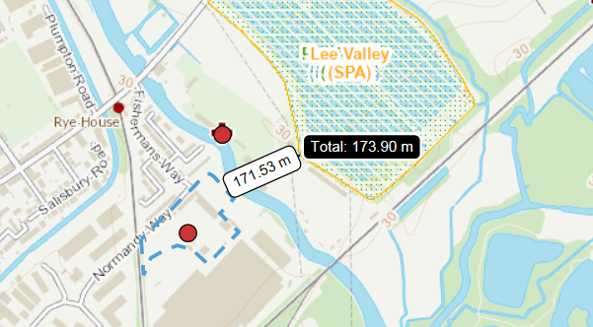

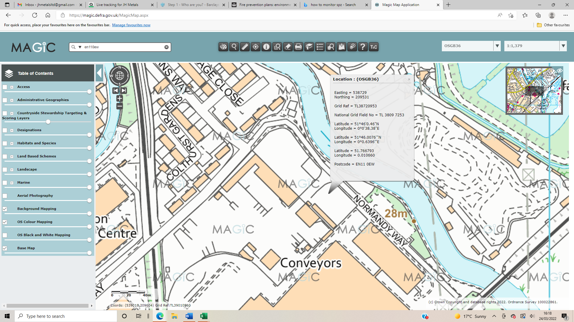

The requirements of the water supply can be affected by other conditions, including:
- Early detection and action, to ensure the pile does not become completely involved
- Waste stored in a container would need no more water than the volume of the container
- Ensuring the implantation of this fire prevention plan

Managing fire water

The run-off fire water must be contained due to a possibility of contamination, causing environmental pollution. Potentially this could lead to prosecution or fines, so it is important to ensure prevention from it reaching sensitive receptors and causing pollution of the environment. This includes considerations such as:

- The volume of water that might be used to tackle a fire
- Any substances stored on site
- What the fire water could become contaminated with
- Pathways of how fire water could enter the environment (via drains, direct run-off into watercourses or absorption through the ground) - The whole site it covered with impermeable surfacing – concrete.
- The sensitivity of the environment that would be affected by contaminated fire water
- Current site arrangements that could deal with fire water run-off

The Environment Agency must protect groundwater sources used to supply drinking water from pollution. SPZ’s are zones which show the level of risk to the source from contamination and assess the risk to groundwater from fire water running off the hardstanding areas of the site. This could be from any activity that might cause pollution in the area. Below is a map showing the site location within the outer zone – SPZ2, meaning that the zone is 400-day travel time of pollutant to source. This has a 250 or 500 metres minimum radius around the source depending on the amount of water taken.

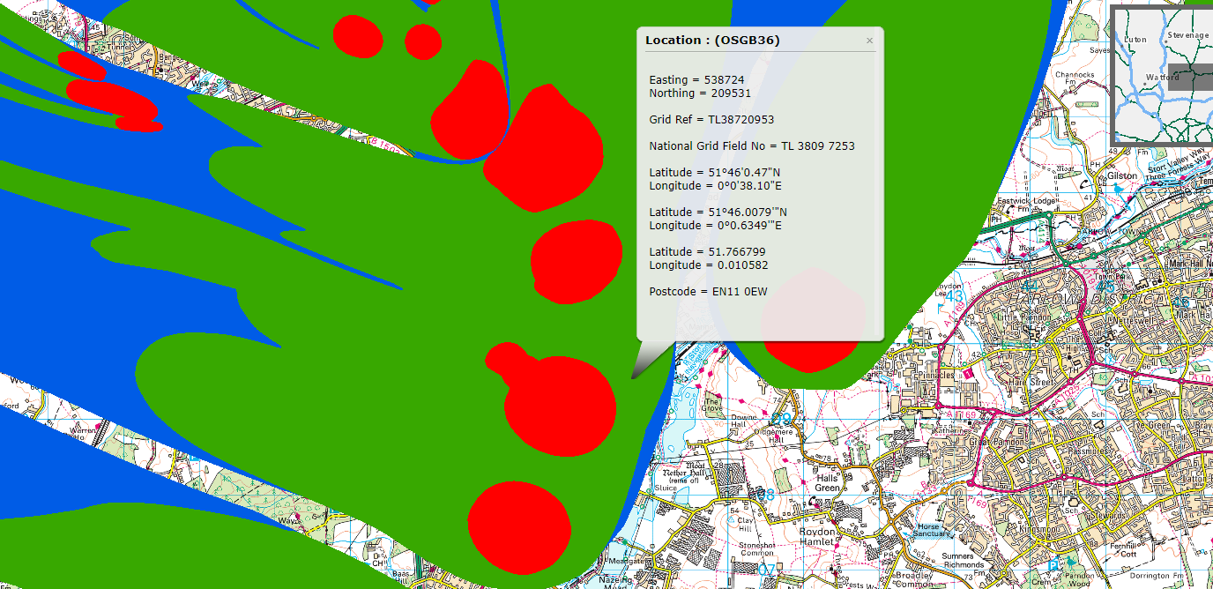

Fire Water Containment
To prevent fire water from causing pollution, containment is the best method, whether it be permanent or temporary. Methods to contain fire water at JH Metals include:
- The two drains on site can be intercepted and shut off by the valve so that the drainage system can be isolated to contain contaminated water (especially if POP’s are present). Although this is managed by the landlord, this can be accessed at all times.
- Depending on the amount of water, suitable spill kits or drainage covers can be used to protect the drains on site. Booms can be used to isolate drains or divert or contain spillages. On site we have absorbent booms – these are filled with absorbent material to contain the liquid as best as possible, in which are located in areas that can be easily accessed so can be promptly used if a fire occurs.

It is vital that all steps that are reasonably practicable are accomplished to minimise pollution from fire water, however it may be impractical and unsafe to implement temporary containment measures in close proximity to a fire, so all procedures are assessed by the site manager before any actions take place. The main priority is to prevent fire water from reaching surface waters (rivers, streams, estuaries, lakes, canals, or coastal waters into the ground), as if not it may be considered as an offence and the Environment Agency may take enforcement action.

It is ensured by the management at JH Metals Ltd that if a fire does occur on site, any waste and water is disposed of legally and that drainage systems (drains and interceptors) are fully checked by authority for contamination before the drainage systems are opened again after the event.

Appendix 1
FIRE SAFETY MANAGEMENT STRATEGY
Fire
Evacuation
Drills
Fire Safety
Inspections
and Audits
Operative
Management

Monthly
At least once
annually

Fire Safety
Systems
Maintenance
Building
Design and Alterations

Statutory Compliance
Condition Assessment
Fault Management
Corrective Maintenance
Fire Safety Design Standards

Fire Safety
Training
Fire Extinguishers
Fire Safety Awareness
Induction
Database
Training

Premises
Design

Aspects/ Impacts register
Housekeeping
Maintenance Records
Insurance Requirements

Appendix 2
FIRE SAFETY MAINTENANCE CHECKLIST
 | YES | NO | N/A | COMMENTS
Daily Checks (not normally recorded)
Escape Routes
Can all fire exits be opened immediately and easily? |  |  | 
Are fire doors clear of obstruction? |  |  | 
Are escape route clear? |  |  | 
Fire Warning Systems
Is the main indicator panel showing “normal”? |  |  | 
Are air horns in their correct place? |  |  | 
Escape Lighting
Are luminaries and exit signs in good condition? |  |  | 
Is the emergency lighting and signs working normally? |  |  | 
Firefighting Equipment
Are all fire extinguishers in place? |  |  | 
Are all fire extinguishers clearly visible? |  |  | 
Are all fire hydrants accessible for the fire service? |  |  | 
Weekly Checks
Escape Routes
Do all emergency fastening devices work correctly? |  |  | 
Are fire doors clear of obstruction? |  |  | 
Are all external escape routes clear? |  |  | 
Fire Warning Systems
Did the fire alarm work correctly when tested? |  |  | 
Did staff and all others hear the alarm working? |  |  | 
Did any linked fire protection system operate correctly? |  |  | 
Did visual alarms, pagers, or vibrating pads work? |  |  | 
Do voice alarms work and was the message understood? |  |  | 
Escape Lighting
Are charging indicators visible and illuminated? |  |  | 
Firefighting Equipment
Are all firefighting equipment in working order? |  |  | 
Are all fire extinguishers mounted 1 - 1½ metres? |  |  | 
Monthly Checks
Escape Routes
Do all electronic release mechanisms work correctly? |  |  | 
Do all automatic doors “failsafe” in the open position? |  |  | 
Are all self-closing devices working correctly? |  |  | 
Are all door seals and intumescent strips in good condition? |  |  | 
Are all external stairs in good condition and non-slip? |  |  | 
Do all roller shutters for compartmentation working correctly? |  |  | 
Do all internal fire doors close against their rebate / stop? |  |  | 
Escape Lighting
Do all luminaries and exit signs working when tested? |  |  | 
Are emergency generators working correctly? |  |  | 
Firefighting Equipment
Is the “pressure” in stored pressure extinguishers correct? |  |  | 
 | YES | NO | N/A | COMMENTS
Three Monthly Checks
General
Are emergency tanks / ponds at their normal / correct level? |  |  | 
Are vehicles blocking fire hydrants or access to them? |  |  | 
Additional items from manufacturers requirements? |  |  | 
Six Monthly Checks
General
Has the emergency evacuation lift (if fitted) been tested? |  |  | 
Have sprinkler systems been tested by a competent person? |  |  | 
Have release and closing mechanisms on fire resisting compartment doors and shutters been tested? |  |  | 
Fire Warning Systems
Has the system been checked by a competent person? |  |  | 
Escape Lighting
Do all luminaries work for a third of their rated value? |  |  | 
Annual Checks
Escape Routes
Do all fire doors work correctly? |  |  | 
Is escape route compartmentation in good condition? |  |  | 
Fire Warning Systems
Has the system been checked by a competent person? |  |  | 
Escape Lighting
Do all luminaries operate on test for their full duration? |  |  | 
Has the system been checked by a competent person? |  |  | 
Firefighting Equipment
Has all equipment been checked by a competent person? |  |  | 
Miscellaneous
Have dry / wet risers been tested by a competent person? |  |  | 
Has smoke control systems been tested by a competent person? |  |  | 
Has external access for the fire and rescue service been checked for availability at all times? |  |  | 
Have any fire fighters switches been tested? |  |  | 
Are fire assembly points clearly indicated by signs? |  |  | 

Date of completion:………………………………………………

Completed by:………………………………………………………

Signed:…………………………………………………………………
Appendix 3


