NON TECHNICAL SUMMARY | JH METALS LTD  Hugill, Connor

Scope
JH Metals is a privately owned business in which the premises is rented from a private landowner, with only one location for both site and office and composed of a small close-knit team. The site is a small yard where materials are appropriately segregated when stored while awaiting collection for onward processing. Working Hours are Monday – Friday: 8am- 5pm, Saturday: 8am- 1pm and closed on Sunday. JH Metals currently holds a valid waste carriers licence, registered upper tier - Registration No: CBDU313677, Expiry date: 14/11/2025. One office employee is trained as WAMITAB Level-4 (Waste Management Industry Training and Advisory Board).
JH Metals provides a professional, high standard service that prioritises end-of-life vehicles and help support with recycling for a better future. It is a priority that JH Metals ensures to recognise how it’s activities will potentially affect the condition of the environment inherited by future generations, and what practices are in place to subside these aspects.
As a minimum standard JH Metals will undertake its actions in accordance with all its current and applicable compliance obligations such as legal and contractual requirements as well as those it may voluntarily subscribe to such as ISO 14001.

Proposal
JH Metals Ltd proposes to obtain a bespoke permit - Authorised Treatment Facility (metal recycling, vehicle dismantling) in which this non-technical summary has been prepared in support of the application with the Environment Agency. The bespoke permit for the Authorised Treatment Facility involves duties such as:
- Certificate of destruction - Vehicles including passenger vehicles, light goods vehicles under 3.5 tonnes and 3-wheeled motor vehicles that have reached their end of life (scrapped) must be issued with an official CoD. This is generated using the online DVLA system.
- Depollution – All ELV’s must be depolluted which involves the removal of the battery, fuel, wheels, tyres and lead balance weights, liquefied gas tank (if present), all other liquids (coolants, antifreeze, brake fluid, air-conditioning gas, shock absorber fluid, windscreen wash, all oils), oil filters, parts with mercury, like switches, catalytic converter etc. Also, any potential explosive materials like air bags and seat belt pre-tensioners can either be removed or set off.
- Store parts for resale safely - Store any parts that could contain liquids on an impermeable surface.
- Store liquids safely – store separately in clearly labelled, leakproof containers.
- Store batteries safely - Store upright in clearly labelled, acid-resistant, leakproof containers.
- Store car shells safely - Once fully depolluted, store on a hardstanding/ impermeable surface.
- Meet recycling and recovery targets - The recycling and recovery target for ELVs is 95%, the recycling rates achieved must be sent to the Department for Environment, Food & Rural Affairs.
At the moment, the current focus will remain on providing a professional, high standard service that prioritises end-of-life vehicles and help support with recycling for a better future.

Site Location and Description
The proposed area of the site is located at National Grid Reference (NGR) TL 38735 09517, with the site boundary 171.53 metres from a SPA, RAMSAR & SSSI. The site is adjacent to the main road of Normandy way and the site entrance is located left of the site of Robert Gibbs Contracting company. Also, Sainsbury’s Distribution centre is located nearby.
The area for application is shown on maps below, with site areas highlighted in blue.
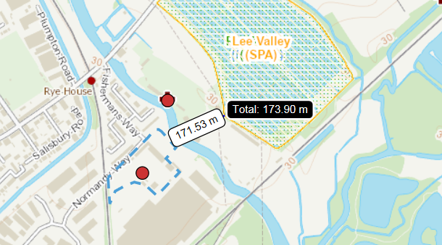

The diagram below illustrates the main area of responsibility for the company at the yard and head office, with the organisational boundaries marked in red.
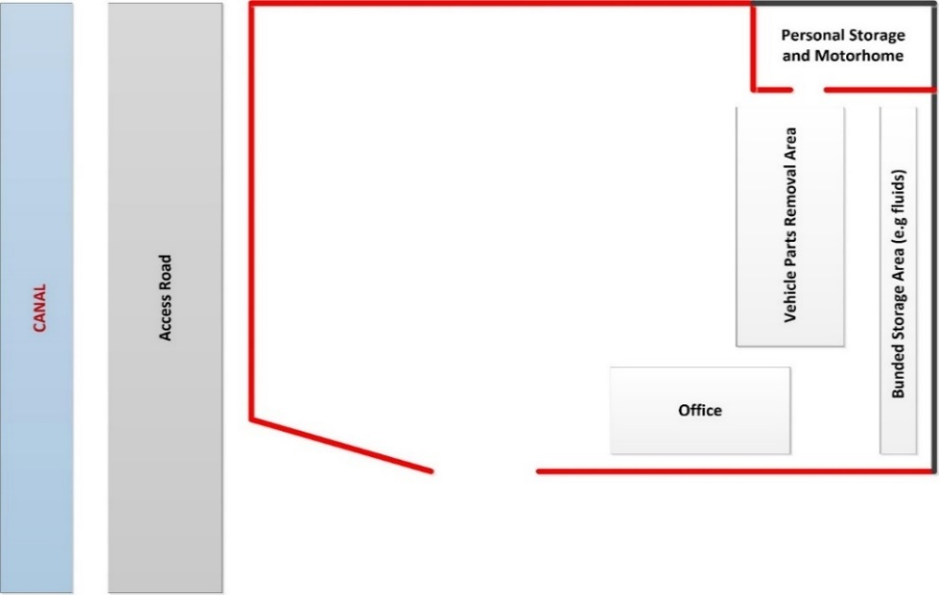

The yard has two interceptor tanks that are managed by an automatic pump system. These drains discharge into the landlord’s interreceptor tank (Robert Gibbs), which then discharges into the sewers. From our site, we have no direct discharge into the sewers. Our interceptor discharge is checked on a regular monthly basis for contamination through visual inspection and is also periodically emptied by a licenced waste carrier with consignment notes. The Landlord’s discharge is checked by Thames Water. The site has an upstand around the perimeter.
The yard has two interceptor tanks that are managed by an automatic pump system. These drains discharge into the landlord’s interreceptor tank (Robert Gibbs), which then discharges into the sewers. From our site, we have no direct discharge into the sewers. Our interceptor discharge is checked on a regular monthly basis for contamination through visual inspection and is also periodically emptied by a licenced waste carrier with consignment notes. The Landlord’s discharge is checked by Thames Water. The site has an upstand around the perimeter and is covered in Pav 4 concrete. Also, it is ensured that an adequate quantity of absorbent granules and matts are available at all times on site in case of a spill and replaced if used.
The map below shows the layout of the site, including drainage.

Review of Environmental Impacts
JH Metals is committed to the continual improvement of its environmental performance through the use of its environmental management system and will ensure pollution is prevented and the environment is protected, and not exposed to harm as a result of its undertakings.
As part of the ongoing operation of JH Metals, management meetings are held to discuss matters affecting the site, the environment and all other factors that must be considered to ensure any potential impacts. In its proposal, planning and decision-making, JH Metals will take due care of the environmental impact of its activities, in which they will:
- Promote environmentally safe implementation of collection, de-pollution and onward sale and processing of vehicles and parts
- Control harmful emissions to the environment
- Deal safely with contaminated materials and all other waste materials taking care to protect the environment
- Seek to develop ways to reduce the environmental impacts of current and future intended activities
- Pursue a policy of waste minimisation
- Develop, through information instruction and training, continuously improving environmental awareness of its personnel with regard to environmental issues.

JH Metals will contribute to the future well-being of the environment through managing its activities in an environmentally conscientious way.

Traffic

It is ensured by management that there is no impact on traffic associated with the current and proposed activities. All traffic is directed at the entrance of the site and it is ensured that work operations only take place on site. Customer vehicles are parked on side road to avoid build-up of traffic on main road.

Noise

It is ensured that the proposed development and current activities are undertaken within relevant noise guidance limits and recommendations for noise levels. It is concluded that the proposed treatment operations are unlikely to result in complaints regarding noise and that there is a low risk of nuisance or significant impact in respect of noise. Tools and plant are not used consistently, only during working hours and not kept running idle.

Dust

It is ensured that all current site operations and proposed activities will not result in a significant impact on the environment surrounding the site as a result of the generation of dust. Housekeeping is kept up to date to ensure a safe and tidy workspace and the yard is swept at least once a day to minimalise dust accumulating.

Document and Data Control

The management system of JH Metals illustrates the company's intentions with regards to the elements of both environmental and health and safety requirements, in which there are procedures in place so that good practices are controlled throughout the company. All internally managed documents will be held electronically on the computer system.

All stored documents and records will be easily identifiable, accessible, and retrievable so that it is possible to trace records to relevant activities. These documents will be stored for the appropriate retention period and records with sensitive information (e.g. personal information) will be shredded. Documents and records are maintained in order to demonstrate the effective operation of the incorporated management system to ensure that work has been carried out correctly.

