Bespoke Permit Application
Best available techniques
Diane Rainsford
[Year]
Contents
Pre-Acceptance Procedure 2
Acceptance Procedure 2
Waste Storage 2
Treatment 2
Immobilisation 2
Management 2
Management System 2
Technical Competence 2
Operations and Maintenance 2
Plant Management 2
Aspects and Impacts Monitoring 2
Raw materials selection 3
Waste minimisation audit 3
Water use 3
Waste handling 3
Waste recovery or disposal 3
Energy 3
Accidents 3
Noise 3
Monitoring 3
Emissions monitoring 3
Monitoring of process variables 3
Closure 3

Pre-Acceptance Procedure

In order to prevent the acceptance of unsuitable wastes which may lead to adverse reactions or uncontrolled emissions, a pre-acceptance procedure has been implemented within the management system. This procedure ensures the suitability of the waste for the proposed treatment route. The steps in the following process flow are carried out before any decision is made to accept a waste. Document reference: B3-T3-2.1-A Process Flow Diagrams

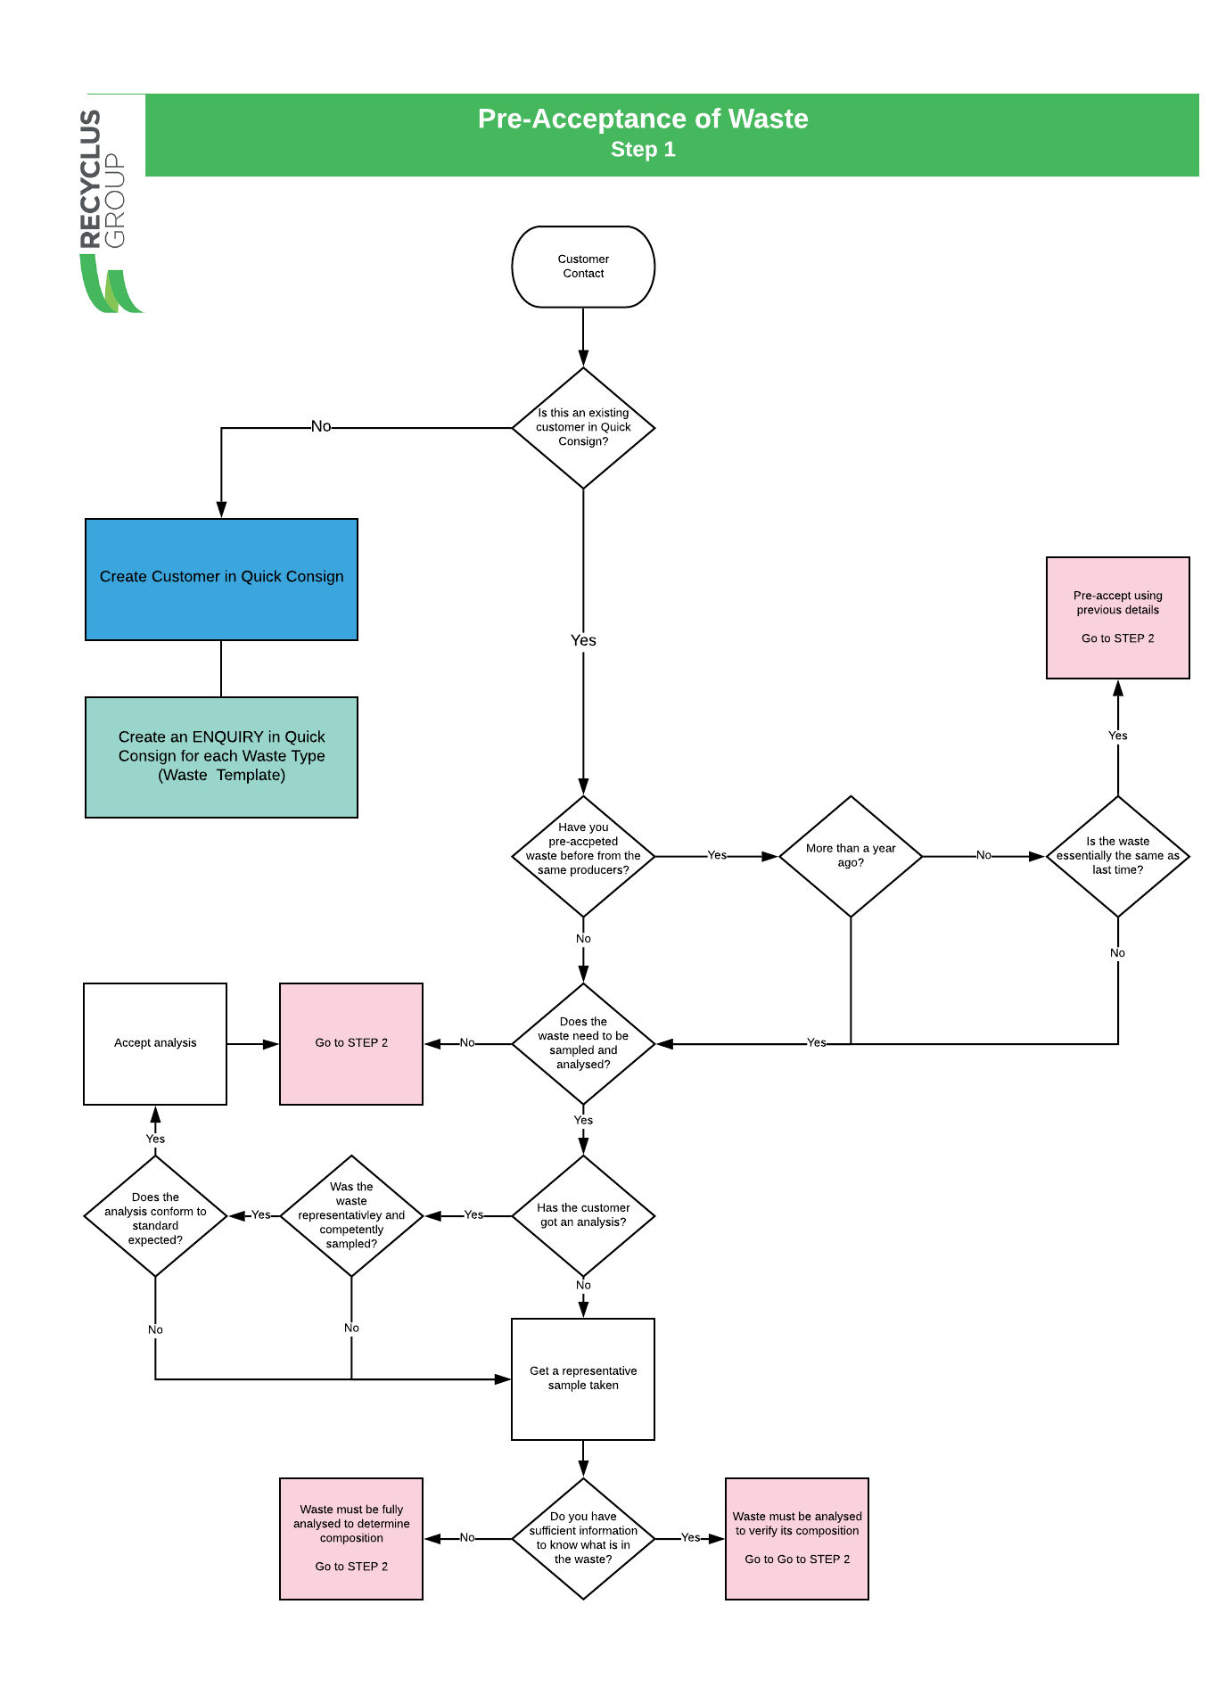

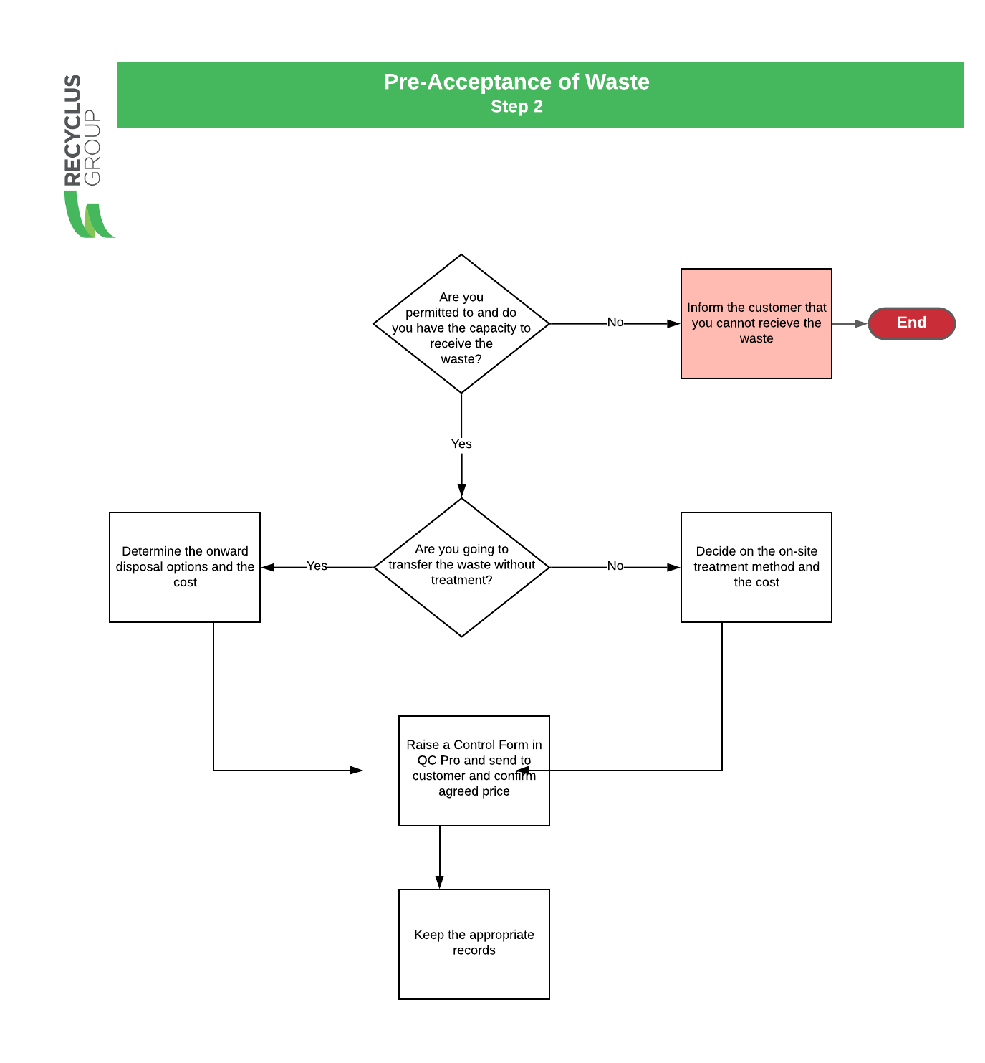

Records
All records required for the movement of the waste from the producer to the facility are maintained in the company’s waste tracking system – Quick Consign (QC). Document Reference: B3-T3-2.1-C Waste Document System

Acceptance Procedure
The company have implemented a documented system to ensure that all waste arriving on site has been pre-accepted to ensure that there is capacity on site at the time of receipt.
Document Reference: B3-T3-2.1-B Materials Receipt & Dispatches

A procedure for the acceptance & pre-treatment of waste has been documented [see below or refer to Document Reference: B3-T3-2.1-A Process Flow Diagrams ] This procedure ensures the following

- Load inspection and control of vehicles
- checking paperwork arriving with the load
- unloading to allow inspection and sampling
- visual load inspection
- Labelling of dolavs, drums and pallets etc.
- assess consistency with pre-acceptance information and proposed treatment method
- rejection criteria
- record keeping in relation to producer details, analysis results and treatment methods
Period review of acceptance records and the process are completed as part of the internal audit programme.
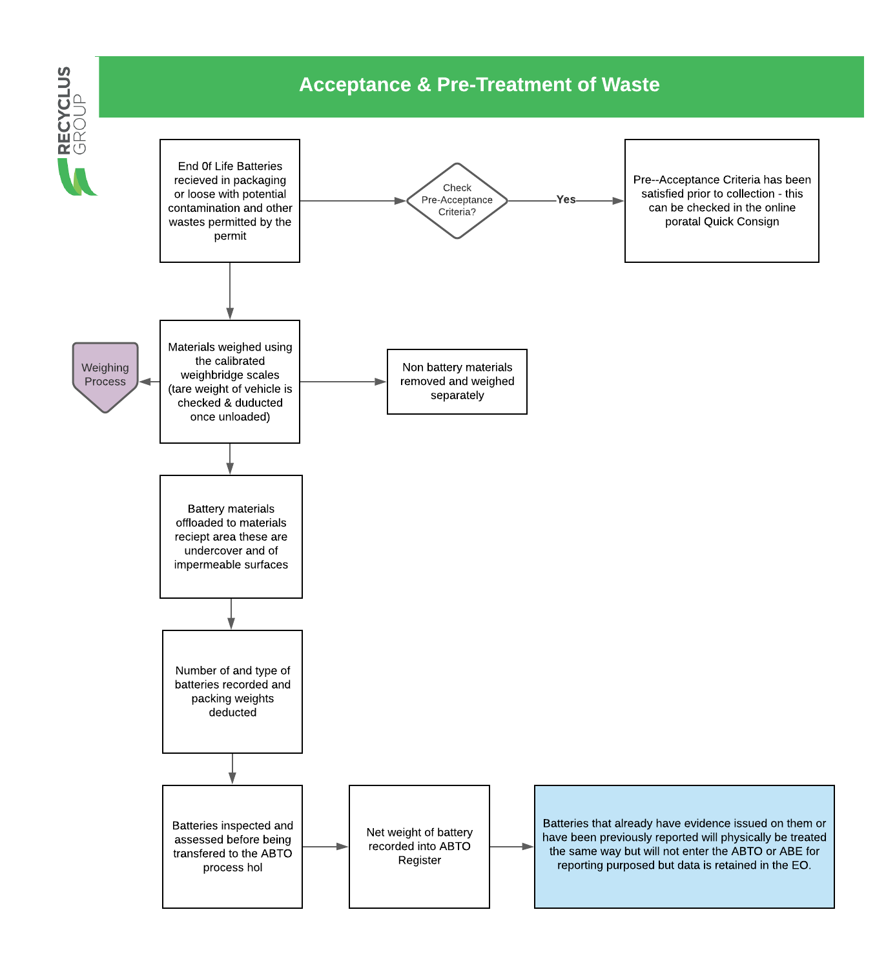
Load Arrival
The Acceptance Procedure [above] ensures that the following points are addressed:
- weighed,
- not be accepted into site unless sufficient storage capacity exists and site is adequately manned to receive waste
- documents checked and approved, and any discrepancies resolved before the waste is accepted
- any labelling that does not relate to the contents of the drum removed before acceptance on site.

Load Inspection
Before a load is accepted it is visually inspected immediately on arrival at the site following initial conformity checks before the load is removed from the vehicle.
In addition to weighbridge weights of the vehicle every container is checked to confirm quantities against accompanying paperwork. All containers are inspected to ensure they are clearly labelled and have well-fitting lids. Any damaged, corroded, or unlabelled drums or containers are put into a quarantine area and dealt with appropriately.
Following inspection, the waste is unloaded into a dedicated sampling/reception area and the waste tracking system unique reference number is attached to the consignment.

Sampling and Rejection of Waste
The process for the sampling and rejection of waste is detailed in the procedure above.

Drum Labelling
All containers being stored on the site including Drums and Dolavs are labelled as follows:
- the location of each drum
- the duration of storage
- the chemical identity of the drums contents
- the hazard classification for each drum
Labels are populated through the Waste Tracking System

Records
All records required for the movement of the waste from the producer to the facility are maintained in the company’s waste tracking system – Quick Consign (QC). Document Reference: B3-T3-2.1-C Waste Document System
The waste tracking system holds all the information generated during pre-acceptance, acceptance, storage, treatment and/or removal off-site. Records are maintained daily and reflect deliveries, on-site treatment, and despatches. The tracking system keeps a record of the waste inventory and includes:
- date of arrival on-site
- producers' details
- all previous holders
- a unique reference numbers
- pre acceptance and acceptance analysis results
- package type and size
- intended treatment/disposal route
- record accurately the nature and quantity of wastes held on site, including all hazards and identification of primary hazards
- where the waste is physically located in relation to a site plan
- where the waste is in the designated disposal route
- identification of staff who have taken any decisions re acceptance or rejection of waste streams and decided upon recovery / disposal options

All records relating to pre-acceptance are maintained in the Quick Consign system and are readily available at the installation for cross-reference and verification at the waste acceptance stage.
Records are held for a minimum of two years after the waste has been treated or removed off-site.
Records are available online so are easily accessible especially in the event of an emergency.
The system adopted is capable of reporting on the following:
- total quantity of waste present on-site at any one time, in appropriate units, for example, drums, dolavs etc.
- breakdown of waste quantities being stored pending on-site treatment, classified by treatment route
- breakdown of waste quantities on-site for storage only, that is, awaiting onward transfer
- breakdown of waste quantities by hazard classification
- indication of where the waste is located on site relative to a site plan
- comparison of the quantity on site against total permitted
- comparison of time the waste has been on-site against permitted limit

The system is secure, and back-ups are maintained by the systems administrator.

Waste Storage

Offloading
All consignments once they have been off-loaded are placed in a holding area. Once inspected if the consignment is not planned to go through the Battery Breaker process that day or it is for onward shipment it will be moved to a designated storage area with impervious surface with self-contained drainage, to prevent any spillage entering the storage systems or escaping off-site.

Records
Once material is stored the Waste Records System will be updated with a location of the consignment which has been placed in storage.

Turnover
If the loads have been placed in the reception area it will not normally be left in this area for longer than 24 hours in normal working times. If there is a holiday or there is a plant breakdown this should not be greater than 5 days.

Treatment
General
HBR maintain documented information which demonstrate the flow of the Treatment Process. Document Reference: B3-T3-2.1-A Process Flow Diagrams. In addition to this as part of our documented management system HBR maintain a documented description of the Treatment Process in document reference B2-2e_DR – 11.2021 Treatment Summary and a description of the management system in document reference B2-3d_DR-11.2021 Description of Management System.
Diagrams of the plant including the location of tanks and treatment plant design have been documented
Chemical Reactions
2.1.4 TREATMENT

The proposed treatment of all feed materials (Lead Acid Batteries) is the same for all feed inputs.

All batteries will be destroyed to liberate all the internal components and each of these components will be treated for the purposes of creating either a product for sale as a feed material for an ongoing process (the majority of the materials) or cleaned of hazardous contamination for disposal.

The batteries, when destroyed, create 5 separate streams which are as follows:

Metallic Lead and Lead Alloys
Lead Oxide Paste
Battery Acid/Sodium Sulphate
Plastic Casings
PVC Internal Dividers

The proposed operation separates all of the streams based on either particle size or particle density, and once separated they are either cleaned or chemically treated to remove any hazardous contamination.

1) The machinery used is referred to as the Battery Breaker which initially separates the metallic fractions from the lead oxide paste and plastic fractions using particle density by way of differences in settling rate.

The metallic fraction is removed via an inclined screw conveyor which allows the liquid to drain back into the breaker. Once the metallic fraction is removed it can be washed using circulating process water to remove traces of battery acid.

2) The lead oxide paste is much finer than the rest of the fractions and using its high density (specific gravity) it creates a stable slurry which acts as a more accurate separation media for the lightest fractions. The particles of Lead Oxide are initially suspended in the Battery Acid liberated during the breaking process.

The lead oxide paste settles out in the breaker and is ‘dragged’ out into a discharge screw. This paste is actually and acidic slurry of lead oxide and lead sulphate. The lead sulphate content of the slurry is a function of the age and state of the feed batteries but by running continuously the content remains relatively constant since the batteries are effectively homogenised.

To reduce the production of Sulphur Dioxide gases at the smelter facility, the lead sulphate can be converted to lead oxide using Sodium Hydroxide. This is referred to as desulphurisation.

3) The lead oxide paste is discharged from the battery breaker via a horizontal screw conveyor to maintain a level of liquid content. This heavy slurry is the homogenised and comminuted in a Rod Mill or a Ball Mill.

The slurry is continuously fed into the mill with a controlled dose of Sodium Hydroxide solution (50%) to firstly neutralise the entrained battery acid

2NaOH (aq) + H2SO4. = Na2SO4 + 2H2O

and then secondly to raise the pH to a suitable basic level, typically above ph 12.5 and below pH 13.5.

This level of pH converts the Lead Sulphate into a solution of Sodium Sulphate, which is the only liquid product.

PbSO4 + 2NaOH =. PbO + Na2SO4 + H2O

The mill is used in conjunction with a classifier circuit to ensure no energy is wasted in excessive size reduction and to provide an addition monitoring point for the pH within the circuit.

Once the particles of lead oxide and lead sulphate are of a small enough size, they exit the milling circuit into a conditioning tank. As the Sodium Hydroxide is used in the conversion of the Lead Sulphate, the resultant slurry becomes pH neutral or very slightly acidic (pH 6.5 - 7.0)

This resultant lead oxide slurry in Sodium Sulphate solution is sent to a filter press to remove the liquid from the solid lead oxide.

The filter press has an inset washing system which ensures the maximum extraction of sodium sulphate. As the wash water becomes less contaminated with Sodium Sulphate, the conductivity of the liquid reduces towards background water levels.

Monitoring the conductivity of the wash water stream and ensuring it drops below 20uS/cm will result in a clean, non-hazardous lead oxide paste.

Therefore, the resultant products are:

2) A neutral Lead Oxide filter cake at an average moisture content of 8 - 10% which can be handled easily on conventional conveyor systems.

3) An aqueous solution of Sodium Sulphate, which can be used as a feed stock for the industrial production of Gypsum (Calcium Sulphate)

4) Using the trommel screen which is integral with the breaker, the plastic fractions and the PVC dividers ‘float’ across the dense slurry and into the screen. These larger particles of plastic migrate up the inside of the trommel whilst any entrained slurry paste through the holes back into the lead oxide slurry tank.

The relatively dry plastics then fall into a separate water bath which reduces the amount of adherent acid on the plastics and effectively washes the plastic.

The Polyurethane based plastics continue to float across the tank and are pushed into an inclined screw conveyor which removes the plastic from the tank and allows the majority of the wash water to drain back into the wash bath.

The plastic is collected in Dolav boxes for removal to further processing by plastic recycling companies.

5) The PVC dividers from inside the batteries will sink in the water bath (but not in the dense slurry) and this allows a separation to take place in the water bath. The PVC dividers are extracted from the water bath by a different inclined screw conveyor, which again allows drainage to take place.

These dividers are only a small fraction of the feed in terms of weight and are collected in Dolav boxes for disposal. This is currently the only material which is not further recycled.

MASS BALANCES

The throughput of the battery breaker is limited by the capacity of the Filter Press which is used to generate the Lead Oxide press cake.

The overall throughput of the system is limited to 5 tonnes per hour of solid lead oxide, and the lead oxide paste typically compromises 40% of the original battery feed. Therefore the initial feed rate is in the order of 12 tonnes per hour of whole batteries.

The average breakdown of products from the breaker is as follows:

Feed Batteries = 100%

Metallic Fraction = 40%
Lead Oxide Fraction = 40% (comprising 90% Lead Oxide and 10% Lead Sulphate)
Battery Acid = 12%
Plastic Fraction = 7.5%
PVC Dividers 0.5%

This means that it is possible to estimate the initial chemical requirements for the process, which can then be optimised using the pH control within the milling circuit.

Feed 12tph

Metallics 5tph
Initial Lead Oxide 4.5tph
Initial Lead Sulphate 0.5tph
Battery Acid 1.44tph
Plastics 0.9tph
PVC Dividers 0.06tph

For acid neutralisation, the majority (99%) of the battery acid is assumed to transfer wholly to the lead oxide slurry.

Therefore the starting point for acid in the milling circuit is 1.43 tph on average.

This means that the amount of sulphuric acid present is dependent on the feed rate and the average amount of Sulphuric Acid in solution. Typically, the battery acid in the batteries is 20% by weight after significant battery usage.

This would mean that the average amount of Sulphuric Acid available for neutralisation would be 0.3tonnes per hour

According to stoichiometry, it takes 2 moles of Sodium Hydroxide to neutralise 1 mole of Sulphuric Acid, or in terms of weight 0.3 tonnes of Sulphuric Acid would require 0.12 tonnes of Sodium Hydroxide to neutralise the acid.

In order to raise the pH of the slurry to pH 13 would require 10kg of NaOH per 1000 litres of water.

Therefore on average the amount of liquid added to the circuit is 1.2 tonnes via the battery acid and up to 0.8 tonnes via the spray bars in the battery breaker, which is approximately 2000 litres, and therefore requires 20kg of NaOH to raise the ph to a value of 13.

The amount of Sodium Hydroxide to convert the Lead Sulphate present in the feed would be also evaluated stoichiometrically. It requires 2 moles of Sodium Hydroxide to convert 1 mole of Lead Sulphate, or in terms of weight, 0.5tph of Lead Sulphate requires 0.14tph of Sodium Hydroxide.

This means the total amount of Sodium Hydroxide required per hour should be in the region of 0.28tph (0.12 + 0.02 + 0.14).

This is the starting addition rate which is constantly modified as the pH varies inside the circuit. The circuit requires pre-filling with paste slurry and therefore also needs pre-filling with the requisite amount of Sodium Hydroxide to ensure the continuous monitoring has a stable starting point to work from.

WATER BALANCE

The proposed operation is designed to use minimal water during operation, instead utilising the water in the battery acid and the chemical reagent to do the majority of the work. The only additions to the circuit are via the spray bars in the hammer mill feed chute and the top-up for the process water tank if the washing system on the filter press does not reach low conductivity in a pre-determined amount of process time.

Typically the wash bars will provide around 500 litres an hour to the circuit. This has the effect of reducing aerosol acid created during the breaking process and flushing the side walls of the hammer mill feed chute.

There is also an automatic top-up system on the process water tank which is fed via a small 20mm feed pipe. The tank has a ballcock system which, when activated, allows a small amount of water into the tank.

The amount of water added to the circuit via the batteries is on average 1200 litres per hour
The amount of water added to the circuit via the spray bars is 500 litres per hour
The amount of water added to the circuit via the Sodium Hydroxide solution is 280 litres per hour

The amount of water exiting the circuit via the Sodium Sulphate solution is 1400 litres per hour
The amount of water exiting the circuit via the cake is 500 litres per hour
The amount of water exiting the circuit via entrainment with the other products is 80 litres per hour

The overall use of water has been minimised to ensure optimum reaction time and minimal water usage.

Process Map – identify the pathways within the process for the specific substance or substances
Mass Balance
Defined end point of the process. The suitable inputs to the process must be defined, and the design must take into account the likely variables expected within the waste stream

Immobilisation

Management

Management System
Halo Battery Recycling (HBR) have implemented an integrate Health, Safety, Environmental and Quality Management system which has been designed to meet the requirements of ISO 9001, ISO 14001, ISO 45001 and fulfil the BAT requirement for this application.
Detailed relevant procedures for the Management System for the installation have been submitted in document reference: B2-3d_DR-11.2021 Description of Management System.
It is the intention that this management system will be audited by UKAS accredited Certification Body, AUVA to achieve ISO 14001:2015.

Technical Competence
In accordance with the requirements of the BREF the site will be controlled by a technically competent person who holds a WAMITAB certificate. A copy of the certificate has been submitted in document reference: JH Wamitab Certificate

Operations and Maintenance
Within the Management System HBR have implemented a series of documented procedure to control operations that may have an adverse impact on the environment; these include:

Plant Management
Procedure for identifying, reviewing, and prioritising items of plant for which preventative maintenance regime is appropriate [insert ref]
Preventative Maintenance Programme covering all plant, whose failure could lead to impact on the environment, including regular inspection of major ‘non-productive’ items such as tanks, pipework, bunds and filters etc. A register of plant and equipment has been documented and submitted in document reference: B3-T3-2.3-1 Installation Inventory and Inspection

Aspects and Impacts Monitoring
Procedure for the identification, assessment and management of significant environmental aspects and impacts has been documented in accordance with the requirements of ISO 14001 [B3-T3-2.3-2 Aspects and Impacts]

Raw materials selection

Waste minimisation audit
Through our process which has been developed to ensure we are processing with the use of clean technologies, together with a high standard of housekeeping and monitoring of material usage against key performance measures, HBR are committed to the reduction of waste.

Water use
Except for domestic water which is used in specifically in daily showering by Operators due to the exposure of lead and battery acid water used in the process is recycled. HBR complete a Water Efficiency Audit at least once every 4 years.
Through our programme of Objectives and Targets to ensure we maximise the reuse of water within our process and freshwater consumption is measured and recorded on a regular basis.
Water used in the battery recycling process is re-used but there is an uptake from the battery acid collection. Water consumption is measured at the point of entry into the process daily consumption is recorded and monitored against key performance measures.
Every effort is taken to minimise the risk of contamination of surface waters or groundwater by fugitive releases of liquids or solids. The facility has been fully bunded and the floor sealed with a polyurethane coating preventing any accidental release reaching surface water or groundwater.

Waste handling

Waste recovery or disposal

  - Filter cake
Filter cake and sludges removed from the process have high contents of Lead (Pb) and are sent with the other recycled Lead products for onwards recycling.
  - Contaminated containers
Any battery dolavs or drums received containing batteries will be returned to the customer/supplier for re-use.

Energy
HBR do not have a CCA or DPA in place within the Emissions Trading Scheme. However, as part ouf our Objectives and Targets monitoring programme energy consumption is recorded and monitored monthly against key performance measures including the recording of CO2 savings as a result of our energy saving measures.

Accidents
The installation is not subject to COMAH.
  - Identification of Hazards
As part of our documented management system and operational controls hazards both of an environmental and health and safety nature have been identified, assessed for risk and the risk hierarchy has been implemented. These include as follows:
- Arrangements for the storage, segregation and separation of differing waste types
- Procedures for the internal transfer of waste materials
- Transfer of substances (e.g., filling and emptying of vessels)
- Overfilling of vessels
- Emissions from plant or equipment
- Failure of containment
- Failure to contain firewater
- Wrong connections made in drains or other systems
- Incompatible substances allowed to come into contact
- Unexpected reactions or runaway reactions
- Failure of main services
- Operator error
- Vandalism
These hazards have been assessed through our environmental Aspects and Impacts process and are recorded in the Aspects and Impacts register of our Management System. The assessment has considered the potential impacts, the nature of the activities which could result in the impact being realised, the status of the activity and whether it is normal, abnormal, or emergency etc., and controls have been put in place to eliminate, minimise, or mitigate.

Noise
The installation has implemented basic good practice measures for the control of noise including the maintenance of plant and machinery. A noise assessment at the permitter of the installation has been undertaken to ensure that the field rating level (L_{AR,TR}) does not exceed 50 dB by day. The plant does not operate at night.

Monitoring
  - Emissions monitoring
Monitoring is completed in accordance with the Site Permit which includes as follows:
Air Monitoring
This will be completed by a competent 3rd party supplier in accordance with the requirements of the permit. The installation has no requirement for LEV installation therefore this is the only type of monitoring required.

Closure
Site Closure Plan
The company maintain a site closure plan which demonstrates that, in its current state, the installation can be decommissioned to avoid any pollution risk and return the site of operation to a satisfactory state. The plan is kept updated as changes occur.

