2023

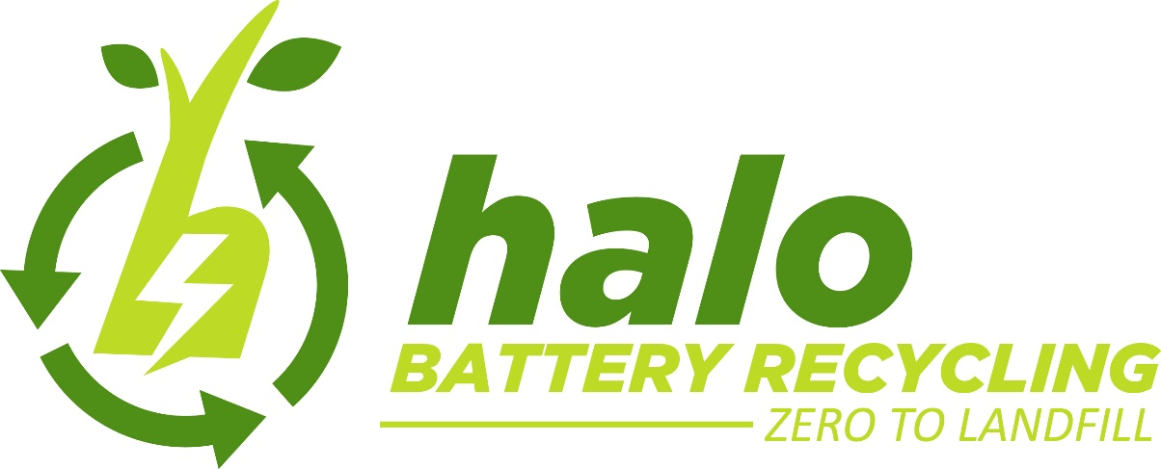

Request for Information: Response

Application number: EPR/CP3444QR/V002

Rev | Date | Detail | By | Check
Draft | 06/03/2023 | LiBatt response to EA Schedule 5 Notice | JD | DR

Contents

1 Application Charge 3
1.1 EA Comments 3
1.2 Halo Response 3
2 Missing Information 3
2.1 EA Comments 3
2.2 Halo Response 5

Application Charge

EA Comments

Unfortunately, the application payment you sent is incorrect. The correct application charge is
£15,647. You have already paid £14,901. This leaves a balance of £746 to pay.

Halo Response

£746 has been paid

Missing Information

EA Comments

I need to ask you for some missing information before I can do any more work on your application. Please provide us with more information to the following questions:

  - You need to send us a Noise and Vibration Management Plan as we consider the works undertaken on site to be a noise risk. The plan should meet the requirements of our guidance on noise and vibration management (https://www.gov.uk/government/publications/noise-and-vibration-management- environmental-permits). The charge for our assessment of your plan is not included in your baseline application charge. You will therefore need to make an additional payment of £1,246. Please see Section 1 above regarding your application charge. Please ensure you send us both your Noise Management Plan and the Noise Impact Assessment undertaken and any modelling files used in the assessment.

  - Your non-technical summary states the following “It is therefore the intention for the installation to deploy its resources for the treatment and recycling of waste Lead-acid batteries, but also to accommodate the repackaging and consolidation of other batteries and waste electrical and electronic equipment in relatively low quantities." Please could you provide further details regarding what is meant by ‘other batteries’, if not already the ones listed in Table 1.3. In addition, please be aware that you cannot currently accept waste, electrical and electronic equipment (WEEE) on site. If you wish to do so, you must supply us with further details of the EWC codes that you wish to accept, along with the expected tonnage and updates to supplied documentation to include WEEE, for example, your BAT assessment and Environmental Risk Assessment. Please note that if you wish to accept WEEE onto site, this could to be classed as new activity on your permit and there will be an additional charge for this.
  - Please update your non-technical summary titled B2-5c_DR-11.2021 Non-Technical Summary to include written details about the changes you wish to make to your permit, in particular, details regarding the proposed battery breaking equipment.
  - Please provide a detailed description of how fugitive emissions, including air emissions of metals, VOCs and acid vapours will be controlled, captured and monitored from each stage of the process from the receipt of waste and through each stage of the battery breaking process.
  - Please describe the methods used to ensure that there will be no release of polybrominated diphenyl ethers that are persistent organic pollutants (pbde POPs) through accidental release of plastic fractions or through emissions to sewer and how they will be controlled, captured and monitored.

  - The Wamitab certificate for the site Technically Competent Manager (TCM), named as Ronald Birchall (supplied on 25/06/2022), shows an expiry date of 07/11/2018. Please provide a copy of a current continuing competence certificate for the sites TCM. Please also provide details as required by Application Form Part C2, Section 3b.
  - There appears to be a document missing from your submission –Application Form Part C3, section 1. The document reference has been supplied as B3 – 1b_DR – 11.2021 Waste Types. Please submit this document if you would like it to be assessed as part of your application
  - With regards to Part C3, Table 3 Technical Standards, please provide details demonstrating how the battery breaker complies with the waste BAT Conclusions and the appropriate measures.In addition to existing measures that refer to batteries, we would expect waste battery recycling facilities to be permitted and operated in line with other relevant standards (including emission limits) set out in our appropriate measures guidance, specifically:

    - Treating metal waste in shredders: appropriate measures for permitted facilities Waste batteries contain metal and are usually treated for the primary purpose
of recovering this metal. We would expect relevant standards set in this guidance to be met where batteries are stored or shredded.

    - Appropriate measures for the transfer and treatment of WEEE
Although waste batteries are not a type of WEEE, they are common electrical components of WEEE, and we would expect measures for their treatment or transfer to be consistent with relevant standards set in this guidance.

    - Chemical waste: appropriate measures for permitted facilities Where the waste chemical components, materials or residues from waste batteries (for example, black mass, electrolyte) are stored or treated we would expect the relevant standards set in this guidance to be met
  - Following a visit from the Environment Agency on 31/01/2023, there appears to be a generator on site that it is not currently included in your permit. Please provide details regarding this generator, including its thermal input. Please see our guidance on Medium Combustion Plant (MCP). If the generator is an MCP, please complete Appendix A of application form Part C2.5 (Medium Combustion Plant section only). You do not need to complete the whole form. A link to the application form is provided here. Please also complete a H1 assessment for emissions to air.
  - Please complete Application Form Part C3, Section 6 (or provide references to documents that provide answers to these questions).

  - Please provide a detailed site plan, showing the layout of the site and clearly showing storage areas/bays/tanks etc. Please include emission point S1.

Halo Response

Ref | Link | Comments
a | Noise and Vibration Management Plan | A new document has been created
b | Halo B2-5c_DR-11.2021 Non-Technical Summary | Reference to WEEE Waste has been removed and ‘other batteries’ has been corrected to ‘unexpected waste’
c |  | A description of the change in process and the reasons etc. has been added to the document
d | Halo Dust and Emissions Management Plan | A new document has been created
e | Halo Dust and Emissions Management Plan | Material will be considered as POPs unless otherwise proved this has been documented in the Dust Emissions Management Plan opposite.
f | Application-for-a-permit-Part-C2-general-varying-a-bespoke-permit  Leigh Davies Primary Competence | Leigh Davies who works for the Recyclus Group directly has completed his Level 4 Wamitab. Form C2 has been updated to reflect the change in TCM and the certificates for Leigh Davies have been added to the drop box.
g | B3-1b_DR - 11.2021 Waste Types | The missing document has been added to the dropbox
h | Form C3  Halo Appropriate Measures 2023  B3 Explanation | Part C3, Table 3 Technical Standards has been updated.  A table of document references relating to the application of appropriate measures has been created and placed in the dropbox, see link opposite to Halo Appropriate Measures  B3 Explanation has been updated.
i | Halo Application-to-vary-a-bespoke-permit-to-add-MCPSG  H1 Assessment Printouts | Part C2.5 has been completed.  H1 Assessment tool was used to complete the Emissions to air relating to the emissions from the generator
j | N/A | Part C3 Section 6 relates to Gas Engines this is not applicable to our process.
k | Site Plans  Sensitive Receptors | Site plans including Emission Point 1

