Contents
References 2
Purpose 2
Roles & Responsibilities 2
Legal and Other Requirements 2
Emergency Response Plans and Procedures 2
Shutdowns 2
Customers 3
Alternative Disposal or Recovery Options 3
Management Procedures 3
End-of-Waste Material 4
Auditing 4
Contingency Categories 4
Contingency Actions 6
Un-planned Plant Shutdown 6
Planned Plant Shutdown 6
Supply concerns 6
Plant management 7
Critical Parts Management 7
Critical Control Points 8
Key Personnel 10
Labour shortage 10
Contractors 10
Emergency Response Levels 11
Contingency Tables 11

References
- Metal shredders: appropriate measures for permitted facilities 2022
- Chemical waste: appropriate measures for permitted facilities 2020
- Waste electrical and electronic equipment (WEEE): appropriate measures for permitted facilities 2022

Purpose
This contingency plan has been documented and implemented to ensure that Halo Battery Recycling:
- Comply with all our permit conditions and operating procedures during maintenance or shutdown at our site, or elsewhere
- Do not exceed storage limits in our permit
- We continue to apply appropriate measures for storing and handling waste
- Stop accepting waste unless we have a clearly defined method of recovery or disposal and enough permitted storage capacity

Roles & Responsibilities
Halo Battery Recycling personnel are responsible for the environmental performance of their activities for complying with relevant permit requirements and for ensuring that all environmental objectives associated with the site are achieved.

Legal and Other Requirements
Applicable legislation, regulations, and guidance regarding emergency environmental incidents

Emergency Response Plans and Procedures
The organisation have a documented Accident Management and Fire Prevention Plan which has identified and set out control measures and emergency action for the most significant risks which have been identified as being possible accident scenarios for the site.
In addition to this a summary table of scenarios has been documented within this Contingency Plan to demonstrate the types of scenarios, the communication requirements and actions that will be required in the event of an emergency. This plan has been included in the Integrated Management System and will be reviewed alongside the site risk assessments.

Shutdowns
Halo Recycling have identified several scenarios for planned and unplanned shutdown in the Summary Table of Scenarios within this document:
- If Halo has planned shutdown the Site Manager has the responsibility to ensure that during the length of time for which the shutdown is planned that receipt of batteries which are unable to be processed during the shutdown period does not exceed the maximum allowable quantities to be held on site in accordance with the site permit this includes whole batteries, work in progress and recycled waste. If there is a risk that this amount could be exceeded the Site Manager must liaise with the Senior Management Team who should take action to stop supply to the site.
- Where the Off-Takers of recycled materials have planned or unexpected shutdown and are unable to accept recycled waste the Site Manager should assess the risk of the site exceeding the maximum allowable quantities to be held in accordance with the site permit and liaise with the Senior Management Team to identify an alternative Off-Taker for the wate or to temporarily stop supply to site until the situation is rectified.
As part of the agreements for taking the waste our off takers should be made aware that they are required to communicate in a timely manner periods of planned shutdown and as soon as possible where there is an emergency.

Customers
Customers are made aware that we have limitations for the quantity of waste we can accept to site and that in the event of a planned shutdown we will be unable to take waste. Customers are made aware in advance when we have a planned shutdown and that in the event of an unplanned shutdown that we will be temporarily unable to accept waste.

Alternative Disposal or Recovery Options
Where possible we will identify other sites or companies who we can rely on as part of our contingency plan ensuring that they can:
- take the waste at short notice
- are authorised to do so in the quantities and types likely to be needed – in addition to carrying out their existing activities
We will not discount alternative disposal or recovery options on the basis of extra cost or geographical distance if doing so means we could exceed our permitted storage limits or compromise our storage procedures.

Management Procedures
Identification of known or predictable malfunctions
In the table below we have identified predictable plant malfunctions and set out the action that will need to be implemented in the event of an occurrence.
Plant Register
Within the management system we have implemented a list of all plant and equipment and as the system develops and the plant is installed and tested, we will include in this a list of critical spares which are held on site or identify the suppliers and lead time for delivery etc.
Preventative Maintenance
Within the Plant Register the maintenance and inspection programme will be documented for each item of plant. In addition to this Plant Register the table below has identified all plant and equipment whose failure could directly or indirectly lead to an impact on the environment or human health
The plant register will also identify ‘non-productive’ or redundant items such as tanks, pipework, retaining walls, bunds, mobile plant, reusable waste containers (for example wheeled carts), ducts, filters, and security systems
As part of the preventative maintenance programme, we will make sure we have the spare parts, tools, and competent staff needed before We start maintenance

End-of-Waste Material
The process is still being developed and although it is expected that we will produce end-of-waste material at our facility we currently do not. In the event that we do, we will ensure that our contingency planning must consider issues with storage capacity for end-of-waste products and materials that fail the end-of-waste specification.

Auditing
As part of our integrated management system, we have a schedule of internal audits which includes auditing our performance against all these contingency measure and reports are shared with the Site Manager and Senior Management Team.
In addition to our internal audit programme our management system is also audited by a third-party certification body as part of our ISO Certification process.

Contingency Categories
This contingency plan has identified 3 main categories as follows:

Contingency Actions

Un-planned Plant Shutdown
Un-planned Plant shutdown of 3 days or more (see plant management)

We will notify our interested parties:
- Staff
- Suppliers
- Customers
- Insurance
- Contractors
We will keep an open dialogue with all interested parties on our progress with an Un-planned shutdown

Planned Plant Shutdown
Planned Plant shutdown, this will be scheduled in line with our customer’s needs.
We will notify our interested parties:
- Staff
- Suppliers
- Customers
- Insurance
- Contractors
We will keep an open dialogue with all interested parties on our progress with a planned shutdown.
In both cases we will manage our waste storage appropriately to meet permitting requirements.

Supply concerns
An open and engaged relationship with our suppliers and customers to ensure we have a contingency plan in place for short inventories that may affect the supply chain. Develop a transparent scheduling system with suppliers and customers. We will only work with authorised and a compliant supply chain.
We will notify our customers if we cannot accept waste.
We will audit the supply chain to ensure that they can be adaptable in times when waster quantities can change.

Plant management

Critical Parts Management
Within the Management System the organisation has implemented a Consumables and Critical Parts Management System. All critical parts have been identified and the suppliers and lead time for these parts and the number held in the stores. Where the lead time is greater than 3 days a policy is in place to hold these parts in stock and replace in the event they are used.
Regular stock takes are documented in the system to ensure that required parts are available. In the event of an unplanned shutdown the following process is followed:
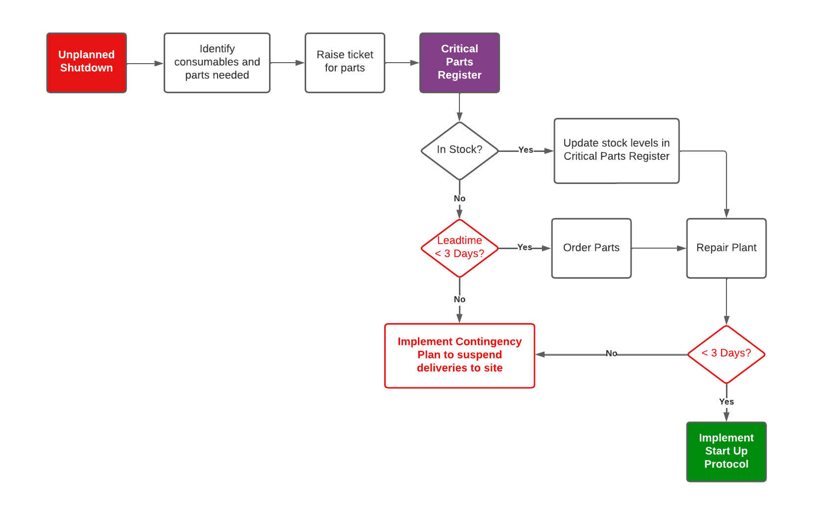

For planned shutdown the Engineering Team will ensure that all parts are on hand before the works commence and if the shutdown will take longer than 3 days customers are notified in good time to enable them to make alternative arrangement for waste during this period.
We have a broad skill base and a local contract engineering support team to help work on any unforeseen break down
It will be in our long-term plan to have plants located in the UK to have the flexibility to support any extra capacity needs or unforeseen breakdowns.
There will be a culture of Preventative and improvement management across the organisation to help maintain all equipment to a good working standard.
Efficiencies and out will be tracked and reported to identify any negative trends and areas for re-focus.

Critical Control Points

Critical control points have been identified throughout the process; these have been identified on the plans below. These plans show phases 1 & 2 of the project. The reference numbers on the map relate to hazards identified in the Hazid which has been documented in preparation for the completion of a Hazop once the plant is installed and can be assessed.
The tables below demonstrate the areas from the Hazid which have been identified as critical control points in the site map. For further details refer to Appendix 2b Halo HAZID Table
A critical control point is a stage in the process in which a failure mode may cause an environmental/health and safety concern. Such critical control points will be visibly idented and monitored by our engineering team.

Figure 2 Site Map Phase 1 Critical Control Points

Excerpt from Appendix 2b Halo HAZID Table
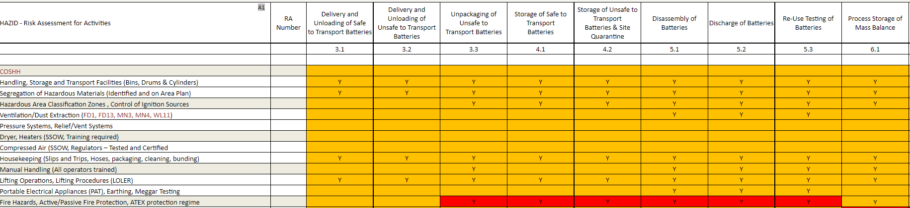
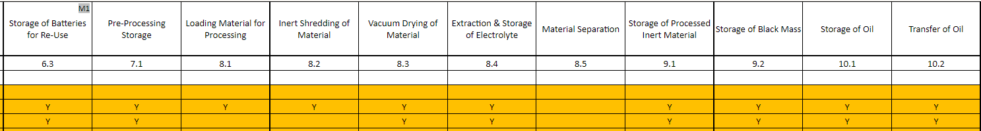

Key Personnel
Through our Training & Competencies Management system we will ensure that we continuously review the competency and performance of our employees in particular those who have roles which require them to report to the regulators, manage and maintain the and provide technical support and guidance to the ABTO and ABE activities at the site.
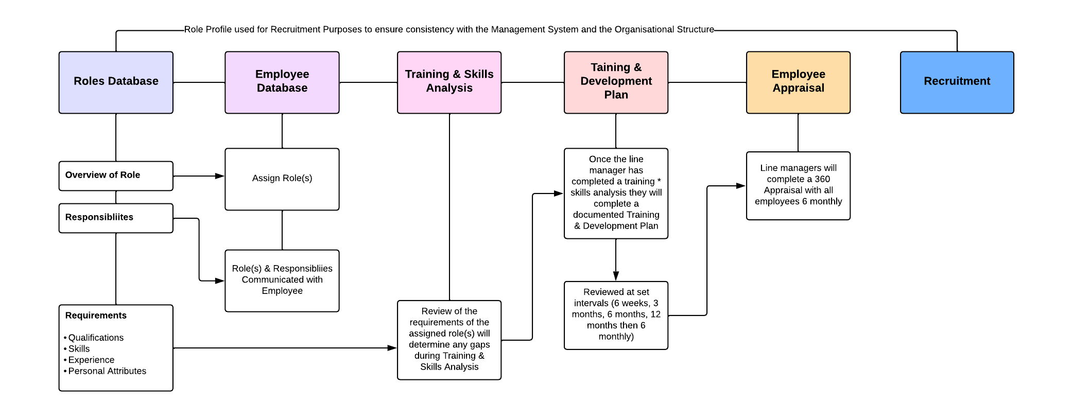

Labour shortage
Our resource training plan will strive to improve flexibility in skills across the organisation.
Operatives will have training to help support both plants.

Contractors
We have a support network of highly skilled and experienced contractors – electrical, plumbing, construction, plant implementation, compliance consultants.
A contingency plan review will be conducted in the event of a failure in our procedures/policies.
The plan will be formally reviewed annually by a 3rd party expert.

Emergency Response Levels

Contingency Tables

Scenario | Trigger | Response | Interested Parties | Responsibilities |  | Timeline
 |  |  |  | Who | What
Unplanned Shutdown | Emergency failure of plant and equipment or an emergency event which requires the plant to be shut down | Follow plant shutdown protocol (see Accident Management & Fire Prevention Plan) | Customer  Suppliers  Approved Contractors | Site Supervisor | Ensure plant shutdown protocol is followed.
 |  |  |  | Site Manager | Investigate the cause identify if there were any fugitive emissions, >3 days downtime etc) informs as necessary, plans maintenance and restart. | Site Shut Down
Planned Shutdown | Planned Maintenance | Follow plant shutdown protocol (see Accident Management & Fire Prevention Plan) | Customer  Suppliers  Approved Contractors | Site Manager | Ensure that flow of feedstock is managed along with the plans to close the plant to ensure that permissible amounts of waste in accordance with the permit are not exceeded whilst the plant is non operational | Planned Shutdowns will work to planned timeframe
No off-taker provision | Off Taker Plant shutdown (planned/unplanned) | Depending on the lead time before supply to the off-taker can be restarted or an alternative off-taker can be used Temporary Plant Shut down may be necessary if it is deemed that maximum capacity of waste materials in accordance with the permit could be reached.  Temporary cease to operation.  Stop deliveries of new feed | Customers  Off-Takers | Senior Management Team | In the event of no-off taker provision the SMT should contact Customers and cancel any planned deliveries of batteries until an agreement can be made with alternative off-taker or the situation with the preferred off-take has been resolved. The SMT should be aware of the maximum capacity of batteries and waste products that can be stored on site to be compliant with the permit. | Within 2 working day.

Scenario | Trigger | Response | Interested Parties | Who | What | Timeframe
Labour shortage | Pandemic, strike action another unforeseen event | If insufficient labour is available to operate the plant safely site shutdown protocol should be followed. | Employees  Senior Management Team  Customers  Suppliers | Senior Management Team | If the plant has insufficient labour to operate safely then a full or partial shutdown of the operation should be implemented | Immediately
Fire | Arson, electrical or mechanical failure of equipment, unsafe storage of feedstock and products | Follow emergency response plan | Emergency Services  EA  Sensitive Receptors | Site Manager | Follow Emergency Procedure for Fire (Shut Plant Down if Safe to do so, Evacuate the Site, Call Emergency Services)  Inform the Senior Management Team  Inform the Compliance Team | Immediately
 |  |  |  | Senior Management Team | Implement Business Contingency Plan for Operations - Transfer all employees to sister plant Halo, Admin Operations to be completed from there if the whole site has had to be evacuated. A small fire may be contained and other buildings on the site may still be able to be occupied) | Immediately
 |  |  |  | Compliance Team | Liaise with the Emergency Services and the Environment Agency | Immediately
Oil Spill | Tank failure and loss of containment in the bund | Turn the interceptor transfer pump on to divert the oil from the interceptor as it fills into another tank | Environment Agency  Emergency Services | Site Manager | Call emergency services if containment is lost from the site | Immediately
 |  |  |  | Compliance Team | Liaise with the Emergency Services and the Environment Agency | Within 24 hours

Scenario | Trigger | Response | Interested Parties | Who | What | Timeframe
Flood | Adverse weather conditions such as heavy rainfall | Shut down all processes, make the site safe by isolating supply to buildings if applicable and safe to do so. | If applicable emergency services would be called | Site manager | Ensure site shutdown protocol is followed. | As soon as risk is realised
Hazardous Gas Leak | Damage to gas line | Follow Site Shutdown Protocol, Evacuate site if significant leak | Emergency Services  National Gas Emergency Service  (0800 111 999) | Site Manager | Assess the risk and decide if Site Evacuation is necessary | As soon as risk is realised
Loss of Utility Supply | Power supply failure or gas failure due to adverse weather or rupture to the supply off-site etc. | If available switch to portable generator supply or follow site shutdown protocol | Utility Companies | Site Manager | Assess the risk and decide if site needs to close. | As soon as risk is realised
Dust Extraction Failure | Mechanical breakdown | Shut Down Process, Maintain Unit, Spill Management | EA (if fugitive emissions are identified) | Site Supervisor | ensures Shut Down Process is followed and all equipment is safely isolated
 |  |  |  | Site Manager | Assesses situation (fugitive emissions, >3 days downtime etc) informs as necessary, plans maintenance and restart.
 |  |  |  | Compliance Team | Fugitive Emissions have been reported by Site Manager, assess the impact, and inform EA if deemed necessary
 |  |  |  | Senior Management Team | >3 days Plant Shut down has been reported by site manager, monitor the situation, and liaise with the site manager and compliance team to assess whether deliveries need to be suspended
Dust Extraction - Pipe Failure | Mechanical Breakdown (pipe rupture) | Shut Down Process, isolate electricity to area, Close doors (should be closed under normal operating conditions) wait for dust to settle clean up |  | Site Manager | Assesses situation (fugitive emissions, >3 days downtime etc) informs as necessary, plans maintenance and restart.
Scenario | Trigger | Response | Interested Parties | Who | What | Timeframe
Electrolyte Storage - Container Liquid Leak | Barrel ruptures | Electrolyte bund will contain the spilt liquid  Liquid Spill Management
Gas System - Compressed Air failure | Damage to equipment | Shut Down Process, Maintain Unit
Pressurised System Failure | Poor maintenance, damage to equipment | Shut Down Process, isolate pressurized system Maintain Unit
Incompatible Material Contact | Contaminated feedstock (unexpected waste) in the battery breaker could lead to fire and or explosion | Shut Down Process, Fire Management Plan, Quarantine Material

