Halo Battery Recycling limited
St George’s Works
Bradleys Lane
Tipton
Dy4 9ez

DUST & Emission management plan
(DEMP)

Steve Andrew
Version Number: 1
Date: 20 feb 2023
Issue and Revision Record

Revision | Date | Originator | Checker | Company Approver | Description of Changes

1.Introduction 4
1.1Sensitive Receptors 6
2.Operations at HALO BATTERY Recycling 9
2.1Waste Deliveries to HALO BATTERY 10
2.2Overview of Waste Processing, Dust, and Other Emission Controls 10
SITE ACTIVITIES. 12
2.3 Mobile Plant and Equipment. 14
3.Dust and Particulate (PM10) Management 14
3.1Responsibility for Implementation of the DEMP 15
3.2Sources and Control of Fugitive Dust/Particulate Emissions 15
Breaking the source-pathway-receptor model for each of the identified sources. 16
Volatile organic compounds (VOCs) 23
3.3 Other considerations 23
Water usage/ availability: 23
3.4Enclosure of Waste Processing & Storage Areas 23
3.5Visual Dust Monitoring 23
4.Particulate Matter Monitoring 23
5. In-Process Emissions Control and Monitoring 23
5.1Feed Materials 23
5.2 Shredding of feed batteries 23
5.3Drying of materials 23
5.4PVC and Plastic 23
6.Reporting and Complaints Response 23
6.1Engagement with the Community 23
6.2Reporting of Complaints 23
6.3Escalation and Management Responsibilities 23
6.4Summary 23
APPENDICES 23
Appendix A - Site Location plans 23
Appendix B - Dust Complaint Form 23

1. Introduction

The installation operated by Halo Battery Recycling (HBR) is a hazardous waste installation, primarily involved in the treatment and processing of lead acid batteries.

Lead Acid batteries are a ubiquitous form of waste, classed as hazardous due to the Lead compound content of the battery.

The installation is designed to house a breaking phase for the battery recycling process, and the separation equipment to sort the broken fractions of the breaking process. This means that the final products are lead metal fractions, plastic, electrolyte, PVC separators and Lead Oxide paste.

The process diagrams will provide a more detailed description of the process.

The site is located in Tipton where the local authority is the Sandwell Council and is an Air Quality Management Area (AQMA) which is declared for nitrogen dioxide NO2 and particulate matter PM10. As the site is located within an AQMA, there will be a need for boundary air quality monitoring once the plant is operational. This must provide long term measurement of PM10 for data to be added to the AQMA set of results.

Any dust or emissions generated throughout the process has been recorded in an Emissions Inventory to show where it is produced and the controls required to abate. The emission points which occur in the battery recycling process are located in an enclosed building and will be fitted with local exhaust ventilation (LEV) to capture vapours and prevent them being released to atmosphere. These vapours are likely to contain Sulphuric Acid.

All LEV equipment must be fitted with appropriate filters, which in the case of the Sulphuric Acid would be Carbon filters as a minimum. There may be a need for an alkali scrubber system should the process be found to require it once the operation can be tested.

The Halo Battery system would use H-Type filters, which are 99.5% efficient at removal of extremely toxic dusts such as asbestos, and therefore suitable for the removal of less dangerous vapours as produced by the breaker system. The processing building layout and plant for the battery recycling process has been specifically designed to reduce emissions.

This document has been created to support the application of a Permit Variation to allow the automatic recycling of Lead Acid batteries and was requested by the EA as part of the application process.

The purpose of the document is to demonstrate the controls in place to identify, reduce and control vapour produced through the Lead Acid battery recycling process and forms part of the organisations integrated HSEQ Management System and is intended to be read and understood by the operational management team of Halo Battery Recycling Ltd.

1.1 Sensitive Receptors

In table 1.1 we have listed the most significant sensitive receptors with a 1km radius of the site which could potentially be affected by fugitive emissions and in table 1.2 we have listed other activities within the same radius which are likely to generate emissions to air. We have added a map of the area below.

A wind rose diagram for the site is shown below which advises the position of the boundary monitoring system. All operations take place in an enclosed building with dust control measures.

According to the Met Office, the main prevailing wind direction is from the SSE of the site considering averages for the last 5 years.

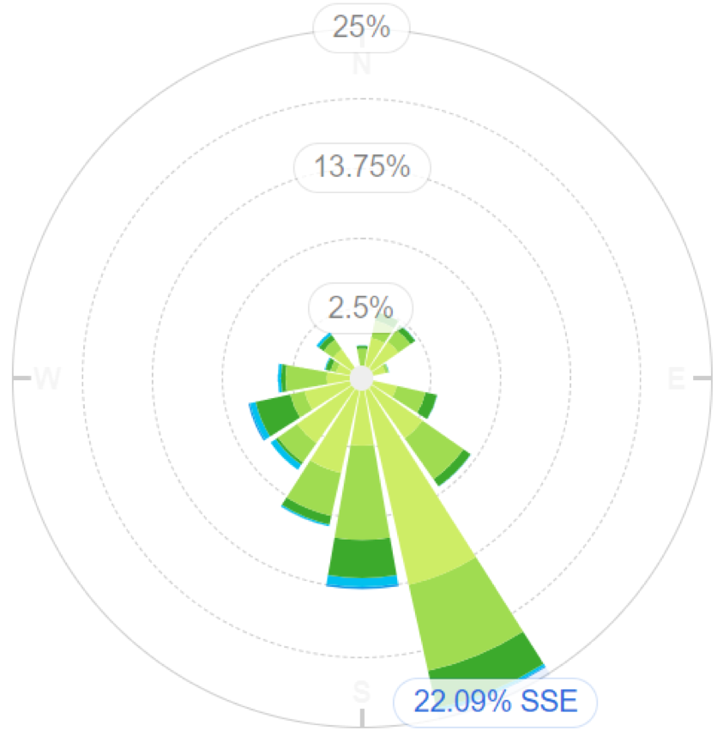

Figure 1.1 Wind rose for Halo Battery site

This would therefore project the position of the Site Boundary Monitoring Device into the NNW corner of the site.

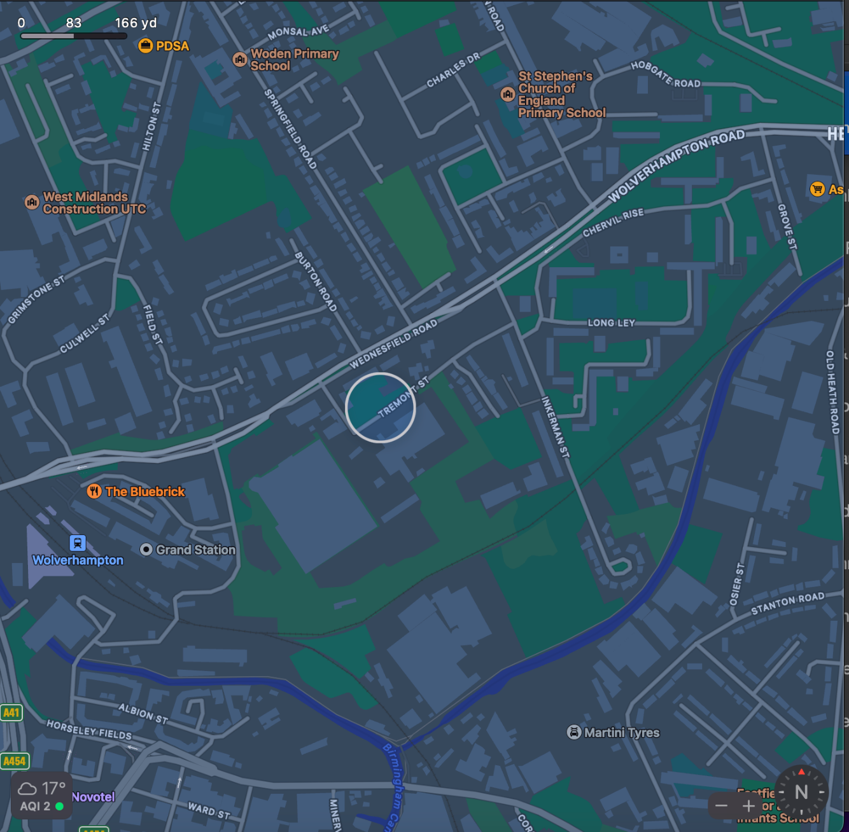

Figure 1.2 Sensitive receptors within 1 km of Halo Battery site

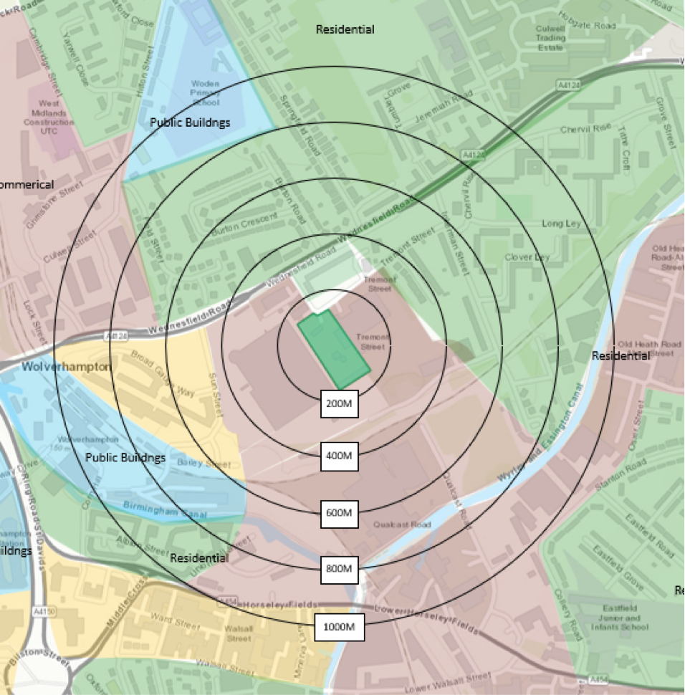

Figure 1.3 Distance to sensitive receptors

Boundary | Closest property | Distance from HALO BATTERY site boundary (m)
North | Flats and residential housing | 100
East | Flats and residential housing | 200
West | Clayton Park | 800
South | Flats and residential housing | 100
South East | Summerhill Primary Academy | 1000
North West | Wallbrook Primary Academy | 150
South East | Tibbington Play Area | 300

Table 1.1 Distances to selected, representative sensitive locations

Company | Address | Type of Business | Distance from HALO BATTERY site boundary (m)
 |  |  | 50
 |  |  | 50
 |  |  | 100
 |  |  | 50
 |  |  | 400

Table 1.2 Sources of dust and other emissions

2. Operations at HALO BATTERY Recycling

2.1 Waste Deliveries to HALO BATTERY

Waste is delivered by road in curtain sided vehicles. We would expect approximately 3 to 4 deliveries and approximately 3 to 4 collections per day at full capacity. Halo Battery do not have their own transport so the emission rating for the vehicles is unknown.

Batteries will be received in ADR approved packaging and depending on the condition and safety of the batteries being delivered this will range from palletised loads to ADR Boxes specifically designed for the transport of unsafe Lead acid batteries.

All deliveries will be received with consignment notes and dangerous goods notes if required. All deliveries will be pre-planned by Halo Battery. The materials being delivered will not be dusty or have any emissions.

2.2 Overview of Waste Processing, Dust, and Other Emission Controls

There is a detailed site layout and processing plan which is shown in Appendix 1.

All materials are stored in sealed boxes or shrink-wrapped pallets prior to processing which are stored in a covered building. The recycling process also operates in a covered building.

The site surface is impermeable concrete therefore easy to clean and prevents dust and particulate generation.

The site is intending to operate a 500 kVa mobile generator which is located outside building 3 and will be used to commission the processing plant. The site will operate 2 LPG forklift trucks.

 |  |  | Destination within facility
European Waste Code (EWC) | Product Description | Tonne / Week |  |  | Recycle(Shed 3)
16 06 01 | Lead Batteries | 500 |  |  | 500 | 0
Total |  | 500

Table 2.1 Typical waste types brought to HALO BATTERY

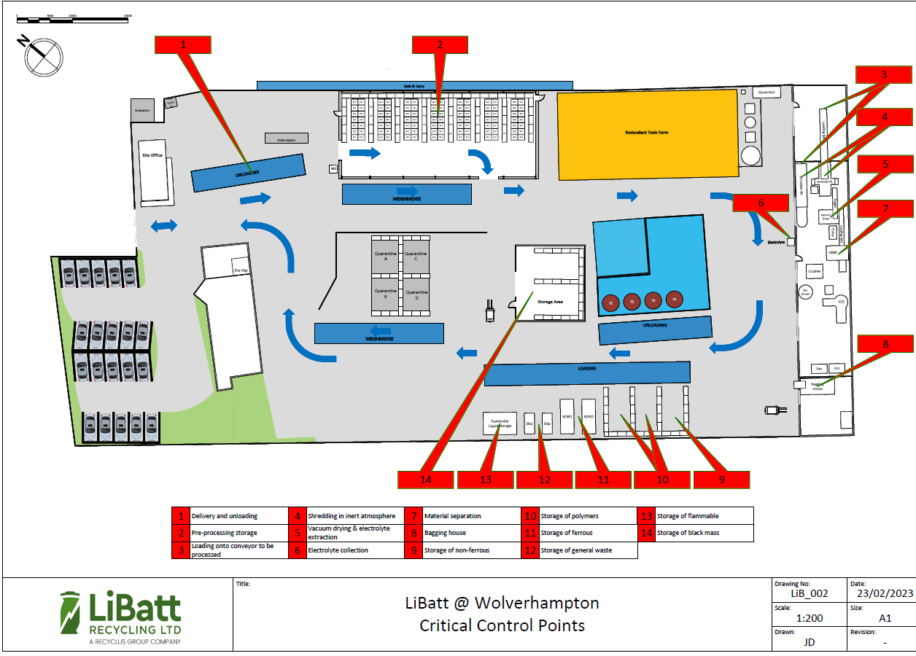

Figure 2.1: Site layout plan
SITE ACTIVITIES.

The overall site layout is shown in Appendix 1 along with basic process diagrams for each of the recycling steps within the buildings. The various areas have a purpose as follows:

- Delivery Area - Sealed boxes and shrink-wrapped pallets are removed from curtain-sided vehicles

- Storage Area 1 - Sealed boxes and shrink-wrapped pallets are placed inside a building prior to processing or repacking

- Process Area 1 – Lead acid batteries are removed from transportation packaging and sent to a bespoke crusher system

- Process Area 2 - Broken lead acid batteries are discharged via a screw conveyor into an upward current separator. The electrolyte in the batteries can be partially vapourised at this point, creating the need for LEV at the transfer point. The rLEV removes the vapour which is then passed through a carbon filter to remove vapour, odour and any possible fine particulate matter trapped in the vapour droplets.

- Process Area 3 – The upward current separator allows heavy metallic lead to sink onto a screw conveyor. This screw conveyor removes the heavy lead metal fractions to a collection system.

- Process Area 4 – The lighter fractions are carried by the flowing current into a trommel screen where material greater than 10mm is passed into a separator bath. This bath is used to remove plastic from the PVC separators. The PVC separators are collected at one end of the bath, the plastic at the other.

- Process Area 5 - Material in the flowing current which is less than 10 mm passes through the trommel screen into a separation bath where the lead oxide paste settles out. The lead oxide paste is ‘dragged’ out into a screw conveyor and this heavy slurry is pumped via a feed tank into the filter press.

- Process Area 6 – The filter press removes excess electrolyte from the Lead Oxide paste so that a cake is formed at approximately 8% moisture.

- Storage Area 2 - All products of the process are collected and stored in sealed bags inside a separate building prior to loading onto curtain-sided vehicles for dispatch to onward processing facilities.

Due to this being an existing permitted site, the plant operational areas were designed to utilise existing buildings and to provide a one directional through flow of material to minimise handling and transport distances.

In order to minimise fugitive emissions during the process, the following considerations were made:

- Doors on all buildings/bays
- Vapour extraction at the appropriate process step
- Size of fans and airflow to ensure all vapours locally captured
- Generator exhausts are monitored and flowrates and compositions periodically measured.

2.3 Mobile Plant and Equipment.

Nitrogen Dioxide gas is a by-product of internal combustion engines and the site uses several items of plant with internal combustion engines. The following table lists the type, mobile and emission ratings for the mobile plant and equipment used on site:

Description | Make | Model | Emission Rating
Generator for Processing Plant | CAT
Forklift 1 | TBC
Forklift 2 | TBC

All diesel equipment is leased/hired.

The maintenance schedule used to keep the plant running for all machines is as per manufacturers recommended frequency.

Where diesel is used, ultra-low/low sulphur fuel is the preferred option, and a supply is maintained on site.

The company has controls which are in place to reduce emissions. These include anti-idling site rules and oil tanker loading procedures.

3. Dust and Particulate (PM10) Management

The amount of dust generated is a function of the control measures for hazardous dust generation.

However, as a completely wet process, there are no significant dust emissions attached to this application.

3.1 Responsibility for Implementation of the DEMP

The responsible person for the DEMP and making sure it works is the Site Manager who will be assisted by a deputy site manager, to be appointed upon award of the permit variation.

The DEMP is reviewed annually or as necessary due to changes in site operations or conditions.

The DEMP has been prepared by the Technical and HSEQ Specialists for the Recylcus Group and will continue to maintain and ensure controls are in place. Controls which have been identified as being required by the DEMP will be monitored through site inspections which will be the responsibility of the Site Manager and compliance with these controls and site inspections will be monitored and assessed through internal audits as part of the integrated management system.

Management controls required as part of the DEMP will be communicated through training and toolbox talks which will be delivered by the Technical and HSEQ Specialists

3.2 Sources and Control of Fugitive Dust/Particulate Emissions

Sources

Details of all the operations at Bradleys Lane that have the potential to produce dust and particulates are listed in the emissions inventory and are described as follows.

- Plant treating waste is internally situated process plant and all operations have been analysed for the potential of dust
- Waste is stored internally and not exposed to prevailing winds
- All site surfaces are concrete and do not generate their own particulate emissions
- All materials are in either sealed boxes or bags with no concern about dust generation unless a bag or box is dropped and a spillage occurs. At which point the company spill containment protocol will be used.
- All emissions generated by vehicles would be via diesel exhaust as vehicles travel around the yard which has a concrete surface.
- The single site generator is located inside the Process Building. The engine is contained in a sound-proofed cabinet to minimise noise emissions.

Breaking the source-pathway-receptor model for each of the identified sources.

All operations including delivery are not susceptible to dust generation, primarily because all deliveries are in sealed packaging and all operations are undertaken within buildings with associated dust prevention.

The site speed limit is 5mph and all site vehicles are subject to maintenance and inspection as required. Delivery and dispatch vehicles are not owned or controlled by the organization but as part of our supplier controls transport companies will be required to demonstrate that their vehicles road legal and as a result must pass national emissions limits.
Normally, when an issue of emissions is identified, the primary course of action is to temporarily cease operations, correct any issues with the control systems and inform the regulator of any potential problems.

Source | Pathway | Receptor | Type of impact | Where relationship can be interrupted
Debris | falling off lorries | N/A. Minor impact on receptors within 200m | Visual soiling, also consequent resuspension as airborne particulates (inconsequential compared to main road) | Cover lorries before leaving site.
Tipping, storage and sorting of waste inside buildings | Escape from buildings and subsequent atmospheric dispersion | Depends on the prevailing wind conditions at the moment of escape. May spread up to affect receptors up to 1km if plant not shut down in timely manner. | Visual soiling and airborne particulates; only a major failure in a bagging facility would generate an impact and only if the doors were open. The size of the discharge and the wind direction may affect the closest receptors. | Maximise containment, open doors only for entry of vehicles.
Vehicle exhaust emissions | Atmospheric dispersion | Depends on the prevailing wind conditions at the moment of escape. Minor impact on receptors within 200m | Airborne particulates (inconsequential compared to main road) | Regulatory controls and best-practice measures to minimise source strength
Non-road-going machinery exhaust emissions | Atmospheric dispersion | Depends on the prevailing wind conditions at the moment of escape. Minor impact on receptors within 200m | Airborne particulates (inconsequential compared to main road) | Regulatory controls and best-practice measures to minimise source strength

Table 3.1 Source-pathway-receptor routes

Abatement Measure | Description / Effect | Overall consideration and implementation | Trigger for implementation
Preventative Measures
Enclosure within a building  (This option is relevant to Halo Battery) | Creating a solid barrier between the source of dust and particulates and receptors is likely to be the most effective method of control, provided that the building entrances and exits are well managed. | New site process so strongly recommended to fully enclose from the outset.  This is a required ‘standard design feature’ by Office of the Deputy Prime Minister (ODPM) guidance.  If your site is in a sensitive location then you are likely to be required to fully enclose your activities in a building.  Ensure that procedures are in place to manage the building and its integrity. | Will this be used all the time the site is operational? Yes  Are there any situations that this abatement measure will not be used or areas of the site that this won’t be used on? No  Are there any limitation to this abatement measure? No
Dust extraction systems | These include wet scrubbers, baghouses (bag filters), filters and gravitational settling. These are effective when coupled with local exhaust extraction, ventilation to remove dust and particulates from the process airstreams. | The process local vapour extraction for the appropriate process steps.  Note: sites in Air Quality Management Areas (AQMA) are finding this the only effective way to control dust and particulate emissions so point sources at waste transfer stations are becoming more common now. | Will this be used all the time the site is operational? Yes  Are there any situations that this abatement measure will not be used or areas of the site that this won’t be used on? No  Are there any limitations to this abatement measure? No
Site / process layout in relation to receptors | Locating particulate emitting activities at a greater distance and downwind from receptors may reduce receptor exposure, provided that emissions from the source are not dispersed over significant distances. | As an existing site, the plant layout takes into consideration the size of the buildings and the shortest route through the process to minimise handling and vehicle movements. | Will this be used all the time the site is operational? Yes  Are there any situations that this abatement measure will not be used or areas of the site that this won’t be used on? No  Are there any limitations to this abatement measure? No
Site speed limit, ‘no idling’ policy and minimisation of vehicle movements on site | Reducing vehicle movements and idling should reduce emissions from vehicles. Procurement policy to only purchase clean burn road vehicles and non-road going mobile machinery. Enforcement of a speed limit may reduce re-suspension of particulates by vehicle wheels. | Easy to implement as part of good practice.  Should be identified clearly in the site management system and implemented as appropriate measures.  Site speed limit is set at 5mph  No Idling is the default position for vehicles when delivering or collecting batteries. | Will this be used all the time the site is operational? Yes  Are there any situations that this abatement measure will not be used or areas of the site that this won’t be used on? No  Are there any limitations to this abatement measure? No
Good housekeeping | Having a consistent, regular housekeeping regime that is supported by management, will ensure site is regularly checked and issues remedied to prevent and remove dust and particulate build up. | Easy to implement and requires minimal equipment.  Encourages a sense of pride and satisfaction amongst the staff which promotes vigilance and a positive culture.  Staff should target the areas not caught by the road sweeper and other cleaning apparatus.  Details on the frequency, job roles and areas covered should be documented here. | Will this be used all the time the site is operational? Yes  Are there any situations that this abatement measure will not be used or areas of the site that this won’t be used on? No  Are there any limitations to this abatement measure? No
Easy to clean concrete impermeable surfaces  (This is the case at Halo Battery - All roads are concrete) | This should reduce the amount of dust and particulate generated at ground level by vehicles and site activities. | Halo Battery has concrete surfaces to ensure there are maintenance and cleaning procedures in the management system and they are implemented. | Will this be used all the time the site is operational? Yes  Are there any situations that this abatement measure will not be used or areas of the site that this won’t be used on? No  Are there any limitations to this abatement measure? No
Reduction in operations (waste throughput, vehicle size, operational hours) | Reducing the amount of activity on site during windy weather as well as associated traffic movements should result in reduced emissions and reduced re-suspension of dust and particulates from a site. | Effective in terms of dust and particulate reduction but unlikely to be popular/implemented by operators. It may be the only option when other steps fail. Ensure the site has procedures to reduce activity on site if required through complaints or known issues, or adverse weather conditions. This may include installing a weather station to alert the site to windy weather and when they need to reduce agreed activities. | Will this be used all the time the site is operational? Yes  Are there any situations that this abatement measure will not be used or areas of the site that this won’t be used on? No  Are there any limitations to this abatement measure? No
Remedial Measures
On-site sweeping  (Hired in option during spillage protocol only) | Sweeping may be used in managing larger debris, dust and particulates but this may also cause the mobilisation of smaller particles.  Road sweeping vehicles damp down dust and particulates whilst brushing and collecting dust and particulates from the road surface, particularly at the kerbside.  This may generate dust and particulate movement that may become a health and safety issue if the filters and spray bars on the sweepers are not maintained. | Easy to apply but less effective than other measures.  Should be covered in the management system and procedures and implemented thoroughly.  Be specific and consider including photos of the apparatus. The range of road sweeping equipment is very broad and you should detail what is being used.  We would expect to see training procedures to ensure that staff are clear on what needs to happen and when.  We would expect to see maintenance schedules detailing when consumable items on road sweepers are replaced (filters, brushes etc). | Will this be used all the time the site is operational? Yes  Are there any situations that this abatement measure will not be used or areas of the site that this won’t be used on? No  Are there any limitations to this abatement measure? No
Dust and particulate monitor with trigger alarm  (This option will be investigated completely when the site is operational) | Installation of a dust and particulate monitor with specified alarm trigger level can alert site staff when short-term particulate concentrations are elevated in order that site practices can be reviewed or application of mitigation measures increased. | Worthwhile installing as a real-time tracker of dust and particulate concentrations. Helpful to monitor environmental performance and also to track the effectiveness of improvements made at the site.  Note - The alarm trigger isn’t set in permit conditions as a “compliance limit” but by the operator in the Dust Management Plan as an “action level” to alert the operator that they may be generating dust. The operator should stop once the alarm sounds and if they believe they are the source then they should modify their operations and report to the EA. If the dust isn’t coming from their operations then they should note it down and continue with their operations. Experience has shown us that a limit of less than 75 ug/m3 (over a 5 min average) for PM10 should be considered by operators initially and reviewed down after the system has been in place for some time. NOTE - Regulatory emphasis should NOT be placed on the exceedance but instead on the action the operator takes, if they are the source, to prevent a re-occurrence. | Will this be used all the time the site is operational? TBA  Are there any situations that this abatement measure will not be used or areas of the site that this won’t be used on? No  Are there any limitations to this abatement measure? No
Table 3.2 Measures that will be used on site to control dust/particulates (PM₁₀) and other emissions

This is not an exhaustive list of all abatement options, and there may be other technology and abatement options that exist to achieve the same or a greater outcome in reducing the risk of pollution.

Volatile organic compounds (VOCs)

Volatile organic compounds (VOCs) are substances with low boiling points that evaporate from solids or liquids used in industrial processes, for example, ethyl carbonates in battery electrolytes, formaldehyde evaporating from paint, or benzene from fuel.

The following steps will be employed to prevent emissions of VOCs:
- enclose any liquid containers on site
- fit carbon filters to capture VOCs on any vents
- installed sealed transfer (vapour balance) systems for collecting condensed VOCs
- tank vent systems that minimise breathing losses, for example pressure or vacuum valves, and knock-out pots where necessary

If VOCs are accidentally released on site, oil spillages will be countered with techniques of adsorption (using a solid or liquid to absorb the oil). Electrolyte spillages will be countered in the same way.

The company will also prevent vapour and fluid emissions by:
- managing all inventories
- preventing leaks from any pipework or fluid transport systems
- using white paint, insulation and active temperature controls to reduce the temperature in any VOC storage tanks

3.3 Other considerations

Water usage/ availability:

One issue is the company does not possess its own mobile washing facility, so one option is to hire in a road sweeper which has been ready filled at the hire company depot. If a hire vehicle is not available, the company possesses a jet washer which can be used to damp down minor spillages from product storage bags.

In the event of a drought:

Where water may be in short supply, or a hired-in vehicle is not available fully loaded, then vacuum cleaners for dust spillage from storage containers is a viable option for spillage control.

3.4 Enclosure of Waste Processing & Storage Areas

Using the information provided by the Environment Agency in the table below, it is entirely consistent with best practice that all operations and storage occurs inside buildings as per the intended operations at Bradleys Lane.

Waste Weight | All waste material is stored in enclosed covered buildings and is not susceptible to becoming wet from weather conditions
Water Saving | Water is constantly monitored to ensure minimal usage of fresh water in the system. Liquids are recycled in the process wherever possible.
Management Savings | It is much easier to control dust inside a building without wind affecting the emissions. It is a passive control measure and will work with limited staff and management oversight therefore the operation has been designed for all materials and processes to controlled inside a building
Odour & Noise Control | Storage of material and processing are maintained inside a building in order to reduce/control odour and noise

3.5 Visual Dust Monitoring

Dust (PM10 and PM2.5) measurements will be completed by an approved contractor/laboratory with appropriate MCERTS etc to measure a baseline dust level once the site is operational. From this the organisation will agree with the Environment Agency any requirements for dust monitoring equipment as required.

Visual dust monitoring will be carried out by the company, which ensures the business is being pro-active to ensure it isn’t affecting local neighbours.

Site walking includes visual checks on buildings and doors, these sites are shown on the site plan in the document named Appendix 2d Emission Points with LEV Drawings.pdf. All abnormal observations are recorded in the site log, whether generated on site or by outside locations.

All storage is internal, therefore there is no plan for out of hours monitoring.

If an emission is detected then the primary response is to carry out the following actions.

- Ensure all doors are shut.
- Shut Down operation
- Fix broken equipment, clean up spills, check integrity of vapour extraction filters etc.

4. Particulate Matter Monitoring
As above, particulate matter monitoring will be completed by an external organsiation with appropriate MCERTS to assess the levels and agreement will be made with the EA once this has been completed. Until the process is operational it is not expected that the process will create significant particulates.

As the Halo Battery facility lies within the Sandwell AQMA, there may be a requirement for site boundary air quality monitoring, which provides long-term data recording for use in the AQMA. The position of any site boundary monitoring equipment will be influenced by the prevailing wind data as shown in the wind rose diagram, and the location of the majority of the significant sensitive receptors.

The boundary air monitoring system will also incorporate the ability to measure Nitrous Oxide (NO2) and VOCs as necessary.

Figure 4.1 Location of PM monitoring equipment at Lincoln Street

5. In-Process Emissions Control and Monitoring

From the time that material arrives on site, it is subject to close scrutiny. Once the feed material is passed into the processing system, the whole process is both totally enclosed and kept inside buildings fitted with suitable LEV to control fugitive emissions.

5.1 Feed Materials are subject to regular visual and temperature checks to monitor the thermal stability. Smoke is an obvious indicator of thermal stability issues. The procedure for dealing with at-risk feed materials is to quarantine in sealed steel boxes with flame arrestors to allow controlled release of pressure in the event of an emergency situation.

5.2 Shredding of feed batteries occurs in an enclosed hammer mill with internal spray bars to avoid excessive vapour generation.

The hammer mill product falls into an enclosed screw feeder. However, the end of the conveyor is open to atmosphere allowing the possibility of vapour production. This area will be classed as the first emission point within the process. This point will be discharged inside the building and an overhead LEV system will be employed to control the atmosphere inside the building.

5.3 Drying of materials occurs in a press filter. The cake generated by the press filter is washed by process water to remove excess electrolyte which is then recycled back into the hammer mill spray bars. The low moisture contant of the cake means that no dust is generated during transport through the system and any excess Battery Acid is removed which minimises the possibility of any liquids pooling in the storage containers.

5.4 PVC and Plastic will be separated from each other in a float/sink bath. The PVC and plastic will be mechanically transported to a collection system where both products are still damp at the filling point.

This is important because this is the waste stream that may contain POPs and therefore the product will be tested for POP content on a regular basis. The frequency of sampling and testing is detailed in the ISO management system.

The fact that the materials are damp means that the possibility of fugitive emissions of POP-containing plastic is minimised.

6. Reporting and Complaints Response

The existing permit does not have an emissions plan since the only allowable operation is the manual treatment and storage of batteries. Therefore, the reporting of dust is currently untested.

6.1 Engagement with the Community

The company will be proactive in dealing with the local community. Whilst it is not anticipated that the process will cause any issues of noise, odour or dust, it will take positive steps to visit the neighbours and explain the operational processes and try to alleviate any concerns by in-person visits on a regular basis.

If necessary, the company will hold open meetings to show that there is a safe operational system in place.

The company has already engaged with the local fire station and senior officers to explain the process and any foreseeable issues which may occur in the event of a failure in any of the control systems.

6.2 Reporting of Complaints

Any complaints, either by phone, email, or in person, will be dealt with in an open and professional manner.

Using the form shown in Appendix B, all complaints will be investigated, and once signed off by the site management, a copy of the form will be sent to the complainant to show that the issue has been taken seriously.

All reports should be dealt with and a response issued within 2 working days where at all possible.

6.3 Escalation and Management Responsibilities

Complaints are handled by the site manager or deputy within 2 working days of being received.

There is a sign on the main gate with both an office number and an emergency contact number which will be manned 24 hours a day, 7 days a week.

6.4 Summary
The DEMP is a document within the ISO management system and so will be reviewed on an annual basis unless a developing need arises.

Whilst the process has been designed to eliminate dust emissions by complete enclosure and dust collecting systems, the chances of fugitive emissions have been addressed within the DEMP.

Constant vigilance by the employees of the company will be key in minimising the chances of potential emissions and this document will help in maintaining an understanding of the company’s responsibilities.

APPENDICES

Appendix A - Site Location plans
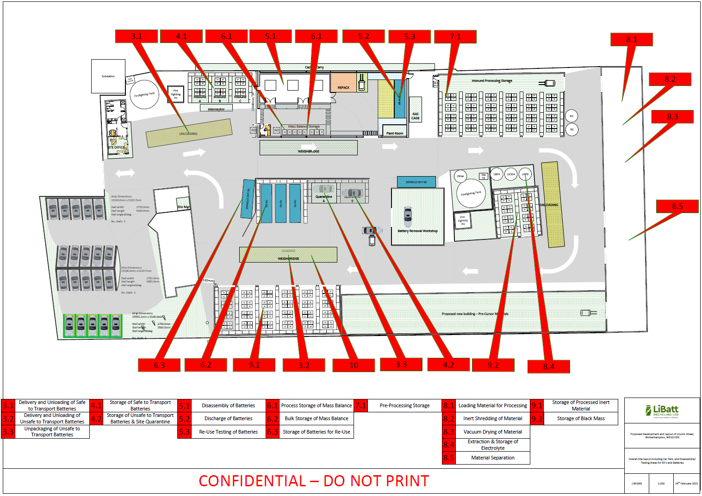
Figure A1 - Location plan showing the position of process steps

Appendix B - Dust Complaint Form

Customer Details
Customer Name -
Address –

Postcode -
Customer Contact Details -
Tel -
Email -
Date -
Complaint Ref Number -
Complaint Details -
Investigation Details
Investigation carried out by -
Position -
Date & time investigation carried out -
Weather conditions -
Wind direction and speed -
Investigation findings -
Feedback given to Environment Agency and/or local authority -
Date feedback given -
Feedback given to public -
Date feedback given -
Review and Improve
Improvements needed to
prevent a reoccurrence -
Proposed date for completion of the improvements -
Actual date for completion -
If different insert reason for delay -
Does the dust management plan need to be updated -
Date that the dust management plan was updated -
Closure
Site manager review date
Site manager signature to confirm no further action required

