When a collection of batteries is accepted our collections administrator will take the following steps using our online management software Quick Consign

1. Open a New Enquiry

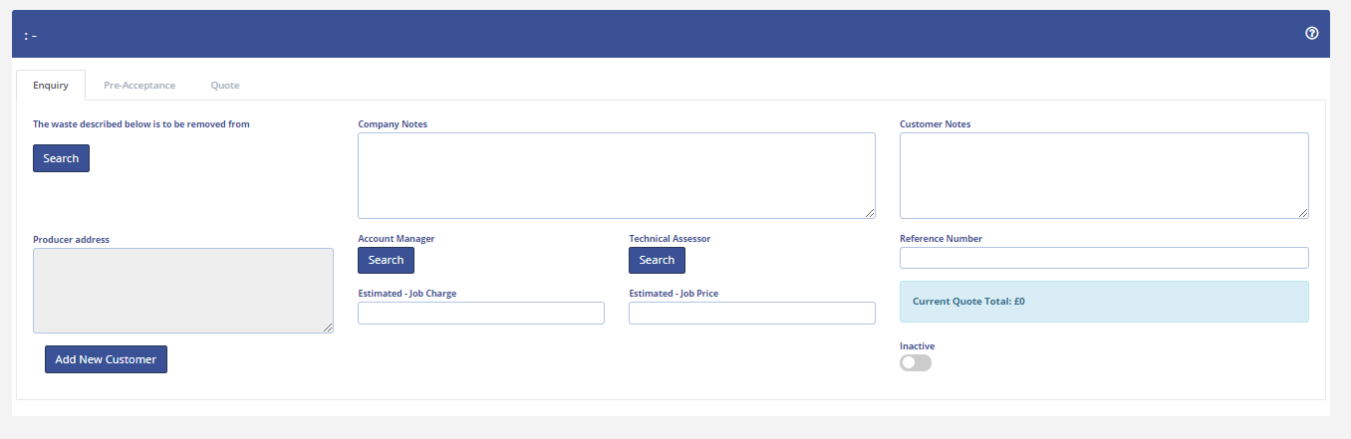

2. Existing customers will be registered in our data base. In the event that an enquiry has come from a new customer then a new customer will be created 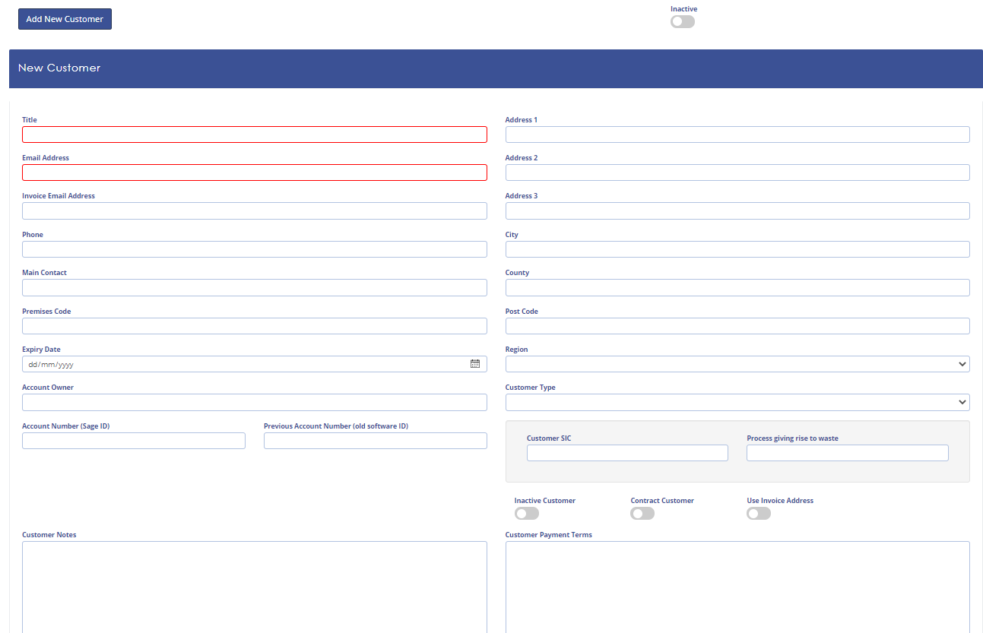

3. While completing the Enquiry the Pre-Acceptance and label requirements are completed
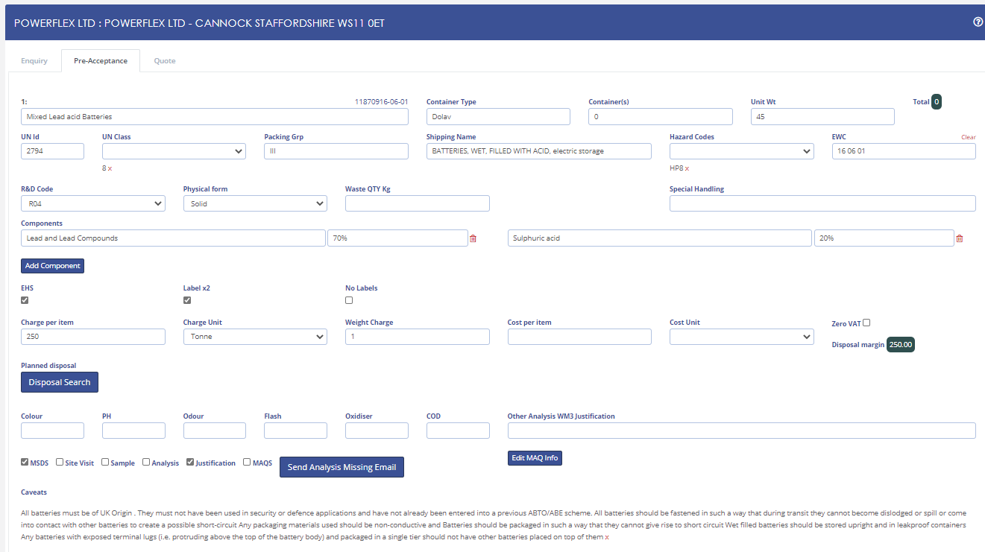

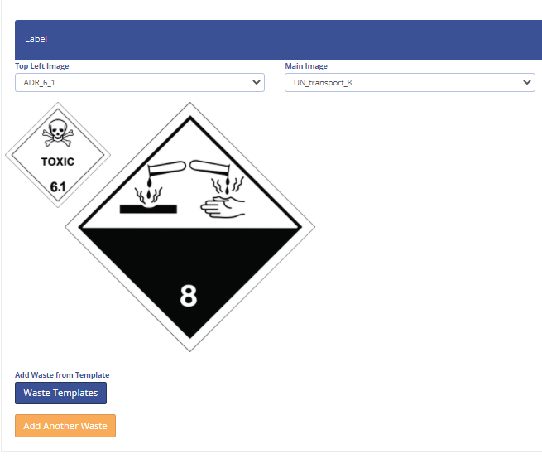

4. Once this has been completed the quotation and pre-acceptance are emailed to the customer. When the customer confirms acceptance of the quotation the quote is “Accepted” in the system
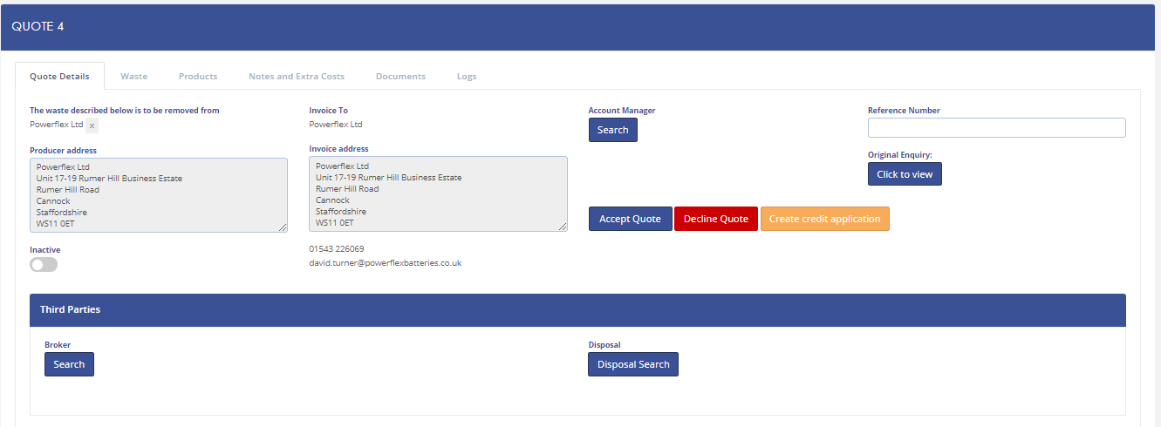

5. The customer receives an email confirming Job Details and Waste Streams etc.
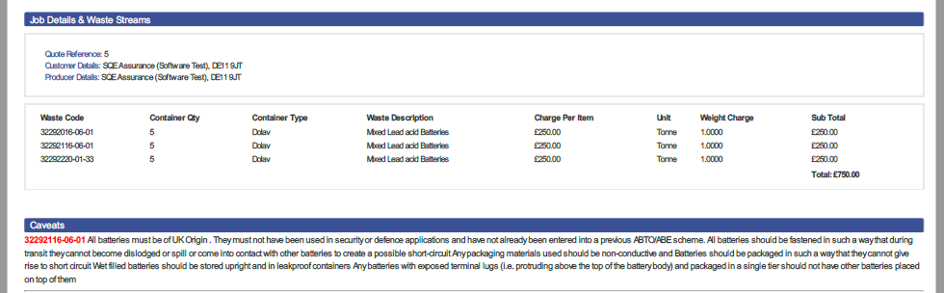

6. A consignment note is automatically generated within the system and the collection is scheduled.

All parties receive a copy of the consignment note. The collecting drive will require the consignment note to be signed at the time of collection.

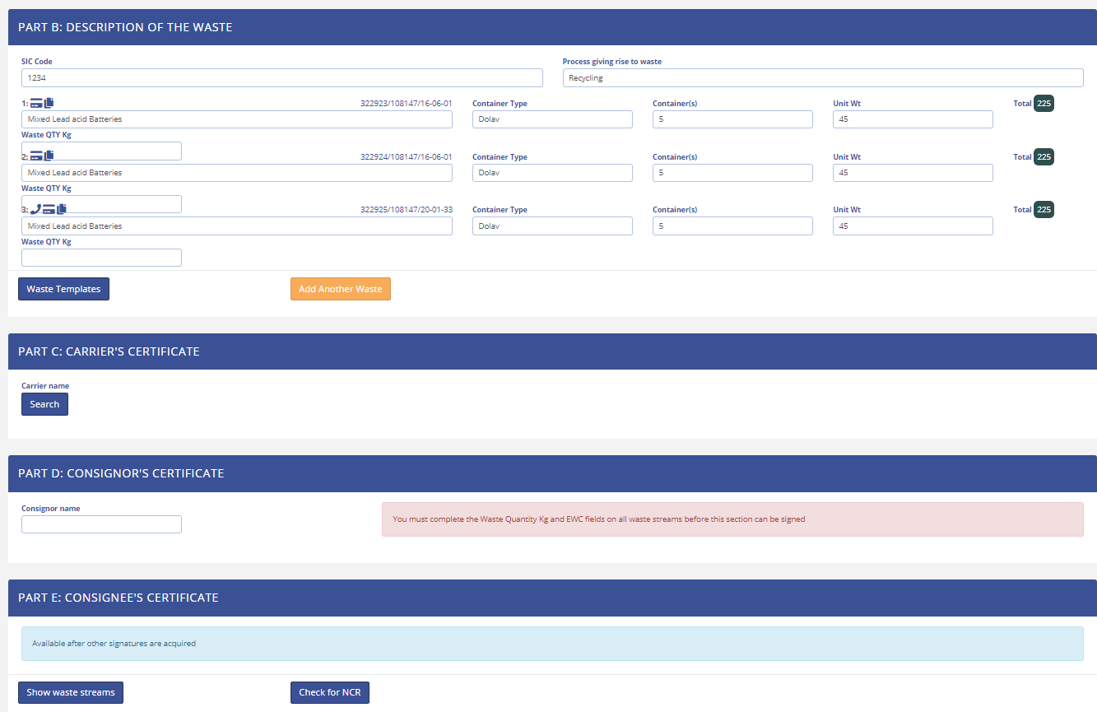

7. A risk assessment for collection is created for the collecting driver.

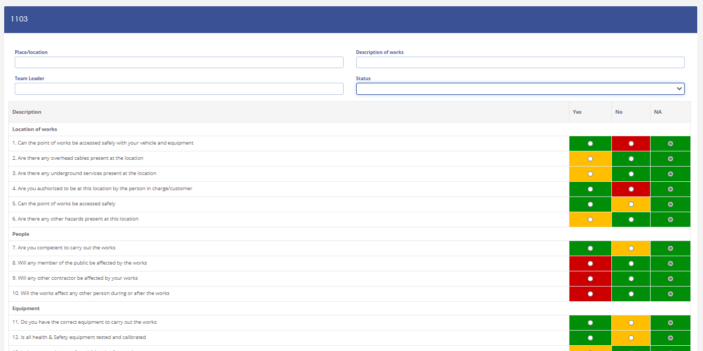

8. The collection date of the materials is confirmed in Part C of the Consignment Note

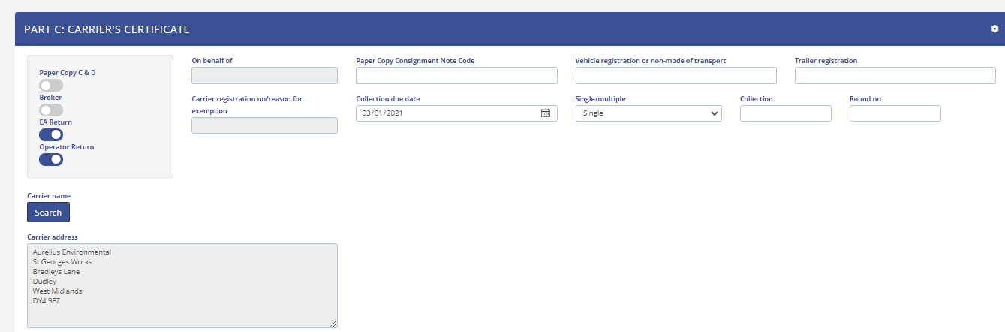

And this is confirmed by both the Carrier and the Consignor on receipt. All collections of batteries are deliver to HBR on the same day as collection.
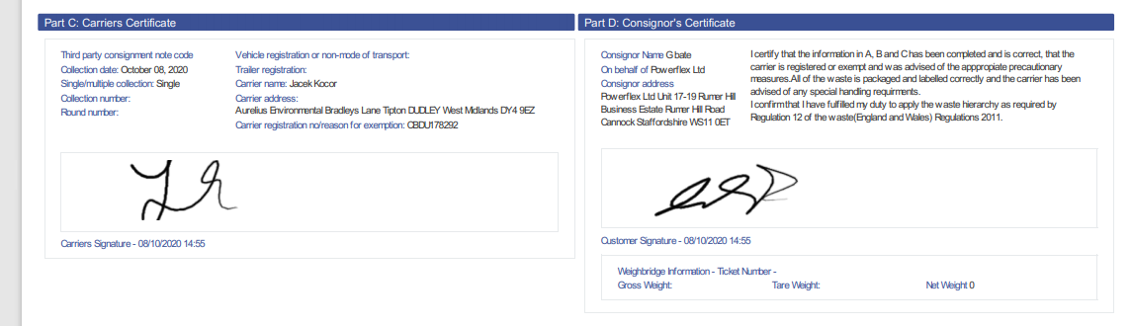

9. On receipt of the consignment the carrier's vehicle is placed on the weigh bridge and the loaded weight and tare weight of the vehicle are recorded on a weighbridge ticket. This ticket is attached to the incoming load inspection note and the Collections Administrator will duly enter the Gross and Tare Weights into Part D of the consignment note to complete the process.

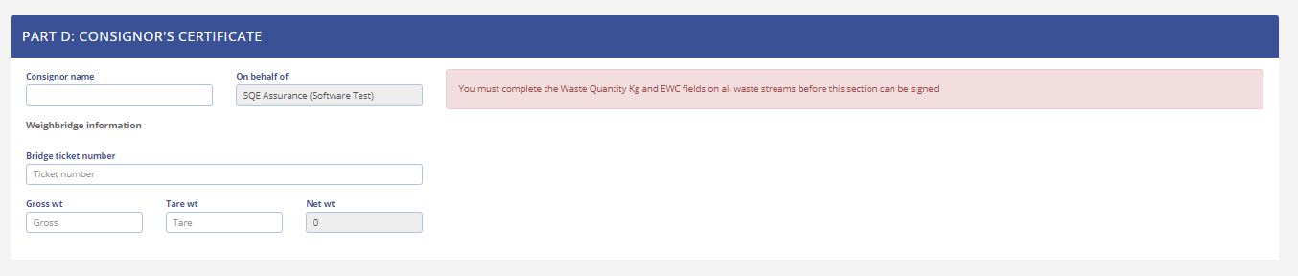

10. At the same time as completing the weights in the Consignment Note the Collections Administrator will enter the collection information into the ABTO/ABE Spreadsheet which will be duly checked by the competent person for Aurelius Environmental.

When waste has been physically checked and sorted the manual weigh sheets will be updated by the operator with the location in which the consignment has been stored. These locations within Quick Consign are then updated by the Administrator this provides evidence for stock management.

