200 m
400 m
600 m
800 m
1,000 m

Halo Battery Recycling Ltd
Green & open spaces
Residential & schools
Industrial & commercial
Schools, churches & community centres

Receptor | Direction | Distance  from Halo
Green & open spaces | All | < 200 m
Residential | All | < 200 m
Industrial & commercial | All | < 200 m
Parkside Complex Needs Care Home | Southeast | < 400 m
Wallbrook Primary Academy | Northwest | < 400 m
Brook Street Community Centre | South | < 800 m
Christ Church Coseley | Northwest | < 1,000 m
Christ Church C of E Primary School | Northwest | < 1,000 m
Tipton Nursery | East | < 1,000 m
Birmingham Canal | South to West | < 1,000 m
The Rowan School | West | > 1,000 m
Wednesbury Oak Primary School | Northeast | > 1,000 m
Glebefields Primary School | East | > 1,000 m
St Pauls C Of E Primary School | Southeast | > 1,000 m
Foxyards Primary School | Southwest | > 1,000 m
Sedgley Rd Residential Home | Southwest | > 1,000 m

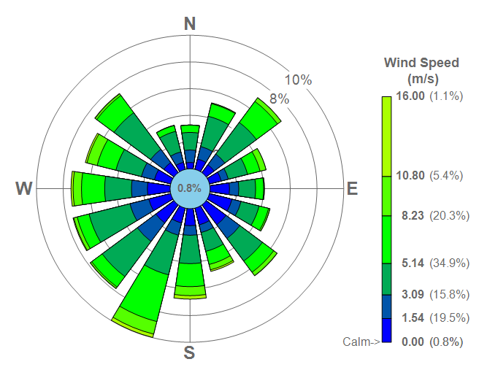

Sources:

Google Maps – Halo Battery Recycling
https://goo.gl/maps/8DjhsDuyXcDD8fNS7

Draw a circle on a map
https://www.mapdevelopers.com/draw-circle-tool.php

Google My Maps zones
https://www.google.com/maps/d/u/0/edit?mid=1KjCu_b9jmtpcuUTCX8q6xj5a0GTARxA&usp=sharing

Environment Agency Guidance on Sensitive Receptors
https://www.gov.uk/government/publications/fire-prevention-plans-environmental-permits/fire-prevention-plans-environmental-permits#fire-prevention-plan-contents

Wind Data for South West UK
https://southwest-environmental.co.uk/further%20info/in%20depth/wind_data_for_yeolvilton.html

